University of Wales Trinity Saint David
Wales Institute of Science & Art


Torsion of Shafts

Mechanics & Dynamics (ACHA 4026)

Isaac Revans
2304556
December 2025
Contents
1 Introduction 2
2 Experimental Procedure 2
3 Results 3
4 Analysis 4
5 Conclusion 6
6 Evaluation 6
7 Bibliography 7

Introduction
Understanding the torsional behaviour of shafts is essential for the safety and efficient design of different engineering mechanisms. Twisting action in metal can be found all over engineering, with car chassis, aeroplanes, shafts, axles and much more. The experiment aimed to determine how different metal rods twisted when subjected to a force in a clamp. This experiment gives the basic understanding of how brass, steel and aluminium shafts react under a rotating force. This report displays the data collected from the experiment, explaining how it was completed, the data itself and evaluating how it could be improved in the future. The experiment investigates the torsion of solid rods and measures the resultant angle of twist when different weights are applied.

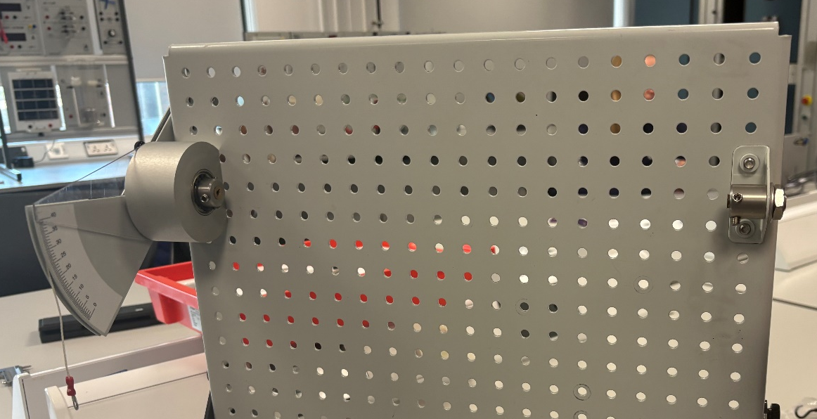
Experimental Procedure
Figure 1 : work panel
This Torsion of metals experiment was conducted using three different shafts of metal, all of which were 0.34m in length. The shaft would be placed within the clamp on the right-hand side, and a Torque arm scale on the left, ensuring it was set to 0. Weights are then added to the Torque arm, increasing in increments of 100 grams up to 500 grams; any more and the metal shafts may be twisted beyond their elastic limit. Figure 2 shows steel in the clamp and 200 grams of weights attached to the Torque arm, with the scale reading 5 degrees or twist on the metal rod. The angle is measured on the torque scale every 100 grams, reading the twist angle in degrees. The diameter is measured using a calliper to achieve an accurate reading of each metal shaft before it is placed within the work panel. Knowing the dimensions of the shafts is important to understand how the material reacts to the effects of torsional twist. For the aluminium shaft, the weight is capped at 400 grams to prevent twisting the rod beyond its elastic limit. Brass and steel are both capped at 500. From this data collected, the torque and twist angle in radians can be calculated. 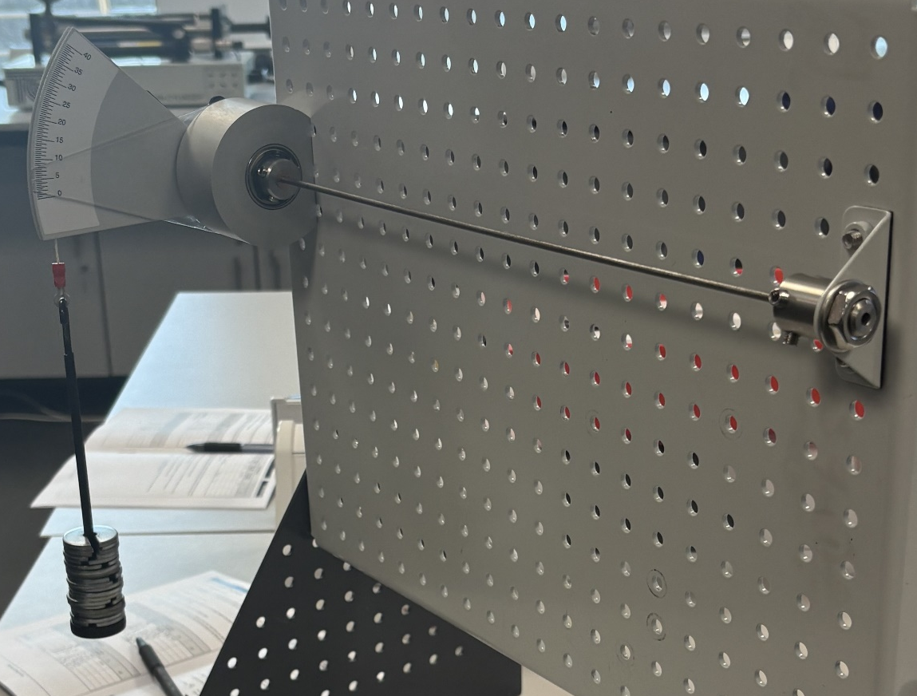
Figure 2 : 200 grams with steel

Results
When the force on the torque arm increased, the angle of twist on the shaft increased. Aluminium proved to be the most affected material, with 8 degrees of twist from the first 100 grams of force, and 31 degrees of twist from the 400 maximum grams of force. This was more than both Steel and Brass, where at 400 Brass had a recorded 23.5 degrees of twist, and Steel had only 10 degrees of twist. From the data, Steel is shown be able to withstand more torsional twist than both Brass and Aluminium. The diameter was recorded within the experiment, which gives the Polar Second moment of Area (J). 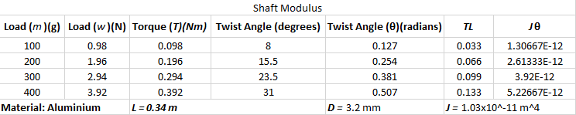
Figure 3 : Aluminium data
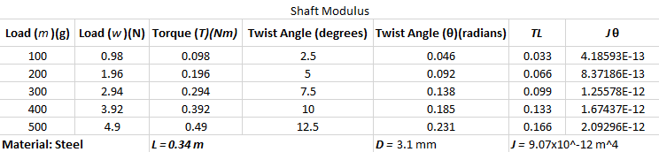
Figure 4 : Steel data
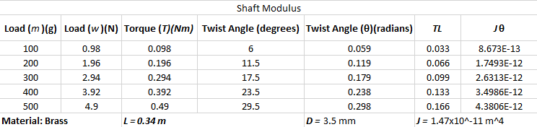
Figure 5 : Brass data

Analysis
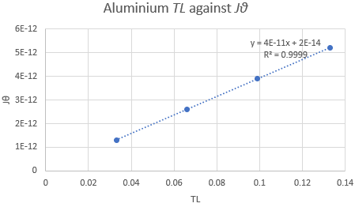
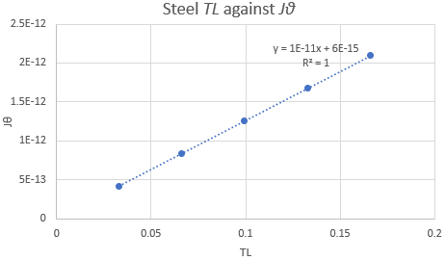
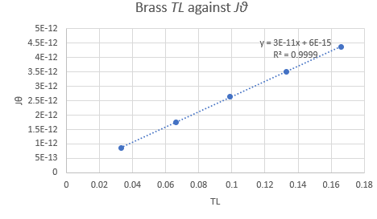
The purpose of collecting the data was to turn it into shear modulus values, to ensure how accurate the experiment is by comparing its values to a textbook's value. Data from the experiment enabled the twist angle in radians to be calculated. J was found by calculating $J=\frac{πD^{4}}{32}$ meaning the polar second moment of area for the steel shaft, being 3.1mm in diameter, was $9.07x{10}^{-12}m^{4}$. Using the equation $\frac{T}{J}=\frac{Gθ}{L}$ for torsion, the equation is rearranged to $θ=\frac{LT}{JG}$ to calculate the twist angle in radians. This gives a more precise reading of how much the shafts have twisted under a certain amount of force. Data from this experiment shows how aluminium is affected more than steel by torsional twist. From figures 3, 4 and 5, the last 2 columns, TL and Jθ, are put into a graph to calculate the shear modulus of each material. This is shown in figures 6, 7 and 8.
Figure 7 : Aluminium graph
Figure 6 : Brass graph

Figure 8 : Steel graph
The general equation of a line on a graph, y=mx+c, is used to find the value of the shear modulus. The torsion equation is rearranged from $\frac{T}{J}=\frac{Gθ}{L}$ so that $Jθ=\frac{1}{G}\left(TL\right)$ To ensure Jθ and TL match the X and Y values in the original graph equation. In Figure 7, the gradient of the line is shown to be 4E-11, translating to 4*10^-11. To find the value of G, it must be put in the equation where the gradient is equal to $\frac{1}{G}$, rearranged to make $\frac{1}{m}$ = G. The final value of shear modulus for Aluminium from the experiment was 2.5*10^10 or 25GPa. That same process is repeated for each graph.

Conclusion
This experiment was carried out to test the effects torsional twist has upon metal shafts. From the data collected, the results showed that in the aluminium test, the shear modulus calculated was 25GPa, which is in close agreement with published values of 24-28GPa. For Brass, shown in figures 5 and 6, the Shear modulus values calculated came to be 33GPa. This is slightly below published values for Brass, being around 37-40GPa. This could be due to human error, where, during the experiment, the shaft was not tightened enough, or the scale was not accurately set to 0. Human factors within experimental procedures can affect the data received from said experiments. From the data during the experiment, the Shear modulus for steel was 100GPa. This is much higher than expected, as the average shear modulus is 79-85GPa. Being 15-20 over the expected shear modulus level shows that the experiment was not as accurate as it could have been. This shows the effect human error can have within lab experiments. Possibilities could include the shaft not being tightened in the clamp or scale, causing the bar to slip and the scale to move freely without tension from the shaft. Scales must be set to zero when starting an experiment, and if that was not done properly, it could have affected the results from the steel.

Evaluation
From this, the data shows that torsion of shafts experiments can be recorded accurately, with proof of the calculation of the shear modulus check. The procedure ensured that the data collected from the metal shafts were recorded accurately and provided a correct evaluation of how the materials reacted to the torsional force applied to the rods. The data from the steel shaft shows that it was not done accurately due to the Shear Modulus being too high. To prevent human error when reading the scale, multiple people were a part of the experiment, reading and agreeing on what the scales came to. The experiment could be more accurate by repeating the experiment for each metal shaft. This would give a larger scale of data to record, giving more results for a finer accurate finish. The Scale for reading the angle of twist went in increments of .5 degrees; this could be made smaller so that the degrees read were more accurate to the actual angle of twist performed by the metal rod.

Bibliography
TecQuipment Ltd. 2012.Torsion Kit ES5 Engineering Science Guidance Notes.

