Computer architecture and operating systems

Mark Awobokun (2311796)

Operating systems

Contents
Computer architecture and operating systems 0
Mark Awobokun (2311796) 0
Task 1 2
Task 2 5
Task 3 5
Task 4 8
Task5 10
Task 6 11

Introduction
In this report I will be describing various key features of operating systems for windows, Linux and other various operating systems. I will also be giving and using commands such as batch and bash and I will be making power cell and Linux OS script ad at the end of this I will show proof of my inclusion in a Linux command course.

Task 1
Memory and process management – memory is the collection of data in a specific format which comprises a large group of bytes. Memory management is the ability of operating systems to subdivide memory among different processes, the main function of memory management is to make sure memory is utilized efficiently. Some more functions of memory management:
- Keeping track of used memory space by programs on the OS
- Minimizing fragmentation issues
- Maintaining data integrity
Some commands used in memory and process management are:
- Ps – this displays information about running programs.
- Jobs – displays and manages running jobs.
- Pmap – displays memory map of processes.
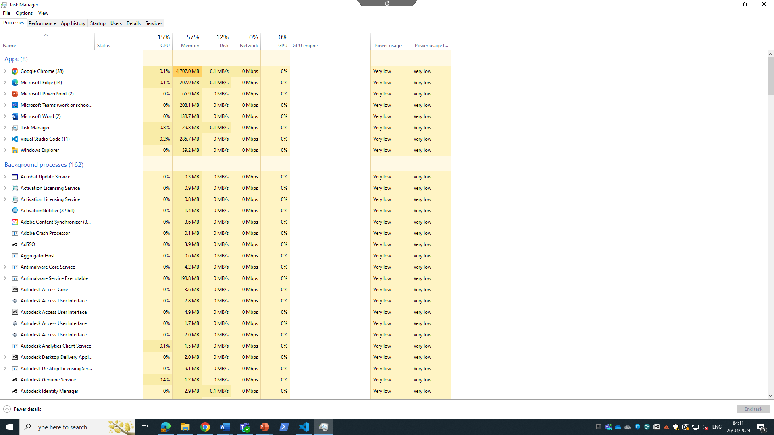
File system management - this is a system mainly used to locate, organise, and store data. The key aspects entail:
- File organisation – such as creating folders, naming and renaming files and moving and copying folders.
- Setting file permissions – setting access rights for users like allowing them to read, write and execute.
- Disk space management - monitoring disk usage and space, removing useless files and folders, and compressing folders for space management.
- File system backup and recovery – creates back up of files and folders, using backup software or tools like Dropbox 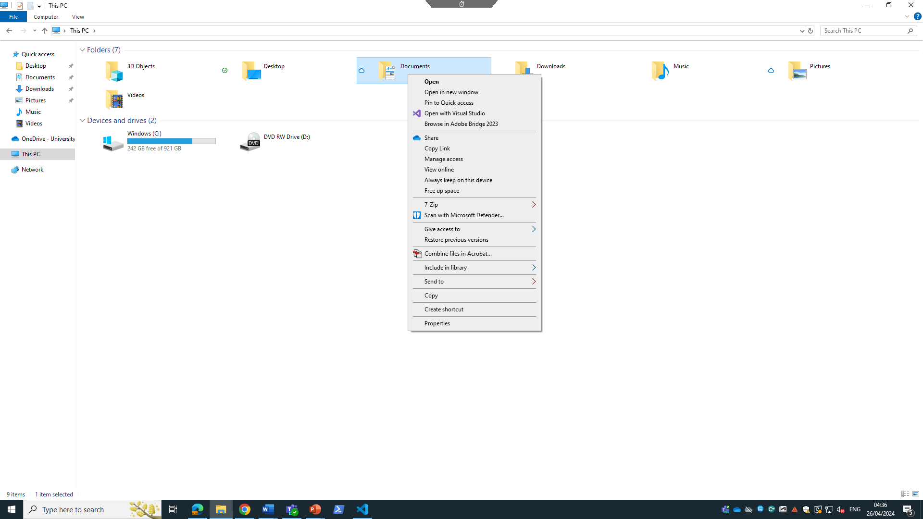
- This screenshot is where file system management can be found.
System security and network management- these are critical components for maintaining secure and efficient computer system, it is also a method of managing firewalls and policies and monitor access across the network. Some major functions include:
- Firewall configuration – placing firewalls to control traffic from outgoing networks.
- User authentication- managing accounts and passwords of users.
- Malware protection – placing antivirus software that detect viruses from attacking the computer as well as scanning the system for any malware.
- Network security – implement’s various security checks such as firewalls and access control.
- Network performance optimization- improves speed and reliability.
- Network troubleshooting – resolving network connectivity issues. 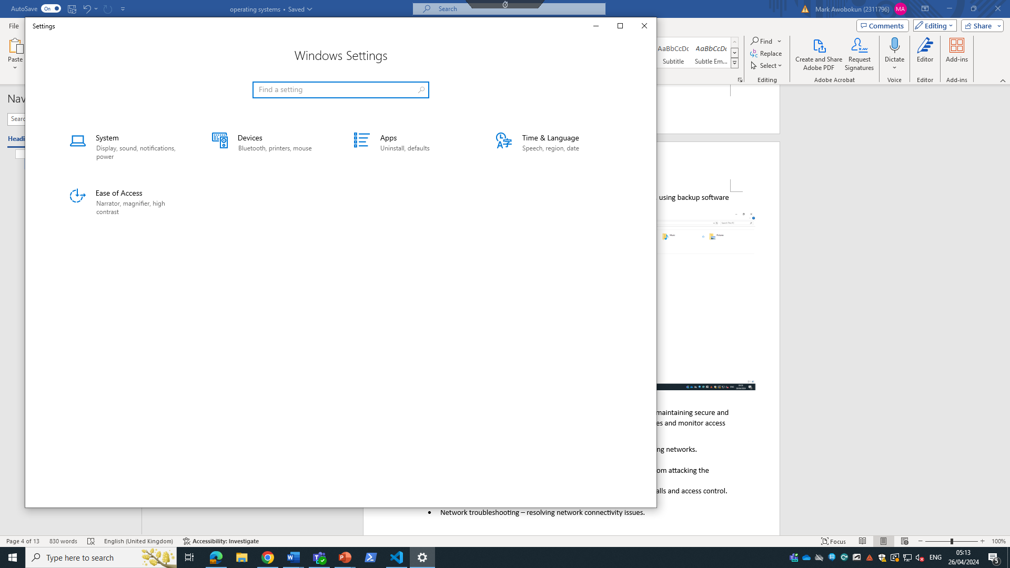
Device management - this is the process of managing, monitoring and controlling devices connected to the network system. Such as the status of the device and the condition the devices are in, some functions include:
- Hardware inventory management – managing the hardware components of the system such as the server, laptop and workstations.
- Security management – installing firewalls and antivirus software.
- Remote management – devices are monitored remotely by troubleshooting, updating and configuration changes.
Some tools used to manage devices are mobile device management (MDM), desktop management software like Microsoft SCCM and network management protocols like SNMP. 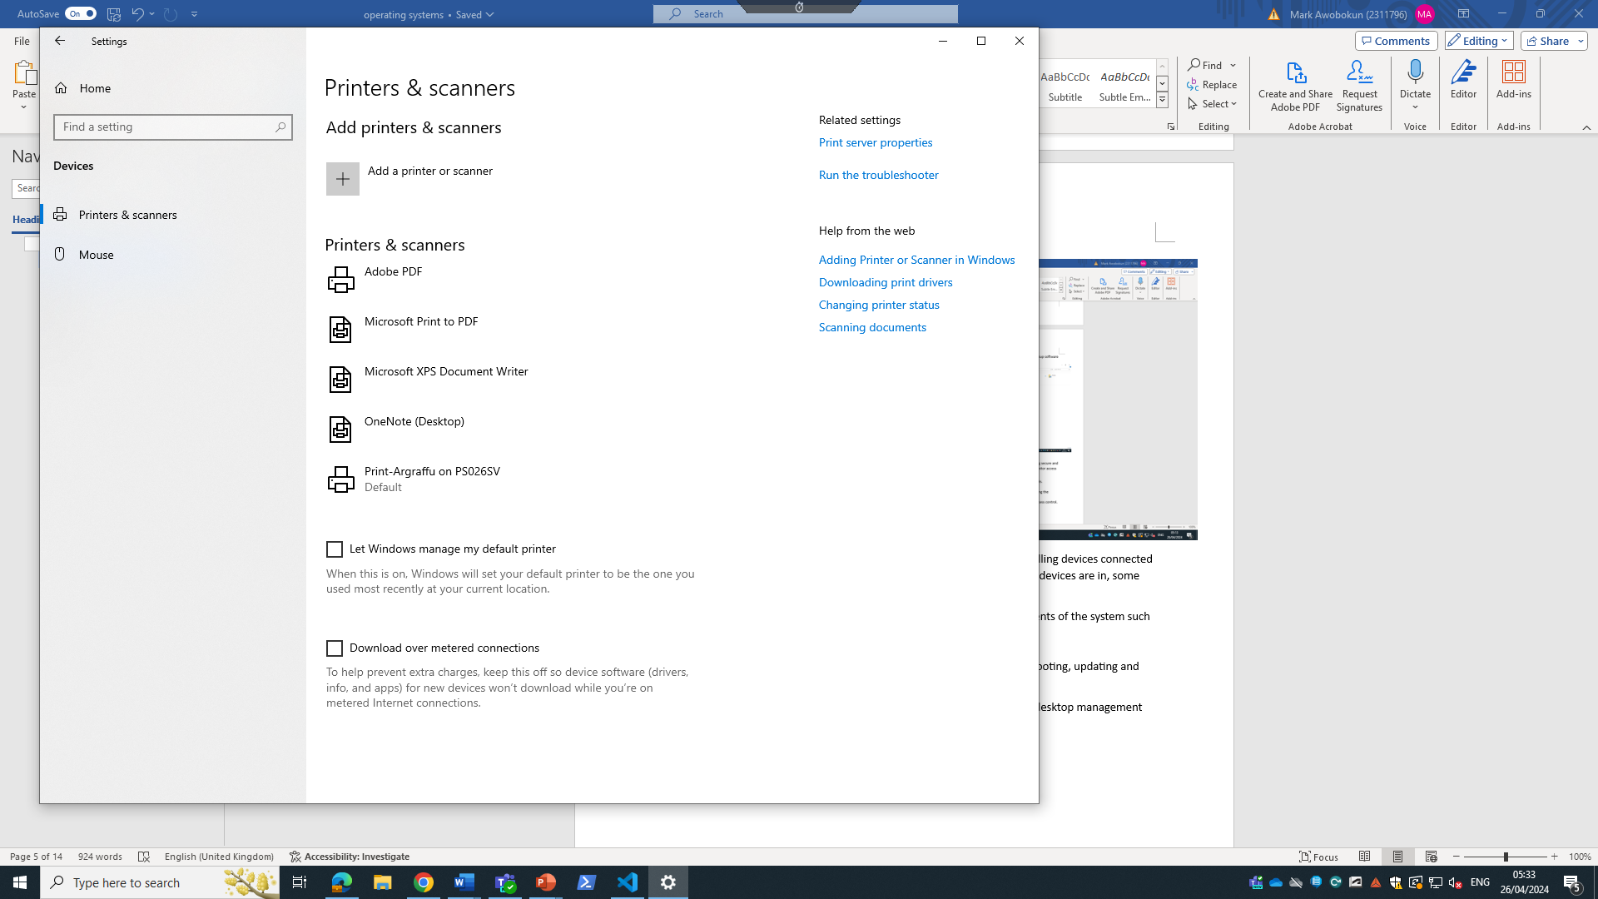

Task 2
There are a lot of batch commands available for programmers to use but in here I will show 10 commands.
- @echo off – this code makes sure the command doesn’t repeat itself when it has been run and only the final output will be shown.
- Echo – this code shows the text or variable on screen 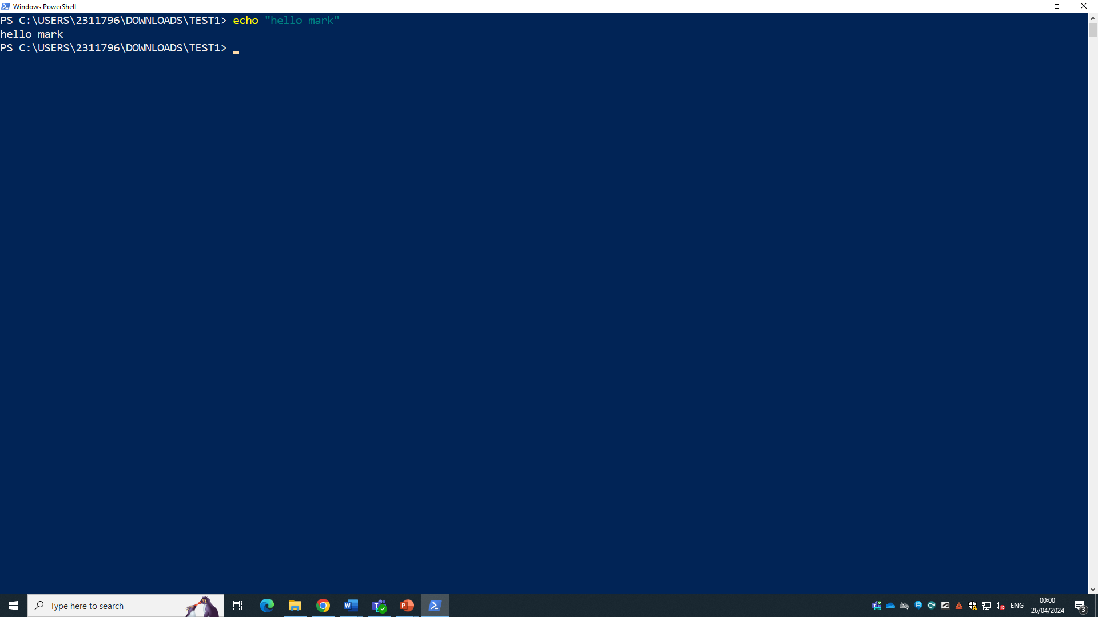.
- Set – displays the list of variables for example set name=mark
- IF – this is a command used in conditional statements and when the conditions have been met for example IF %name%=john Echo hello John
- Exit – closes the program.
- Pause- pauses the program and waits for user input.
- Del – this batch command deletes variables and not directories.
- Colour- changes the colour of the background.
- Copy – makes it possible to copy the file.
- Date – displays and updates the system date and time.

Task 3
Listed below will be 10 basic bash commands used in operating systems.
- Echo – displays text on the screen, this is commonly used in batch files and shell scripts. Also, it is useful for showing the value of variable which tells the shell how the user works .
- Cp – this command is used when u want to backup files.
- Cd – change directory command, which allows the user to navigate through different files and directories easily for info 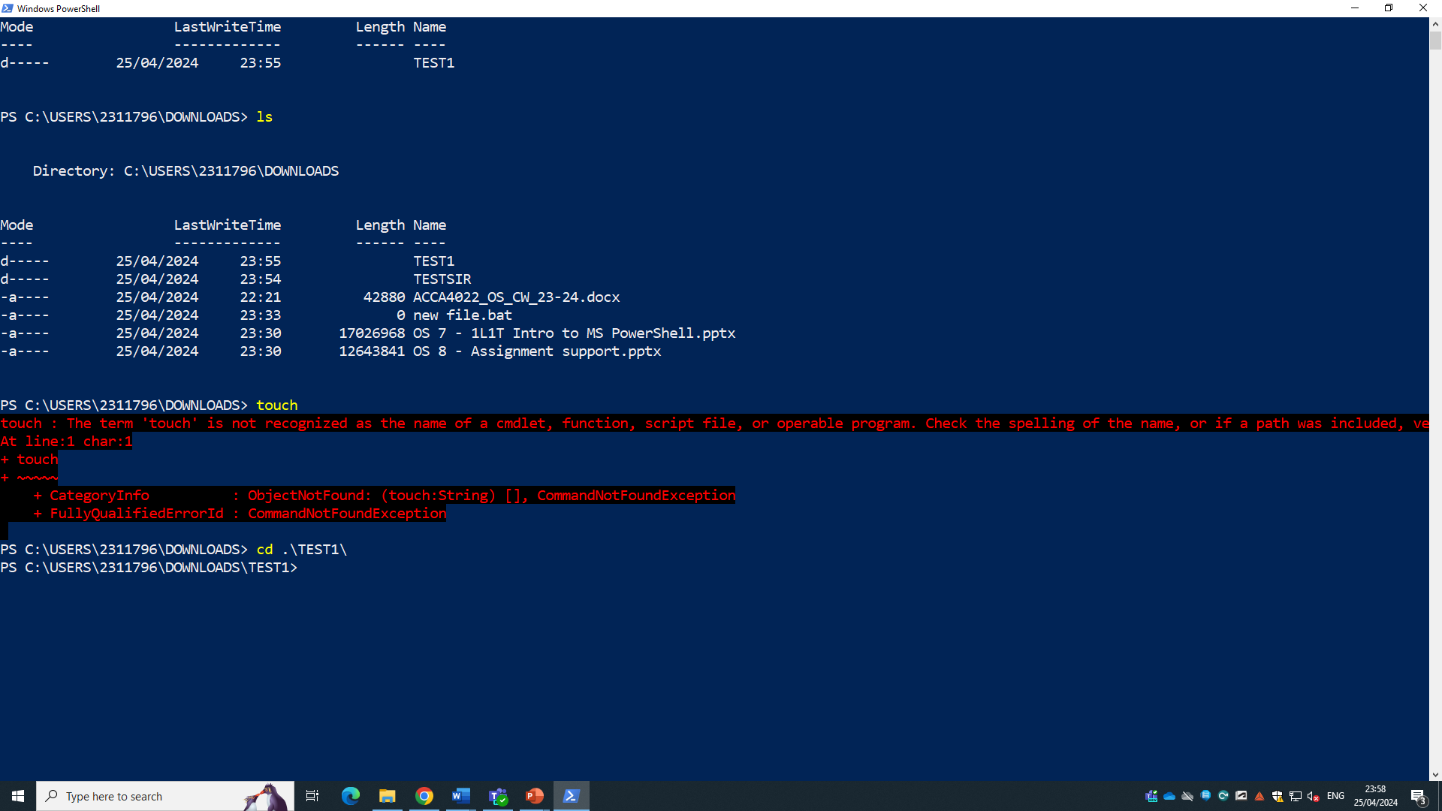.
- Ls – list directory is the most used command which allows the user to show all the files within a specified directory 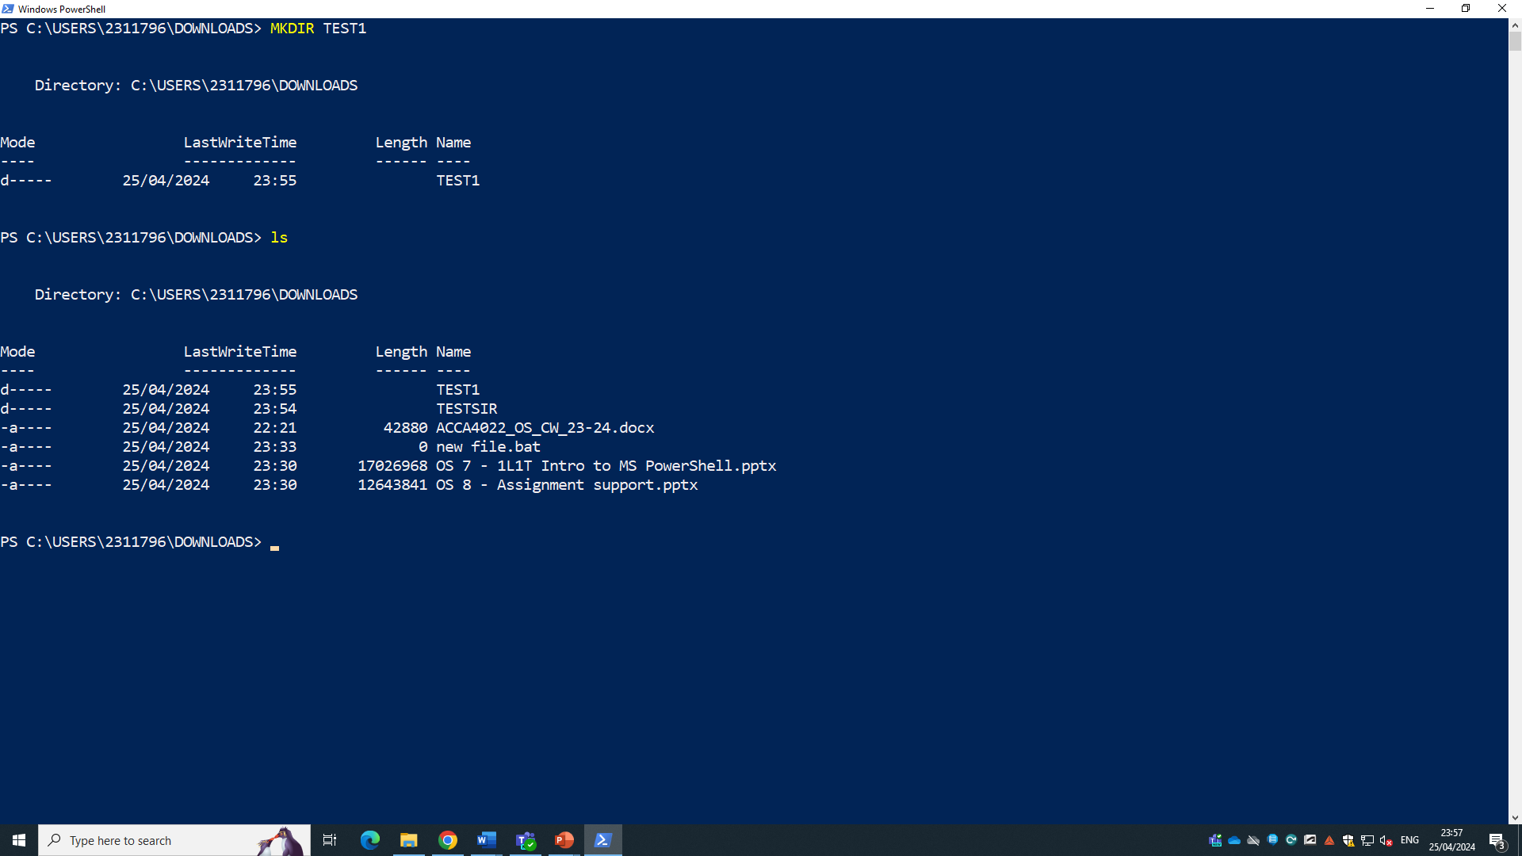
.
- Touch -this command creates a file, or files and it can be used to change timestamps on files and directories.
- Mkdir – this is a command that is used to create a directory simultaneously making the process faster. 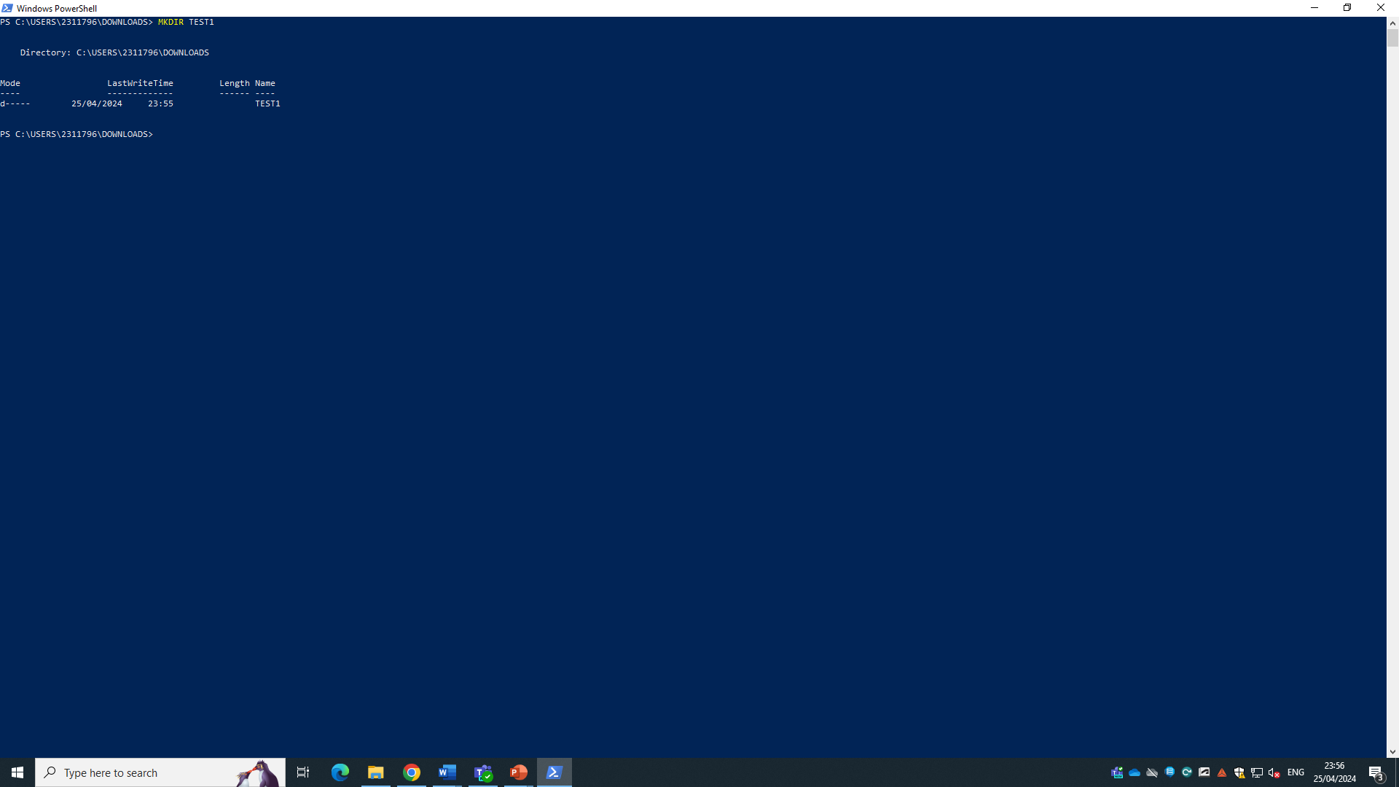
As you can see I made a new file with the command
- Rmdir – this will remove the directory which in turn can help clean up space and make it more organized.
- Rm – this is also a command used to delete directories the difference between rm and rmdir is that rmdir deletes empty directories while rm deletes directories or files if they contain data or not 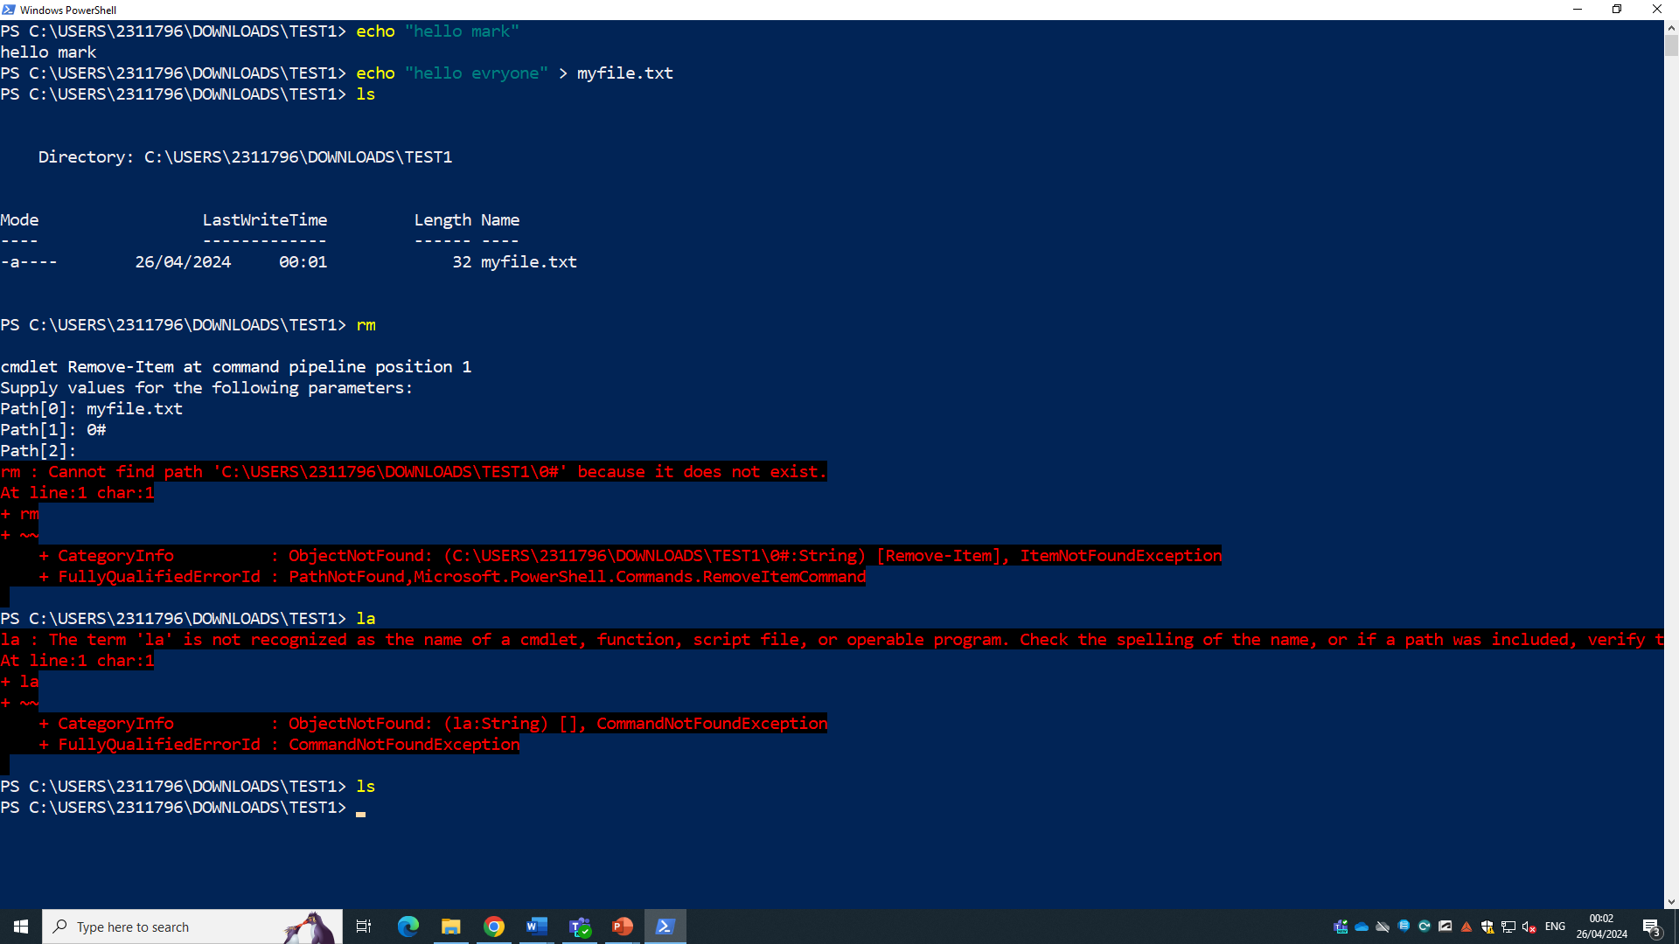the rm removed the myfile.txt.
- Locate – this is the easiest way to find a file. It can be used for a wide search or narrow search.
- Cat – this command lets u read a file, create a file and concentrate a file it is a very versatile command.

Task 4
I will be using 7 commands to make a script namely- if statement, variable, loop, array, function, user input and switch
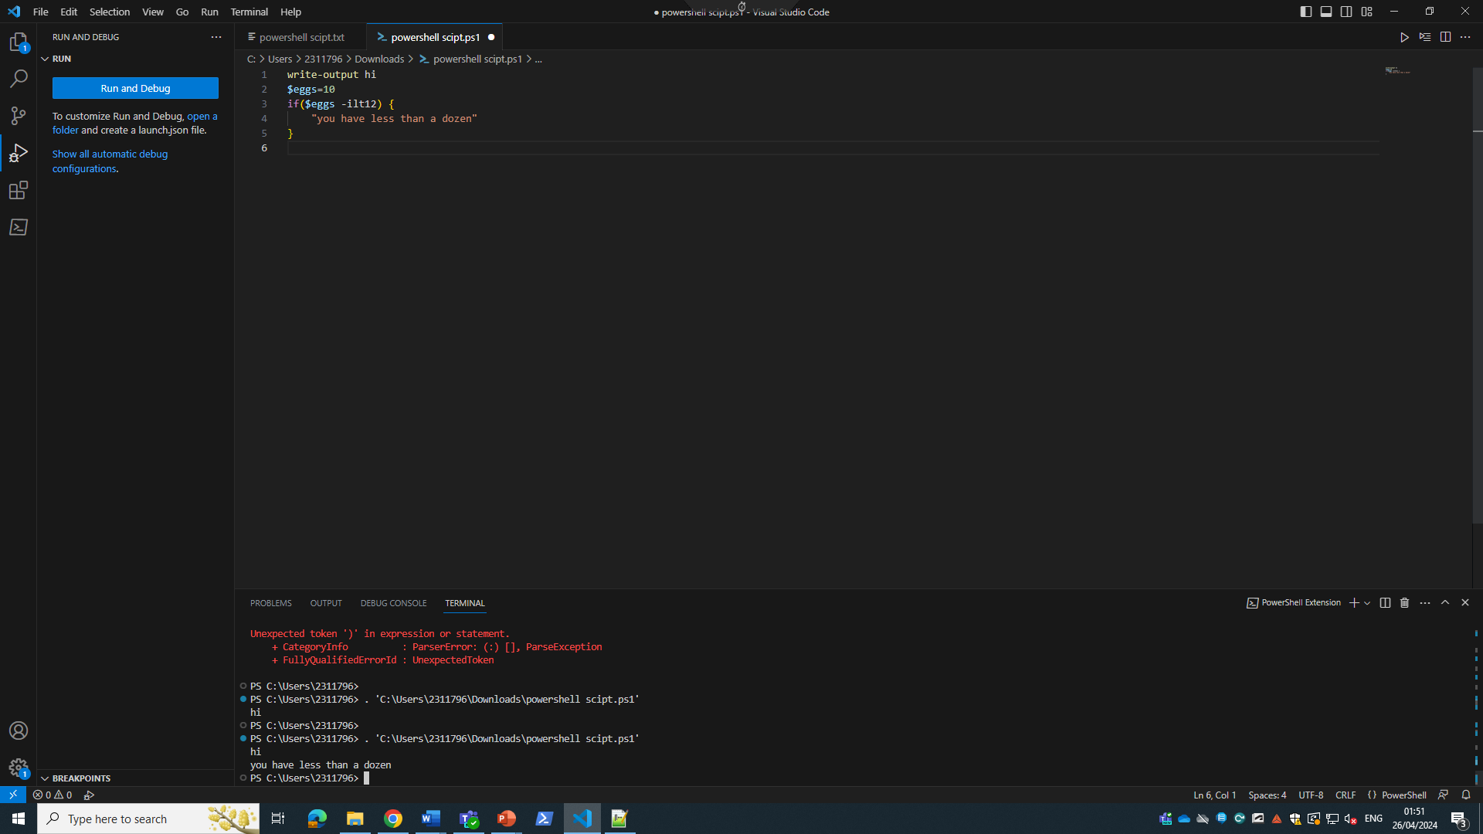
In this screenshot I have used the variable function to set the value of $egg = 10 and I have used the if statement to give the statement that if the value of eggs is less than 10 it will show that we don’t have a dozen eggs. 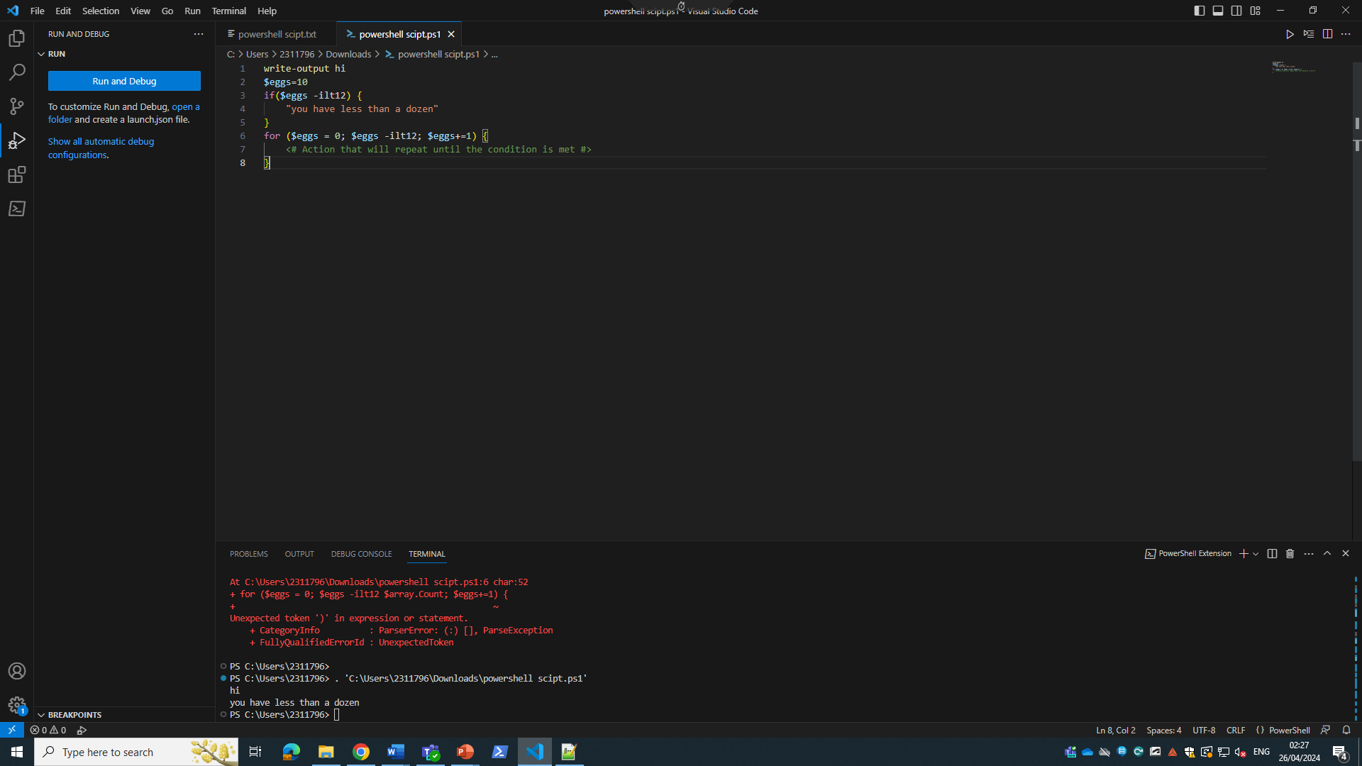
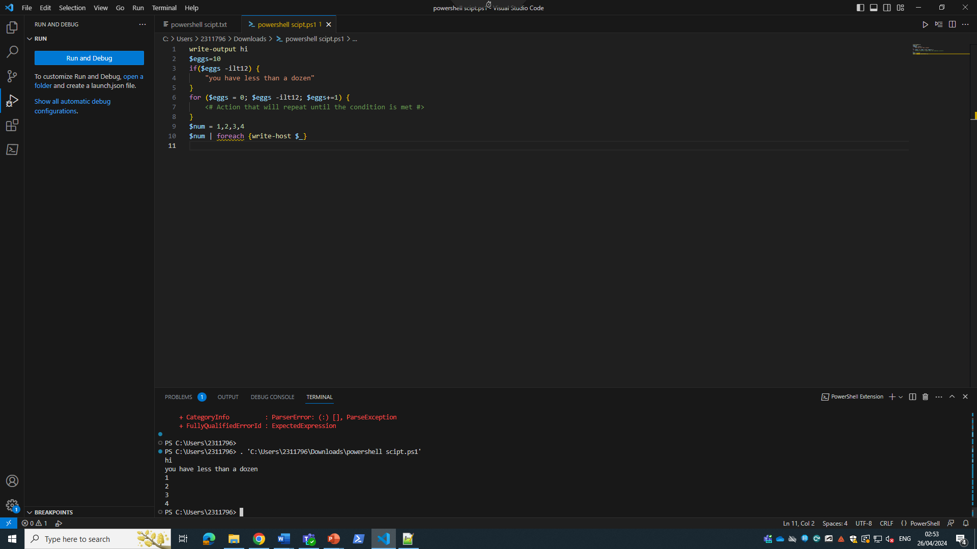
In this screenshot I used for reach to loop the command
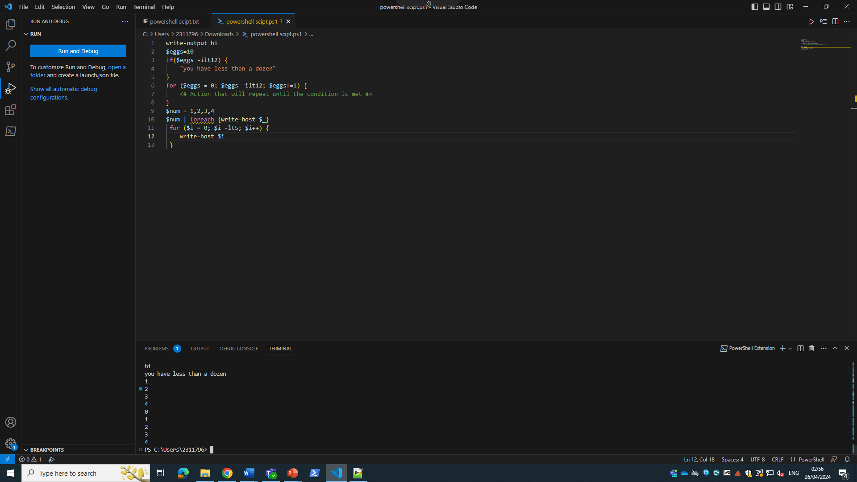

I used the for function to loop the carriable to count to 4 till $i = 5 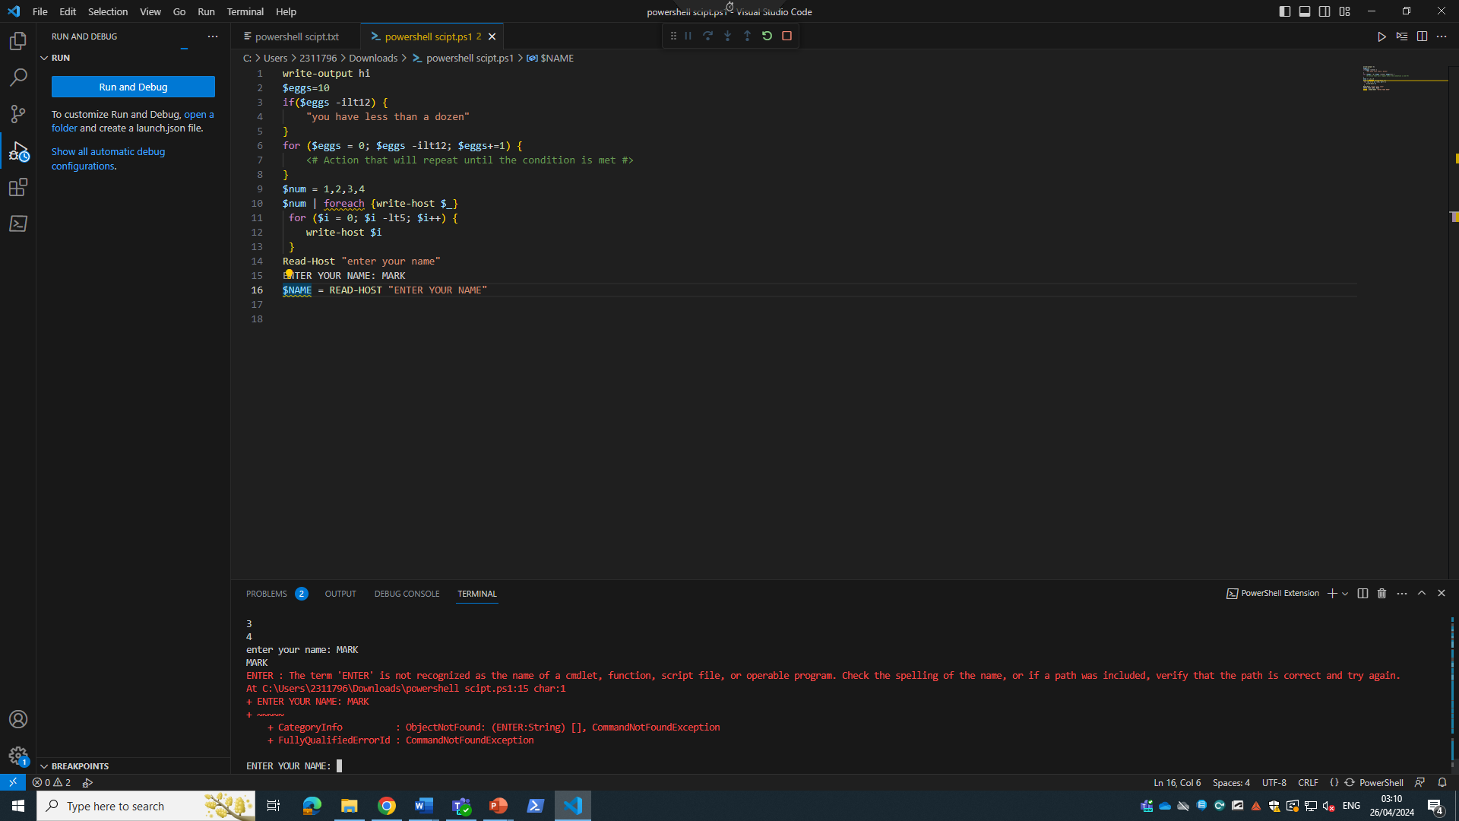
USER INPUT I entered my name

Task5

Task 6
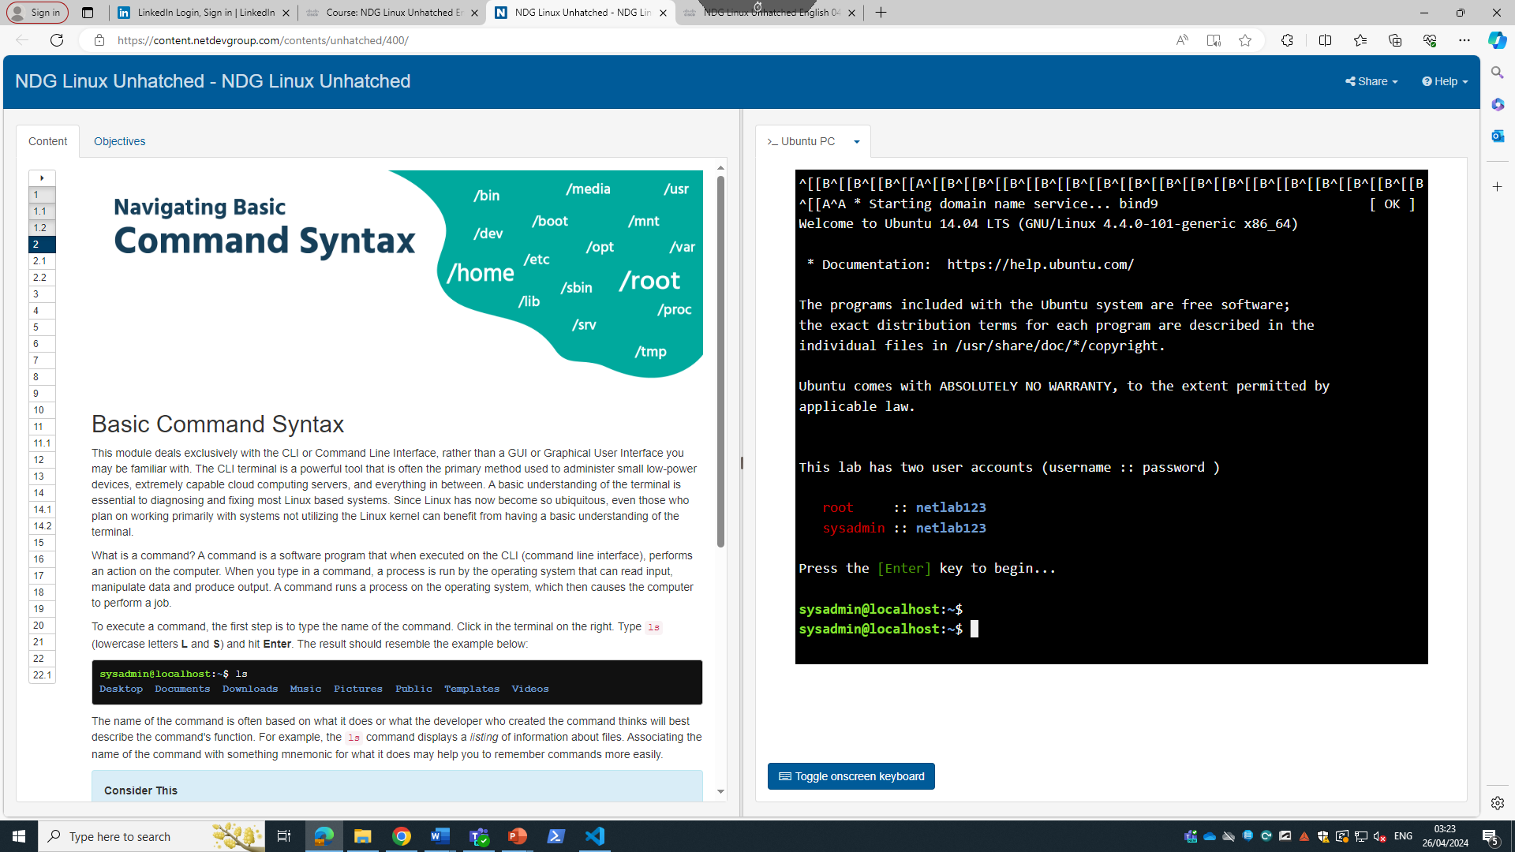
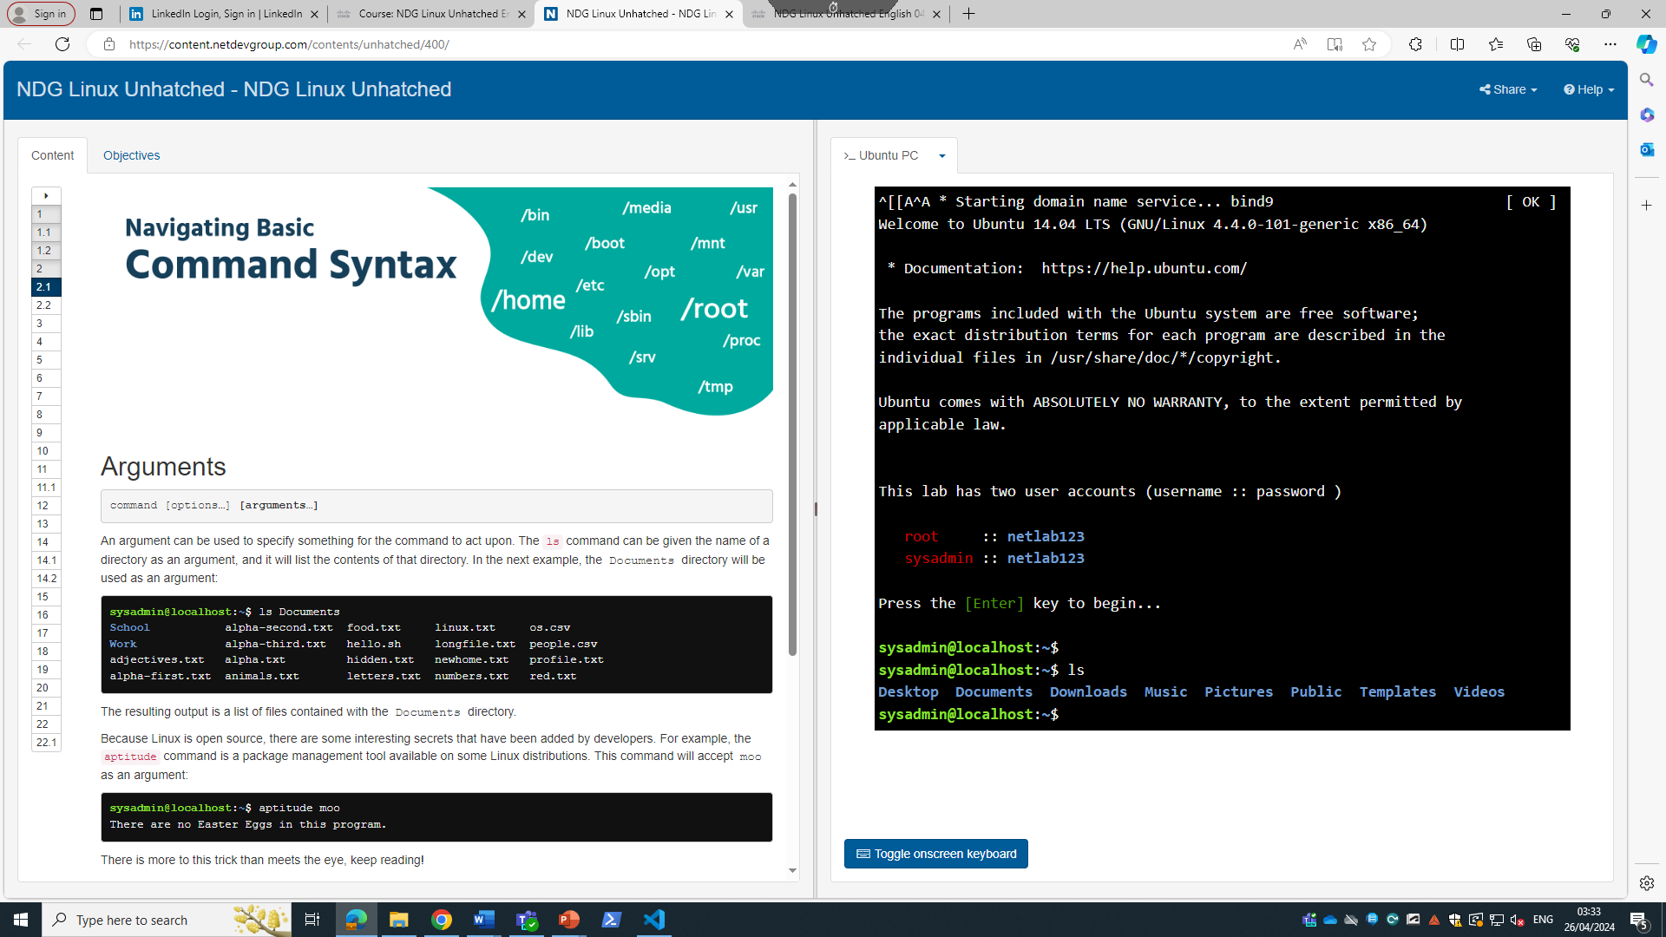
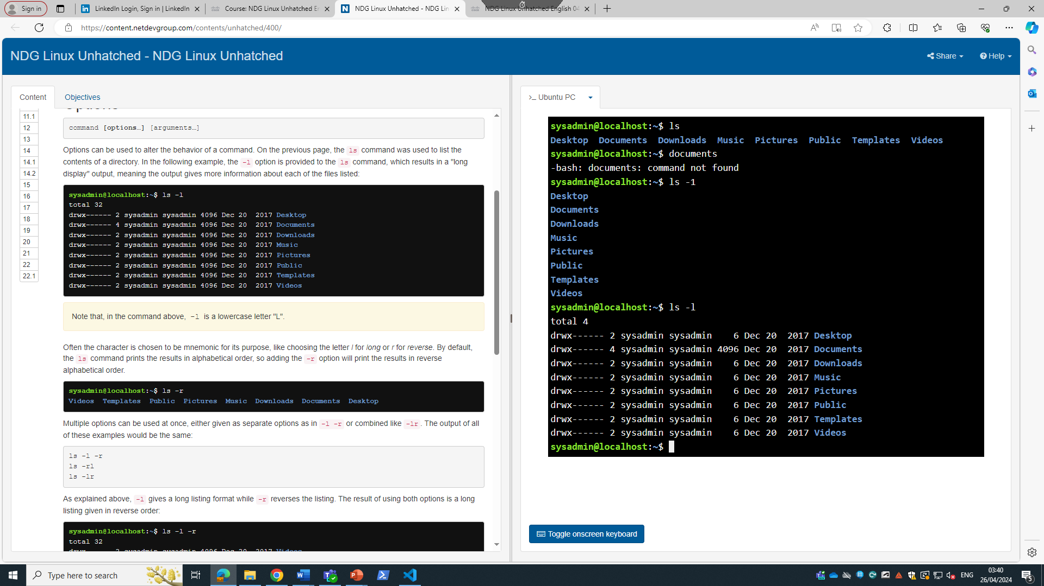
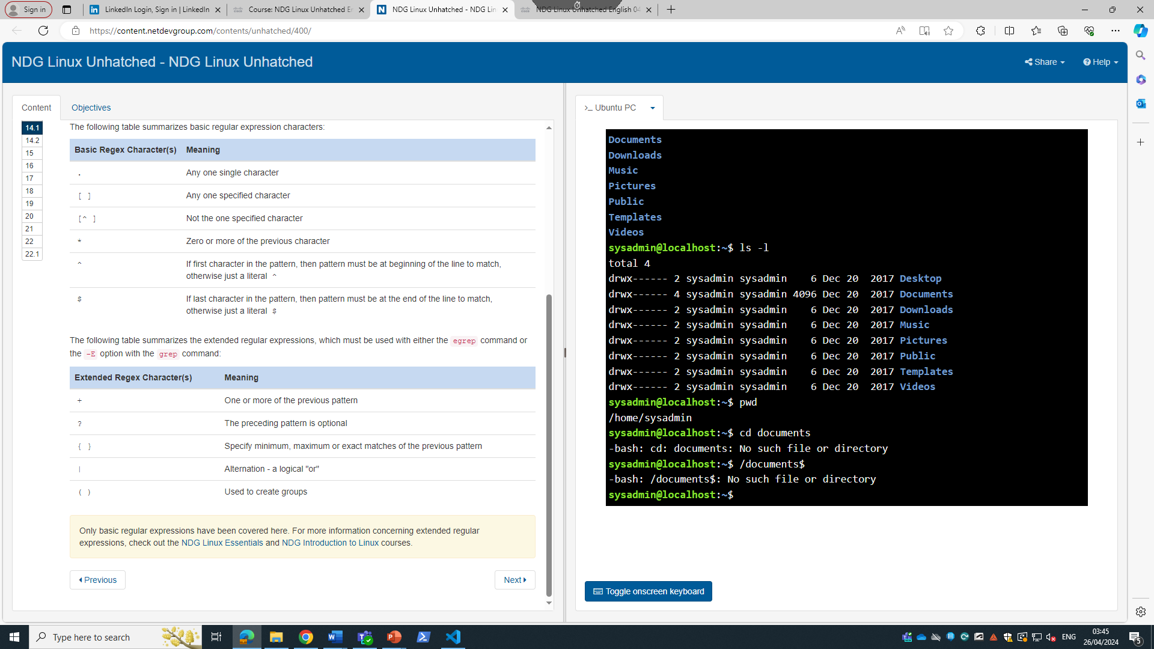
These screenshots show proof of my involvement in Linux system course using the cisco network academy course.

Conclusion
In this report I have learnt about various key features, as well as various commands used in programming and in my research, I have decided that the Linux OS system is the easiest system to use with its easy-to-understand command language and availability while I believe the Microsoft operating system is a little more difficult to navigate when programming.
I have also learnt that the need for security and device management are essential in the computer network scheme as it prevents people from taking our vital information as well as letting us make sure our devices, passwords and managing our networks preventing others from using it without proper authorisation.

Reference list
[1. 2. 3. 4. 5. 6. 7. 8. 9. 10. 11. 12. 13]
References
[1] "Memory Management in Operating System." GeeksforGeeks. https://www.geeksforgeeks.org/memory-management-in-operating-system/ (accessed Apr 26,).
[2] "Bash cheat sheet: Top 25 commands and creating custom commands." Educative. https://www.educative.io/blog/bash-shell-command-cheat-sheet (accessed Apr 26,).
[3] "Writing a Windows batch script." GeeksforGeeks. https://www.geeksforgeeks.org/writing-windows-batch-script/ (accessed Apr 26,).
[4] "Batch Scripting Commands | Useful List of Batch Scripting Commands", EDUCBA, https://www.educba.com/batch-scripting-commands/ (accessed Apr 26, 2024).
[5] "about Variables - PowerShell." https://learn.microsoft.com/en-us/powershell/module/microsoft.powershell.core/about/about_variables?view=powershell-7.4 (accessed Apr 26,).
[6] "How to Use PowerShell Variables", https://blog.netwrix.com/, https://blog.netwrix.com/2018/10/04/powershell-variables-and-arrays/ (accessed Apr 26, 2024).
[7] "How to Use PowerShell For Loop, While Loop, and Other Loops", https://petri.com/how-to-use-powershell-for-while-loops/ (accessed Apr 26, 2024).
[8] "What are the different types of loops in PowerShell? - Guide | PDQ." https://www.pdq.com/blog/guide-to-loops-in-powershell/ (accessed Apr 26,).
[9] "How to use If statements in PowerShell | PDQ." https://www.pdq.com/blog/how-to-use-if-statements-in-powershell/ (accessed Apr 26,).
[10] "The Linux command line for beginners." Ubuntu. https://ubuntu.com/tutorials/command-line-for-beginners (accessed Apr 26,).
[11] "What is a File management system? | Glossary." Bynder. https://www.bynder.com/en/glossary/file-management-system/ (accessed Apr 26,).
[12] "What Is Network Security Management?" Palo Alto Networks. https://www.paloaltonetworks.com/cyberpedia/what-is-network-security-management (accessed Apr 26,).
[13] P. Singh. "Device Management in Operating System." Scaler Topics. https://www.scaler.com/topics/device-management-in-operating-system/ (accessed Apr 26,).

