Juan Xu
Dr Jessica Clapham
Key Issues in Linguistics (HPEN7004)
26th, Nov. 2023
Assignment 2
An assessment of “English language learners’ use of self-regulatory strategies for foreign language anxiety in China”

Krashen’s theory of “Affective filter hypothesis” (1983, pp.124-136) proposes that the affective filter has a significant impact on learners’ language learning success: positive emotions like high motivation, self-confidence, a good self-image, and relaxed mood contribute to learners’ successful language acquisition while negative emotions, like fear, shyness, stress, anxiety, boredom, lack of motivation and self-confidence, etc. tend to cause a higher affective filter that decreases the efficiency of learners’ second language acquisition. Foreign language anxiety (FLA), defined as “a distinct complex of self-perceptions, beliefs, feelings, and behaviors related to classroom language learning arising from the uniqueness of the language learning process” (Horwitz et al., 1986, p. 128), is extensively regarded to be a negative affective variable that scares the learners and cause high affective filter in their exercise of input and output of language,
greatly reducing learners’ efficiency in their second language acquisition (Arnold, 2005; Horwitz, 2001). Therewith, a substantial of studies have concentrated on the possible causes and feasible methods and strategies that can help students alleviate their FLA, such as psycho-social training (Kralova, et al., 2017), computerized pronunciation practice (Shams, 2005), and cooperative learning techniques (Naagahashi, 2007), etc. which have been verified with positive effect. However, most of the studies just value the effect and influence of teachers and other agents from the perspective of instructors, paying little attention to learners’ self-regulation for FLA. As is known to all “What the learner contributes is central to the language learning process” (Breen, 2004). Learners’ adoption of some affective strategies to “regulate emotions, motivations, and attitudes” from their own perspective is also an important part of their language learning process(Oxford, 1990, p. 135). Therefore, follow-up research has been carried out to study learners’ self-regulatory strategies including cognitive, affective, behavioral, and so on to coordinate their learning process by regulating their anxious feelings (Paris & Paris, 2001, pp.89-101). Based on this, it can be hypothesized that students can coordinate their English learning process by arranging, planning, and evaluating metacognition to alleviate their anxiety and better understand the affective dimension of their second language learning through social interaction with others. However, currently, the question of how learners use various self-regulatory strategies to deal with FLA in a wide range of L2 self-regulatory processes still remains unresolved. Given the impact of SLA (Dewaele, 2015; Garrett & Young, 2009; Oxford, 2015) and the importance of learners’ self-regulatory processes in coping with affective challenges (Bown & White, 2010), this research aims to investigate how Chinese EFL students adopt various self-regulatory strategies to deal with the challenge of FLA. Specifically, the study attempts to address two questions:
1. How do Chinese English learners use self-regulation strategies to cope with FLA?
2. What are the differences between students with different FLA levels in the use of self-regulatory strategies?
The methodology of this study is concerned with the participant, instrumentation, procedure, and data analysis. This empirical research was conducted among 753 college students from 7 universities in central China. These participants are from 21 intact EFL classes with different majors. Concerning the instrumentation, two questionnaires were carried out to measure students’ general FLA in College English Course and the strategies they employ to deal with it by using the Chinese version of the 33-item FLCAS (Foreign Language Classroom Anxiety Scale) (Horwitz et al., 1986). The 5-point Likert scale from never or almost never true of me to always or almost always true of me was used to evaluate the students’ degree of anxiety. The higher scores students get, the higher anxiety in their English learning. Then a new scale generated with the combination of deductive (information was collected through interviews with students) and inductive (theoretical input obtained from research areas covering learning strategy, self-regulated learning, and cognitive therapy) approaches was employed to detect students’ self-regulatory strategies for FLA. In specific, first, two semi-structured focus group interviews, concerning students’ awareness of their English learning anxiety, strategies they often employ to deal with FLA, and attitudes towards FLA, were carried out respectively with students of different grades and majors to obtain firsthand materials of students’ adoption of FLA self-regulatory strategies. Following the interviews, a primary pool of 40 items measuring students’ self-regulatory strategies for FLA was generated. Likewise, the 5-point Likert scale from never or almost never true of me to always or almost always true of me was used. The higher scores they get, the higher frequency of strategy they use.
The procedure of this research consists of pilot study and large-scale investigation. First, the primary new scale was piloted on 300 students from five classes in an agricultural university to check its validity and reliability. Finally, 286 valid copies were conserved for analysis. The Cronbach’s Alpha was adopted to test the validity and reliability of the questionnaire and determined the 31-item scale for its acceptable reliability. Then with the questionnaire formed by incorporating the newly-generated FLA self-regulatory strategy scale, the improved Chinese version of FLCAS, and some background information of students, like gender, grade, and major, a large-scale investigation was conducted among 770 undergraduates from 21 intact classes in 7 universities in Hubei province of China during regular class time, abiding by ethical standards.
Altogether, 753 valid questionnaires were left for analysis. The 753 questionnaires, among which 418 were from males and 335 from females, were coded and analyzed with SPSS 20. First, the component structure of the newly generated FLA self-regulatory strategy scale was determined with the use of Exploratory Factor Analysis (EFA) and Confirmatory Factor Analysis (CFA). Then the descriptive statistics, such as the mean, standard deviation, maximum and minimum values were calculated to generally get the picture of students’ use of FLA self-regulation strategies for FLA. Finally, a General Linear Model (GLM) univariate procedure was employed to verify whether there were differences in the use of self-regulation strategies between students with different FLA levels. The results are as follows.
First, with the employment of Exploratory Factor Analysis (EFA) and Conformative Factor Analysis(CFA), six factors for FLA self-regulatory strategy scale were identified, including Avoidance Strategy, Cognitive Strategy, Metacognitive (Management) Strategy, Affective Strategy, Social Strategy, and Metacognitive (Appraisal) Strategy. The reliability of the six factors was validated with the use of Cronbach’s alpha.
Second, regarding the students’ use of self-regulatory strategies for FLA, according to the five-point Likert scale, the frequency of students’ use of self-regulatory strategies for FLA is medium (mean frequency was 2.891), showing that students can take the initiative to adopt some strategies to alleviate their anxiety in the process of English learning. Among the six strategies, Cognitive Strategy is the most preferred choice with the highest frequency (mean value is 3.478), followed by Metacognitive (Appraisal) Strategy (mean value is 3.166). Affective Strategy (mean value is 3.155) and Metacognitive (Management) Strategy (mean value is 2.954) are medium-used. In comparison, students adopt Avoidance Strategy (mean value is 2.256) and Social Strategy (mean value is 2.364) very infrequently (See table 3).
Third, with regard to the differences in the use of self-regulatory strategies for FLA. According to the benchmarks proposed by Xiao and Wong (2014), this research classified students into three anxiety groups—high anxiety(above110)group, mild anxiety(90-110)group, and low anxiety(below 90) group—based on their scores in 33-item FLCAS. The results found that among the 753 students, more than 2/3 of students (521 students) belonged to either high anxiety group (229 students) or mild anxiety group (292 students)) in their English learning, indicating that FLA was a common phenomenon among college students in their English learning. Regarding the use of self-regulatory strategies by students of different FLA levels, students’ frequency of use of the four strategies including Metacognitive (Management) Strategy, Cognitive Strategy, Metacognitive(Appraisal) Strategy, and Social Strategy reduced with the increasing level of their anxiety (See table 4). That is to say, the higher anxious they are, the less frequently they use the four types of strategies, and vice versa. In terms of Avoidance Strategy, on the contrary, students with high anxiety use it most frequently and students with low anxiety use it least frequently. Concerning Affective Strategy, students with mild anxiety employed it most frequently while low and high-anxiety students were the same with medium frequency. In general, students with mild anxiety demonstrated the highest frequency of using self-regulatory strategies, followed by students with low anxiety and high anxiety. Meanwhile, General Linear Model (GLM) univariate procedures were adopted to compare the different impacts of the three anxiety levels on students’ self-regulatory strategies for FLA and found that students in the high-anxiety group used Avoidance Strategy greatly more frequently than those in mild and low anxiety groups; as for Metacognitive (Management) Strategy, Cognitive Strategy, Metacognitive (Appraisal) Strategy, and Social Strategy, students in high-anxiety group employed them substantially less frequently than those in the other groups; while students with mild anxiety demonstrated dramatically higher frequent use of Affective Strategy than those in the other groups. Overall, students with mild-anxiety performed the most frequent use of self-regulatory strategies than those with high and mild anxiety (See table 5).
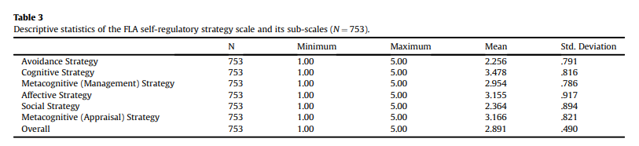
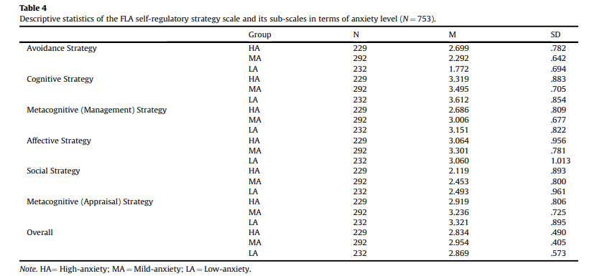
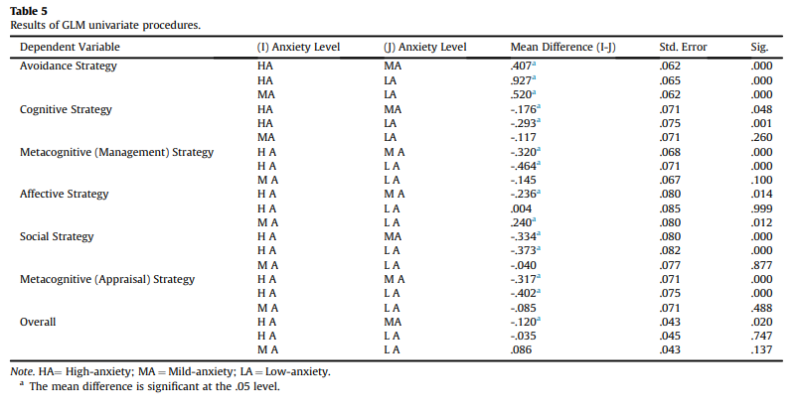
From the results of the research, it can be concluded as follows. In the first place, this research showed that generally students used self-regulatory strategies to a medium degree, and in specific, Cognitive Strategy, Metacognitive (Appraisal) Strategy, and Affective Strategy were their preferences to cope with their anxiety in English learning. Besides, students’ use of Avoidance Strategy with least frequency suggested that they can take proactive measures to deal with anxiety instead of negatively avoiding it in the process of English learning which demonstrates that learners are active agents who can manage and control the affective side of their language learning process. All of these correspond to the statement of individual agency in Bandura’s social cognitive theory (1989) that learners are people with human agency who actively engage in constructing the terms and conditions of their own learning (Lantolf & Pavlenko, 2001, p. 145). In this research, most students’ use of cognition-related strategies shows that as active individual agencies, they can be aware of the fact that self-motivation, self-encouragement, the enhancement of self-confidence, and positive language learning beliefs are of importance to easing anxiety in their language acquisition.
In the second place, with regard to the impact of students’ anxiety levels on their use of self-regulatory strategies, it turned out that students’ frequency use of four types of strategy (including Metacognitive(Management) Strategy, Cognitive Strategy, Metacognitive (Appraisal) Strategy, and Social Strategy) reduced as students’ anxiety levels increased. This shows that learners with less anxiety in language learning tend to better control their emotions in different learning environments. At the same time, as their anxiety levels increased, students performed more significantly frequently use of Avoidance Strategy, which supported the argument that learners who feel higher anxious about language learning are inclined to bear irrational emotions, fail to control their impulses, and become less successful than others (Broidy, 2005). Additionally, the study also found that students with mild anxiety were prone to adopt affective strategies most frequently, suggesting that they prefer a direct and proactive way to deal with anxiety instead of other cognitive or social ways. The results again verify the rationality of Krashen’s “Affective filter hypothesis”. Learners with clear learning goals and moderate anxiety will have low affective filters, pushing the comprehensible language input to smoothly enter their acquisition mechanism device and accelerating the process of language acquisition. On the contrary, high anxiety will lead to high affective filters which will form obstacles in the brain preventing language input from entering the language acquisition device, thus failing to produce language acquisition. In this study, students in low-anxiety group tended to adopt positive and effective strategies like Metacognitive (Management) Strategy, Cognitive Strategy, Metacognitive(Appraisal) Strategy, and Social Strategy most frequently to alleviate their anxiety and reduce their affective filters in their second language acquisition; while students with high anxiety adopted the negative strategy--- Avoidance Strategy most frequently, showing their high affective filters which may be detrimental to their language acquisition.
Therefore, as significant others, teachers are supposed to be sensitive to signs of anxiety shown by students, encourage them to adopt some effective self-regulatory strategies, and provide them with external support to mitigate the negative effects of anxiety.

Bibliography

Arnold, J. (2005) Affect in language learning. Beijing: Foreign Language Teaching and Research Press.
Bandura, A. (1989) ‘Human agency in social cognitive theory’. American Psychologist, 44(9), pp.1175-1185. Available at: https://doi.org/10.1037/0003-066X.44.9.1175
Bown, J., & White, C. J. (2010) ‘Affect in a self-regulatory framework for language learning’. System, 38(3), pp. 432-443. Available at: https://doi.org/10.1016/j.system. 2010.03.016
Breen, M. (2014) Learner contributions to language learning: New directions in research. New York: Routledge.
Broidy, M. (2005) ’Emotional intelligence: personality, gender and cultural factors‘(Unpublished doctoral dissertation). NJ: Fairleigh Dickinson University.
Dewaele, J.-M. (2015) ‘On emotions in foreign language learning and use’. The Language Teacher, 39(3), pp. 13-15. Available at: https://doi.org/10.37546/JALTTLT39. 3-3
Garrett, P., & Young, R. F. (2009) ’Theorizing affect in foreign language learning: An analysis of one learner’s responses to a communicative Portuguese course‘. The Modern Language Journal, 93(2), pp.209-226. Available at: https://doi.org/10.1111/j.1540-4781.2009.00857.x
Horwitz, E. K., Horwitz, M. B., & Cope, J. A. (1986) ’Foreign language classroom anxiety‘. The Modern Language Journal, 70(2), pp.125-132. Available at: https://doi.org/10.2307/327317
Horwitz, E. K. (2001) Language anxiety and achievement. Annual Review of Applied Linguistics, 21, pp.112-126. Available at: https://doi.org/10.1017/S0267190501000071
Krashen, S. D., & Terrell, T. D. (1983) The natural approach: language acquisition in the classroom. Oxford: Pergamon Press.
Kralova, Z., Skorvagova, E., Tirpakova, A., & Markechova, D. (2017) ‘Reducing student teachers’ foreign language pronunciation anxiety through psychosocial training’. System, 65, pp.49-60. Available at: https://doi.org/10.1016/j.system.2017.01.001
Lantolf, J. A., & Pavlenko, A. (2001) ‘Second Language Activity theory: Understanding language learners as people‘. In M. P. Breen (Ed.), Learner contributions to language learning, pp.141-158. Harlow, UK: Longman.
Nagahashi, T. L. (2007) Techniques for reducing foreign language anxiety: Results of a successful intervention study. Akita City: Akita University Press.
Oxford, R. L. (1990) Language learning strategies: What every teacher should know. New York: Newbury House/Harper & Row.
Oxford, R. L. (2015) ‘Emotions as the amplifier and the primary motive: Some theories of emotion with relevance to language learning’. Studies in Second Language Learning and Teaching, 5(3), pp.371-393.
Paris, S., & Paris, A. (2001) ’Classroom applications of research on self-regulated learning‘. Educational psychologist. London: Routledge
Shams, A. N. (2005) ’The use of computerized pronunciation practice in the reduction of foreign language classroom anxiety‘(Unpublished doctoral dissertation). Tallahassee: Florida State University.
Xiao, Y., & Wong, K. F. (2014) ‘Exploring heritage language anxiety: A study of Chinese heritage language learners’. The Modern Language Journal, 98(2), pp. 589-611. Available at: https://doi.org/10.1111/modl.12085
Yan Guo, Jinfen Xu & Xudong Liu (2018) ’English language learners’ use of self-regulatory strategies for foreign language anxiety in China‘. System, 76, pp.49-61. Available at: https://doi.org/10.1016/j.system.2018.05.001

