Solomon Simukoko (P118928)

A
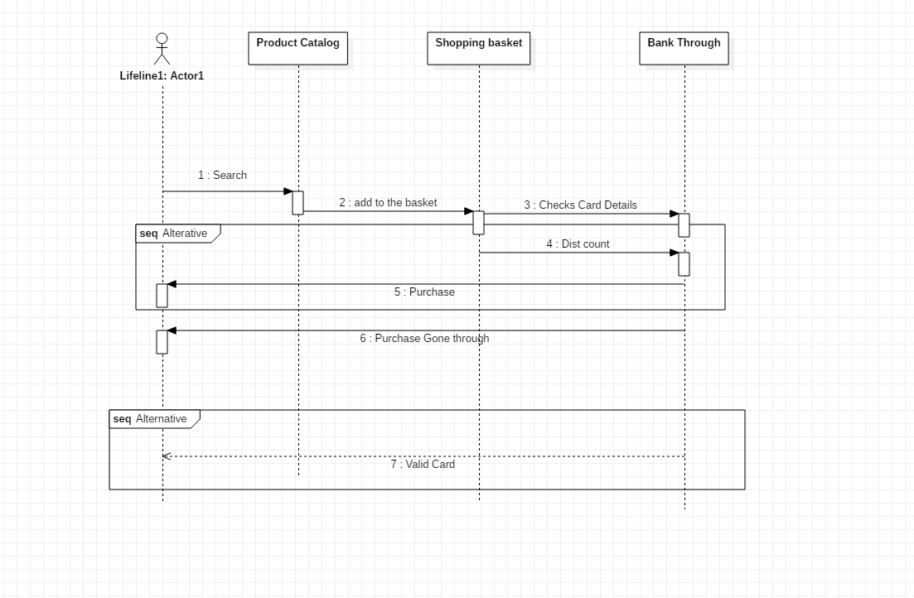

A2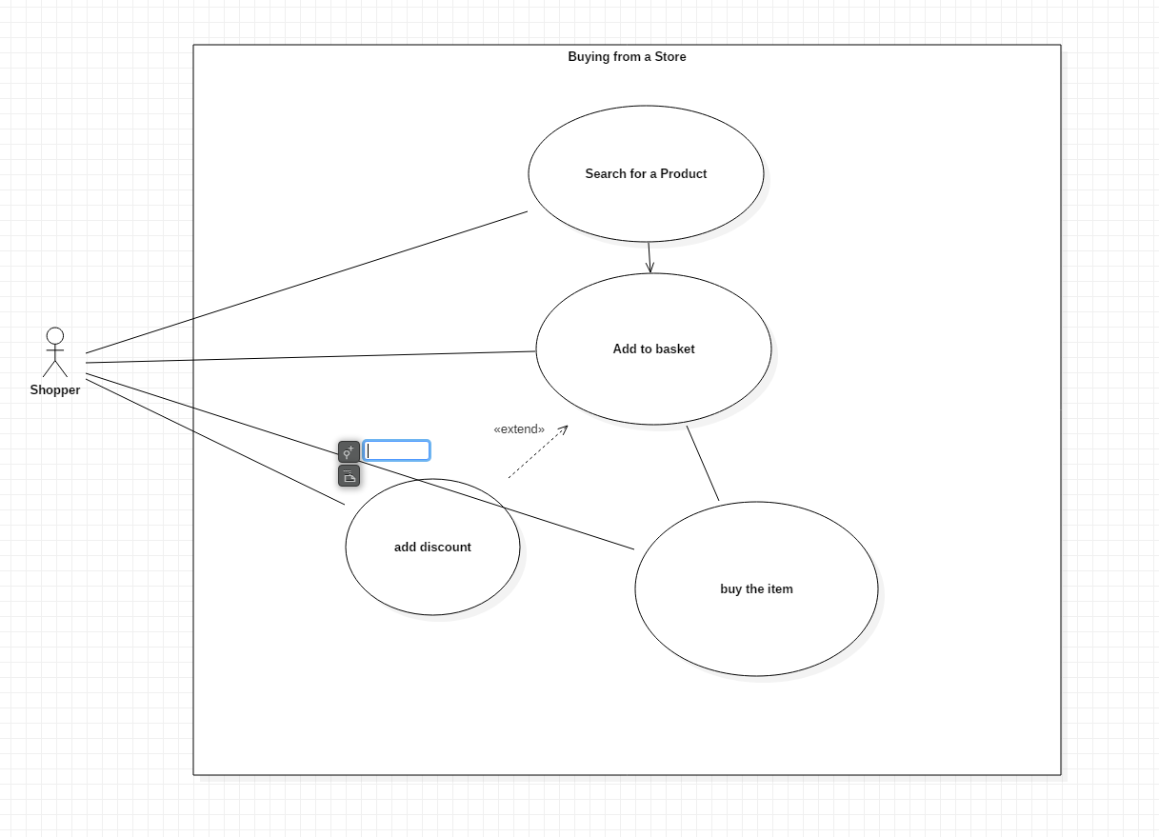

B1 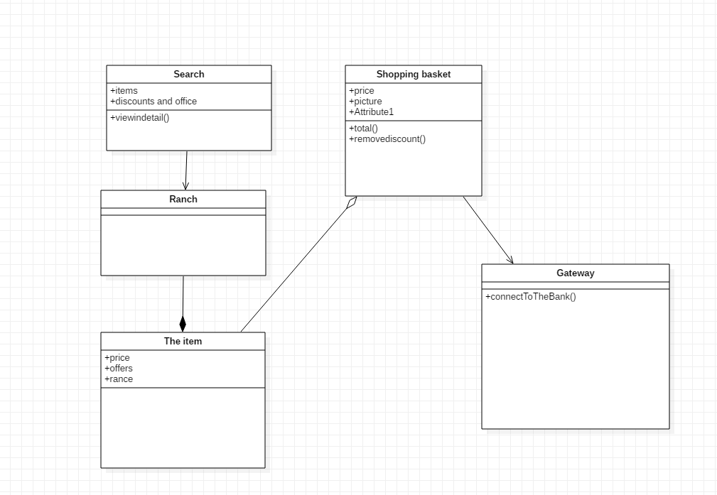

Q2
- Created a repository at which can be access from the following url
git clone https://mukatakulima@bitbucket.org/mukatakulima/unitest.git
B

- I would allow member of my time to Clone this give them a local copy of the work
- Then different developer will be asked to create branches of the different feature the are working on
- All change will be staged using git add and then
- The code will committed
- Then which a section will be done a pull request will be done for peer review
- Then the team lead will merge the code back in
- Other thing which the lead could to check progress are git status to see what commits have been made; git log to view the log ; git blame to see who did what;
C) I would use the Agile Scrum
Scrum is arranged into team called squads the lead is called the scrum master. The product owner will create what he calls a product backlog. All the member all the team including the Business Analyst will create what are called user stories. The team will decide what goes into their sprint (Which can be for a week to a month). This elements which go into the sprint are called the sprint backlog. To there are meets which take place firstly the daily meeting which is the meeting in which is also called the daily stand. In this meeting some states what they have done the day before and what they are going to do. At the end of the sprint they are two meeting the sprint review where the product owner come to see what has been done and the sprint retrospective which is a review of the sprint.

Q3
- I have clone down my repository using the following command
git clone https://mukatakulima@bitbucket.org/mukatakulima/unitest.git
b)

import java.util.*;

public class JSDiceRndGenerator {

public static void main(String[] args){

function addDiscount(return, total){

if(repeat== 1){
newtotal = (17/100)*total
return total
}

}

}

}
c) I have clone down the repository and down the follow command

- Git clone
- Git Add the file
- Git commit
- Git push
At the point of git push I am having an error constantly

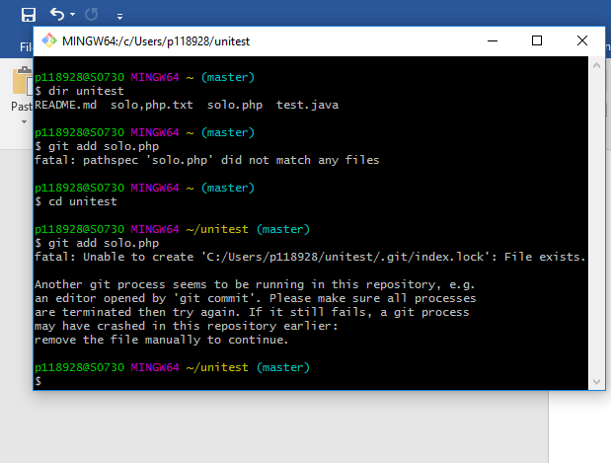
Q4
Test can be done using Test Driven Development
To conduct Test driven development you need to conduct test first development
Test can be done using the following a double
- Stud which test data
- Fake which is a double with info
- Mock which contents nothing

