Online Portfolio
Student Details | Information
Student Name | Iasmina Ratiu
Student ID | 4214787
Programme | BSc (Hons) Health and Social Care
Module Title | Changemakers: Building Your Personal Brand for Sustainable Employment
Module Code | BMHP5015
Lecturer | Brian M
Assignment Title | Component 1: Online Portfolio
Submission Date | 31 July 2026
Word Count | 2200
University | University of Wales Trinity Saint David

1. Introduction
This portfolio is a reflection of the activities which have been undertaken on Moodle within BMHP5015 and how these have contributed to my knowledge of employability, personal branding and professional identity within the field of health and social care. Career focus was selected as the role of a healthcare assistant, which requires practical skills, communication and professional behaviour at all times.
The portfolio will be used to explore whether there is evidence, feedback and realistic development to support the professional claims. Reflection is used to articulate what has been learnt, its significance, where and why certain activities have limitations and how the learning could inform future practice. This is important because reflection should result in better behaviour, not merely be a record of thought. Continuing professional development (CPD) is also expected to be undertaken by health and care professionals to maintain their skills (HCPC, 2024c).
The final Gibbs Reflective Cycle brings the key learning together and links it with a clear development plan.

2. Activity One: Personal Employability Skills Audit
[Insert Figure 1 here]
Figure 1: Personal employability skills audit completed on Moodle.
The skills audit involved me reviewing my communication skills, teamwork, empathy, time management, problem-solving, digital skills, decision-making, leadership and emotional resilience. Most importantly, it helped to clarify the concept of employability. Before doing the activity, employability could easily be viewed as having a qualification and being willing to work to earn money. A review of the audit revealed that employers are also interested in evidence of a person's communication and response to pressure, as well as their ability to work with others and complete tasks. This broader perspective is supported by research, which reveals that employability is grounded in knowledge of a job's requirements as well as transferable skills (Tushar and Sooraksa, 2023).
The findings of the audit were helpful but may not be taken at face value. Confidence, memory and expectations of self are factors affecting self-assessment. One thing you know could be better than you think, and another thing you don't know could be worse. Tuononen et al. (2022) have identified that not all students are aware of or acquire generic skills in the same manner. The audit, therefore, should be reviewed against comments made by the tutor, results of group work, placement comments and completed tasks.
This learning is relevant to health and social care. A healthcare assistant may be aware of what to do and then find themselves in a precarious situation through a lack of communication, a lack of reporting or by working outside their scope of practice. Communication and teamwork must be evaluated on the basis of action and not confidence.
My response is to make a monthly skills record of the task completed, the skill used, the outcome and any feedback given. This will provide more evidence for future applications and help to lessen the need for self-judgement.

3. Activity Two: Personal Values and Professional Identity
[Insert Figure 2 here]
Figure 2: Moodle activity on personal values and professional identity.
The values activity shifted the focus of discussion from what I believe to how I behave. The care experienced by service users is impacted by respect, dignity, compassion, equality, honesty, confidentiality and accountability. Respect, dignity and compassion are at the heart of the NHS Constitution. It also connects the treatment of staff and patients to safety, experience and outcomes (Department of Health and Social Care, 2023). These are thus not just personal qualities but also responsibilities.
Repeated behaviour helps to develop one's professional identity. It is demonstrated by being punctual, using appropriate language, dressing appropriately, keeping records, keeping information confidential and responding appropriately when uncertain. The Code of Conduct is a set of standards that healthcare support workers and adult social care workers in England are expected to adhere to (Skills for Care and Skills for Health, 2013). If someone's daily conduct goes against a strong professional identity, then they cannot claim to be a strong professional.
A crucial balance to consider is that there is no such thing as excess compassion. A desire to help can result in a worker making decisions or doing something outside the scope of their job. To provide person-centred care, support must be given and the service user's choice, voice and independence must be protected. Personal views should also be controlled and not be allowed to influence fair treatment. A requirement of HCPC standards is that professionals do not allow their values, beliefs and biases to lead to discrimination or diminish the quality of care (HCPC, 2024a).
The good news about values-based reflection is that it sets a standard to follow when making decisions in the future. The problem is that the values become abstract and remain only words unless associated with action. I will apply this learning by ensuring that my communication maintains dignity, by ensuring that the records are accurate and by asking for advice when the task is beyond my capability.

4. Activity Three: Building a Personal Brand
[Insert Figure 3 here]
Figure 3: Personal-brand activity or Moodle forum contribution.
My developing professional brand is:
A future healthcare assistant who is reliable, respects dignity, communicates clearly and takes responsibility for ongoing learning.
This statement is about behaviour, not appearance. The selected qualities of reliability, respect and learning can be measured through attendance, communication, completed training and feedback.
Personal branding can assist a candidate to convey a coherent message on a CV, application, interview and online profile. It can also assist in career planning, as it asks the applicant to determine what they can offer. According to Gorbatov, Khapova and Lysova (2018), personal branding is a strategic action of conveying professional worth to others. But a good statement isn't enough to make an effective professional brand.
The greatest benefit is consistency. If all of these are present in education, experience and communication, then the employer will get a better picture of the applicant. Personal branding is associated with perceived employability and career success, but the content of a personal brand is not solely about the words; it is also about active career behaviour (Gorbatov, Khapova and Lysova, 2019).
The main problem is self-promotion without evidence. Having a clean profile can help make it seem as though someone is more capable or has the attributes they are expected to have as strengths. Trust is therefore important in health and social care, and behaviour has an impact on the level of trust. It is not very meaningful to say that someone is compassionate if they do not pay attention to a service user. But with no evidence of responsible practice, claiming reliability is weak.
My personal brand will therefore be backed up by examples of education, training, volunteering or employment. If there is not enough evidence, I will not report it as a strength but will use it as a development aim.

5. Activity Four: Digital Professionalism and Online Presence
[Insert Figure 4 here]
Figure 4: Moodle activity on digital professionalism and online presence.
The digital professionalism activity showed that a digital profile can be beneficial when it comes to employability, but it can also have a negative impact on professional trust. Employers can see public pictures, comments and profile information outside the application process. Privacy settings restrict access, but this does not mean that content cannot be copied or shared.
HCPC guidance notes that content shared on social media may end up being viewed by individuals other than the original target audience. Healthcare professionals are also advised not to share sensitive details about service users and carers online (HCPC, 2024b).
This is a significant risk in health and social care. Even if the name does not appear in a post, it can identify a person if there is information about their age, location, state of health or situation. For instance, discussing cases within the workplace, posting photographs from care settings or making disparaging comments may be a breach of confidentiality and compromise public trust.
Digital professionalism also means maintaining accurate care records. The CQC expects care providers to keep secure, accurate, complete and up-to-date records of the people using care services and the care they receive (CQC, 2024).
Career objectives, training and qualifications can be indicated in a professional LinkedIn profile. However, it should not contain unsupported claims or personal care information. One of the problems of online branding is that it can be hard to distinguish between personal and professional identities.
My action is to review public posts, ensure there is an appropriate picture for my profile, ensure that the qualifications and dates are correct, review my privacy settings and avoid posting about real care circumstances. This will help to promote employability whilst maintaining confidentiality.

6. Activity Five: Comparison with the Healthcare Assistant Role
[Insert Figure 5 here]
Figure 5: Moodle career activity and healthcare assistant role evidence.
The healthcare assistant role has been chosen. Healthcare assistants work with patients in hospitals and, in some cases, in their own homes. Verbal communication, teamwork, patience, sensitivity, attention to detail, calm behaviour under pressure and basic digital ability are all identified as desirable skills for the job by the National Careers Service (n.d.).
These skills link to those explored in the employability audit, making the role appropriate for testing career readiness. Caring for people was highlighted as a quality, but it was revealed that this was not enough. Employers need to be sure that an applicant can take direction, maintain privacy, be aware of issues, operate safely and interact with other people who could be from diverse backgrounds.
The Care Certificate standards include person-centred care, communication, duty of care, safeguarding and handling information. The standards were revised in March 2025, bringing their total number to 16 as a result of changes in the health and social care sector (Skills for Care, 2025a).
The job is realistic, but readiness should not necessarily be assumed because of academic study. Practical skills may be demonstrated through placement, volunteering, supervised tasks or paid work. There are several disadvantages when it comes to matching skills to a job description, one of which is that a job description alone won't be able to fully describe the emotional demands, stress and local processes involved in a workplace. However, hands-on experience and feedback from a supervisor are required.
I will provide one clear example for each requirement of a job and make a realistic assessment of the gaps. When evidence is lacking, I will fill in any gaps by undertaking appropriate training or supervised practice before presenting the skill as established. This is more authentic and conducive to safer practice.

7. Personal Development Action Plan
Development goal | Action | Timescale | Evidence of progress
Enhance professional communication | Engage in frequent group discussions, prepare two mini-presentations and ask for input on clarity, confidence and listening. | Within three months | Improved presentation performance, stronger interview examples and written feedback.
Obtain relevant health and social care experience | Apply for an appropriate health and social care placement, support role or volunteering opportunity. | Within six months | Completed hours, comments from a supervisor and practical examples of teamwork, reliability and safe conduct.
Create a professional digital presence | Update my CV and professional online profile, review qualifications and dates, review privacy settings and remove inappropriate public content. | Within one month | An accurate and complete profile in which every professional claim is supported.

These goals are achievable because they have an action, timescale and measure of progress. Practice, feedback and reflection are more likely to be effective in skills development when repeated as a series of activities, not as an isolated event. While there are varying degrees of effectiveness in delivering soft-skills programmes, it is crucial to monitor progress through observation and feedback in relation to actual performance (Orih et al., 2024).
There is also a broader workforce strategy for adult social care that targets the recruitment, development and retention of staff who have the right values and skills. Further development will therefore contribute to employment and career progression (Skills for Care, 2025b).

8. Conclusion
Employability became better understood and was examined critically through the Moodle activities. In addition to a qualification, communication, safe conduct, professional values, digital responsibility and continued learning are all important.
Feedback and evidence were needed to aid self-judgement, but the skills audit proved helpful as a starting point. The values and personal-branding activities showed that behaviour should be consistent with professional claims. The healthcare assistant comparison was able to pinpoint a realistic career and note the training and work experience that this role calls for. The action plan now provides direct action points for developing communication skills and also supports building practical experience and a professional profile.

9. Overall Gibbs Reflective Cycle
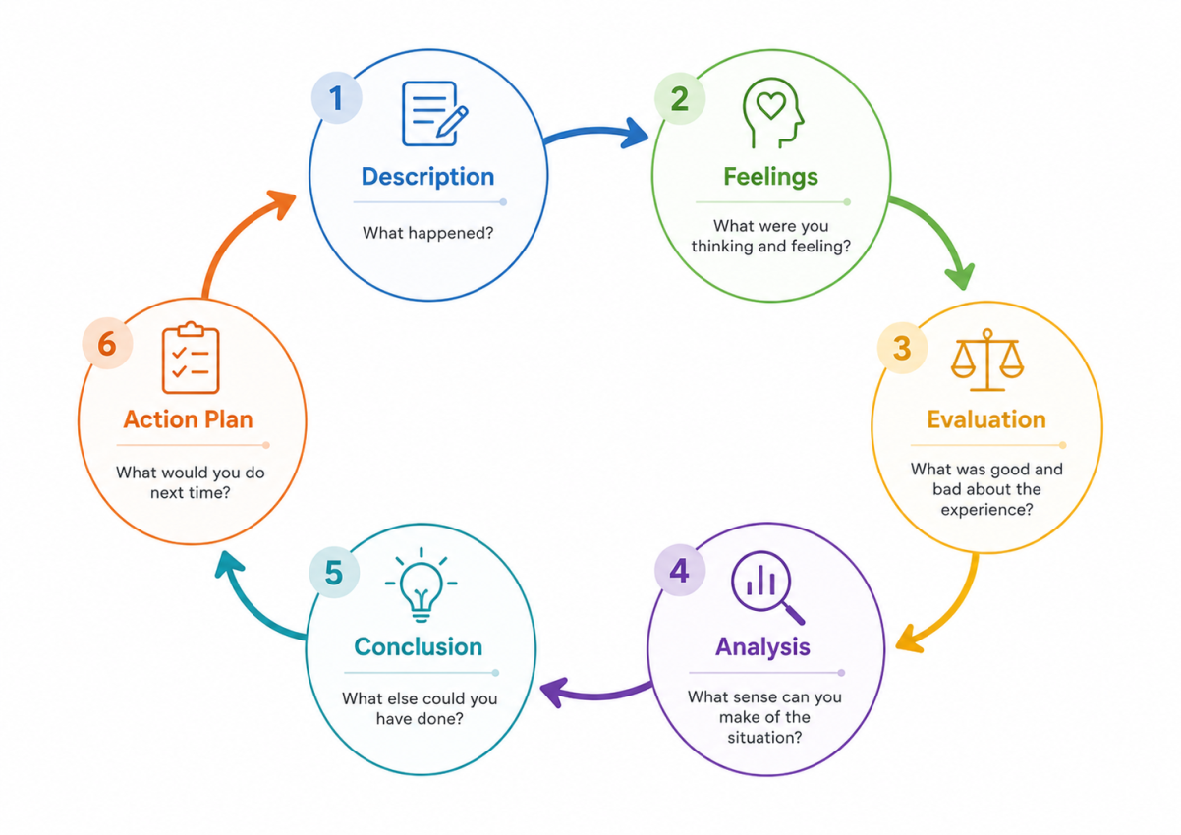
Figure 6: Gibbs Reflective Cycle used to structure the overall reflection on learning and professional development.
Stage | Overall Reflection
Description | I completed the Moodle activities relating to employability skills, personal values, professional identity, personal branding, digital professionalism and career planning. I compared the learning with the requirements of a healthcare assistant role.
Feelings | My activities helped me become clearer about my career. They also demonstrated that it is a lot easier to say than to prove that one has positive professional attributes. This made the reflection useful but challenging.
Evaluation | The activities were helpful in prioritising professional responsibilities and development. The major drawback is that self-assessment does not provide a real assessment of how I will act in practice.
Analysis | The portfolio shows that employability is based on knowledge, conduct and evidence. Reflection can facilitate development when it involves action, not just a description of experience. It is useful to use Gibbs' cycle because it allows for a plan of action to be put into place in the future after the description and evaluation (Gibbs, 1988).
Conclusion | I need feedback, training and examples to support my professional claims. I must also acknowledge the limits of my abilities and seek advice when needed.
Action Plan | I will follow the three development goals, monitor my progress every month and incorporate new training, feedback and experience into my professional evidence.

Gibbs' model has a clear six-stage structure consisting of description, feelings, evaluation, analysis, conclusion and action planning. It has a very clear format, but reflection will only be beneficial if the action plan is followed and reviewed.

Reference List
Care Quality Commission (CQC) (2024) ‘Regulation 17: Good governance’. Available at: https://www.cqc.org.uk/guidance-providers/regulations/regulation-17-good-governance (Accessed: 30 July 2026).
Department of Health and Social Care (2023) The NHS Constitution for England. Available at: https://www.gov.uk/government/publications/the-nhs-constitution-for-england/the-nhs-constitution-for-england (Accessed: 30 July 2026).
Gibbs, G. (1988) Learning by Doing: A Guide to Teaching and Learning Methods. Oxford: Further Education Unit, Oxford Polytechnic.
Gorbatov, S., Khapova, S.N. and Lysova, E.I. (2018) ‘Personal branding: Interdisciplinary systematic review and research agenda’, Frontiers in Psychology, 9, article 2238. Available at: https://doi.org/10.3389/fpsyg.2018.02238 (Accessed: 30 July 2026).
Gorbatov, S., Khapova, S.N. and Lysova, E.I. (2019) ‘Get noticed to get ahead: The impact of personal branding on career success’, Frontiers in Psychology, 10, article 2662. Available at: https://doi.org/10.3389/fpsyg.2019.02662 (Accessed: 30 July 2026).
Health and Care Professions Council (HCPC) (2024a) Standards of Conduct, Performance and Ethics. Available at: https://www.hcpc-uk.org/standards/standards-of-conduct-performance-and-ethics/ (Accessed: 30 July 2026).
Health and Care Professions Council (HCPC) (2024b) Guidance on the Use of Social Media. Available at: https://www.hcpc-uk.org/standards/meeting-our-standards/communication-and-using-social-media/guidance-on-use-of-social-media/ (Accessed: 30 July 2026).
Health and Care Professions Council (HCPC) (2024c) ‘Reflection and meeting your standards’. Available at: https://www.hcpc-uk.org/standards/meeting-our-standards/reflective-practice/reflection-and-meeting-your-standards/ (Accessed: 30 July 2026).
National Careers Service (n.d.) ‘Healthcare assistant’. Available at: https://nationalcareers.service.gov.uk/job-profiles/healthcare-assistant (Accessed: 30 July 2026).
Orih, D., Heyeres, M., Morgan, R., Udah, H. and Tsey, K. (2024) ‘A systematic review of soft skills interventions within curricula from school to university level’, Frontiers in Education, 9, article 1383297. Available at: https://doi.org/10.3389/feduc.2024.1383297 (Accessed: 30 July 2026).
Skills for Care (2025a) Care Certificate Standards. Available at: https://www.skillsforcare.org.uk/Developing-your-workforce/Care-Certificate/Care-Certificate-standards.aspx (Accessed: 30 July 2026).
Skills for Care (2025b) A Workforce Strategy for Adult Social Care in England. Refreshed July 2025. Available at: https://www.skillsforcare.org.uk/Workforce-Strategy/resources/Supporting-resources/Workforce-Strategy-for-Adult-Social-Care-in-England-July-2025.pdf (Accessed: 30 July 2026).
Skills for Care and Skills for Health (2013) Code of Conduct for Healthcare Support Workers and Adult Social Care Workers in England. Available at: https://www.skillsforcare.org.uk/Support-for-leaders-and-managers/Managing-people/Code-of-Conduct.aspx (Accessed: 30 July 2026).
Tuononen, T., Hyytinen, H., Kleemola, K., Hailikari, T., Männikkö, I. and Toom, A. (2022) ‘Systematic review of learning generic skills in higher education: Enhancing and impeding factors’, Frontiers in Education, 7, article 885917. Available at: https://doi.org/10.3389/feduc.2022.885917 (Accessed: 30 July 2026).
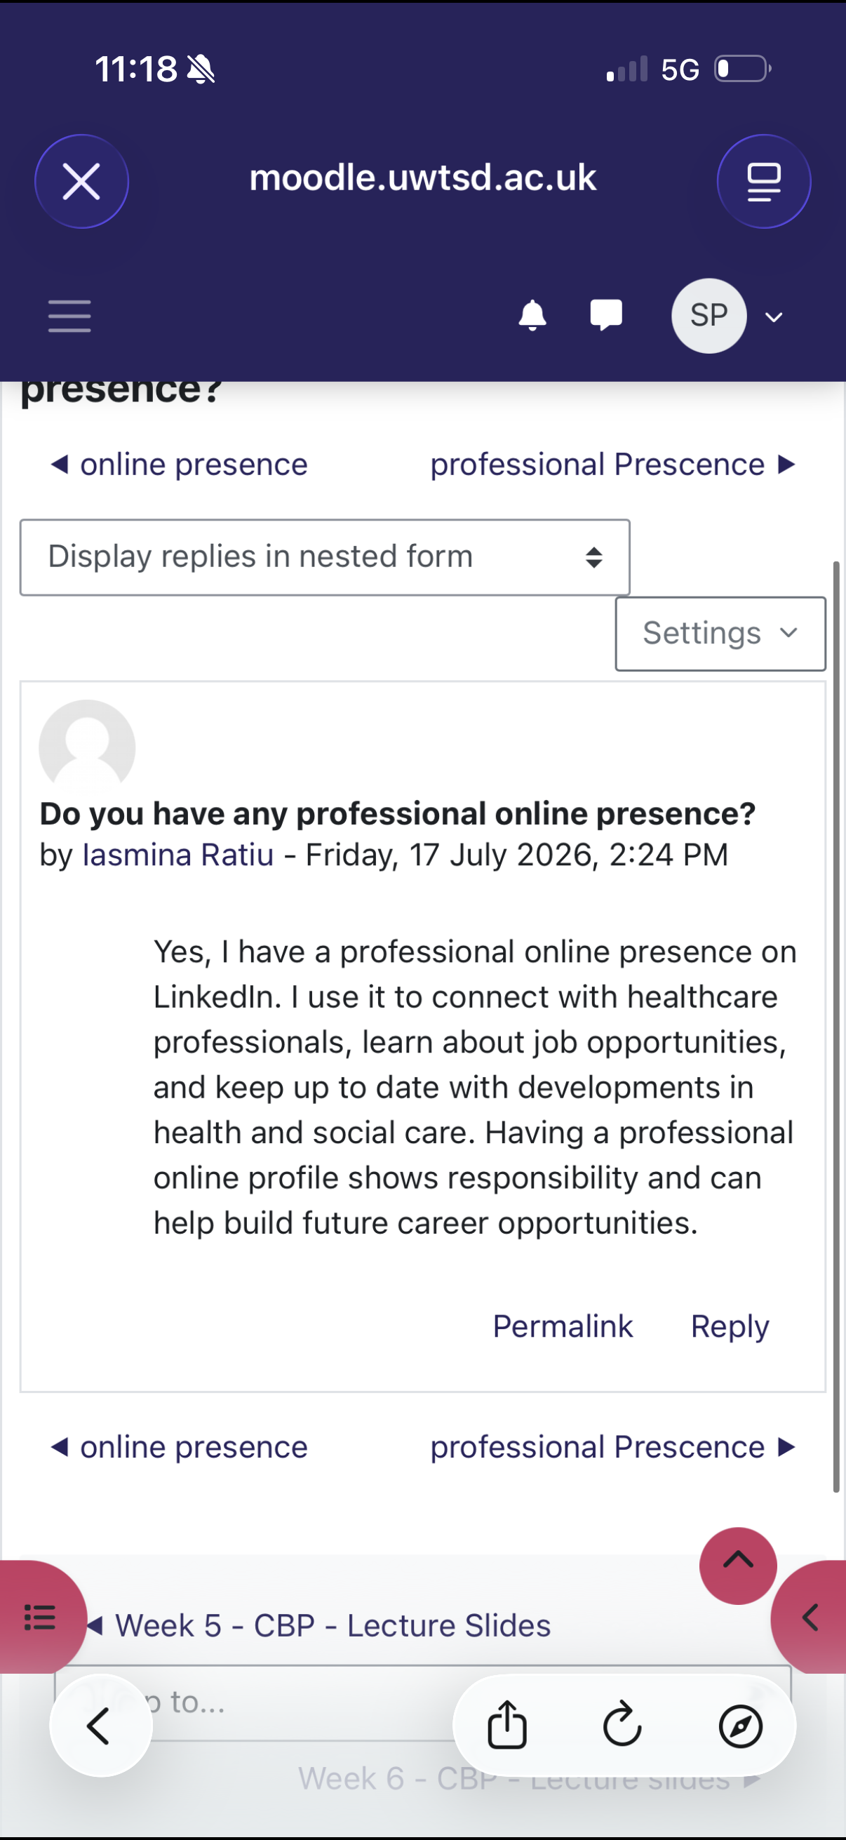
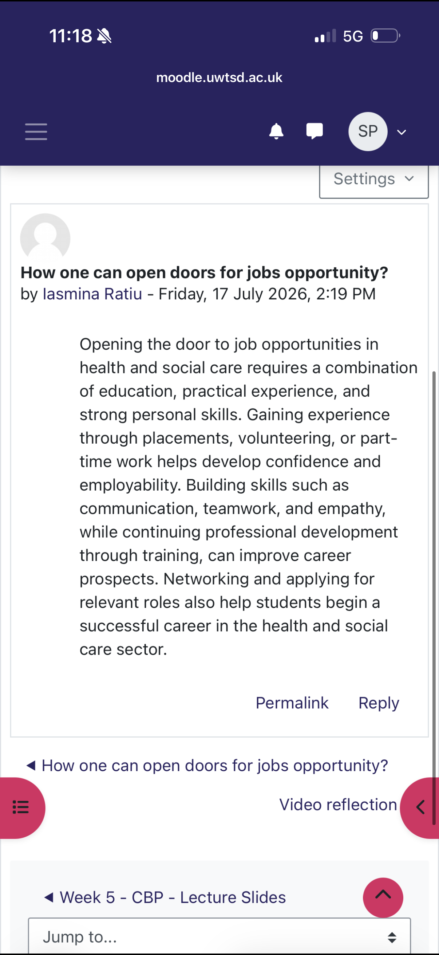
Tushar, H. and Sooraksa, N. (2023) ‘Global employability skills in the 21st century workplace: A semi-systematic literature review’, Heliyon, 9(11), article e21023. Available at: https://doi.org/10.1016/j.heliyon.2023.e21023 (Accessed: 30 July 2026).


