Introduction to Web and Database Concepts

Student Name: Ethan Shellem-Prince
Student Number: 2109509
Course: Computing (Software Engineering)
Date of Submission: 03/05/2022

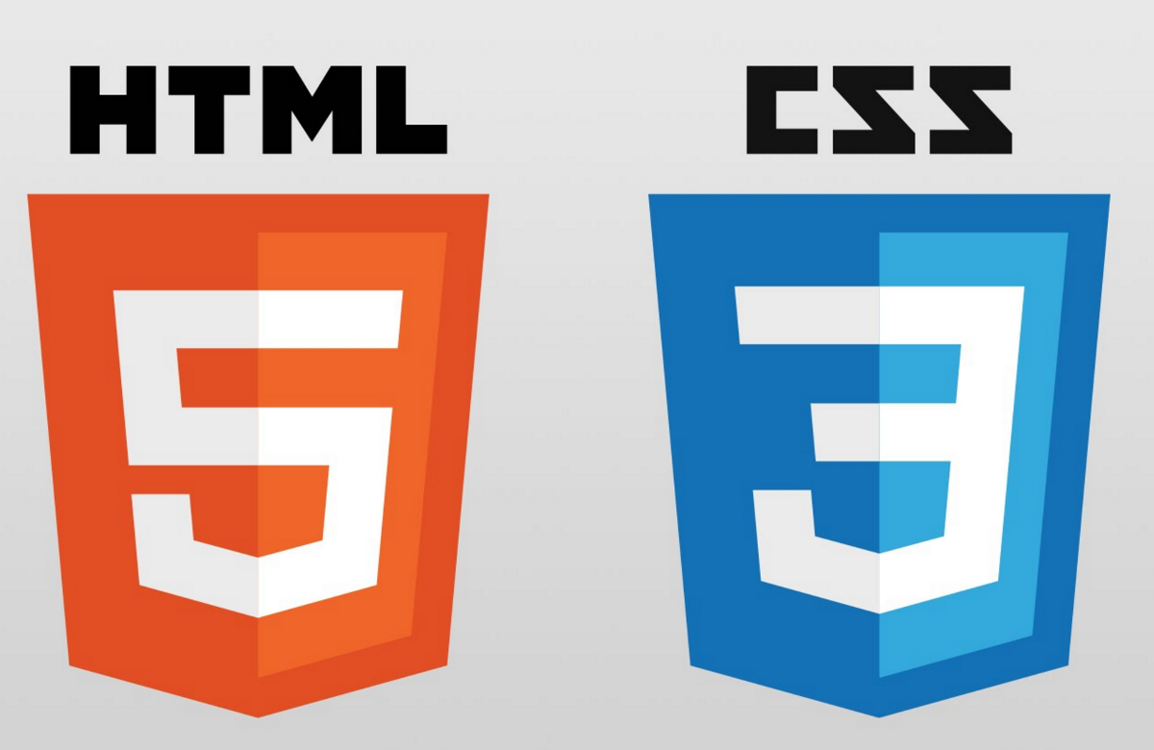

Table of Contents
Introduction ………………………………………………………………………………………………………………… 3
Requirements ………………………………………..……………………………………………………………………. 3
Implementation ………………………………………………………………..………………………………………… 4
Wireframes ……………………………………………………………………………………………………… 4
Evaluation of Wireframes ……………………………………………………………………………….. 6
HTML Screenshot ……………………………………………………………………………………………. 7
Homepage …………………………………………………………………………………….………………… 7
First Page ……………………………………………………………………………………………..…..…….. 8
Second Page ……………………………………………………………………………………………………. 9
Third Page ……………………………………………………………………………………………….………. 10
Forth Page ………………………………………………………………………………………………………. 11
Validation ……………………………………………………………………………………………………………………. 12
Evaluation ………………………………………………………………………………………………………………..…. 13
Website usability and Accessibility ………………………………………………………………….. 13
Usability for my website ………………………………………………………………………………….. 14
Search Engine Optimisation …………………………………………………………………………….. 16
SEO for my website …………………………………………………………………………………………. 16
WCAG2.1 Principles ……………………………………………………………………………………………………. 17
References ………………………………………………………………………………………………………………….. 18
Appendices …………………………………………………………………………………………………………………. 19

NOTE: I have submitted a ZIP file with all HTML, CSS and Images to the relevant moodle submission. In case of error please find a shared link to my folder -https://1drv.ms/u/s!AqOP_3S9SE48pxCtL7JWWxGrquht?e=dPzvCj
Introduction
In this report you will find details and descriptions of my hand-coded HTML website. I will provide screenshots showing each page with extended descriptions on what is contained within. I will justify my website and explain my thought processes. I will also provide further improvements and changes to make if re-issuing the website.

Requirements
I have built a functioning website using HTML and CSS. I decided to base the website of a hobby of mine, Fishing. I decided to design a website to promote my business ‘Hatchers Fishery’s’. We are large fishery that holds 3 lakes any many species of fish. I have decided to base the website around edible fish, I think this will interest more people rather than a catch and release based website.
The main aim of the website is to provide details of the facilities we offer to the general public. The website holds information about the lakes, fish species, pricing and hire of gear.
The website is open to the public, but mainly focusing on families and avid fishermen. I have used many different copyright free images to try and bring in more visitors from the web.

Implementation
Before using HTML to make the website I decided to produce some wireframes of the design I was aiming for. I used MicroStation, a CAD Software to produce some simple website layouts.
Wireframes
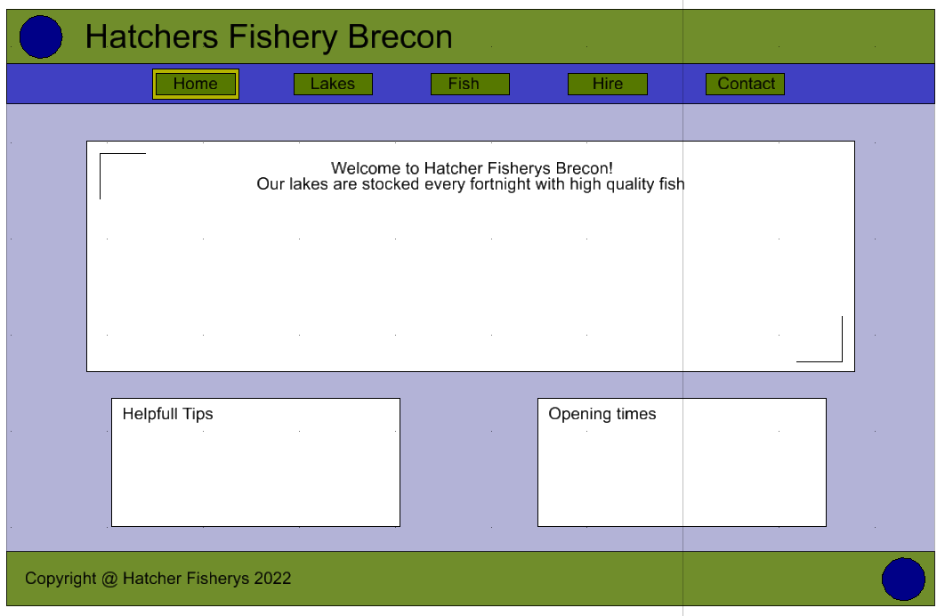
Homepage -

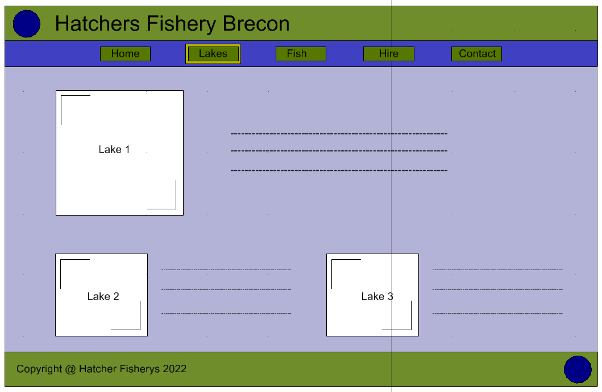
Page 1 (Lakes) -

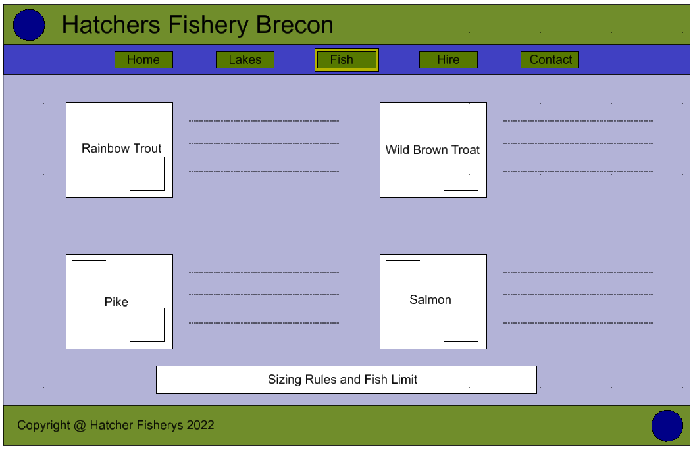
Page 2 (Fish) –

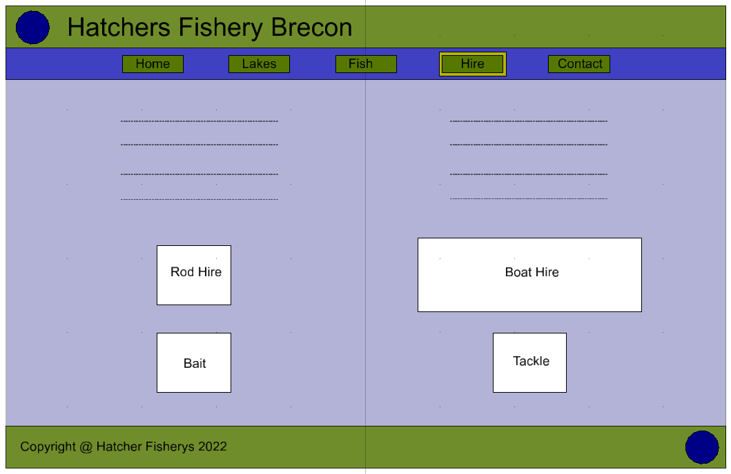
Page 3 (Hire) –

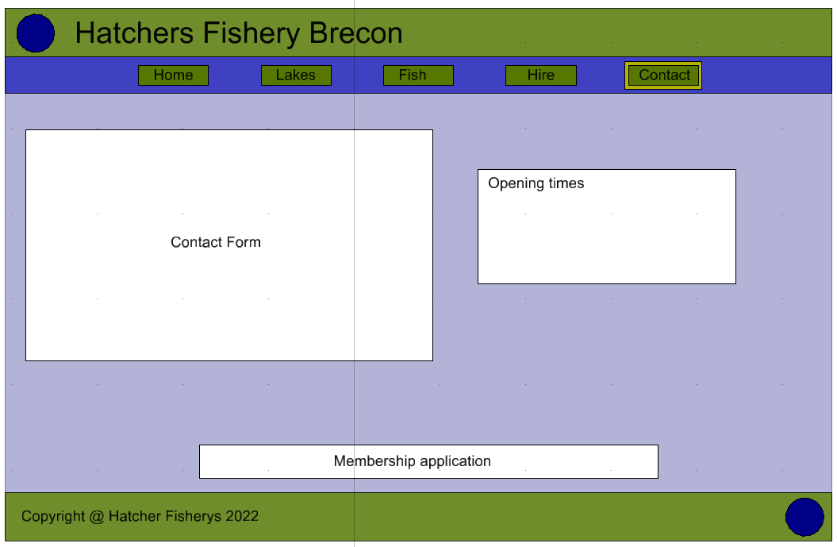
Page 4 (Contact) -

Evaluation of Wireframes

I was very happy with the overall layout of my wireframe design. I intended to stick with the same design when producing the website in HTML. I felt the layout was very simplistic but yet included all of the key details for the scenario. I decided to use Green and Blue as the main colours as these resemble fishing and the outdoors. The green would show off the headings and key features whereas the blue would fade into the background behind the images and text.
I was very happy with the placement of the Logo (Top left and Bottom Right). I decided to create logo so it would define the business I am promoting. I created the logo using MicroStation, this way I would not have any problems with copyright. I produced a logo that would best suit the website and its colours. As shown the Logo is shows ‘H F’ standing for ‘Hatchers Fishery’s’. I then made a simple fish outline using 2D linework.

HTML Screenshots
I will now provide screen shots of my finished website, these screenshots will be taken from internet explorer. This is what the user will directly see when using the website online.
All of the images used in the website are copyright free and have licencing to modify, share and use commercially.
Note: all of the screenshots are in two pieces.
Homepage -
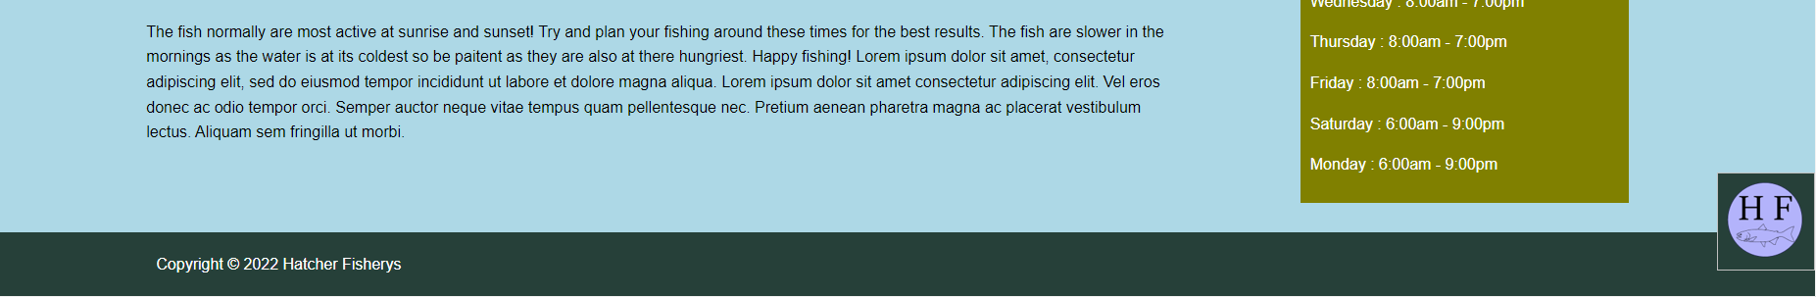
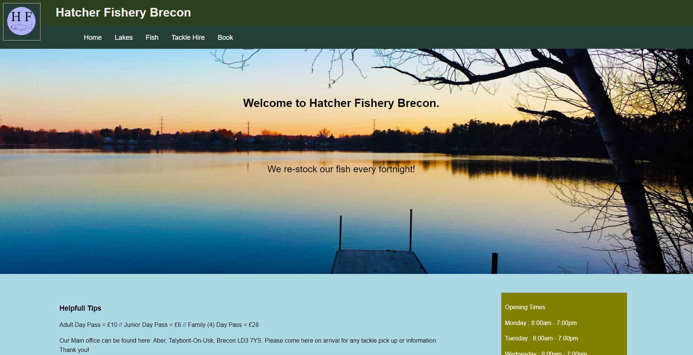

The homepage is the first page the user sees when accessing the website. The first thing I wanted the user to see was a large inviting image. I hoped to have their interest straight away. I decided to have the key information presented at the bottom. This information includes the Opening times and Cost. For me these are the first things to think about when it going to an outdoor adventure.
I have clearly presented the text so the user doesn’t have to look all over for it. The text itself varies in colour, this is due to the blue and green background being used. For me black text stand out the best when a blue background is in place and white text is best when a green background is being used.

Page 1 (Lakes) -
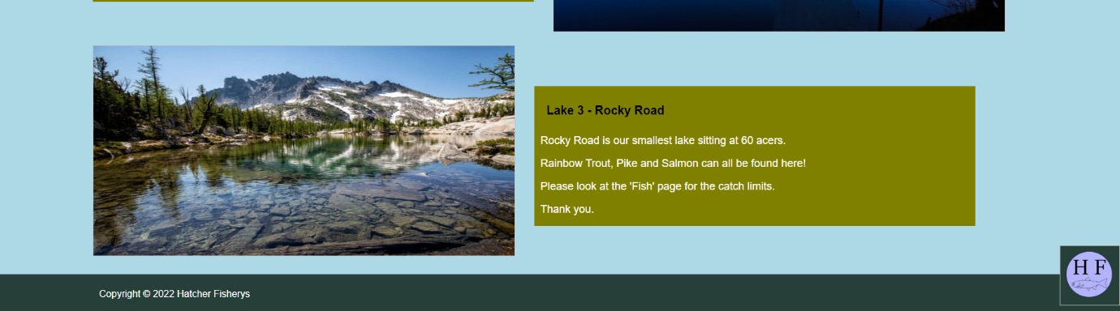
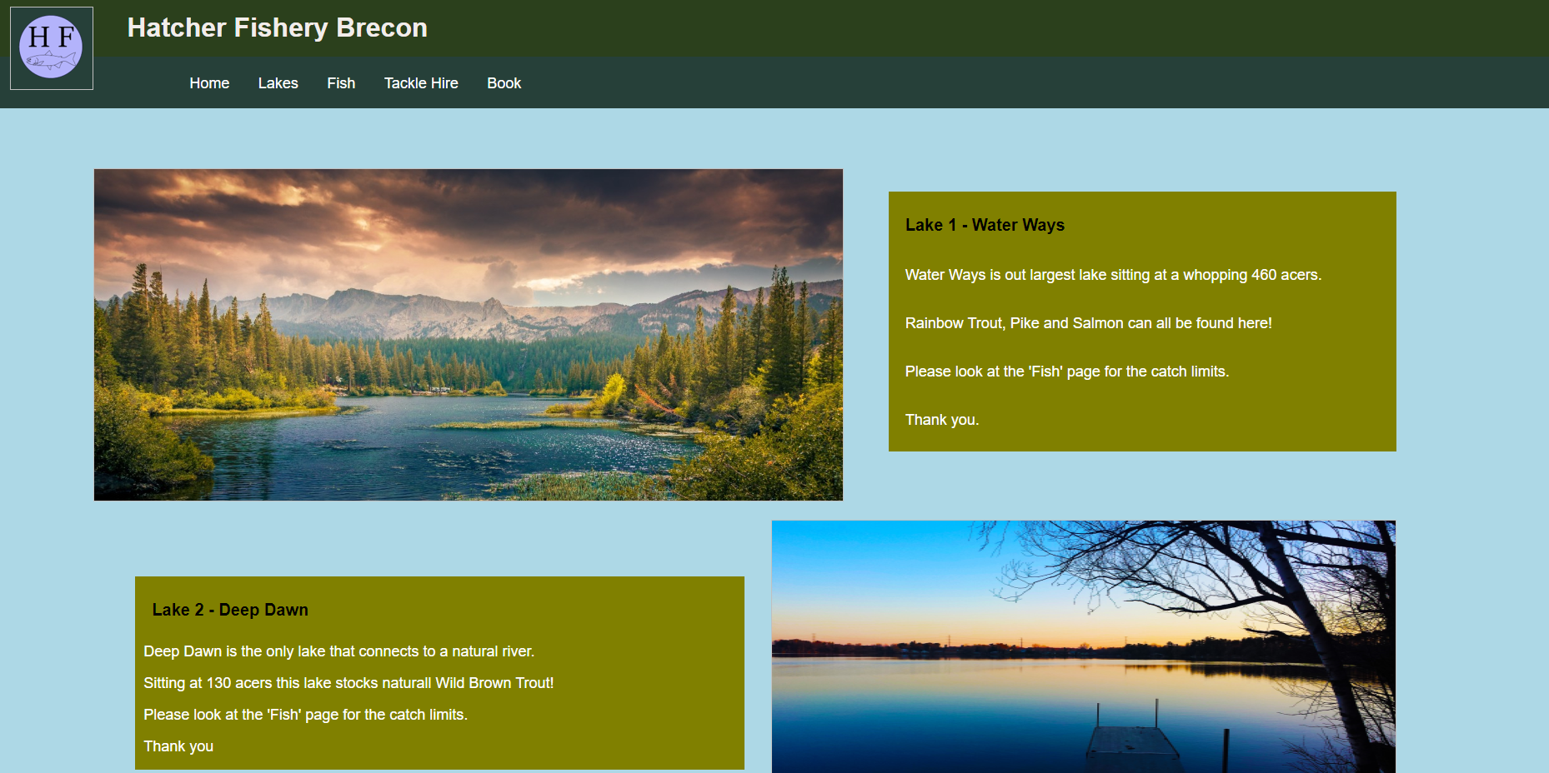

This is the first page that includes fishing information. I wanted to make this page very eye-catching. I decided to use large images to present the 3 lakes Hatcher Fishery’s offers. The images also come with a brief description of the size and which fish are stocked within. I have each lake a catchy name to make the page a bit more family friendly.
I decided to stagger the images on this page to allow them to be larger. If the images were directly below each other the page would become more compact and bulky.

Page 2 (Fish) -
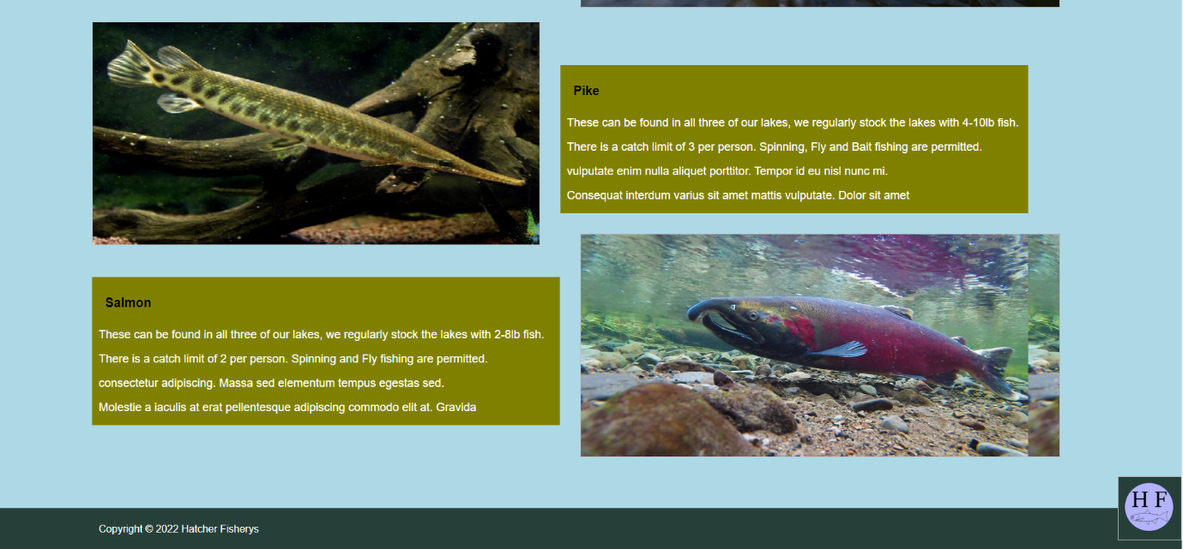
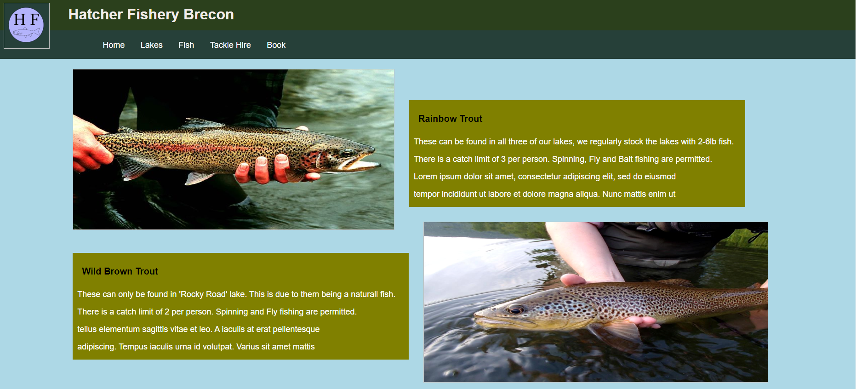

This page is based on holding fishing information. I decided to choose 4 common fish that are found in lakes and rivers . Each different fish has its own image and description. This way every user will be able to identify there catch and understand the rules and regulations for each fish.
I decided to make specific rules regarding the amount of fish you can take per person. I clearly state the limit and type of fishing aloud per fish/lake. I also include the weight of the fish we stock to give the users perspective of the fish they might catch.

Page 3 (Hire) -
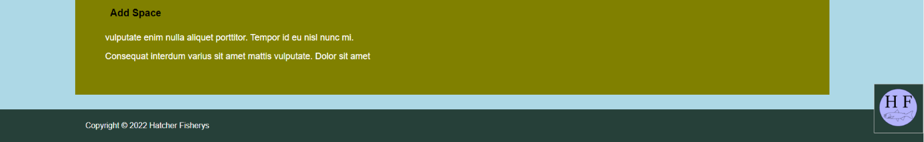
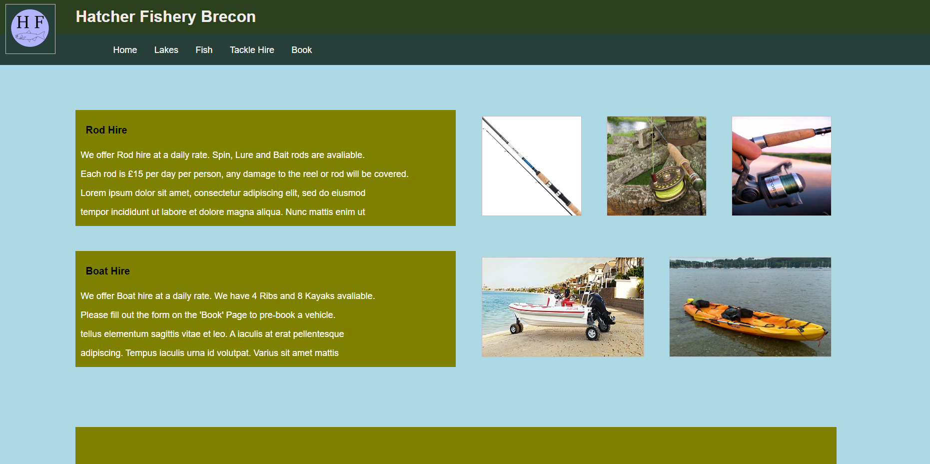

This page is to promote what services and hire we offer. I decided to promote the use of Rod and Boat hire on the website to bring it a wider range of people. Boat hire is very popular in the summer months, hopefully this will bring more users to the site.
I have given a description of what we offer as well as the pricing. For the boat hire I have directed the user to the form on the ‘Book’ page. I decided to put the booking on another page to increase the time spent and usability of the site.
I have added a space for Adds at the bottom. I hope to earn some income from this to further develop the website.

Page 4 (Contact) -
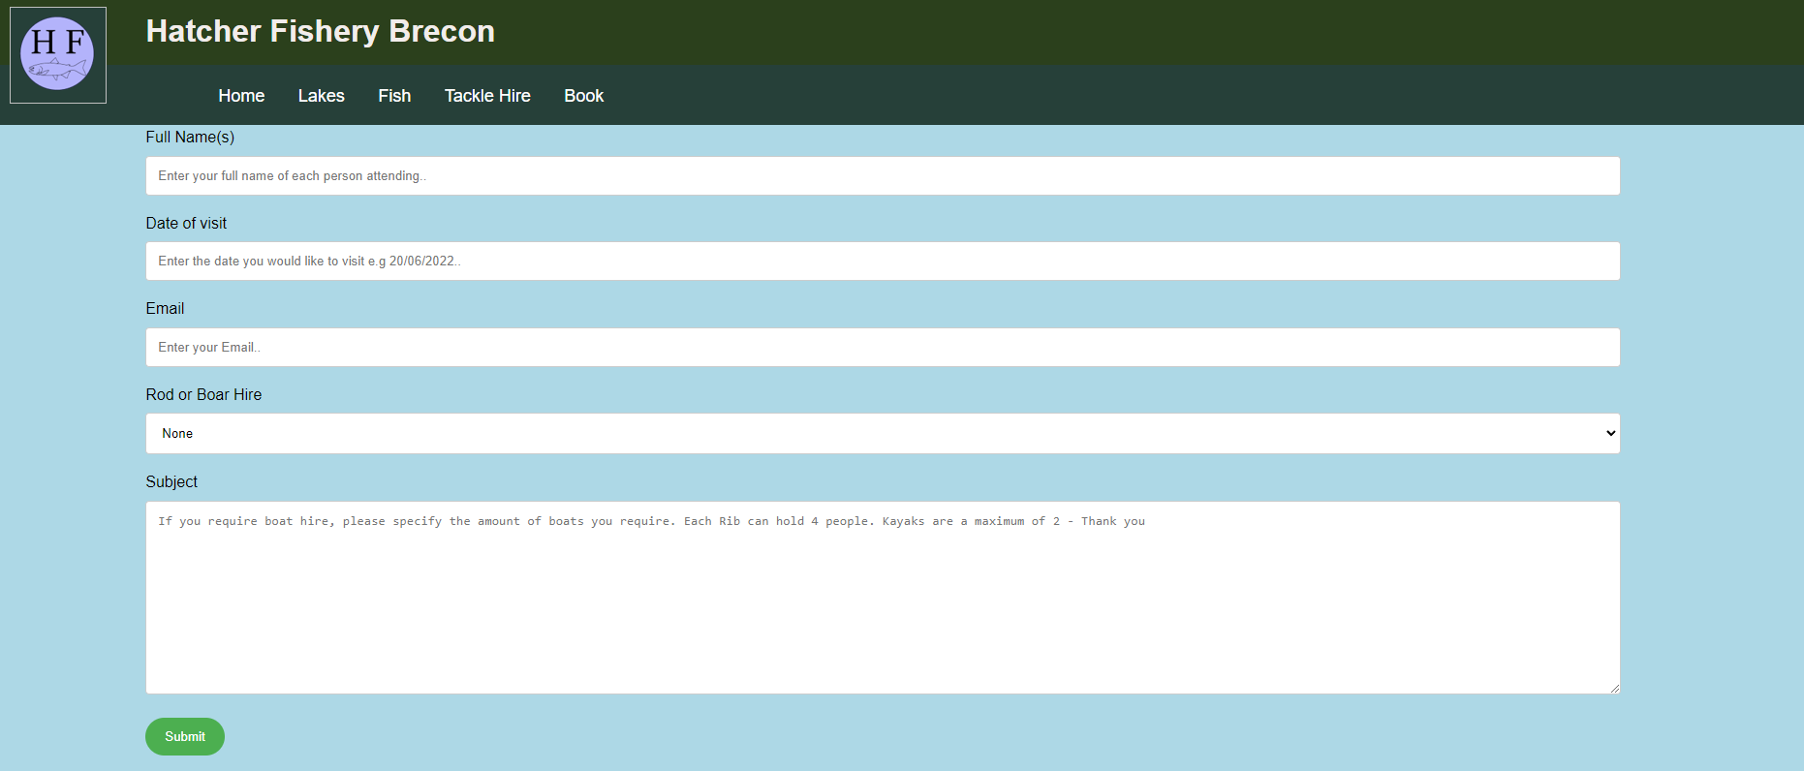
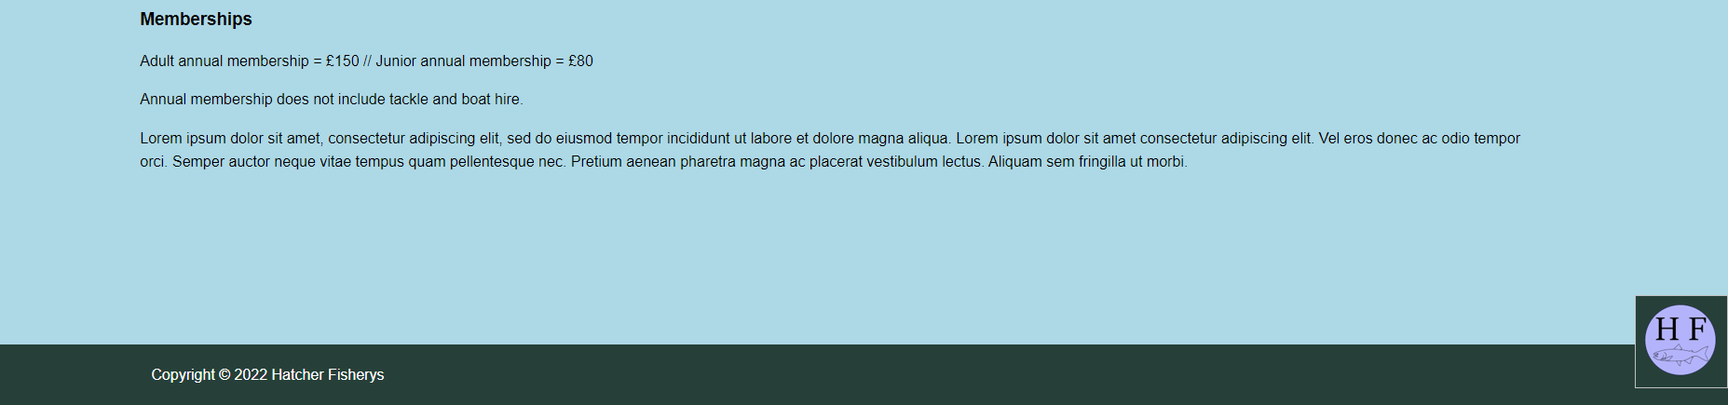
The final page is a booking page, this allows the user to book a specific date or enquire about the facilities available. This page links back to the ‘Tackle Hire’ page as I have included a drop down list of the type of hire required. I have given an example in each box, this should prevent the user from entering the wrong information.
I have also included some extra information about possible memberships for the public. I hope to capture the more regular users here.

Validation
I used the The W3C Markup Validation Service tool to validate the homepage of my website. Please see below for the error I occurred.
HTML
Error: Saw a start tag image.
From line 16, column 1; to line 16, column 17
/header>↩↩<image id='logo'>↩<div

I played with this error by changing the ‘image id’ to a ‘section id’ by doing this the whole homepage became blank. I tried to identify the issue in the CSS but could not resolve the issue. This part of code is referring to the logo in the top left of the page. I decided to keep the ID as ‘image’ as that’s what the Logo is.

Error: Element img is missing required attribute src.
From line 16, column 1; to line 16, column 17
/header>↩↩<image id='logo'>↩<div
Attributes for element img:

I believe this error is due to ‘image’ being used as a ID. When using ‘image’ HTML usually requires a .url and .png to be linked to it. This was the image ID can detect a picture from the creators library.

Error: Element p1 not allowed as child of element section in this context. (Suppressing further errors from this subtree.)
From line 49, column 1; to line 49, column 4
you!</p>↩<p1>The fi
Content model for element section:
Flow content.

I could fix this error by changing the type of text being used. I changed the <p1> to <p> and this fixed the error. However I decided to keep the error in as I have already set up CSS to read and amend the <p1> text.
Overall I had 7 error but all are repeats of the above.

CSS
I used the W3C CSS Validator results for Homepage.css (CSS level 3 + SVG) tool to validate my CSS script for the Homepage.
Overall these are the errors I occurred.
49 |  | Value Error : text-align centre is not a text-align value : centre
140 |  | Parse Error changes }
148 |  | Parse Error

49 – This has now been changed to meet the requirements of ‘left’. The nav bar text has been set to left on all pages but here I have typed centre.
140 – This error was refereeing to an extra } I had mis typed before a text colour change. This has now been amended.
148 – This is the last line of code used in my CSS. I tried to delete the extra spaces that were there but had no luck removing this error.
After re-running the CSS code I now only have the ‘Parse Error’ on line 148.

Evaluation
Website usability and Accessibility
Usability generally refers to the ease of use in a product. In this case we will be looking into website usability. There any many different aspects that contribute to a website usability.
For example,
- Navigation
- Familiarity
- Consistency
- Visual clarity
- Efficiency
- Accessibility
If the website doesn’t have a well structures layout, the user can find it hard to navigate around the page. This will result in the user becoming inpatient and therefor leaving the webpage.
The website would need to have an aspect of consistency to it. This will allow to user to feel comfortable and confident when using the website as they will start to understand the patterns used.

Accessibility plays a very large role in website usability. The site needs to be accessible to all users even if that have a slight disability such as losing in hearing. The accessibility of a website can be constantly improved. There is always a better and more accessible way of producing the end result. As stated in book ‘Don’t make me think, revisited: a common sense approach to web usability’
‘The single best thing you can do to improve your site’s accessibility is to test it often, and continually smooth out the parts that confuse everyone. In fact, if you don’t do this first, no matter how rigorously you apply accessibility guidelines, people with disabilities still won’t be able to use your site. If it’s not clear to begin with, just fixing code problems is like [insert your favourite putting-lipstick-on-a-pig metaphor here].’ [1]
The main outcome of the above statement is that the best way to improve accessibility is constant testing. There are always ways to improve the accessibility of your webpage. The main way to solve these problems is to simply fix and amend your code.
If I were to review my website for accessibility updates, I would add in a text sizing feature. I would allow the user to zoom in and out of the webpage without adjusting the website layout. Currently when you zoom into my website the page moves the location of the text. Even though its still readable the user may become confused while using the zoom. I have worn glasses since the age of 2 years old, I sometimes struggle to read very small text on webpages and the zoom feature plays a key role in helping me read.

Usability for my website
When designing my website I wanted it to be very simple and easy to use. There are many websites available that are too complex resulting in the usability being poor.
The functionality of my website is very high. It serves its purpose very well, I say this because it holds all of the relevant utilities. For example it has an easy to use navigation bar with key words suggesting to the user what the pages consist off. If the user is only looking for key information this allows them to narrow down there use and time on the website. Therefor making it very functionable.
I would suggest that the usability is also very good. I have designed the layout to allow users to read from top to bottom. The layout is very similar throughout all pages. I have ensured that the Header, Navigation bar and Footer is in the same place throughout all sheets. The information contained is also quite similar, I have kept the text size the same throughout all the pages. This includes the header and paragraph size.
The main colours I used were Green and blue. Green is a very common colour with fishing website this is because the majority of fishing clothes are green allowing them to blends in to the natural surroundings making the fisherman invisible to the fish.

I used three main shades of green,




Pale green
(#264039)

Military green
(#2B401C)

Olive


I used Pale and Military green for the Title and Nav bar background colour. I feel these two colours completement each other very well especially presented with white text over the top. I wanted to keep the green throughout each page. I decided to make the majority of the fishing information to be held in an Olive text box. The text stands out very well above the Olive but it does not overpower the overall look of the page.
The blue sky blue background (#add8e6) complements the overall pages very well. The colour does not overpower any of the pages as it just fades into the background. This allows the text and images to stand out making the user feel more confident in navigating to the correct information. Instead of having ‘White Space’ on the website I simply changed the background colour to the sky blue. In the statement below, it states how white space can improve the concentration of users.
Sky Blue
(#add8e6)
‘When you’ve got less distractions, your concentration is vastly improved. Websites that have lots of clutter in their web design can inadvertently distract their online visitors. Having a website that has whitespace in the sidebars can stop readers from getting distracted as they’re reading. If you want your visitors to read your blog and then convert into a lead, you need to limit the distractions.’ [2]
The website is very each to use, I decided to put the key information on separate pages. I did this to try and make the use of the website easier than others. For example I have titled each page with one word e.g. ‘Lakes’, ‘Fish’. The aim of this is to allow easy usability.
I used large pictures when describing the Fish and Lakes. The use of pictures in a website can make it feel very inviting and warm. I have seen a lot of website not use any large images and fill the pages with information. The may make the user bored resulting in them not using the website regularly.
The text layout is very simple to read, I have placed the text right next to the images allowing users to distinguish what the information is referring too. I have made each header slightly larger than the information text. I made this consistent throughout all pages.
The website is also very efficient with a large contact form on the last page, I have given examples of the information that should be input into them. This will remove the majority of error when using the form. I have also added a drop down in the form with the options of equipment hire (if any).

Search Engine Optimisation (SEO)
Search Engine Optimisation refers to the improvement of traffic being directed to the website or web page from search engines such as www.google.com.
SEO mainly targets unpaid traffic. Unpaid traffic refers to users that may come from other avenues such as image or video searches, also known as ‘natural’ traffic. SEO for website can be improved by optimising your target audience.
There any many ways you can improve your websites SEO, all of the below can result in more traffic being directed to your website.
- Giveaways/Free samples
- Share useful links
- Paid promotions
- Purchasing SEO software
SEO for my website
Firstly I have produced a brand name for my website. The brand is ‘Hatcher Fishery’s’ this means if the user where to search for Hatcher Fishery’s the webpage would come up on the first google page if not the top. This is the main connection between the user and the website is the brand name, the URL for the website would be www.HatcherFisherys.com.
I have also used many different Copyright free images of Lakes, Fish and Equipment. The combined images add up to 12. When a user searches for an image that is used in my website they may be directed to it. I have purposely used popular images of Lakes and Fish to improve the chance of unpaid traffic.
I have added in a small section for ‘Add Space’ on the hire page. This allows different companies to promote there products for hire. I did this with the intent of producing more income to the website allowing us to grow and develop it more.
I have also added in the address and contact information for the webpage. When published I would add in the office site onto google maps with the same Contact details used on the website. This would improve the link between the google search and website.
As stated below using google maps is a key feature to make your website more popular.
In fact, an advanced technique that you may want to explore is to search Google Maps using your business name, address, and phone number to see if there are any duplicates or near-duplicates of your business information, and, if so, to claim those as well. Doing so will help Google consolidate this information, and the benefit to you is that you will go from having several “weaker” listings to having a single strong consolidated listing. [3]
It is important to check for any duplicate addresses when filling in the google map information as this may confuse the search algorithm. It is much better to have the address all pointing to one website instead of different ones, this will result in making the websites search results more popular.

WCAG2.1 Principles
WCAG is the Web Content Accessibility Guidelines. They have 4 main design principles,
- Perceivable
- Operable
- Understandable
- Robust
To meet the first guideline you need to ensure the users can understand and use the service in there own way. I have adapted this guideline in my website as I have used many different text sizes and images to promote the information.
The second guideline requires the website to be fully operable and easy to use. I have met this guideline by providing a consistent layout with easy to use bottoms and navigation. As well as this I have provide the user with all the information and contact details.
The third guideline requires the user to understand the information being presented to them. I have clearly stated the information without the use of advanced wording. I find all the information presented is well written and easy to follow. I have given examples of text when I require the user to fill in booking forms.
The final requirement requires the website to be robust, this means the website must be able to adapt to advancing technology. For example the website must be able to be used on a mobile and computer device. This is a requirement I have struggled with. My website will convert down into a mobile phone viewing size by the layout does not stay the same. Some of the information gets a little jumbled. This is something I will review and develop in the future.

References

References

[1] | S. Krug, Don't make me think, revisited: a common sense approach to web usability, Massachusetts: Steve Krug, 2014.
[2] | J. David, "White Space Is King: 7 Benefits Of Having White Space On Your Site," Digital 22 , 16 04 2020. [Online]. Available: https://www.digital22.com/insights/benefits-of-having-white-space-on-your-site#:~:text=There%20are%20many%20benefits%20of%20having%20white%20space,site%3F%20Well%2C%20for%20starters%2C%20they%20aren%E2%80%99t%20being%20lazy.. [Accessed 17 04 2022].
[3] | E. Enge, The art of SEO, Massachusetts: O'Reilly, 2012.

Appendices
Homepage – HTML
<!DOCTYPE html>
<html>
<head>
<meta charset="utf-8" />
<title> Ethans Assignment </title>
<link rel="stylesheet" type="text/css" href="Homepage.css">
</head>

<body>
<header id="main-header">
<div class="container">
<h1> Hatcher Fishery Brecon </h1>
</div>
</header>

<image id='logo'>
<div class='container'>
</div>

<image id='footer-logo'>
<div class='container'>
</div>

<nav id="navbar">
<div class="container">
<ul>
<li><a href="Homepage.html">Home</a></li>
<li><a href="Lakes.html">Lakes</a></li>
<li><a href="Fish.html">Fish</a></li>
<li><a href="TackleHire.html">Tackle Hire</a></li>
<li><a href="Book.html">Book</a></li>
</ul>
</div>
</nav>

<section id="showcase">
<div class="container">
<h1> Welcome to Hatcher Fishery Brecon.</h1>
<p> We re-stock our fish every fortnight!<p>
</div>
</section>

<div class="container">
<section id="main">
<h3>Helpfull Tips</h3>
<p>Adult Day Pass = £10 // Junior Day Pass = £6 // Family (4) Day Pass = £28 </p>
<p> Our Main office can be found here: Aber, Talybont-On-Usk, Brecon LD3 7YS. Please come here on arrival for any tackle pick up or information. Thank you!</p>
<p1>The fish normally are most active at sunrise and sunset! Try and plan your fishing around these times for the best results. The fish are slower in the mornings as the water is at its coldest so be paitent as they are also at there hungriest. Happy fishing!
</p1>
<p1> Lorem ipsum dolor sit amet, consectetur adipiscing elit, sed do eiusmod tempor incididunt ut labore et dolore magna aliqua. Lorem ipsum dolor sit amet consectetur adipiscing elit. Vel eros donec ac odio tempor orci. Semper auctor neque vitae tempus quam pellentesque nec. Pretium aenean pharetra magna ac placerat vestibulum lectus. Aliquam sem fringilla ut morbi.</p1>
</section>

<aside id="sidebar">
<p> Opening Times <p>
<p> Monday : 8:00am - 7:00pm <p>
<p> Tuesday : 8:00am - 7:00pm <p>
<p> Wednesday : 8:00am - 7:00pm <p>
<p> Thursday : 8:00am - 7:00pm <p>
<p> Friday : 8:00am - 7:00pm <p>
<p> Saturday : 6:00am - 9:00pm <p>
<p> Monday : 6:00am - 9:00pm <p>
</aside>
</div>

<footer id="main-footer">
<div class='container'>
<p2> Copyright &copy; 2022 Hatcher Fisherys</p2>
</div>
</footer>

</html>
Homepage – CSS
body{
background-color:#add8e6;
font-family:Arial, Helvetica, san-serif;
font-size:16px;
line-height:1.6em;
margin:0;
}

.container{
width:80%;
margin:auto;
overflow:hidden;
}

#logo{
float:left;
width:100px;
height:100px;
margin-top:-60px;
margin-left:50px;
background-color:#264039;
background-image:url(LOGO.png);
}

#footer-logo{
float:right;
width:100px;
height:100px;
margin-top:1050px;
margin-left:-100px;
background-color:#264039;
background-image:url(LOGO.png);
}

#main-header{
background-color:#2B401C;
color:#F2EDEB;
}

#navbar{
background-color:#264039;
color:#F2EDEB;
}

#navbar ul{
padding:0px;
text-align:left;
padding:0px;
margin-top:20px;
width:100%
}

#navbar li{
display:inline;
}

#navbar a{
font-size:18px;
padding-right:30px;
}

a{
color:white;
text-decoration:none;
}

a:hover{
color:orange;
}

#main-footer{
background-color:#264039;
color:#white;
text-align:left;
padding:20px;
margin-top:30px;
width:100%;
}

#main-footer p2{
color:white;
}

#main{
float:left;
width:70%;
padding:10px;
box-sizing:border-box;
}

#sidebar{
float:right;
width:22%;
background-color:olive;
color:#fff;
padding:10px;
box-sizing:border-box;
}

#showcase{
background-image:url(LAKE.png);
background-size:2000px;
opacity:1.0;
background-position:center right;
min-height:600px;
margin-bottom:50px;
text-align:center;
}

#showcase h1{
color:black;
font-size:30px;
line-height:6;
padding:30px;
}

#showcase p{
color:black;
font-size:25px;
line-height:0;
padding:30px;
}

@media (max-width:1000px) {
#main{
width:100%;
float:none;
}

#sidebar{
width:100%;
float:none;
}

#navbar li{
display:block;
}

global text changes
h3 {
color:black;
}
p1 {
color:black;
}
p2 {
color:white;
}
Lakes – HTML
<!DOCTYPE html>
<html>
<head>
<meta charset="utf-8" />
<title> Ethans Assignment </title>
<link rel="stylesheet" type="text/css" href="Lakes.css">
</head>

<body>
<header id="main-header">
<div class="container">
<h1> Hatcher Fishery Brecon </h1>
</div>
</header>

<image id='logo'>
<div class='container'>
</div>

<image id='footer-logo'>
<div class='container'>
</div>

<nav id="navbar">
<div class="container">
<ul>
<li><a href="Homepage.html">Home</a></li>
<li><a href="Lakes.html">Lakes</a></li>
<li><a href="Fish.html">Fish</a></li>
<li><a href="TackleHire.html">Tackle Hire</a></li>
<li><a href="Book.html">Book</a></li>
</ul>
</div>
</nav>

<div class='container'>
<section id='Lakeonetext'>
<h3>Lake 1 - Water Ways</h3>
<p> Water Ways is out largest lake sitting at a whopping 460 acers. </p>
<p> Rainbow Trout, Pike and Salmon can all be found here! </p>
<p> Please look at the 'Fish' page for the catch limits. </p>
<p> Thank you. </p>
</section>
</div>

<image id='Lakeoneimage'>
<div class='container'>
</div>

<div class='container'>
<section id='Laketwotext'>
<h3>Lake 2 - Deep Dawn</h3>
<p> Deep Dawn is the only lake that connects to a natural river. </p>
<p> Sitting at 130 acers this lake stocks naturall Wild Brown Trout! </p>
<p> Please look at the 'Fish' page for the catch limits. </p>
<p> Thank you </p>
</section>
</div>

<image id='Laketwoimage'>
<div class='container'>
</div>

<div class='container'>
<section id='Lakethreetext'>
<h3>Lake 3 - Rocky Road</h3>
<p> Rocky Road is our smallest lake sitting at 60 acers. </p>
<p> Rainbow Trout, Pike and Salmon can all be found here! </p>
<p> Please look at the 'Fish' page for the catch limits. </p>
<p> Thank you. </p>
</section>
</div>

<image id='Lakethreeimage'>
<div class='container'>
</div>

<footer id="main-footer">
<div class='container'>
<p2> Copyright &copy; 2022 Hatcher Fisherys </p2>
</div>
</footer>

</html>
Lakes – CSS
body{
background-color:#add8e6;
font-family:Arial, Helvetica, san-serif;
font-size:16px;
line-height:1.6em;
margin:0;
}

.container{
width:80%;
margin:auto;
overflow:hidden;
}

#Lakeonetext{
float:right;
width:40%;
padding:0px;
background-color:olive;
box-sizing:border-box;
margin-top:100px;
margin-bottom:100px;
}

#Lakeonetext h3{
color:black;
font-size:20px;
line-height:0;
padding:20px;
}

#Lakeonetext p{
color:white;
font-size:18px;
line-height:0;
padding:20px;
}

#Lakeoneimage{
float:left;
width:900px;
height:400px;
margin-top:-440px;
margin-left:150px;
background-color:#264039;
background-image:url(Lakeone.png);
}

#Laketwotext{
float:left;
width:48%;
padding:0px;
background-color:olive;
box-sizing:border-box;
margin-top:50px;
margin-bottom:100px;
margin-left:10px;
}

#Laketwotext h3{
color:black;
font-size:20px;
line-height:0;
padding:20px;
}

#Laketwotext p{
color:white;
font-size:18px;
line-height:0;
padding:10px;
}

#Laketwoimage{
float:right;
width:750px;
height:350px;
margin-top:-400px;
margin-left:50px;
margin-right:190px;
background-color:#264039;
background-image:url(Laketwo.png);
}

#Lakethreetext{
float:right;
width:48%;
padding:0px;
background-color:olive;
box-sizing:border-box;
margin-top:40px;
margin-right:50px;
}

#Lakethreetext h3{
color:black;
font-size:20px;
line-height:0;
padding:20px;
}

#Lakethreetext p{
color:white;
font-size:18px;
line-height:0;
padding:10px;
}

#Lakethreeimage{
float:left;
width:700px;
height:350px;
margin-top:-300px;
margin-left:200px;
background-color:#264039;
background-image:url(Lakethree.png);
}

#logo{
float:left;
width:100px;
height:100px;
margin-top:-60px;
margin-left:50px;
background-color:#264039;
background-image:url(LOGO.png);
}

#footer-logo{
float:right;
width:100px;
height:100px;
margin-top:1260px;
margin-left:-100px;
background-color:#264039;
background-image:url(LOGO.png);
}

#main-header{
background-color:#2B401C;
color:#F2EDEB;
}

#navbar{
background-color:#264039;
color:#F2EDEB;
}

#navbar ul{
padding:0px;
text-align:centre;
padding:0px;
margin-top:20px;
width:100%
}

#navbar li{
display:inline;
}

#navbar a{
font-size:18px;
padding-right:30px;
}

a{
color:white;
text-decoration:none;
}

a:hover{
color:orange;
}

#main-footer{
background-color:#264039;
color:#264039;
text-align:left;
padding:20px;
margin-top:30px;
width:100%
}

@media (max-width:1000px) {
#main{
width:100%;
float:none;
}

#navbar li{
display:block;
}

global text changes
}h3 {
color:black;
}
p1 {
color:black;
}
p2 {
color:white;
}

Fish – HTML
<!DOCTYPE html>
<html>
<head>
<meta charset="utf-8" />
<title> Ethans Assignment </title>
<link rel="stylesheet" type="text/css" href="Fish.css">
</head>

<body>
<header id="main-header">
<div class="container">
<h1> Hatcher Fishery Brecon </h1>
</div>
</header>

<image id='logo'>
<div class='container'>
</div>

<image id='footer-logo'>
<div class='container'>
</div>

<nav id="navbar">
<div class="container">
<ul>
<li><a href="Homepage.html">Home</a></li>
<li><a href="Lakes.html">Lakes</a></li>
<li><a href="Fish.html">Fish</a></li>
<li><a href="TackleHire.html">Tackle Hire</a></li>
<li><a href="Book.html">Book</a></li>
</ul>
</div>
</nav>

<div class='container'>
<section id='Fishonetext'>
<h3>Rainbow Trout</h3>
<p> These can be found in all three of our lakes, we regularly stock the lakes with 2-6lb fish. </p>
<p> There is a catch limit of 3 per person. Spinning, Fly and Bait fishing are permitted. </p>
<p> Lorem ipsum dolor sit amet, consectetur adipiscing elit, sed do eiusmod </p>
<p> tempor incididunt ut labore et dolore magna aliqua. Nunc mattis enim ut </p>
</section>
</div>

<image id='Fishoneimage'>
<div class='container'>
</div>

<div class='container'>
<section id='Fishtwotext'>
<h3>Wild Brown Trout</h3>
<p> These can only be found in 'Rocky Road' lake. This is due to them being a naturall fish. </p>
<p> There is a catch limit of 2 per person. Spinning and Fly fishing are permitted. </p>
<p> tellus elementum sagittis vitae et leo. A iaculis at erat pellentesque </p>
<p> adipiscing. Tempus iaculis urna id volutpat. Varius sit amet mattis </p>
</section>
</div>

<image id='Fishtwoimage'>
<div class='container'>
</div>

<div class='container'>
<section id='Fishthreetext'>
<h3>Pike</h3>
<p> These can be found in all three of our lakes, we regularly stock the lakes with 4-10lb fish. </p>
<p> There is a catch limit of 3 per person. Spinning, Fly and Bait fishing are permitted. </p>
<p> vulputate enim nulla aliquet porttitor. Tempor id eu nisl nunc mi. </p>
<p> Consequat interdum varius sit amet mattis vulputate. Dolor sit amet </p>
</section>
</div>

<image id='Fishthreeimage'>
<div class='container'>
</div>

<div class='container'>
<section id='Fishfourtext'>
<h3>Salmon</h3>
<p> These can be found in all three of our lakes, we regularly stock the lakes with 2-8lb fish. </p>
<p> There is a catch limit of 2 per person. Spinning and Fly fishing are permitted. </p>
<p> consectetur adipiscing. Massa sed elementum tempus egestas sed. </p>
<p> Molestie a iaculis at erat pellentesque adipiscing commodo elit at. Gravida </p>
</section>
</div>

<image id='Fishfourimage'>
<div class='container'>
</div>

<footer id="main-footer">
<div class='container'>
<p2> Copyright &copy; 2022 Hatcher Fisherys </p2>
</div>
</footer>

</html>
Fish – CSS
body{
background-color:#add8e6;
font-family:Arial, Helvetica, san-serif;
font-size:16px;
line-height:1.6em;
margin:0;
}

.container{
width:80%;
margin:auto;
overflow:hidden;
}

#Fishonetext{
float:right;
text-align:left;
width:48%;
padding:0px;
background-color:olive;
box-sizing:border-box;
margin-top:90px;
margin-right:50px;
}

#Fishonetext h3{
color:black;
font-size:20px;
line-height:0;
padding:20px;
}

#Fishonetext p{
color:white;
font-size:18px;
line-height:0;
padding:10px;
}

#Fishoneimage{
float:left;
width:700px;
height:350px;
margin-top:-300px;
margin-left:200px;
background-color:#264039;
background-image:url(RainbowTrout.png);

}

#Fishtwotext{
float:left;
width:48%;
padding:0px;
background-color:olive;
box-sizing:border-box;
margin-top:50px;
margin-bottom:100px;
margin-left:10px;
}

#Fishtwotext h3{
color:black;
font-size:20px;
line-height:0;
padding:20px;
}

#Fishtwotext p{
color:white;
font-size:18px;
line-height:0;
padding:10px;
}

#Fishtwoimage{
float:right;
width:750px;
height:350px;
margin-top:-400px;
margin-left:50px;
margin-right:190px;
background-color:#264039;
background-image:url(BrownTrout.png);
}

#Fishthreetext{
float:right;
width:48%;
padding:0px;
background-color:olive;
box-sizing:border-box;
margin-top:40px;
margin-right:50px;
}

#Fishthreetext h3{
color:black;
font-size:20px;
line-height:0;
padding:20px;
}

#Fishthreetext p{
color:white;
font-size:18px;
line-height:0;
padding:10px;
}

#Fishthreeimage{
float:left;
width:700px;
height:350px;
margin-top:-300px;
margin-left:200px;
background-color:#264039;
background-image:url(Pike.png);

}

#Fishfourtext{
float:left;
width:48%;
padding:0px;
background-color:olive;
box-sizing:border-box;
margin-top:50px;
margin-bottom:100px;
margin-left:10px;
}

#Fishfourtext h3{
color:black;
font-size:20px;
line-height:0;
padding:20px;
}

#Fishfourtext p{
color:white;
font-size:18px;
line-height:0;
padding:10px;
}

#Fishfourimage{
float:right;
width:750px;
height:350px;
margin-top:-400px;
margin-left:50px;
margin-right:190px;
background-color:#264039;
background-image:url(Salmon.png);
}

#logo{
float:left;
width:100px;
height:100px;
margin-top:-60px;
margin-left:50px;
background-color:#264039;
background-image:url(LOGO.png);
}

#footer-logo{
float:right;
width:100px;
height:100px;
margin-top:1500px;
margin-left:-100px;
background-color:#264039;
background-image:url(LOGO.png);
}

#main-header{
background-color:#2B401C;
color:#F2EDEB;
}

#navbar{
background-color:#264039;
color:#F2EDEB;
}

#navbar ul{
padding:0px;
text-align:centre;
padding:0px;
margin-top:20px;
width:100%
}

#navbar li{
display:inline;
}

#navbar a{
font-size:18px;
padding-right:30px;
}

a{
color:white;
text-decoration:none;
}

a:hover{
color:orange;
}

#main-footer{
background-color:#264039;
color:#264039;
text-align:left;
padding:20px;
margin-top:30px;
width:100%
}

@media (max-width:1000px) {
#main{
width:100%;
float:none;
}

#navbar li{
display:block;
}

global text changes
}h3 {
color:black;
}
p1 {
color:black;
}
p2 {
color:white;
}
Tackle – HTML
<!DOCTYPE html>
<html>
<head>
<meta charset="utf-8" />
<title> Ethans Assignment </title>
<link rel="stylesheet" type="text/css" href="Tackle.css">
</head>

<body>
<header id="main-header">
<div class="container">
<h1> Hatcher Fishery Brecon </h1>
</div>
</header>

<image id='logo'>
<div class='container'>
</div>

<image id='footer-logo'>
<div class='container'>
</div>

<nav id="navbar">
<div class="container">
<ul>
<li><a href="Homepage.html">Home</a></li>
<li><a href="Lakes.html">Lakes</a></li>
<li><a href="Fish.html">Fish</a></li>
<li><a href="TackleHire.html">Tackle Hire</a></li>
<li><a href="Book.html">Book</a></li>
</ul>
</div>
</nav>

<div class='container'>
<section id='Rodtext'>
<h3>Rod Hire</h3>
<p> We offer Rod hire at a daily rate. Spin, Lure and Bait rods are avaliable. </p>
<p> Each rod is £15 per day per person, any damage to the reel or rod will be covered. </p>
<p> Lorem ipsum dolor sit amet, consectetur adipiscing elit, sed do eiusmod </p>
<p> tempor incididunt ut labore et dolore magna aliqua. Nunc mattis enim ut </p>
</section>
</div>

<image id='SpinRod'>
<div class='container'>
</div>

<image id='FlyRod'>
<div class='container'>
</div>

<image id='BaitRod'>
<div class='container'>
</div>

<div class='container'>
<section id='Boattext'>
<h3>Boat Hire</h3>
<p> We offer Boat hire at a daily rate. We have 4 Ribs and 8 Kayaks avaliable.</p>
<p> Please fill out the form on the 'Book' Page to pre-book a vehicle. </p>
<p> tellus elementum sagittis vitae et leo. A iaculis at erat pellentesque </p>
<p> adipiscing. Tempus iaculis urna id volutpat. Varius sit amet mattis </p>
</section>
</div>

<image id='RibImage'>
<div class='container'>
</div>

<image id='KayakImage'>
<div class='container'>
</div>

<div class='container'>
<section id='AddSpace'>
<h3>Add Space</h3>
<p> vulputate enim nulla aliquet porttitor. Tempor id eu nisl nunc mi. </p>
<p> Consequat interdum varius sit amet mattis vulputate. Dolor sit amet </p>
</div>
</section>

<footer id="main-footer">
<div class='container'>
<p2> Copyright &copy; 2022 Hatcher Fisherys </p2>
</div>
</footer>

</html>
Tackle – CSS
body{
background-color:#add8e6;
font-family:Arial, Helvetica, san-serif;
font-size:16px;
line-height:1.6em;
margin:0;
}

.container{
width:80%;
margin:auto;
overflow:hidden;
}

#Rodtext{
float:left;
text-align:left;
width:50%;
padding:0px;
background-color:olive;
box-sizing:border-box;
margin-top:90px;
margin-right:50px;
}

#Rodtext h3{
color:black;
font-size:20px;
line-height:0;
padding:20px;
}

#Rodtext p{
color:white;
font-size:18px;
line-height:0;
padding:10px;
}

#SpinRod{
float:right;
width:200px;
height:200px;
margin-top:-220px;
margin-right:700px;
background-color:#264039;
background-image:url(SpinRod.png);
}

#FlyRod{
float:right;
width:200px;
height:200px;
margin-top:-220px;
margin-right:450px;
background-color:#264039;
background-image:url(FlyRod.png);
}

#BaitRod{
float:right;
width:200px;
height:200px;
margin-top:-220px;
margin-right:200px;
background-color:#264039;
background-image:url(BaitRod.png);
}

#Boattext{
float:left;
width:50%;
padding:0px;
background-color:olive;
box-sizing:border-box;
margin-top:50px;
margin-bottom:100px;
margin-left:0px;
}

#Boattext h3{
color:black;
font-size:20px;
line-height:0;
padding:20px;
}

#Boattext p{
color:white;
font-size:18px;
line-height:0;
padding:10px;
}

#RibImage{
float:right;
width:325px;
height:200px;
margin-top:-320px;
margin-right:575px;
background-color:#264039;
background-image:url(RibImage.png);
}

#KayakImage{
float:right;
width:325px;
height:200px;
margin-top:-320px;
margin-right:200px;
background-color:#264039;
background-image:url(KayakImage.png);
}

#AddSpace{
float:left;
width:100%;
padding:50px;
background-color:olive;
box-sizing:border-box;
margin-top:20px;
margin-right:50px;
}

#AddSpace h3{
color:black;
font-size:20px;
line-height:0;
padding:20px;
}

#AddSpace p{
color:white;
font-size:18px;
line-height:0;
padding:10px;
}

#logo{
float:left;
width:100px;
height:100px;
margin-top:-60px;
margin-left:50px;
background-color:#264039;
background-image:url(LOGO.png);
}

#footer-logo{
float:right;
width:100px;
height:100px;
margin-top:1020px;
margin-left:-100px;
background-color:#264039;
background-image:url(LOGO.png);
}

#main-header{
background-color:#2B401C;
color:#F2EDEB;
}

#navbar{
background-color:#264039;
color:#F2EDEB;
}

#navbar ul{
padding:0px;
text-align:centre;
padding:0px;
margin-top:20px;
width:100%
}

#navbar li{
display:inline;
}

#navbar a{
font-size:18px;
padding-right:30px;
}

a{
color:white;
text-decoration:none;
}

a:hover{
color:orange;
}

#main-footer{
background-color:#264039;
color:#264039;
text-align:left;
padding:20px;
margin-top:30px;
width:100%
}

@media (max-width:1000px) {
#main{
width:100%;
float:none;
}

#navbar li{
display:block;
}

global text changes
}h3 {
color:black;
}
p1 {
color:black;
}
p2 {
color:white;
}
Book – HTML
<!DOCTYPE html>
<html>
<head>
<meta charset="utf-8" />
<title> Ethans Assignment </title>
<link rel="stylesheet" type="text/css" href="Book.css">
</head>

<body>
<header id="main-header">
<div class="container">
<h1> Hatcher Fishery Brecon </h1>
</div>
</header>

<image id='logo'>
<div class='container'>
</div>

<image id='footer-logo'>
<div class='container'>
</div>

<nav id="navbar">
<div class="container">
<ul>
<li><a href="Homepage.html">Home</a></li>
<li><a href="Lakes.html">Lakes</a></li>
<li><a href="Fish.html">Fish</a></li>
<li><a href="TackleHire.html">Tackle Hire</a></li>
<li><a href="Book.html">Book</a></li>
</ul>
</div>
</nav>

<div class="container">
<form action="action_page.php">

<label for="fname">Full Name(s)</label>
<input type="text" id="fname" name="firstname" placeholder="Enter your full name of each person attending..">

<label for="lname">Date of visit</label>
<input type="text" id="lname" name="lastname" placeholder="Enter the date you would like to visit e.g 20/06/2022..">

<label for="Email">Email</label>
<input type="text" id="Email" name="Emailadress" placeholder="Enter your Email..">

<label for="Rod or Boar Hire">Rod or Boar Hire</label>
<select id="Rod or Boar Hire" name="Rod or Boar Hire">
<option value="None">None</option>
<option value="Rod S">Rod - Spin</option>
<option value="Rod F">Rod - Fly</option>
<option value="Rod B">Rod - Bait</option>
<option value="Boat R">Boat - Rib</option>
<option value="Boat K">Boat - Kayak</option>
</select>

<label for="Specific">Subject</label>
<textarea id="Specific" name="Specific" placeholder="If you require boat hire, please specify the amount of boats you require. Each Rib can hold 4 people. Kayaks are a maximum of 2 - Thank you" style="height:200px"></textarea>

<input type="submit" value="Submit">

</form>
</div>

<section id="main">
<div class="container">
<h3>Memberships</h3>
<p>Adult annual membership = £150 // Junior annual membership = £80 </p>
<p> Annual membership does not include tackle and boat hire.</p>
<p1> Lorem ipsum dolor sit amet, consectetur adipiscing elit, sed do eiusmod tempor incididunt ut labore et dolore magna aliqua. Lorem ipsum dolor sit amet consectetur adipiscing elit. Vel eros donec ac odio tempor orci. Semper auctor neque vitae tempus quam pellentesque nec. Pretium aenean pharetra magna ac placerat vestibulum lectus. Aliquam sem fringilla ut morbi.</p1>
</section>

<footer id="main-footer">
<div class='container'>
<p2> Copyright &copy; 2022 Hatcher Fisherys </p2>
</div>
</footer>

</html>
Book – CSS
body{
background-color:#add8e6;
font-family:Arial, Helvetica, san-serif;
font-size:16px;
line-height:1.6em;
margin:0;
}

.container{
width:80%;
margin:auto;
overflow:hidden;
}

#logo{
float:left;
width:100px;
height:100px;
margin-top:-60px;
margin-left:50px;
background-color:#264039;
background-image:url(LOGO.png);
}

#footer-logo{
float:right;
width:100px;
height:100px;
margin-top:1050px;
margin-left:-100px;
background-color:#264039;
background-image:url(LOGO.png);
}

#main-header{
background-color:#2B401C;
color:#F2EDEB;
}

#navbar{
background-color:#264039;
color:#F2EDEB;
}

#navbar ul{
padding:0px;
text-align:centre;
padding:0px;
margin-top:20px;
width:100%
}

#navbar li{
display:inline;
}

#navbar a{
font-size:18px;
padding-right:30px;
}

a{
color:white;
text-decoration:none;
}

a:hover{
color:orange;
}

input[type=text], select, textarea {
width: 100%;
padding: 12px;
border: 1px solid #ccc;
border-radius: 4px;
box-sizing: border-box;
margin-top: 6px;
margin-bottom: 16px;
resize: vertical
}

input[type=submit] {
background-color: #4CAF50;
color: white;
padding: 12px 20px;
border: none;
border-radius: 50px;
cursor: pointer;
}

input[type=submit]:hover {
background-color: #45a049;
}

#main{
float:left;
width:100%;
padding:10px;
box-sizing:border-box;
}

#main-footer{
background-color:#264039;
color:#264039;
text-align:left;
padding:20px;
margin-top:390px;
width:100%
}

@media (max-width:1000px) {
#main{
width:100%;
float:none;
}

#navbar li{
display:block;
}

global text changes
}h3 {
color:black;
}
p1 {
color:black;
}
p2 {
color:white;
}

