

Developing Relationships and Workplace Achievements
- BMSW 5102

Assignment Title: “Training and Development needs for a HR officer”

Module Tutor: Dr Nandish Patel
Student Name: Natalia Pinzaru (1906870)

London – 2021
Introduction
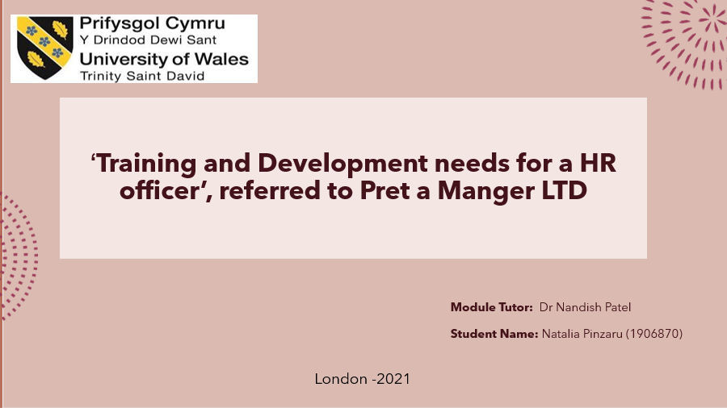
Slide 1.
The purpose of this presentation is to identify the development stages but also the necessary training in the field of human resources in order to get to work with it. Last but not least, to know exactly what this job entails, what other functions or obligations it involves, what kind of skills is required and the awareness of the benefits brought to the company but also of the self in the performance stages.
I chose to write about Pret a Manger because it is a famous company with a fairly large network that extends to several countries. It is known that the first restaurant was first opened in London by Jeffrey Hyman. A second reason why I decided to write about this shop is that I was a loyal customer of theirs, until the pandemic came and stopped me at home. Moreover, I know things about them, given the fact that I worked in this company. In the context of what has been said, I come with a presentation following the research done but also my accumulated knowledge about how Pret a Manger selects people, then principles and what stages of learning must go through those who want to get to work in the department human resources, within the company.

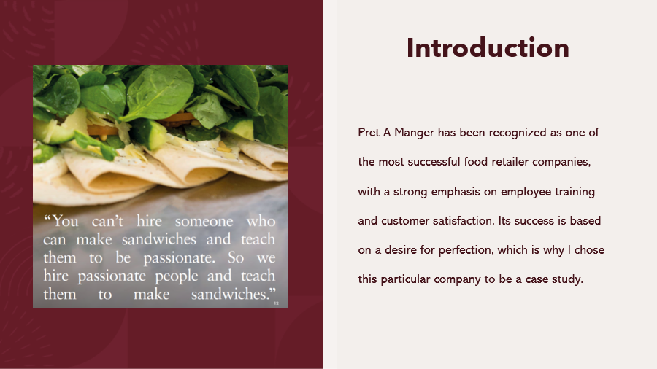
Slide 2.
The Pret store is not only successful in terms of selling organic food and beverage, but also in terms of recruitment and opportunities to evolve professionally. And this immediately refers to personal development. Through practical training as well as a series of certified qualifications offered by the members of the Pret team in stores but also of the assistance centers are opportunities to advance in the career in many different roles and in a not so long time. There are various talent programs that allow the creation of an internal talent pipeline which benefits the teams and company.

