  Component One: Student Journal (learning log) 750 words +/- 10%  Contribution to Overall Module Assessment: 25% | Student No: | 2240975
 | Module Title: | Operating Hotel Facilities
 | Module Code: | 4006
 | Lecturer: | Dan Payne
 |  |  | s
Component-1
What is Gibbs's Model Of Reflection?
To assist individuals in comprehending their actions, thoughts, and concepts using a rigorous process of contemplating past experiences, Graham Gibbs formulated the Gibbs model of reflection. The notion is implemented in education, healthcare, professional development, and professional development to promote reflective practice and ongoing quality enhancement (Amrik, 2014). The Gibbs Model effectively delineates the reflective process into distinct components, facilitating a comprehensive evaluation of personal experiences while concurrently promoting knowledge acquisition, self-reflection, and the formulation of effective strategies for forthcoming undertakings (IFC, 2003).
Description:
Beginning on January 13, 2023, I officially started my employment at the Novotel Hotel in the capacity of a housekeeper. I was overseen by an attentive supervisor, Max, and I was fortunate to have a team of committed colleagues, including Dagmara, Joe, and George. Employee training was required to ensure adherence to the hotel's stringent standards regarding the appropriate utilisation of chemical products and materials (Jayawardena, 1993). A comprehensive cleansing regimen was executed to maintain a sanitary and welcoming environment, encompassing tasks such as flushing the toilets and gazing through the windows. The position necessitated an extensive array of responsibilities, spanning from logistical execution of room cleaning protocols to strategic shift planning (Andrews, 1985), thereby offering a comprehensive perspective on the intricacies of the department. Following a short interval for room examinations, my cleaning schedule consisted of two shifts: 9:00 a.m. to 1:00 p.m., and 4:35 p.m.
Feelings:
Upon commencing my practicum, I encountered a spectrum of affective states, comprising inquisitiveness, apprehension, and a moderate sense of disquiet. Initial resistance accompanied by a lack of confidence was attributed to the difficulty of establishing and upholding elevated benchmarks (Janet, Brenda, & David, 2005). At first, I experienced a range of sentiments, including inquisitiveness and unease. I gained confidence after a prolonged period of concern regarding the adherence to stringent standards regarding the arrangement of my room and furnishings. The recognition I received from my supervisor for independently cleaning a room enlightened me about the transformative potential of experiential learning (Austria, 2023 ). My concerns were significantly mitigated when my supervisor complimented me on my independent achievement of scrubbing an entire room.

Evaluation:
With my experience working as a housekeeping employee at Novotel Hotel, I had a very positive environment with the housekeeping staff. Exceptional guidance and a sense of accomplishment characterised the impression I received from my supervisor and colleagues. Scrupulous attention to detail led to outstanding task completion and the establishment of a positive work environment (Branson & Joan, 1988). The custodial staff's positive attitude, supportive colleagues, and sense of accomplishment consistently left an impression on me. Especially my supervisor, the constructive criticism from colleagues complemented the commendable effort (Khatri, 1996).
Analysis:
To underscore the importance of adaptability and effective communication in a perpetually evolving environment, the practical event was examined. Performing tasks in a dynamic setting requires an exceptional degree of flexibility and effective correspondence. Notwithstanding my proficiency in complying with bedtime and sanitation protocols, the chemical training curriculum revealed certain aspects that required improvement (Amrik, 2014). Upon the initiation of the chemical training session, my deficiencies were detected, while my strengths were ascertained by rigorously adhering to protocols regarding hygiene and bedmaking. In addition, the algorithm identified specific issues. By applying what I have learned, I hope to increase my comprehension of chemical products (Casado & Matt, 2012). Upon observing the collective endeavours of the team, my viewpoint regarding the housekeeping staff's function in hotel operations was significantly altered (Millan & Rossiter, 2006). These insights enhanced my performance as a service provider in the hotel industry.
Conclusion:
It was a pleasure to work as a housekeeper at the Novotel Hotel. I consequently progressed professionally and gained a deeper understanding of a variety of cleansing procedures. Participating in our group project facilitated my comprehension of the maintenance department's duties and inspired me to pursue a future career in the hotel industry. The Novotel hotel, housekeeping placement was not just a series of tasks. It was an immersive learning experience. The challenges encountered and success celebrated during this period have become builders born with my understanding of housekeeping operations (Maharani, Ni-Putu, & Gusti-Ayu, 2021).
Action plan:
The inclusion of a comprehensive Health and Safety Guide within the action plan will prove to be of tremendous assistance to the sanitation staff. It underscores the criticality of maintaining situational awareness and adhering to established safety procedures (Martin, 1986). Adhering to these regulations ensures the protection of team members and the provision of high-quality services. To sustain its safety culture, the Novotel Hotel may implement the following measures: foster transparent lines of communication, provide regular training sessions, and strictly enforce adherence to established standards (Hospitality, 2021).

Component Two: Health and Safety Guide

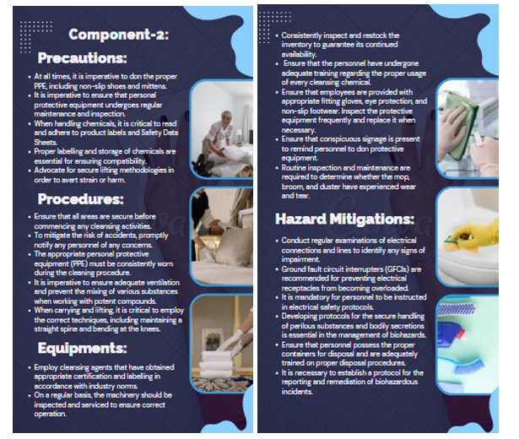

Reference List

References
ammoniaknowhow. (2021). What are the Safety Critical Elements? Retrieved from ammoniaknowhow: https://ammoniaknowhow.com/what-are-the-safety-critical-elements/
Amrik, s. (2014). Emergence of training programs in small scale hotels in Punjab region of India. Research journali’s Journal of Human Resource.
Andrews, S. (1985). Hotel housekeeping: Training manual. New Delhi: Tata McGraw-Hill.
Austria. (2023 , January). How to spot a clean hotel room: our housekeeping service experts share their tips! Retrieved from Markas: https://www.markas.com/en/housekeeping-tips--1-891.html
Branson, & Joan, C. (1988). Hotel, hostel and hospital housekeeping. London: book power.
Casado, & Matt, A. (2012). Housekeeping management. Hoboken: John Wiley & Sons.
Hospitality, L. (2021). Impact you can have on the world. Retrieved from Hospitality Learning Online: https://www.hospitalitylearningonline.com/impact-you-can-have-on-the-world
IFC. (2003). International Fire Code. Washington: International Code Council.
Janet, S., Brenda, M., & David, J. (2005). A model of customer and retention for hotels. Journal of Quality assurance in hospitality and tourism, 1-23.
Jayawardena, C. (1993). Food and Beverages management in the context of large hotel operations”, in Jayawardena, C. (Ed.), Tourism, Hoteliering and hospitality education. Vijeya Publication in Sri Lanka PP, 61-71.
Khatri, N. (1996). A ‘4R’ environmental model for Andaman and Nicobar. Cornell Hotel and Restaurant administration quarterly, 62-6.
Maharani, Ni-Putu, D., & Gusti-Ayu, P. (2021). Gusti Ayu Putu Wita Indrayani, and Ni Desak Made Santi Diwyarthi. "Pengaruh Gaya Kepemimpinan terhadap Motivasi Kerja Karyawan Departemen Housekeeping di Hotel A Ubud. Jurnal Bisnis Hospitaliti 10,, 1-12.
Martin, R. (1986). Professional management of housekeeping operations. . New York: Wiley.
Millan, D., & Rossiter, P. (2006). Trends and Challenges : the strategic role of hospitality management association. in Jayawardena, C.(Ed.)International Trends and Challenges in Tourism & Hospitality business, Vijitha YAPA Publications , Sri Lanka , PP, 3-12.
NEXTDOOR, E.-T. (2021, SEPTEMBER ). Workplace housekeeping and safety tips. Retrieved from Business: https://business.nextdoor.com/en-us/small-business/resources/blog/workplace-housekeeping-tips
Raghubalan, G. (2009). Hotel housekeeping: Operations and managemen. New Delhi: Oxford University Press.
Sam. (2023, January). Guest room cleaning procedure.pptx. Retrieved from Slideshare: https://www.slideshare.net/samkeliso/guest-room-cleaning-procedurepptx
Satria, N., & Dhanin. (2022). Analysis Of Leadership Style Application And Motivation By Managers In Improving Housekeeping Employees Performance At Bumi Senyiur Hotel Samarinda. Jurnal Syntax Fusion 2, 520–28.
Schneider, M. (1999). The professional housekeepe. New York: J. Wiley.
Superbloov. (2021). What is Safety Management System (SMS)? SafetyCulture. Retrieved from Super Bloov: https://www.formasup.fr/?k=what-is-safety-management-system-sms-safetyculture-ii-5l3g34Uo
Tracy, H. (2016 , April). Make office housekeeping a priority. Retrieved from safety and health: https://www.safetyandhealthmagazine.com/articles/13880-make-office-housekeeping-a-priority
Wahyu, Niken, U., Mulyati, & Maya, O. (2022). Pengaruh Kualitas Pelayanan Housekeeping Department Terhadap Tingkat Kepuasan Tamu Menginap Di Hotel Santika Premiere Harapan Indah Bekasi. Journal of Mandalika Review 1, 24–29.
Wittemann, A. (1989). Hotel housekeeping runner. Las Vegas, NV: Camelot Consultants.

