

Postgraduate/Distance Learning
Assignment coversheet & feedback form

THIS SHEET MUST BE THE FIRST PAGE OF THE ASSIGNMENT YOU ARE SUBMITTING (DO NOT SEND AS A SEPARATE FILE)

For completion by the student:
Student Name: Clair-Joanna Napier-McDonald

Student University Email: 1814727@student.uwtsd.ac.uk
Module code: HPCA7003  Module title: History Of Astrology | Student ID number:  1814727 |  |  | Educational support needs:  Yes/No
Assignment title: Compare and contrast the treatment of ONE astrological planet, star, zodiac sign or constellation, in at least THREE primary source documents

Assignment due date: 3rd June 2019
This assignment is for the 1st 2nd 3rd 4th 5th 6th module of the degree
I confirm that this is my original work and that I have adhered to the University policy on plagiarism.
Signed ……Clair-J. Napier-McDonald………………………………………………………
Email submission:if you are submitting this form via email, please tick this box
(as a substitute for your signature) to confirm that you agree to the above declaration.
Assignment Mark
1st Marker’s Provisional mark
2nd Marker’s/Moderator’s provisional mark
External Examiner’s mark (if relevant)
Final Mark

NB. All marks are provisional until confirmed by the Final Examination Board.

For completion by Marker 1 :
Comments:

Marker’s signature: |  |  | Date:
For completion by Marker 2/Moderator:

Comments:

Marker’s Signature: |  | Date:
External Examiner’s comments (if relevant)

External Examiner’s Signature: |  | Date:

Compare and contrast the treatment of ONE astrological planet, star, zodiac sign or
constellation, in at least THREE primary source documents.
Word count: 1998

For the purpose of this essay three images have been chosen for comparison all feature an interpretation of the planet Venus. The three images chosen are an Akkadian cyclinder seal (2254-2193 BCE), a print entitled ‘Venus’ (1539, British Museum, London) and a painting entitled ‘Taurus’ (1975, Netherlands).

Image 1.
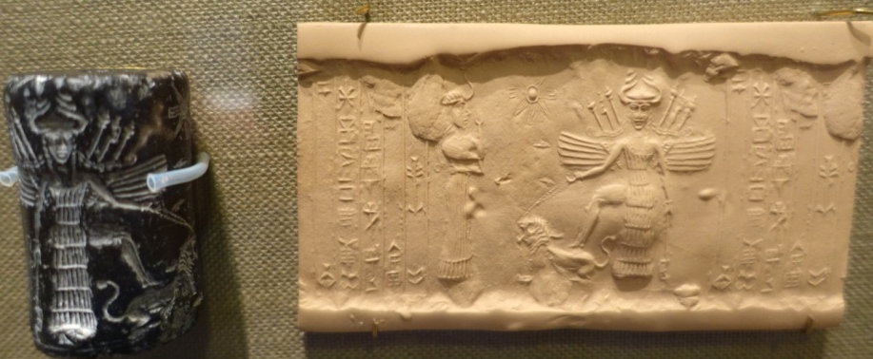

Figure 1
In the Akkadian cylinder seal (Oriental Museum, University of Chicago, 2019), there is an image of Ishtar the Akkadian personification of Venus depicted as holding a lion by a leash. Not only is she stood on the lion which denotes control over aggression and power (which the lion represents) but the fact that she holds the leash with one hand suggests that this is enacted with ease, giving an impression that power is easily wielded by Ishtar and therefore because of this she might also be representing the ‘victorious’.
The Oriental Museum dated the seal to the years 2254-2193 BCE at least a thousand years before the Astral Omen texts of Enuma Anu Enlil. which gives insight to dating Akkadian cosmology. The creator of the seal indicates to us a cosmology with multiple deities as there are two in this image, identified also by the eight pointed star. The other goddess (Ninishkun) is in discussion with Ishtar and as Ishtar is not holding any weapons up in the air or towards the other goddess it might be possible to assume that she has not made any decision to take action or to bestow blessings and the primary focus of the situation is Ninishkun’s actions which are of discourse. It is likely that this seal represents an appeal by which a human has appealed to a lesser goddess to petition on their behalf rather than addressing Ishtar directly. This could indicate that the lesser goddess is a ‘personal’ or ‘household’ deity invoked to be a mediator. As the cylinder is made from a stone which is of decorative value such as a semi-precious stone, and 4.2cm by 2.5cm in size we can assume that an object such as this would have been crafted with great skill for someone with the wealth to purchase it. As the image shows an intermediary deity it is possible to assume that this object was not created for a monarch who might be expected to appeal to Ishtar directly. There is evidence that the Akkadian king Nimrun-Sin was possibly the first king to deify himself in the 23rd century BCE and so one could expect that if the seal were created for a king he would feature in the image rather than Ninishkun.
The image depicts Ishtar as wearing a warrior’s kilt and weapons which was masculine dress of the period thus implying both feminine and masculine aspects. The planet Venus, when visible in the sky could be seen at both morning and evening which thus incurred the notion of ‘duality’ being associated with it and therefore the deity associated with the planet also.
In an article written by I. Zsolnay (2010) she discusses the use of curses which call upon the goddess Ishtar to cause the defeat of a king by rendering him powerless. Zsolnay writes that in removing the king’s power, that which makes him masculine is removed which therefore in turn, increases his femininity. This again reflects the duality and a balance of gender qualities.
When writing about the Sumerian version of Ishtar, Inanna, Meador (2001) states ‘This goddess is not bound by being female......She even turns man into woman, woman into man’ referring to Jung (1875-1961) and his writings about the duality of the Mesopotamian cosmos, and writes ‘Unlike the pair An and Ki, (heaven and earth, male and female), Inanna is a single deity in whose being opposing pairs of creation are gathered.’
This image communicates clearly what it is intended by the artist and there is no danger of interpretive error unlike written text which as Evans (1947-) asserts, once the information is found it then has to be put into a context in order to become evidence, however the act of doing so is open to the preconceived concepts and relativity which affects the understanding of the historian.

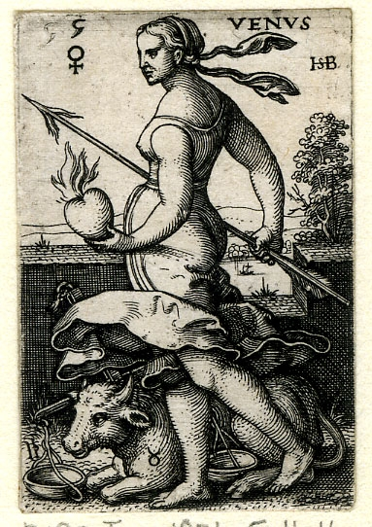
Image 2.

Figure 2
The second image chosen for the purpose of this essay is a sixteenth century print entitled ‘Venus’ which was created by German artist Sebald Beham (1500-1550) in 1539. Currently held in the British Museum, London, it is part of a collection of seven images called ‘Seven Planets/ Deities with their days’, each portraying a sign of the zodiac and is 4.3cm by 2.9cm.
In this image Venus is depicted again as a woman but rather than the balanced Mesopotamian goddess she is predominantly female, of strong build but feminine. On the left flank of the bull there is the symbol of Taurus just to confirm that it represents Taurus, this could indicate that at the time this image was created, a bull in imagery could perhaps represent more than one meaning ie: had this image been created three years earlier, the bull could have represented the Lutheran Queen of England (Anne Boleyn) and so the image would have instantly become political. This highlights that in contrast to the previous image there is some further understanding needed in order for the image to communicate to the viewer effectively.
Her build is powerful which further echoes the theme of peasantry but in doing so refers to the ‘earthiness’ of one who works the land and of the relevance of Taurus being an ‘Earth’ sign. She wields an oversized burning arrow in her right hand while in her left hand she holds a burning heart as though she has either caught it or is threatening to stab it with the arrow. The burning aspect of the arrow and heart might indicate passion and along with it the destruction which may come with it. Venus still retains a power which is constructive and destructive.
The HSB in the upper right is Beham’s monogram. To the left we have the cross hanging from a circle which is the symbol of Venus as appears in astrological charts and above that the number 5 indicating it is the fifth plate in the series. Belam was branded by the Nuremburg Council as one of the ‘Godless Painters’ and banished from Nuremburg just two months before Nuremburg became Lutheran for declaring his disbelief in Transubstantiation and the ‘Holy Sacraments’ of Catholicism. Nuremburg at this time was under direct control of the catholic pope but it had recently seen the events of the church reformation. Rebellion against catholic teachings was spreading. Beham was known to have been influenced by a schoolmaster called Hans Denck who was thought to have been influenced by Andreas Karlstadt (1486-1541) a contempory of Martin Luther.
That Beham has chosen the astrological subject indicates that he had knowledge of certain astrological information. The print was created in a time when Beham was trying to promote his woodcut illustrations for books in Frankfurt so it is possible that, due to the original size of this image it was intended for a book. It is also possible that he created such as subject in such small dimensions because he wished to be discrete with the subject matter. He had already fallen into trouble for not adhering to mainstream beliefs.

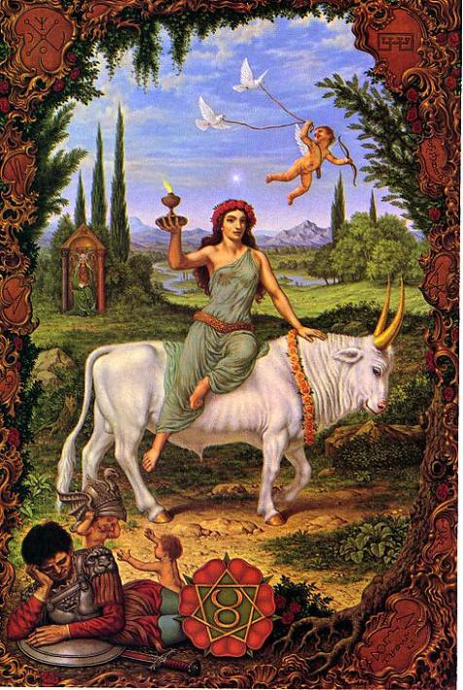
Image 3.

Figure 3

The third image chosen for this essay is Taurus from a collection of twelve paintings called The Zodiac (1973-75, Virtual Johfra Museum) by Dutch artist Johfra Bosschart (1919-1998). The original painting was 90cms by 60cms.
A former scholar of the International Rosicrucian School, Johfra incorporated symbology pertaining to Rosicrucian teachings and was the founder of an art genre termed ‘Meta-Realism’ which brought realism and mysticism together. According to this image, Venus personified has become just the evening star and the warrior Morning star has given its attributes to Mars. Mars coincidently, lays inactively at the bottom of the image to show he has no role in Taurus so the removal of the masculine is even more enforced. Around the frame of the image are mystical and astrological symbols of Venus and the angelic dominions which belong to the planet and the zodiac realm of Taurus. The entire picture is crammed with symbology which refers to the Kabbala, Hermeticism, Gnosticism, Tarot and to achemy, most of which Bosschart would have studied as a Rosicrucian. Unlike Beham who created a tiny image to be inserted on a book page, Johfra is quite openly displaying his knowledge of the occult because this image, along with the eleven others were intended and commissioned as posters. However, Bosschart is communicating an image with many symbols that were only known to esoteric societies. In this image the artist makes a statement indicating he is affiliated with an esoteric school and he can declare this openly. He also communicates a statement that alienates the majority but targets a minority with the inclusion of the occult.

Conclusion
When comparing the three interpretations of Venus it was evident that as we moved forward in time, the images appeared to remove the original masculine aspect from a persona which was balanced. This could possibly be a social reflection of the growing suppression of the female in male dominated societies as cosmology became more male dominated. It is also possible to see an insight as to the cosmological background of the artists; the first image reflects a society which appears to revolve around its cosmological beliefs to one where the artist almost secretly reveals his own cosmology within a society which is suppressed by its cosmology and finally the third which reflects a society where one is free to choose and combine multiple cosmologies. All three images give insight which as primary sources may leave less to the error of translation and communicate just as well as any written document.

Bibliography
Bosschart, J. (May 2001), ‘Johfra and The Signs of the Zodiac: Taurus and Gemini’, May-June
Rays from the Rose Cross publication, The Rosicrucian Fellowship, California.
Campion, N. (2013), ‘Astrology and Cosmology in the World’s Religions’, New York
University Press, New York.

Enheduanna. Meador, B.D.S. (2000), ‘Inanna, Lady of Largest Heart: poems of the Sumerian
high priestess Enheduanna’. Austin: University of Texas Press, p20.
Evans, R. (2018), In Defence of History, Granta Books, London, p76-77
Heeßel, Nils P., (2018), ‘Dating EAE: When was the Astrological Series Enuma Anu Enlil
Created?’ pp. 253-63, in C. J. Crisostomo, E. A. Escobar, T. Tanaka and N. Veldhuis, eds, The Scaffolding of Our Thoughts: Essays on Assyriology and the History of Science in Honor of Francesca Rochberg. Leiden/Boston: Brill.
Ives, E. (2005) ‘The Life and Death of Anne Boleyn: The Most Happy’, Wiley-Blackwell, UK,
chpt 18-19
Jung, C.G. (1953), ‘Psychology and Alchemy’. London: Routledge & Kagan, Paul, par. 2
Kolb, R. (2009), ‘Martin Luther: Confessor of The Faith’, Oxford University Press.
Zsolnay, I. (2010), ‘Išhtar, “Goddess of War, Pacifier of Kings”: An Analysis of Išhtar’s Martial
Role in the Maledictory Sections of the Assyrian Royal Inscriptions’, ‘Annual of Ancient Near East, Old Testament, and Semitic Studies’, Russian State University of Humanities, Wisconsin, Eisenbrauns, Indiana.

Websites
Image of Venus from the ‘SEVEN PLANETS’ by Sebald Beham 1539, British Museum, ref:
1931,0511.14 <https://www.britishmuseum.org/research/collection_online/collection_boject_details.aspx?objectld=1517146&partld=1&searchText=++++The+Seven+Planets&page=1> [accessed 09/05/2019]

Mesopotamia, Symposia, The Oriental Institute website,
< https://oi.uchicago.edu/research/symposia/religion-and-power-divine-kingship-ancient-world-and-beyond-0>, [accessed May 25th 2019].

Sebald Belam, The J. Paul Getty Museum website <http://www.getty.edu/art/collection/artists/456/sebald-beham-german-1500-1550/> [accessed 21/05/19]

Stewart, A.G., ‘Sebald Beham: Entrepreneur, Printmaker, Painter’, ‘Journal of Historians of Netherlandish Art’ website,
< https://jhna.org/articles/sebald-beham-entrepreneur-printmaker-painter/> [accessed 21/05/19]

‘Taurus’, The Zodiac Series by Johfra Bosschart (1919-98) painted between 1974-5
< https://www.flickr.com/photos/gnosisonline/4775135148/in/gallery-48262203@N02-72157626847361075/> [accessed 06/05/19]
The Ishtar Akkadian Cylinder Seal currently in the Oriental Museum, University of Chicago,

The University of Chicago website: <https://upload.wikimedia.org/wikipedia/commons/0/0d/Cylinder_seal_-_Oriental_Institute_Museum%2C_University_of_Chicago_-_DSC07246.JPG> [accessed 2010]

The Virtual Johfra Museum website,
< https://www.johfra.nl/index.php?lang=EN&menu=01&sub=09> [accessed 02/05/19].
Woebeck,C., ‘Johfra’, My Astrology Book website, < www.myastrologybook.com/Johfra-Bosschart.htm> [accessed 18/05/19]

The Ishtar Akkadian Cylinder Seal currently in the Oriental Museum, The University of Chicago, University of Chicago website: < https://upload.wikimedia.org/wikipedia/commons/0/0d/Cylinder_seal_-_Oriental_Institute_Museum%2C_University_of_Chicago_-_DSC07246.JPG> [accessed 04/05/2019]
Image of Venus from the ‘SEVEN PLANETS’ by Sebald Beham 1539, British Museum, ref: 1931,0511.14 <https://www.britishmuseum.org/research/collection_online/collection_boject_details.aspx?objectld=1517146&partld=1&searchText=++++The+Seven+Planets&page=1> [accessed 09/05/2019]
It is unclear where the original painting is currently held, however it is on virtual exhibition and copyright attributed to The Virtual Johfra Museum website, www.johfra.nl/index.php?lang=EN&menu=01&sub=09 [accessed 02/05/19].
The Ishtar Akkadian Cylinder Seal currently in the Oriental Museum, University of Chicago < https://upload.wikimedia.org/wikipedia/commons/0/0d/Cylinder_seal_-_Oriental_Institute_Museum%2C_University_of_Chicago_-_DSC07246.JPG> [accessed 04/05/2019]
Heeßel, Nils P., ‘Dating EAE: When was the Astrological Series Enuma Anu Enlil Created?’ pp. 253-63, in C. J. Crisostomo, E. A. Escobar, T. Tanaka and N. Veldhuis, eds, The Scaffolding of Our Thoughts: Essays on Assyriology and the History of Science in Honor of Francesca Rochberg. Leiden/Boston: Brill, 2018
Mesopotamia, Symposia, The Oriental Institute website, <https://oi.uchicago.edu/research/symposia/religion-and-power-divine-kingship-ancient-world-and-beyond-0>, [accessed May 25th 2019].
I, Zsolnay, ‘Išhtar, “Goddess of War, Pacifier of Kings”: An Analysis of Išhtar’s Martial Role in the Maledictory Sections of the Assyrian Royal Inscriptions’, ‘Annual of Ancient Near East, Old Testament, and Semitic Studies’, Russian State University of Humanities, Wisconsin, Eisenbrauns, Indiana 2010
Enheduanna. B.D.S. Meador. ‘Inanna, Lady of Largest Heart: poems of the Sumerian high priestess Enheduanna’. Austin: University of Texas Press 2000, p20.
C.G. Jung, ‘Psychology and Alchemy’. London: Routledge & Kagan, Paul, 1953, par. 2
Enheduanna. B.D.S. Meador. ‘Inanna, Lady of Largest Heart: poems of the Sumerian high priestess Enheduanna’. Austin: University of Texas Press 2000, p18
R. Evans. In Defence of History, Granta Books, London, 2018, p76-77
Image of Venus from the ‘SEVEN PLANETS’ by Sebald Beham 1539, British Museum, ref: 1931,0511.14 https://www.britishmuseum.org/research/collection_online/collection_boject_details.aspx?objectld=1517146&partld=1&searchText=++++The+Seven+Planets&page=1
E. Ives, ‘The Life and Death of Anne Boleyn: The Most Happy’, Wiley-Blackwell, UK, 2005, chpt 18-19
R. Kolb, ‘Martin Luther: Confessor of The Faith’, Oxford University Press, 2009
Sebald Belam, The J. Paul Getty Museum website < http://www.getty.edu/art/collection/artists/456/sebald-beham-german-1500-1550/ > [accessed 21/05/19]
A.G. Stewart, ‘Sebald Beham: Entrepreneur, Printmaker, Painter’, ‘Journal of Historians of Netherlandish Art’ website, < www.jhna.org/articles/sebald-beham-entrepreneur-printmaker-painter/ > [accessed 21/05/19]
‘Taurus’, The Zodiac Series by Johfra Bosschart (1919-98) painted between 1974-5 < https://www.flickr.com/photos/gnosisonline/4775135148/in/gallery-48262203@N02-72157626847361075/> [accessed 06/05/19]
The Virtual Johfra Museum website, < www.johfra.nl/index.php?lang=EN&menu=01&sub=09> [accessed 02/05/19]. There is a permanent exhibition of Johfra works at The Unicorn Museum, Spoorstraat 28, 9971 BE ULRUM, Netherlands.
C. Woebeck, ‘Johfra’, My Astrology Book website, < www.myastrologybook.com/Johfra-Bosschart.htm> [accessed 18/05/19]

