

Module: Marketing Management LCMB7024

Sustainability Brand Extension:
Unilever → Earthbound
Regenerative Plastic-Free Personal Care

Student Name: Jawel Israel
Student ID: 2246633

Lecturer: Dr Haoran Liu
Submission Date: 14th August 2026

Word Count 2,500 words

Table of Contents
Introduction 3
1. Element 1: Sustainable Brand Extension Poster 4
2. Element 2: Segmentation, Targeting, Differentiation and Positioning (STDP) Analysis 5
2.1. Market Segmentation 5
2.1.1 Geographic segmentation 5
2.1.2 Demographic segmentation 5
2.1.3 Psychographic segmentation 5
2.1.4 Behavioural segmentation 6
2.2 Target Audience 6
2.3 Differentiation 6
2.4 Positioning 7
3 Element 3: Marketing Mix (7Ps) 8
3.1 Product 8
3.2 Price 8
3.3 Place (Distribution) 9
3.4 Promotion 9
3.5 People 10
3.6 Process 10
3.7 Physical Evidence 11
4 Element 4: Reflection 12
References 14

Introduction

A comprehensive sustainability brand extension strategy for Unilever through the creation of Earthbound, a new standalone brand dedicated to regenerative, 100% plastic-free personal care. Responding to escalating plastic pollution and rising demand for clean beauty, the proposal enables Unilever to lead in regenerative personal care while protecting the equity of core brands such as Dove.

The submission comprises four interconnected elements. Element 1 presents a visual poster that summarises the strategic rationale, company purpose, customer trends, sustainability alignment, and benefits for consumers and investors. Element 2 applies the Segmentation, Targeting, Differentiation and Positioning (STDP) framework to identify key market segments, define the primary target of eco-conscious Gen Z and Millennial consumers, establish differentiation through plastic-free packaging and regenerative ingredients, and articulate clear positioning. Element 3 operationalizes the strategy via a detailed 7Ps marketing mix, showing how product, price, place, promotion, people, process and physical evidence support the regenerative purpose and Unilever’s Compass commitments. Element 4 offers critical reflection on the learning process, skills gained and areas for future development.

Collectively, these elements deliver a coherent, academically rigorous proposal that advances commercial growth alongside measurable sustainability progress.

Element 1: Sustainable Brand Extension Poster
The poster below presents the proposed sustainability brand extension from Unilever to the new standalone brand Earthbound, focused on regenerative, 100% plastic-free personal care. It summarises company purpose, customer trends, sustainability alignment, customer benefits and investor benefits, concluding with strategic rationale.
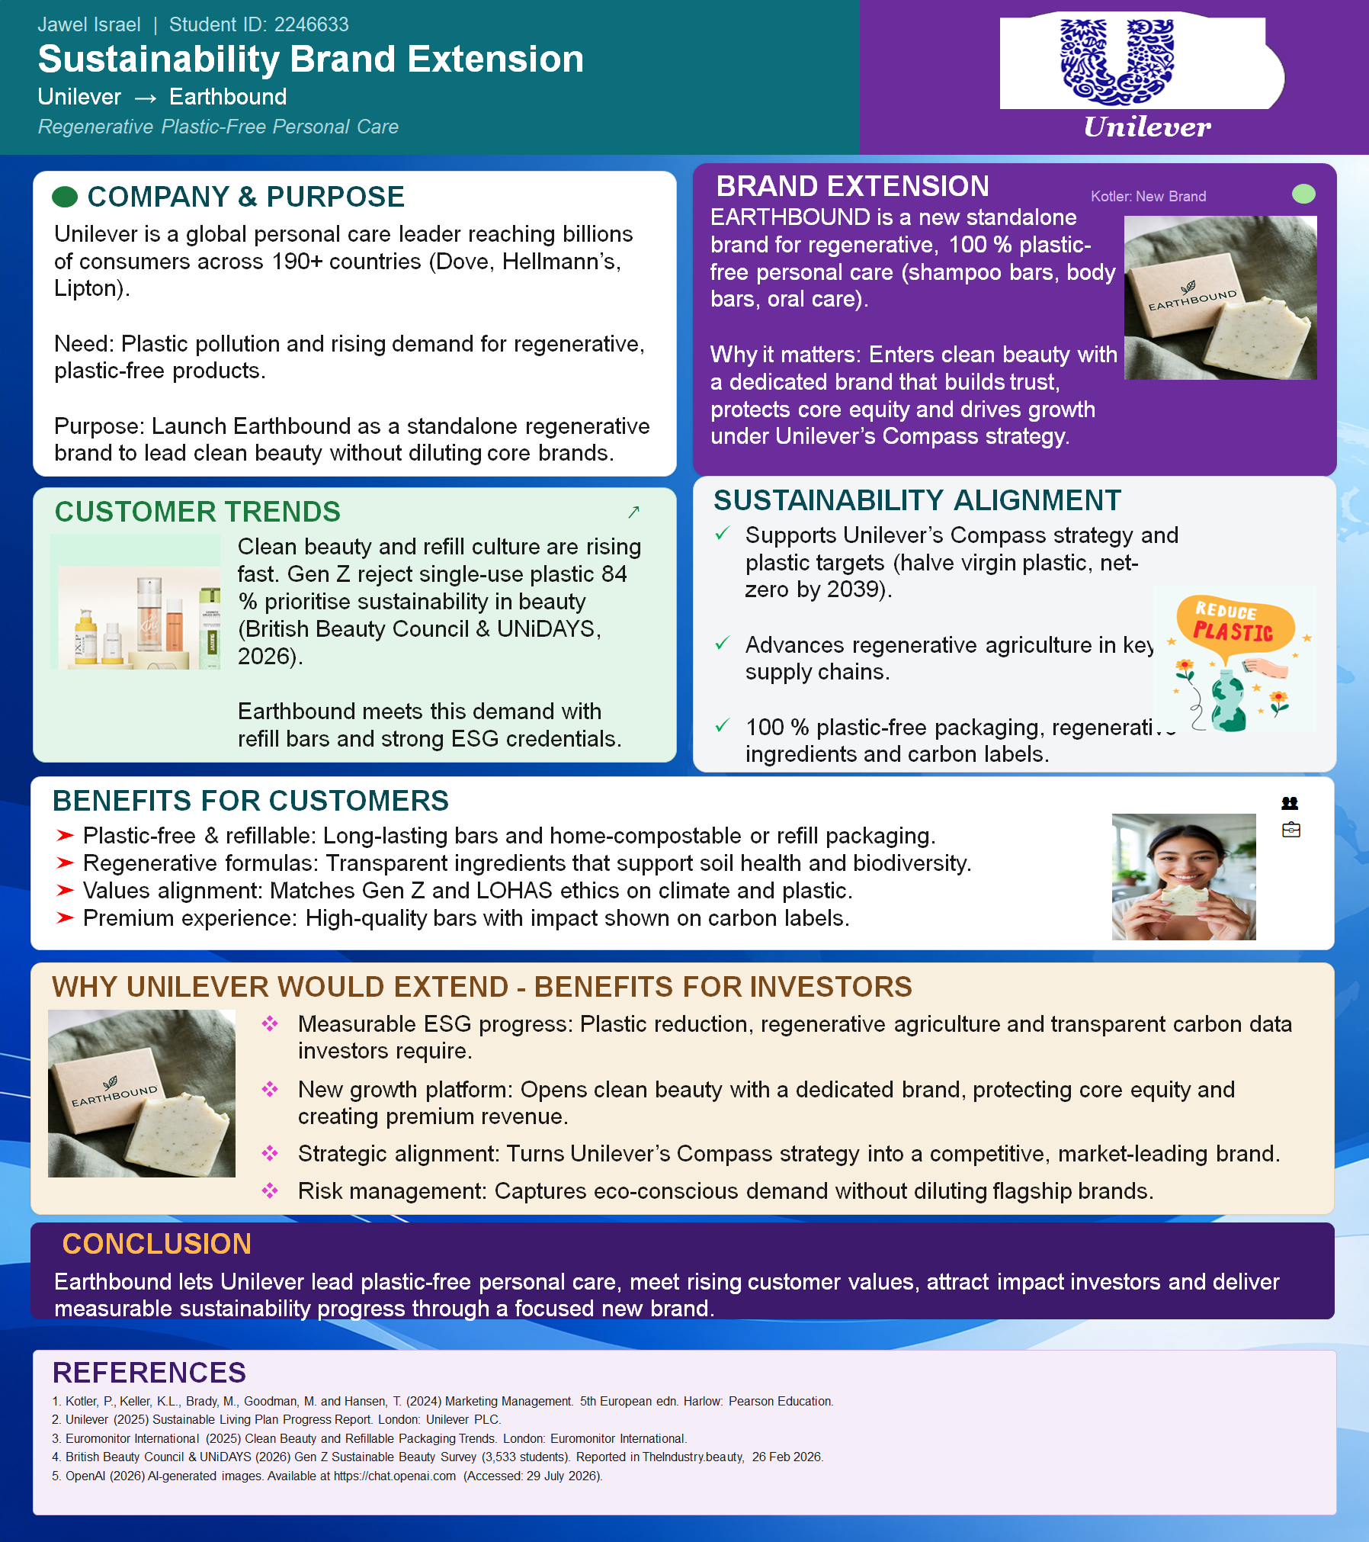
Figure 1: Sustainable Brand Extension Poster – Unilever → Earthbound (Source: Author, 2026)

Element 2: Segmentation, Targeting, Differentiation and Positioning (STDP) Analysis
This section applies the STDP framework (Kotler et al., 2024) to the proposed earthbound brand extension. Earthbound is positioned as a standalone regenerative, 100% plastic-free personal care brand (shampoo bars, body bars and oral care) that enables Unilever to enter the clean beauty segment without diluting the equity of its core brands such as Dove.

Market Segmentation
Effective segmentation divides the heterogeneous personal care market into homogeneous groups that can be reached with tailored offerings (Kotler et al., 2024). Four classic bases are employed.

Geographic segmentation
Primary focus is placed on developed markets with high environmental awareness and established retail infrastructure for premium personal care: the United Kingdom, Western Europe (particularly Germany, France and the Nordics) and North America. Secondary opportunities exist in urban centres of Australia and selected Asian markets where clean beauty demand is rising rapidly (Euromonitor International, 2025). These regions also align with Unilever’s existing distribution strength and its Compass plastic-reduction targets.

Demographic segmentation
The core demographic is adults aged 18–40 (Gen Z and younger Millennials), predominantly female but increasingly gender-inclusive, with mid-to-high household incomes and tertiary education. This cohort demonstrates higher willingness to pay a premium for verified sustainable products and is digitally native (British Beauty Council & UniDAYS, 2026). Household size is typically 1–3 persons, favouring compact, long-lasting bar formats over bulk liquid bottles.

Psychographic segmentation
Earthbound targets the LOHAS (Lifestyles of Health and Sustainability) segment and value-driven “conscious consumers”. These individuals prioritise environmental impact, ingredient transparency, regenerative agriculture and circular packaging. They exhibit high environmental concern, reject single-use plastics (84% of Gen Z according to British Beauty Council & UniDAYS, 2026) and seek brands that align with their personal ethics on climate and biodiversity. They are influenced by peer communities, science-backed claims and carbon labelling rather than pure status signalling.

Behavioural segmentation
Behaviourally, the segment comprises heavy users of personal care who already experiment with solid bars, refills or zero-waste routines, or who express strong intent to switch. Occasions include daily self-care rituals and “conscious consumption” purchases triggered by social media or in-store sustainability messaging. Loyalty is conditional on continuous proof of impact (carbon labels, regenerative sourcing data) rather than habitual brand loyalty alone (Kotler et al., 2024).

Target Audience
The primary target is eco-conscious Gen Z and younger millennial consumers (18–35) living in urban or suburban areas of the UK and Western Europe who actively seek plastic-free, regenerative personal care and are prepared to pay a moderate premium for verified sustainability credentials. This group is large, growing, and currently underserved by mainstream mass brands that still rely heavily on virgin plastic packaging. Secondary targets include LOHAS parents seeking family-safe, plastic-free options and impact-oriented investors who value measurable ESG progress.
Selecting a focused target rather than an undifferentiated mass approach protects Unilever’s core brand equity while allowing Earthbound to build authentic credibility in the clean beauty space (Keller, 2013; Kotler et al., 2024). Concentration strategy also maximises the impact of limited marketing resources on a high-value, high-growth segment.

Differentiation
Differentiation is achieved on multiple dimensions that competitors (indie clean brands and existing Unilever lines) find difficult to replicate simultaneously:
- 100% plastic-free product and packaging system solid bars with home-compostable or refillable secondary packaging, eliminating virgin plastic entirely.
- Regenerative agriculture credentials ingredients sourced from regenerative farming practices that improve soil health and biodiversity, directly supporting Unilever’s 1-million-hectare regenerative agriculture ambition (Unilever, 2025).
- Transparent carbon labelling on every product, providing quantifiable climate data that builds trust and differentiates from vague “eco” claims.
- Standalone brand architecture a new brand rather than a line extension of Dove or another core brand, thereby protecting parent equity while signalling genuine commitment to the clean beauty category (Aaker and Keller, 1990; Keller, 2013).
These points of difference create a unique value proposition that combines product superiority, environmental impact and brand integrity.

Positioning
Earthbound is positioned as “the regenerative, plastic-free personal care brand that delivers premium performance and measurable planetary benefit.” The positioning statement can be expressed as:
For environmentally conscious Gen Z and Millennial consumers who reject single-use plastic and demand regenerative ingredients, Earthbound is the premium personal care brand that provides high-performance solid bars with fully plastic-free packaging and transparent carbon labels, because it is backed by Unilever’s regenerative agriculture programmes and Compass sustainability strategy yet operates as an independent brand free from the associations of conventional mass-market lines.
This positioning occupies a clear perceptual space between mass-market Unilever brands and high-priced indie clean brands, offering accessible premium pricing, scientific credibility and authentic sustainability. It supports Unilever’s Compass goals of halving virgin plastic and advancing regenerative agriculture while creating a new growth platform that attracts both consumers and impact investors (Unilever, 2025; Kotler et al., 2024).

Element 3: Marketing Mix (7Ps)
The marketing mix operationalizes the STDP strategy. Given the experiential and service-like nature of refill systems and the importance of physical evidence in sustainability claims, the extended 7Ps framework (Booms and Bitner, 1981; adapted for sustainability by Pomering, 2017) is applied. Each element is designed to reinforce Earthbound’s regenerative, plastic-free positioning and Unilever’s Compass commitments.

Product
The core product range comprises solid shampoo bars, body bars and oral-care tablets/bars formulated with regenerative, transparent ingredients that support soil health and biodiversity. Packaging is 100% plastic-free: primary format is the solid bar itself; secondary packaging uses home-compostable materials or reusable/refillable systems. Every unit carries a carbon label quantifying lifecycle emissions. Product quality is maintained at premium levels to avoid the common perception that sustainable alternatives compromise performance (Kotler, 2011). Continuous innovation in regenerative feedstock and biodegradable actives will keep the range at the forefront of clean beauty, directly advancing Unilever’s targets to reduce virgin plastic and implement regenerative practices on one million hectares by 2030 (Unilever, 2025). The product strategy also incorporates modular formats that facilitate home refills, thereby extending customer lifetime value while reducing material intensity. By focusing on high-performance solid formats, Earthbound addresses both functional needs and the growing consumer rejection of single-use plastics documented in recent Gen Z research (British Beauty Council & UniDAYS, 2026).

Price
A premium-but-accessible pricing strategy is adopted. Bars are priced above conventional liquid equivalents on a cost-per-use basis yet remain competitive with leading indie clean brands. The price communicates quality and impact while recognising that Gen Z consumers, although value-driven, exhibit price sensitivity (Attest, 2024). Value-based pricing is supported by transparent cost-of-impact communication (carbon savings, plastic avoided). Introductory offers and multi-bar refill subscriptions can reduce the trial barrier. This approach protects margins needed for regenerative sourcing investments and signals that sustainability is not a low-cost afterthought. Psychological pricing cues, such as “cost-per-wash” comparisons against bottled competitors, help consumers recognise the economic advantage of longer-lasting bars. Over time, a tiered pricing architecture (standard regenerative, premium certified regenerative) can capture additional willingness-to-pay among the most committed LOHAS consumers without alienating the broader target.

Place (Distribution)
Distribution combines selective physical and digital channels to match the target audience’s shopping behaviour. Priority channels include: Earthbound-branded online store and Unilever e-commerce platforms; specialist clean beauty and zero-waste retailers; selected premium grocery and pharmacy chains with strong sustainability credentials; and refill stations in urban locations. Mass-market supermarket placement is deliberately limited in the launch phase to avoid equity dilution and to preserve the premium, purposeful image. Omni channel availability supports both discovery (social commerce, TikTok Shop) and convenience (home delivery of refill packs), aligning with Gen Z hybrid shopping habits (CEW UK, 2025). Strategic exclusivity in early distribution also creates scarcity value and encourages trial through curated retail environments where staff can educate consumers. As brand awareness grows, controlled expansion into broader Unilever channels can be considered, always prioritising fit with the regenerative positioning over pure volume.

Promotion
Promotion emphasises education, transparency and community rather than pure persuasion. Key tactics include: influencer and creator partnerships with authentic sustainability advocates; carbon-label storytelling and regenerative farm content on owned channels; partnerships with environmental NGOs; and limited traditional advertising focused on the “plastic-free & regenerative” dual claim. Messaging layers sustainability benefits onto core product performance (clean hair, soft skin) because combined claims increase appeal (CSB research cited in Strategy and Business, 2025). All communications avoid green washing by providing verifiable data and third-party certifications, thereby building the trust essential for a new brand in a sceptical category. Content marketing will feature farm-level regenerative stories and user-generated content from early adopters, fostering a community of advocates. Measurement of promotional effectiveness will include not only sales lift but also shifts in brand trust and perceived sustainability authenticity, metrics that are increasingly important for impact-oriented investors.

People
Front-line staff in refill stations and brand experiences, as well as digital customer-service teams, are trained as sustainability ambassadors capable of explaining regenerative agriculture, carbon labelling and proper bar usage. Internal culture mirrors the brand purpose: employees are engaged through Unilever’s existing sustainability learning programmes and Earthbound-specific training. This “people” element ensures consistent delivery of the brand promise and turns every interaction into an opportunity to reinforce differentiation. Recruitment for customer-facing roles will prioritise individuals who already demonstrate personal commitment to sustainability, ensuring authentic conversations rather than scripted green claims. On-going feedback loops from staff will also inform product and process improvements, embedding continuous learning into the brand’s operations.

Process
Customer processes are designed for convenience and circularity. Online ordering of bars and refill packs is frictionless; a subscription model ensures regular replenishment while reducing packaging waste. In-store refill processes are simple, hygienic and time-efficient. Behind the scenes, supply-chain processes prioritise regenerative sourcing verification, low-carbon logistics and closed-loop packaging recovery. These processes operationalize the Compass strategy and create a seamless, low-friction experience that encourages long-term behavioural change toward plastic-free routines. Digital tools, such as an app that tracks personal plastic savings and carbon impact, further embed the brand in customers’ daily lives and provide data for continuous process optimisation. Clear returns and composting guidance reduce post-purchase friction and reinforce the circular promise.

Physical Evidence
Physical evidence is critical for a sustainability brand whose benefits are partly intangible. Tangible cues include: the solid bar itself and its tactile quality; home-compostable or reusable packaging with clear carbon labels; in-store refill stations designed with natural materials and educational displays; and digital evidence such as interactive carbon dashboards and farm-origin stories on the website and app. Consistent visual identity (earthy yet modern palette, leaf motifs balanced with scientific typography) reinforces the regenerative positioning. These cues reduce perceived risk and make the sustainability claim tangible and credible (Bitner, 1992; Pomering, 2017). Packaging design will avoid green clichés while still signalling natural origin, striking a balance that appeal to both aesthetic-conscious Gen Z consumers and those seeking scientific legitimacy. All physical touch points are audited for consistency with the plastic-free and regenerative claims to prevent any dilution of trust.
Collectively, the 7Ps create a coherent, self-reinforcing system that delivers the Earthbound positioning, supports Unilever’s measurable sustainability targets, and generates premium revenue while protecting core brand equity. The mix is deliberately integrated so that decisions in one element (for example, regenerative ingredient sourcing) cascade positively into product quality, pricing justification, promotional storytelling and physical evidence, maximising strategic coherence and long-term brand equity building.

Element 4: Reflection
Developing a sustainable brand extension strategy for Unilever’s Earthbound has been a formative learning experience that integrated academic theory with contemporary business practice. The process required systematic application of brand development concepts, the STDP framework and the extended marketing mix, while remaining grounded in Unilever’s real Compass commitments on plastic reduction and regenerative agriculture. Navigating the tension between commercial growth objectives and genuine sustainability impact forced me to move beyond descriptive analysis toward critical, justification-based argumentation
One of the most valuable insights was the strategic rationale for launching a standalone brand rather than extending an existing power brand such as Dove. Academic literature on brand extension fit and risk of equity dilution (Aaker and Keller, 1990; Keller, 2013) became concrete when considering how a plastic-free, regenerative proposition could either strengthen or contaminate associations with mass-market lines. Designing Earthbound as a new brand allowed Unilever to capture clean-beauty growth without compromising the broader portfolio an insight that sharpened my understanding of brand architecture decisions in large FMCG organisations. This decision also illustrated the practical value of Kotler’s brand development strategies when applied to sustainability contexts.
Preparing the poster demanded the translation of complex strategic analysis into a visually coherent, concise narrative. This exercise strengthened skills in synthesis, visual communication and prioritisation of key messages under space constraints. The need to balance academic rigour with visual impact taught me how to communicate sophisticated ideas to mixed audiences. Delivering or preparing for the poster presentation further developed confidence in articulating strategic recommendations and responding to questions on sustainability claims and commercial viability. These communication competencies are directly transferable to professional marketing and sustainability roles where stakeholders range from technical experts to senior executives.
Critical evaluation of sources proved essential. Balancing corporate reports (Unilever Compass progress), market data (Euromonitor, British Beauty Council) and academic frameworks required constant judgement about credibility and recency. I became more adept at distinguishing genuine regenerative agriculture commitments from superficial green claims, an important capability in an era of heightened green washing scrutiny. The exercise also reinforced the importance of using a wide range of current sources.
On a personal level, the project deepened my appreciation of how commercial strategy and planetary boundaries can be aligned. Working through the 7Ps highlighted that sustainability is not merely a product attribute but must permeate pricing, distribution, processes and physical evidence. This systems perspective will inform future professional practice. I also developed greater resilience in dealing with incomplete or contradictory information common in emerging sustainability markets and learned to make reasoned judgements under uncertainty.
Areas for future development include greater use of primary research (for example, consumer interviews or conjoint analysis on willingness-to-pay for carbon labels) and more rigorous financial modelling of the extension’s contribution to Unilever’s plastic and regenerative agriculture targets. Strengthening quantitative skills and exploring circular-economy business models in greater depth would enhance the robustness of similar projects. In future work I would also allocate more time to iterative feedback on visual and written outputs. Overall, the assessment has significantly advanced my ability to design, critically justify and communicate sustainable marketing strategies at postgraduate level, equipping me with both theoretical mastery and practical insight for professional application.

References
Aaker, D.A. and Keller, K.L. (1990) ‘Consumer evaluations of brand extensions’,
Journal of Marketing, 54(1), pp. 27–41.
Attest (2024) Gen Z beauty trends 2025: authenticity, inclusivity. Available at:
https://www.askattest.com/blog/research/gen-z-beauty-trends (Accessed: 1 August
2026).
Bitner, M.J. (1992) ‘Servicescapes: the impact of physical surroundings on
customers and employees’, Journal of Marketing, 56(2), pp. 57–71.
Booms, B.H. and Bitner, M.J. (1981) ‘Marketing strategies and organization
structures for service firms’, in Donnelly, J.H. and George, W.R. (eds.) Marketing of
services. Chicago: American Marketing Association, pp. 47–51.
British Beauty Council and UniDAYS (2026) Gen Z sustainable beauty survey.
Reported in TheIndustry.beauty, 26 February.
CEW UK (2025) Kyra’s Gen Z state of beauty report: 2024-25. Available at:
https://cewuk.co.uk (Accessed: 1 August 2026).
Euromonitor International (2025) Clean beauty and refillable packaging trends.
London: Euromonitor International.
Keller, K.L. (2013) Strategic brand management: building, measuring, and managing
brand equity. 4th edn. Harlow: Pearson.
Kotler, P. (2011) ‘Reinventing marketing to manage the environmental imperative’,
Journal of Marketing, 75(4), pp. 132–135.
Kotler, P., Keller, K.L., Brady, M., Goodman, M. and Hansen, T. (2024) Marketing
management. 5th European edn. Harlow: Pearson Education.
OpenAI (2026) AI-generated images. Available at: https://chatgpt.com (Accessed: 29
July 2026).
Pomering, A. (2017) ‘Marketing for sustainability: extending the conceptualisation of
the marketing mix to drive value for individuals and society at large’, Australasian
Marketing Journal, 25(2), pp. 157–165.
Strategy+Business (2025) A better way to market sustainable products. Available at:
https://www.strategy-business.com (Accessed: 1 August 2026).
Unilever (2025) Sustainable living plan progress report / Compass strategy updates.
London: Unilever PLC. Available at: https://www.unilever.com/sustainability
(Accessed: 1 August 2026).
Unilever (2025) Protecting and regenerating nature. Available at:
https://www.unilever.com/sustainability/nature (Accessed: 1 August 2026).

