COMPONENT 2: COURSEWORK WRITTEN ASSIGNMENT
MODULE: LCHS4003 – INTRODUCTION TO HEALTH AND SOCIAL CARE
STUDENT NAME:
Gulfam Yousaf

STUDENT ID: 2310989

Table of Contents
Introduction 2
Section 1: Effective communication 2
Section 2: Administrative skill and record keeping 3
Section 3: Collaborative working 5
Conclusion 6
Reference list 7

Introduction
Health and social care skills like communication, data management and administrative knowledge are some of the potential aspects of a caregiver that helps to deal with patients. The case of Mrs. Mann helps in exploring that she is a 72 years old woman, who has been discharged from hospital after hip surgery. Moreover, for taking care of the patient a personal caregiver has been assigned for her to take care in the homely environment. However, in this case, language barrier has been addressed as a key challenge as Mrs. Mann is talking in Urdu, whereas the caregiver only understands English. Based on this issue, a mismanagement in documentation has been observed in Mrs. Mann’s care giving procedure. This current assignment is focusing on an analysis of communication theories along with the importance of administrative skills for maintaining flexible outcomes in caregiving practices.

Section 1: Effective communication
Communication skill is important for care given practices in terms of maintaining flexible interaction with patients. However, based on the case of Mrs. Mann a crucial language barrier has been observed with the care giver, which further causes key challenges in maintaining effective data tracking and documentation issues. As discussed by Pandey et al. (2021), language and cultural barriers impact healthcare practices due to the possibilities in data mismanagement. However, in this case, application of Berlo (1996) model of communication stands for implementing feedback-based communication initiatives in health and social care practices for maintaining successful documentation practices. As opined by Larsson (2024), Berlo (1996) model stands for maintaining feedback-based communication between caregivers and patients for tracking the process of caregiving practices. Moreover, this model also focuses on reducing risk of cultural sensitivity by developing stable knowledge on different cultural needs. As stated by Stephanou (2023), cultural sensitivity is a potential barrier in health and social caregiving practices that further impacts on growth of an individual's understanding to tackle emotional demand of patients. However, involvement of feedback analysis perspective can be examined as beneficial for the caregiver of Mrs. Mann. This can also aid in developing emotional connections to reduce cultural sensitivity along with Berlo’s model.
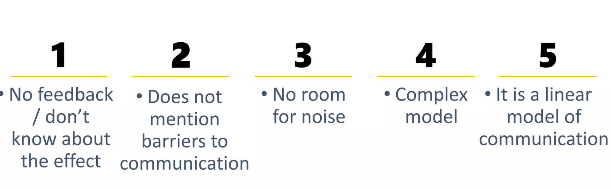
Figure 1: Key steps of Berlo (1996) model
(Source: Influenced by Larsson, 2024)
The cultural conflict between Mrs. Mann and her caregiver further can be resolved with the integration of Shannon and Weaver's Model of Communication as it helps in tracking sources of information. As discussed by Nwagwu and Akanji (2024), Shannon and Weaver's Model is beneficial for maintaining a direct interaction between caregivers’ information and healthcare authorities’ information receiver. It further can help to reduce potential risk of data mismanagements during health and social caregiving practices. In this context, Bratches et al. (2021) revealed that the key message of the caregiver's original signal also can be interpreted by implementing transmitted review management practices. It further helps to determine risk management initiatives within an organisational context along with the consideration of standardised communication procedure.
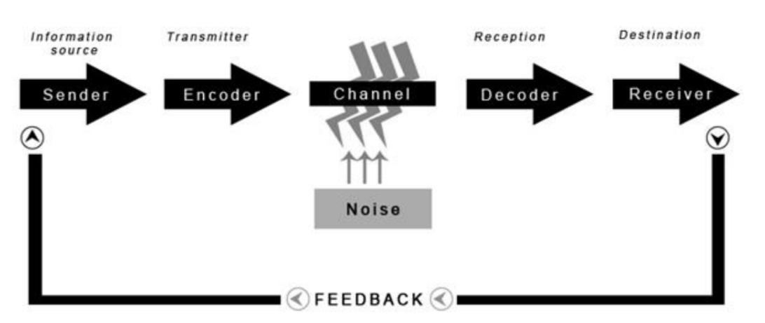
Figure 2: Shannon and Weaver's Model of Communication
(Source: Derived from the lecture notes)
The above figure reveals the process of maintaining health and social care-based communication initiatives through standardised channels of communication. However, during the consideration of this model the caregiver of Mrs. Mann needs to consider the Equality Act of 2010 in terms of maintaining cultural acceptance between patient, caregiver and channel of communication for authentic data transmission. The Equality Act of 2010 stands for reducing social and cultural biases in society to maintain equal rights in the health-social care context (Gov UK, 2025). Thus, the caregiver of Mrs. Mann also can receive an advantage for gaining equal rights during her work by reducing cultural biases.

Section 2: Administrative skill and record keeping
Maintaining accuracy of documentation is an important factor in social and healthcare practices in terms of establishing successful treatment possibilities of patients. As opined by Wager et al. (2021), accurate data documentation based on patients’ state of intervention is an essential factor for establishing successful treatment practices in healthcare setup. However, the case study of Mrs. Mann highlights that lack of accuracy in keeping record of current investment requirements has been explored as a potential challenge causing data mismanagement. Based on this issue, the caregiver’s actions on delayed medication adjustment have called for internal investigation. Based on these issues, integration of Caldicott's principles can be proven as effective for maintaining confidential data transmission through online end-to-end encryption-based initiatives. As stated by Savage (2021), Caldicott's principles stand for maintaining data confidentiality in healthcare for maintaining patient information safety. It further can assist the caregiver of Mrs. Mann to cooperate with internal investigators by maintaining information confidentiality.
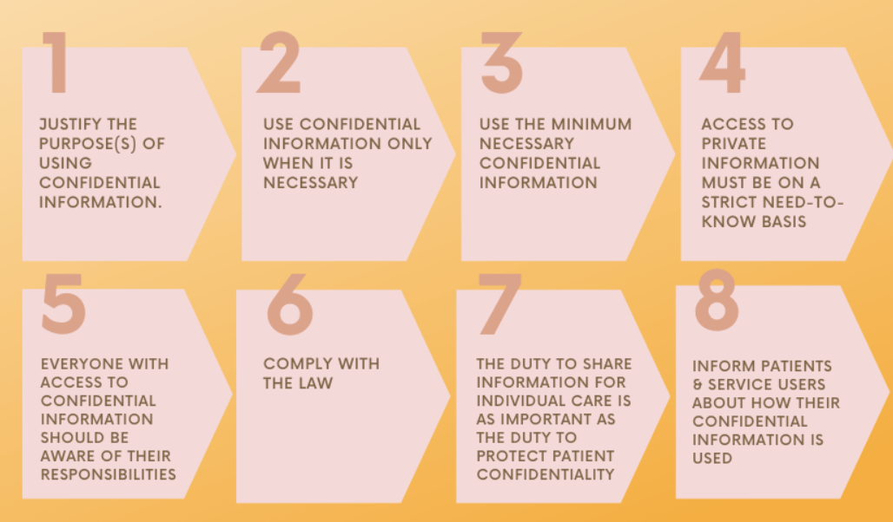
Figure 3: Key principles of Caldicott
(Source: Influenced by Savage, 2021)
The above analysis further depicted that integration of Data protection Act of 2018 is another key demand for the caregiver of Mrs. Mann for working on the process of developing safety and security of information. Data protection Act of 2018 stands for implementing a process of confidentiality of data of an individual in the health and special care perspective (NCBI, 2025). It also can help the caregiver of Mrs Mann to work on maintaining data confidentiality initiatives to determine standardised healthcare data security practices.
The analysis of the case study also helps to explore that the caregiver of Mrs. Mann also needs to work on NMC Codes. Healthcare NMC codes stands for implementing quality or performance of healthcare staff in terms of establishing sustainable health and social care initiatives (NMC, 2025). Furthermore, professional staff training is another key perspective of the NMC code of health and social care for maintaining quality consistency. Based on this context, the caregiver of Mrs. Mann also can receive an advantage for receiving professional training to meet caregiving skills.
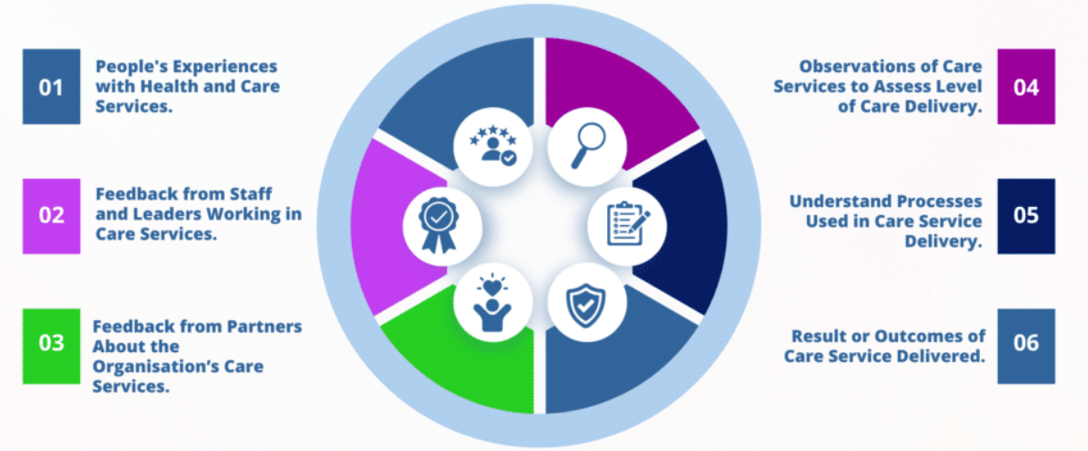
Figure 4: CQC standards
(Source: Caring for care, 2025)
The above analysis helps to explore that patients and staff's feedback need to be prioritised based on CQC Standards of Healthcare. The CQC standards of healthcare stands for implementing quality of patients’ safety and security along with the consideration of staff and patients feedback analysis program (Caring for care, 2025). It further also can gain patients overview on the safety regulations within healthcare context for gaining a stable process of resolving challenges of patient management. Thus, it can be stated that the standardisation context for maintaining standardised caregiving possibilities can be proven as a beneficial approach to improve quality of caregiving in the context of information management.

Section 3: Collaborative working
Multi-agency collaboration is a potential practice in health and social care to improve patient information safeguarding initiatives. As opined by Parker et al (2023), multi-agency collaboration allows to improve quality of social care by improving proper communication initiatives. Moreover, this aspect also has been found as beneficial for the caregiver of Mrs. Mann to work on communication and data management practices. Furthermore, shared care plans like outlining intervention goals in documents is one of the procedures of maintaining regular communication through multi-agency collaboration. It also helps caregivers to promote data security during the advanced process of patient care giving practices.
The major risks in working with multi-agency collaboration is the lack of proper training among the caregiver professionals. As per the suggestion of Anderson et al. (2021), poor employee training is a possible challenge that causes declined productivity in the health and social care setup. Furthermore, lack of understanding on maintaining information security is a potential challenge for caregivers to work through multi-agency collaboration. As per the opinion of Zanke and Sontakke (2024), lack of knowledge on data privacy hampers patient management practices in terms of developing effective growth in health and social care practices.
This current issue of caregiving can be mitigated by considering skilful caregiver hiring practices. As stated by Bhati et al. (2023), health and social care authorities need to hire skilful employees for patient management initiatives. Along with this, implication of data privacy through knowledge on Caldicott principles also can help to mitigate the risk of working with multi-agency collaborations. Thus, the adoption of Caldicott principles has been explored as a potential practice for determining effective caregiving practices through multi-agency collaboration.

Conclusion
It can be summarised that skill of communication in healthcare is important in the case of Mrs. Mann as lack of it has caused information mismanagement. Moreover, administrative skills of the caregivers of Mrs. Mann have been addressed as another crucial factor that can help her to assist in completing regular medications. The analysis further helps to learn that integration of Caldicott's principles can be proven as effective for maintaining confidential data transmission through online end-to-end encryption-based initiatives. Furthermore, professional staff training is another key perspective of the NMC code of health and social care for maintaining quality consistency. It further also can gain patients overview on the safety regulations within healthcare context for gaining a stable process of resolving challenges of patient management. Additionally, multi-agency collaboration is a potential practice in health and social care to improve patient information safeguarding initiatives. Henceforth, Caldicott principles has been explored as a potential practice for determining effective caregiving practices through multi-agency collaboration.

Reference list
Anderson, M., O'Neill, C., Clark, J.M., Street, A., Woods, M., Johnston-Webber, C., Charlesworth, A., Whyte, M., Foster, M., Majeed, A. and Pitchforth, E., (2021). ‘Securing a sustainable and fit-for-purpose UK health and care workforce’, The Lancet, 397(10288), pp.1992-2011. https://pmc.ncbi.nlm.nih.gov/articles/PMC9634455/pdf/main.pdf
Bhati, D., Deogade, M.S. and Kanyal, D., (2023). ‘Improving patient outcomes through effective hospital administration: a comprehensive review’, Cureus, 15(10), p.e47731. https://pmc.ncbi.nlm.nih.gov/articles/PMC9634455/pdf/main.pdf
Bratches, R.W., Scudder, P.N. and Barr, P.J., (2021). ‘Supporting communication of visit information to informal caregivers: a systematic review’, PloS one, 16(7), p.e0254896. https://journals.plos.org/plosone/article/file?id=10.1371/journal.pone.0254896&type=printable
Caring for care, (2025). ‘CQC Single Assessment Framework (SAF)’, Caring for care Available at: https://caringforcare.co.uk/cqc-single-assessment-framework/ (Accessed: 7 November, 2025)
Gov UK, (2025) ‘Equality Act 2010: guidance’, Gov UK. Available at: https://www.gov.uk/guidance/equality-act-2010-guidance (Accessed: 5 November, 2025)
Larsson, R., (2024). Making ‘it’work: Nurses as essential linchpins in the home care context. Lund University.
NCBI, (2025). ‘Data privacy in healthcare: Global challenges and solutions’ NCBI Available at: https://pmc.ncbi.nlm.nih.gov/articles/PMC12138216/ (Accessed: 6 November, 2025)
NMC, (2025). ‘The Code’, NMC Available at: https://www.nmc.org.uk/standards/code/ (Accessed: 7 November, 2025)
Nwagwu, W.E. and Akanji, H.A., (2024). ‘Information seeking behaviour of informal caregivers at the premier tertiary teaching hospital in Nigeria’, Information Development, p.02666669241264745. https://journals.sagepub.com/doi/pdf/10.1177/02666669241264745
Pandey, M., Maina, R.G., Amoyaw, J., Li, Y., Kamrul, R., Michaels, C.R. and Maroof, R., (2021). ‘Impacts of English language proficiency on healthcare access, use, and outcomes among immigrants: a qualitative study’, BMC health services research, 21(1), p.741. https://link.springer.com/content/pdf/10.1186/s12913-021-06750-4.pdf
Parker, S., Hartley, J., Beashel, J. and Vo, Q., (2023). ‘Leading for public value in multi-agency collaboration’, Public Policy and Administration, 38(1), pp.83-106. https://oro.open.ac.uk/75138/3/75138.pdf
Savage, S., (2021). ‘7.03 Confidentiality and Data Protection Policy V4’. 0. policy, 3, p.1. https://www.st-annes.org.uk/wp-content/uploads/2021/06/7.03-Confidentiality-and-Data-Protection-Policy-V4.0-January-2023.pdf
Stephanou, M., (2023). ‘Caregiver burden: Support needed for those who support others and the National Health Service’, Patient Experience Journal, 10(2), pp.23-33. https://pxjournal.org/cgi/viewcontent.cgi?article=1796&context=journal
Wager, K.A., Lee, F.W. and Glaser, J.P., (2021). Health care information systems: a practical approach for health care management. John Wiley & Sons. https://brazosport.simplesyllabus.com/api2/doc-pdf/7a4063zc5/2025-26-FA1-8-MHSM-3311-40-.pdf
Zanke, P. and Sontakke, D., (2024). ‘Safeguarding patient confidentiality in telemedicine: A systematic review of privacy and security risks, and best practices for data protection’. Int. J. Current Sci. Res. Rev, 7(6), pp.3910-3922. https://pdfs.semanticscholar.org/363a/f6584d05016b25249fe28478a033ab5b2c4c.pdf

