World Travel Market Report
Module BMTH4014 Lecturer: Jacqui Jones
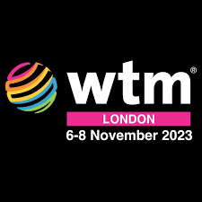
Student: Jake Pearson (WTM1 2022)
This year Visit Wales will be attending World Travel Market like never seen before. WTM (World Travel Market) is the ultimate showroom for countries to show off what they can offer the tourism industry, including Official suppliers, tour operators and Industry professionals that create the packages and deals used by people in every corner of the world. WTM enables growth and development threw out the travel and tourism industry by bringing industry leaders together with six annual events spread across four continents with over 51,000 attendees in London alone as published in WTM2 (2022). These events facilitate over $7bn US dollars in industry deals per year (WTM3 2022) whilst creating connections between professionals at all levels of the industry.

WTM has been chosen to launch the Visits Wales new campaign as it is not only an industry leading event but also has provides the opportunity to target a unique physiographic audience of travel professionals looking for new opportunities to promote and sell to a wider demographic. These industry professionals offer a lot of opportunity for Wales as they are looking for travel and tourism opportunities on all levels of Plog’s model featured in Litvin, & Smith, W. W. (2016). The key to this campaign is opportunity WTM gives Visit Wales the chance to grab the attention of industry professionals, inspire interest in the country of Wales and what it has to offer, which in turn creates desire to come and explore Wales which leads to the Action of people coming to visit Wales AIDA (1898). The purpose of visit Wales is to inspire tourism and show the world what Wales has to offer, World travel market is the best possible stage to launch this campaign, which will be bigger and better than ever before.

This year’s stand will have a key focus, in 2023 and 2024 Wales is celebrating the ‘Year of Trails’ showcasing Wales’s UNESCO heritage, historical castles and more (UKIB 2022). This fortunate turn of events means the incorporation of these aspects of Welsh culture are now a priority in the Visit Wales stand and will give focus on a primary event taken place in Wales to promote the cultural exploration of the Welsh nation allowing tourists a glimpse of Welsh pride and culture.

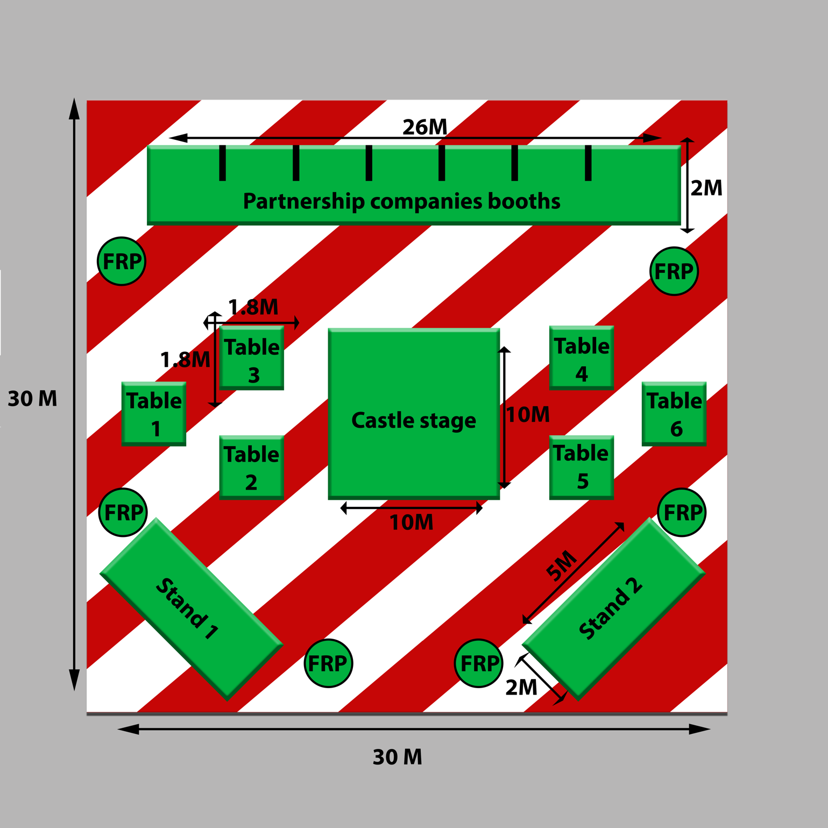
This year’s stand at WTM will be bigger and bolder than any past stand, the stand itself will be 30m long by 30m wide. Located in the centre of the European stands, the Welsh stand will be strategically placed around the main walkways and will feature a large red and white floor design utilising Welsh colours to signify Welsh pride and draw the attention of the target audience. The stand itself will also future a full 360-degree entry design with individual sides being used for specific aspects of the stand for example partnership companies such as tour operators looking to promote their businesses and the FRP’s who provide information and the show.

Design 1 (mock castle)
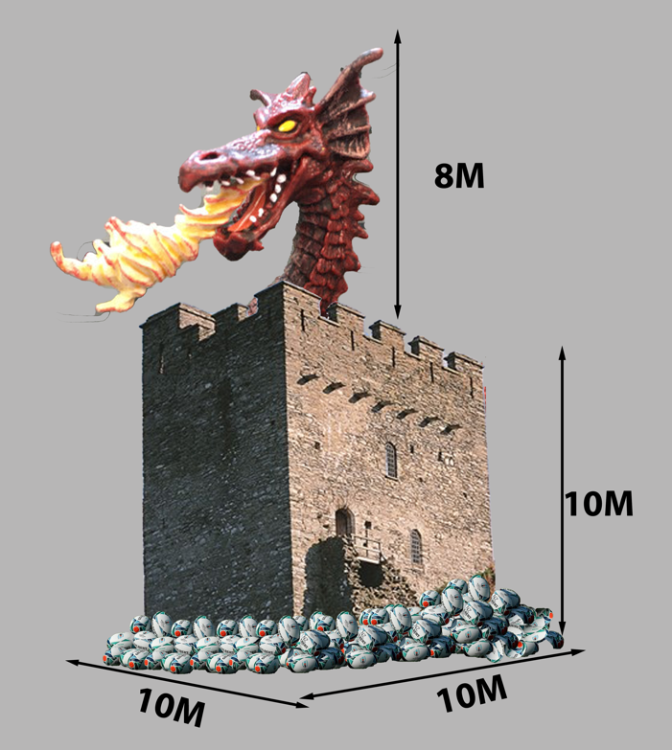
This year’s stand is primarily focused on the architectural and cultural aspects of Wales in line with the ‘year of trails’ showcase taking place this upcoming year. The design on the right will be the centre stage of the Visit Wales stand utilising Wales historic castles this centre piece holds is a castle with a 10M width X 10M Length and a base hight of 10M design. The base of the castle is surrounded by rugby balls showing Welsh pride in our national sport and the strength of Welsh culture. The strongest aspect of the centre stage stand is the dragon head design situated on the top of the base castle, utilising the iconic Welsh dragon as a standout symbol to separate Wales from the conventional designs and use the ultimate symbol of Welsh culture to capture the target audience of industry professionals. The dragon head itself uses interior mental flaming and a device called ‘Not A Flame Thrower’ created by The Boring Company, which is listed below, to give the dragons head a fire breathing affect which capture the strength of Wales.
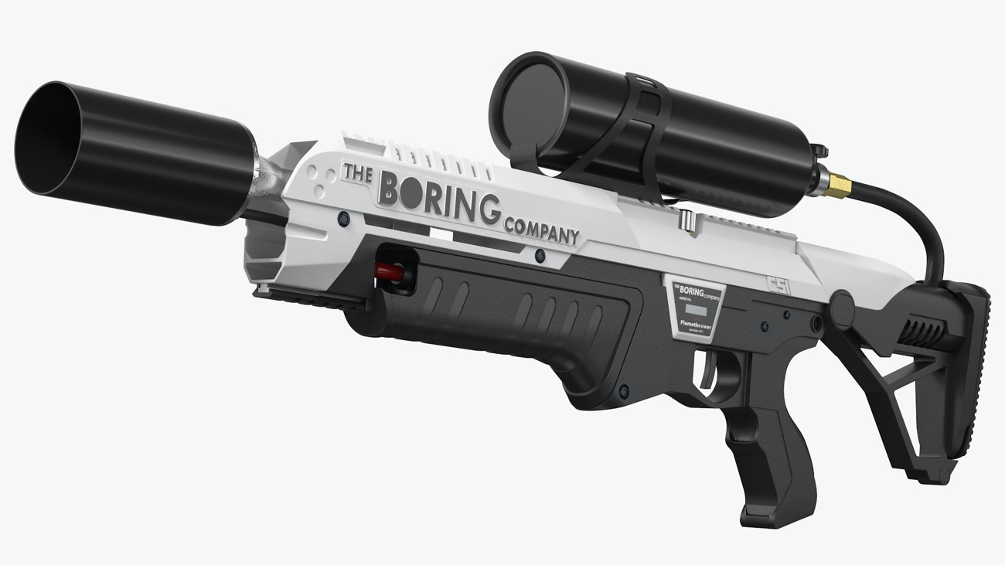
(TBCNAF 2022)


(Mathew 2017)


The second biggest Attraction to the stand this year will be the FRP (Flamethrower Rugby Players) keeping both Welsh pride and culture prominent and strong whilst creating a larger scale attraction and show utilising the ‘Not A Flamethrower’ to pair with the dragon design to create a show of Welsh fire which will grab the attention off all. The Not A Flamethrowers themselves will be converted as seen above with a Welsh inspired conversion kit to keep to the Visit Wales colour scheme and give clear visibility of ownership. When looking back at the stands design there will be six FRP positioned around the stand in full rugby attire all equipped with a converted Not A Flamethrower in strategic positions to optimise visibility in the venue. Every twenty minutes the stand will play the Welsh national anthem threw speakers built into the castle, whilst both the FRP and the dragons head produce fire to show the strength and cultural pride of the Welsh people.
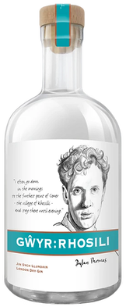
Alongside the fire show and general attraction there will be two base information mini stands at the front of the main entrance. Stand 1 will utilise Welsh made Welsh own products such as Welsh gin made by the Gower gin company to draw people in with free samples and traditional Welsh cakes using both their smell and taste to entice people’s attention. Mini Stand one will be the primary cultural information stand and will be covered with images of activities and events that have more cultural meaning and connection with the community, this Mini stand shows the more self-actualisation level of Maslow’s hierarchy (1943).
Mini Stand 2 will utilise more Welsh pride looking at events such as rugby and more physical activity’s such as adventure tourism, eco-tourism and sports tourisms. Mini Stand 2 will also utilise Welsh made whiskey made at the Penderyn Distillery (GGC 2022)
and Welsh inspired gift bags with leaflets and
Rugby balls.

The back walkway of the stand consists of one long table with separators making 7 large booth which will be utilised by seven of visit Wales’s biggest partnership businesses in the industry. These booths will all stick to the same colour scheme and values of this year’s visit Wales campaign. They will be Welsh owned and Welsh run family businesses to ensure revenue generated goes into the Welsh economy and the heritage of Wales.

Visit Wales itself will have 6 main tables to conduct business, these tables will only be for serious professional deals and will utilise the mini stands to find serious industry leaders and investors and target the correct psychographic. All tables threw out the stand will have Daffodil flowers on them as they are the national flower of Wales and have distinguishable yellow features which will shine thew the traditional red and white Welsh colour scheme. Which is built into the floor design as seen on page two.

This year’s visit Wales will be bigger than ever, the centre castle design will have a budget of £100,000 to create model and set up the design and £10,000 for the disassembly and safe removal to prevent damage which could prevent the reuse of design. The stand uses a 30M X 30M design which results a base square meter cost of £1500 per square metre, resulting in a cost of £1,350,000 for the floor space the stand is built on. The flooring itself comes in at £50 per square meter, after taking away the centre castle 100 square meters the stand will require 800 square meters costing £40,000.

Costs per tables include a total of two larger tables for mini-Stands at £3000 each and six primary conference tables at £1500 bringing table costs to £21,000. The two mini stands will have 100 bottles of Gower rooftop gin at £40 a bottle, 100 bottles on Penderyn whiskey at £50 a bottle, 500 gift bags at £10 each and 1000 Welsh cakes per day at 0.25 pence each. The two mini stands and the tables costs comes to £35,750. The partnership companies’ booths will cost £0 as they will be paying for their booth costs with a £5000 flat fee and a condition based 5% charge on any earnings from the event which will go towards preservation funds for UNESCO heritage sites located around Wales.

The final breakdown costs of staff
Type of Staff | Pay per hour | Number of workers | Total cost 12h x 3days
FRP | £10 | 6 | £2160
Mini stands | £10 | 4 | £1440
Main table | £20 | 6 | £4320
Castle operator | £15 | 1 | £540
Total staff cost: £8,460

The FRP requires six full rugby kits at £60 each, paired with 6 Not a flame thrower at £500 each with £50 conversion kits and £50 fire safety lesson. The stand will also require a £10,000 decoration budget. The total cost for this venture by Visit Wales will be £231,926 (excluding WTM rental fee)

This Venture by Visit Wales will be an injection of cash flow into Wales tourism industry, which will gain Wales the reputation it deserves in the travel industry, which is what Visit Wales is all about.

Harvard Referencing

AIDA. (1898) communication theory. Available at: https://www.communicationtheory.org/aida-model/ (Accessed: 15 December 2022).

Gower Gin. (2022) Gower Rhosili Gin Review & Tasting Notes
Available at: https://www.theginguide.com/gower-rhosili.html (Accessed: 15 December 2022).

Mathew, S. (2017) The new Wales rugby kit has just been revealed and this one is unique Available at: https://www.walesonline.co.uk/sport/rugby/rugby-news/new-wales-rugby-kit-just-13777137 (Accessed: 15 December 2022).

Litvin, & Smith, W. W. (2016). A new perspective on the Plog psychographic system. Journal of Vacation Marketing, 22(2), 89–97. https://doi.org/10.1177/1356766715580187

Maslow. (1943) Maslow's Hierarchy of
Need. Available at: https://canadacollege.edu/dreamers/docs/Maslows-Hierarchy-of-Needs.pdf (Accessed: 16 December 2022).

UKIB. (2022) VISIT WALES TO ATTEND WORLD TRAVEL MARKET 2022.
Available at: https://www.ukinbound.org/member-news/visit-wales-to-attend-world-travel-market-2022/ (Accessed: 15 December 2022).

WTM1 (2022) world travel market. Available at: https://www.facebook.com/wtmlondon/ (Accessed: 15 December 2022).

WTM2. (2022) Who Attends WTM London. Available at: https://www.wtm.com/london/en-gb/about/attendee-profile.html (Accessed: 15 December 2022).

WTM3. (2022) About World Travel Market. Available at: https://www.wtm.com/portfolio/en-gb/about.html (Accessed: 15 December 2022).

Castle design images used

NWHC (2022) Dolwyddelan. Available at: https://www.northwalesholidaycottages.co.uk/things-to-do-in-north-wales/dolwyddelan-castle/Accessed : 15 December 2022).

BBC (2020) World Rugby plan to introduce 'fit and proper person test' as part of governance review Available at: https://www.bbc.co.uk/sport/rugby-union/53083478 (15 December 2022).

Fairy findings (2022) Red fire-breathing dragon. Available at: https://findingfairies.co.uk/products/red-fire-breathing-dragon (Accessed: 15 December 2022).

Not a flame thrower

Turbosquid (2022) The Boring Company Not A Flamethrower Available at: https://www.turbosquid.com/3d-models/boring-company-flamethrower-3d-1629214 (Accessed: 15 December 2022).

