
Student Name: Nishtha Savaliya
Student ID: 2530041
Programme: Master of Business Administration (MBA)

Module Name: Marketing Management

Assignment Title: A CRITICAL ANALYSIS OF THE MACRO MARKETING ENVIRONMENT AND STRATEGIC RESPONSES OF UBER AND BOLT IN THE RIDE-HAILING INDUSTRY

Module Code: LCMB7024

Lecturer’s Name: Laila Maazouz, Dian Mayasari (London)

Work Count: 2491

Table of Contents
Task 1: 3
1. Introduction 3
2. Industry and Conceptual Context 3
3. Pioneer and Follower Organisations Concept 4
4. Macro Marketing Environment Analysis 5
a) Overview of Macro Environment (PESTLE) 5
b) Political and Legal Factors 5
c) Technological Factors 6
5. Implications for Competitive Position 7
Task 2: 8
6. Strategic Responses to Sustain Growth 8
a) Uber 8
b) Bolt 9
7. Porter’s Generic Strategies Analysis 10
a) Uber 10
b) Bolt 10
8. Ansoff Matrix Analysis 11
9. Comparative Evaluation of Strategic Effectiveness 11
10. Conclusion 12
References 13

Task 1:

Introduction
The Ride-hailing business model has been one of the clear examples of the digital platform reshaping consumer markets, mobility and competitive strategy in the city. Companies in this industry operate two-sided markets, matching drivers and passengers via mobile applications, algorithmic matching and dynamic pricing engines instead of merely offering transportation services. Bolt, however, is a later-entrant follower organisation that expanded by adapting an existing platform model to compete in selected markets.
This report critically examines two macro environmental forces which affect both the firms: political/legal forces and technological change. It further makes a comparison between the strategic responses of Uber and Bolt in terms of General Strategies of Porter and Growth Matrix of Ansoff. The report indicates that Uber has been pursuing differentiation and platform expansion, when Bolt has been pursuing lower cost accommodation and targeted growth.

Industry and Conceptual Context
Ride-hailing is a service business, which is developed based on a platform where value is created through minimizing transactional friction between customers and drivers. It is based on its business model of fast matching, confidence, and basic payment and good management of network effects (Rhee et al., 2023).
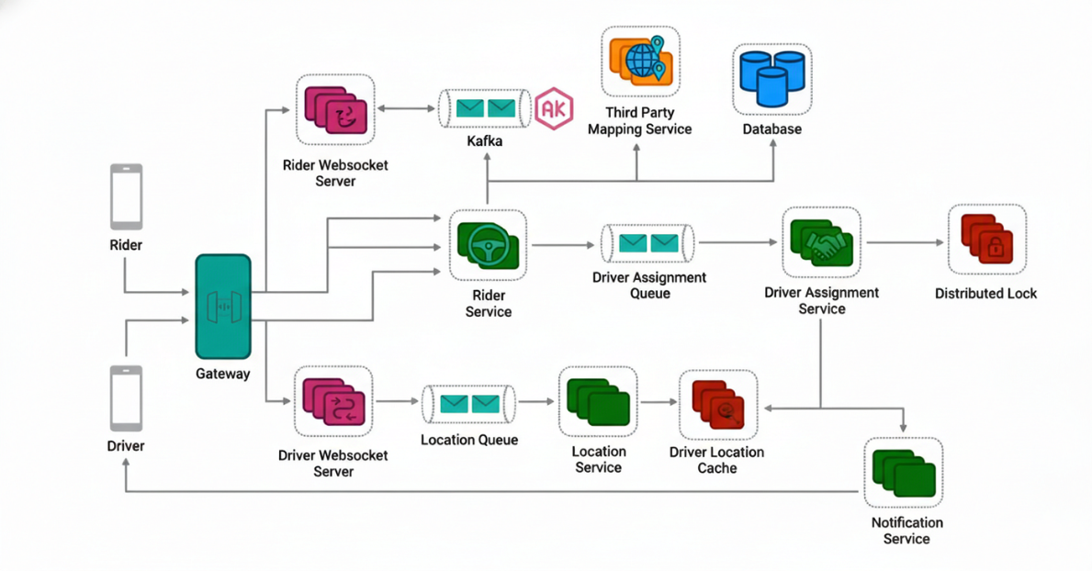
Figure 1: Ride hailing platform ecosystem diagram
(Source: Medium.com, 2026)
The distinction between pioneer and follower is therefore of analytical value. First mover advantages: Uber was the first, with brand name, early movers and shapers of consumer expectations of app-based mobility. Being his follower, Bolt did not create the category but could observe the current market trends, analyze the case of Uber and refer to a more selective developmental model (Shankar Walunj et al., 2025). Macro-environmental analysis is essential strategically because these companies are competing in volatile markets in which regulation and technological change directly affect cost, legitimacy and strategic freedom.

Pioneer and Follower Organisations Concept
The distinction between pioneer and follower organisations are relevant in the case of ride hailing. The first mover as in the case of Uber have first mover advantages where they can build brand recognition and customer expectations. They define the market landscape and are likely to establish the norms of app-based mobility. The pioneers are used by their disciples such as Bolt. They research market trends, they research what the pioneers have been through and how they enter the markets with smooth models. This strategy allows the followers to mitigate the risk of entering the market since they can build on the available strategies and focus on efficiency and cost-effectiveness to achieve a competitive advantage.

Macro Marketing Environment Analysis

Overview of Macro Environment (PESTLE)
PESTLE factors are political, economic, social, technological, legal, and environmental forces that make up the macro environment of the ride-hailing industry. All these factors have a combined impact in terms of strategic choice that can affect market entry, operational performance and competitive positioning. These forces are essential in understanding how to make it through regulatory environments, technological dynamics, and consumer demands.

Political and Legal Factors
The political and legal forces form some of the most significant external elements in the ride-hailing sector and determine whether the platform business models can be approved, restricted or reworked. According to OECD review, ride-hailing has disrupted long-established taxi markets, and there is policy discussion on how to create fair competition, labour rights and status of platform drivers. OECD also singles out notable effects of the independent contractor model on employment protection and that is why labour classification continues to be the subject of political and legal intervention (Zhou et al., 2025).
Political and legal change is an opportunity and threat to Uber. Its market share, financial capabilities and brand recognition allow it to absorb compliance costs more than small players. This can strengthen legitimacy and entry barriers against weaker players in highly regulated settings. However, the same visibility exposes Uber to unreasonable suspicion of labour status, safety, insurance and market behaviour. As the company that happens to be the closest related to the rise of ride-hailing, Uber tends to become the primary target of lawsuits and criticism. This is a first-mover liability, where early domination in the market establishes a regulatory resource burden and competitive advantage (Zhong et al., 2022).
The environment where Bolt operates is unchanged with respect to the learning, but the strategic implication is varied. As a follower, it can afford to enter markets that have already been entered by previous firms and take the regulatory environment risk. This is a chance as Bolt will be able to experience what Uber has been through legal issues and to be more adaptable in its operations to the host policies and become a more adaptable competitor. But this is a disadvantage due to the smaller number of resources that Bolt has. The expansion of compliance costs can further strain its business model should the safety, insurance, data protection, or job rules become more stringent (Chalermpong et al., 2023).

Technological Factors
Technological change is a tangible macro-environmental force of the ride-hailing market because applications such as Uber and Bolt are digital platforms rather than traditional transportation companies. Their competitiveness depends on the quality of apps, algorithmic matching, route optimisation, digital payments, safety systems and effective use of data to increase efficiency of services and customer experience (Tang et al., 2023).
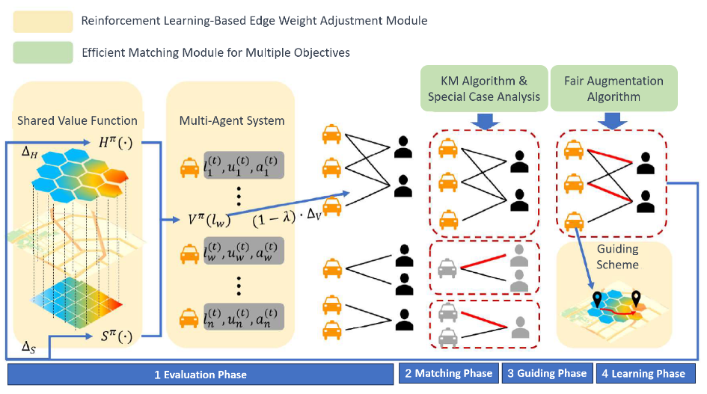
Figure 2: Algorithmic matching ride hailing diagram
(Source: Mdpi.com, 2026)
In Uber, this environment presents a great opportunity. First it has the advantage that it created early platform capabilities and had substantial amounts of operational data across multiple markets. This scale maximizes effectiveness in a match and provides consistency of services and broadening platforms integration. Technology boosts the differentiation strategy of Uber at a strategic level because it is not just a ride-hailing service. However, technological leadership is also a potentially dangerous challenge. The costs of constitutional upkeep of a large-scale digital platform include extensive expenditures on software, cybersecurity, safety systems, payment infrastructure and innovation partnerships. The larger the platform, the greater the cost of technical excellence maintenance will be (Afeche, Liu and Maglaras, 2022). Other than that, technological eminence puts it at risk of data protection, privacy and governance. Uber is therefore in a strategic paradox: the same technology that has been its strength is the one that continues to cost it dearly the price of never-ending innovation. The loss of differentiation can be eradicated within a relatively short span unless that rate is upheld since digital elements are readily replicated.
The Bolt technological position is not as clear. As a follower, it did not have to develop the original ride-hailing paradigm that forms a tangible point of difference. By learning and repeating what has worked digitally, Bolt can be sure that the resources are directed at efficiency, usability, and local market fit as opposed to the entire expense of technological experimentation. Nonetheless, the small size of Bolt limits the technological opportunity available to the company (Flor, Ortuño and Guirao, 2022). It is less rich in data than Uber, its ecosystem is smaller and its ability to influence the next generation of AI-enabled or autonomous mobility is weaker. Bolt thus is more of an execution-based than an innovation-based technology strategy.

Implications for Competitive Position
In combination, political/legal and technological forces affect the competitiveness of Uber and Bolt differently. Uber has a substantial competitive edge in brand equity, platform scale, efficiency, and strategic flexibility. It also enjoys the advantage of having the strength to absorb regulatory pressures and invest in the next-generation technologies because it has the capability to operate globally. This assists in justifying long-term market position better. Increased legal attention, however, brings with them increased reputational risk and increased cost of innovation. The competitive advantage of Uber, therefore, is fair, but it is more susceptible to the external impact (Acheampong, 2022).
The positioning of Bolt is thinner, although not possibly weaker under any conditions. It benefits as a follower through strategic learning, lower market-creation expenses and the ability to access customers with a price-sensitive value proposition. This would allow Bolt to be highly competitive in markets whereby cost, regional flexibility and ease of operation are of higher rank than the range of the ecosystems. However, its smaller size does not allow it to affect regulations, to take up the rising compliance costs or to drive future changes in technology. Its competitiveness is then more conditional.

Task 2:

Strategic Responses to Sustain Growth

Uber
Uber has managed political and legal pressure by adjusting to the institution as opposed to pulling out. As the regulation has become stricter the company has still been operating under formal compliance models but uses its size to convert regulatory burden into an obstacle to small competitors. This is a tactical explanation because it transforms the competition as a disruptive entry into the market to a long-term controlled survival. In the meantime, Uber has been making investments in platform development and related mobility capabilities that hint at technological change as a contributor to future development rather than a need that is defensive. Its involvement in autonomous mobility is particularly notable, as it implies an attempt to remain relevant in an environment of transport potentially radicalized (ștefan, Popa and Tărăban, 2023).
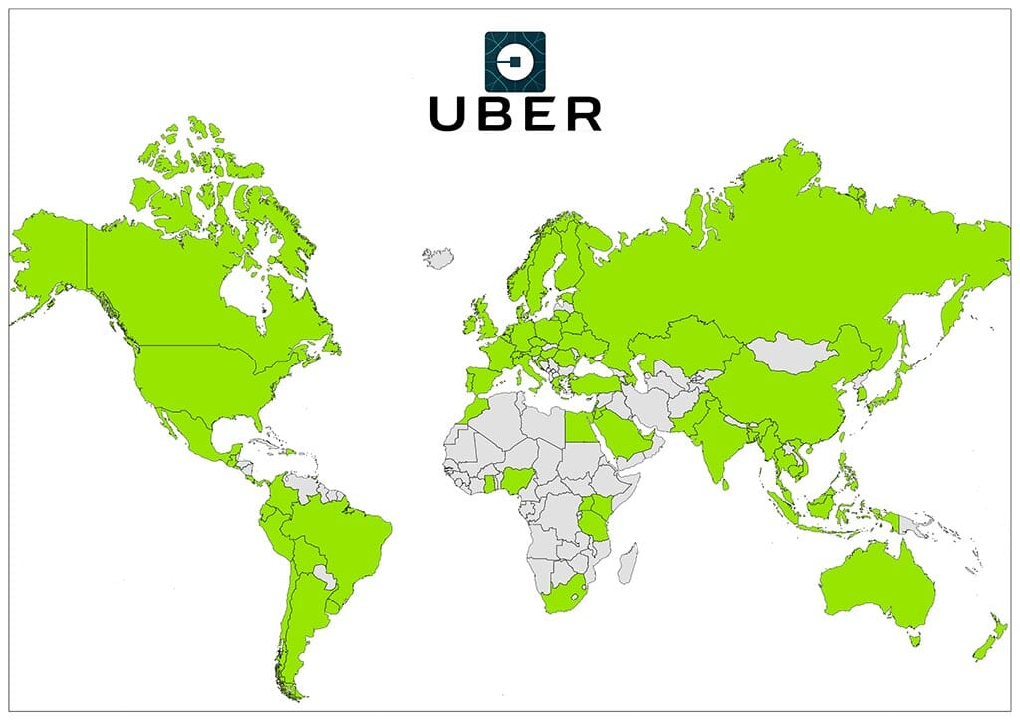
Figure 3: Uber global expansion map
(Source: Mappr.co, 2026)
Implementation of the Porters Generic Strategies portrays Uber as being in the pursuit of the broad differentiation. It is not primarily competing on price but tries to advantage on the strength of its brand, the scope of its services, network performance, convenience and ongoing invention. The logic is that the data and size capacity of the approach enhances familiarity among the customers as well as consistency of its operation. Based on the Growth Matrix developed by Ansoff, Uber displays indications of market penetration through increasing the usage in existing markets, market development through globalization, product development through enhancing the platform and mobility related services, and limited diversification through extending the ecosystem. However, this is a model that consumes resources. Its long-term sustainability will be anchored on the additional ability of Uber to transform the scale into profitability and regulatory legitimacy.

Bolt
The strategic response adopted by Bolt has been more selective and efficiency oriented. Unlike Uber, which is more of a macro response to macro pressures, Bolt has tended to react to local pressures with macro cost discipline and market focus. This is in line with the reasoning of followers. Politically, legally, Bolt will not be able to position itself as disruptive, but as a participant who is responding to markets where the issue of regulation is already partially resolved. It appears to emphasize platform reliability, safety, privacy and functional polish over frontier innovation, technologically. The driver-oriented programs and commission-oriented policies in some markets also help to support the affordability and flexer value propositions.
Bolt can be most favorably aligned to the cost approach in the selected markets according to Porters Generic strategies (Setiawan and Wandebori, 2025). Its competitiveness reasoning lies in offering a viable app-based service, as well as a leaner business model compared to the first mover. As the Growth Matrix that Ansoff has developed shows, market penetration and market development are the most productive direction to take in Bolt and can be sustained by competitive prices and expansion to the right regions. The product development is selective rather than in the situation with Uber. This is a business-wise consistent approach because it does not incur some of the expenses of frontier differentiation. However, the competition that is based on efficiency can be more easily re-enacted by larger competitors, especially when they are competing intensely based on the price. Systematic cruel execution and wise market selection are what make Bolt sustainable rather than industry-wide platform leadership.

Porter’s Generic Strategies Analysis

Uber
Uber strategic direction is wide differentiation, where the Uber brand, the wide (expansive) services and innovation of its technology allow it to have a competitive advantage. By prioritising platform size and service reliability, Uber is expected to increase customer loyalty and market penetration, guaranteeing sustainability in the long run by means of strategic investments and penetration in the market.

Bolt
Bolt is compatible with the cost leadership strategy and focuses on the efficiency and affordability in the chosen markets. Through lean operations and sensitivity to the price-sensitive customer segments, Bolt will be able to gain market share without the massive resource investments that first-movers have made but enables strategic flexibility and focused growth.

Ansoff Matrix Analysis
The strategic tool Ansoff Matrix analyses growth strategies of such businesses as Uber and Bolt. This is based on four quadrants, which are Market Penetration, Market Development, Product Development, and Diversification. Uber focuses on market penetration through an increase in utilization of the current markets as well as market penetration through globalization. It is also concerned with product development through increasing its platform and mobility services. Bolt, however, focuses on penetrating and developing new markets in specific geographical areas by taking advantage of pricing competition. The matrix assists the two companies to ensure growth strategies are aligned to the market conditions to maximize the opportunities and reduce risks.

Comparative Evaluation of Strategic Effectiveness
The strategic comparison of Uber and Bolt demonstrates that two growth logics have an equal contrast and an equal macro-condition. Uber has responded through further differentiation, institutionalisation of compliance, and expansion of platform capability. Bolt has responded by taking advantage of the benefits of followers, maintaining the cost down and doing adaptive growth. Both responses make sense but cannot be applied long term equally.
The Uber strategy appears more sustainable because it converts macro pressure to strategic consolidation. Regulation is costly, yet it may be beneficial to firms capable of paying at scale, and technology assists organisations capable of investing before the market. This gives Uber more basis on which competitive advantage can be defended in the long term. The model, however, is vulnerable to overextension, publicity and rising costs of innovation. Bolt will be nimbler in some markets, and where incumbency is not as strongly safeguarded by regulators, a price-sensitive customer base will allow Bolt to gain local momentum more quickly. The efficiency as the basis of Bolt is, however, less favorable when the competitive conditions become tighter (Farida and Setiawan, 2022).
Overall, Uber is better placed to sustain its long-term growth, since its strategy has compounding network effects, greater strategic options and greater resilience to complex macro conditions. Bolt is a real and at least partially workable challenger, but not structural leadership, but rather a conditional one depending upon selective market conditions.

Conclusion
Political/legal forces and technological change are the major strategic marketing issues in the ride-hailing business since it is the issue of strategic legitimacy of the market, cost structure, and the basis of competition. These forces affect Uber and Bolt differently because they are innovators and imitators. Uber enjoys economies of scale, brand loyalty and technological availability though it is open to more criticism and pressure of innovation. Bolt is less susceptible to regulation or technological orientation, has flexibility, lower path-creation factors and a lower competitive model, though. Overall, the differentiation-based and growth-oriented model that Uber uses is more sustainable in the long run, and the follower model that Bolt employs is most efficient in the situation of local adaptation and cost competitiveness.

References
Acheampong, R.A., 2022. Smart mobility in urban Africa: Geography of diffusion, user characteristics and emerging impacts of digital platform/app-based mobility services. In Transport and mobility futures in urban Africa (pp. 349-371). Cham: Springer International Publishing.
Afeche, P., Liu, Z. and Maglaras, C., 2022. Ride-hailing networks with strategic drivers: The impact of platform control capabilities on performance. Rotman School of Management Working Paper, (3120544), pp.18-19.
Bolt.eu. (2026). Bolt | Fast and Affordable Rides. [online] Available at: https://bolt.eu/en/. [Accessed 19 Mar. 2026].
Chalermpong, S., Kato, H., Thaithatkul, P., Ratanawaraha, A., Fillone, A., Hoang-Tung, N. and Jittrapirom, P., 2023. Ride-hailing applications in Southeast Asia: A literature review. International Journal of Sustainable Transportation, 17(3), pp.298-318.
Farida, I. and Setiawan, D., 2022. Business strategies and competitive advantage: the role of performance and innovation. Journal of open innovation: Technology, market, and complexity, 8(3), p.163.
Flor, M., Ortuño, A. and Guirao, B., 2022. Ride-hailing services: Competition or complement to public transport to reduce accident rates. The case of Madrid. Frontiers in psychology, 13, p.951258.
Mappr.co. (2025). Available at: https://cdn.mappr.co/wp-content/uploads/2021/02/image-1.jpeg. [Accessed 18 Mar. 2026].
Mdpi.com. (2026). Available at: https://www.mdpi.com/electronics/electronics-13-00775/article_deploy/html/images/electronics-13-00775-g002.png [Accessed 18 Mar. 2026].
Medium.com. (2026). Blocked. [online] Available at: https://miro.medium.com/v2/resize:fit:1400/1. [Accessed 18 Mar. 2026].
Rhee, K.S., Zheng, J., Wang, Y. and Tan, Y., 2023. Value of information sharing via ride-hailing apps: An empirical analysis. Information Systems Research, 34(3), pp.1228-1244.
Setiawan, N.A.N. and Wandebori, H., 2025. Market Penetration As A Proposed Marketing Strategy: Case Of PT. Atourin Teknologi Nusantara. EKOMBIS REVIEW: Jurnal Ilmiah Ekonomi dan Bisnis, 13(1), pp.489-500.
Shankar Walunj, T., Singhal, S., Nair, J. and Kavitha, V., 2025. On the interplay between pricing, competition and QoS in ride-hailing. Dynamic Games and Applications, pp.1-55.
Ștefan, S.C., Popa, I. and Tărăban, I., 2023. Strategic orientation of Romanian healthcare organizations from a contingency theory perspective based on Porter’s generic strategy model. Systems, 11(10), p.488.
Tang, W., Xie, N., Mo, D., Cai, Z., Lee, D.H. and Chen, X.M., 2023. Optimizing subsidy strategies of the ride-sourcing platform under government regulation. Transportation Research Part E: Logistics and Transportation Review, 173, p.103112.
Uber.com. (2026). https://www.uber.com/in/en/ride/?ad_id=614919360179&adg_id=143634984230&campaign_id=17954041642&cre=614919360179&dev=c&dev_m=&fi_id=&gad_campaignid=17954041642&gad_source=1&gbraid=0AAAAADiA3jrTxmhFTM-To-GYqkDkgKQDz&gclid=Cj0KCQjwve7NBhC-ARIsALZy9HUVRzoGzpYqRyj60Ov2L8SwPHqvXXuRMq8GYASVvPfUvGrTjCi8XvQaAqCYEALw_wcB&gclsrc=aw.ds&kw=uber&kwid=kwd-12633382&match=b&net=g&placement=&tar=&utm_campaign=CM2197857-search-google-brand_77_-99_IN-National_r_web_acq_cpc_en_T1_Generic_BM_uber_kwd-12633382_614919360179_143634984230_b_c&utm_source=AdWords_Brand [Accessed 19 Mar. 2026].
Zhong, Y., Yang, T., Cao, B. and Cheng, T.C.E., 2022. On-demand ride-hailing platforms in competition with the taxi industry: Pricing strategies and government supervision. International Journal of Production Economics, 243, p.108301.
Zhou, Q., Wang, J., Jiao, Y. and Du, J., 2025. Balancing Supply with Demand on Ride-Hailing Platforms in Markets with Price Regulations: An Operational Approach. Manufacturing & Service Operations Management, 27(5), pp.1515-1531.

