Nacktschnecke: Independent Project
By Niamh Provan
Over the course of several weeks, I was set the task of creating a piece of performance, my only restriction was that the length needed to be a minimum of thirty minutes. Through this time I feel that I pushed myself both physically and mentally to produce a piece of theatre.
“I want to explore the fundamental principles of language in a comical way. I want to create a piece using the social lens of Brexit without focussing on the political dynamics and instead the social connections between the different countries we are connected to and how miscommunication effects us all.”
At the beginning of the project, I wrote down what I intended to create and develop within my piece, as seen above. I have gone through a lot of different ideas and have been inspired by many different stimuli leading up to the beginning of this project as well as throughout it. It was a lot of little things that lead to making up the bigger whole of the performance but something that I feel kick-started my interest in language and communication was the experience that I gained from studying abroad.
Brexit has been such a large topic and focal point within the United Kingdom that travelling to another country created a new distance from it which I had not been able to experience prior. I was surprised by the amount of Americans who wanted to discuss topics like Brexit or the EU; they then seemed more surprised when I struggled to be able to explain what either of them meant.
This lead me to theorise about how a lot of what happened with Brexit was due to miscommunication (MacShane, 2015, xvii-vxiii) myths and mistruths were calculated around Brexit that created confusion for those voting or then caused some to not because of it. The topic of Brexit created an interest but I wanted to step back and look more into why it happened rather than what happened.
Communication and language are extremely broad topics; there are so many languages in the world today, some we are not even aware of. The supposed amount of languages is estimated to be 6,909. (Anderson, 2012, Page 11) Language is taught rather than being something that we are inherently born with, your first language is not something you are born with, and instead, it only depends on where you are born. (Deutscher, 2011, Page 9)
So through this, I decided that I wanted to involve it with my work. I wanted to explore more than just verbal communication and look at how we use body language to communicate. Brauer (2002, Page 78) interested me because they explored a booklet that supposedly makes it possible to learn Greek by using old Greek body language to communicate, so I wanted to take that idea into my practice. Through exploration, I was able to expand further upon any text I created and use physicality to transfer messages as well. Using this I was able to develop the German script so that it could be understood even if the language could not, from feedback after the performances I learnt that it was transferable and enjoyable for audience members to feel like they could understand a story in another language through the use of repetition and movement.
A large part of the piece was the box. Originally I intended to use a large crate that I could fit into and I was not expecting to have it involved throughout the entire piece, only during the beginning and end. I was inspired by a piece of theatre titled ‘Headcount’ (2018) to play with clowning; I wanted to incorporate these comic elements that they used in their piece, such as making different parts of their bodies more noticeable by stuffing their costumes to expand their stomachs or their shoulders. I was going to do this using a large crate to display my smallness in size.
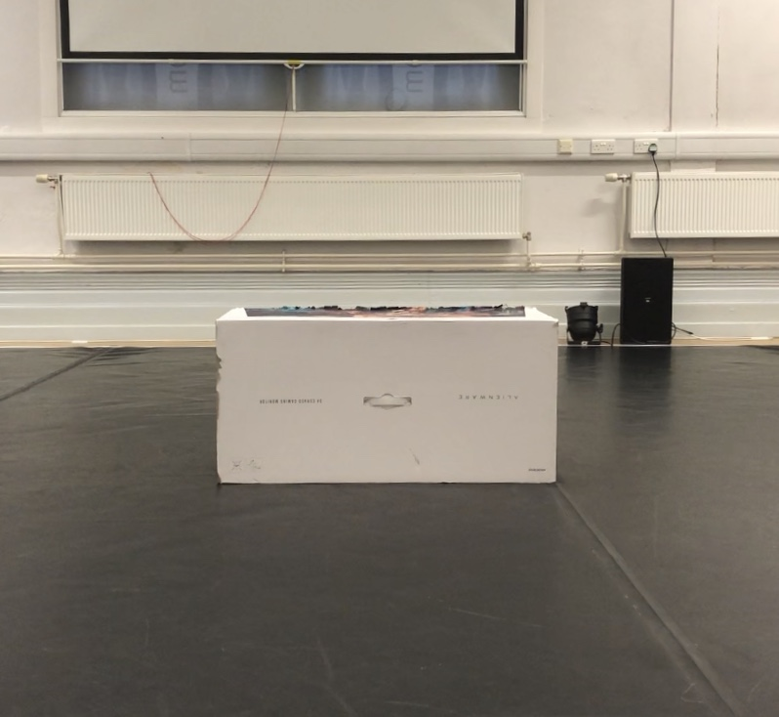
(A Box, Niamh Provan, 2019)
However, I was not able to source a crate. I was able to get a box which had been left in the space, seen above. Using Peter Brooks method of found objects (1996, Page 150) I spent time playing with the box and exploring the possibilities of what it could be. The box has many transformations throughout the piece, not only as a mode of delivery for the first two characters but also as a television spewing our newspapers or a podium for the queen. The box follows Brooks insight into using objects in a ‘metaphoric fashion,’ the box shares a lot of qualities with what it becomes which then is integrated into the scenes.
I always intended for the piece to be abstract. Very simply I wanted things to happen and then it is over, I wanted to create a disassociation from the real world. I did this by displacing the fourth wall and having a direct relationship between the characters and the audience.
I used the Brechtian method of Epic Theatre to influence how I structured my work. My initial purpose of the piece was to just create something enjoyable for half an hour, but further than that, I wanted the audience to think about why things are happening rather than what is happening.
The facts are displaced by the fiction throughout the piece. For example, the holiday scene was inspired by both the cultural fascination with winning free things as well as the questions from the British Citizenship Test. (circa 2019)
However, fiction can often cover up the fact. As research, I personally took the Citizenship test and I failed every time I tried it. I believe that there is a preconceived notion of what being British is but it has become severely outdated and the fact that what is ultimately a history test decides whether or not someone can be a citizen is extremely interesting because if British citizens cannot pass the test then how valid can it truly be.
By crossing these factual elements into a rather absurd scene it can blur the line between what is real and what is not, there is only the belief that the questions and answers I am asking are correct because that has been suggested to the audience solely from context. There is no incentive to double check whether or not what the host is saying is true; there is just a suspended disbelief in what the character is saying based on preconceived notion.
The scene has the ability to question our own views of nationalism, as well as our belief in what is British and whether that even truly matters anymore. Benedict Anderson speaks of a nation as an ‘Imagined Community,’ (Holdsworth, 2010) there is a sense of connection that comes with nationalism that I feel has been lost through politics and belief in our own country. In my opinion, I feel that it would be important in the long run to take Anderson’s theory of how the nation is a comradeship and integrate it into our communities moving forward.
Another fiction over fact usage is the royalty element distributed throughout the piece. From using the colour purple to light the space (Przybyla, circa 2017) to having postage stamps, with the Queens' face on them on each of the boxes. All of this leads up to the finale of the Queen and Philip as googly eyes on two hands.
The character of the Queen generates a new course for the piece. Both her purpose and Philip’s is to challenge the perception of titles and the assumed narrative. The character I created is playing out the stereotype of ‘above it all’ royalty. This Queen does not actually desire to be Queen and would rather have made her fame elsewhere, however, she never had the choice to. When given the chance it is ultimately ruined and we can only assume that she may try to take the chance again and continue to fail.
Philip is another incarnation of this concept. On a different level to the Queen physically, he tries to also be something that his others would not assume him to be based on his title. His ideas are not allowed the light of day and when he tries something he also fails, whether that be bringing confetti or trying to support the Queen's dream to sing.
Each person already has a set perspective on what royalty is to them and so I wanted to develop these characters to question that perception of what else can go on that we, the public, are not made aware of. From the feedback, I found that some audience members, even those who were royalists, found that this scene made them question our need for royalty. Although they did not completely agree with the mockery, they appreciated the need to have these discussions about how royalty fits into contemporary society. (Darrian Quigg, 2019)
I had quite a few challenges to overcome through the process. The biggest one I found is that I feel more secure thinking about the microscopic details, in one regard it can be seen as a strength but when working on an independent project I need to also be able to step back and view the larger picture.
It was when I received feedback on possibly adding more boxes that I realised I had been neglecting that part of the production. I then went on to find that once I spent more time on the rest of the set and making it look the part, a lot of the ideas that had been stuck in my head were able to reveal themselves more within the space. As seen below, I found that having the materials fabricated in the space allowed me to see how the piece was coming together and create a better image in my head about what it was actually going to look like.
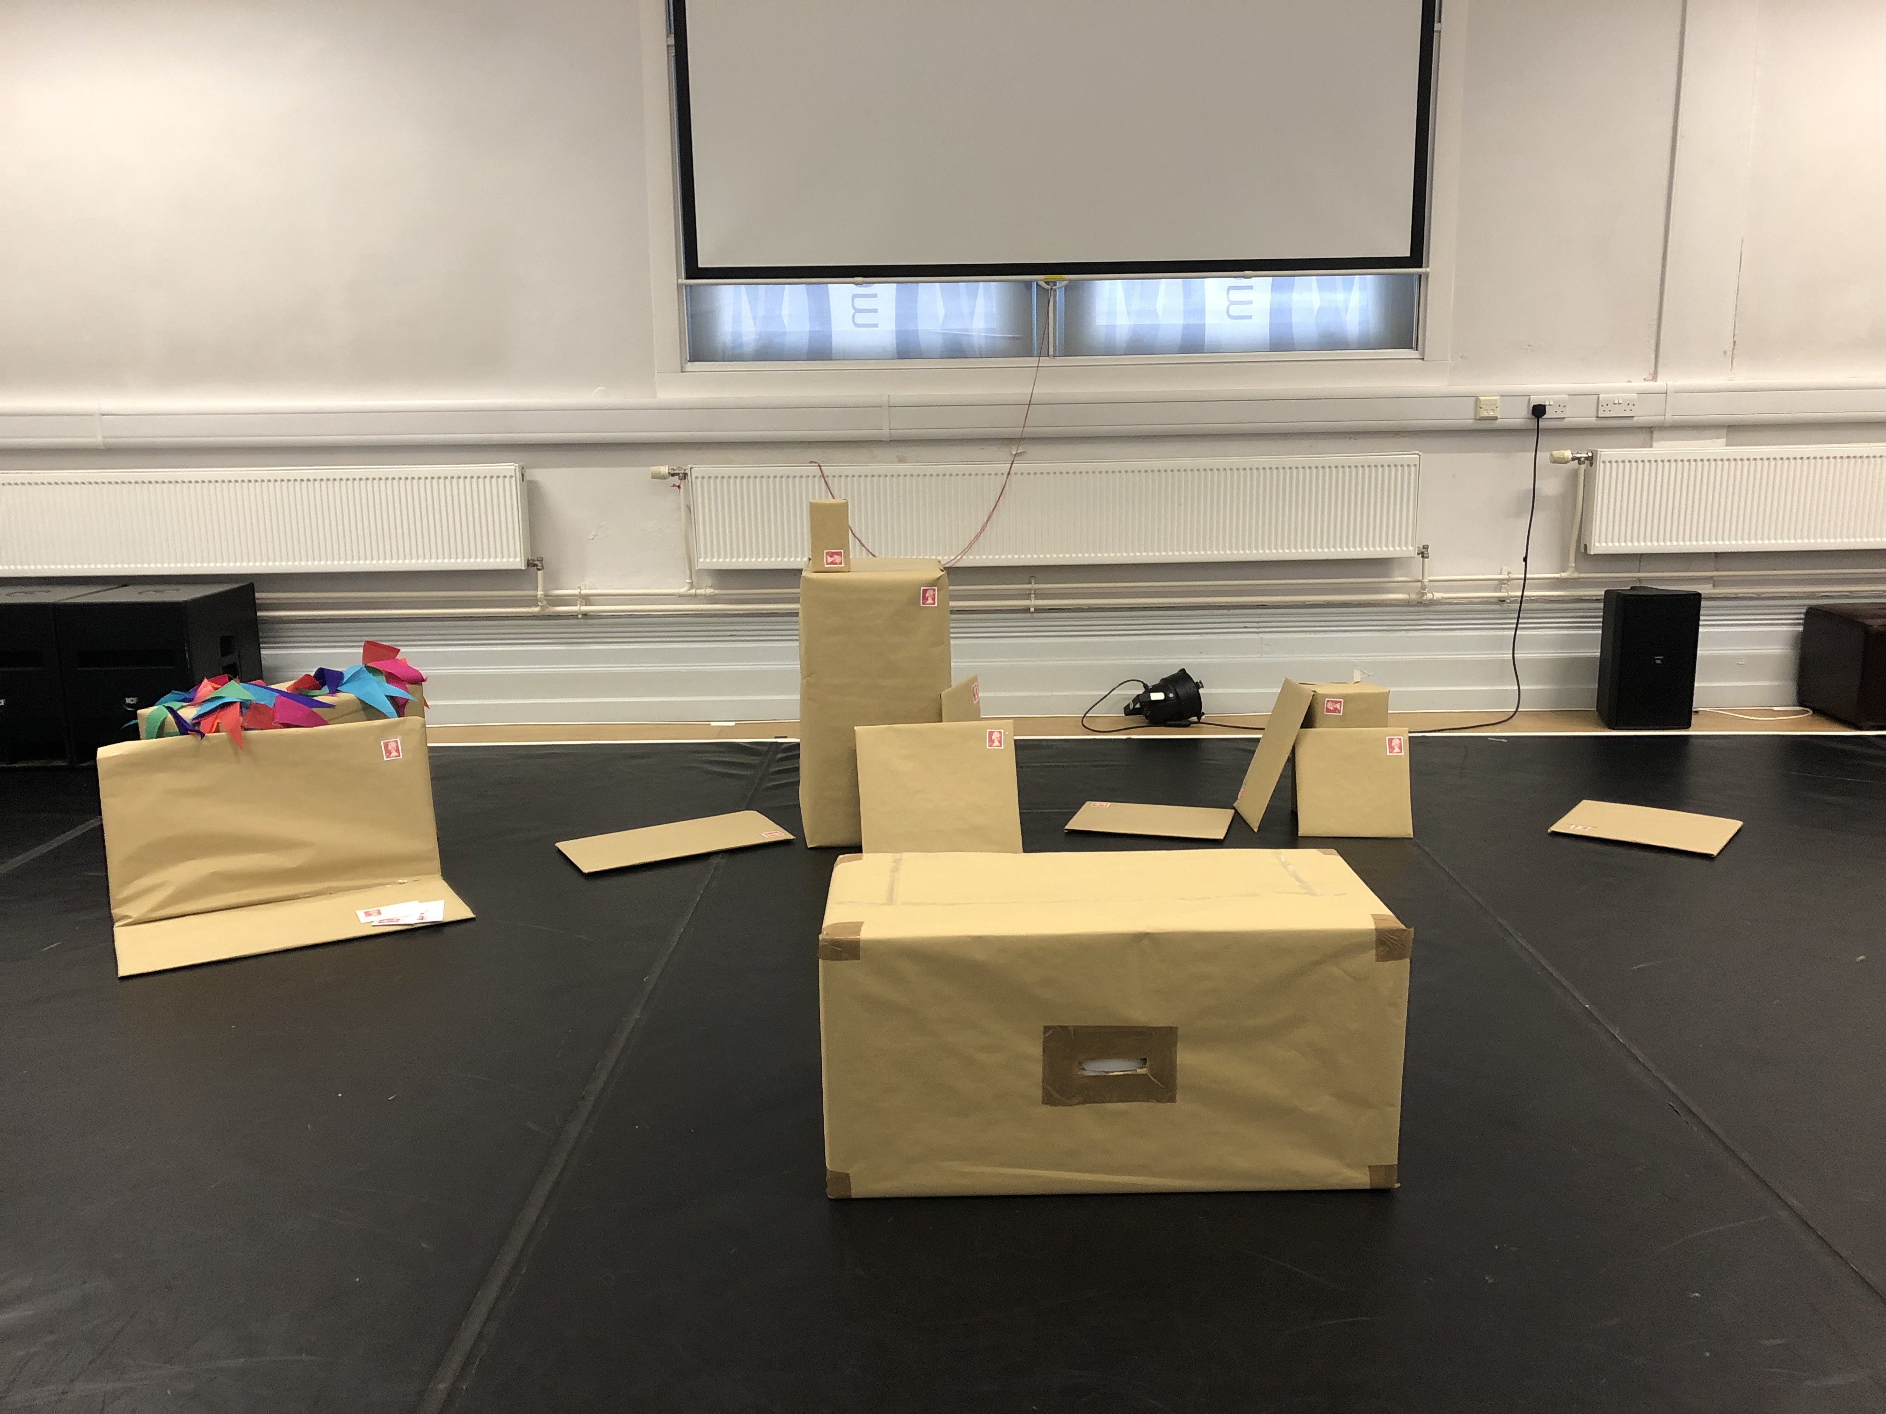
(Wrapped Boxes, Niamh Provan, 2019)
From the beginning of the process I placed too much pressure on myself to create work and have it completed as quickly as possible, this only halted the development of my work. I did not allow myself the space to play and I created unreachable expectations. I do enjoy the piece I have made, however, I could have allowed myself to enjoy the process more than I did.
Ultimately both performances did what I wanted them to do. My original intention was that I wanted to make people laugh and enjoy themselves for half an hour, which I did. Feedback from audience members has given me insight into how new eyes perceived the piece that I had been working on for several weeks.
Even when the script changed languages the audience members I spoke to still felt that they could follow along with the narrative based on the context I had created and the repetitive movement. Through the work I wanted to show that communication can rely on more than just voice or language and I have been able to achieve that. (Summar Jade, 2019)
Each of the performances had their differences. I felt a noticeable change in connection between the first performance and the second. In the first performance I felt more fluid and in tune with the audience, however, in the second I felt a disconnection as if I had placed a barrier between me and the viewers. Several variables could have caused this to happen, for example; the audience was larger in the second piece, there were also family members in the second row and part of me became very self-aware that I was performing completely alone.
It is good to be aware of the things that can halt me when performing as it is ultimately the first step to being able to analyse and overcome them from a reflective standpoint.
I have found through this process that I prefer to work with at least one other person. I enjoy having someone else to work with in the space and bounce ideas off, even though it has been great to develop my own personal ideas I think that I need to involve others more in future products, as it was extremely helpful through the process to receive feedback on the ideas I was working on.
The piece was, in my opinion, successful. Nevertheless, I do not truly believe that work can ever stop developing. I think that this piece still has so much more room to grow if it were to be developed further. There are so many more questions that I have now about how it could be taken further, such as changing the language or the directive of the narrative. Both English and German lead the narrative and they could be given more centred scenes and more room to develop as characters.
Overall I am proud of the work that I created and think that I did develop my practice over the weeks that I was working on it, although it was challenging, I think that it was necessary to combat new challenges and understand how to do so. I hope to take this forward into my future work.

Reference List:
Anderson, S. (2012) Languages: A Very Short Introduction. Oxford, Oxford University Press.
Brauer, Gerd. (2002) Body And Language: Intercultural Learning Through Drama. Westport, Ablex Publishing.
Counsel, C. (1996) Signs of Performance. London, Routledge.
Deutscher, G. (2011) Through The Language Glass. London, Arrow Books.
‘Head Count’ by Mandy Rose and Jeremy Linnell (2018) [The Gate Theatre, Cardiff, 14 June 2018]
Holdsworth, N. (2010) Theatre & Nation. Hampshire, Palgrave Macmillan.
Jade, S. (2019) Facebook message, 13 March.
MacShane, D. (2015) Brexit: How Britain Left Europe. London: I.B. Tauris & Co. Ltd.
Provan, N. (2019) A box. [image]
Provan, N. (2019) Multiple Boxes. [image]
Przybyla, D. (circa 2017) Purple Color Psychology and Meaning. Available At: https://www.colorpsychology.org/purple/ (Accessed: 26 February 2019)
Quigg, D. (2019) Facebook message, 13 March.
(circa 2019) Life in the UK Test. Available at: https://lifeintheuktestweb.co.uk/ (Accessed 11 February 2019)
Bibliography:
Brook, P. (1968) The Empty Space. London, Penguin Books.
Fredman, R. and Reade, I. (1996) Essential Guide To Making Theatre. London, Hodder & Stoughten.
Freshwater, H. (2009) Theatre & Audience. Hampshire, Palgrave Macmillan.
Goven, E. and Nicholson, H. and Normington, K. (2007) Making A Performance: Devising Histories And Contemporary Practices. London, Routledge.
Loftus, V. (2014) ‘The Greatest Irish Insults, Ranked in Order Of Severity’ The Daily Edge. 16 March. Available at: https://www.dailyedge.ie/irish-insults-ranked-1355761-Mar2014/ (Accessed: 26 February 2019)
NerdAlert (2016) Why You Should Always Talk With Your Hands [video] Available at: https://www.youtube.com/watch?v=NBZpVdq5lGI (Accessed 12 February 2019)
Stevens, S. (2016) The Brexshit Book. London, Pavilion.
TEDx Talks (2017) Puppets and Perception [video] Available at: https://www.youtube.com/watch?v=X_Molj8L6nM (Accessed 19 February 2019)
TEDx Talks (2017) Reading Minds Through Body Language [video] Available at: https://www.youtube.com/watch?v=W3P3rT0j2gQ (Accessed 12 February 2019)
TLDR News. (2018) May’s Proposed Brexit Deal Explained – Explaining Brexit [video] Available at: https://www.youtube.com/watch?v=lE7nN0cgs9A&list=WL&t=0s&index=40 (Accessed: 2 February 2019)
TLDR News. (2019) Game Theory Explains Why No Deal is Inevitable - Brexit Explained [video] Available at: https://www.youtube.com/watch?v=BHiT9VPkgUY&t=554s (Accessed: 19 February 2019)
Willet, J. (1964) Brecht On Theatre: The Development Of An Aesthetic. (ed.) Berkshire, Cox & Wymen Ltd.
1234567890tgb (2019) Randy Buys A Bookshelf Off Gumtree [video] Available at https://www.youtube.com/watch?v=Mq_wZE93ZAY&t=18s (Accessed 19 February 2019)

