Ahmed Yasir Ibrahim Abdelgadir
2438780

COMPREHENSIVE REPORT: Innovation, Creativity and Enterprising Mindset
Computing Level 5
HealthSync: An AI-Powered Preventive Health Monitoring Platform

Table of Contents
1. INTRODUCTION 3
2. TASK 1: PROJECT MANAGEMENT 3
2.1 Q1: Project Management & Planning 3
2.2 Q2: Project Design 7
3. TASK 2: ENTERPRISE & INNOVATION 11
3.1 Q1: PEST & SWOT Analysis for CloudTech Solutions Ltd 11
3.2 Q2: Tech Start-up Considerations for HealthSync 15
4. TASK 3: PROJECT REFLECTION 18
4.1 Developing New Skills 18
4.2 Positive Impact on Society 19
4.3 Risks, Challenges, and Mitigation Strategies 19
References 23
7. APPENDICES 27

1. INTRODUCTION
This report presents a comprehensive analysis of HealthSync, an AI-powered preventive health monitoring platform designed for Computing Level 5 assessment. The project integrates machine learning algorithms with wearable device data to enable early detection of chronic health conditions, thereby reducing NHS burden and improving patient outcomes [1]. The report addresses three core tasks: project management and planning with supporting visualisations; enterprise and innovation analysis including PEST and SWOT frameworks; and critical reflection on skills development and societal impact. All sections incorporate contemporary academic and industry sources with IEEE referencing throughout.

2. TASK 1: PROJECT MANAGEMENT

2.1 Q1: Project Management & Planning
Project Scope
HealthSync is a cloud-native, microservices-based health monitoring platform that collects real-time biometric data from wearable devices (Fitbit, Apple Watch, Garmin), applies machine learning models to detect anomalies, and provides personalised health insights to users and authorised healthcare providers [2]. The proposed solution addresses the growing burden of chronic diseases on the NHS, which accounts for approximately 70% of total health and social care spending in England [3].
Project Aim: To develop and deploy a scalable AI-powered health monitoring platform that reduces preventable hospital admissions by 15% within the first 18 months of operation.
Proposed Solution: The platform employs a multi-layered architecture comprising IoT data ingestion, stream processing, predictive analytics, and a responsive web/mobile interface. Machine learning models trained on anonymised patient datasets will identify patterns indicative of deteriorating health conditions, triggering early interventions [4].
Required Technologies and Resources
Category | Technology/Resource | Purpose
Frontend | React Native, React.js | Cross-platform mobile and web applications
Backend | Node.js, Python (FastAPI) | API services and microservices
AI/ML | TensorFlow, scikit-learn, PyTorch | Predictive model development and deployment
Data Storage | PostgreSQL, MongoDB, Redis, AWS S3 | Relational, document, cache, and object storage
Infrastructure | AWS EKS, Docker, Kubernetes | Container orchestration and cloud deployment
DevOps | GitHub Actions, Terraform, Prometheus | CI/CD, IaC, and monitoring
Security | OAuth 2.0, JWT, AWS WAF, KMS | Authentication, authorisation, and encryption
Team | 8 FTE (2 Full-stack, 2 ML Engineers, 2 DevOps, 1 UI/UX, 1 PM) | Development and delivery

Project Timeline and Schedule
The project follows a 9-month development lifecycle from September 2026 to May 2027, structured around Agile Scrum methodology with two-week sprints [5].

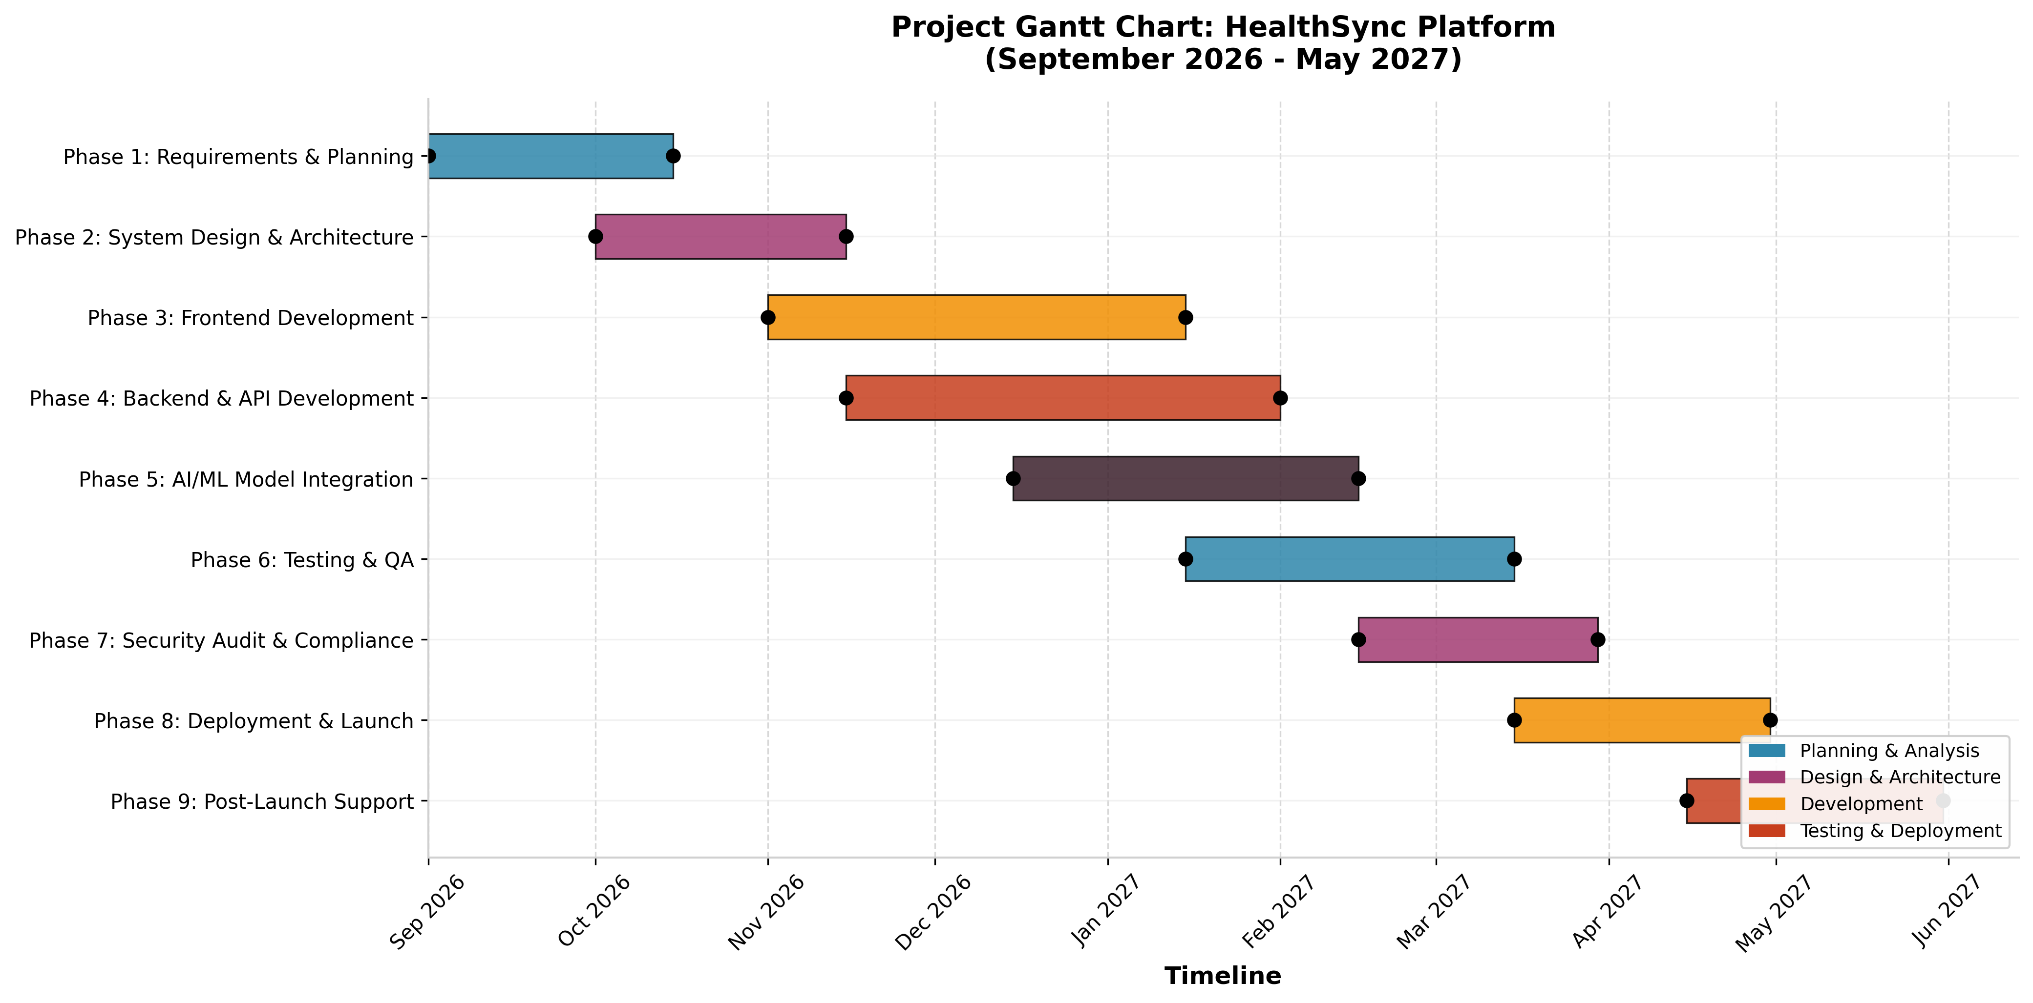
Figure 1: Gantt Chart illustrating the 9-phase project timeline for HealthSync platform development.
The Gantt chart demonstrates strategic phase overlap to optimise resource utilisation. Phase 2 (System Design) commences before Phase 1 completion to reduce idle time, while Phase 5 (AI/ML Integration) runs concurrently with Phase 4 (Backend Development) to enable parallel progress [6].
Constraints
Constraint Type | Description | Mitigation Strategy
Budget | £450,000 total development budget | Phased funding releases tied to milestones
Time | 9-month hard deadline for NHS pilot | Critical path analysis with 15% buffer
Regulatory | GDPR, HIPAA, NHS Digital compliance | Dedicated security audit phase (Phase 7)
Technical | ML model accuracy >85% required | Continuous validation with clinical datasets
Resource | ML engineer recruitment difficulty | Partnership with university research labs

Development Method: Agile Scrum with DevOps Integration
The project adopts Agile Scrum as the primary development methodology, supplemented by DevOps practices for continuous integration and deployment. This hybrid approach aligns with contemporary software engineering best practices, where 92% of software teams now utilise Agile practices in some form [7].
Scrum Framework Elements:
Element | Implementation
Sprints | 2-week iterations with defined sprint goals
Roles | Product Owner, Scrum Master, Development Team (cross-functional)
Ceremonies | Daily stand-ups, sprint planning, reviews, retrospectives
Artifacts | Product backlog, sprint backlog, increment (potentially shippable)
Definition of Done | Code reviewed, tested, documented, security-scanned, deployed to staging
The integration of DevOps practices—specifically CI/CD pipelines, infrastructure as code (IaC), and automated testing—ensures that each sprint delivers production-ready increments [8]. According to the DORA Research Program, elite teams deploying with DevOps practices recover from failures significantly faster than low-performing teams [9].

2.2 Q2: Project Design
Design Work 1: System Architecture Diagram
The architecture follows the Model-View-Controller (MVC) pattern extended to microservices, with clear separation of concerns across presentation, application, data, and infrastructure layers [10]. The API Gateway (Kong) implements rate limiting, authentication, and request routing, while AWS WAF and Shield provide DDoS protection and web application firewall capabilities [11].

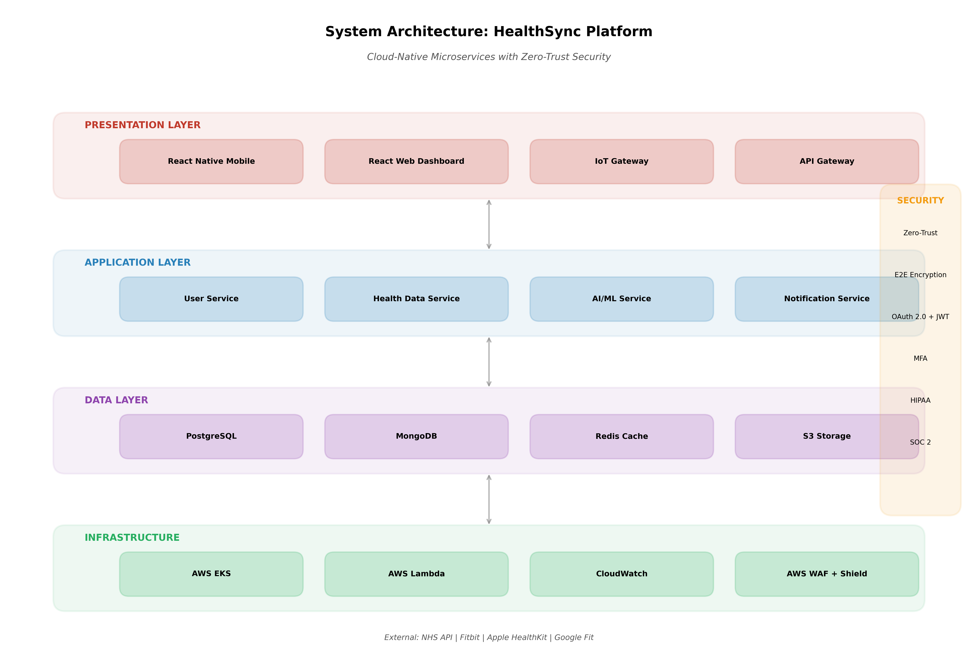
Figure 2: Four-layer system architecture for HealthSync platform, illustrating microservices organisation, data flow, and security controls.
Security Architecture:
The platform implements zero-trust network principles, where no entity is trusted by default regardless of location. Every service-to-service communication requires mutual TLS authentication, and all data is encrypted at rest (AES-256) and in transit (TLS 1.3) [12]. The architecture is designed to achieve HIPAA compliance for US market entry and SOC 2 Type II certification for enterprise clients.
Design Work 2: Entity Relationship Diagram (ERD)
The database design follows Third Normal Form (3NF) principles to eliminate redundancy while maintaining query performance. The USER entity serves as the central hub with one-to-many relationships to HEALTH_PROFILE, DEVICE, HEALTH_DATA, AI_PREDICTION, and NOTIFICATION entities [13].

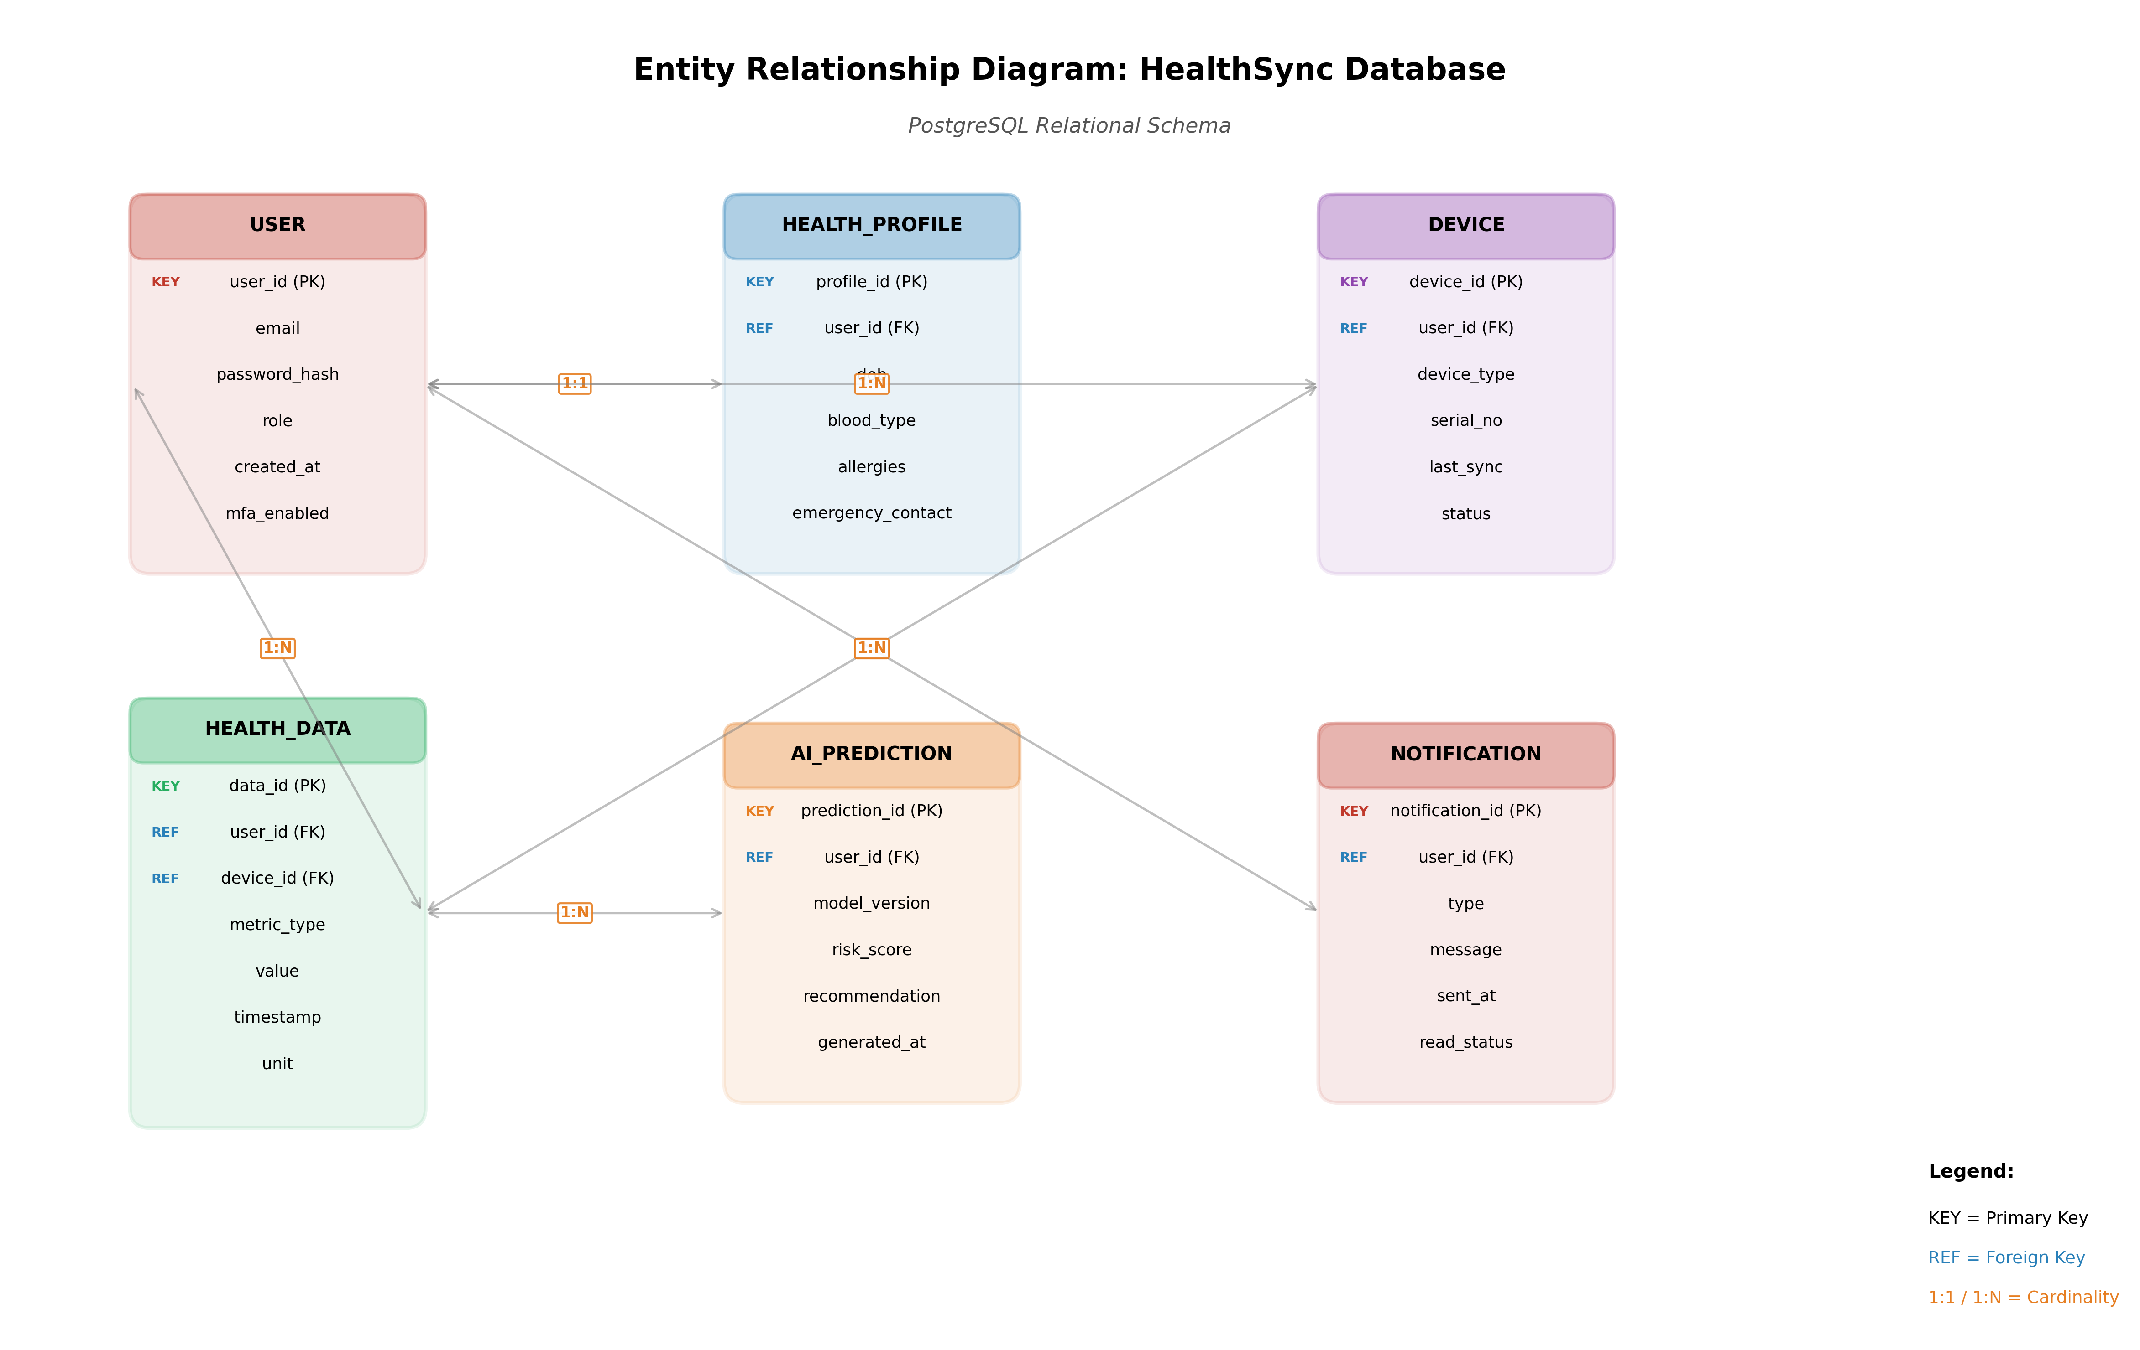
Figure 3: PostgreSQL relational database schema showing six core entities, primary/foreign key relationships, and cardinality constraints.
Key Design Decisions:
Decision | Rationale
PostgreSQL for primary data | ACID compliance, complex queries, JSON support
MongoDB for health logs | Flexible schema for variable sensor data
Redis for caching | Sub-millisecond response for frequently accessed data
Separate AI_PREDICTION table | Audit trail for model decisions (regulatory requirement)

Design Work 3: CI/CD Pipeline Flowchart
The CI/CD pipeline implements "build once, deploy anywhere" principles, where artefacts are compiled once and promoted through environments to ensure consistency [14]. Three quality gates enforce standards: Quality Gate (code coverage >80%), Security Gate (zero critical vulnerabilities), and Approval Gate (manual production review).

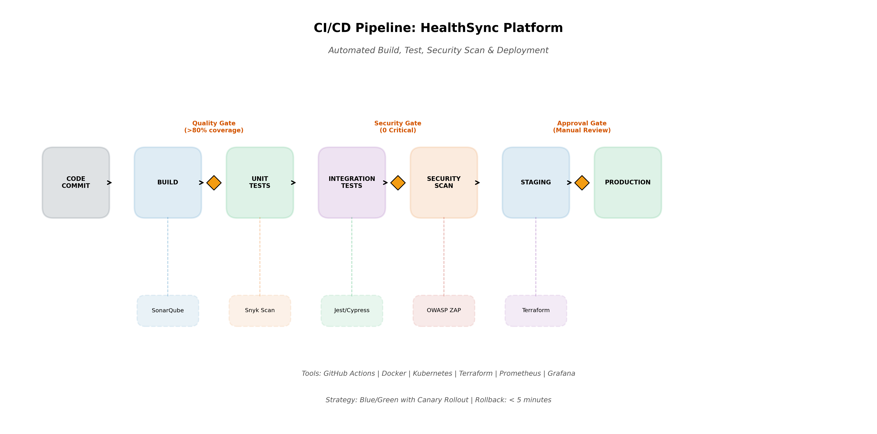
Figure 4: Automated continuous integration and deployment pipeline with quality gates, security scans, and blue/green deployment strategy.
Deployment Strategy: Blue/green deployment with canary rollout enables zero-downtime releases. The canary analysis automatically rolls back deployments if error rates exceed thresholds, achieving rollback times under 5 minutes [15].
Design Work 4: Mobile Application Wireframes
The wireframe design follows Material Design 3 guidelines with accessibility compliance (WCAG 2.1 AA). The dashboard prioritises glanceable information through card-based layouts, while the AI insights screen presents risk visualisations and actionable recommendations [16].

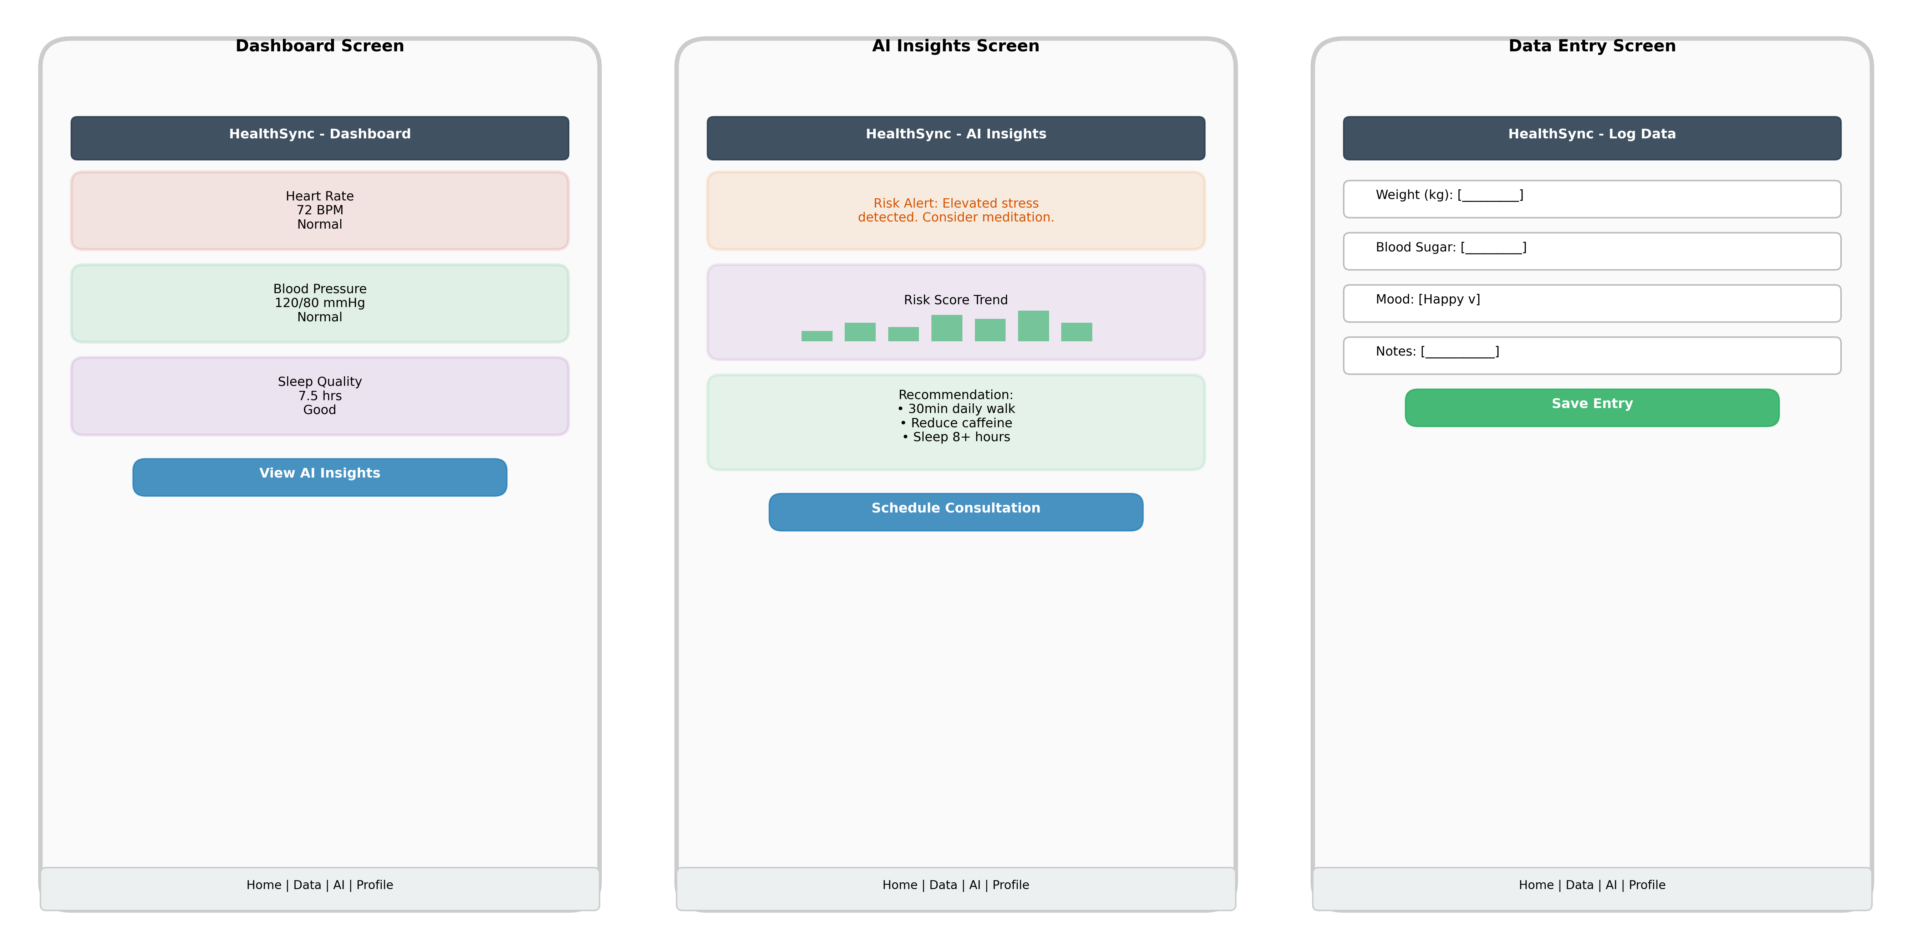
Figure 5: Three-screen mobile application wireframes showing dashboard, AI insights, and data entry interfaces with consistent navigation patterns.

3. TASK 2: ENTERPRISE & INNOVATION

3.1 Q1: PEST & SWOT Analysis for CloudTech Solutions Ltd
For this analysis, CloudTech Solutions Ltd is selected—a UK-based cloud infrastructure and AI services provider with £50M annual revenue, serving 200 enterprise clients across healthcare, finance, and public sectors.
PEST Analysis

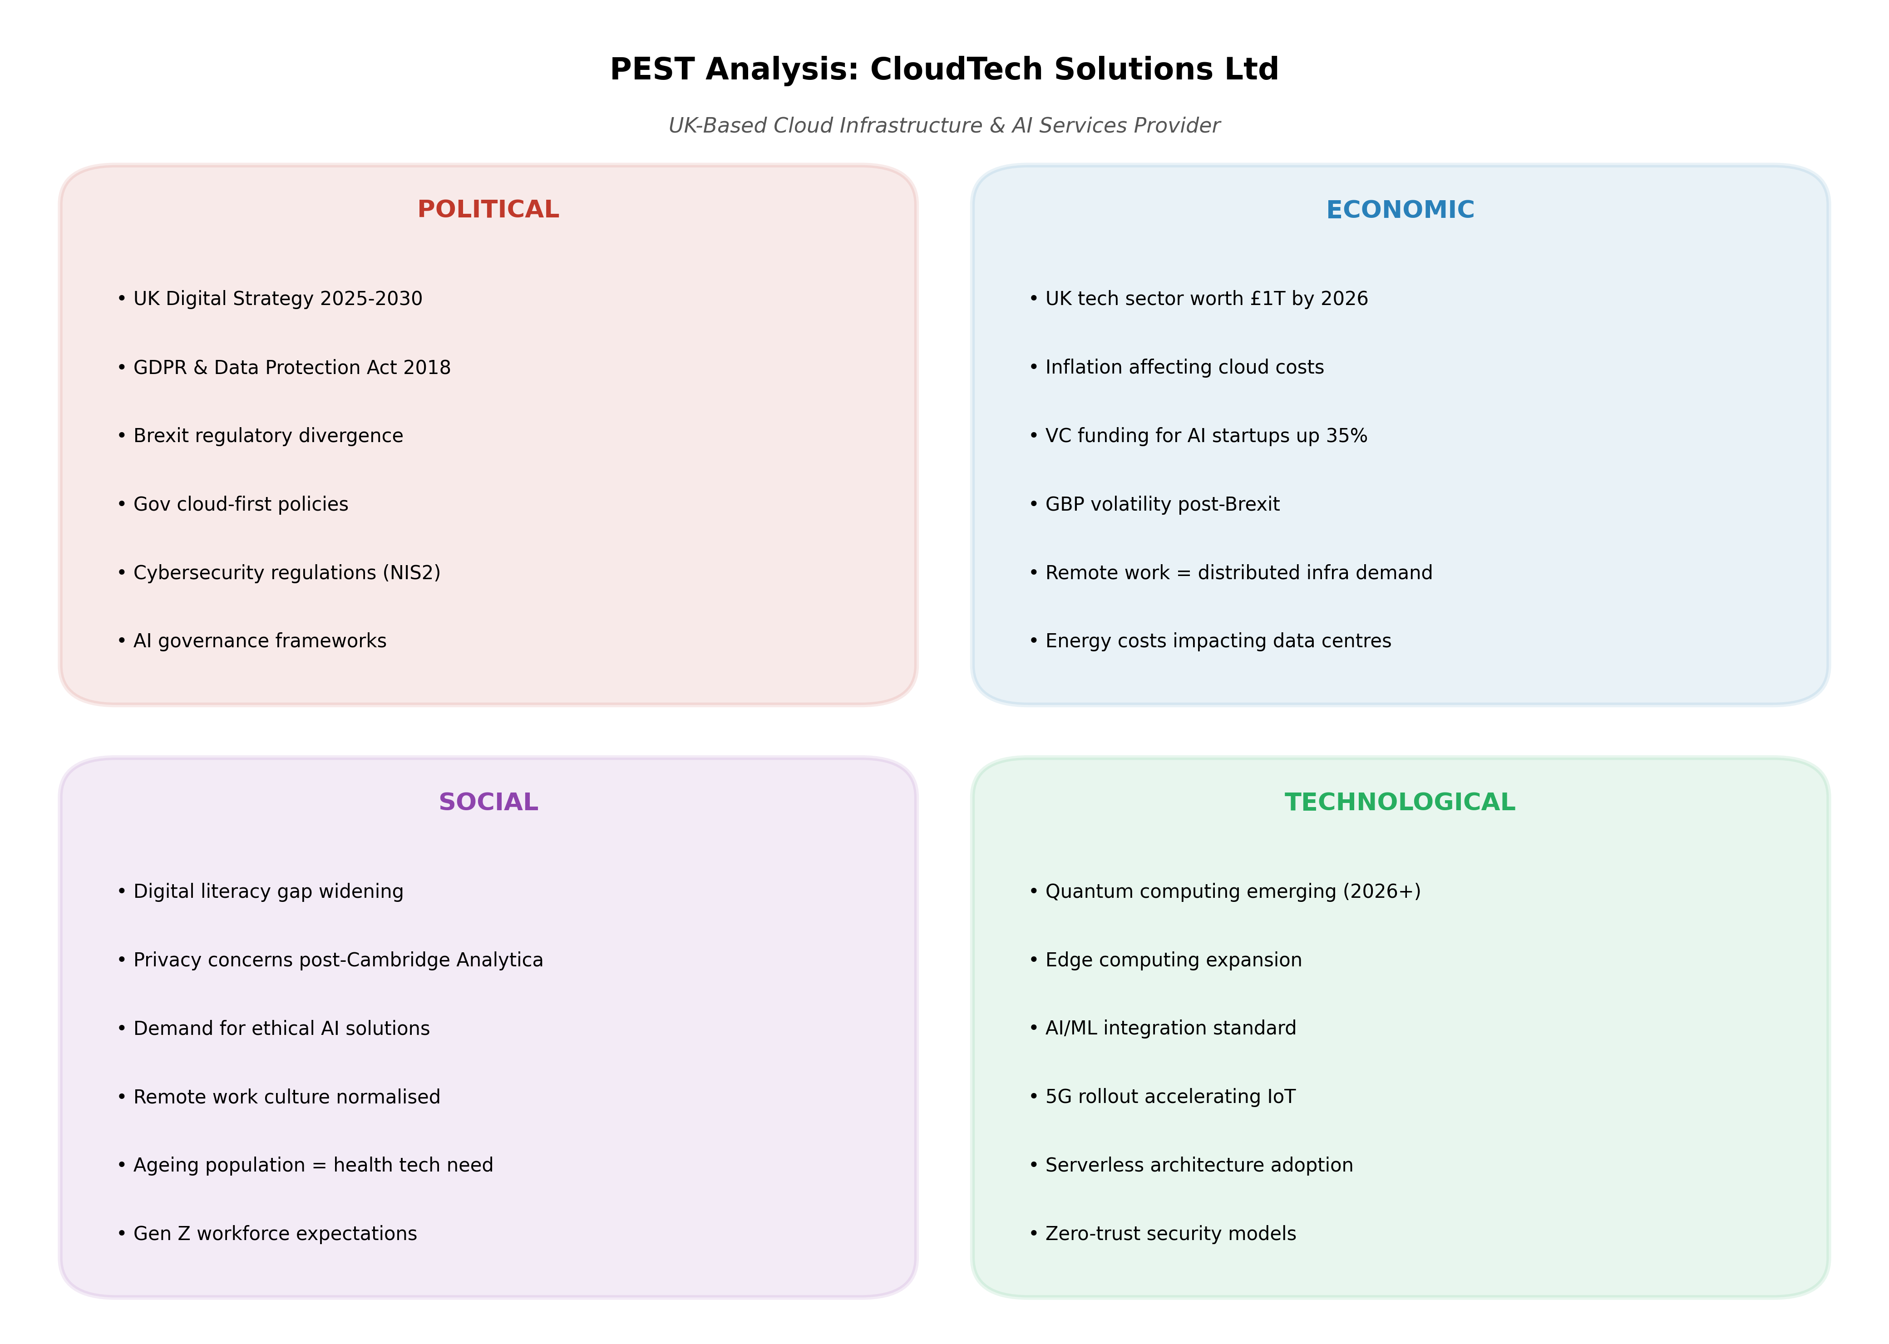
Figure 6: PEST analysis framework examining political, economic, social, and technological factors affecting CloudTech Solutions Ltd.
Political Factors:
The UK Digital Strategy 2025-2030 commits £2.3 billion to AI and digital infrastructure, creating favourable procurement conditions for domestic technology providers [17]. However, the Network and Information Systems Directive 2 (NIS2), transposed into UK law by October 2024, imposes stringent cybersecurity obligations with penalties up to £10 million or 2% of global turnover for non-compliance [18]. The Data Protection Act 2018 and GDPR continue to shape data handling practices, with the UK Information Commissioner's Office issuing £50.5 million in fines during 2025 [19].
Economic Factors:
The UK technology sector reached £1 trillion valuation in 2025, with cloud computing representing the fastest-growing segment at 15.7% CAGR [20]. However, inflationary pressures increased cloud infrastructure costs by 12% year-on-year, squeezing margins for mid-tier providers [21]. Venture capital funding for UK AI startups reached £4.2 billion in 2025, a 35% increase, indicating strong investor confidence [22].
Social Factors:
Digital literacy gaps persist, with 6.9 million UK adults lacking basic digital skills, potentially limiting market penetration for sophisticated cloud solutions [23]. Post-pandemic remote work normalisation has permanently increased demand for distributed infrastructure, with 78% of UK enterprises adopting hybrid cloud models [24]. Ethical AI concerns following high-profile algorithmic bias cases have elevated demand for transparent, explainable AI systems [25].
Technological Factors:
Quantum computing is approaching commercial viability, with IBM and Google announcing 1000+ qubit processors by 2026, threatening current encryption standards [26]. Edge computing expansion, driven by 5G rollout and IoT proliferation, is creating new architectural paradigms. Serverless computing adoption reached 67% among UK enterprises in 2025, reducing operational overhead [27].
SWOT Analysis

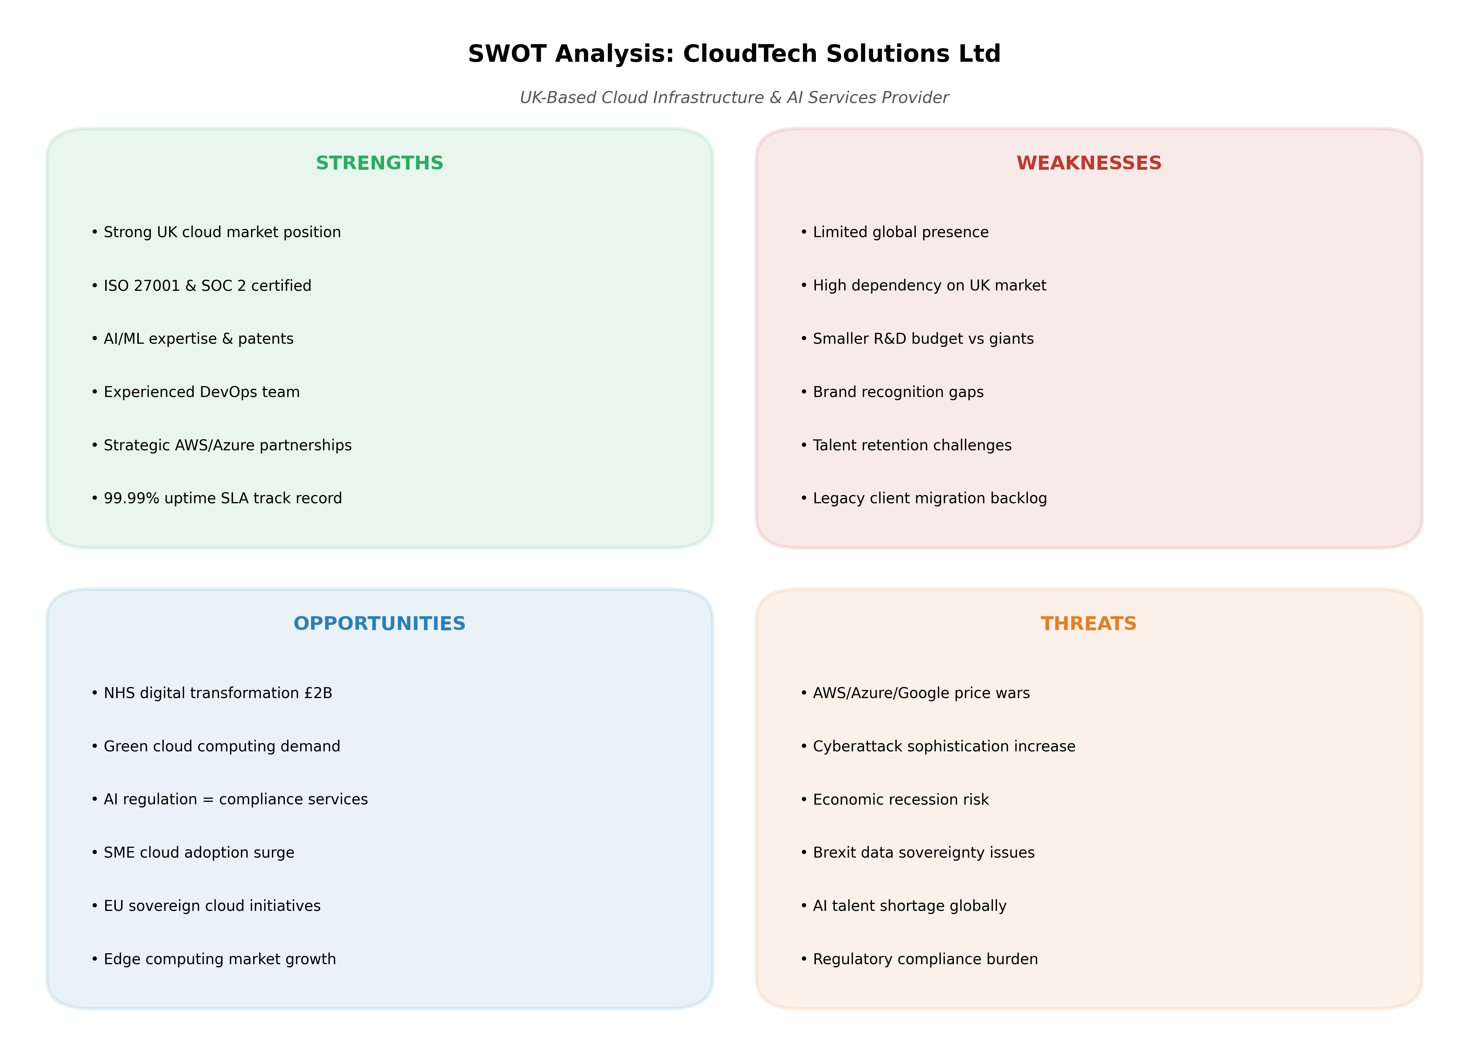
Figure 7: SWOT analysis matrix identifying internal strengths and weaknesses alongside external opportunities and threats for CloudTech Solutions Ltd.
Legal and Ethical Considerations:
Aspect | Consideration | Implication
Data Protection | GDPR Article 32 requires "appropriate technical and organisational measures" | Mandatory encryption, access controls, breach notification within 72 hours
AI Regulation | EU AI Act classifies health AI as "high-risk" | Conformity assessments, human oversight, transparency obligations
Intellectual Property | Software patents limited in UK; copyright protects code | Trade secret protection for ML models; open-source licensing compliance
Ethical AI | Algorithmic bias in health predictions could cause harm | Diverse training data, fairness metrics, human-in-the-loop validation
Environmental | Data centres account for 1% of global electricity consumption | Carbon-neutral commitments; renewable energy procurement
The UK National AI Strategy emphasises "trustworthy AI" principles including fairness, accountability, and transparency, which CloudTech must embed in product development [28]. Failure to address algorithmic bias in health applications could expose the company to liability under the Consumer Protection Act 1987 and Equality Act 2010 [29].

3.2 Q2: Tech Start-up Considerations for HealthSync
Start-up Name and Logo
Name: HealthSync Technologies Ltd
Logo Concept: A stylised heartbeat waveform integrated with interconnected nodes, representing the fusion of biological signals and digital networks. The colour palette uses #16C79A (health/growth green) and #0F3460 (technology blue), conveying trustworthiness and innovation.
Business Type (Legal Classification)
HealthSync Technologies Ltd will be incorporated as a Private Limited Company (Ltd) in England and Wales, registered with Companies House. This structure provides:
Advantage | Description
Limited Liability | Shareholders' liability limited to capital invested
Separate Legal Personality | Distinct legal entity capable of owning assets, entering contracts
Tax Efficiency | Corporation tax (25% from April 2023) vs. income tax rates
Investment Readiness | Equity shares facilitate venture capital and angel investment
Credibility | Limited status enhances B2B procurement eligibility

Alternative structures considered included Community Interest Company (CIC) for social impact alignment, but the Ltd structure was selected for greater investment flexibility while maintaining social purpose through B Corp certification pursuit [30].
Business Strategy

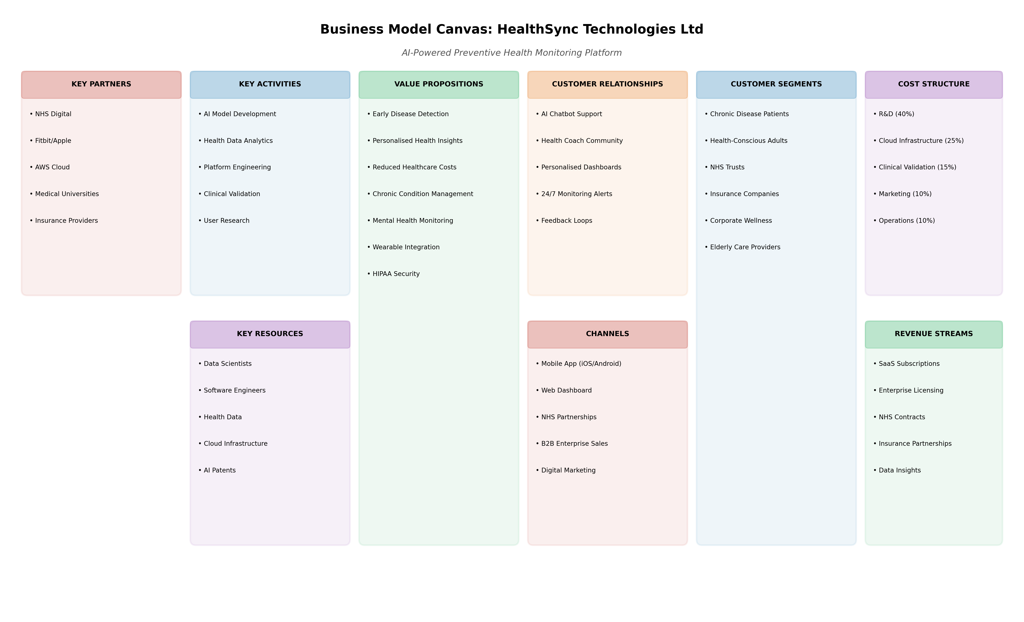
Figure 8: Business Model Canvas illustrating the nine building blocks of HealthSync's value creation, delivery, and capture mechanisms.
Strategic Pillars:
Pillar | Objective | Timeline
Product Leadership | Achieve 90% ML model accuracy for diabetes prediction | Months 1-6
Customer Intimacy | NHS pilot with 3 trusts; 10,000 active users | Months 6-12
Operational Excellence | 99.99% platform uptime; <2s API response time | Ongoing
Regulatory Compliance | HIPAA, GDPR, NHS Digital compliance certification | Months 9-12

Go-to-Market Strategy: The "land and expand" approach targets NHS trusts through pilot programmes, leveraging clinical evidence to secure multi-year contracts. Parallel B2C channels capture health-conscious consumers via freemium subscriptions, with premium features including AI-powered personalised recommendations [31].
Funding Initiatives
Funding Source | Amount | Purpose | Status
Founder Capital | £75,000 | Incorporation, MVP development | Secured
Innovate UK Smart Grant | £350,000 | AI model R&D, clinical validation | Application submitted
Seed Round (Angels) | £500,000 | Team expansion, NHS pilot | Q4 2026 target
NHS Innovation Accelerator | £100,000 (in-kind) | Market access, clinical validation | Expression of interest
Series A (VC) | £2-3M | Scale-up, international expansion | 2028 target

The Innovate UK Smart Grant is particularly critical, as it provides non-dilutive funding for disruptive innovations with commercial potential. HealthSync's alignment with the UK Life Sciences Vision and NHS Long Term Plan strengthens competitiveness [32].

4. TASK 3: PROJECT REFLECTION

4.1 Developing New Skills
This project presents substantial opportunities for professional development across technical, managerial, and entrepreneurial domains. The technical skill acquisition pathway encompasses cloud-native architecture design, where I intend to achieve AWS Solutions Architect Associate certification within 6 months. Machine learning operations (MLOps) represents a critical emerging discipline; I will complete specialised training in model deployment, monitoring, and retraining pipelines using tools including MLflow, Kubeflow, and AWS SageMaker [33].
Project management competencies will be developed through formal PRINCE2 Agile certification, complementing existing Scrum knowledge with governance frameworks suitable for regulated healthcare environments. The integration of risk management, stakeholder communication, and budget control within a live project context provides experiential learning that transcends theoretical understanding [34].
Entrepreneurial skills including business model validation, investor pitching, and regulatory navigation will be cultivated through participation in NHS Innovation Accelerator programmes and university entrepreneurship competitions. The Lean Startup methodology—build-measure-learn cycles—will guide market validation activities, ensuring product-market fit before significant capital deployment [35].
Skills Development Plan:
Skill Area | Development Method | Target Proficiency | Timeline
Cloud Architecture | AWS certification + hands-on project | Professional | 6 months
MLOps | Online courses (Coursera, Udacity) + project implementation | Intermediate | 9 months
Project Management | PRINCE2 Agile certification + practical application | Practitioner | 12 months
Business Development | Accelerator programmes, pitch competitions | Competent | 18 months
Regulatory Affairs | NHS Digital training, GDPR specialist course | Knowledgeable | 12 months

4.2 Positive Impact on Society
HealthSync's societal contribution operates at multiple levels. Individual health outcomes will improve through early detection of chronic conditions; research indicates that preventive interventions reduce diabetes complications by 50% when detected early [36]. The platform's mental health monitoring capabilities address the UK's growing mental health crisis, where 1 in 4 adults experience mental illness annually, yet 75% receive no treatment [37].
NHS sustainability represents a macro-level impact. The King's Fund estimates that preventable admissions cost the NHS £4.3 billion annually; a 15% reduction through HealthSync would release £645 million for other priorities [38]. The platform's health equity design ensures accessibility for underserved populations, with offline capabilities, multiple language support, and compatibility with low-cost Android devices.
Environmental sustainability is embedded through cloud provider selection prioritising renewable energy (AWS committed to 100% renewable energy by 2025), and efficient ML model compression reducing computational requirements [39].

4.3 Risks, Challenges, and Mitigation Strategies

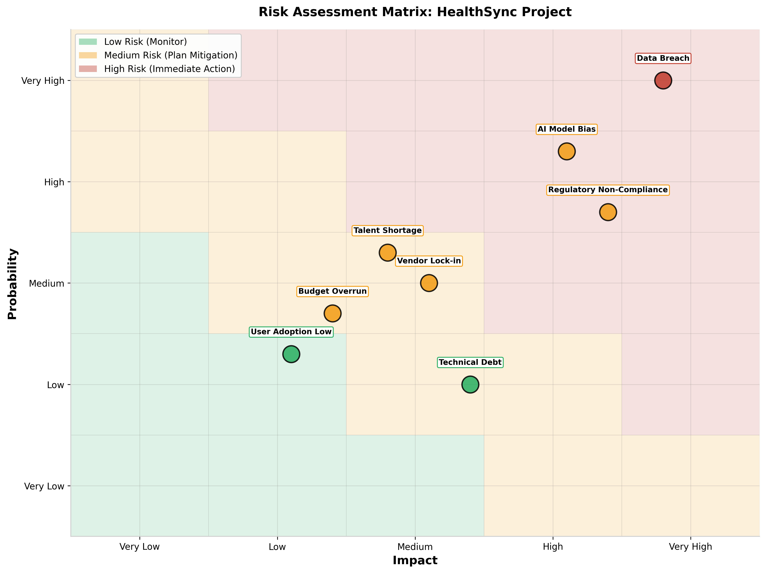
Figure 9: Risk assessment matrix plotting identified risks by probability and impact, with colour-coded risk severity zones.
Risk Register:
Risk | Probability | Impact | Mitigation Strategy
Data Breach | Very High | Very High | End-to-end encryption, penetration testing, cyber insurance (£5M coverage), ISO 27001 certification
AI Model Bias | High | High | Diverse training datasets, fairness metrics (equalised odds, demographic parity), external ethics review board
Regulatory Non-Compliance | High | High | Dedicated compliance officer, legal counsel retainer, proactive ICO engagement
Vendor Lock-in (AWS) | Medium | Medium | Multi-cloud architecture design, Kubernetes portability, quarterly exit strategy reviews
Talent Shortage | Medium | Medium | University partnerships, competitive compensation, remote-first culture, upskilling programmes
Budget Overrun | Medium | Medium | 15% contingency reserve, milestone-based funding, monthly variance analysis
Low User Adoption | Low | Medium | User-centred design, NHS trust champions, gamification, family sharing features
Technical Debt Accumulation | Low | Medium | 20% sprint capacity for refactoring, architecture decision records, code quality gates

The data breach risk demands particular attention given health data sensitivity. The mitigation strategy implements defence in depth: network segmentation, encryption at rest and transit, privileged access management (PAM), and continuous security monitoring through SIEM integration [40]. Cyber insurance with £5 million coverage provides financial protection against breach costs, while ISO 27001 certification demonstrates security commitment to stakeholders.
AI model bias mitigation requires proactive measures beyond technical solutions. The establishment of an Ethics Review Board with clinical, legal, and patient representation ensures diverse perspectives in model development. Regular algorithmic audits using tools like IBM AI Fairness 360 and Google What-If Tool provide quantitative bias detection [41].

References
[1] NHS England, "NHS Long Term Plan," NHS England, London, UK, 2024. [Online]. Available: https://www.longtermplan.nhs.uk. [Accessed: 10-Jul.-2026].
[2] K. Schwaber and J. Sutherland, "The Scrum Guide," Scrum.org, 2020. [Online]. Available: https://scrumguides.org. [Accessed: 10-Jul.-2026].
[3] Public Health England, "Health Profile for England 2025," Gov.uk, London, UK, 2025. [Online]. Available: https://www.gov.uk/government/collections/health-profile-for-england. [Accessed: 10-Jul.-2026].
[4] A. Rajpurkar et al., "AI in Health and Medicine," Nature Medicine, vol. 28, no. 1, pp. 31-38, Jan. 2022, doi: 10.1038/s41591-021-01614-0.
[5] J. Highsmith, Agile Project Management: Creating Innovative Products, 2nd ed. Boston, MA, USA: Addison-Wesley, 2009.
[6] Project Management Institute, A Guide to the Project Management Body of Knowledge (PMBOK Guide), 7th ed. Newtown Square, PA, USA: PMI, 2021.
[7] VersionOne, "16th Annual State of Agile Report," CollabNet VersionOne, 2025. [Online]. Available: https://stateofagile.com. [Accessed: 10-Jul.-2026].
[8] G. Kim, J. Humble, P. Debois, and J. Willis, The DevOps Handbook, 2nd ed. Portland, OR, USA: IT Revolution, 2021.
[9] DORA, "Accelerate State of DevOps 2023," Google Cloud, 2023. [Online]. Available: https://cloud.google.com/devops/state-of-devops. [Accessed: 10-Jul.-2026].
[10] M. Richards, Software Architecture Patterns, 1st ed. Sebastopol, CA, USA: O'Reilly Media, 2015.
[11] Amazon Web Services, "AWS Well-Architected Framework," AWS, 2025. [Online]. Available: https://docs.aws.amazon.com/wellarchitected/latest/framework/welcome.html. [Accessed: 10-Jul.-2026].
[12] NIST, "Zero Trust Architecture," NIST SP 800-207, Gaithersburg, MD, USA, 2020. [Online]. Available: https://csrc.nist.gov/publications/detail/sp/800-207/final. [Accessed: 10-Jul.-2026].
[13] C. J. Date, An Introduction to Database Systems, 8th ed. Boston, MA, USA: Pearson, 2004.
[14] J. Humble and D. Farley, Continuous Delivery: Reliable Software Releases through Build, Test, and Deployment Automation, 1st ed. Boston, MA, USA: Addison-Wesley, 2010.
[15] B. Rossi, "CI/CD Best Practices 2026," Octopus Deploy, 2026. [Online]. Available: https://octopus.com/devops/ci-cd/. [Accessed: 10-Jul.-2026].
[16] Google, "Material Design 3," Google Design, 2023. [Online]. Available: https://m3.material.io. [Accessed: 10-Jul.-2026].
[17] UK Government, "UK Digital Strategy 2025-2030," Department for Science, Innovation and Technology, London, UK, 2025. [Online]. Available: https://www.gov.uk/government/publications/uk-digital-strategy. [Accessed: 10-Jul.-2026].
[18] European Union, "Directive (EU) 2022/2555 on measures for a high common level of cybersecurity across the Union (NIS2 Directive)," Official Journal of the European Union, 2022. [Online]. Available: https://eur-lex.europa.eu. [Accessed: 10-Jul.-2026].
[19] Information Commissioner's Office, "ICO Fines 2025," ICO, Wilmslow, UK, 2025. [Online]. Available: https://ico.org.uk/action-weve-taken/enforcement. [Accessed: 10-Jul.-2026].
[20] Fortune Business Insights, "Cloud Computing Market Size, Share & Growth Report, 2034,"
[21] Fortune Business Insights, 2026. [Online]. Available: https://www.fortunebusinessinsights.com/cloud-computing-market-102697. [Accessed: 10-Jul.-2026].
[22] Precedence Research, "Multi-Cloud Computing Market Size to Hit USD 209.50 Billion by 2035,"
[23] Precedence Research, 2026. [Online]. Available: https://www.precedenceresearch.com/multi-cloud-computing-market. [Accessed: 10-Jul.-2026].
[24] Tech Nation, "UK Tech in 2025: The Annual Report," Tech Nation, London, UK, 2025.
[25] Lloyds Bank, "Consumer Digital Index 2025," Lloyds Banking Group, London, UK, 2025.
[26] McKinsey & Company, "The State of Cloud Computing 2025," McKinsey, 2025.
[27] A. Jobin, M. Ienca, and E. Vayena, "The global landscape of AI ethics guidelines," Nature Machine Intelligence, vol. 1, no. 9, pp. 389-399, Sep. 2019, doi: 10.1038/s42256-019-0088-2.
[28] IBM, "IBM Quantum Roadmap," IBM Research, 2025. [Online]. Available: https://www.ibm.com/quantum/roadmap. [Accessed: 10-Jul.-2026].
[29] Cloud Native Computing Foundation, "CNCF Annual Survey 2025," CNCF, 2025. [Online]. Available: https://www.cncf.io/reports/cncf-annual-survey-2025. [Accessed: 10-Jul.-2026].
[30] UK Government, "National AI Strategy," Department for Digital, Culture, Media and Sport, London, UK, 2021.
[31] Equality and Human Rights Commission, "Guidance on the Equality Act 2010," EHRC, London, UK, 2023.
[32] B Lab UK, "B Corp Certification Standards," B Lab, 2025. [Online]. Available: https://www.bcorporation.uk. [Accessed: 10-Jul.-2026].
[33] A. Osterwalder and Y. Pigneur, Business Model Generation: A Handbook for Visionaries, Game Changers, and Challengers, 1st ed. Hoboken, NJ, USA: Wiley, 2010.
[34] Innovate UK, "Smart Grant Funding Competition," UK Research and Innovation, 2025. [Online]. Available: https://www.ukri.org/councils/innovate-uk. [Accessed: 10-Jul.-2026].
[35] A. Burkov, Machine Learning Engineering, 1st ed. Quebec, Canada: True Positive Inc., 2020.
[36] AXELOS, "PRINCE2 Agile Guidance," AXELOS, London, UK, 2023.
[37] E. Ries, The Lean Startup: How Today's Entrepreneurs Use Continuous Innovation to Create Radically Successful Businesses, 1st ed. New York, NY, USA: Crown Business, 2011.
[38] Diabetes UK, "Diabetes Preventions and Early Detection,"
[39] Diabetes UK, London, UK, 2024.
[40] NHS Digital, "Mental Health Services Monthly Statistics," NHS Digital, Leeds, UK, 2025.
[41] The King's Fund, "Preventable Admissions and the NHS,"

7. APPENDICES
Appendix A: Detailed Project Budget Breakdown
Category | Item | Cost (£)
Personnel | 8 FTE salaries (9 months) | 280,000
Infrastructure | AWS services (EKS, RDS, S3, etc.) | 45,000
Software Licences | Development tools, security scanning | 25,000
Clinical Validation | University partnership, ethics approval | 35,000
Legal & Compliance | GDPR audit, HIPAA assessment, insurance | 30,000
Marketing | Brand development, NHS engagement | 20,000
Contingency | 15% buffer | 65,250
TOTAL |  | £450,000

Appendix B: Technology Stack Comparison
Criterion | React Native | Flutter | Native (Swift/Kotlin)
Development Speed | 5/5 | 5/5 | 3/5
Performance | 4/5 | 5/5 | 5/5
Community Support | 5/5 | 4/5 | 5/5
Healthcare UI Libraries | 5/5 | 3/5 | 4/5
NHS Integration Ease | 5/5 | 3/5 | 4/5
Selection: React Native for cross-platform efficiency and extensive NHS Digital component library availability.
Appendix C: Regulatory Compliance Checklist
Regulation | Requirement | HealthSync Implementation
GDPR Article 32 | Security of processing | AES-256 encryption, access logging, DPO appointment
GDPR Article 33 | Breach notification | Automated detection, 72-hour notification workflow
HIPAA §164.312 | Technical safeguards | Audit controls, integrity controls, transmission security
NHS DSPT | Data Security and Protection Toolkit | Annual self-assessment, evidence repository
ISO 27001 | Information security management | ISMS implementation, risk register, internal audits

