

UWTSD MBA HKBM7015
HKBM7015 Change and Stability Management

An Analytical Report to evaluate Tai Hing Group Change

Student Name | ： | Yin Ho, Tong (Tommy)
Student ID Number | ： | 2322644
Date of Submission | ： | 28 April 2024
Lecturer | ： | Dr. Joe Leung

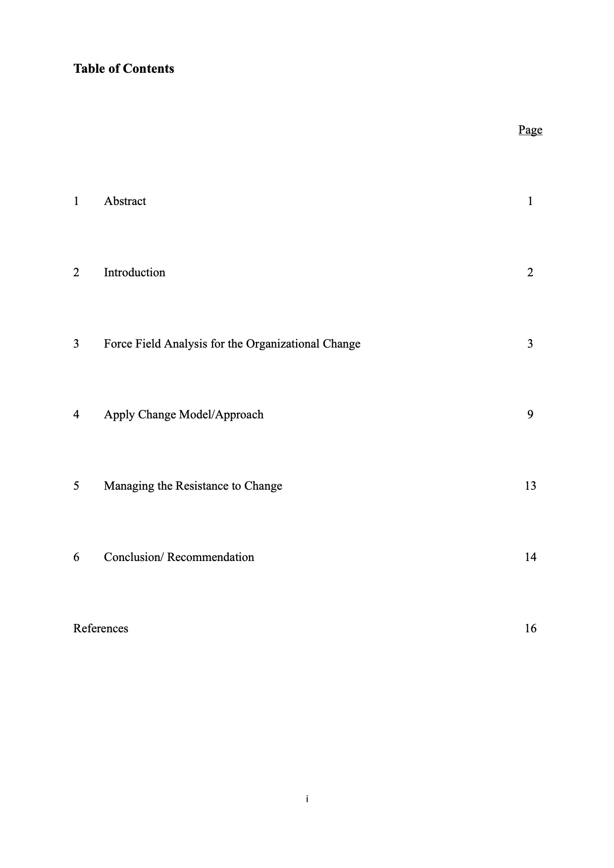
11
Abstract
This report analyzes the organizational change at Tai Hing Group, focusing on key elements for successful change implementation. It includes a Force Field Analysis to understand the driving and restraining forces affecting the change, an application of a Change Model, an examination of leadership during the change process, strategies for driving successful organizational change, and effective methods for managing resistance to change. By examining these aspects, we gain insights into the change initiative's effectiveness and identify areas for improvement. The report also highlights the potential benefits of embracing the transformation.

Key Focus Areas:
- Force Field Analysis: Understand the driving and restraining forces affecting change.
- Change Model Application: Guide the change process.
- Leadership Style: Examine the role of leadership in driving change.
- Strategies for Successful Change: Implement best practices for change.
- Managing Resistance to Change: Overcome challenges and resistance.

Expected Outcomes:
- Insights into Change Effectiveness: Gain insights into the effectiveness of the change initiative.
- Identification of Improvement Areas: Identify areas for improvement in the change process.
- Realization of Potential Benefits: Highlight the potential benefits of embracing the transformation.

- Introduction
Tai Hing Group Holdings Limited, established in 1989(Tai Hing, 2023), has grown from a single restaurant to become one of the largest multi-brand casual dining restaurant operators in Hong Kong. Listed on the Hong Kong Stock Exchange (HKEX) in June 2019(ETnet, 2019), the group operates approximately 200 restaurants across Hong Kong, Macau, and China, employing around 7,000 staff.
Recent Challenges:
Tai Hing Group has faced significant challenges in recent years. Revenue declined by approximately 15.7% to HK$2,675 million in FY2022(Tai Hing, 2022) compared to HK$3,173 million in FY2021(Tai Hing, 2021). This decline is primarily attributed to the impact of the COVID-19 pandemic and related control measures, which disrupted operations and affected consumer demand.
Profitability has also been negatively impacted, with the group reporting a loss attributable to owners of HK$43.2 million in FY2022.
In addition to the pandemic's impact, the catering industry experienced further challenges due to changing consumer behavior (Focus Economics, 2024). Hong Kongers shifted their consumption patterns towards "northbound consumption," traveling to mainland China for various purposes, including dining and shopping (Danyl Lim, 2024). This shift further affected the local restaurant industry, including Tai Hing Group's operations.
The purpose of this organizational change analysis report is to evaluate the change initiatives undertaken by Tai Hing Group in response to these challenges, assess their effectiveness, and identify areas for improvement to ensure the company's long-term success and sustainability.
2 Force Field Analysis for the Organizational Change
This section employs Force Field Analysis, a technique introduced by Kurt Lewin in 1943(Kurt Lewin,1943), to evaluate the driving and restraining forces that influence the proposed organizational change at Tai Hing Group. This analysis aims to uncover the dynamics of change within the organization and identify areas that require intervention for successful implementation.
By examining the interplay between driving forces, which push for change, and restraining forces, which resist change, we gain insights into the complexity of the change process and can develop strategies to overcome challenges and leverage opportunities.

Force Field Analysis graph 1
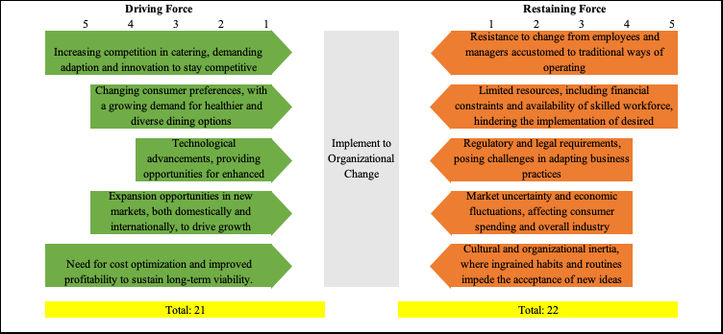

Driving Forces:
- Increasing competition in the restaurant industry, demanding adaptation and innovation to stay competitive. (KPMG, 2016)
- Changing consumer preferences, with a growing demand for healthier and diverse dining options. (Portis Global, 2023)
- Technological advancements, providing opportunities for enhanced customer service and operational efficiency. (Forbes, 2023)
- Expansion opportunities in new markets, both domestically and internationally, to drive growth. (People’s Daily, 2024)
- Need for cost optimization and improved profitability to sustain long-term viability.
(PWC, 2024)

Restraining Forces:
- Resistance to change from employees and managers accustomed to traditional ways of operating.
- Limited resources, including financial constraints and availability of skilled workforce, hindering the implementation of desired changes.
- Regulatory and legal requirements, posing challenges in adapting business practices.
- Market uncertainty and economic fluctuations, affecting consumer spending and overall industry performance.
- Cultural and organizational inertia, where ingrained habits and routines impede the acceptance of new ideas.

The force field analysis highlights the need for Tai Hing Group to carefully navigate the interplay of these driving and restraining forces, but the restraining force with total scoring of 22 by comparing to driving force of 21. Therefore, more force field analysis is needed for Force Field Analysis graph 2.

Force Field Analysis graph 2
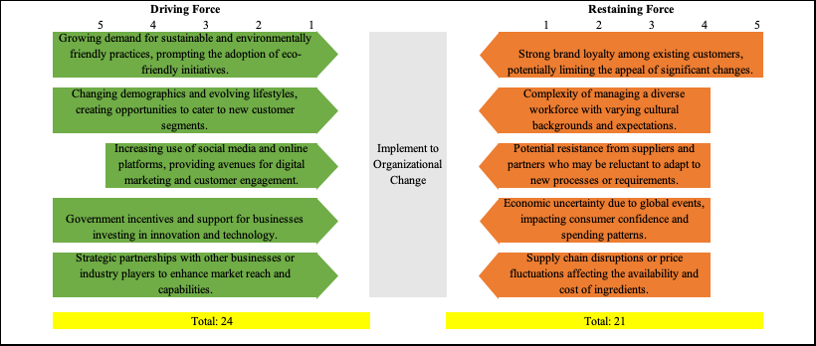

Additional Driving Forces for Tai Hing Group:
- Growing demand for sustainable and environmentally friendly practices, prompting the adoption of eco-friendly initiatives. (WhaTech, 2024)

- Changing demographics and evolving lifestyles, creating opportunities to cater to new customer segments. (McKinsey & Company, 2021)
- Increasing use of social media and online platforms, providing avenues for digital marketing and customer engagement. (Global Newswire, 2024)
- Government incentives and support for businesses investing in innovation and technology. (Deloitte, 2023)
- Strategic partnerships with other businesses or industry players to enhance market reach and capabilities. (Investopedia, 2017)

Additional Restraining Forces for Tai Hing Group:
- Strong brand loyalty among existing customers, potentially limiting the appeal of significant changes.
- Complexity of managing a diverse workforce with varying cultural backgrounds and expectations.
- Potential resistance from suppliers and partners who may be reluctant to adapt to new processes or requirements.
- Economic uncertainty due to global events, impacting consumer confidence and spending patterns.
- Supply chain disruptions or price fluctuations affecting the availability and cost of ingredients.
By considering these additional forces in the Force Field Analysis, Tai Hing Group gains a comprehensive understanding of the challenges and opportunities associated with organizational change. The total score of driving forces is 24, while the total score of restraining forces is 21. This indicates that the driving forces hold a slight advantage, suggesting that the conditions are favorable for successful change implementation.
However, Tai Hing Group must recognize the dynamic and complex nature of the restaurant industry. The force field analysis highlights the need for continuous monitoring and adaptation to ensure successful organizational change. By developing a well-rounded strategy that leverages the driving forces and addresses the restraining forces, Tai Hing Group can navigate the challenges and capitalize on the opportunities presented by the changing landscape.

3 Apply Change Model/Approach
By echoing for apply change to Tai Hing Group, in which they can benefit from implementing John Kotter's 8-Step Change Model to successfully navigate organizational change. (John Kotter, 2012) This comprehensive framework provides a structured approach to guide Tai Hing Group through the complexities of change management, ensuring a smoother transition and increased likelihood of success.

Step 1: Create a Sense of Urgency

Tai Hing Group should initiate the change process by creating a compelling sense of urgency among its employees. This can be achieved by effectively communicating the need for change, emphasizing the external challenges and internal inefficiencies that demand transformation. By fostering a shared understanding of the urgency, Tai Hing Group can motivate its workforce to embrace and actively participate in the change process.

Step 2: Form a Powerful Guiding Coalition

The next step involves establishing a strong guiding coalition comprising influential leaders and change agents from various levels and departments within Tai Hing Group. This coalition should possess the necessary expertise, credibility, and commitment to drive the change initiative forward. By empowering this group to make decisions and take action, Tai Hing Group can ensure effective coordination and alignment throughout the organization.

Step 3: Develop a Change Vision and Strategy

Tai Hing Group should articulate a clear and inspiring vision for the future, outlining the desired outcomes of the change process. This vision should be accompanied by a well-defined strategy that outlines the specific steps and initiatives required to achieve the desired transformation. By communicating this vision and strategy effectively, Tai Hing Group can gain buy-in from employees and stakeholders, fostering a shared sense of purpose and direction.

Step 4: Communicate the Change Vision

Effective communication is crucial for successful change management. Tai Hing Group should develop a comprehensive communication plan to disseminate the change vision, strategy, and progress updates to all employees. This can be achieved through various channels, including town hall meetings, internal newsletters, and regular updates from leaders. By ensuring transparent and consistent communication, Tai Hing Group can build trust, reduce resistance, and maintain employee engagement throughout the change process.

Step 5: Empower Employees for Broad-Based Action

Empowering employees is essential for successful change implementation. Tai Hing Group should provide employees with the necessary resources, training, and support to enable them to take ownership of the change process. This involves removing barriers, delegating responsibilities, and encouraging employees to contribute their ideas and suggestions. By fostering a culture of empowerment, Tai Hing Group can harness the collective knowledge and creativity of its workforce, leading to more effective and sustainable change.

Step 6: Generate Short-Term Wins

Creating short-term wins is crucial for maintaining momentum and motivation during the change process. Tai Hing Group should identify and celebrate small successes along the way, recognizing and rewarding employees who contribute to these achievements. By acknowledging progress and celebrating milestones, Tai Hing Group can reinforce the positive aspects of change, boost employee morale, and sustain enthusiasm for the long-term transformation.

Step 7: Don’t Let Up

As Tai Hing Group achieves initial successes, it is important to consolidate these gains and continue driving further change. This involves institutionalizing the changes that have been implemented, ensuring they become embedded in the organization's culture and practices. By building on the momentum generated from short-term wins, Tai Hing Group can sustain the change process and achieve more significant and lasting transformation.

Step 8: Make Changes Stick

The final step involves anchoring the changes in Tai Hing Group's corporate culture. This requires aligning the organization's values, beliefs, and behaviors with the desired change. Tai Hing Group should reinforce the new ways of working, celebrating successes, and continuously reinforcing the importance of change. By integrating the changes into the organization's culture, Tai Hing Group can ensure long-term sustainability and resilience in the face of future challenges.

By diligently applying John Kotter's 8-Step Change Model, Tai Hing Group can systematically navigate the complexities of organizational change, increasing the likelihood of a successful transformation that drives improved performance, adaptability, and long-term success in the competitive restaurant industry.

4 Leadership and Implementing Successful Organizational Change
Tai Hing Group's should adop authoritarian (autocratic) leadership style, (Burn, 1978) characterized by top-down management, has proven effective in driving sustainable organizational change. (Bass, 1985) This leadership approach aligns with the Six Core Themes and Practices in leading organizational change, as outlined by renowned scholar John Kotter: (John Kotter, 2012)
1. Vision:
Tai Hing Group's authoritarian leadership ensures a clear and compelling vision for the organization's future. The top-down approach allows leaders to effectively communicate their vision and strategic direction, ensuring that all employees are aligned and focused on achieving the desired outcomes.
2. Purpose:
The authoritarian leadership style emphasizes a shared sense of purpose and mission within the organization. Leaders clearly articulate the "why" behind the change, fostering a strong sense of commitment and motivation among employees.
3. Shared Value:
Tai Hing Group's top-down management approach facilitates the establishment of shared values and beliefs throughout the organization. Leaders set the tone and expectations, ensuring that employees understand and embrace the core values that guide the change process.
4. Strategy:
The authoritarian leadership style enables the development and implementation of a well-defined strategy for organizational change. Leaders make strategic decisions and provide clear direction, ensuring that all efforts are aligned and focused on achieving the desired goals.
5. Empowerment:
Despite its top-down nature, Tai Hing Group's authoritarian leadership style also emphasizes employee empowerment. Leaders delegate responsibilities and provide employees with the necessary resources and support to execute their tasks effectively.
6. Engagement:
The authoritarian leadership approach fosters employee engagement by creating a structured and disciplined work environment. Employees understand their roles and responsibilities, and they are held accountable for their performance. This accountability contributes to a high level of engagement and commitment to the change process.

By effectively applying these Six Core Themes and Practices, Tai Hing Group's authoritarian leadership style creates a conducive environment for successful organizational change. The clear vision, shared purpose, strong values, well-defined strategy, employee empowerment, and high engagement contribute to the organization's ability to adapt, innovate, and thrive in a dynamic and competitive business landscape.

Furthermore, the authoritarian leadership style provides several additional advantages in the context of organizational change:

1. Swift Decision-Making:
In times of change, quick and decisive decision-making is crucial. The top-down approach allows leaders to make decisions promptly, ensuring that the organization can respond swiftly to challenges and opportunities.

2. Clear Accountability:
The authoritarian leadership style clearly defines roles and responsibilities, making it easier to hold individuals accountable for their actions. This accountability promotes discipline and ensures that change initiatives are executed effectively.

3. Consistency in Implementation:
Top-down management ensures that change initiatives are implemented consistently throughout the organization. This consistency is essential for successful change, as it prevents confusion and ensures that all employees are working towards the same goals.

4. Crisis Management:
In times of crisis or uncertainty, an authoritarian leadership style can provide stability and reassurance to employees. The clear direction and decisive decision-making of leaders can help the organization navigate difficult situations and emerge stronger.

5. Managing the Resistance to Change
It is important to note that Tai Hing applying authoritarian leadership style also has its limitations such as “Resistance to Change”. Organizational change often encounters resistance from various stakeholders, (The Economic Times, 2023) and Tai Hing Group is no exception. To effectively manage and overcome resistance, it is essential to understand the underlying aspects that contribute to this phenomenon.
1. Individual's Predisposition Toward Change:
Some individuals are inherently more resistant to change than others. Factors such as personality traits, past experiences, and personal values can influence an individual's openness to change. For instance, employees who are risk-averse or have a preference for stability may be more resistant to change initiatives.
Strategies:
- Communication and Education: Provide clear and transparent information about the change, its rationale, and the benefits it will bring. This helps to address misconceptions and build understanding.
- Involvement and Participation: Encourage employees to participate in the change process by seeking their input, ideas, and suggestions. This fosters a sense of ownership and reduces resistance.
- Role Modeling: Encourage leaders and change agents to embrace and demonstrate the desired change. Their positive attitudes and behaviors can influence others to follow suit.
2. Surprise and Fear of the Unknown:
Sudden and unexpected changes can create uncertainty and anxiety among employees. The fear of the unknown can lead to resistance as individuals struggle to adapt to the new situation.
Strategies:
- Gradual Implementation: Introduce changes gradually to allow employees time to adjust and become comfortable with the new ways of working.
- Clear Communication: Provide regular updates and information about the change process to reduce uncertainty and alleviate fears.
- Support and Training: Offer training and support to employees to help them develop the skills and knowledge needed for the change.
3. Climate of Mistrust:
A lack of trust between employees and management can significantly amplify resistance to change. When employees perceive that the change is being imposed on them without their input or consideration, they are more likely to resist.
Strategies:
- Build Trust: Foster a culture of trust and transparency by involving employees in decision-making processes and demonstrating genuine care for their well-being.
- Open Communication: Encourage open dialogue and feedback to address concerns and build trust.
- Demonstrate Fairness: Ensure that the change process is perceived as fair and equitable, with benefits distributed justly among all stakeholders.
4. Fear of Failure:
The fear of failing to adapt to the change or not being able to perform effectively in the new environment can lead to resistance. This fear is particularly strong when the change involves new technologies or processes that employees are unfamiliar with.
Strategies:
- Training and Development: Provide comprehensive training and support to equip employees with the necessary skills and knowledge to succeed in the changed environment.
- Mentorship and Coaching: Offer mentorship and coaching programs to help employees transition smoothly and gain confidence in their abilities.
- Positive Reinforcement: Recognize and reward employees who successfully embrace and contribute to the change.
5. Loss of Status and/or Job Security:
Changes that involve restructuring, job redesign, or automation can trigger fears of losing status, power, or even job security. These concerns can lead to strong resistance from affected employees.
Strategies:
- Clear Communication: Communicate openly about the impact of the change on jobs and roles. Address concerns and provide clarity on how employees will be supported during the transition.
- Redeployment and Upskilling: Offer opportunities for redeployment or upskilling to help employees transition to new roles within the organization.
- Outplacement Support: Provide outplacement services and support to assist employees who may be affected by job loss.
By understanding and addressing these key aspects of resistance to change, Tai Hing Group can develop targeted strategies to mitigate resistance and create a more conducive environment for successful organizational change.

6. Conclusion/Recommendation
Tai Hing Group has the potential to achieve successful organizational change by addressing the challenges it faces and implementing strategic initiatives. Here are some key recommendations:
1. Enhance Customer Communication:
- Establish a dedicated customer service department to promptly address customer inquiries, complaints, and feedback.
- Implement a customer relationship management (CRM) system to centralize customer data and improve personalized communication.
- Regularly conduct customer surveys and use the insights to continuously improve products, services, and customer experiences.
2. Establish Corporate Social Responsibility (CSR) Department:
- Create a CSR department to promote Tai Hing Group's commitment to sustainability, ethical practices, and community engagement.
- Develop initiatives that focus on reducing environmental impact, supporting local communities, and promoting Hong Kong's traditional BBQ food and food safety standards.
- Communicate CSR efforts effectively to customers, stakeholders, and the general public to enhance brand reputation and foster trust.
3. Restructure for Profitability:
- Conduct a comprehensive analysis of product profitability and customer preferences.
- Restructure the menu and operations to maximize the most profitable products, such as BBQ food.
- Offer strategic discounts and promotions on BBQ items to attract customers and increase sales.
4. Enhance Employee Training and Development:
- Provide comprehensive training programs for new hires, focusing on culinary skills, food safety, and customer service.
- Offer continuous training and development opportunities for existing employees to enhance their skills and knowledge.
- Implement a mentorship program to pair experienced cooks with new hires for on-the-job guidance and support.
5. Improve Food Quality Standards:
- Establish and enforce strict food safety and quality control procedures throughout the organization.
- Regularly conduct food safety audits and inspections to ensure compliance with regulations and standards.
- Invest in high-quality ingredients and update stir-fryer system to maintain and enhance food quality.
By implementing these recommendations, Tai Hing Group can overcome challenges, drive successful organizational change, and position itself for long-term growth and success in the competitive restaurant industry.


