Instrumentation and control assignment:

Sections to include:
Abstract: This report details the simulation of an angular positioning system for CIWS turret. Using Simulink to design a PID controlled closed-loop system, it was possible to create a system that met the transient response and overshoot limits set out within the brief. Additionally, such a system has been assessed to be stable, robust, and has no steady state error. These assessments were made by examining the time response of the system, as well as analysing the Nyquist, Bode and Pole-Zero plots for the system, by using MatLab and the forward and closed loop transfer functions of the system.
Introduction: This report details the investigation into the performance of a simulated angular positioning control system for an automated Close-in Weapon System (CIWS) turret. The aim, as outlined in the brief for this task, was to create a control system that could achieve the task of bringing the process of an angular positioning system for a CIWS turret under control. The system had to do this within 2 seconds, and with no more than a 5% overshoot value.
Within this report can be found details of the simulation set-up and parameters used therein, the simulation results, discussion, and finally, conclusions from this task. However, the rest of this introduction section provides some background information on the nature of control systems and some of the surrounding theory that is relevant to understanding how they work and how they can be analysed.
What is a control system? A control system can be thought of as a collection of connected components and processes that takes an input signal from the environment, in order to produce some form of output. This output signal will be the result of the combined effects of whatever components and processes make up the system. [1]
There are several examples of where control systems are used:
- Driverless car guidance system [1]
- Flywheel governor to regulate steam flow in a steam engine [2]
- An overhead crane positioning system [3]
Physical systems will make use of several components such as transducers, sensors, and actuators in their set-up. Transducers are devices which can convert energy from one form into another (usually physical phenomena are transferred into electrical signals). For example, mechanical energy can be turned into electrical energy via a piezo-electric crystal. Sensors, which can be passive or active, provide measurement of electrical signals. Finally, actuators are devices which an alter or influence the environment, such as an electric motor used to rotate a gun turret. [1] [4]
Control systems can be placed into two categories. Open and closed-loop systems. An open loop system takes inputs signals from the environment and produces an output signal that is not monitored in any way. For example, a punch-card controlled loom would take the input of the punch-card in order to weave a piece of fabric. However, if an error occurs in the cards or some other factor from the environment, this will not be detected by the system, which will continue to weave the fabric. [2] In contrast to this, a closed loop system has some form of feedback mechanism that allows it to monitor the output signal and feed this back into the system alongside any inputs from the environment. Diagrams of both these types of system can be seen below:
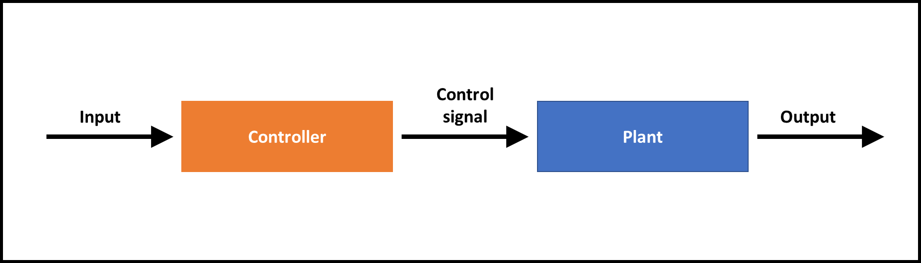
Figure 1 – open-loop control system [1]
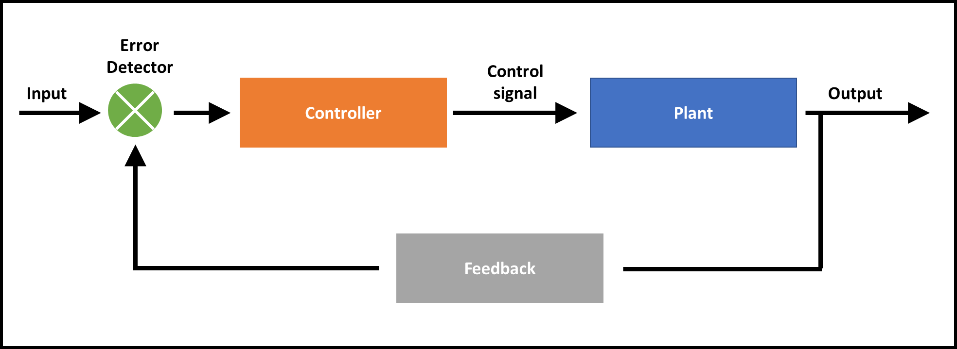
Figure 2 - closed-loop control system [5]
Within closed loop control systems, controllers are used to affect the plant in order to produce a desired output value also known as a “set-point”. They will do this by using a feedback and input signal to control the plant and affect the output signal until it reaches the set-point. [5] Controllers can be either discrete or continuous. A discrete controller is very simple and essentially acts as a switch in order to bring the output value to the set-point. These kinds of controllers are simple and easy to implement, but they are not always efficient, and they do not settle on the set-point value. [6]
Continuous controllers can constantly control the plant to bring the output signal closer to the set-point. There are several different types of continuous controller: proportional (P), proportional-integral (PI), proportional-differential (PD), and proportional-integral-differential (PID) controllers. For the purposes of this assignment a PID controller would be used in the system simulation. This type of controller works by reducing the signal error through direct comparison with the error signal through the proportional control component. The integral aspect controls the plant signal by looking at how the integral of the error signal changes with time in order to help the output value reach the set-point. The differential aspect looks at how the rate of change of the error signal is changing with time in order to reduce the amount of overshoot of the system. [7]

Mathematical representations of systems:
To help study and understand a control system, a mathematical model can be used in order to represent a physical system and predict how it might behave. Different systems will require different mathematical models depending on the type of variables that affect the system. For time invariant closed-loop systems the transfer function is a good example of a mathematical model that can be used to analyse the transient or frequency responses of a system. For a linear time-invariant system, the transfer function G(s) is:
$$G\left(s\right)=\frac{X(s)}{Y(S)}$$
Equation 1 - Basic transfer function equation [5]
Where X(s) and Y(s) are the Laplace transforms of the system input and output respectively. [5] [8]
For a closed loop feedback control system, a more complex transfer function is used:
$$C\left(s\right)=\frac{G\left(s\right)}{1+G\left(s\right)H\left(s\right)}F(s)$$
Equation 2 - closed-loop feedback transfer function [5]
Whereby C(s) is the system output, G(s) is the forward transfer function, H(s) is the feedback transfer function and F(s) is the system input. This equation is used as the output is dependent on both the forward transfer function, the feedback transfer function and the input. [1]
For a system where there is feedback but no feedback transfer function, the system is said to be a unity feedback system. [9] This type of closed-loop system will have a transfer function of the form:
$$C\left(s\right)= \frac{G\left(s\right)}{1+G\left(s\right)}F(s)$$
Equation 3 - unity feedback closed-loop transfer function [5]
These mathematical models can be visually represented using block diagrams which can help to understand the flow of signals in the system. Each block represents the transfer function of a component and can be a useful visual aid. See below examples of block diagrams for closed-loop, and unity closed-loop control systems [5]:
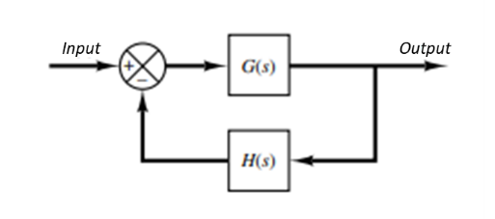
Figure 3 - closed-loop block diagram with feedback transfer function
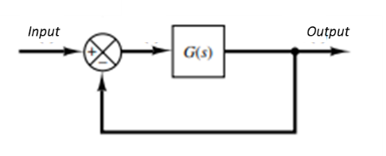
Figure 4 - unity closed-loop feedback block diagram
Ways of assessing performance and stability:
The stability of a system can be likened to the ability of the system to maintain its steady state for a range of inputs. I.e. the system output should converge on a desired value and not diverge from it. An example of an unstable system would be one that overcorrects when it overshoots the set point. This would lead to a run-away series of overcorrections. Any system overshoots should dampen with time to converge on the set-point. [10]
There are several different methods that can be used to determine whether or not a system will be stable or not. These include pole-zero plots, root-locus plots, Nyquist plots and Bode plots.
Pole-Zero plots
These can be used to visualise the stability of a system by plotting the transfer function in the S plane. This is composed of a Frequency (y) and Damping (x) axis. Poles are represented by Xs and zeros are represented by Os, they both represent areas where the Transfer function tends to infinity and zero respectively. These plots can be used to predict the time-domain response of a system by looking at the location of poles. Poles situated to the left of the origin represent stable systems, whereas poles to the right of origin represent unstable systems. Poles close to the origin represent slower stabilising/destabilising systems. Whereas poles further away from the origin represent rapidly stabilising/destabilising systems [11] [8]. See figure below:
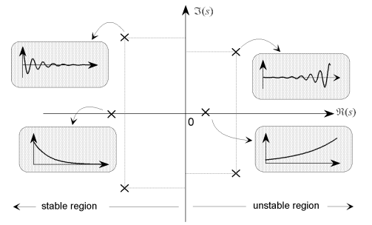
Figure 5 - Pole-Zero plot stability region analysis [11]
Nyquist plots
These are graphical representations of the forward transfer function only. They can be used to determine the stability of a system by looking at the number of times the plot encircles the origin of the graph. The Nyquist criterion is based off of Cauchy’s theorem which plots contours from the S plane onto the Complex plane. The details of how exactly this is achieved is beyond the scope of this report, suffice to say that for analysis purposes, as long as the contour plot does not encircle the origin point and is travelling clockwise then this indicates that the system is stable. It also indicates that there are no Poles or Zeros on the right-hand side of the S plane. They can also be used to identify the gain and phase margins for the system. [1] [10]
The gain margin is the amount of gain that would be required to make a system unstable. The greater the gain margin, the more stable the system. Similarly, the phase margin is the amount of phase shift that would be required for the system to become unstable. Again, the larger the margin, the more stable the system. [12]
Bode plots
These can be used to identify both the Gain and frequency margins as with Nyquist plots. However, they cannot be used to determine if a system will be stable or unstable. [8]

Simulation Setup
Simulink was used to create a model of the control system for the CIWS gun turret. Figure 6 shows the set-up below:
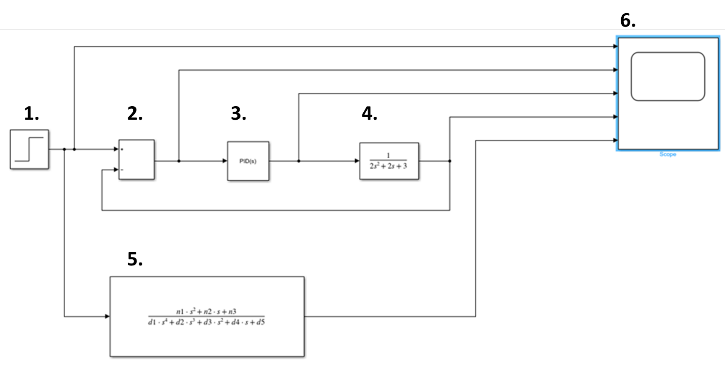
Figure 6 - Control system simulation layout in Simulink
The elements to this model are as follows:
- Step generator
- Comparator block with properties set to + -
- PID controller block
- Forward transfer function block
- Closed loop transfer function block
- Oscilloscope
The PID controller block was manually tuned until the response was within the brief parameters of a maximum 2 second response time as well as a 5% maximum overshoot value. See fig. 7 for the PID controller parameters which were used:
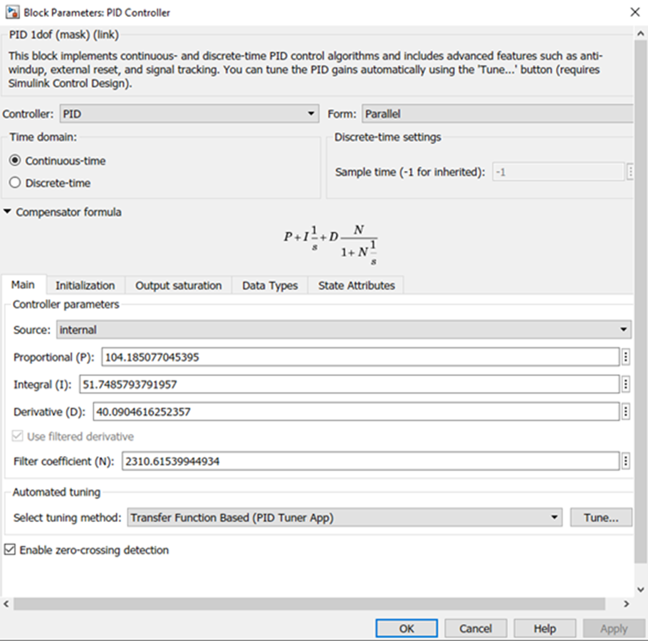
Figure 7 - PID controller block parameters.
These block parameters produced a system with the following transient response times and percentage overshoot:
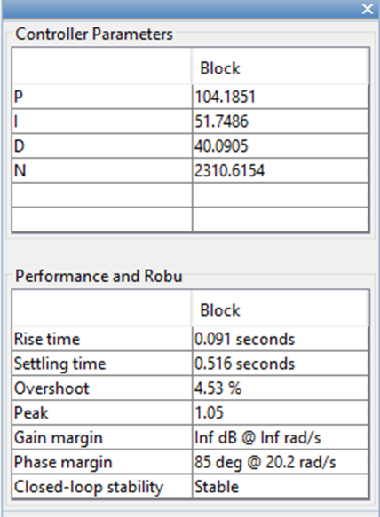
Figure 8 - Controller block parameters and performance information such as settling time and overshoot values.
The forward transfer function block had the following parameters:
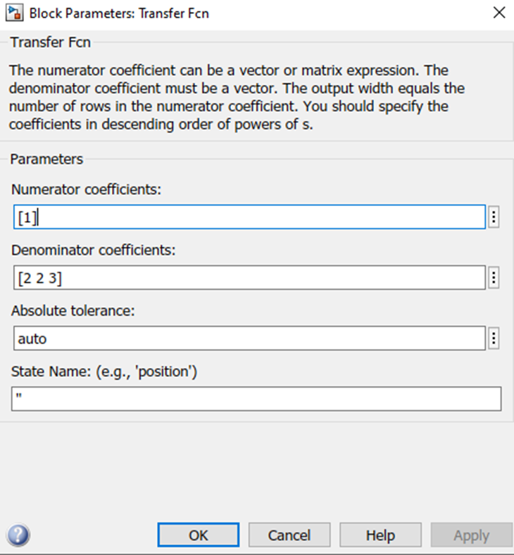
Figure 9 - Transfer function block parameters. (This block represented the plant in the system)
These values were pre-chosen and assigned as part of the investigation brief.
The Closed-loop transfer function had the following parameters:
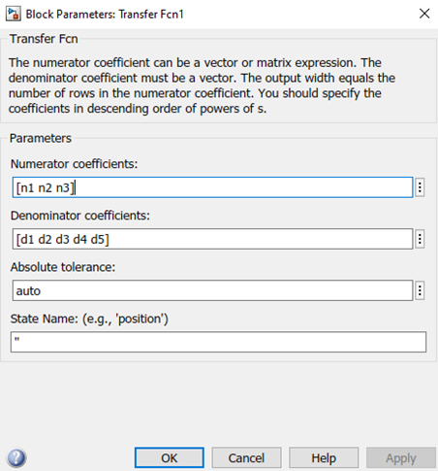
Figure 10 - Closed-loop transfer function block parameters.
Where the values of n1, n2, and n3 were equal to:
N1 = Kp+(N*Kd)
N2 = (Ki+(N*Kp))
N3 = N*Ki
And the values of d1, d2, d3, d4, and d5 were calculated using MatLab whereby d 1-5 were equal to:
D1 = a
D2 = (a*N)+b
D3 = Kp+(N*Kd)+(b*N)+c
D4 = (N*Kp)+Ki+(c*N)
D5 = N*Ki
Where Kp, Ki, Kd, and N, were taken from the proportional, integral, differential, and filter coefficient values from the PID controller block. And a, b, and c were also equal to 2, 2, and 3 respectively. Essentially the block represents the closed-loop system transfer function Equation 3 discussed in the introduction:
$$C\left(s\right)= \frac{G\left(s\right)}{1+G\left(s\right)}F(s)$$

In this case F(s) is equal to one and so can be discounted. G(s) is the forward transfer function which is equal to the product of the controller transfer function K(s) and the plant transfer function P(s) which are equal to:
$$K\left(s\right)=Kp+Ki\frac{1}{s}+Kd\frac{s}{\frac{1}{N}S+1}$$
Equation 4 - Simulation controller transfer function
$$P\left(s\right)= \frac{1}{{as}^{2}+bs+c}$$
Equation 5 - Simulation plant transfer function
By substituting G(s) for K(s)P(s), and expanding, then the closed loop transfer function for this system (C(s)) results in:
$$C\left(s\right)=\frac{\left(Kp+KdN\right)s^{2}+\left(KpN+Ki\right)s+KiN}{{as}^{4}+{\left(Na+b\right)s}^{3}+{\left(Nb+c+Kp+KdN\right)s}^{2}+\left(Nc+KpN+Ki\right)s+KiN}$$
Equation 6 - Simulation unity closed-loop transfer function

Hence the nature of the variables of N1-3 and D1-5. The values for a, b, and c were 2, 2, and 3 respectively. Which, as previously stated, were pre-chosen and assigned as part of the brief.
Results:
Below can be seen images of the various graphs plotted using MatLab from the simulations run using the set-up described in the previous section:
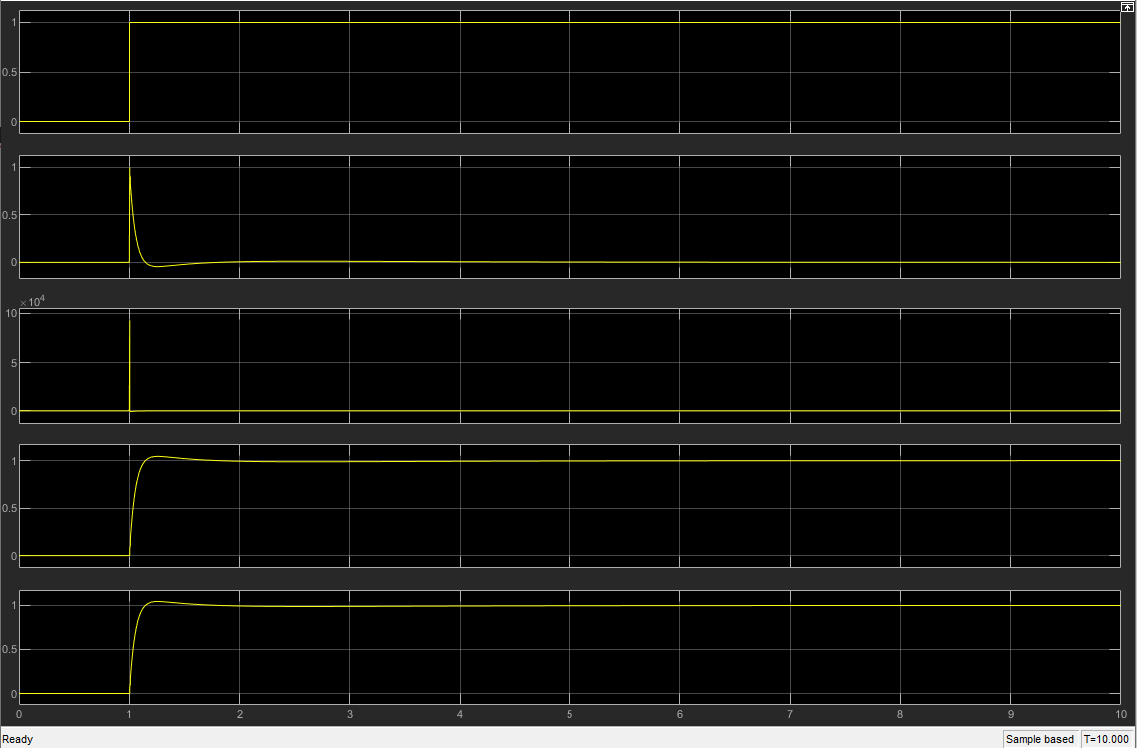
Figure 11 - Oscilloscope signal response graphs showing from top to bottom: step generator signal, error signal, controller signal, forward transfer function singal, and system transfer function signal

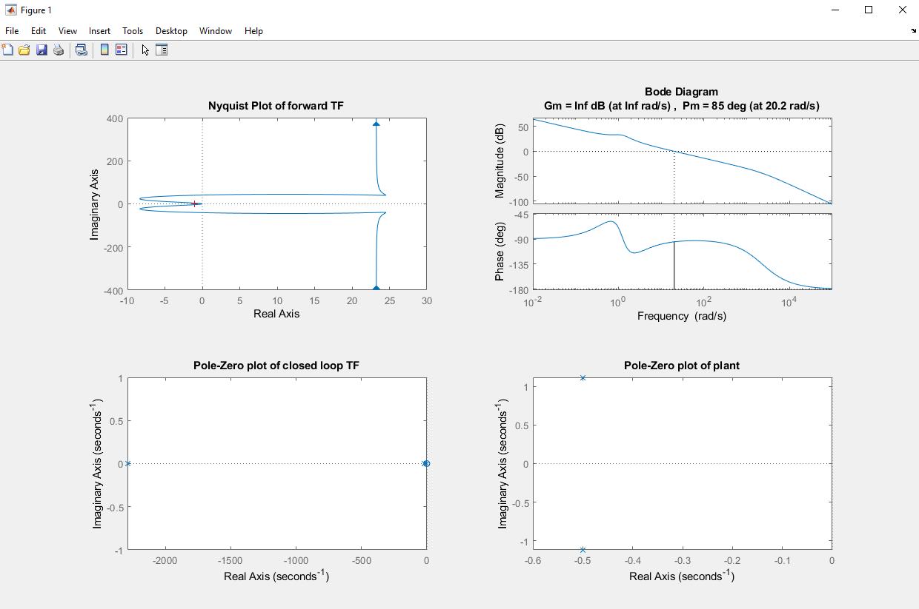
Figure 12 - image of the Nyquist plot for the forward transfer signal of the system.
Figure 13 - Bode plot for the forward transfer function. Note the values displayed for the Gain margin (Gm) adn teh Phase margin (Pm) at the top of the image.
Figure 14 - Image of the Pole-Zero plot for the closed loop transfer function. Note that all poles and zeros are to the left of the imaginary axis (negative portion of the real axis). Poles represented by crosses and Zeros represented by circles
Figure 15 - Pole-Zero plot for the plant. Note that the poles are to the left of the imaginary axis.
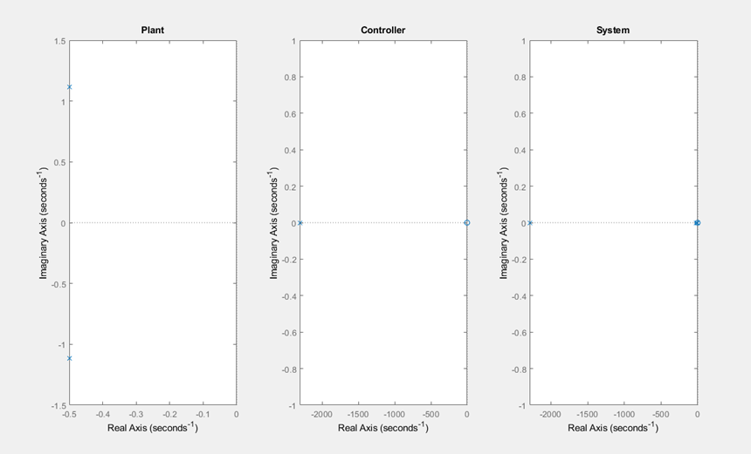
Figure 16 - Pole-Zero plots comparing the Plant, Controller, and System transfer functions. Note that all poles in all plots are to the left of the imaginary axis.
Discussion:
The initial image from the oscilloscope (fig. 11) is a good visual representation of the signal responses at different points in the system. The final graph shows the response of the whole closed loop system transfer function. It can be seen from the graph that the system maintains a transient response time of about half a second, and that the overshoot is less than 5%. The steady state error is 0 as the output signal converges onto the set-point value of the step signal.
The Nyquist plot (fig. 12) does not encircle the origin and is in a clockwise rotation. From this it can be deduced that the system is stable [1], and that there are no poles or zeros present on the right of the imaginary axis in any Pole-Zero plots for the forward transfer function.
The Bode plot (fig 13) clearly shows that the gain margin for the system is infinite, and that the phase margin for the system is 85 degrees. The infinite gain margin means that no matter how much gain is added to this system it will not become unstable. With the phase margin value, typically a phase margin above 45 degrees is considered acceptable for a stable system [12], and so a phase margin value of 85 degrees shows that the system is robust to changes in phase shift.
The pole-zero plot of the closed loop transfer function (fig. 14) indicates that the system is stable, due to the fact that all poles are located on the left-hand side of the graph (negative portion of the real axis). The proximity of these poles to the imaginary axis indicates a response closer to an exponential decay in error signal opposed to an exponentially decaying sinusoidal response. The existence of poles far away from the origin point indicates a fast response time to the system. This concurs with the evidence from the oscilloscope read-outs which indicate a fast response time.
The pole zero plot of the plant (fig. 15) indicates that the plant alone is a stable system due to the poles being a complex conjugate pair. The fact that they do not exist on the real axis means that the response will be an exponentially decaying sinusoidal signal. The close proximity of the poles to the origin also indicates a longer response time.
Finally, the plant, controller, system pole zero plots (fig. 16) allow for a side-by-side comparison to show that the both the system as a whole and all its elements are inherently stable. With all pole-zero plots having no poles appearing on the positive side of the real axis. It can also be seen that the controller and system plots have poles much further away from the origin of the graph. This supports the notion that it is indeed the controller which provides such a rapid response time for the whole system rather than the plant having a naturally high, and exponentially decaying response time.
Conclusion:
The results from this simulation clearly indicate that it is possible to successfully model the angular positioning system for a CIWS turret using Simulink. In addition, by using the values that were found using the PID tuner function, it has been shown that a simulation of a system that was within the parameters outlined in the brief (a 2s or less response time, and an overshoot value less than 5%) can be created. The system has been shown to have a transient response time of 0.5 seconds, and also has no steady state error, due to the nature of how a PID controller works.
Furthermore, by using the various stability analysis methods such as pole-zero plots, Nyquist and bode plots. It has been shown that such a system using these PID parameters is stable and robust against both gain, and phase-shift changes. Not only is the overall system itself stable, but the pole-zero plots individual components indicate that the plant itself (the forward transfer function) is also a stable system alongside both the controller and overall system performance.

References

[1] | R. D. a. R. Bishop, Modern Control Systems, Pearson Education, Limited, 2018.
[2] | Encyclopaedia Britannica Editors, "Encyclopaedia Britannica," August 2013. [Online]. Available: https://www.britannica.com/technology/control-system. [Accessed 01 January 2022].
[3] | P. T. T. P. X. D. N. D. P. Nga Thi-Thuy Vu, "Robust adaptive control of overhead 3D crane system," in Adaptive Robust Control systems, Online, 2018.
[4] | L. a. TimMellow, "Chapter Three - Electromechanoacoustical circuits," in Acoustics (sound fields, transducers, and vibration), Academic Press, 2019, pp. 81-141.
[5] | K. Ogata, Modern Control, Prentice Hall, 2010.
[6] | Y. B.R.Mehta, Industrial Process Automation Systems - Design and Implementation, Butterworth-Heinemann, 2015.
[7] | M. Z. Sy Najib Sy Nalim, Control SYstems Engineering, UTeM Press, 2010.
[8] | Control Systems - Classical, Modern, and AI-Based Approaches, Boca Raton: CRC Press, 2019.
[9] | W. Bolton, "Chapter 10 - system response," in Instrumentation and Control Systems, Newnes, 2021, pp. 227-256.
[10] | R. N. Clarke, Control System Dynamics, Cambridge University Press, 1996.
[11] | M. D. O. M. ENGINEERING, "Analysis and Design of Feedback Control Systems," MIT DEPARTMENT OF MECHANICAL ENGINEERING.
[12] | H. Zumbahlen, Linear Circuit Design Handbook, Newnes, 2008.

