
Master of Business Administration
International Business pathway



International Market Entry Strategy and Marketing Mix:
A Comparative Analysis of Cadbury in the United Kingdom and India

Assessment Component 1: Individual report. Weight: 100%

Module name: International Marketing: Principles and Practices
Module code: LCMB7026
Lecturer name: Aimr Homayounfard

Student name: HIRABEN RAMABHAI MODHAVADIYA
Student ID: 2532030

Word count: 5109
Submission date: 13th August 2026

AI Use Acknowledgement
I acknowledge the use of ChatGPT (OpenAI) (https://chatgpt.com/) during August 2026 for permitted support in this assignment.

Research and Data Analysis: Used to help find and compare relevant academic, industry and regulatory information about Cadbury and the UK and Indian markets.
Example prompts:
• “Find recent reliable sources on Cadbury in the UK and India.”
• “Compare relevant market and cultural data for the UK and India.”
Proofreading: Used to check my own writing for grammar, clarity and academic wording.
Example prompt:
• “Check this paragraph for grammar and clarity without changing my meaning.”
Creative Materials: Some figures were created by me, while ChatGPT was used to create selected figures based on information and analysis I had already prepared.
Example prompt:
• “Create an STP strategy figure for Cadbury in India showing segmentation, targeting and positioning.”

I confirm that I have not presented AI-generated text as my own work. AI was used only for permitted research/data analysis, proofreading and selected creative materials. It was not used to create the assignment structure, arguments, conclusions or reflective account. I have kept my drafts, notes and supporting materials as evidence if required.

Table of Contents
Section 1: International Market Entry Strategy and Marketing Mix of Cadbury in the United Kingdom and India 5
1. Introduction 5
2. Comparative Macro Environmental Analysis: PESTEL 5
3. Comparative Cultural Analysis: Hofstede's Cultural Dimensions 8
3.1 Advantages of the Hofstede framework 9
3.2 Limitations of the Hofstede framework 9
4. Comparative STP: Segmentation, Targeting and Positioning 9
5. Comparative International Marketing Mix: The 7Ps 11
5.1 Product 11
5.2 Price 12
5.3 Place 12
5.4 Promotion 13
5.5 People 13
5.6 Process 13
5.7 Physical evidence 13
6. Market Entry Strategy in India 14
6.1 Advantages of wholly owned entry 14
6.2 Disadvantages of wholly owned entry 14
7. Ethical Evaluation of Cadbury's Marketing Mix in India 15
7.1 Ethical practice 1: Product and process 15
7.2 Ethical practice 2: Promotion and people 15
7.3 Questionable practice 1: Product, process and physical evidence 16
7.4 Questionable practice 2: Place and process 16
8. Recommendations 17
Conclusion 18
Section 2: Reflective Account 19
References 22

Section 1: International Market Entry Strategy and Marketing Mix of Cadbury in the United Kingdom and India

1. Introduction
This report aims to compare the international market entry strategy and marketing mix of Cadbury in the home market (United Kingdom) and host market (India). Founded in Birmingham by John Cadbury in 1824, Cadbury's switched to the purpose built Bournville village in 1879. It was a separate listed British firm until Kraft Foods made an eleven and a half billion pound takeover bid in January 2010, which was then met with a hostile response, and since Mondelez International split off from Kraft in 2012, it has been owned by Mondelez.
The two country footprint is an instructive contrast. The brand is holding onto a position of dominance in Britain, with Cadbury Dairy Milk being the top-selling brand by retail sales in 2025, and the Cadbury family accounting for about 30 per cent of the market (Statista, 2025). Launched in India in 1948, it truly established the modern chocolate category, and today, Mondelez has over sixty per cent of the category, with Dairy Milk alone at more than forty per cent, but consumption per head is still less than two hundred grams per year compared with five to ten kilograms per head in much of Western Europe (India Brand Equity Foundation, 2025a). One market is for defence, the other, for building.
The report uses PESTEL and Hofstede framework to review the two macro environments, discusses segmentation, targeting and positioning, and extended mix of seven elements, and reviews the entry mode and ethical conduct of the mix in India. Similarities and differences are highlighted throughout rather than two case studies are presented.

2. Comparative Macro Environmental Analysis: PESTEL
This part highlights the political, economic, social, technological, environmental and legal factors affecting Cadbury in the two countries and indicates if they are favourable or unfavourable.
Table 1: PESTEL analysis of the United Kingdom and India for Cadbury.
Factor | United Kingdom | India | Verdict
Political | Stable, but public health activism is aimed squarely at confectionery | 100 per cent FDI on the automatic route in food processing (Department for Promotion of Industry and Internal Trade, 2025; Invest India, 2025) | Favourable in India
Economic | US$12.48bn in 2025; low growth, volume decline, household cost pressure | US$3.05bn in 2025; forecast CAGR above 7 per cent; intake below 200g a year | Favourable in India
Social | Health consciousness; ageing population; Easter and Christmas peaks | Young population; festival gifting; vegetarianism; substitution for traditional sweets | Favourable in India
Technological | Mature ecommerce and retail media, but powerful retail gatekeepers | Quick commerce near 10 per cent of e grocery spend; kirana digitisation; UPI | Favourable in India
Environmental | Cocoa deficit near 478,000 tonnes; packaging scrutiny; high claim sensitivity | Same upstream exposure, lower consumer salience; heat raises cold chain cost | Unfavourable in both
Legal | Volume price promotion, location and advertising restrictions from 2025 and 2026 | Labelling rules and mandatory 2 per cent CSR spend; no advertising restriction | Unfavourable in the UK

Table 1 leads to three findings. The first is that the two economies are going in different directions. The British market is valued at approximately twelve and a half billion United States dollars in 2025 but is growing at a slow pace and is projected to shrink in the early 2030s due to the shrinking budgets of the households (IMARC Group, 2025; Mordor Intelligence, 2025a; 2025b); the Indian market is valued at approximately three billion dollars in 2025 and is projected to grow at seven per cent or more in the early 2030s. The contrast is illustrated in figure 1 and is the central asymmetry of this report: Britain brings scale and cash, India brings growth.
Secondly, one global phenomenon has opposing local effects. Cocoa reached a peak price of nearly thirteen thousand United States dollars per tonne in December 2024, one hundred and forty per cent higher than the average price recorded in January 2024, following a shortfall in production of approximately 478,000 tonnes, and the lowest closing stocks in forty six years. The shock in Figure 2 creates a problem of margin in a market that cannot take much more in one country, and a problem of pack size in another country, in Britain where the shock is margin, and in India where it is price.
Thirdly, the legal frameworks are very different and irreconcilable. Volume price promotions, prime store location and, from January 2026, television advertising before 9pm and paid online advertising of less healthy food is now restricted in Britain, all of which explicitly capture chocolate (Department of Health and Social Care, 2024; 2025; Legislation.gov.uk, 2025; House of Commons Library, 2025). India does not have such a restriction, but it does require some disclosure and a two per cent corporate social responsibility allocation, which has been demonstrated to have an impact on the behaviour of foreign subsidiaries, rather than simply disclosure (Saikia, Bhattacharya and Dwivedi, 2024). In India, it is net positive and in Britain it is net negative.
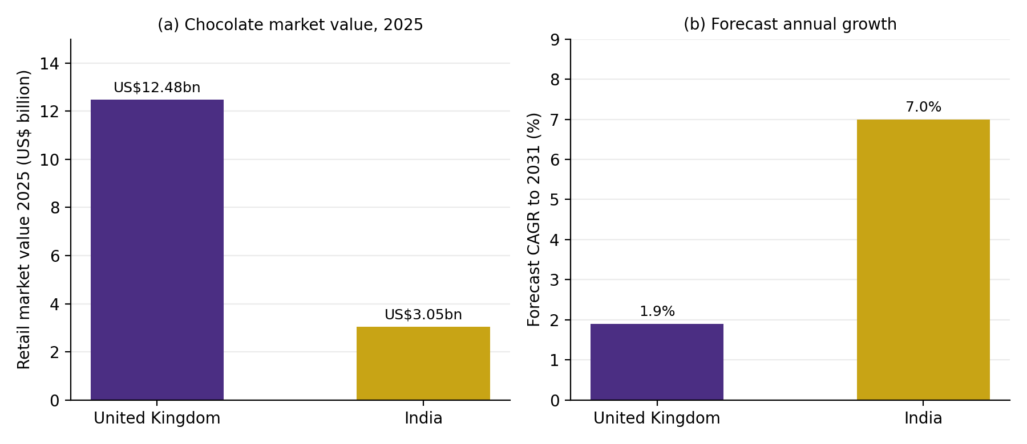
Figure 1: Chocolate market value and forecast growth, 2025.
Source: author, from Mordor Intelligence (2025a; 2025b) and IMARC Group (2025).

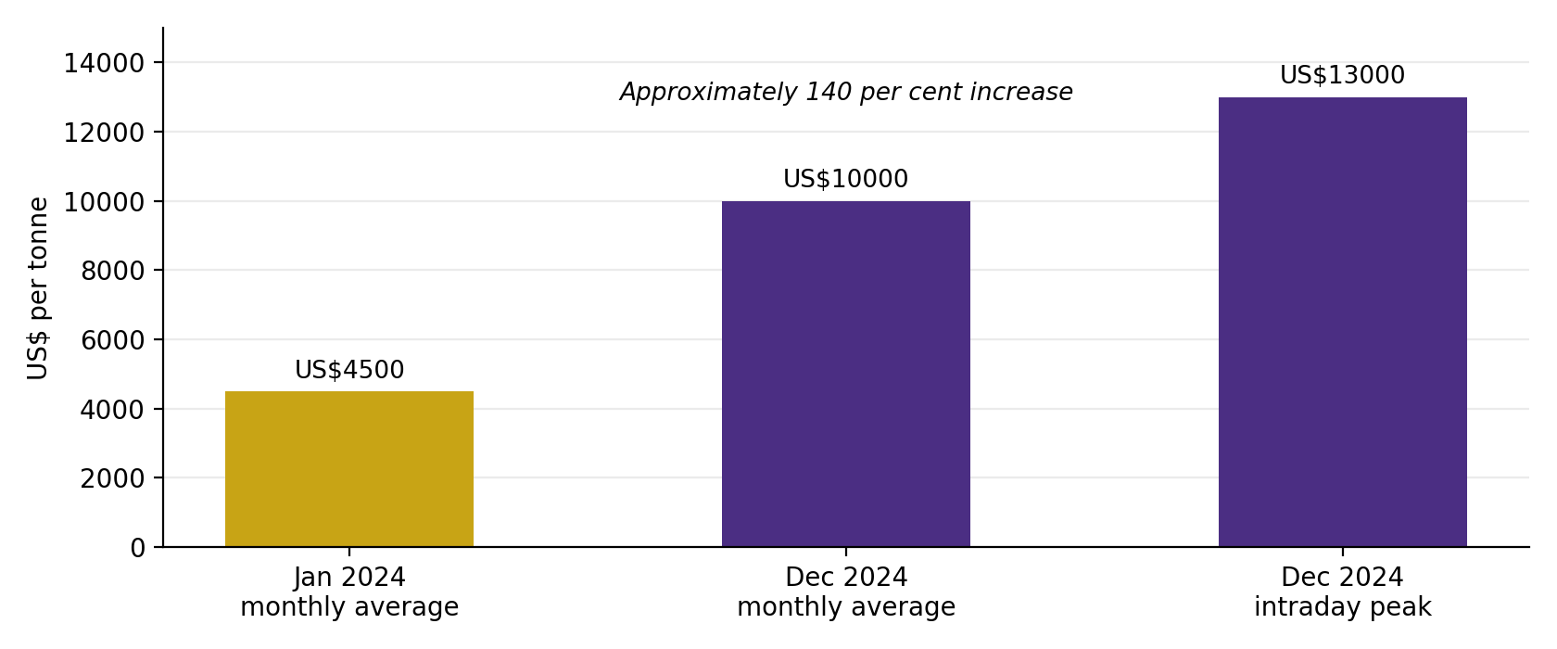
Figure 2: The cocoa input shock, 2024.
Source: author, from ConfectioneryNews (2025).

3. Comparative Cultural Analysis: Hofstede's Cultural Dimensions
The Hofstede six dimension model is used to compare the underlying values of the two societies in order to understand how identical marketing stimuli are received, as influenced by national culture. The scores are shown in figure 3.
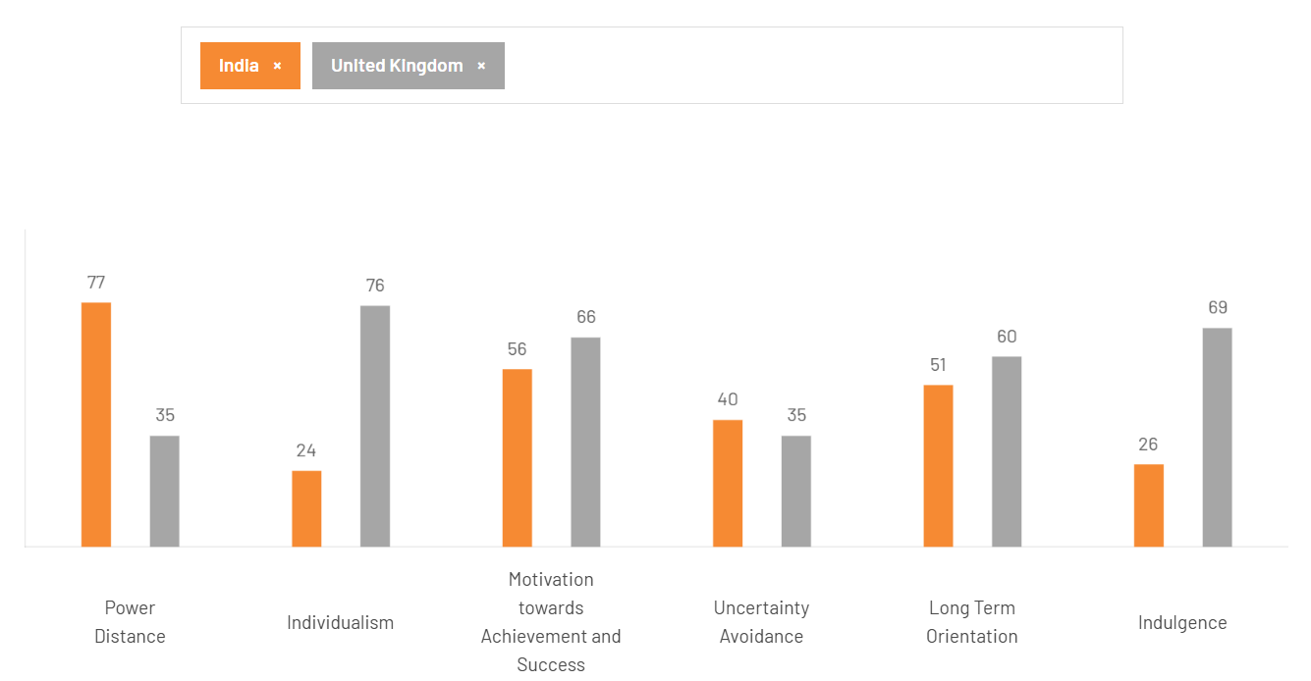
Figure 3: Hofstede six dimension comparison. Source: author, from The Culture Factor Group (2024).
The two societies differ most in terms of power distance and individualism, with Britain having a score of 35 and India having a score of 77, and individualism of 89 and 48 respectively (The Culture Factor Group, 2024). British communication is therefore individual and Cadbury's communication is private, Indian communication is for the family, the elder and the community. The Indian invitation to eat something sweet, and the later positioning of Dairy Milk as the sign of a good start, works because they place the product in collective ritual, not personal reward, which aligns with evidence that positioning that combines global desirability and local cultural meaning performs better than either of these two alone (Osmanoglu, Ozsomer and Biliciler, 2024).
The best single difference in terms of being operationally useful is indulgence – Britain 69, India 26. A society that is indulgent is one that promotes unearned self gratification, and it allows the impulse consumption that is the mainstay of the British business. A restrained society needs a justification and the Indian programme provides it by introducing the concept of consumption as celebration, achievement or gifting, rather than appetite, which then sets the context for almost all the distinctive features of the Indian mix. The countries are more similar on achievement orientation and uncertainty avoidance, and the same score on long term orientation (LTO) is 51, which makes heritage claims plausible in both countries.

3.1 Advantages of the Hofstede framework
It is parsimonious, quantifies an otherwise slippery construct, allows for comparison across over one hundred societies, and is based on an unusually large dataset that is revalidated with World Values Survey items for one hundred and two countries (Minkov and Kaasa, 2022). It is still the most frequently used instrument in cross cultural business research because of its longevity, which provides managers with a common language that is not found in other competing frameworks (Ouyang et al., 2025).

3.2 Limitations of the Hofstede framework
The raw data were from workers at one U.S. tech firm, and were not representative of the societies they were meant to represent. More seriously for this report, the model takes the nation as the unit of analysis. Within India, linguistic, religious and regional differences seem to be more than the distance between Britain and India as wholes, and to consider one score as the culture of over a billion people is an ecological fallacy that leads to confident but empty inferences. The dimensions have also been criticized for their conceptual ambiguity and overlap, and comparative evaluation shows that there are alternative frameworks that are conceptually better on a number of criteria (Yeganeh, 2025). Culture is assumed to be 'unchanging' while the material culture of the urban Indian middle class has evolved since data collection and cultural adaptation of advertising produces small effects that have eroded over time (Hornikx, Janssen and O'Keefe, 2026). The model is thus employed as a hypothesis generator instead of proof.

4. Comparative STP: Segmentation, Targeting and Positioning
British segmentation has been behavioural and occasion based, not demographic as penetration is close to universal, and segments are defined by moment of consumption. In the developed markets of chocolate, occasion and format are found to be discriminating factors more than the demographic factors, as confirmed by attribute based research (Sondhi and Chawla, 2021). Figure 4 outlines the British strategy, which is multi segment under one brand umbrella, and positioning is based on heritage and generosity via the glass and a half device.
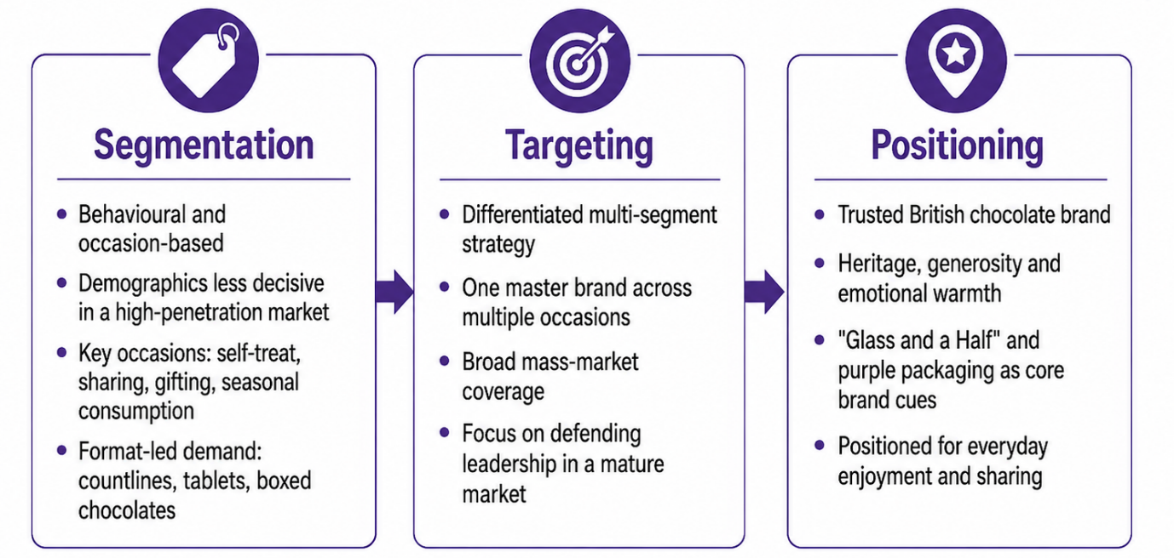
Figure 4: STP strategy for Cadbury in the United Kingdom.
The Indian segmentation (Figure 5) is split almost equally between price tier and by occasion, with five rupees packs targeting trial, mid tier bars targeting regular urban drinking and Celebrations and Silk packs targeting gifting and premium indulgence. Another uniquely Indian segment is the substitution segment where consumers are opting for packaged chocolate over traditional sweets. Targeting is differentiated and sequential, attracting time and rural consumers with low priced formats and premium formats for urban affluent consumers.
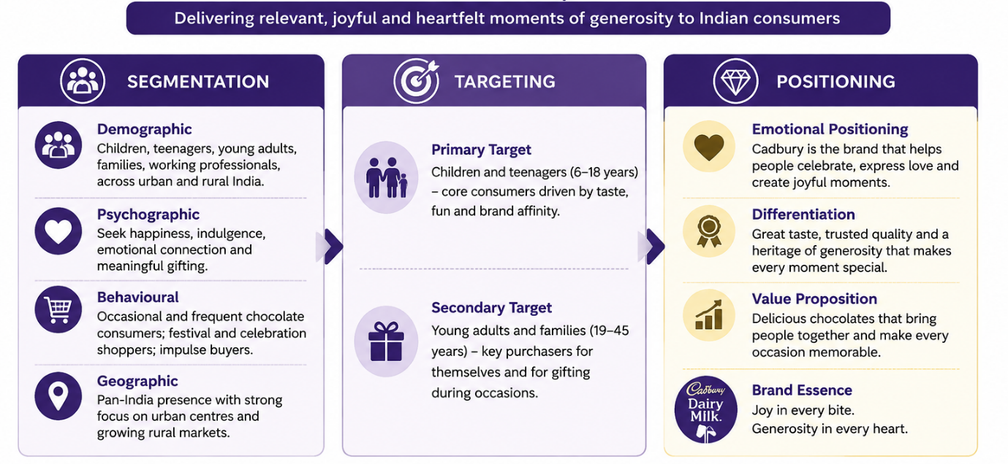
Figure 5: STP strategy for Cadbury in India.
The key is on positioning. British positioning differentiates a brand within an established category, Indian positioning establishes the category itself – the competitive frame is mithai, and any expression of sweetness is an expression of Indian celebration – the propositions are not that Cadbury is good chocolate but that chocolate belongs in an Indian celebration. This is a more ambitious undertaking and is why emotional storytelling is being disproportionately invested into by Indians. It also has a risk that is not present in Britain as when sentiment is against foreign ownership, the brand that becomes the standard choice for celebration is the obvious target and ethnocentric factors measurably impact food purchase intention in India (Chaturvedi, Agnihotri and Tripathi, 2024).

5. Comparative International Marketing Mix: The 7Ps
Booms and Bitner added the element of people, process and physical evidence to the marketing mix, and meta analytic evidence supports the idea that these elements have independent explanatory power and do not represent "flair" to the marketing mix (Rohit, Ranjan and Shainesh, 2025).

5.1 Product
The recipe itself is adapted. The Indian product has been designed for a hot climate chain and a sweeter taste, while all Indian variants are vegetarian and have the required green mark and the British formulation is based on fresh liquid milk. The difference in structure is evident in figure 6: the British range is structured around format, the Indian range is based on price. Full standardisation was never practical as it would not only include the packaging graphics but also the heat stability and certification.
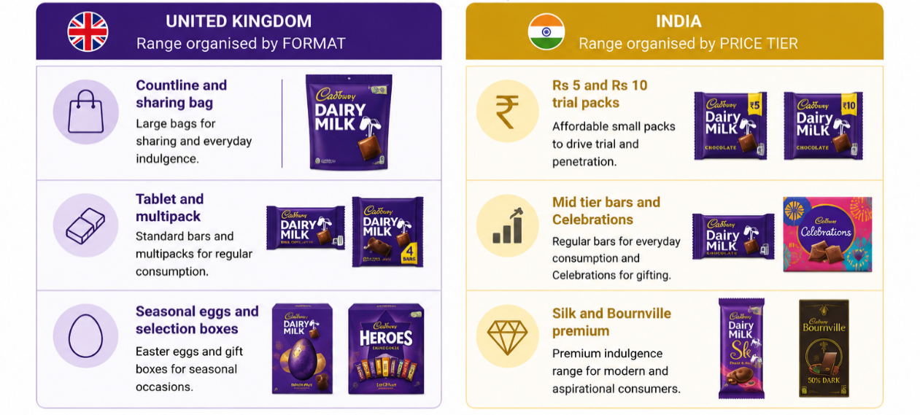
Figure 6: Product range architecture, United Kingdom and India.

5.2 Price
The pricing logic is near opposite as shown in figure 7. British pricing is premium compared to private label and has been traditionally controlled by promotional depth, which is now limited, and hence the pack remains fixed with the price change. The entry price points are psychological barriers that govern Indian pricing, and the firm has the five or ten rupee price, and adjusts grammage accordingly. In emerging markets, the issue of multinational strategy is more than just a cost issue and is one of affordability and accessibility (Alteren, 2023).
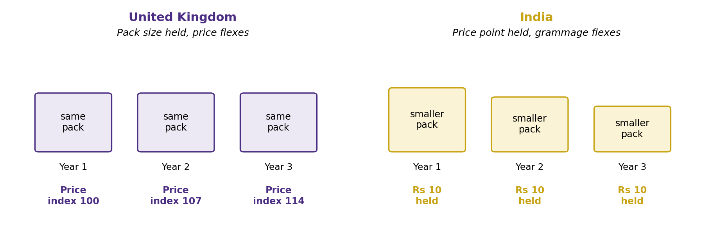
Figure 7: Price architecture, showing the British price flex against the Indian grammage flex.

5.3 Place
The channel structures are compared in figure 8. Britain focuses volume into a handful of grocery multiples, where prime shelf space is now limited by law; India has a vast number of independent outlets, growing modern trade and quick commerce, which now account for about a tenth of electronic grocery sales and are expanding at more than forty per cent per year (India Brand Equity Foundation, 2025b). Cold chain capability is a costly Indian requirement, there is no equivalent in Britain and it's the reason for the capital programme of about four thousand crore rupees to 2026 – and for chocolate capacity at Sri City of about sixteen hundred crore rupees.
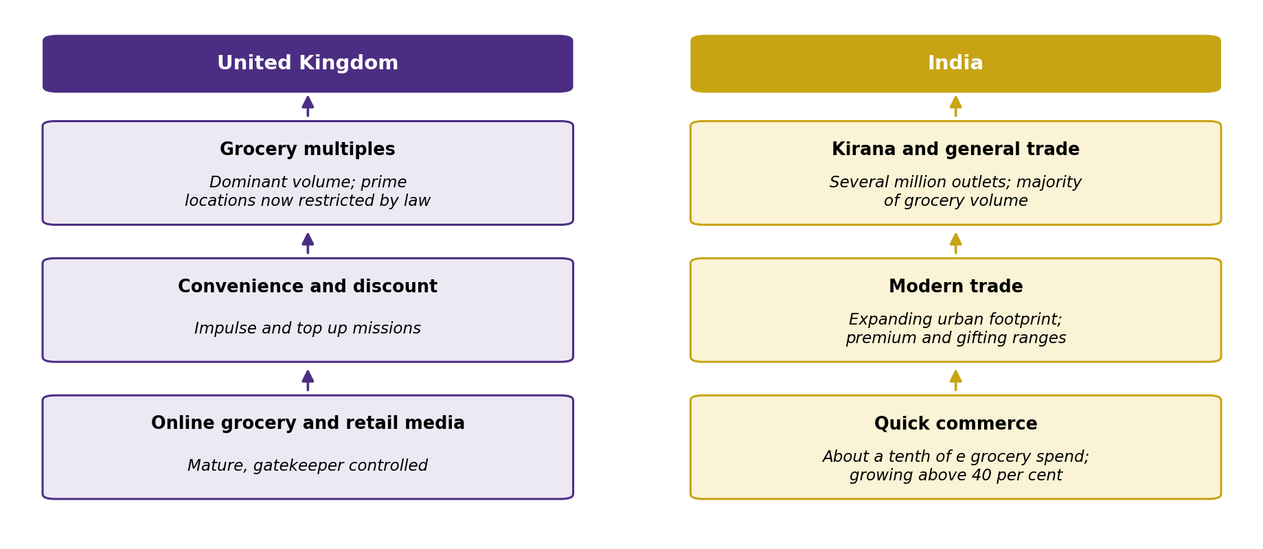
Figure 8: Distribution channel structure. Source: author, from India Brand Equity Foundation (2025b).

5.4 Promotion
Cultural distance is most obvious in promotion. Indian communication is more focused on festivals and the use of celebrity endorsements, while British communication relies more on subtle emotion and heritage and Easter and Christmas. Rashkova et al. (2024) describe Cadbury as converging on some channels while diverging on others, a description which fits the case of firms well, as they rarely standardise or adapt wholesale. Evidence suggests that adapted promotion does not necessarily outperform standardised promotion, and the Indian localisation investment should be based on category creation and not assumed to be superior (Hultman and Oghazi, 2024).

5.5 People
This is mostly indirect in Britain, with retail partners and a small field force. Central and expensive in India, since the distributor network, van salesmen and merchandisers get the brand to the long tail of retail and the retailer is also a customer, a storage partner and a point of quality risk. The education programme started following the 2003 crisis, which has reached approximately one hundred and ninety thousand outlets, indicates that the Indian retailer is part of the product experience and not just a channel.

5.6 Process
British processes emphasise category management, retail media planning and compliance with the new restrictions, while Indian processes emphasise cold chain integrity, tamper evident packaging, distributor governance and traceability. The cocoa sourcing programme (Cocoa Life) is a shared upstream programme, but with varying downstream salience in each market as of the end of 2024 (Cocoa Life, 2025; Mondelez International, 2025a).

5.7 Physical evidence
The typography, the glass and a half symbol and the purple wrapper are standardized globally and, as evidenced (Ghorbani and Westermann, 2025), are a valuable asset of the brand. Below that, the Indian execution is a vegetarian symbol, multilingual text and a closed inner wrapping, acting as a purity seal. Sustainability messaging on pack is also a growing risk if it is detected as it will have measurable consequences on brand image (Tu et al., 2024; Branca, Resciniti and Babin, 2024). The mix is thus standardised in identity and adapted in substance: the brand assets move without change, the recipe, the certification, the price architecture, the route to market and the intensity of service are localised.

6. Market Entry Strategy in India
The instructive case is India, where the brand came as an outsider and has undergone a number of commitment settings, as outlined in Figure 9. Indirect exporting began in 1948, and had little capital risk but was a low cost way to gain market knowledge. Due to increasing demand and the impracticality of importing, the company shifted to local production and eventually to backward integration by cultivating cocoa in the southern part of India. This has continued with the wholly owned subsidiary becoming the ultimate parent with the 2010 Kraft acquisition, but the operating mode was not changed. According to entry mode research, firms tend to choose high commitment equity modes when they have proprietary knowledge that is hard to protect contractually, when the product must be subject to strict quality control, and when institutional distance is not too great (Silva, Ogasavara and Pereira, 2024). All three conditions apply.
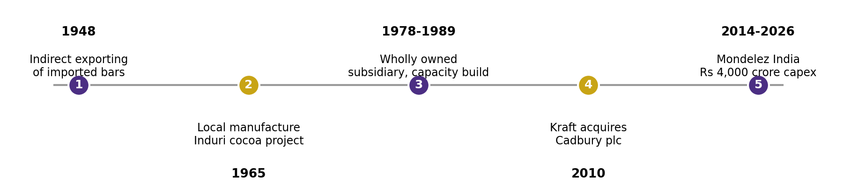
Figure 9: Escalating commitment in Cadbury’s Indian entry path, 1948 to 2026.

6.1 Advantages of wholly owned entry
Full equity control ensured absolute protection of formulation and brand assets, it secured the full margin from a category the company was pioneering and it allowed the investment to have a payback period no licensee would have accepted. It facilitated the building of a proprietary distribution system with millions of small outlets, which is now a formidable barrier to entry, and a quick unilateral response in the case of contamination which might be resisted or postponed by a joint venture partner during the 2003 crisis.

6.2 Disadvantages of wholly owned entry
The mode is capital-intensive, given the current investment of approximately four thousand crore rupees over three years, and it puts all the political, regulatory, currency and reputational risk on the parent side, with no local partner to take up any of these risks. It did not immediately transfer local regulatory capacity, a lack which was central to the examination of the compliance failure in Section 7.4, and it did not quickly provide information on local consumption norms, making this its most important cultural proposition until the 1990s, when the Indian programme was launched. A partnership with an established Indian distributor would have been a compromise on margin and control, in exchange for speed and legitimacy. The decision, on balance, turned out to be a good one, in the context of the category building horizon, but it was not entirely costless; and the recommendation, again, is to leave full ownership but to move more of the regulatory and pricing decision-making to the Indian management team.

7. Ethical Evaluation of Cadbury's Marketing Mix in India
This section considers two examples of ethical practice and two of ethically questionable practice, relating each to the mix elements it implicates.

7.1 Ethical practice 1: Product and process
Cocoa Life is a substantive, not a declaratory commitment, and will apply to about ninety one per cent of the cocoa volume consumed by all of the firm's chocolate brands by the end of 2024, increasing from eighty five per cent one year ago (Cocoa Life, 2025; Mondelez International, 2025b). This is important because child labour in West African cocoa is a structural problem, not a random occurrence, and is linked to the poverty of farmers and the small and scattered size of farm operations (Busquet, Bosma and Hummels, 2021). However, these programmes have been criticized for their minimal impact on farmers' incomes that can be measured (Martins et al., 2023). The programme is thus viewed as genuine, but not enough, a contrast to the greenwashing verdict.

7.2 Ethical practice 2: Promotion and people
One of the ethical promotions is an Indian festive campaign, which was launched in 2021 with the help of personalised advertising technology, where the names of small neighbourhood retailers were inserted into an advertisement on the front of a celebrity. It established a plan to allocate the media budget to independent retail outlets that are struggling due to the pandemic with an aim to benefit the stakeholder over commercial interests without replacing one with another. It works on promotion and people too at the same time and it is part of the statutory corporate social responsibility framework in India, which has led to real changes in behaviour beyond compliance with reporting requirements (Saikia, Bhattacharya and Dwivedi, 2024).

7.3 Questionable practice 1: Product, process and physical evidence
Worms were detected in Cadbury Dairy Milk bars and the sales of the product dropped by about thirty per cent in October 2003, weeks before Diwali, when the Maharashtra food authority was getting complaints about the worm infestation. The ethical lapse was not just the infestation itself, which happened at the retail storage, but the first attitude, which was to blame the retailer before the company realised that packaging that was not suitable for the known storage conditions in India, was a design failure for which it was responsible. The comeback was strong: a retailer education programme for approximately one hundred and nineteen thousand outlets, imported packaging machinery valued at an estimated of fifteen crore rupees, the introduction of a sealed inner wrap as a purity guarantee and the relaunch with a trusted celebrity endorser. The literature on food recall indicates that firms are more effective at repairing their brand image through accommodative approaches than through defensive approaches (Yu et al., 2023; Kang et al., 2023), and more often than not, firms incorrectly define the boundaries of their responsibility in the initial stages of a food recall (Astvansh, Antia and Tellis, 2024). Eventually Cadbury got to the accommodating position but the defensive interval is the one that is criticised.

7.4 Questionable practice 2: Place and process
In January 2017, Mondelez paid a thirteen million dollar civil penalty for the United States Securities and Exchange Commission, in connection with payments made by Cadbury India to a local agent in 2010 to secure a licence for a factory at Baddi in the Indian state of Himachal Pradesh (Ropes and Gray, 2017). The agent earned some $90,000 over six months for services that were, in fact, performed by the company's staff, such as applying for licences. This has implications for place, since the factory was to be expanded and for process, since a failure was a failure to do due diligence with third parties. It represents a hazard of the entry mode examined in Section 6, namely the lack of local regulatory capacity with regard to full ownership.
A second practice is not so obviously wrong as to be contested. Keeping nominal prices the same while lowering grammage maintains the accessibility, but hides the true gain from price anchoring consumers. Expectations for ethics are increasing in emerging markets, which may catch companies off-guard who view them as ethically unchallenging (Kutaula et al., 2024).

8. Recommendations
The recommendations below are based on a specific finding in the PESTEL, Hofstede or marketing mix analysis and not on good practice in general.
Recommendation 1. The PESTEL analysis has identified that the chocolate volume price promotion, prime at store location and paid online advertising are now permanently banned in Britain. Cadbury should refocus the British promotional model around brand advertising that is not limited to the defined categories, collaborative efforts with retailers to ensure solutions that are compliant with the brand and gifting occasions in Figure 9 in which the product is a gift – not a snack.
Recommendation 2. The economic comparison in Figure 1 demonstrated that there was a big British market with little growth, and a much smaller Indian market with a 7% or higher rate of growth. That should dictate capital allocation, and the promise to build Indian manufacturing and cold chain capacity should be insulated from the margin pressure of the cocoa shock in Figure 2, since the capacity built now will dictate the share position when the category reaches scale.
Recommendation 3. The technological finding in Table 1 with the support of Figure 8, identified quick commerce as the fastest moving Indian channel and an unusually good fit for an impulse category. Cadbury should create a mix for itself, instead of porting the general trade mix, adopt the right pack formats to complete the basket, set the price correctly without cannibalising the traditional trade price ladder, and offer different promotion mechanics to different digital channel users, as place, promotion and physical evidence are key to the formation of brand equity in emerging market digital channels (Ahmed et al., 2024).
Recommendation 4. Section 3.2 showed that the restrictions imposed mean that a single national score hides within it variation which could be as large as the distance between Britain and India. A regionally based segmentation based on language, festival calendar and dietary norm is required, as the ecological fallacy of the national cultural template is measurable marketing waste (Hornikx, Janssen and O'Keefe, 2026).
Recommendation 5. In Section 7.1, the evaluation proved Cocoa Life substantive, but at the same time raised the concern that sourcing coverage is not equal to farmer welfare. Cadbury should report metrics on outcomes of the increase or decrease in income of the verified households, as well as coverage percentages, and should avoid making claims that exceed the data (Nugraha, Chen and Yang, 2024; Tu et al., 2024).
Recommendation 6. The governance failure in Section 7.4 was a result of lack of due diligence towards an intermediary, which is a risk associated with the entry mode analysed in Section 6. Compliance capability should always be a part of the people and process considerations in every high growth market and agents that are involved in any regulatory issues must be documented as diligent. The marketing impact of a repeat episode will be the loss of brand equity the Indian business relies on.

Conclusion
A single marketing mix is not suitable for both markets. Brand assets and core proposition carry through, but recipe and certification, price architecture and route to market and service intensity are re-configured locally; Britain is a big, but legally limited market while India is a growth market at low prices. British consumption is justifiable because there is no gap and Indian consumption is presented as celebration because there is a gap. The all-ownership entry was appropriate to a decades-long category building project, but focused on risk, with a mixed ethical track record.

Section 2: Reflective Account
This reflective account is based on Gibbs' reflective cycle to structure experiential learning, which includes description, feelings, evaluation, analysis, conclusion and action plan, to reflect on the process of researching, analysing and preparing for Section 1.
Description: The task involved a comparative report on Cadbury's strategy of entering the international markets and marketing mix in 2 countries, together with evaluation of the chosen entry mode and the ethical marketing practice in one country, based on the PESTEL, Hofstede, STP and the 7 element mix. I picked the UK and India, delved deeper into India and opted for ethical analysis as the reported incidents of cultural and regulatory conflict are much more prevalent there than in the home market. The process I went through was divided into four stages: case selection, evidence collection, evidence application of the frameworks, and drafting. I created a source list before I wrote anything and evidence gathering was about half the time.
Feelings: At first I was confident, but in retrospect the least useful state that I was in during the assignment was one of confidence, so I assumed that I would be familiar with Cadbury, and that familiarity equates with insight. But that was shattered as I started digging and realized that a lot of what I believed, came from case summaries of dubious origin, with no actual information available. The worst moment has been when I discovered the 2017 regulatory settlement relating to payments via an agent in India. I was going to write an ethics piece about the contamination of 2003 and had thought the remainder of the record would be pretty good, but when the rest of the record was a governance failure, I gave up a partial story that I'd half-written. It was telling that I didn't want to include it, it showed me an advocacy approach to a brand I loved.
Evaluation: Well done for focusing on finding a concrete level of similarity or difference, not describing two markets in parallel. The same long term orientation values explaining why heritage claims are successful in both countries contrasted with the very different indulgence values explaining why the Indian programme needs to justify indulgence through celebration, provided the report an analytical non-descriptive backbone. The application of the Hofstede framework was also used in a critical way, which enhanced the work, as it was used to feed into a recommendation rather than being a paragraph of theory. Not as well was the initial over-reliance on the easy sources like trade articles, info from some of the companies, or case summaries without citations where disclosures made by the companies, publications by the government, or peer reviewed literature would have been stronger. In revision, I replaced several, making an enormous difference in the evidence.
Analysis: One of the reasons why so many of the difficulties occurred was that familiarity with a consumer brand amounted to knowledge of it. Consumer exposure provides a window on the output of a marketing programme, and not on its logic, constraints or costs; the analytical work is in the gap. There was a lesson here however, with the regulatory settlement – I had picked out an ethical story before I had completed the evidence collation. Reflective practice is a process outlined in the literature which is the very same function that structured reflection is helping to uncover, for which, therefore, Gibbs' cycle has not been a formality. (Ezezika and Johnston, 2023; Ocampo et al., 2025) The weakness outlined below is evident in my initial draft of the marketing mix section. Organisationally, frameworks like the seven element mix and PESTEL are seductive as they provide headings, and completing headings is more like analysis and less like sorting.
Conclusion: I believe that my subject knowledge was satisfactory, but at first my research discipline and critical distance was not. It got better at the moment that I started to see frameworks as tools to test propositions on a particular firm in a particular market instead of filling them with content and believing it would be understood. I could have had a quality hierarchy of sources that I would have agreed on at the start of the research that would have reduced revision at a later stage. I also feel like my proclivity to not want to acknowledge any evidence that throws into doubt the story I want to tell is a genuine weakness, not a hypothetical one, and I think it will come back to bite me at my place of work if I'm not careful.
Action plan: Table 5 converts these conclusions into commitments I can apply and review.
Table 2: Summary of commitments as solid actions.
Action | Rationale | How I will apply it
Agree a source quality hierarchy before searching, prioritising peer reviewed research, regulatory publications and primary company disclosure | Prevents time lost confirming figures whose original source cannot be established | Rank every source at the point of collection and record its provenance immediately
Complete the full evidence base before forming any argument, particularly on ethically loaded questions | Counters the confirmation bias exposed by the 2017 settlement, which I found only after choosing a narrative | Allocate a fixed block of research time to seeking evidence that would undermine my current position
Write the analytical claim for each section as one sentence before drafting the supporting prose | Addresses the description over analysis weakness in my first draft of the marketing mix section | Treat any paragraph that does not support that claim as a candidate for deletion
Treat every theoretical framework as contestable rather than settled | Strengthens critical evaluation, consistent with level seven expectations | Include at least one documented critique or limitation for each model I apply

References
Ahmed, S., Saad, A.T., Chowdhury, S.R., Sobhani, F.A., Hassan, M.S. and Islam, M.A. (2024) 'Impact of marketing mix elements on the brand equity of online food delivery services: an emerging economy perspective', Cogent Business and Management, 11(1), 2380018. Available at: https://doi.org/10.1080/23311975.2024.2380018
Alteren, G. (2023) 'Matching the needs in an emerging market: an investigation of multinational companies' marketing strategies by using the 4As framework', FIIB Business Review. Available at: https://doi.org/10.1177/23197145231158505 (Accessed: 9 August 2026).
Astvansh, V., Antia, K.D. and Tellis, G.J. (2024) 'What is (and isn't) a product recall?', Journal of Public Policy and Marketing. Available at: https://doi.org/10.1177/07439156241242419 (Accessed: 9 August 2026).
Branca, G., Resciniti, R. and Babin, B.J. (2024) 'Sustainable packaging design and the consumer perspective: a systematic literature review', Italian Journal of Marketing. Available at: https://doi.org/10.1007/s43039-023-00084-1
Busquet, M., Bosma, N. and Hummels, H. (2021) 'A multidimensional perspective on child labor in the value chain: the case of the cocoa value chain in West Africa', World Development, 146, 105601. Available at: https://doi.org/10.1016/j.worlddev.2021.105601
Chaturvedi, P., Agnihotri, D. and Tripathi, V. (2024) 'Exploring the role of consumer ethnocentrism in predicting the purchase intention for locally produced organic food in an emerging market', British Food Journal, 126(2), pp. 738-757. Available at: https://doi.org/10.1108/BFJ-04-2023-0323
Cocoa Life (2025) MDLZ Cocoa Life 2024 Cocoa and Forests Initiative progress report. Available at: https://www.cocoalife.org/en/progress/mdlz-cocoa-life-2024-cocoa-forests-initiative-progress-report/(Accessed: 9 August 2026).
ConfectioneryNews (2025) Record cocoa prices in 2025 reshape chocolate production and global markets. Available at: https://www.confectionerynews.com/Article/2025/05/09/record-cocoa-prices-in-2025-reshape-chocolate-production-and-global-markets/ (Accessed: 9 August 2026).
Department for Promotion of Industry and Internal Trade (2025) FDI policy: sectors under automatic route. New Delhi: Government of India. Available at: https://www.dpiit.gov.in/static/uploads/2025/07/1b12c69de7c2e698a7b68f7b8fcf4fe3.pdf (Accessed: 9 August 2026).
Department of Health and Social Care (2024) Restricting promotions of products high in fat, sugar or salt by location and by volume price: implementation guidance. Available at: https://www.gov.uk/government/publications/restricting-promotions-of-products-high-in-fat-sugar-or-salt-by-location-and-by-volume-price (Accessed: 9 August 2026).
Department of Health and Social Care (2025) Less healthy food or drink: advertising and promotions restrictions. Available at: https://www.gov.uk/government/collections/less-healthy-food-or-drink-advertising-and-promotions-restrictions (Accessed: 9 August 2026).
Ezezika, O. and Johnston, N. (2023) 'Development and implementation of a reflective writing assignment for undergraduate students in a large public health biology course', Pedagogy in Health Promotion. Available at: https://doi.org/10.1177/23733799211069993 (Accessed: 9 August 2026).
Ghorbani, M. and Westermann, A. (2025) 'Exploring the role of packaging in the formation of brand images: a mixed methods investigation of consumer perspectives', Journal of Product and Brand Management, 34(2), p. 186. Available at: https://www.emerald.com/jpbm/article-abstract/34/2/186/1243269.
Hornikx, J., Janssen, A. and O'Keefe, D.J. (2026) 'Cultural value adaptation in advertising is effective, but not dependable: a meta analysis of 25 years of experimental research', International Journal of Business Communication. Available at: https://doi.org/10.1177/23294884231199088 (Accessed: 9 August 2026).
House of Commons Library (2025) Advertising of HFSS food and drink to children. Research briefing CBP-10061. London: House of Commons Library. Available at: https://commonslibrary.parliament.uk/research-briefings/cbp-10061/ (Accessed: 9 August 2026).
Hultman, M. and Oghazi, P. (2024) 'On the (in)effectiveness of standardized versus adapted international promotion strategies: evidence from entrepreneurial firms', Journal of Business Research, 170, 114351. Available at: https://doi.org/10.1016/j.jbusres.2023.114351.
IMARC Group (2025) India chocolate market size, share, growth and industry analysis. Available at: https://www.imarcgroup.com/india-chocolate-market (Accessed: 9 August 2026).
India Brand Equity Foundation (2025a) Decoding the growth of India's chocolate market. Available at: https://www.ibef.org/blogs/decoding-the-growth-of-india-s-chocolate-market (Accessed: 9 August 2026).
India Brand Equity Foundation (2025b) The evolution of quick commerce in India: a sectoral analysis. Available at: https://www.ibef.org/research/case-study/the-evolution-of-quick-commerce-in-india-a-sectoral-analysis (Accessed: 9 August 2026).
Invest India (2025) Food processing sector: investment opportunities. Available at: https://www.investindia.gov.in/sector/food-processing (Accessed: 9 August 2026).
Kang, J., Faria, A.A., Lee, J. and Choi, W.J. (2023) 'Will consumers give us another chance to bounce back? Effects of precrisis commitments to social and product responsibility on brand resilience', Journal of Product and Brand Management, 32(6), p. 927. Available at: https://www.emerald.com/jpbm/article-abstract/32/6/927/449279 (Accessed: 9 August 2026).
Kutaula, S., Gillani, A., Gregory-Smith, D. and Bartikowski, B. (2024) 'Ethical consumerism in emerging markets: opportunities and challenges', Journal of Business Ethics, 191(4), pp. 651-673. Available at: https://doi.org/10.1007/s10551-024-05657-4
Legislation.gov.uk (2025) The Advertising (Less Healthy Food and Drink) (Brand Advertising) Regulations 2025, SI 2025/1011. Available at: https://www.legislation.gov.uk/uksi/2025/1011 (Accessed: 9 August 2026).
Martins, F.P., Batalhao, A.C.S., Ahokas, M., Liboni Amui, L.B. and Cezarino, L.O. (2023) 'Rethinking sustainability in cocoa supply chain in light of SDG disclosure', Sustainability Accounting, Management and Policy Journal, 14(7), pp. 258-286. Available at: https://doi.org/10.1108/SAMPJ-03-2022-0132
Minkov, M. and Kaasa, A. (2022) 'Do dimensions of culture exist objectively? A validation of the revised Minkov-Hofstede model of culture with World Values Survey items and scores for 102 countries', Journal of International Management, 28(4), 100971. Available at: https://doi.org/10.1016/j.intman.2022.100971.
Mondelez International (2025a) 2024 Snacking Made Right report. Available at: https://www.cocoalife.org/en/progress/mdlz-2024-snacking-made-right-report/ (Accessed: 9 August 2026).
Mondelez International (2025b) Mondelez International announces 2025 sustainability milestones. Available at: https://ir.mondelezinternational.com/news-releases/news-release-details/mondelez-international-announces-2025-sustainability-milestones1 (Accessed: 9 August 2026).
Mordor Intelligence (2025a) India chocolate market size and share outlook to 2031. Available at: https://www.mordorintelligence.com/industry-reports/india-chocolate-market (Accessed: 9 August 2026).
Mordor Intelligence (2025b) United Kingdom chocolate market size and share outlook to 2031. Available at: https://www.mordorintelligence.com/industry-reports/uk-chocolate-market (Accessed: 9 August 2026).
Nugraha, W.S., Chen, D. and Yang, S.H. (2024) 'Greenwashing in the food industry: a systematic review exploring the current situation and possible countermeasures', Cleaner and Responsible Consumption, 15, 100227. Available at: https://www.sciencedirect.com/science/article/pii/S2666784324000603 (Accessed: 9 August 2026).
Ocampo, F.A., McIntyre, B.G., Massey, D. and Saunders, R. (2025) 'Nursing student reflections on a research internship: a reflective discussion following the Gibbs' reflective cycle', Nurse Education Today, 145, 106481. Available at: https://doi.org/10.1016/j.nedt.2024.106481
Osmanoglu, O., Ozsomer, A. and Biliciler, G. (2024) 'Local and global cobrand positioning and consumer evaluations in emerging markets', Journal of International Marketing. Available at: https://doi.org/10.1177/1069031X241268613 (Accessed: 9 August 2026).
Ouyang, S., Zhang, W., Xue, L., Mat Rashid, A., Shwu Pyng, H. and Hassan, A.B. (2025) 'The cultural compass: a systematic review on cultural dimensions theory in educational settings', SAGE Open, 15(2). Available at: https://doi.org/10.1177/21582440251342160
Poulis, K. (2024) 'Standardization and adaptation as a coconstituted process: the pursuit of relational fit in international markets', Journal of International Marketing, 32(2), pp. 12-32. Available at: https://doi.org/10.1177/1069031X231212414
Rashkova, Y., Moi, L., Marku, E. and Cabiddu, F. (2024) 'Online integrated marketing communication strategies of international brands: standardization versus adaptation approaches', Journal of Marketing Communications, 30(7), pp. 810-833. Available at: https://doi.org/10.1080/13527266.2023.2177710
Rohit, S., Ranjan, K.R. and Shainesh, G. (2025) 'Service marketing mix and customer engagement: a meta analysis', Journal of Business Research, 194, 115363. Available at: https://doi.org/10.1016/j.jbusres.2025.115363
Ropes and Gray (2017) Mondelez agrees to pay 13 million dollars to settle FCPA charges related to inadequate due diligence and accounting controls over third party in India. Available at: https://www.ropesgray.com/en/insights/alerts/2017/01/mondelez-agrees-to-pay-$13-million-to-settle-fcpa-charges-related-to-alleged-bribery-in-india (Accessed: 9 August 2026).
Saikia, A., Bhattacharya, S.N. and Dwivedi, R. (2024) 'Do good, have good: mandatory CSR policy and foreign subsidiary performance in India', Global Business Review. Available at: https://doi.org/10.1177/09721509241278151 (Accessed: 9 August 2026).
Silva, F., Ogasavara, M.H. and Pereira, R. (2024) 'Institutional distances and equity based entry modes: a systematic literature review', Management Review Quarterly, 74(3). Available at: https://doi.org/10.1007/s11301-023-00346-4
Sondhi, N. and Chawla, D. (2021) 'Positioning implications for chocolate brands: an attribute based approach', Global Business Review. Available at: https://doi.org/10.1177/0972150918795360 (Accessed: 9 August 2026).
Statista (2025) Leading chocolate brands in the United Kingdom in 2025. Available at: https://www.statista.com/statistics/1463314/leading-chocolate-brands-uk/ (Accessed: 9 August 2026).
The Culture Factor Group (2024) Country comparison tool. Available at: https://www.hofstede-insights.com/country-comparison-tool (Accessed: 9 August 2026).
Tu, J.C., Cui, Y., Liu, L. and Yang, C. (2024) 'Perceived greenwashing and its impact on the green image of brands', Sustainability, 16(20), 9009. Available at: https://doi.org/10.3390/su16209009
Yeganeh, H. (2025) 'Hofstede, GLOBE, Schwartz and Inglehart's cultural dimensions: a critical examination and assessment', European Business Review, 37(6), pp. 1073-1090. Available at: https://doi.org/10.1108/EBR-05-2025-0144
Yu, W., Cui, F., Han, X. and Lv, M. (2023) 'Does a corporation's food recall strategy affect its brand image and consumers' intention to purchase? A study in the context of cereal recall in China', British Food Journal, 125(4), pp. 1437-1452. Available at: https://doi.org/10.1108/BFJ-01-2022-0023

