A Report into The Effectiveness of the Current Structure of NHS Wales

Joanne Leyson

1805553

Tania Davies

University of Wales Trinity Saint David

Abstract

The effectiveness of the NHS has always been an interesting issue. This following report will investigate the effectiveness of the current structure of NHS Wales, giving an overview of the seven health boards currently operating within Wales, how the trusts are segregated, how the management structures generally work within a board and finally how funding is influenced and where it comes from. To conclude there will be recommendations for the efficiency and usefulness of the current system with current concerns and issues raised.

Contents

- Title Page – Page 1
- Abstract – Page 2
- Contents – Page 3
- Introduction to Report – 4
- Information / Statistics / Guides – Page 6
- Evaluation of Current Structure – Page 10
- Conclusion – Page 12
- Recommendations – Page 13
- Reference List – Page 14

Introduction

The NHS was introduced to the UK on the 5th July 1948 and was executed by the Minster of Health and Welshman Aneurin Bevan (National Health Service Wales NHS, 2019). The very first free national healthcare services offered anywhere in the world, based on persons citizenship rather than payment of fees or insurance (British Broadcasting Centre BBC, 2019). NHS Wales is currently 70 years old and can be argued that the effectiveness today does not match the initial aim back in 1948. Although the workforce has grown significantly employing 1.7m people, that being 10 times more than when the NHS started figures show, there are four times fewer beds available. This is partly due to patients spending less time in hospital but also a lot of the care can be done within the community (BBC, 2019).

NHS Wales consists of seven Local Health Boards (LHBs) that operate within the country, these have replaced 22 LHBs and the 7 NHS trusts in the past prior to October 1st2009. The current boards are as follows;
- Aneurin Bevan Health Board
- Abertawe Bro Morgannwg University Health Board
- Cardiff & Vale University Health Board
- Hwyel Dda Health Board
- Cwm Taf Health Board
- Betsi Cadwaladr University Health Board
- Powys Teaching Health Board

The NHS Wales structure was changed in 2009 to deliver better healthcare to Wales to keep up with the growing older population, more people with chronic illnesses, increasing obesity rates coupled with low levels of physical activity, rural locations, service targets and the challenging financial climate which were having detrimental effect on the previous structure showing it was unfit for the 21st century (NHS Wales, 2019).
In addition to the seven Local Health Boards as shown above, there are three NHS Trusts operating in Wales and are as follows;
- Welsh Ambulance Services NHS Trust
- Velindre NHS Trust
- Public Health Wales

The Welsh Ambulance trust is responsible for all emergency services within Wales. Velindre NHS Trust is a specialist service in cancer care and a range of national support services and the Public Health Wales is an organisation covering a variety of services including; National Public Health Service, Welsh Centre for Health, Welsh Cancer & Surveillance Unit, Congenital Anomaly Register & Information Service for Wales and Screening Services Wales (NHS Wales, 2019).

Information / Statistics / Guides

Management structures were introduced to aid the administration of the organisations and enable doctors, nurses and other health professionals concentrate on there roles from a medial perspective and not an administrative perspective. Over the years the organisations have become larger and more complex to manage which has shown many changes to the structures within the organisations over the years with Doctors, nurses and administrative staff all separated into hierarchies. Where there was once a simple accountability hierarchy from the very front-line services right through to the secretary of state this has become a very complex web of public and private providers with added regulators to ensure smooth management of the structure. Throughout the years and with technology evolving there have been wider developments in the IT, Human Resources and estates management to name a few. With each of these departments growing a need for effective management is also needed. The very nature of the NHS requires leaders and management at multiple levels, including leadership of smaller units and multi-disciplinary teams overseeing the different hospital departments, numerous networks and systems (Kingsfund, 2019).
Below is an example of a hierarchy structure within an NHS Wales board called Betsi Cadwaladr in North Wales.
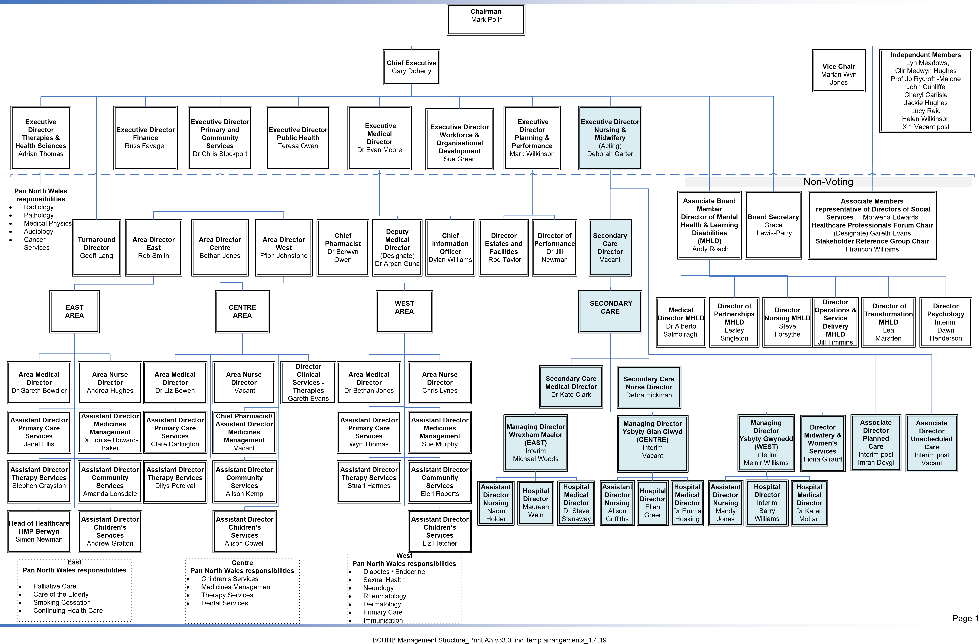

It is also important to remember that Clinicians should be involved more closely to any management process and participate in decisions made on resources or anything that directly effects the care of patients. There was a report released Griffiths (1983) which stated the importance of such actions within the NHS. Another major factor in management structures within the NHS is the political factors and funding. Management usually work from short term goals to meet with the current political climate and ensure delivery, usually making the system vulnerable to reconfiguration, tensions and changes in funding for certain treatments which all affect the pragmatic strategic management systems (Kingsfund, 2019).

The funding needed for NHS Wales comes from a variety of sources including the general taxation of the country to a small proportion from national insurance contributions paid. What is known as a ‘block grant’ is a total sum available to NHS Wales and this comes from the Welsh Government and Westminister. This funding is used for day to day running of health services each year’s and can take the following forms:
- Local health boards to allocate and secure hospital, primary care services and community for the resident populations
- Allocations to the local health boards and NHS trusts for capital developments and operations
- Health improvement funding and any other Welsh Government initiatives
The following information shows how the Statistical Directorate of the Welsh Government an annual breakdown of NHS Wales expenditure and programme budgets by Local Health Boards (Welsh Government, 2019)
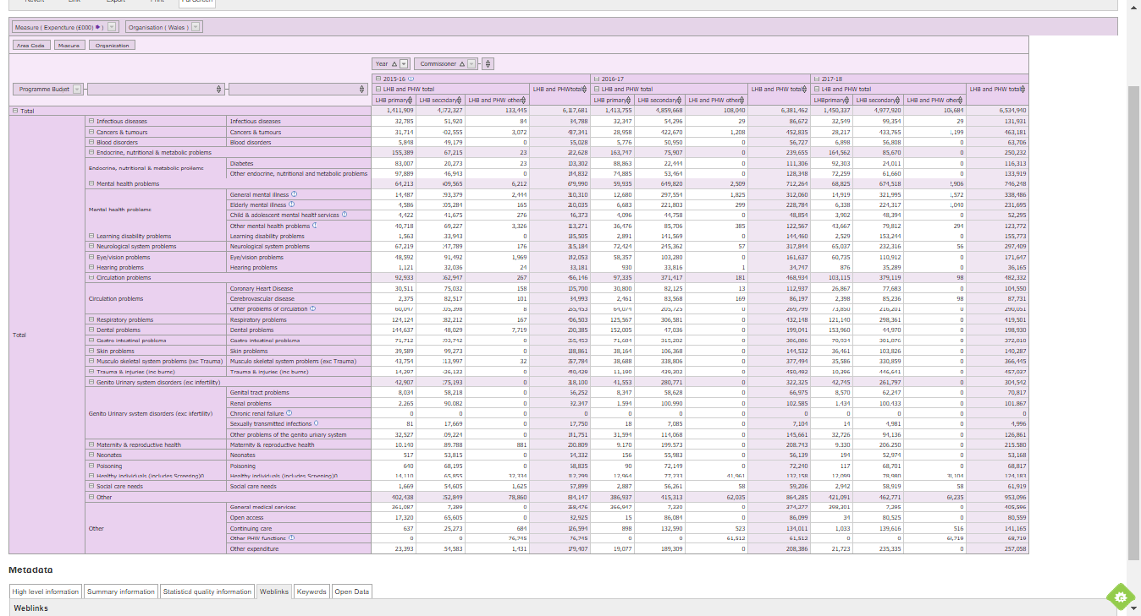

Its important to note that the NHS is and will experience different influences that factor funding and operation. This can be down to the social, economic and political pressures applied, not to mention the aging population and growing population of the UK and increase in certain cases i.e. obesity and diabetes which has a strain on resources. The use of privatised services has increased in current years which has a detrimental effect on finances. It is not uncommon for certain trusts and hospitals to fall into debt and have been put into administration over the last few years (The Medic Portal, 2019)

Evaluation of Current Structure

In 2009 the Welsh Government had set out a change to the current system and structures for the country. The objective of such change was to focus on patient care and to develop a structure that has more transparency in decision making that will benefit patients and staff. The reforms were noted to;
‘…about developing a service which is based on co-operation, collaboration and partnership working. It is not based on market concepts and is value driven. It means a shift in the balance of care, looking at whole systems rather than hospitals. There is a strong emphasis on public health and long-term planning (National Assembly for Wales, 2019: 10)’
This is a positive change for NHS Wales and includes devolution, passing the responsibility to a lower level but controlled by the boards themselves. Another important factor is the regulation and inspection of the structure and organisational delivery is the role of the Community Health Councils (CHCs). These are important to ensure the communication between managers and the public, ensuring efficient running of all NHS premises and providers in Wales. The new structure as shown below, coupled with the focus on planning, will enable the system to use targets and plans. The setting out of the travel of direction, combined with checks and balances is finally shaping how care is delivered within NHS Wales. This is an important strategy and will help reform NHS Wales and help with proposed long-term plans (National Assembly for Wales, 2019).
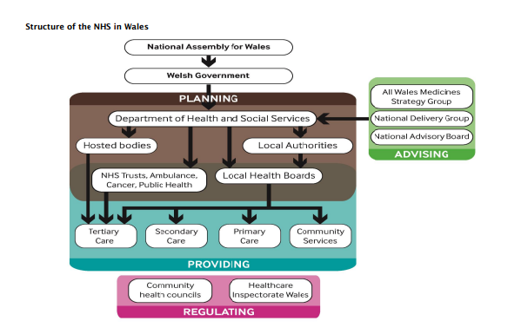

The negatives of the reform in 2009 has been highlighted by reports that show NHS Wales is still controlled by Labour, compared to NHS England & Scotland being controlled by the Conservatives. This opens comparisons and difficult ones at that. NHS Wales has performed like its counter parts however, the one difference that stands out is the purchaser-provider split. This is an internal market where parts of the English NHS can buy services from other parts. NHS Wales do not operate the same scheme therefore has a higher usage of private sector, which can cost relatively more than sharing services within the country. NHS Wales population is also older, sicker and more deprivation than its counterparts which can affect the usage of services (British Broadcasting Centre (BBC), 2015).
In conclusion to the major changes that NHS Wales has implemented over the last 9 years it can be argued that the current system is sill struggling to live up to the plans set out initially. The cost of social care is increasing and with past cuts of funding, it is imperative that funding is to be stepped up to ensure delivery of the services. The ageing population and increased disabilities and life-long health issues presented, shows if current spending isn’t met by increased funding, there will be a funding gap of £18 million by 2030/31 (The Health Foundation, 2019).

Conclusion

The creation of the NHS was very welcomed back in 1948 and came around in a time of austerity and uncertainty after the war. However, with the changing times and increasing population, also the aging population that need caring for, it seems the great idea of a National Health Service is now under great strain. This report has looked at the beginning of the service and overviewed the seven health boards within wales and how the structure helps in running the massively complex institutions of today. In addition the very important management structures and hierarchal type systems which are vital for the health boards and the NHS in general, which need to be efficient and cost effective. Unfortunately, these structures are changed and reformed by different influences, for example, political and funding changes throughout the years. The report also discusses the funding impact of the NHS and where the money comes from and how it is distributed, showing graphs of costs throughout NHS Wales annually. The major reform in 2009 was significant in ensuring the health service could withstand the changing forces and times. Although not achieving the targets set out, it shows the efficiency of reform in comparison to our neighboring countries within the UK. Highlights of the report state that NHS Wales have a different policy to purchase-provider split which has an effect on finances due to the amount of private services used within the system in comparison to NHS England and coupled with our aging population without the correct funding and spending in the next few years, a major funding gap could arise, if not carefully executed in the future.

Recommendations

The following recommendations for the efficiency and usefulness of the current system may have an impact on NHS Wales.

- Less use of private companies within the NHS Wales seven health boards. Introduce a purchase-provider split to allow different boards to purchase services from other welsh health boards if available. This would lower costs paid to private companies at an increased rate.
- Ensuring better communication between managers and clinicians and more decision making at front line level.
- Introduce better care at community level with the help of local authorities. This would ensure the ageing population of Wales would receive care within their own homes rather than the increased hospital admissions and long hospital stays.

References

British Broadcasting Centre BBC (2019) BBC News: The History of the NHS in Charts. Available at: https://www.bbc.co.uk/news/health-44560590 (Accessed on: 19/03/2019)

British Broadcasting Centre (BBC) (2015) The challenge of change in the NHS in Wales. Available at: https://www.bbc.co.uk/news/uk-wales-30881328 (Accessed on 16/04/2019)

Kingsfund (2019) The Changing Role of Managers in the NHS. Available at: https://www.kingsfund.org.uk/publications/future-leadership-and-management-nhs/changing-role-of-NHS-managers (Accessed on: 10/04/2019)

Natonal Health Service NHS. (2019) Health in Wales: History & Context. Available at: http://www.wales.nhs.uk/nhswalesaboutus/historycontext (Accessed on: 19/03/2019)

NHS Wales (2019) Betsi Cadwaladr University Health Board Operational Management Structure. Available at: http://www.wales.nhs.uk/sitesplus/861/page/85813/ (Accessed on: 10/04/2019)

Socialist Health Association (2019) Griffiths Report on NHS (October 1983). Available at: https://www.sochealth.co.uk/national-health-service/griffiths-report-october-1983/ (Accessed on: 10/04/2019)

The Health Foundation (2019) NHS at 70: Whats the problem with social care, and why do we need to make it better? Available at: https://www.health.org.uk/publications/nhs-at-70-what%E2%80%99s-the-problem-with-social-care-and-why-do-we-need-to-do-better (Accessed on 16/04/2019)

The Medic Portal (2019) Challenges Facing The NHS and Current NHS Issues. Available at: https://www.themedicportal.com/application-guide/the-nhs/challenges-facing-the-nhs/ (Accessed on: 16/04/2019)

The National Assembly for Wales (2019) The organisation of the NHS in the UK: comparing structures in the four countries (May 2015) pp. 1-28. Available at: http://www.assembly.wales/research%20documents/15020%20-%20the%20organisation%20of%20the%20nhs%20in%20the%20uk%20comparing%20structures%20in%20the%20four%20countries/15-020.pdf (Accessed at: 16/04/2019)

Welsh Government (2019) Stats Wales – NHS Programme Budget. Available at: https://statswales.gov.wales/Catalogue/Health-and-Social-Care/Health-Finance/NHS-Programme-Budget (Accessed on: 10/04/2019)

