Visual Effects: Creating a Realistic Visual Effect Sequence (ACCA5043)

Animation and vfx
Abigail Jenkins (2115482)
2024
Table of Contents
Project Proposal 2
Production Diary 2
Reflection 22
Final Film 23
References 23
Bibliography 25

Project Proposal
Project Summary
The final video will be a short clip of a person hiding from a giant rat in the sewers.
It will be in the style of a found footage horror movie, so the camera will be held by the actor.
The actor will be a real person, the background will be 3D model and the rat moving through the water will be animated in 2D

Project Description
A greenscreen will be used for the live action performance. The character in the scene will be played by me as it will be easier to organise a recording session and shoot as I will be more aware of the scene than another person. The background will be created using Maya. After modelling the scene in Maya it will be textured in Substance Painter using the brushes freely provided. This will ensure the realism expected from the project brief is achieved. The rat and water effects will be animated using Krita.

Production Diary
30th September 2024

I planned out when I would do things first on Samsung notes then on excel. Used the planner as my macbook wallpaper so I would be reminded of what the plan was that day every time I opened my laptop.

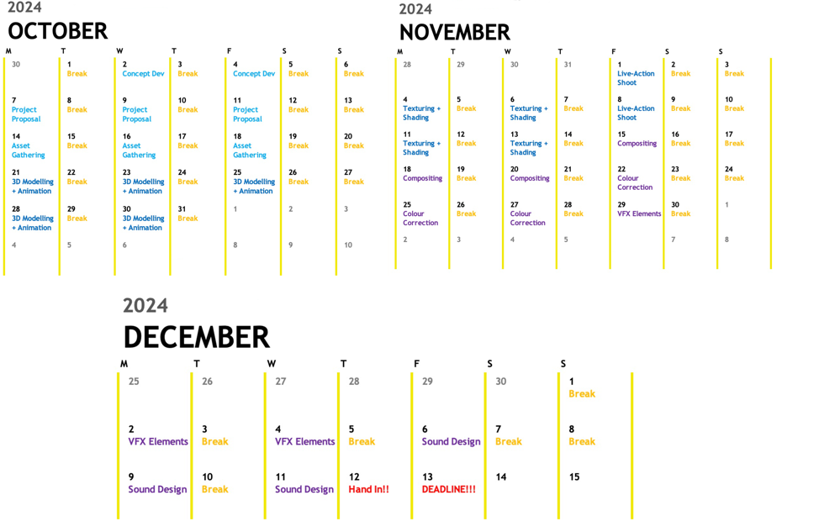

After brainstorming for a bit I decided to do a sequence inspired by found footage films. The video will portray a person hiding from giant rat in a sewer trying to look out into the main sewer with their phone. A few seconds later they will hear footsteps. Before the rats nose comes into frame and startles the person.
The person will be a real actor ( the actor will be me as I would know/understand the movement required for the scene and it would be easier to organise) better Sewer background will be created in Maya, Rat will either be a 3D model or a 2D animation, I have not decided yet.

2nd October 2024

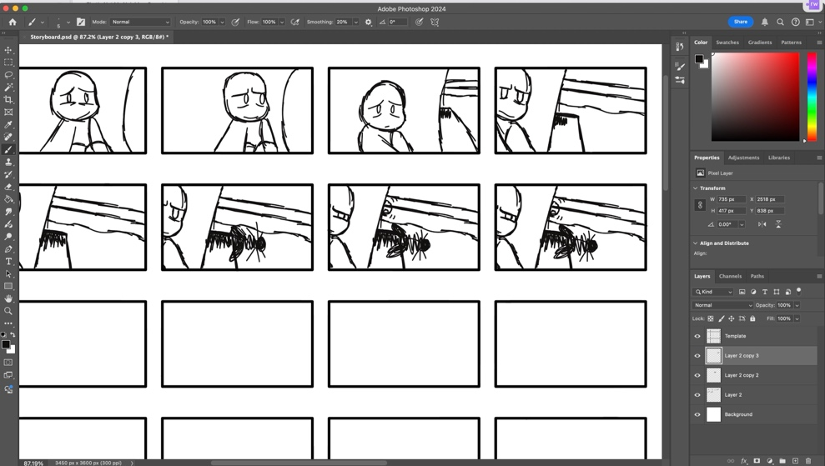
I created a mood board and storyboards (I used a professional storyboard template I had found online [1]) along with a project proposal in order to show off my idea to the tutor more effectively.

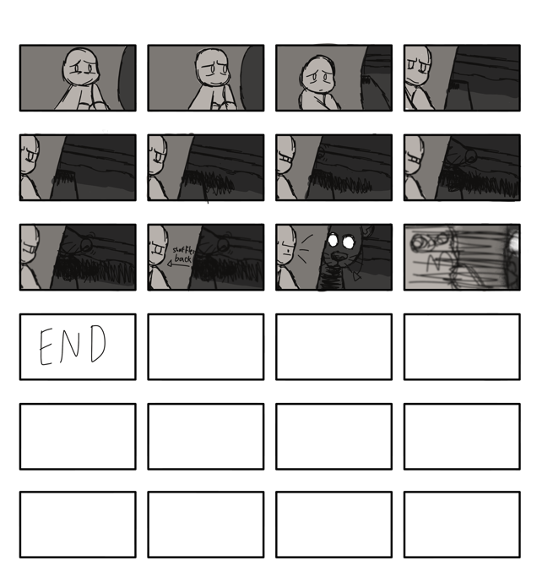
Shaded Version
Lined Version
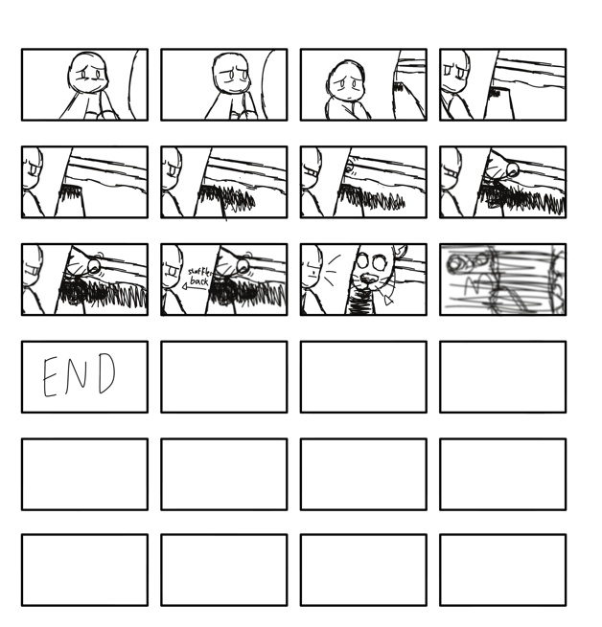
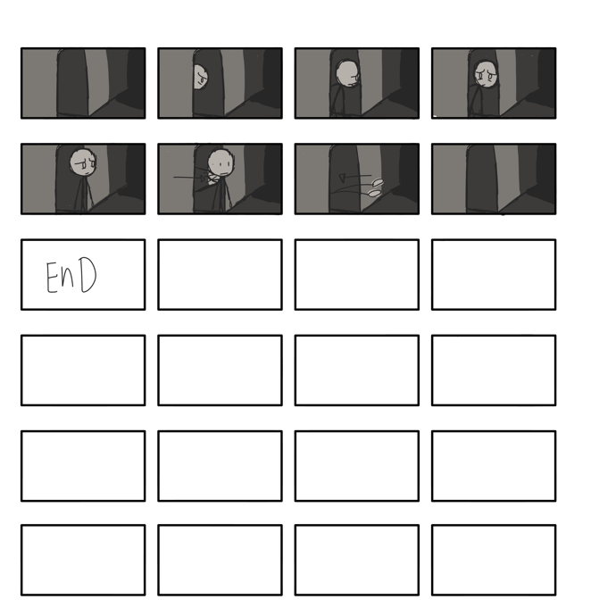
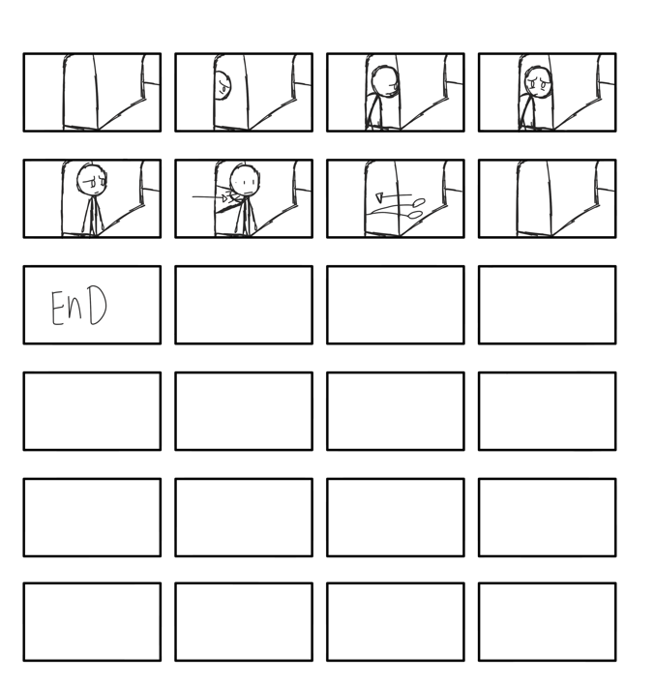
Lined Version
Shaded Version
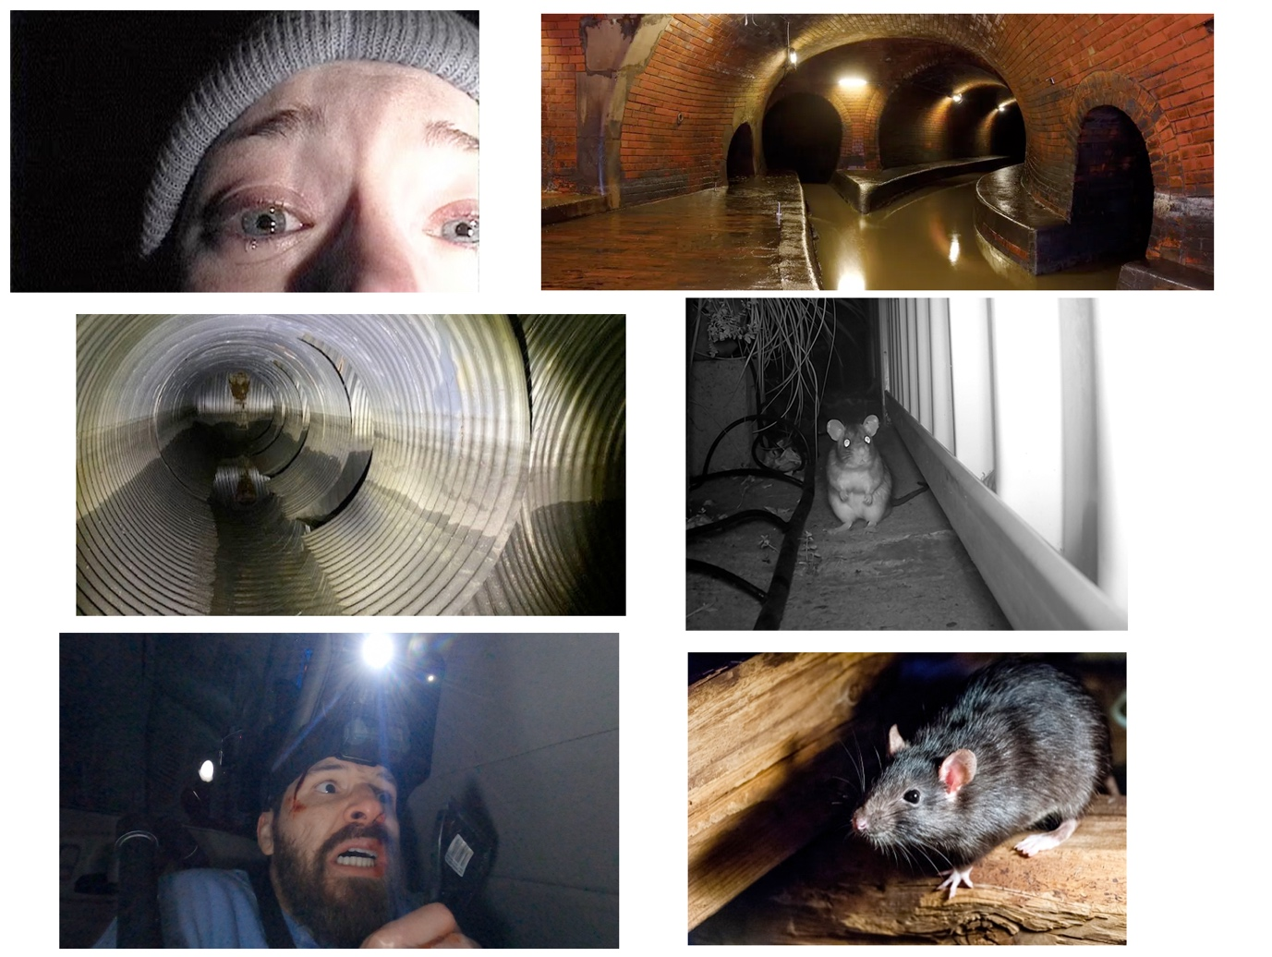
[2] – [7]

11th Oct 2024
I considered the Pros and Cons of using 2D or 3D Animation in my project.
Pros
2D
- Want to master incorporating 2D assets into a 3D world as I think the style is neat
- Would be easier to portray what I want rather than taking the time to either model the rat out or find a suitable free model that would be able to move in the way I want it to.

3D
- Would fit the 3D scene more
- Would take less time as I wouldn’t have to edit the rat into the scene like I would with 2D
Cons
2D
- Might not fit the scene/ look too out of place
- Would take more time, animating it out and editing the final shot into the 3D scene
3D
- Might not be able to find a decent 3D model
- Model might not like being scaled up

I decided to stick with 2D animation for the project as I felt it would be too much hassle trying to find the perfect, copyright free, 3D model of a rat that I could move in the way I wanted it to.

14th Oct 2024

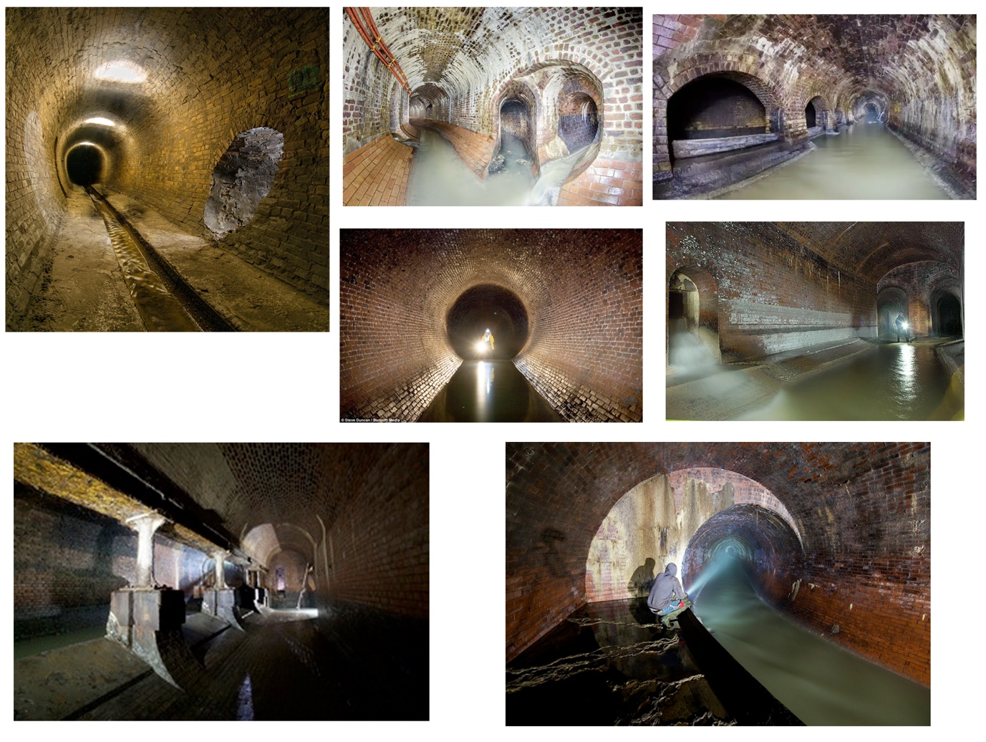
I wanted to go for an older sewer system as it would be more likely to be abandoned, more accessible to the public and generally spookier.
So I did research on older sewer systems and created a moodboard to better inform my concept design.
[8] – [14]

22nd Oct 2024

I created concept art and storyboard’s to help explore the space a bit more.
I also turned two of the storyboards into animatics to find out how long the final scene might be and figure out the timings of both the person and the rat.
(Google doc of animatics = https://drive.google.com/drive/folders/11zTDXvBIEn0pzvUQKTU5EkxymdYXWGVt?usp=drive_link )

Shaded Version
Lined Version
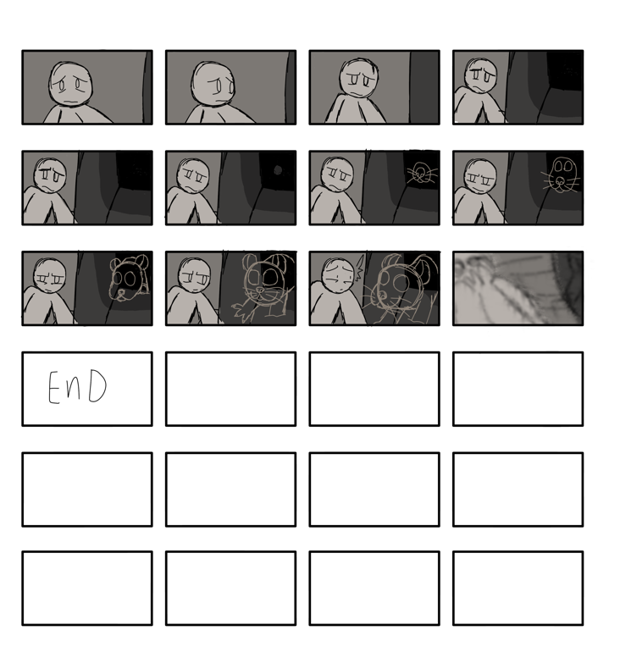
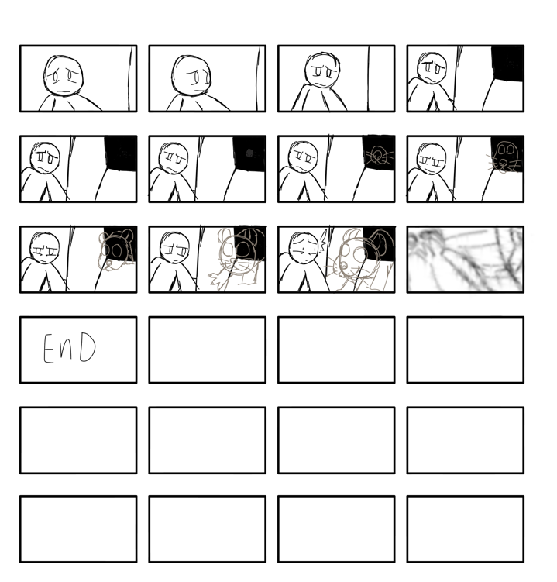
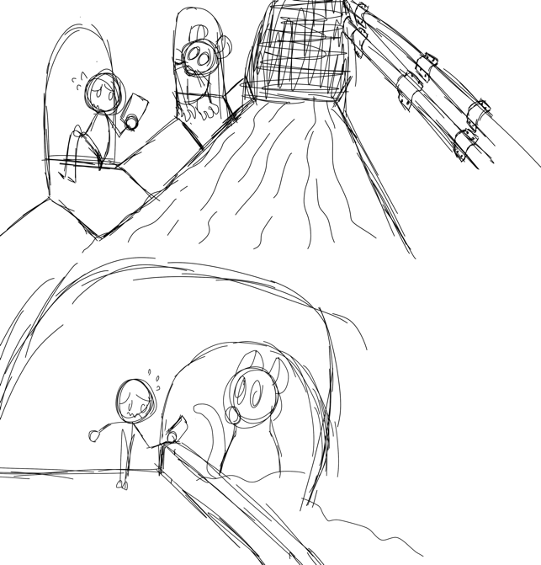
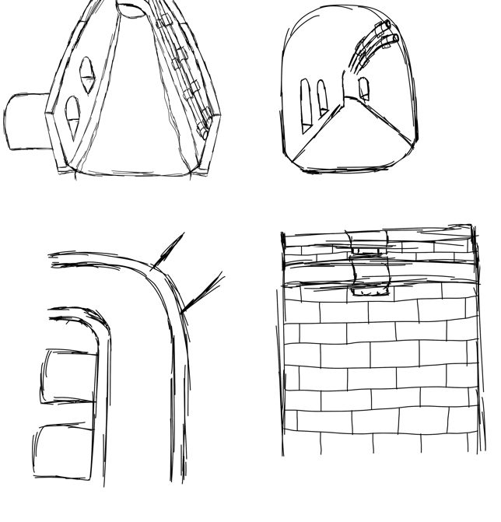

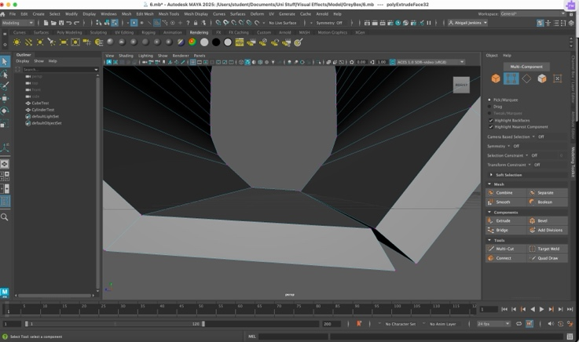
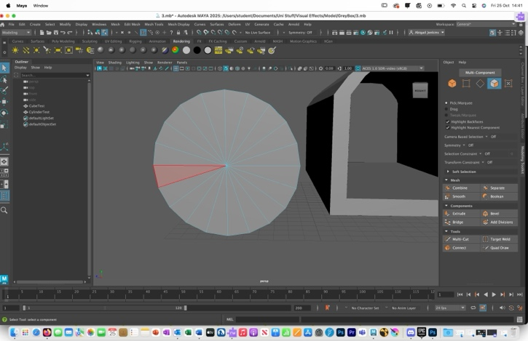
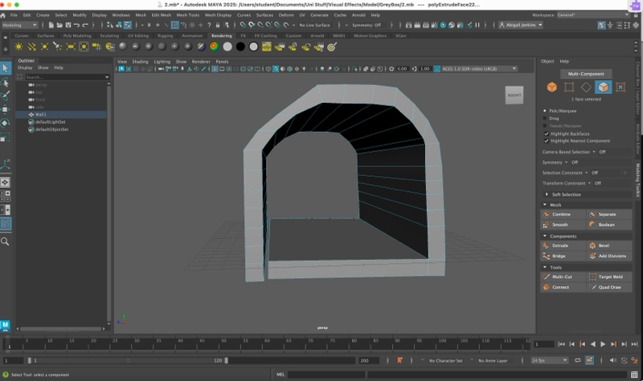
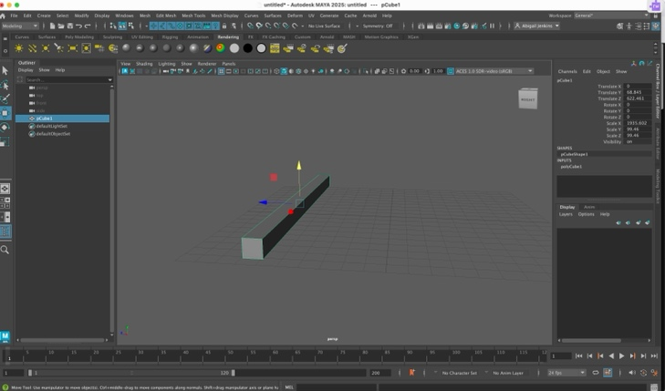
25th Oct 2024
I began constructing the scene in Maya by first creating a cube and extruding it into a tunnel like shape.
After completing it I didn’t like how it looked so I tried modelling it again but this time using a tube as the main base instead. After modelling it into the tunnel shape I wanted, using the extrusion tool and deleting/re-adding faces, I found that it worked out better than the cube based model so I decided to go with that.
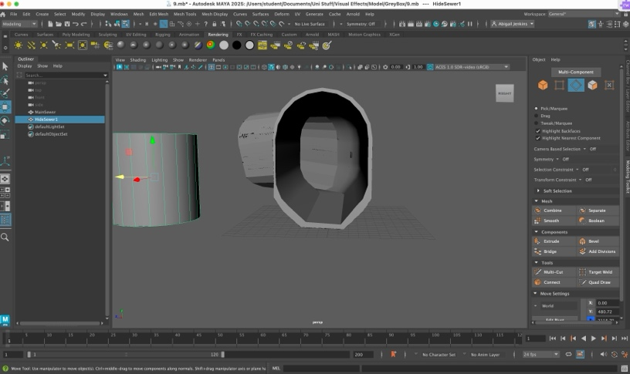

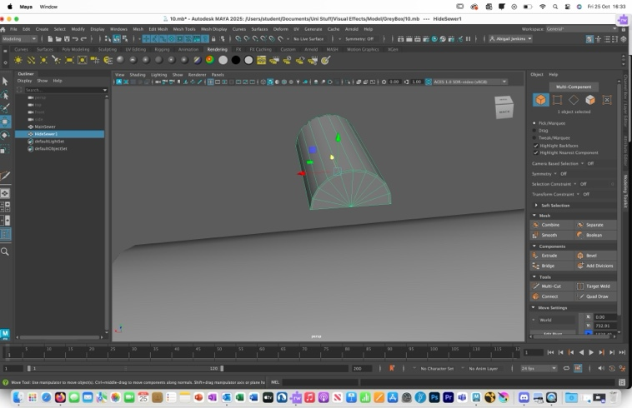
After finishing the mane sewer tunnel off I began modelling the tunnels connected to the main sewer (the one the person is hiding in and the rat comes out of). I used a similar process to the one I used for the main sewer. After completing that I began combining them to the main model by combining the whole model together and then merging the vertices after cutting holes in the main model.
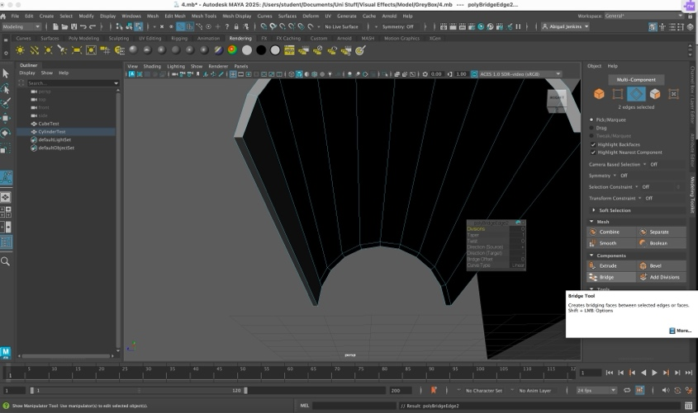
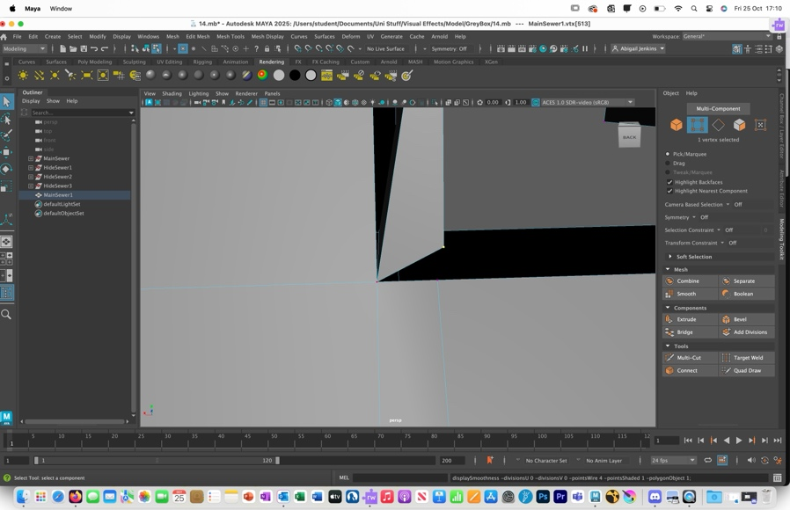

Whilst I modelled I decided to animate the water in 2D rather than trying to simulate it in 3D as I had more experience in that form and thought it would match the rat as it would be the one interacting with it the most.

After finishing that part of the model off I decided to Create another moodboard specifically one testing out different colours.
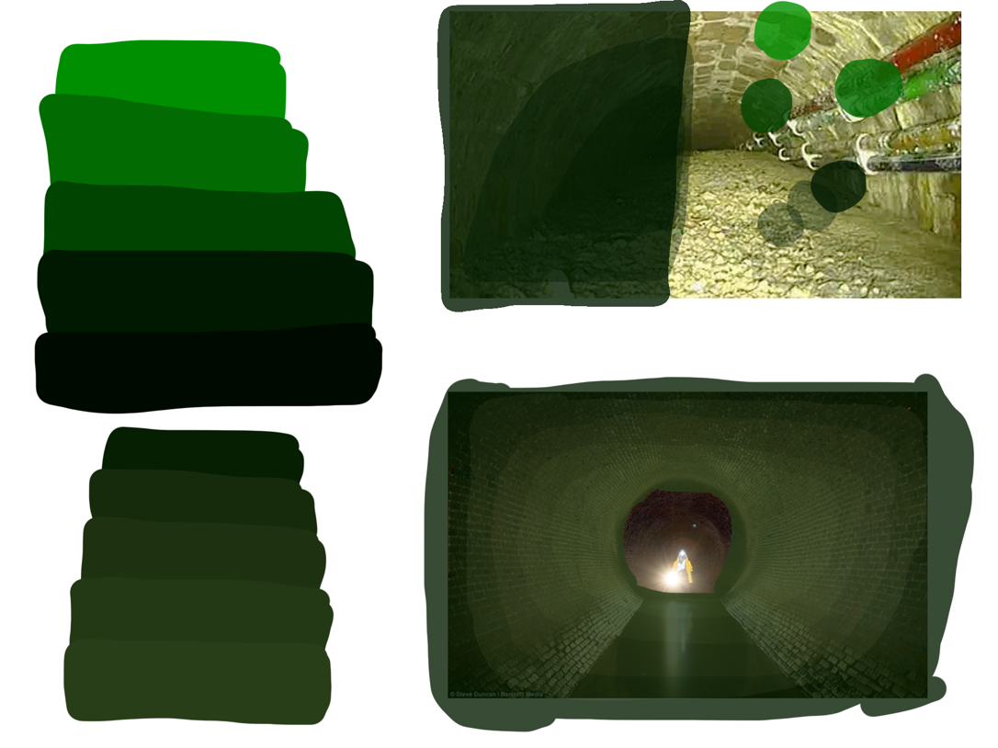

[14]

I mostly focused on green and yellow undertones as I associate that colour with grunge and muck which is what you might find the most in a sewer.

1st Nov 2024

I finished off the main sewer 3D model by smoothing out the details a bit and then began adding the wires that ran along the wall.
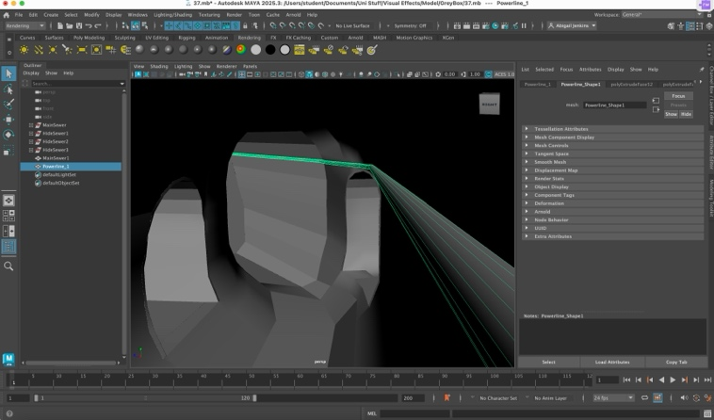
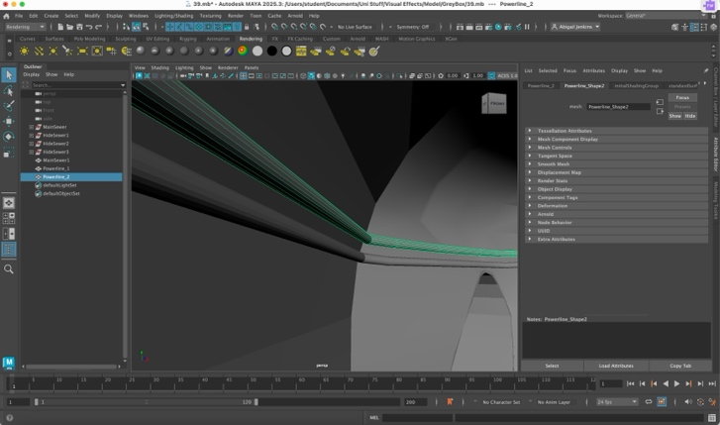
4th Nov 2024
I went to my university building to record my in person footage as it had a greenscreen I could use to help me insert the person into my 3D scene.
I watched the animatic I had created using my storyboards to get a feel on what the character I would be playing as would be doing and then filmed the scene.
I had to retake it a few times, as I kept accidentally catching the roof as the roof was not green screened, but other than that the filming went well.

(Google drive link to the footage taken that day = https://drive.google.com/drive/folders/1euYtuOPB4nNbFWN2ArtOzqryYcCQP48W?usp=sharing )
5th Nov 2024
I completed the 3D model after adding the bolts connecting the wires to the wall.
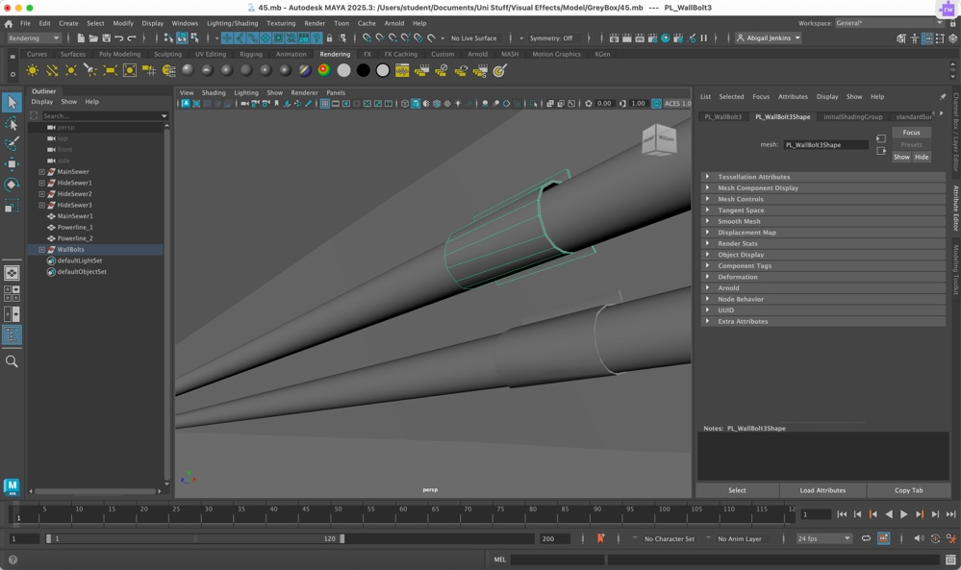

6th Nov 2024
I began sorting out the in person footage. I picked out the most usable ones, the ones without some of the roof in it, and then figured out which one I was going to use.
I was also recommended to look up free online sounds by a support worker during a meeting I had that same day. So I saved some of the sounds I liked the sound of.

11th Nov 2024
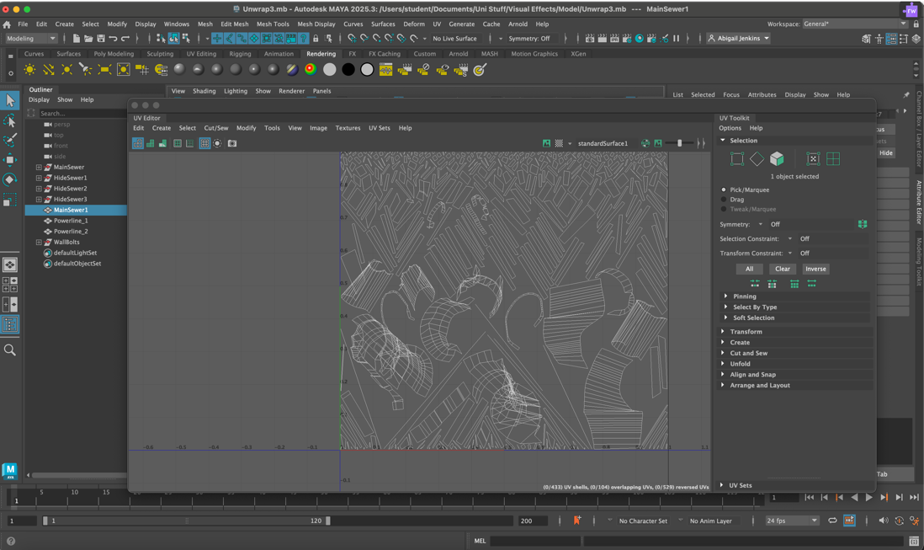
I unwrapped the models UV so I could texture it properly but I ran into a problem as no matter how I cut it, the uv ended up being so warped that I couldn’t use it without the texture becoming disfigured.

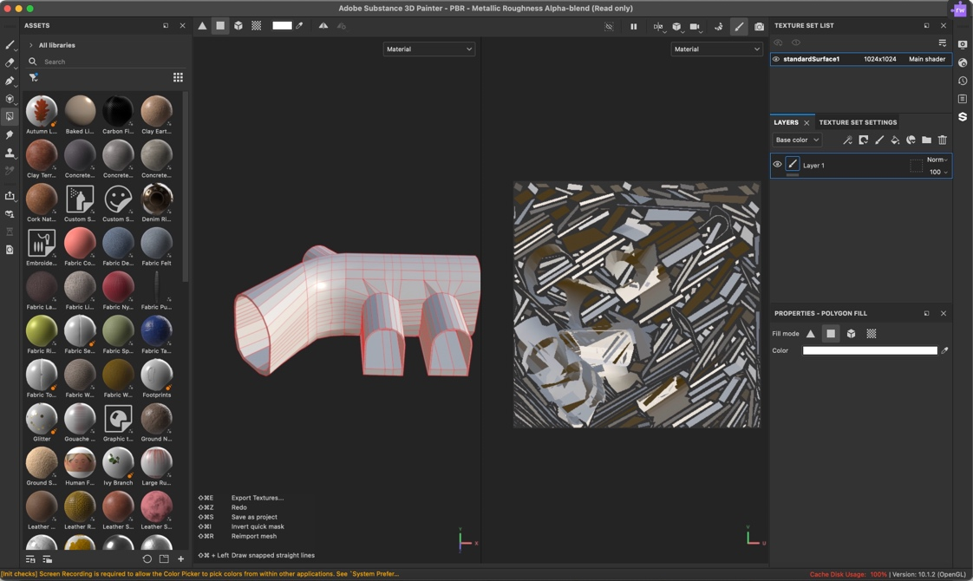
After managing to get it to a point where I might be able to use it I opened Adobe Substance 3D Painter to texture it. However after looking through the free to use material library I discovered that the software didn’t have the texture I needed.

So I decided to use a free stock photo of a brick wall as a texture instead. I had to fix the geometry a bit for the uv unwrap to work.

13th Nov 2024
I decided to abandon the fully connected model and jumped back to a save where I hadn’t connected all of the side tunnels to the main tunnel yet.
Before connecting them I planned to unwrap them all but then ran into another issue as whenever I went to unwrap the UV of the main sewer an error popped up that resulted in faces being cut where I didn’t want them too.
After doing a bit of research I figured out the issue with the UV was one where one of the models faces was only connected to one edge. So I used the clean up tool on the model and that sorted the issue out.
When I finish UV unwrapping, texturing and re-connecting the model I am planning on taking the wires and bolts from the previous model and adding them onto the textured final model.

15th Nov 2024
I finished UV unwrapping everything but the wire and bolts. I moved the shells around a bit so that texturing would be easier and then exported them as PNG’s to my computer.
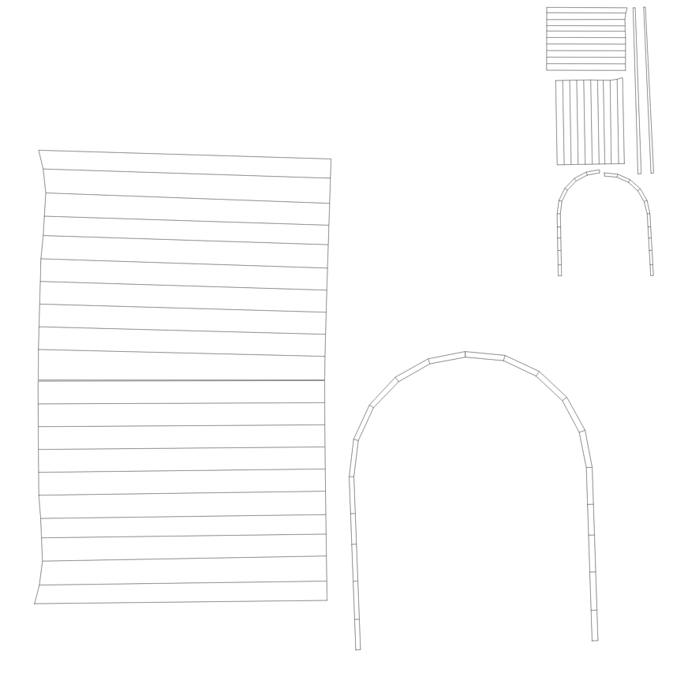
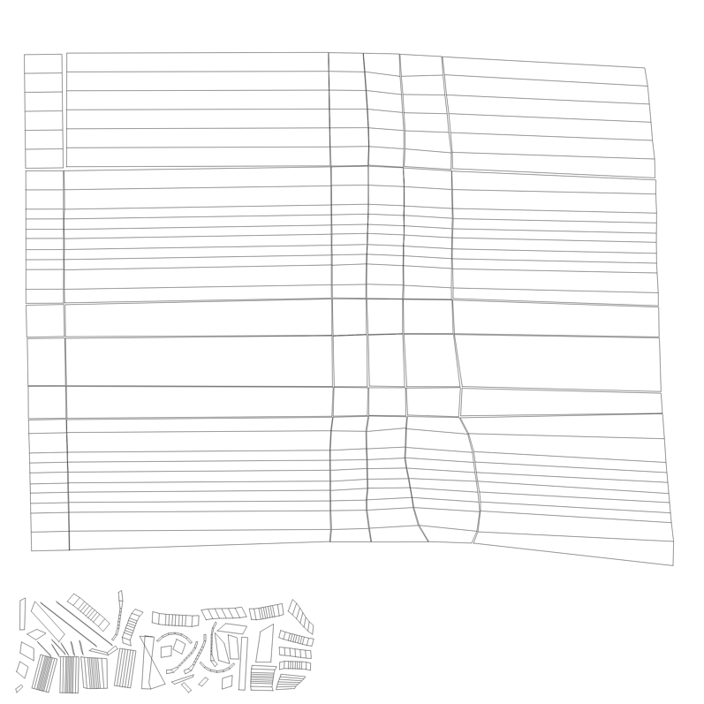

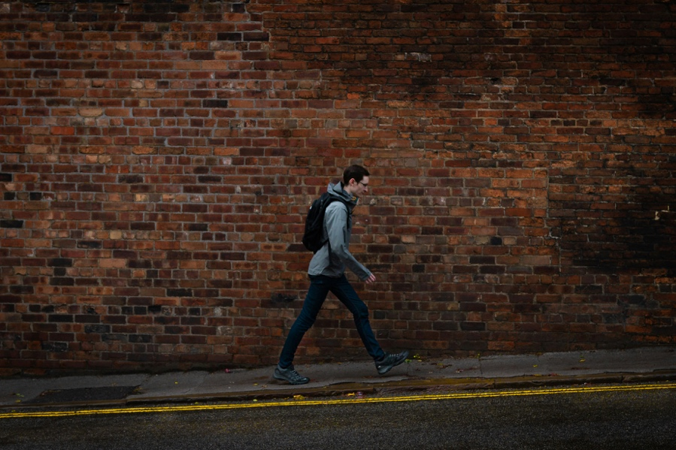
and began searching for free brick wall stock photos to use as textures. I found a texture that matched the type of wall I wanted and began editing it in photoshop. After cutting out a square in the main picture I used the clone stamp tool as, I copied the square to make the texture a reasonable size, to get rid of all the seems in the texture.

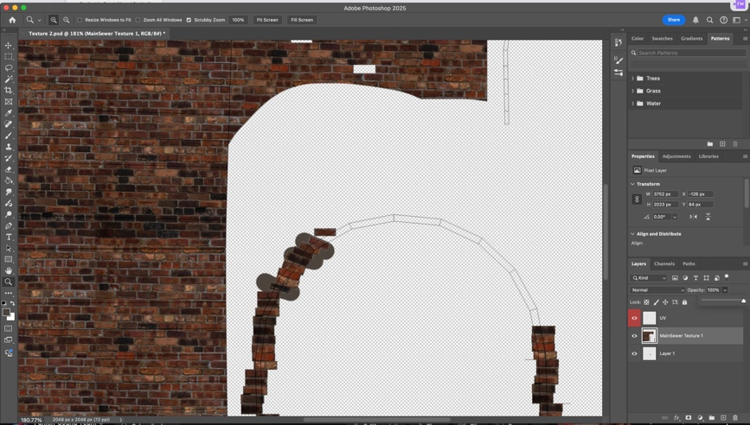
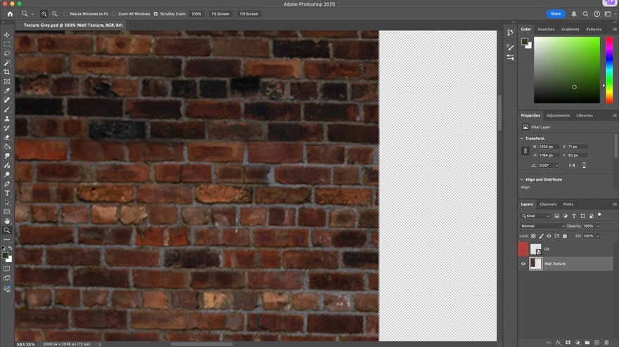
[15]
20th Nov 2024
After adding the textures to the models, I began connecting them all together.
Originally, I had planned for there to be three tunnels in the scene, but after testing out the shot a bit I figured out the shot didn’t include all three tunnels so I just connected two tunnels to the main piece to save on time.
Re added the wires and bolts by saving as deleting the old model and then adding the new file to the new model.

22nd Nov 2024
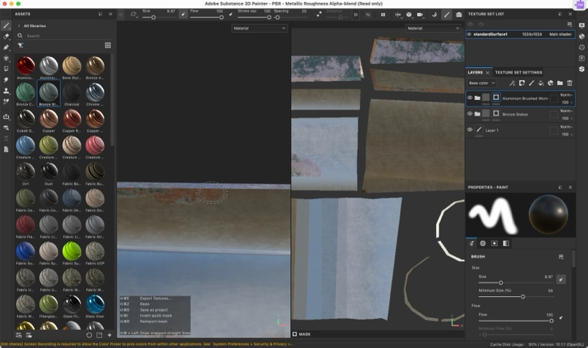
I UV unwrapped the wire and bolts. I textured them in Substance Paint as unlike the brick wall did have the free textures I needed. I only used Plastic Soft Dirty to textured the wire but used more layers for metal wall bolts. After picking the base I liked (Aluminium) I found a rust texture I liked (Bronze statue) and tried to combine it with the base texture. First I tried to use white masks and the paintbrush + polygon fill to draw on the rust. But then I discovered it looked better if I overlayed the rust texture over the base and then lowered the opacity of the rust texture. I used the bolt stamp texture to add fixtures to the edges of the bolts and then exported the textures and added them to my maya model.
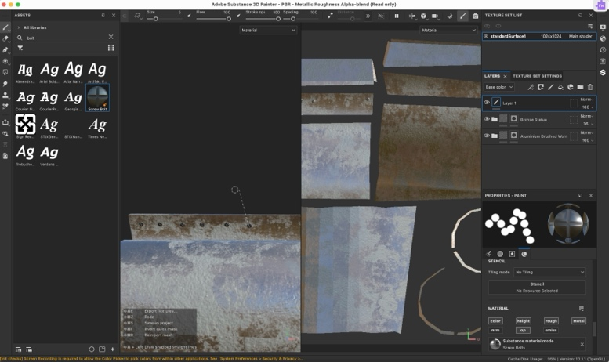
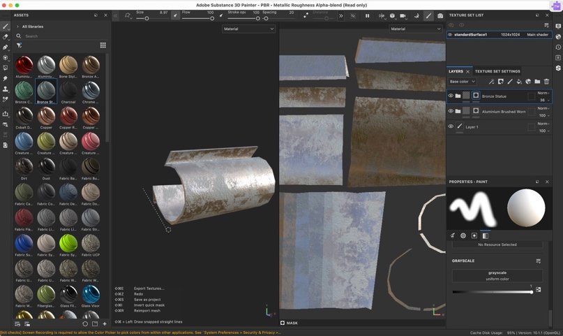
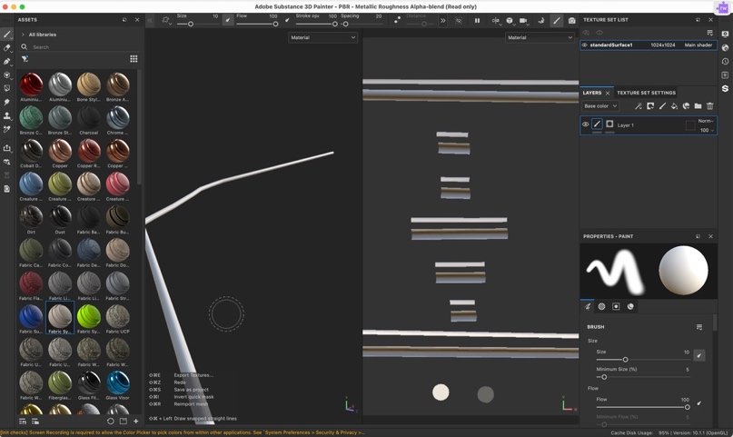

I ran into an issue whilst adding the textures to the wire and bolt models. The wire and bolt textures would not separate, every time I tried to add the wire texture onto only the wire it would put the texture on the bolt as well and vies versa. I tried re-texturing a bolt separately, deleting everything else and then re-adding the file to the model but that didn’t solve the issue. Then I tried exporting the bolt as an FBX file and then re adding it to the model. That seemed to do the trick, So I began re-placing the other wire and the bolts back on to the main sewer model.

25th Nov 2024
I began working on getting the 3D model into Nuke. I put the green screen footage as a base and connected the view node to it but then it rotated. I fixed it by using the transform node to rotate the video, but then the media box didn’t rotate with the footage. So I just decided to scale the video down instead and hope that worked.
I moved on to try and upload the 3D model into nuke. I watched one of the videos the tutor provided [16] but one of the nodes the tutor used wasn’t available to the version I was using on my computer. So I moved to one of the universities computer to see if the version of Nuke on that would work. However the file type of my green screen footage was un-compatible with the version of Nuke. I asked the tutor for help and he informed me that it would only work if the file was converted into a tiff sequence so we did that using Adobe After Effects. After talking about it with the tutor a bit more we figured it would be better to render out a sequence in Maya rather than trying to get the model into Nuke.
During the last few minutes of the session I tried animating the camera in Maya during the last few minutes but it was too quick.

26th Nov 2024
To help accurately time the camera movement in Maya I decided to count how many frames were in my video’s tiff sequence. Before I could do that I had to finalize my decision on which phone video I would use. I chose the video based on how much space I made to show off the model and animated rat.After turning the chosen video into a tiff sequence I counted the frames, moved the camera in the way I wanted it to and it was still too fast. So I looked up the issue online I realised that my Maya settings had reset and changed the Time Slider to 24 frames instead of play every frame. That fixed the speed issue. I edited the footage in Adobe After Effects before turning it into a tiff sequence so I uploaded the tiff files to Premier Pro so I could get the full video to get an accurate timing for the camera animation in Maya.
When I tried to render out the model I only ran into one issue as the render view only showed a black box. But after increasing the render cameras exposure and the light’s intensity I was able to view the model in the render view.

29th Nov 2024
I used the eyedropper tool to grab the one of the greens used in my colour moodboard and made the main light for the 3D scene. Then I animated the other light to simulate a phone screen light so it followed the view of the camera. I began experimenting with the lights intensity to get the darkness for the scene that I wanted. After figuring out how to turn the rendered out sequence into a tiff sequence I rendered out the 3D Maya animation.
During the session I moved back to nuke and attempted the combine both the maya render and the greenscreen footage. But that proved difficult, one because they were both in different formats and two because I couldn’t remove the green screen from the phone footage, using a keylight node, without chunks of my face becoming see-through as well.
After I talked about it with the tutor and experimenting with the footage a bit more by using the colour correction node and moving the footage into Adobe After Effects we came to the conclusion that I needed to re-shoot the greenscreen footage with a better camera and re-render the Maya animation into the same size as the real life footage.

30th Nov 2024
Whilst re-rendering the 3D Maya sequence I had a slight issue with the render view. First I put the measurements in the wrong place so the final footage was flipped on it’s side and then after fixing that I was under the impression that the footage was too zoomed in. Turns out I had the view too zoomed in and the footage was fine.
I proceeded to re-render the Maya scene in the 1080p format.

(Google drive of both Maya renders = https://drive.google.com/drive/folders/1vr-_1KXopjgtrGo-C8q2AW_D44kr9epy?usp=drive_link )
2nd Dec 2024
In preparation for the re-shoot I ran the maya render tiff sequence through Premire Pro to plot out timings for how I should move during the shoot. Whilst waiting I rendered out a brighter version of one of the wider shots of the 3D model so I could animate on it better in Krita. Before starting on the animation by drawing out an animatic in order to get the timings right and experiment how I wanted the rat to move.
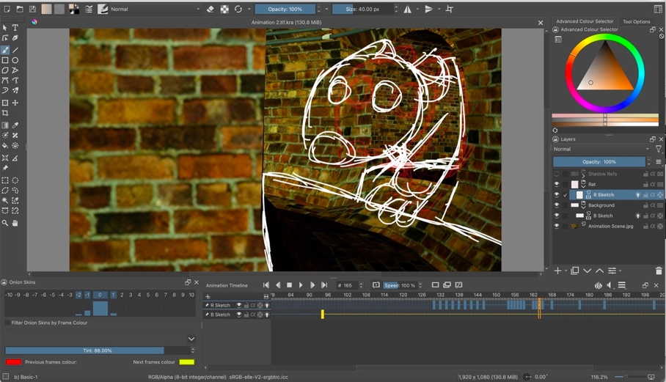

When the session started, I filmed the new footage with the help of the tutor. I used the timings previously acquired to help direct the tutor, who was holding the camera, and we competed the shoot in a reasonable time. After transferring the footage into my computer via hard-drive I continued to work on the animatic.
(A Google-drive link of the final edited version of the footage: https://drive.google.com/drive/folders/15quQHXjnTcdIUNf92c4OrhM8dgS9z-Mv?usp=drive_link )
(I deleted the rest of the footage taken during that day to deal with storage issues after forgetting to save them on a hard drive)

3rd Dec 2024
I finished the animatic, did the inbetweening to make the movement smoother and then moved on to drawing out the colour of the rat today.

4th Dec 2024
I continued to work on the colour.
5th Dec 2024
I worked more on the colour
6th Dec 2024
I finished the rat colour and worked on the water. I made it brown to simulate how dirty the water would be in a sewer and drew out the highlights using a lighter version of the colour, the lighter screen layer option and the gaussian blur filter.
7th Dec 2024
I finished the water animation today. Making both the water exiting the tunnel the rat comes out of and how it moves when the rat lands in the main body of water.
8th Dec 2024
I began working on the rat’s shading by highlighting the eyes. I made the whole rats body darker by selecting the whole thing with the magic wand tool and filling it with a darker colour, before making it see-through. I did the same to the entire animation just to make animating the rat poking through the darkness a bit easier.
9th Dec 2024
After drawing basic shadows in the rats ears and nose and animating the rat poking through the darkness I decided to render it out. I decided it would not be worth putting in more detail as I was running out of time to complete the whole prodject.
After rendering the krita animation as a png sequence I prepared to put the whole thing together by putting the greenscreen footage and the Maya rendered footage into Premier Pro. I made the greenscreen footage see-through in order to compare the timing with the Maya render. After I edited it in a way I was happy with I turned the greenscreen footage into a tiff file using adobe after effects and then put everything into Nuke.

(Google drive of animation of rat = https://drive.google.com/drive/folders/1Prf0EUKoShf2xt_fJftotrM0rEO7bGYq?usp=sharing )

10th Dec 2024
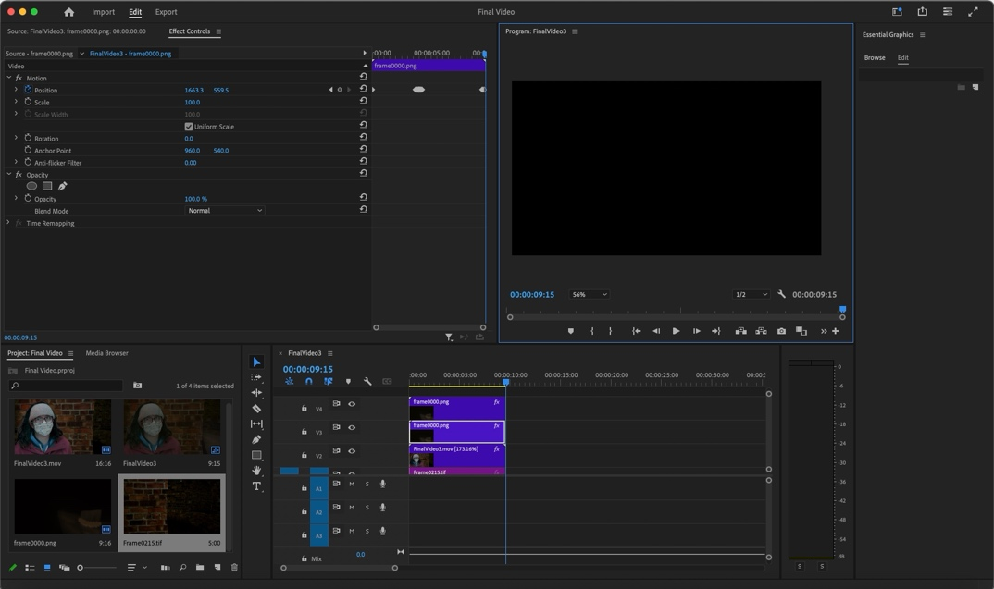
Before starting I decided to add the animation in adobe Premiere Pro after working on the green screen and maya render in Nuke as I felt that would be easier to do considering the time I had left to complete the project and my experience using Nuke compared to Premiere Pro.
I had to re-render the greenscreen footage as the video kept cutting off too early when I ran it in Nuke. I quickly figured out the issue after re-rendering the scene into a different folder. I had rendered the last sequence into the same file I had rendered the older phone filmed greenscreen into so that must’ve messed with the timings.
After solving that issue, I put the new tiff sequence into Nuke again and began editing out the greenscreen. I used a keylight node to get rid of the green screen It worked better than last time. Then I used the merge node to combine the green screen footage and 3D model render only to find out the frame count were different despite both films seeming to being the same length.
Premiere Pros timings seem different from the other software I used to edit the footage, as on Premiere Pro the timings look the same, but after moving the two videos into After Effects It turns out the greenscreen footage is longer.
So I edited the greenscreen footage in After Effects for now. I fixed the issue by enabling time-remapping and speeding the greenscreen footage up enough to match the length of the 3D scene footage. It was still too slow so I decided to just re-render the Maya footage again in Adobe After Effects and that seemed to do the trick.
After solving a storage issue I went into Nuke again. I experimented with the tracker node until the greenscreen footage was moving in the way I wanted it to. I used the transform tool and scaled up the greenscreen footage so I could move it into the place I wanted without it getting rid of the see-through after I moved it out of frame completely. I then used the tracker node and another transform node to connect the greenscreen footage to the Maya footage, so it would move more realistically. Then I made the greenscreen footage match the background’s shadows a bit more with the grade node and experimented with the different sliders until I had something I was happy with. The lift and white points were making the footage too bright so I only used the blackpoint and then darkened the footage more by using one of the sliders just above.
There was still a sticker/marker showing up on the screen that I wasn’t sure how to get rid of. First I tried to keylight it but using it resulted in the keylight getting rid of the other white in the video, so that didn’t work. Then I tried getting rid of it using rotoscoping and merge nodes but that didn’t work so I moved to colour correct and merge node and that kind of worked but only in changing it’s colour and not making it see-through, So I thought I could try keylighting it again but connecting the roto node to it so that the keylight only affects the space I wanted it to but that didn’t seem to work either. I decided I was going to get rid of it in Premiere Pro instead and rendered out the final sequence using a write node.
The background moved when I didn’t want it too so I tried fixing that by using another transform node and moving it back into place. Whilst doing that I realised the problem wasn’t the background but the foreground and began trying to move that instead. After scaling the greenscreen footage up and moving it around there were finally no big black boxes in the final footage anymore.
I put the footage into Premiere Pro and began editing the animation into it by editing the position and keying out the movements. Moving the animation caused the filter I put into it to move as well so I duplicated the filter and moved/keyed it using the transform and rotate tool in the effect tab. I then selected the opacity mask and removed the sticker/marker by inverting the mask and adding a frame of the background underneath the main video.

11th Dec 2024
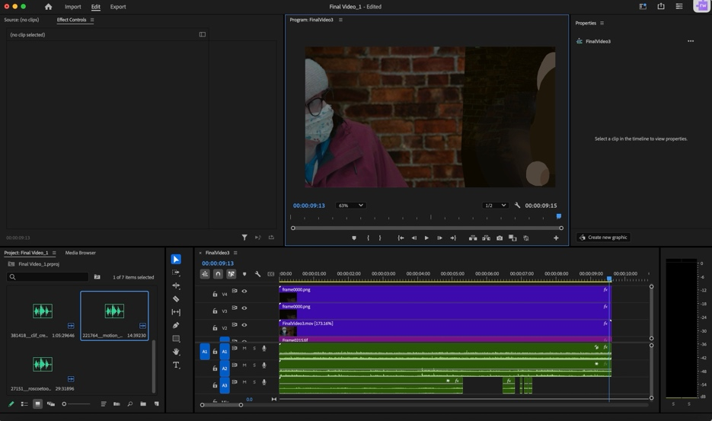
After finishing the main footage, I looked back to the website that was suggested to me and began looking for sounds.
After finding the sounds of something walking through the water and choosing the sound I liked best out of the previously collected sounds I began adding them to the final video. Then I edited the sounds to fit the length of the video and time it to the rat landing/walking in the water and after finishing that I rendered out the whole thing.

[17] – [19]

Reflection

I learnt a lot during this process and am very happy with how I handled the difficulties I faced during this project. I was disappointed with how many times I forgot previous software options so I will begin practicing with the software more, so this doesn’t happen again. I am also unhappy with how some of the issues could’ve been solved sooner or in much easier ways but now that I am aware of this potential issue in my personality, I will be in a better position to solve them next time.
Overall I am proud of what I have accomplished during the project.

Final Film
Google Drive Link = https://drive.google.com/drive/folders/1C_kqXeMFc-aF7PVDGx0Ywz34Pu3a6fLg?usp=sharing

Presentation Slides
Microsoft Share Link = https://uowtsd-my.sharepoint.com/:p:/g/personal/2115482_student_uwtsd_ac_uk/ERXvvkFZPnNKuzGTPSB-4QwB_mXcZ_L3Xcitb6XZ5krckw?e=JKIQG0

References

[1] M. Forward, “Free Professional Commercial Storyboard Template,” Digital Storyboards, Apr. 28, 2013. [Online]. Available: https://digitalstoryboards.com/archives/499 [Accessed Oct. 2, 2024].
[2] D. Myrick and E. Sanchez, Director, The Blair Witch Project, [DVD], Florida: Haxan Films, 1999
[3] Admin, “Optimizing sewers digital age,” kando, Aug. 13, 2019. [Online]. Available: https://www.kando.eco/optimizing-sewers-in-the-digital-age/ [Accessed Oct. 2, 2024].

[4] Eliminate LTD, “Interesting Facts About Rats,” Eliminate LTD, 2023. [Online]. Available: https://www.eliminatesolutions.co.uk/ten-fascinating-facts-about-rats/ [Accessed Oct. 2, 2024].

[5] A. Eliades, “How To Tell If You Have Rats And Mice In Your Home Or Garden,” Deep Green Permaculture, Sep. 16, 2022. [Online]. Available: https://deepgreenpermaculture.com/2022/09/16/how-to-tell-if-you-have-rats-and-mice-in-your-home-or-garden/ [Accessed Oct. 2, 2024].

[6] V. Winter and J. Winter, Director, DeadStream, [DVD], America: Winterspectre Entertainment, 2022.

[7] C. Utesch, “Understanding Sewer Systems in the United States,” Aqualis, 2024. [Online]. Available: https://aqualisco.com/understanding-sewer-systems/ [Accessed Oct. 2, 2024].

[8]Drain and Sewer Services, ”A history of sewers: A journey from Acient to Modern Times,” drain and sewers services, 2024. [Online]. Available: https://www.drainandsewer.co.uk/a-history-of-sewers-a-journey-from-ancient-to-modern-times/ [Accessed Oct. 14, 2024].

[9] A. Powell, “Taking the pee,” The Riba Journal, Oct. 8, 2019. [Online]. Available: https://www.ribaj.com/culture/undergound-guide-to-sewers-stephen-halliday-thames-hudson-london-paris-new-york-bazalgette [Accessed Oct. 14, 2024].

[10] B. Combing, “Victorian Urban Legends: Sewer Wealth,” Beachcombing’s Bizarre History Blog, Feb. 21, 2017. [Online]. Available: https://www.strangehistory.net/2017/02/21/victorian-urban-legends-sewer-wealth/ [Accessed Oct. 14, 2024].

[11]Inloc Robotics, “Sewerage Systems,” inloc robotics, May. 11, 2022. [Online]. Available: https://inlocrobotics.com/en/sewerage-systems/ [Accessed Oct. 14, 2024].

[12] Substormflow, “Manchester Sewer History,” substormflow, Jun. 28, 2015. [Online]. Available: https://substormflow.com/article/manchester-sewer-history/ [Accessed Oct. 14, 2024].

[13] Substormflow, “Hulme Flume,” substormflow, Dec. 13, 2009. [Online]. Available: https://substormflow.com/drain/hulme-flume/ [Accessed Oct. 14, 2024].

[14] A. Clark Estes, “A ‘Concreteberg’ as Long as a Football Field Has Clogged London’s Sewers,” Gizmodo, Apr. 19, 2019. [Online] Available: https://gizmodo.com/a-concreteberg-as-long-as-a-football-field-has-clogged-1834168340 [Accessed Oct. 28, 2024].

[15] M. Feeney, “man walking in sidewalk,” unsplash, Sep. 12, 2018. [Online] Available: https://unsplash.com/photos/man-walking-in-sidewalk-u4mR6IfL9Ko [Accessed Nov. 15, 2024].

[16] Nabeel, Camera Tracking in Nuke : Export Camera Track From Nuke to Maya: Lighting Setup in Maya – PART 1”, YouTube, Apr, 9, 2024 [Online] Available: https://youtu.be/jY2joTMBwcY?si=dTB2lc-G2P3rc288 [Accessed Nov. 25, 2024].

[17] clif_creates, “Water Through Drain (With Reverb),” freesound, Feb. 19, 2017. [Online] Available: https://freesound.org/people/clif_creates/sounds/381418/ [Accessed Nov. 6, 2024].

[18] roscoetoon, “water_drip-echo2,” freesound, Dec. 12, 2006. [Online] Available: https://freesound.org/people/roscoetoon/sounds/27151/ [Accessed Nov. 6, 2024].

[19] Motion_S, “Water Wading,” freesound, Mar. 5, 2014. [Online] Available: https://freesound.org/people/Motion_S/sounds/221764/ [Accessed Dec. 11, 2024].

Bibliography

[1] M. Forward, “Free Professional Commercial Storyboard Template,” Digital Storyboards, Apr. 28, 2013. [Online]. Available: https://digitalstoryboards.com/archives/499 [Accessed Oct. 2, 2024].
[2] D. Myrick and E. Sanchez, Director, The Blair Witch Project, [DVD], Florida: Haxan Films, 1999
[3] Admin, “Optimizing sewers digital age,” kando, Aug. 13, 2019. [Online]. Available: https://www.kando.eco/optimizing-sewers-in-the-digital-age/ [Accessed Oct. 2, 2024].

[4] Eliminate LTD, “Interesting Facts About Rats,” Eliminate LTD, 2023. [Online]. Available: https://www.eliminatesolutions.co.uk/ten-fascinating-facts-about-rats/ [Accessed Oct. 2, 2024].

[5] A. Eliades, “How To Tell If You Have Rats And Mice In Your Home Or Garden,” Deep Green Permaculture, Sep. 16, 2022. [Online]. Available: https://deepgreenpermaculture.com/2022/09/16/how-to-tell-if-you-have-rats-and-mice-in-your-home-or-garden/ [Accessed Oct. 2, 2024].

[6] V. Winter and J. Winter, Director, DeadStream, [DVD], America: Winterspectre Entertainment, 2022.

[7] C. Utesch, “Understanding Sewer Systems in the United States,” Aqualis, 2024. [Online]. Available: https://aqualisco.com/understanding-sewer-systems/ [Accessed Oct. 2, 2024].

[8]Drain and Sewer Services, ”A history of sewers: A journey from Acient to Modern Times,” drain and sewers services, 2024. [Online]. Available: https://www.drainandsewer.co.uk/a-history-of-sewers-a-journey-from-ancient-to-modern-times/ [Accessed Oct. 14, 2024].

[9] A. Powell, “Taking the pee,” The Riba Journal, Oct. 8, 2019. [Online]. Available: https://www.ribaj.com/culture/undergound-guide-to-sewers-stephen-halliday-thames-hudson-london-paris-new-york-bazalgette [Accessed Oct. 14, 2024].

[10] B. Combing, “Victorian Urban Legends: Sewer Wealth,” Beachcombing’s Bizarre History Blog, Feb. 21, 2017. [Online]. Available: https://www.strangehistory.net/2017/02/21/victorian-urban-legends-sewer-wealth/ [Accessed Oct. 14, 2024].

[11]Inloc Robotics, “Sewerage Systems,” inloc robotics, May. 11, 2022. [Online]. Available: https://inlocrobotics.com/en/sewerage-systems/ [Accessed Oct. 14, 2024].

[12] Substormflow, “Manchester Sewer History,” substormflow, Jun. 28, 2015. [Online]. Available: https://substormflow.com/article/manchester-sewer-history/ [Accessed Oct. 14, 2024].

[13] Substormflow, “Hulme Flume,” substormflow, Dec. 13, 2009. [Online]. Available: https://substormflow.com/drain/hulme-flume/ [Accessed Oct. 14, 2024].

[14] A. Clark Estes, “A ‘Concreteberg’ as Long as a Football Field Has Clogged London’s Sewers,” Gizmodo, Apr. 19, 2019. [Online] Available: https://gizmodo.com/a-concreteberg-as-long-as-a-football-field-has-clogged-1834168340 [Accessed Oct. 28, 2024].

[15] M. Feeney, “man walking in sidewalk,” unsplash, Sep. 12, 2018. [Online] Available: https://unsplash.com/photos/man-walking-in-sidewalk-u4mR6IfL9Ko [Accessed Nov. 15, 2024].

[16] Nabeel, Camera Tracking in Nuke : Export Camera Track From Nuke to Maya: Lighting Setup in Maya – PART 1”, YouTube, Apr, 9, 2024 [Online] Available: https://youtu.be/jY2joTMBwcY?si=dTB2lc-G2P3rc288 [Accessed Nov. 25, 2024].

[17] clif_creates, “Water Through Drain (With Reverb),” freesound, Feb. 19, 2017. [Online] Available: https://freesound.org/people/clif_creates/sounds/381418/ [Accessed Nov. 6, 2024].

[18] roscoetoon, “water_drip-echo2,” freesound, Dec. 12, 2006. [Online] Available: https://freesound.org/people/roscoetoon/sounds/27151/ [Accessed Nov. 6, 2024].

[19] Motion_S, “Water Wading,” freesound, Mar. 5, 2014. [Online] Available: https://freesound.org/people/Motion_S/sounds/221764/ [Accessed Dec. 11, 2024].

[20] InspectorJ, “Sewer Soundscape, A,” freesound, Apr. 12, 2016. [Online] Available: https://freesound.org/people/InspectorJ/sounds/342566/ [Accessed Nov. 6, 2024].

[21] InspectorJ, “Water, Dripping, Medium, A,” freesound, Apr. 22, 2015. [Online] Available: https://freesound.org/people/InspectorJ/sounds/271335/ [Accessed Nov. 6, 2024].

[22] Zabuhailo, “sewerage-well,” freesound, Oct. 31, 2012. [Online] Available: https://freesound.org/people/Zabuhailo/sounds/168809/ [Accessed Nov. 6, 2024].

[23] ryansitz, “Wading in Shallow Water,” freesound, Apr. 15, 2016. [Online] Available: https://freesound.org/people/ryansitz/sounds/342932/ [Accessed Dec. 11, 2024].

[24] ConnorM94, “Wading_Through_Water,” freesound, Apr. 1, 2017. [Online] Available: https://freesound.org/people/ConnorM94/sounds/386884/ [Accessed Dec. 11, 2024].

[25] sub-urban, “Old Stone,” flickr, Feb. 12, 2010. [Online] Available: https://www.flickr.com/photos/jondoe_264/4350478637/ [Accessed Oct. 14, 2024].

[26] Vox, “It’s not you – movies are getting darker.”, youtube, Nov. 9, 2022. [Online] Available: https://youtu.be/Qehsk_-Bjq4?si=8np87yaYmp8Ljo2v [Accessed Oct. 28, 2024].

[27] N. Sokolov, “a brick wall with a hole in it,” unsplash, Jun. 10, 2022. [Online] Available: https://unsplash.com/photos/a-brick-wall-with-a-hole-in-it-zTyvwAiqPZM [Accessed Nov. 11, 2024].

[28] A. Giles, “a brick wall with a blue gate,” unsplash, Jul. 1, 2022. [Online] Available: https://unsplash.com/photos/a-brick-wall-with-a-blue-gate-qbDMqmXUxac [Accessed Nov. 15, 2024].

[29] P. Czerwinski, “red brick wall,” unsplash, Dec. 9, 2018. [Online] Available: https://unsplash.com/photos/red-brick-wall-L6I44mGsJmE [Accessed Nov. 15, 2024].

[30] D. De Vylder, “a bicycle leaning against a brick wall with writing on it,” unsplash, Aug. 12, 2023. [Online] Available: https://unsplash.com/photos/a-bicycle-leaning-against-a-brick-wall-with-writing-on-it-G8xXdq5woVM [Accessed Nov. 15, 2024].

