Building and managing a Type 2 Hypervisor platform based virtualised network

Author – Gareth Evans
Student Number – 1810612
Module Name – Network Operating Systems and Services
Module Code – ACCA5023

Contents
1. Introduction 1
2. Creating a virtual Local Area Network (LAN) 1
2.1 Creating the Virtual Machines 2
2.2 Configuring the Virtual Network 3
2.3 Testing Connectivity 7
3. Observational Tasks 8
3.1 What are the differences between a Type 1 and Type 2 Hypervisor? 8
3.2 What is the significance of a subnet mask in an IPv4 address? 8
3.3 What is cloud computing used for and what are its advantages/disadvantages? 9
3.4 . Features seen in VLANs and their purpose 9
4. Conclusion 10
Bibliography 10

Introduction

This report documents the creation of a virtual local area network (VLAN) using a type 2 hypervisor program called VirtualBox. The author aims to build, configure and manage the VLAN and include screenshots of the process across four separate reports that document the different stages of the network. In this document, screenshots demonstrating the creation and configuration of four virtual machines on the VLAN will be annotated by the author. There will also be screenshots showing a ping test between the server machines and the client machines. The server machines will be created using a Windows Server 2019 ISO file. The client machines will use a Windows 10 ISO file. All virtual machines will have network adapters that will be uniquely named and be assigned IP addresses. Following the practical section of the report, the author will discuss aspects of the network that were utilised to demonstrate an understanding of the VLAN creation.

2. Creating a virtual Local Area Network (LAN)

This section of the report contains the screenshots of the creation, configuration and testing of the virtual machines. Each figure includes a brief comment explaining what the author was doing at that step. Please note all steps carried out on Server1 and Client1 were repeated on Server2 and Client2 but with the relevant IP addresses.

2.1 Creating the Virtual Machines

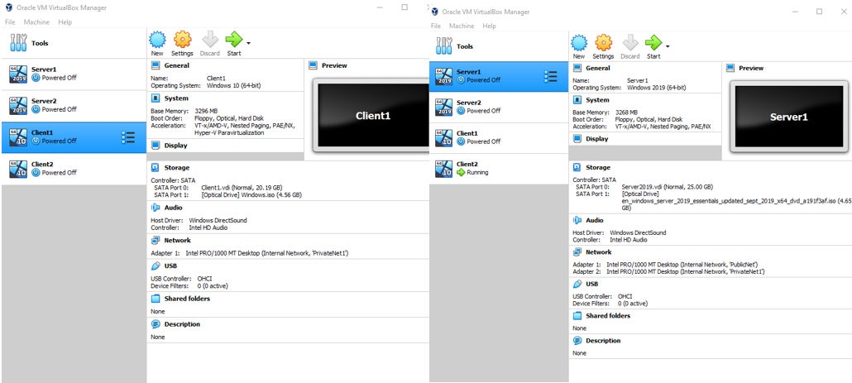
Figure 1 - Creating Servers and Clients in VirtualBox
First, the author installed the most recent version of VirtualBox to build the network. To build this network, ISO files were also needed for the relevant operating systems (OS). In this situation, a Windows 10 and Windows Server 2019 ISO were downloaded. The author first set up the server machine, called Server1. Server 1 was allocated 4096MB in random access memory (RAM) and the size of the virtual hard disk was set to 25GB. The author then had to eventually reduce the RAM size to 3268MB due to restrictions on their local device. The author was unable to run two virtual machines (vms) at the same time. By reducing the RAM, both Server1 and Client1 could run simultaneously. The OS was installed using the ISO file downloaded previously. This step was repeated for Server 2. The author set up Client1 and Client 2 like Server1, however the ISO file used was Windows10, meaning the OS on Client1 & 2 was Windows 10. All machines have an admin password of P@ssw0rd.

2.2 Configuring the Virtual Network
Figure 2 shows the network configuration the author has used when setting up Server1 in VirtualBox. In the network settings for the VM, internal network was selected. Internal networking is where the VM can communicate with external networks, however these external networks are limited to other VMs on the same host which connect to the same internal network.
Figure 2 Configuring adapter settings
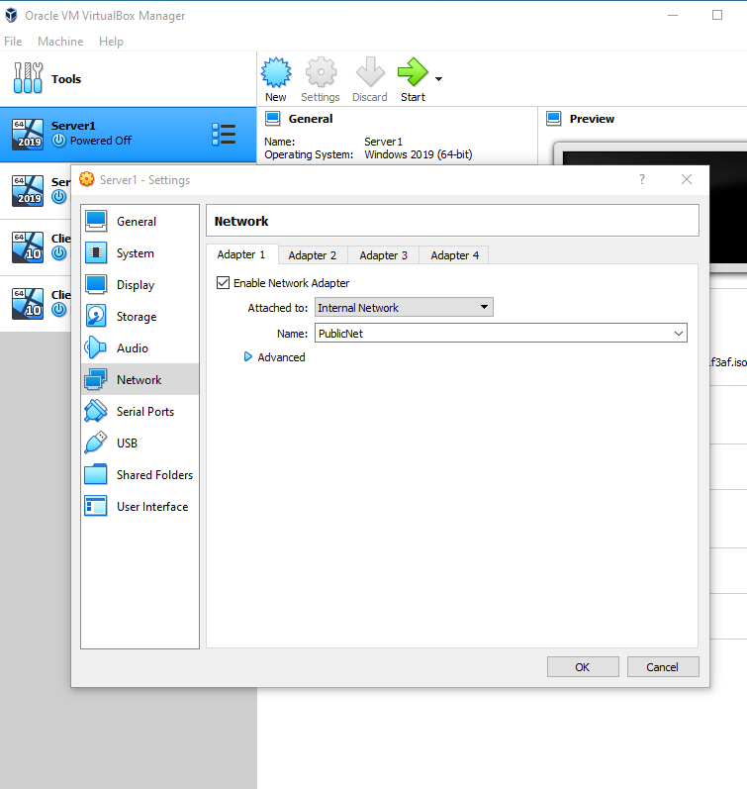

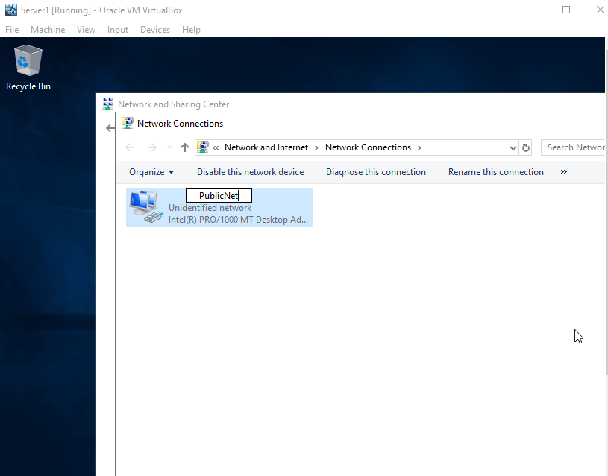
Figure 3 on the right shows the author naming the first network adapter on Server1. Only one adapter was active at this stage and it was named “PublicNet”.
Figure 3 Naming first network adapter on server

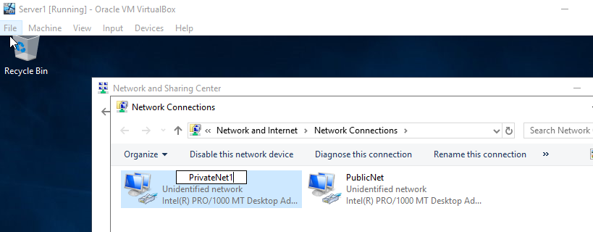
Figure 4 shows the second network adapter on Server1 being enabled and named “PrivateNet1”.
Figure 4 Naming second network adapter on server

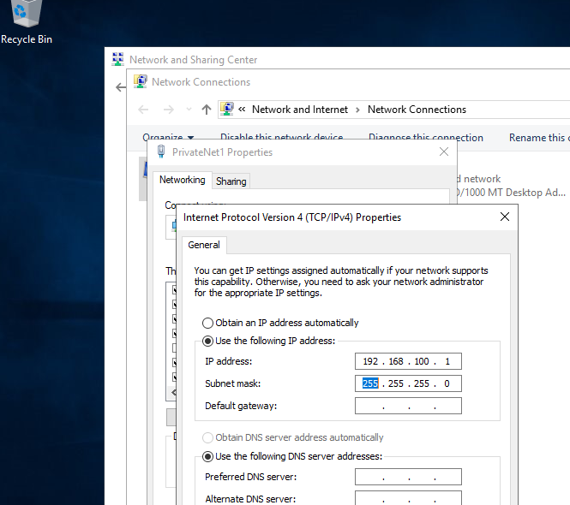
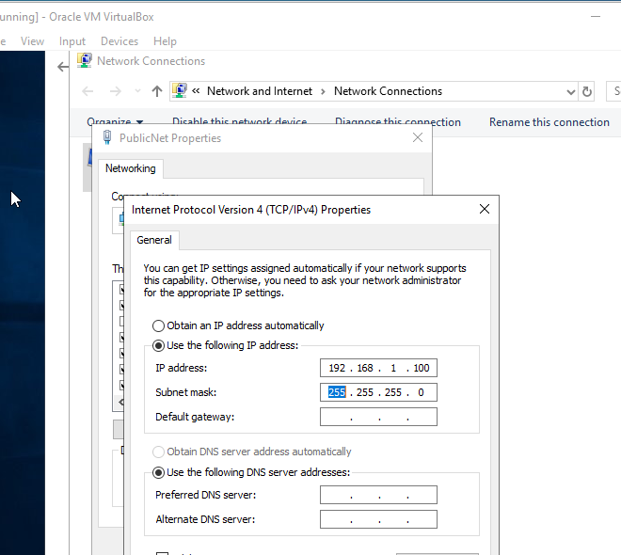
Figure 6 shows the author assigning a class C IP address to the second network adapter on Server1 called “PrivateNet1”.
Figure 5 shows the author assigning a static IP address and subnet mask to the adapter “PublicNet” on Server1. Only Server1 and Server2 will have these “PublicNet” adapters. The IP address assigned is a class C address.
Figure 5 Assigning IP address to next adapter
Figure 6 Assigning IP address to one adapter
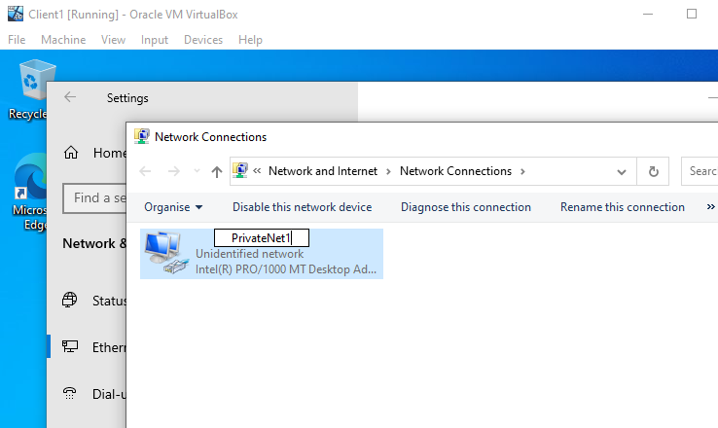
Now working on the windows 10 VM called Client1, the author renames the network adapter to “PrivateNet1”.
Figure 7 Naming adapter on client machine

Figure 8 Assigning IP to adapter on client machine
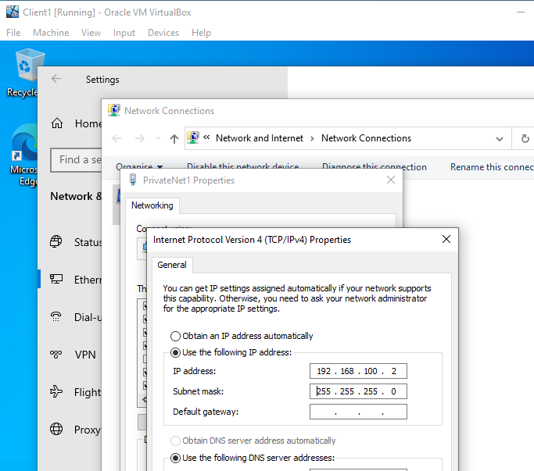
Figure 8 shows the author assigning a class C IP address and subnet mask to the “PrivateNet1” adapter on Client1. Server1 will be able to communicate with Client1 using the addresses assigned as seen in later figures.

2.3 Testing Connectivity

Figure 9 shows a ping test carried out by the author on Server1. The ping sends packets to the target, in this case PrivateNet1 on Client1 and waits for a reply. As seen in figure 9, the reply from Client1 is successful, meaning the two VMs can communicate.
Figure 9 Testing connectivity on Server1
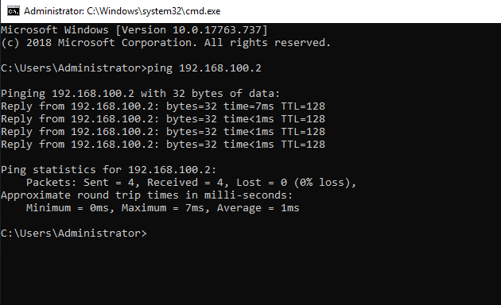

Figure 10 Testing connectivity on Server2
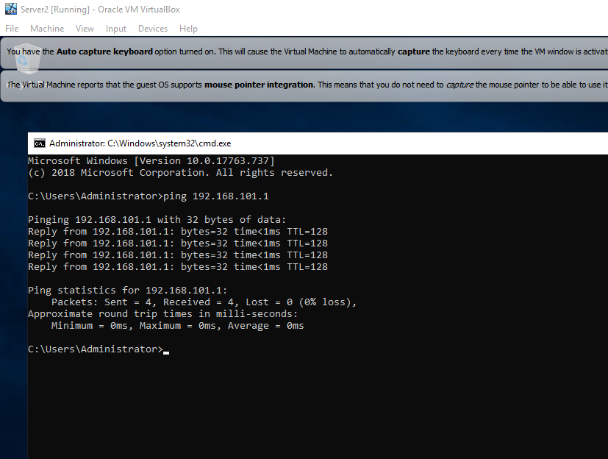
Figure 10 shows a ping test similar to that seen in figure 9, however the test was carried on Server2. The test shows Server 2 trying to communicate with PrivateNet2 on Client2, succeeding with getting a reply.

Observational Tasks

This section will answer four questions that provide context to the VLAN the author has created.

What are the differences between a Type 1 and Type 2 Hypervisor?

A hypervisor is a software used to create and run a virtual machine. Hypervisors are run on physical host machines and allow this host to run multiple virtual machines by sharing resources such as RAM and processing [1]. Current hypervisors are divided into two types, a Type 1 Hypervisor and a Type 2 Hypervisor. The most common hypervisor is the type 1. This is virtualization software that is installed on to the host machines hardware. A type 1 hypervisor is used to control the hardware and on the virtual machines. A type 2 hypervisor runs as a software layer on an operating system [2].
Both types of hypervisors serve the same purpose, what segregates type 1 and type 2 hypervisors comes down to the underlying operating system being present or absent. Type 1 hypervisors runs off the hosts hardware to managed the virtual machines operating systems and performs the resource allocation. Type 2 hypervisor is run as a software on the hosts operating system, using the hosts operating system to provide for the virtual machine operating systems [3].
Type 1 hypervisors are referred to as “Bare metal” hypervisors as they run directly on the physical hardware of the host. There is no need for the host operating system to load. Since type 1 hypervisors have access to the hosts hardware, they are considered the more efficient type available for large networks. They are also more secure than type 2 hypervisors due to the type 1 hypervisors bypassing the host operating system where most vulnerabilities would be found. However, type 1 hypervisors require a separate management machine to provide the administrative role for VMs and configure the hosts hardware. Some examples of type 1 hypervisors include Citrix and Microsoft Hyper-V [4].
Type 2 hypervisors are low cost and easy to install, making them ideal for virtualization beginners and test environments. They provide quick access to an alternative operating system on top of the host operating system. For example, a Linux based operating system can be run off a host with a Windows operating system. However, type 2 hypervisors must have access to the hosts resources, increasing the chance of disruption when compared to type 1. The reliance on the host operating system also makes type 2 hypervisors more of a security risk. If an attacker can compromise the host, the virtual machines are left open to potential harm [5]. Examples of type 2 hypervisors include Oracle VirtualBox and VMWare.

3.2 What is the significance of a subnet mask in an IPv4 address?

A subnet mask is a 32-bit number that separates the IP address into the network addresses and host addresses. A “1” in a subnet mask represents part of the network identity and the “0” represents part of the host address. This means that the subnet mask is how hosts can tell whether network traffic is for the current network or needs to be sent outside the network to reach its destination.
In IPv4, subnet masks are represented in decimal form such as 255.255.255.0. In the example subnet mask, the first 24 bits are identified as the network address and the remaining 8 bits are the host address [6].

3.3 What is cloud computing used for and what are its advantages/disadvantages?

Cloud computing allows end users to access resources such as software, databases and servers over the internet. Organisations can subscribe to cloud service providers to provide computer services such as storage, eliminating the need for hardware or internal management of networks. It is similar to streaming, where rather than downloading a resource on to a device, it is streamed via the internet using a subscription. Types of cloud computing include Software as a Service (SaaS), Platform as a Service (PaaS) or Infrastructure as a Service (IaaS) [7].
The concept behind SaaS is to provide software applications over the internet rather than an organisation having to install it on each individual machine. This allows for flexibility in terms of what device the end users work with. SaaS also means the end user does not need to worry about remaining on up-to-date version of software as they would access the service through a web browser or an app [8].
PaaS is similar to SaaS except it gives a platform for software creation over the internet. PaaS is delivered through the web, meaning developers do not need to be concerned with the device they are working on not being up to the required specification. PaaS allows developer tools to be highly available, is a cost-effective solution and reduces the amount of coding done by a developer [9].
IaaS is best suited for businesses who are looking to utilise on demand resources rather than purchasing hardware outright. Businesses can use IaaS to access or monitor computers, networks or storages through the internet. Infrastructure is delivered directly using virtualization and provides the end user with flexibility in that they are given control over the infrastructure [10].
Current trends suggest that cloud computing is increasingly popular, with Gartner suggesting public cloud revenue is expected to reach $331 billion by 2022 [11]. This does not mean cloud computing is perfect, it certainly comes with its disadvantages. The subscription means data is handed over to the vendor, this is a security risk. It also limits flexibility, with all control being in the hands of the vendor. This may suit some organisations; however some would prefer to have some control over their resources. Cloud computing also relies on there being internet access, if there is no internet access then there is no access to resources [12] .

. Features seen in VLANs and their purpose

Once the VLAN referenced in the earlier section of this report was configured, it was tested using a ping protocol. A ping test is run from the command prompt of a host machine to test if a receiver is active. Ping can either test an IP address or a DNS entry. If the ping is successful, the receiver will send a response with how many packets are received, typically 4 packets. Ping also records the time taken for the receiver to respond to the ping [13]. This feature is not exclusive to a Windows OS, the ping feature can also run in a Linux based OS. Ping functions identically in Windows as it does in Linux, however the results returned in Linux contain more information as seen in figure 11 below. The results in figure 11 returns more information than that seen in figure 9 and 10.
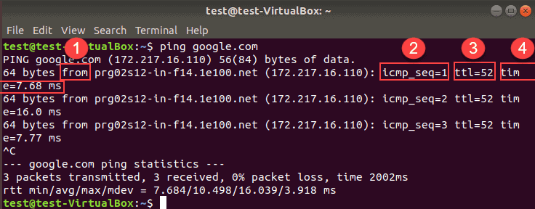
Figure 11 Ping in Linux [17]
Another feature seen in the VLAN seen earlier is the Windows Firewall, a crucial feature in protecting hosts/networks against cyber-attacks. The firewalls were disabled for the purpose of the task, however on physical machines a firewall is an essential feature that must be kept on. The function of a firewall is to analyse each packet that passes through it and decide whether it will be allowed to pass or prevented from passing. The firewall decides this based on rules established by the administrator and acts as a first line of defence [14]. Firewalls can be located anywhere on a network to defend it but are most typically found between components such as the console and application server or the application server and its agents [15]. Firewalls tend to not be necessary in other OS such as Linux or Mac as they both choose to not use services seen as potentially vulnerable. An example of this is ports are closed on Linux or Mac by default unless the user enables them [16].

Conclusion

Through using a type 2 hypervisor such as Oracle’s VirtualBox, the author was able to create a small VLAN containing two server hosts and two client hosts. Names and IP addresses were assigned to the network adapters on each machine so the server machine could communicate with the relevant client machine. Features demonstrated during these tasks include the disabling of Windows firewall and a successful ping test. The author experienced issues when carrying out the initial ping test as seen in earlier sections, but these were resolved when going through the configuration of the adapters. This small network will be developed in further reports to include features such as an active directory and adding the machines to a domain.

Bibliography

[1] | “Hypervisor,” VMWare, [Online]. Available: https://www.vmware.com/topics/glossary/content/hypervisor. [Accessed March 2021].
[2] | J. Brodkin, “"A look at bare-metal hypervisor basics",” Network world, vol. 27, no. 14, p. 1, 2010.
[3] | D. T. J. N. E. Bugnion, Hardware and Software support for virtualization, San Rafael: Morgan & Claypool Publishers, 2017.
[4] | “Type 1 and Type 2 Hypervisors: What Makes Them Different,” Medium.com, 24 May 2019. [Online]. Available: https://medium.com/teamresellerclub/type-1-and-type-2-hypervisors-what-makes-them-different-6a1755d6ae2c. [Accessed March 2021].
[5] | “Hypervisors,” IBM Cloud Education, 8 May 2019. [Online]. Available: https://www.ibm.com/cloud/learn/hypervisors. [Accessed March 2021].
[6] | G. E. N. A. K. Andrew Butterfield, A dictionary of computer science, Oxford university press, 2016.
[7] | G. Pallis, “Cloud Computing: The new frontier of internet computing,” IEEE internet computing, vol. 14, no. 5, pp. 70-73, 2010.
[8] | “What is cloud computing?,” ZDnet, [Online]. Available: https://www.zdnet.com/article/what-is-cloud-computing-everything-you-need-to-know-about-the-cloud/. [Accessed March 2021].
[9] | D. Beimborn, T. Miletzki and S. Wenzel, “Platform as a Service (PaaS),” Business & information system engineering, vol. 3, no. 6, pp. 381-384, 2011.
[10] | “What is IaaS?,” Microsoft Azure, [Online]. Available: https://azure.microsoft.com/en-in/overview/what-is-iaas/. [Accessed March 2021].
[11] | “Gartner Forecasts Worldwide Public Cloud Revenue to Grow 6.3% in 2020,” Gartner, 23 July 2020. [Online]. Available: https://www.gartner.com/en/newsroom/press-releases/2020-07-23-gartner-forecasts-worldwide-public-cloud-revenue-to-grow-6point3-percent-in-2020. [Accessed March 2021].
[12] | A. Larkin, Disadvantages of cloud computing, Cloud Academy Blog, 2019.
[13] | D. Ince, “PING,” in A dictionoary of the internet, Oxford University Press, 2019.
[14] | S.-d. Krit and E. Haimoud, “Overview of firewalls: Types and policies: Managing windows embedded firewall programmatically,” in International Conference of Engineering & MIS, 2017.
[15] | “Firewall Port Information,” IBM, [Online]. Available: https://www.ibm.com/support/knowledgecenter/SSETBF_3.1.1/com.ibm.siteprotector.doc/concepts/sp_firewall_port_information_configfirewallssptraffic.htm. [Accessed March 2021].
[16] | C. Hoffman, “Your Mac’s Firewall is Off By Default: Do You Need to Enable It?,” How To Geek, 10 July 2017. [Online]. Available: https://www.howtogeek.com/205108/your-mac%E2%80%99s-firewall-is-off-by-default-do-you-need-to-enable-it/. [Accessed March 2021].
[17] | “Linux ping commands,” PhoenixNap, 18 April 2019. [Online]. Available: https://phoenixnap.com/kb/linux-ping-command-examples#:~:text=ping%20%E2%80%9Clocalhost%E2%80%9D%20to%20Check%20Local%20Network,-If%20you%20encounter&text=ping%200%20%E2%80%93%20This%20is%20the,the%20name%20to%20ping%20localhost.. [Accessed March 2021].

