  Component One:  What are the key skills required when working in the housekeeping team? 750 words (+/- 10%)  Contribution to Overall Module Assessment: 25% | Student No: | 2209101
 | Module Title: | Operating Hotel Facilities
 | Module Code: | BMIH4006
 | Lecturer: | Lola Villard
In order to maintain the cleanliness and upkeep of guest rooms and public areas, members of the housekeeping team must possess a number of vital abilities. It is assumed that these professionals require understanding of three different sorts of competence in order to function as an ideal executive housekeeper: resource management, asset administration, and technical housekeeping operations (Casado, 2012).
I have participated in technical housekeeping operations while working as a member of the housekeeping staff at the budget Premier INN hotel in Business Park Gillingham. I used to develop the following skills for this position: a strong eye for detail, in order to ensure comprehensive cleaning and strict adherence to cleanliness standards. Since we have a strict deadline for cleaning and setting up rooms, effective time management is essential in housekeeping. To maintain efficient operations, me and my colleagues supposed to priorities, work swiftly without sacrificing quality, and fulfil deadlines.
Maintaining cleanliness and hygiene requires good understanding of cleaning methods, procedures, and the appropriate use of cleaning supplies that were explained to me during the training in the hotel. The cleaning team should be knowledgeable about various cleaning techniques, safety procedures, and how to utilise cleaning supplies and machinery properly (Batinic, 2015).
In order to interact with other team members, give updates on room status, and report any maintenance or visitor issues, housekeepers have to be able to communicate effectively. All of these problems were being reported to the manager by the primary housekeeper that we reported to. The efficient completion of duties and the fast resolution of any problems are ensured via clear communication. The management of cleaning supplies, tools, and duties requires organisation and efficiency. Since we occasionally had rooms reserved with early check-in and they needed to be ready at that time, we were given a list of rooms to clean, and it was our responsibility to make sure that the cleaning jobs were completed by the deadlines.
As a team activity, housekeeping requires the capacity to collaborate with coworkers. According to Jones (2007, p. 47) “promoting teamwork within each individual team requires special effort”. As members of the housekeeping crew at the Premier Inn, Gillingham, we are expected to work well as a team, communicate clearly, and support one another in order to execute all cleaning jobs effectively. The hospitality industry is dynamic, thus housekeeping employees must be flexible in their work and able to adapt. We had been asked to adjust our schedules to adapt to shifting customer needs or help where it was needed in other areas. It's important to have the capacity to change with the times and perform well under pressure.
Responding to requests for extra room amenities, services, and directions are just a few of the many service activities that those in the housekeeping department frequently have the chance to do. The first hotel employee a guest may encounter in the morning is a member of the housekeeping team. These employees' ability to welcome and assist the visitor frequently leaves a positive impression on them (Thomas et al. 2007). Cleaning the rooms were including but not limited to clean the bathroom, clean the closet, hoover the carpet, make the bed, dust the furniture, replenish the guest room and bathroom supplies, check, and secure the room.
To keep the space spotless for visitors, we should notice and take care of even the smallest elements, such stains, dust, or lost goods. The lost goods were handed over to the manager and kept in the lost and found lockers.
For several reasons, housekeeping is essential in the hotel sector. The state of the guest rooms and common areas has a big impact on how happy the guests are. For the health and safety of both guests and employees, it is crucial to maintain a clean and hygienic atmosphere. A hotel establishment's reputation and brand image are directly impacted by housekeeping. When choosing a hotel, cleanliness is frequently one of the most important considerations for customers. Within the hospitality sector, housekeeping can help to promote environmental sustainability. Eco-friendly operations are made possible by implementing green cleaning techniques, energy-saving measures, and trash reduction programmes (Kandampully et al. 2003).
Housekeeping employees may contribute to a hotel or other hospitality establishment's general cleanliness, comfort, and visitor pleasure by having these essential abilities. Guest happiness, health and safety, regulatory compliance, asset protection, operational efficiency, reputation-building, cost containment, and environmental sustainability all depend on good housekeeping in the hospitality sector. In hotels, resorts, and other hospitality facilities, it is essential to upholding a high quality of cleanliness, hygiene, and overall guest experience.

Word Count | 761

Component Two:
Contribution to Overall Module Assessment: 25%
In this scenario – You have just been promoted to team leader for a floor within the hotel. A guest complains that on their arrival, their room had not been properly cleaned. Create an action plan and answer the following questions.

Problem | Why did it happen? | What are you going to do? | How will you prevent this from happening in the future? | What measures would you introduce to improve team effectiveness?
Broken lights | Cleaning during the day. Didn’t checked | Follow up with the guest to check on their satisfaction after resolving the issue. Inquire if there is anything further you can do to enhance their enjoyment of their stay. | Control the housekeeping team's overall performance and oversee housekeeping activities. Using the housekeeping software making a list of activities that must be finished on a particular day or assign the duty of cleaning particular rooms to specific personnel (Revfine, 2003). | Every time you clean a room, check the lights and mark the chore off the to-do list as a housekeeper.
Single use plastic caps | Lack of paper caps and leftover plastic ones before the hotel's sustainability program started. | Eliminate the remaining plastic caps right away as part of a recycling program. Informing your guests of your decision to use fewer single-use products demonstrates awareness and responsibility (Tork, 2023). | Recycling the remain plastic caps and making sure that the housekeepers use the paper ones only. | Establishing a list of subjects that can be replaced with sustainable alternatives and seeing to it that they are eliminated from the hotel property.
Not enough toiletries | Room booked for family of 3 persons, provided with two sets only | Be empathetic to the guest's worries and acknowledge their emotions. Assure them that you value their input and that you take the issue seriously. | Using housekeeper’s cart. It allows room attendants to save time by not having to search for cleaning products or return to the linen area for new supplies (MEWS, 2017). Always double-check the reservation and the special demands of the guests. | Record the complaint and the steps that were taken, as this information can be useful for future process improvement, trend identification, and addressing training needs.
Dust under the bed | Low bed and uses a normal hoover only. | Visit the guest's room in person to evaluate any cleaning issues. Pay close attention to the places the visitor pointed out and determine whether the level of cleaning met expectations. | Using an automatic robot vacuum that assist housekeepers by "thoroughly vacuuming" the room, even under the bed, while they are on duty (Gill, 2022). | Every time following the standard vacuuming, use an automatic robot for improved cleaning results.
Bed bugs | Rooms that aren't frequently inspected or whose new housekeepers aren't familiar with the procedure. | Offer an acceptable substitute to make up for the inconvenience, taking into account the gravity of the situation and the guest's preferences. This can entail changing the guest's accommodation, offering a complementary item or service, or appropriately revising the guest's bill. | Report to the hotel manager and contact immediately Pest Control. Inspect the matters and bed frame, cabinets, sofa. Check for live bed bugs, blood smears, and bed bugs eggs. The rooms next to this needs to be examinates as well (Rentokil, 2018). | Coordinating internal training with the pest control division so that all staff members may frequently inspect the rooms for bedbugs. Helping in developing SOP for new staff and monitoring their compliance with it.

Component Three:
Contribution to Overall Module Assessment: 50%
Your task is to create and prepare a presentation following the detailed scenario provided below.

As the floor housekeeping manager and given the recent guest complaints you need to put together a basic training presentation for your colleagues within the housekeeping team to get the best out of them, ensure that brand standard is being achieved and that Health and Safety procedures are also being followed.

Slide 1 - Hello
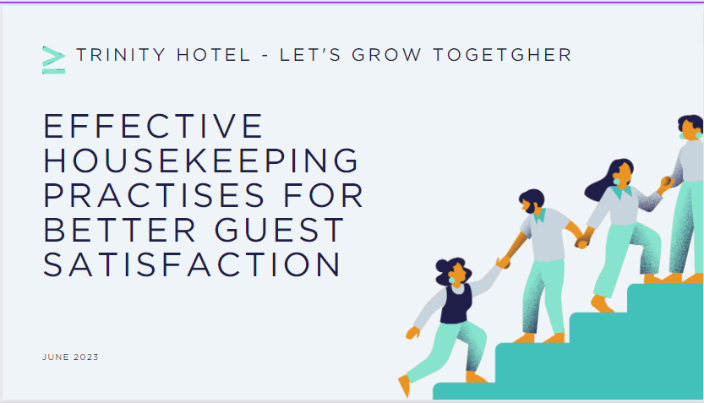
Training Notes: Thank you for coming to this training, everyone. As a floor housekeeping manager of Trinity Hotel, I would like to share with you our updated procedure for best housekeeping practices and increasing the guest satisfaction. “Let’s grow together!”
Slide 2 – Learning outcomes
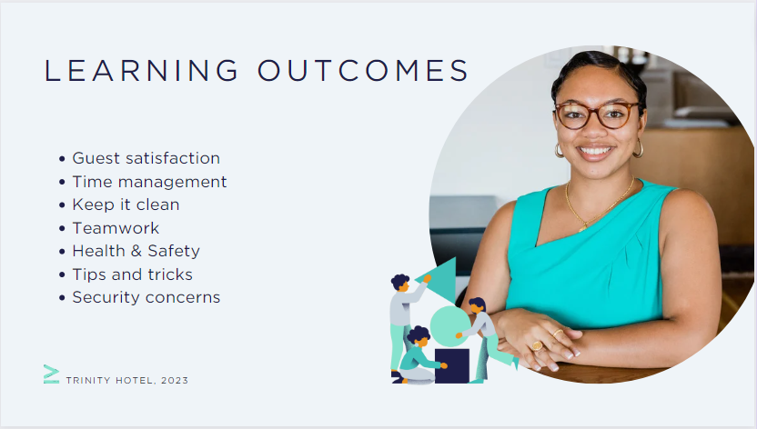
Training Notes: Today, we will talk about how the degree of cleanliness affects how satisfied guests are. I am going to talk about the new housekeeping technologies we have. Other crucial subjects include reporting a problem, teamwork, housekeeping advice, health and safety, and not least security considerations.
Slide 3 – Guest satisfaction
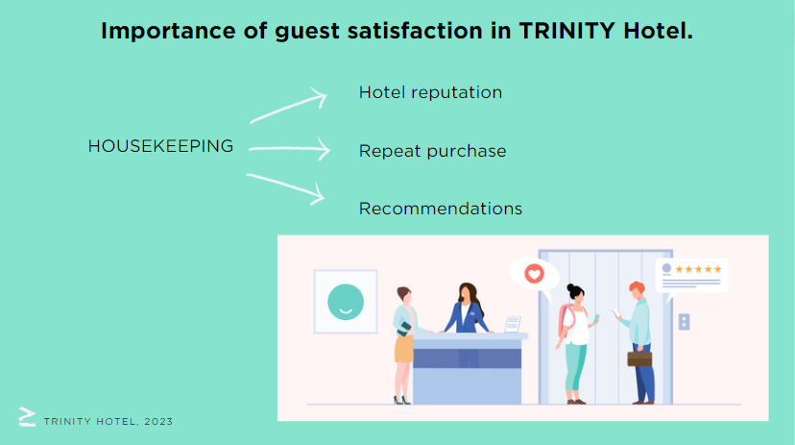
Training Notes: One of the most crucial outcomes of all marketing efforts for our hotel and its reputation is customer satisfaction. Therefore, image will influence customers' purchasing decisions. The primary determinant in deciding a customer's inclination to make a repeat purchase, make a recommendation, and show loyalty is the cleanliness (Kandampully et al. 2000). If the decor is not appealing, the air is not odor-free, and the furnishings and upholstery are not immaculately clean, the hotel may lose a customer as a possible guest. It is apparent that a hotel will receive repeat business if a guest is pleased and satisfied. A happy client will refer other people to the hotel through word of mouth (Bhatnagar et. al, 2019).
Slide 4 – Efficient time management
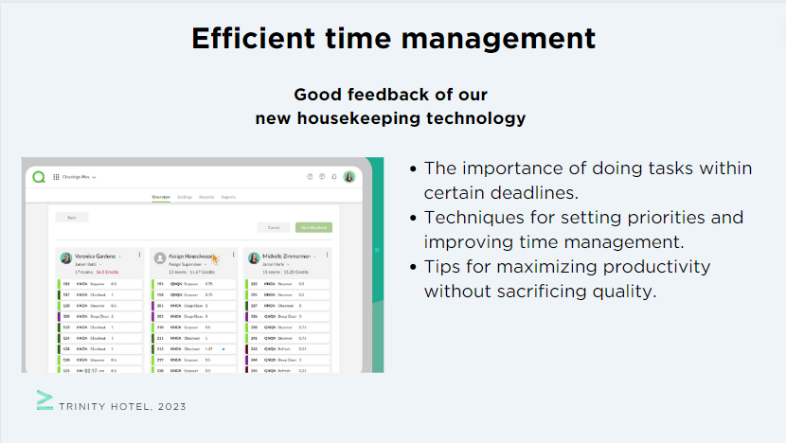
Training Notes: I would like to congratulate everyone for using our new technology for housekeeping. We received a lot of positive feedback.

According to the training this will facilitate better time management and planning during your shifts. It can specify cleanings by credits or time and keep detailed records of your performance. When cleaning is finished, your line manager is informed, resulting in fewer delays for immaculate, guest-ready rooms (Quore, 2023).
Slide 5 - Paying close attention to details and preserving cleanliness and hygiene
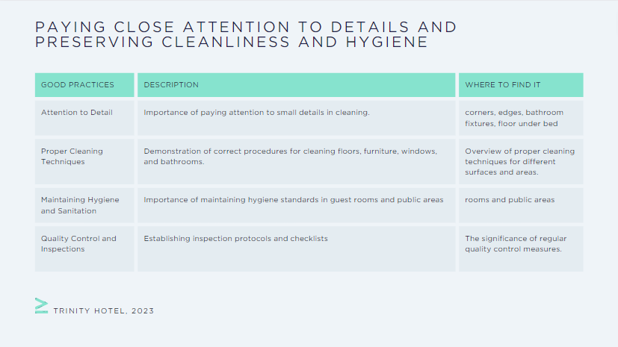
Training Notes: The best cleaning technology ensures that the guests have a safe, clean, and allergy-free space. This translates into training you on the newest tools and technology (Zemke et al. 2015).

Slide 6 - Communication and teamwork
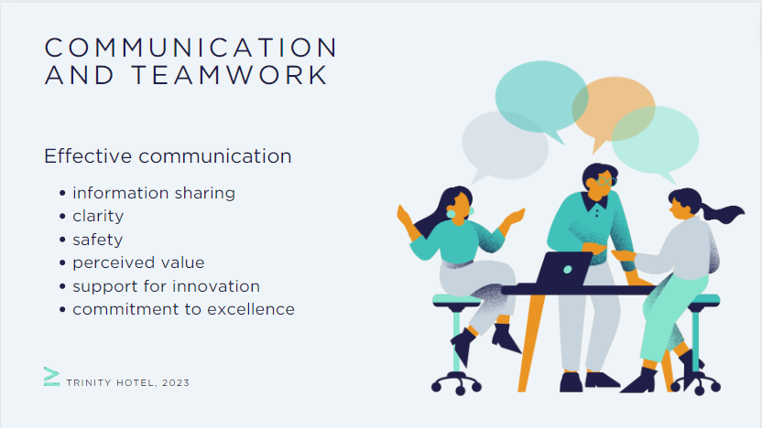
Training Notes: Working as a team can help the organisation as well as the individual employee (Ingram, 2000).
- effective communication within the housekeeping team
- Collaboration with other departments for smooth operations
- Reporting maintenance issues or guest requests promptly (Mullins et. al, 2013)
Slide 7 - Health and safety
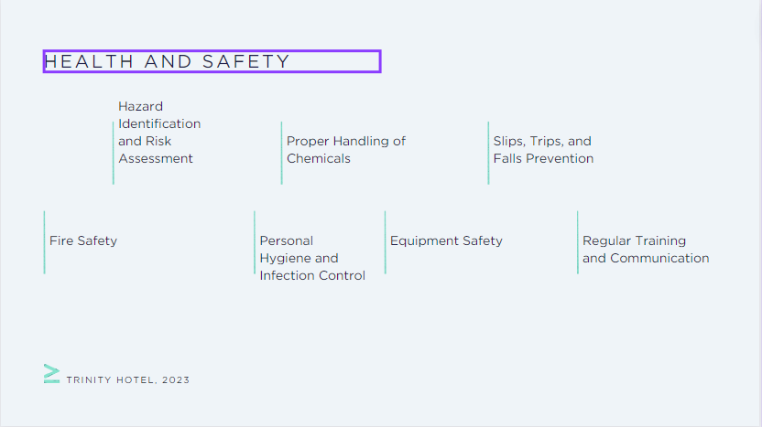
Training Notes:
- To protect the wellbeing of both the housekeeping crew and the guests, health and safety in housekeeping are of the utmost significance.
- recognizing potential risks in cleaning chores and spaces. Assessing dangers' likelihood and seriousness through risk assessments. Techniques for reducing hazards and putting preventative measures in place.
- Safe handling, application, and disposal of cleaning agents. Importance of reading and adhering to safety data sheets and product labels. Instruction on how to handle chemicals while wearing personal protective equipment (PPE).
- identifying and removing possible fall, trip, and slip hazards. Cleaning and maintaining stairs, carpets, and floors correctly. Use of cautionary markers and non-slip mats in risky locations.
- familiarity with emergency protocols and fire escape routes. Using and maintaining fire extinguishers and other firefighting tools correctly. Instruction in assembly points and evacuation procedures.
- stressing the value of good personal hygiene for both employees and visitors. Regular hand hygiene and proper handwashing procedures. Sanitation and cleaning procedures to stop the spread of illnesses.
- instruction in the safe use of cleaning tools like vacuums and buffers. Equipment should be regularly maintained and inspected to ensure user safety. Reporting any equipment flaws or failures.
- ongoing instruction to strengthen safety and health procedures. Establishing clear routes of communication for reporting risks or ideas. Promoting employee involvement and involvement in health and safety programs (MSL, 2023)
Slide 8 – Tips and trips
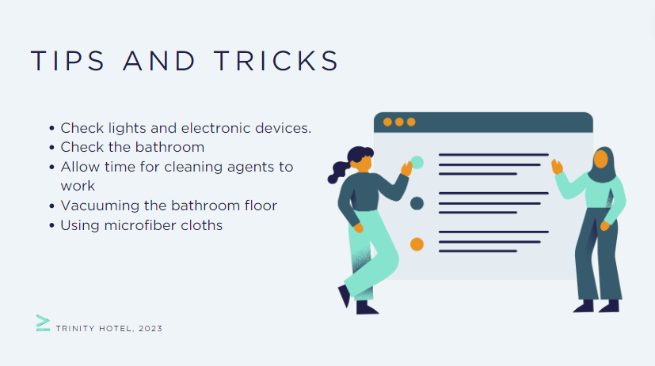
Training Notes:
- Check that everything is functioning by turning on every light and every electronic device;
- Check the restroom for any signs of past visitors, such as fingerprints, hair, smudges on the mirror and even drip marks outside the trash can;
- cleaning a room in phases, sweep or vacuum before mopping;
- Before beginning any wet cleaning, hoover the bathroom floor to prevent hair from adhering to the surface;
- Using it to wipe down surfaces after applying the cleaning agent to them (Fox, 2022).
Slide 9 – Security concerns
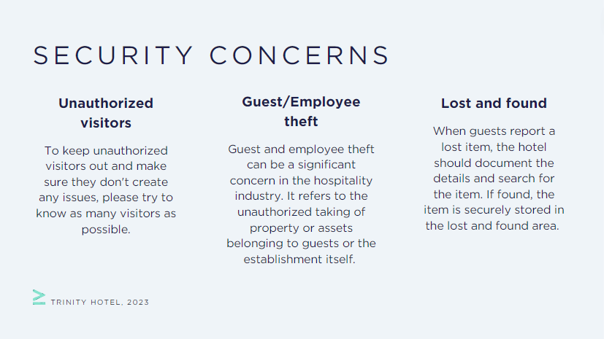
Training Notes:
- It can be challenging for each staff to get to know every visitor. Additionally, we could not recognise the visitors that our guests have. We should also consider enhancing our security procedures. As we already monitor the building by placing security guards at the entrances and updating to the newest surveillance gear.
- Strong security measures, rigorous background checks during the employment process, fostering an environment of honesty and integrity, and fast investigation of any suspected events are all necessary for preventing and dealing with theft. Regular staff training, security measures, safe storage spaces, and well-defined policies and processes are crucial in preventing theft and upholding a dependable environment for both visitors and staff.
- It is important to make attempts to get in touch with the owners of the items and return them because our hotel has a specific policy on how long things can be kept. There should be thorough documentation of lost and found processes, and everyone should receive training on how to handle misplaced items with respect and discretion (United security, 2018)
Slide 10 – Thank you!
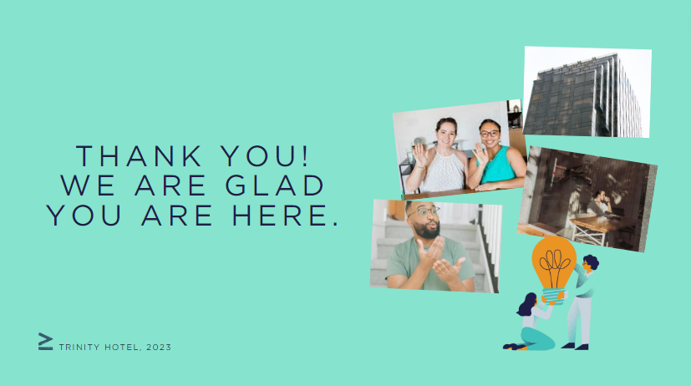
Training Notes: Please let us know as soon as you have any queries or concerns.

References

Batinic, I. (2015) Organization of business in hotel housekeeping. Journal of Process Management and New Technologies, 3(1), 51-54.
Bhatnagar, E., Dheeraj, N. (2019) Impact of housekeeping services and practices on customer satisfaction and repeat business. Prabandhan: Indian Journal of Management, 12(8), 46-57.
Casado, M. (2012) Housekeeping Management. London: Wiley
Fox, J. T. (2022) 20 tips for hotel housekeepers. Available at: https://www.hotelmanagement.net/housekeeping/20-tips-housekeepers (Accessed 10 June 2023)
Gill, R. (2022) Travelodge introduces robot vacuum cleaners at UK hotels. Available at: https://www.businesstravelnewseurope.com/Accommodation/Travelodge-introduces-robot-vacuum-cleaners-at-UK-hotels (Accessed 8 June 2023)
Hotelier magazine (2018) Housekeeping is being slowly transformed by technology. Available at: https://www.hoteliermagazine.com/housekeeping-is-being-slowly-transformed-by-technology/ (Accessed 8 June 2023)
Ingram, H., Desombre, T. (2000). Teams and teamworking in hotels. Tourism and Hospitality Research, 1(4), 351-368.
Jones, T. J. (2007). Professional management of housekeeping operations. Fifth ed. John Wiley & Sons: New Jersey
Johnston, R., Clark, G. & Shulver, M. (2012) Service Operations Management. London: Pearson
Kandampully, J., Suhartanto, D. (2003) The role of customer satisfaction and image in gaining customer loyalty in the hotel industry. Journal of Hospitality & Leisure Marketing, 10(1-2), 3-25. https://doi.org/10.1300/J150v10n01_02
Kandampully, J., Suhartanto, D. (2000) Customer loyalty in the hotel industry: the role of customer satisfaction and image. International journal of contemporary hospitality management. ISSN: 0959-6119
MEWS (2017) The future of hotel housekeeping technology. Available at: https://www.mews.com/en/blog/future-hotel-housekeeping (Accessed 8 June 2023)
MSl (2023) Health and safety compliance in hospitality. Available at: https://msl-ltd.co.uk/health-and-safety-compliance-in-hospitality/ (Accessed 10 June 2023)
Mullins, L. and Dossor, P. (2013) Hospitality Management and Organisational Behaviour. 4th ed. Harlow: Pearson.
Raghubalan, G. and Raghubalan, S. (2016) Hotel Housekeeping - Operations and Management. 3rd ed. India: Oxford University Press
Revfine (2023) Housekeeping technology. Available at: https://www.revfine.com/housekeeping-technology/ (Accessed 8 June 2023)
Rentokil (2018) 5 ways to check for bed bugs in a hotel room. Available at: https://www.rentokil.ie/blog/5-ways-to-check-for-bed-bugs-in-a-hotel-room/ (Accessed 8 June 2023)
Thomas, G.F., Hencer, M. (2007) Housekeeping manager and the administration of housekeeping service. International Journal of Hospitality ant tourism Administration. Vol.9, p. 365-383. https://doi.org/10.1080/15256480802427313
Tork (2023) Sustainability and guest experience in hotels belong together. Available at: https://www.tork.co.uk/your-business/solutions/overview/hotels/hotels-challenge (Accessed 8 June 2023)
Quore (2023) Cleanings plus. Available at: https://www.quore.com/products/cleanings-plus/ (Accessed 10 June 2023)
United security (2018) 5 security threats in hotels and what to do about them. Available ta: https://inbound.usisecurity.com/blog/5-security-threats-in-hotels-and-what-to-do-about-them (Accessed 11 June 2023)
Zemke, D. M. V., Neal, J., Shoemaker, S., Kirsch, K. (2015) Hotel cleanliness: will guests pay for enhanced disinfection? International Journal of Contemporary Hospitality Management, 27(4), 690-710.

