Tiegan Hughes
Advanced Character Animation
M6X02056
Phil Organ

Advanced character animation:
For advanced character I am going to focus on two particular parts of the animation that will be made for independent project. Those two parts will be 30 seconds in total and will be completed using a pre-existing rigged character, basic environment and basic prop.
Although I have two characters, I am only focusing on Ysbryd as she is the main character for this project and Melanie is limited to walking so it would be more interesting and complex to work on Ysbryd due to the detailed movements.
Storyboards:
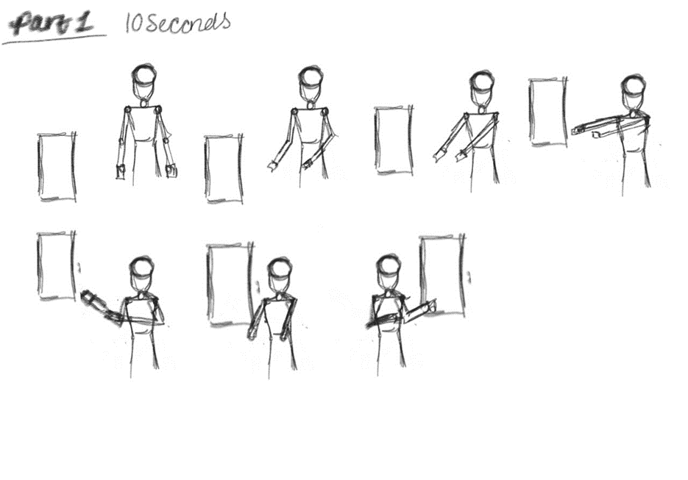
For the first 10 seconds I did not create any forms of storyboards for this part during the preproduction. As this is a scene that would be seen from one of the camera angles I thought I would sketch it out quickly, so I know what to base the 3D on. I made these working storyboards as I want to do the detailed storyboards closer to the time of the final 3D animation.
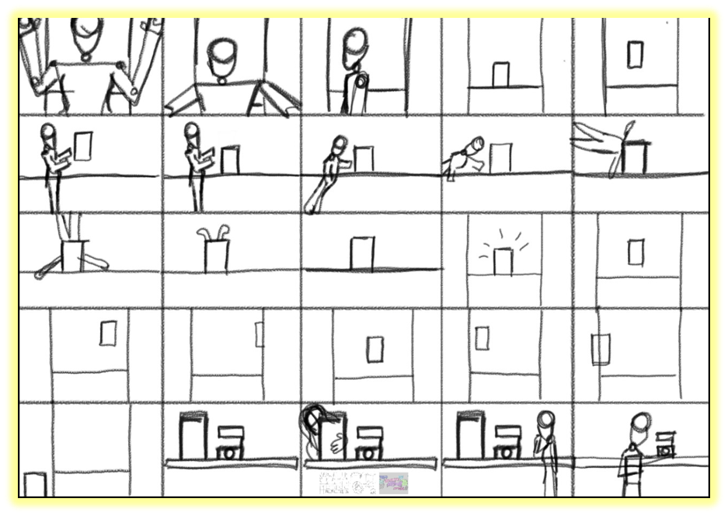
For the second part it was already included within the storyboards. For this part it is going to be almost 20 seconds. The part in particular I want to focus on is the character going into the computer and possessing it.

3D animation:
Movement within 3D animation relates to the inclusion and spacing of frames. Within a movement frequency and magnitude are dependent of spacing. The spacing of these important frames are called key movements. Within a bouncing ball sequence this would be when the ball hits the floor and the highest point of the bounce. Keyframes are “where the greatest degree of the move occurs” (Selby, 2013. P.148). Additionally, the frames in between the key frames are known as in-betweens, in the past in traditional methods of animation people called inbetweeners would have used to create these frames, however, in modern setting the in-betweens can be developed by computers using different types of software. The software varies from 2D and the use of software like Adobe Animate or within 3D using software such as Maya and Z Brush. This method of movement creation by the computer is called tweening (Selby, 2013, p.148). Movement within a 3D animation program reduces the amount of time it takes to animate as the animator instructs the computer where the keyframes are and the software completes the rest of the animation.
I did two animations, 1 that is 10 seconds and another that is just under 20 seconds. I did two as I wanted to focus on different parts of the animation. I used the same rig that was a pre-existing, which had been used last year for the character and creature animation, prop and environment for both. I decided to use the same rig that I used last year because It was the one that worked for me the best out of all of the ones I tried before the actual project. The environment I used was the one I created to draw up one of the environments I sketched for the pre-production of this project, I may use this environment for the final animation, but I would add more detail. For all of the animations I did 25 frames per second with acceptation to a few faster movements where I keyed them closer together.
For the first one I focussed on is the scene where the character makes the computer float around with ghost powers. This one is shorter because there is less action included within this scene.
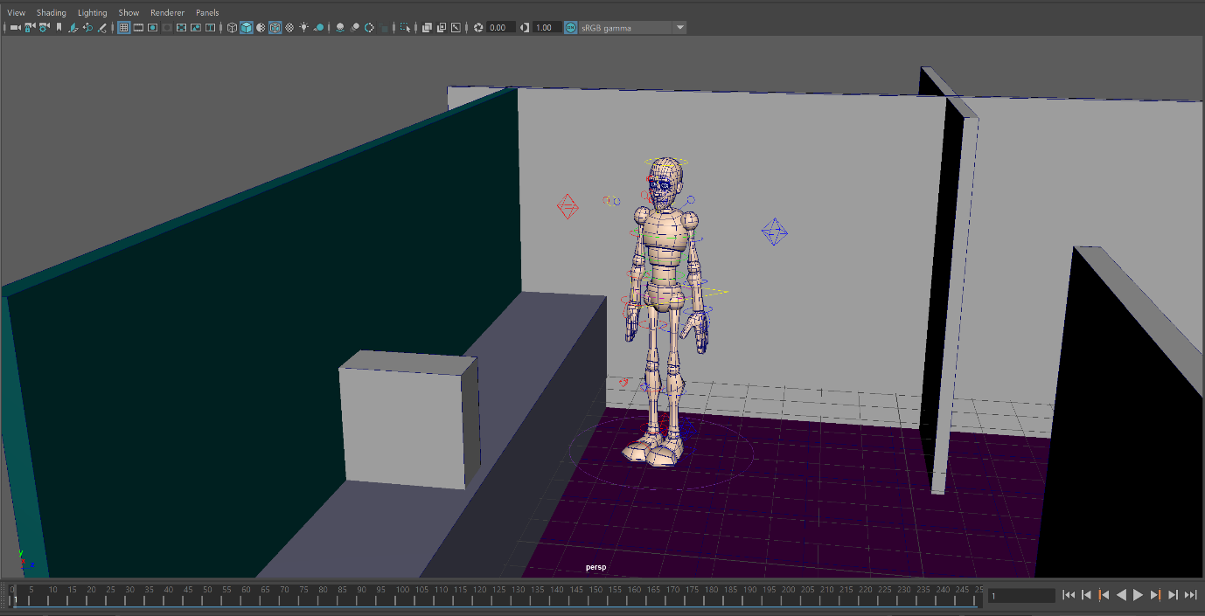
At the start of the scene the character is stood facing towards the computer staring at it
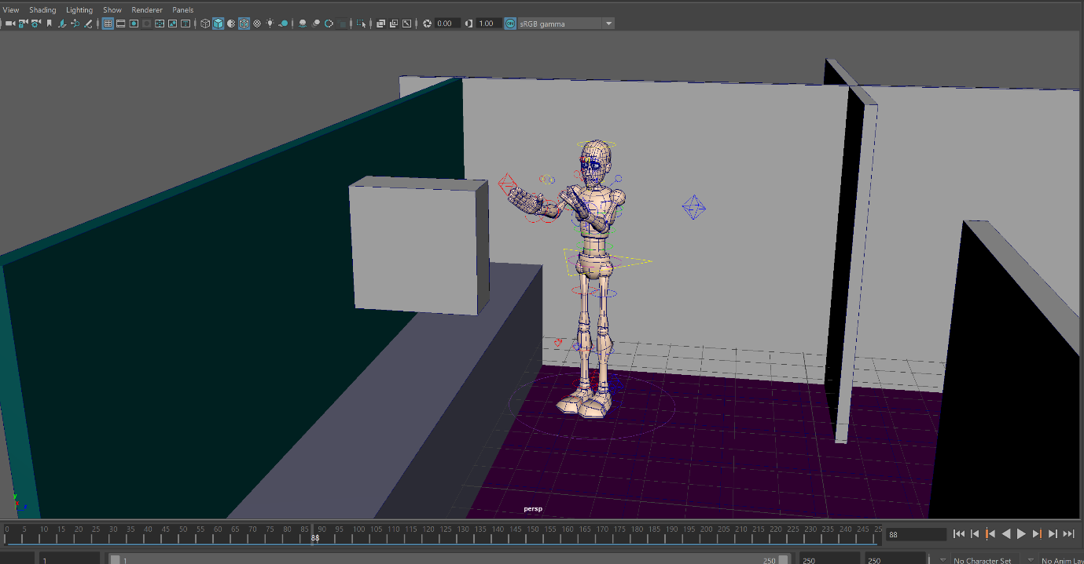
The character lifts the computer up in the air without touching it with their ghost powers
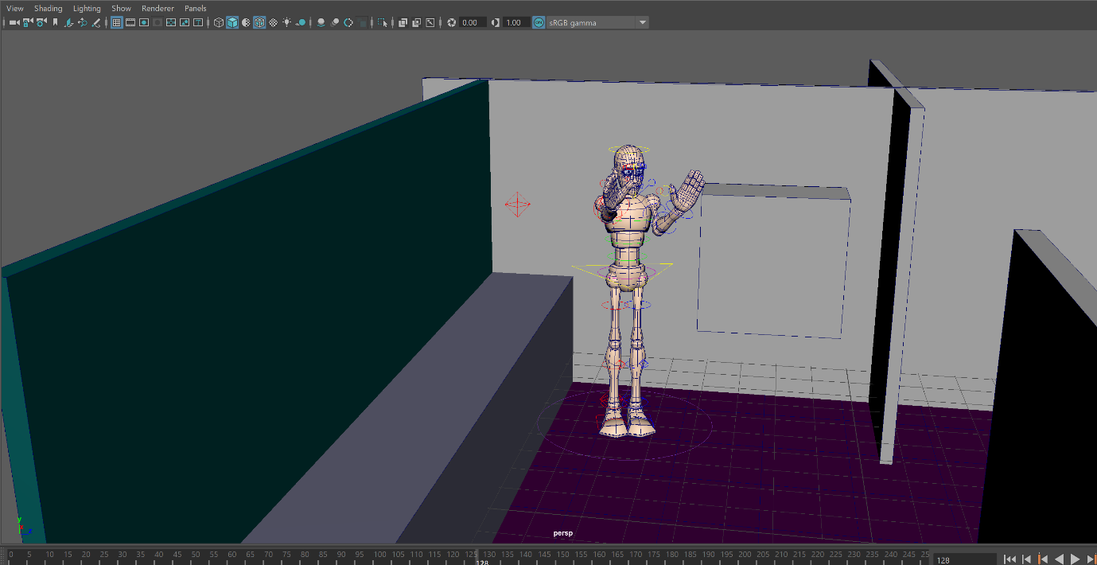
The character makes the computer float through the air towards the other part of the room ( which would be towards where Melanie’s camera would be in the final animation)
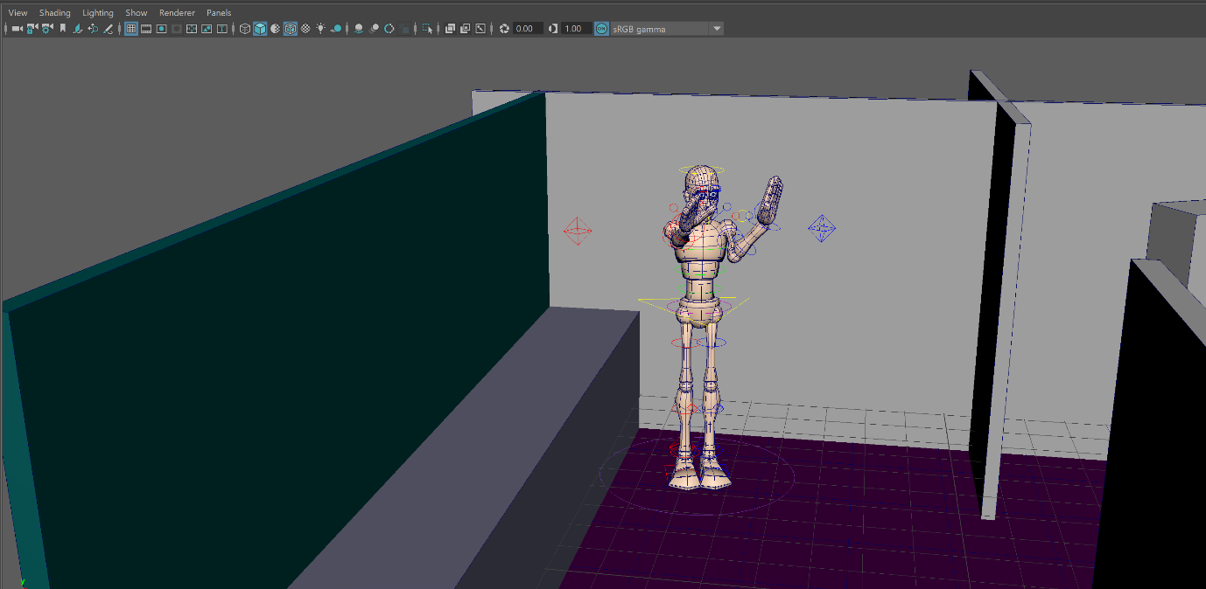
The character successfully moved the computer even though it is their first time as a ghost interfering with objects within the room.
For the second one I focussed on the scene where the character possesses the computer. The beginning of the character jumping into the computer is very slow as the character is a new ghost and has not done it before, so the character does not have much experience and has not had any chance to practice, however the animation gets faster as the character gains more confidence.
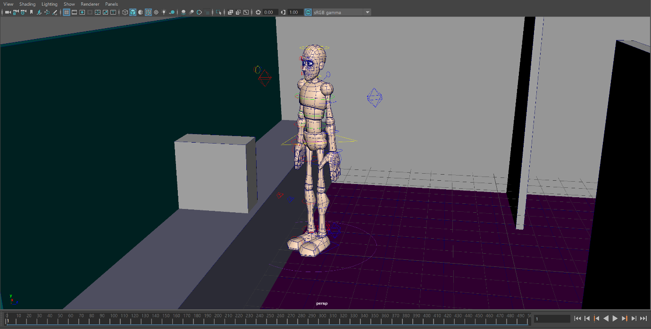
Just like the first animation the character starts with staring at the computer, though this time they are closer.
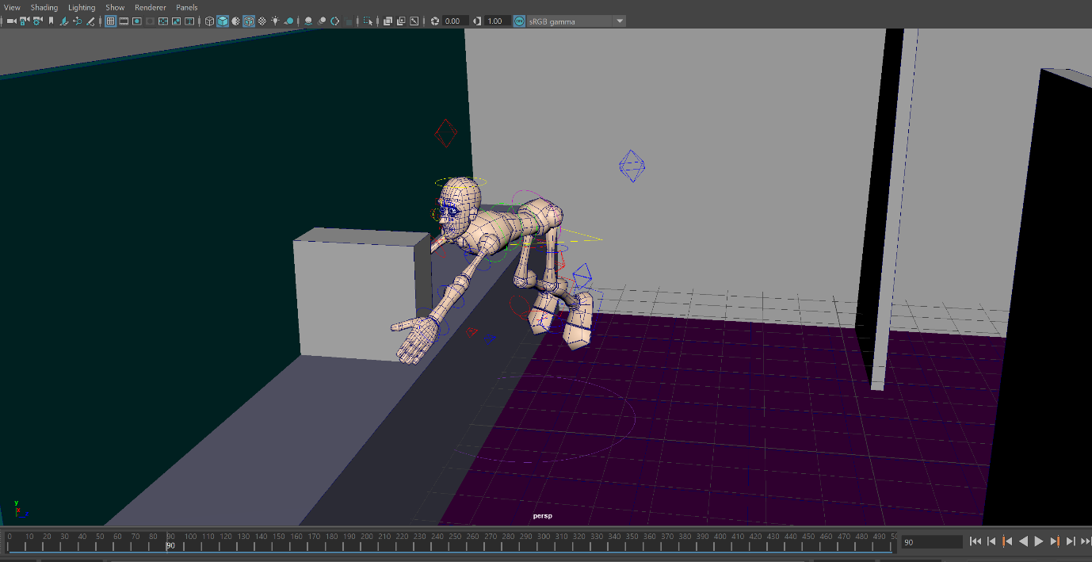
The character bends down nervously towards the computer as they possess it and their legs lift up from the floor
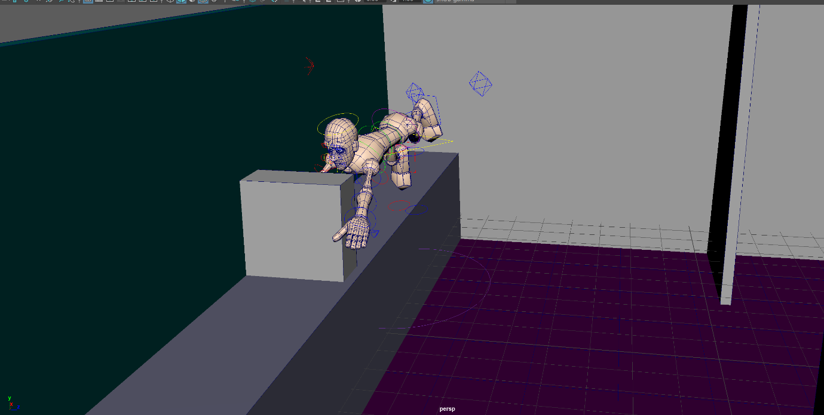
To the characters surprise they float towards the computer as their legs float completely off the floor.
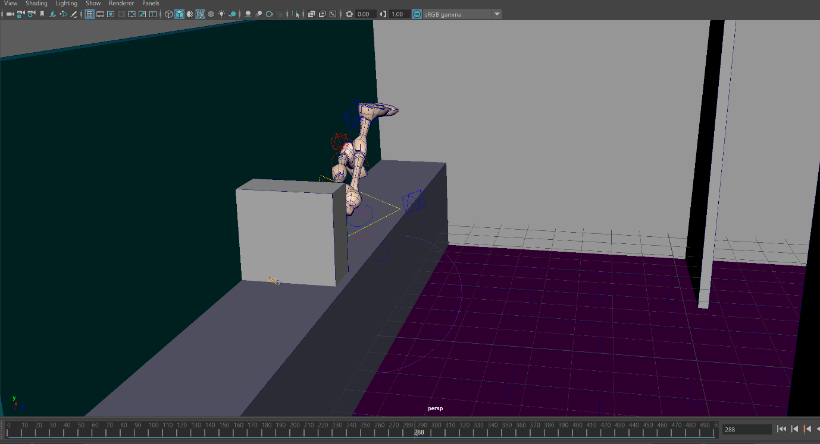
The character disappears completely into the computer face first
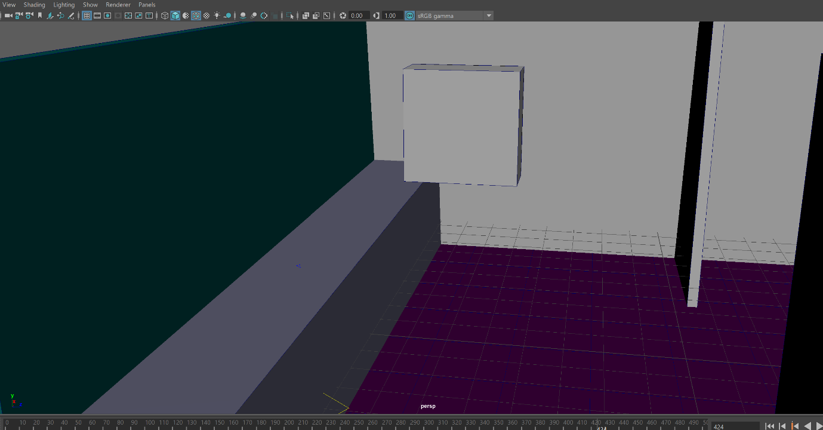
The computer floats off into the other part of the room (where Melanie’s camera would be in the final animation) as the character has now completely possessed the computer.
I do prefer the first animation much more from the second one as I feel that it is better because the second one had more complex movements and was very hard to put together, as the first one was only hand movements I felt it was more successful than the one that had full body movements.
Even though the second one was supposed to be slow I felt it was slower than I originally planned and was not as effective than the first one, however, I felt it still gets the idea across that I want to convey. This project has helped me see where I need to develop ready for the final animation in independent project. I really want to work and practice a lot more of the animation process in particular the part where the character possesses the computer.
I did two different scenes because I wanted to focus on the two parts of the possession. The part where Ysbryd plays around with the computer making it float around the room and then the part where Ysbryd actually goes into the computer and floats off to the other side of the room. I wanted to show variety instead of focussing on just one part and varying that.
I was still only am able to save it as a playblast due to not returning to university however for the final animation I really want to be able to render it out properly. Although I was happy with the animations overall I am still hoping to improve by next year for the final animation and mainly focussing on some movements and the rendering of the final animation. I also want to focus more on facial animation too as I did not do much for this project other than eye movements, this is due to the shot type being extreme long shot for the duration of the scene to see all of the actions that are occurring. I feel like I should have added facial animation to show the expression in the character but also show the audience that the character is feeling a specific way for example confused where her eyebrows could be raised. This would also break up the sequence and create a more dynamic shot flow and develop the story world. For the first animation I mainly focussed on the upper body animation, specifically the arms and it may have benefited from the feet moving too as the character turns around to face the other side of the room, however I just did a basic turn using the entire character I am going to make sure I include this within the final animation as this and facial animation would make the character seem more alive and natural. Also for the final animation I might also make the character scale down as they enter the computer to seem like the character is becoming the size of the computer this would make it more believable than the character disappearing full size in to the device.

Inspiration for these animations:
Inspiration came from multiple sources. The first three things I have already looked into in the past but for something slightly different. The first thing is the ghosts from the Sims. Although I already wrote about these for my first project, however, this time I am directing it more to how the characters move when they are ghosts.
The Sims ghosts are completely humanoid, however they move very different to human sims, they do not walk they float around instead and are able to go through walls, though the ghosts have changed quite a bit since they were in Sims 2 they have still kept the same characteristics overall throughout the games. In Sims 4 you can tell their emotions by the colour they appear as all emotions in Sims 4 have a particular colour assigned to them. All the ghosts throughout the games do not keep their original colour and are transparent which makes it obvious to the audience they are ghosts. As I do not play the game anymore I looked at YouTube for reference for this and I found a video that goes very specific into this called Sims 2 vs Sims 3 vs Sims 4: Ghosts (2016) by The Red Plumbob youtube channel. I do however have two screenshots left from when I did play the game back in 2018. The first image is a dog character, but I felt it showed the transparent design well and the second is a human character that is in the colour green and that symbolises happiness.
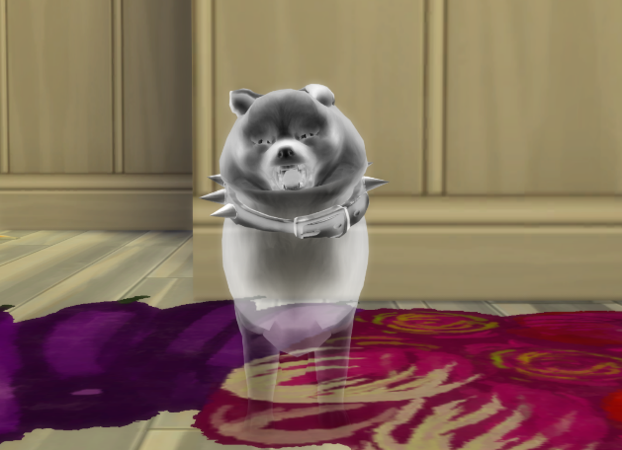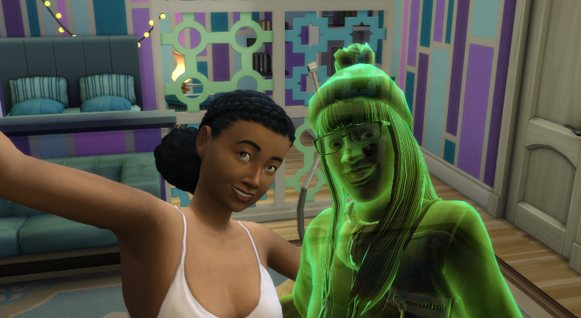
Intel adverts is another area and although I have also looked at these in the past I have not focussed on the very early ones where the computer parts are animated, though these are not ghosts I feel like this was a good idea to look at regardless, as the computer does move around, and I want to see how this has been shown in the past. Another reference is the aliens that they used in their adverts back in the early 2000s and I have written about these before but more about their appearance this time, I am focussing on one specific advert where they take a computer back to their spaceship I got these references from a video called All Intel Commercials v2 (2016) by a youtube channel called Anthony Regner. Although these aliens are not ghosts it Is a very similar idea as Ysbryd possesses a computer and makes it fly around. The early one with the cpu is quite old in terms of animation so
the movement and quality would be very different from what they would do today if they recreated it, but it was interesting to research because it is a much older advert, similarly the aliens are from the mid-2000s according to the video so these are also older in terms of animation and quality.
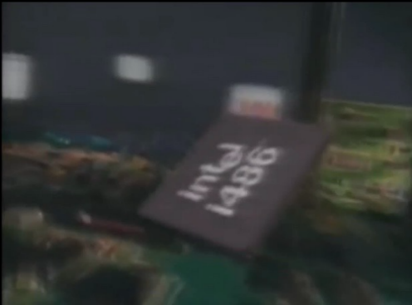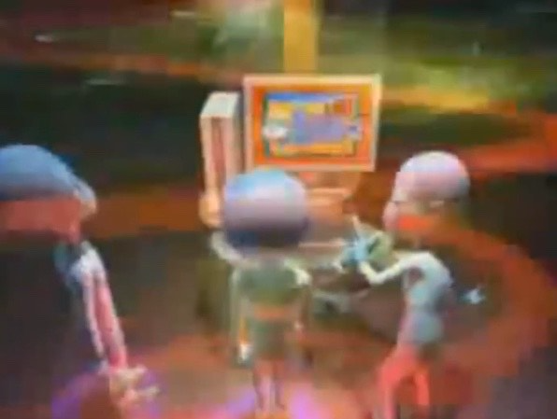
Fig. 2
Fig. 1

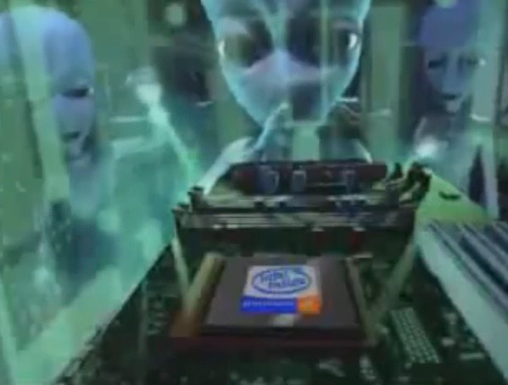
Fig. 3

I have also research areas I have not done before as I wanted to add a variety of sources and expand my knowledge and awareness. I saw a video called top 10 animated cartoon ghosts and I chose four animations from there. I chose two that are not humanoid and two that are.
I was having a hard time thinking about references outside of what I normally stick with as I do not watch that many animated films however after finding this YouTube video it reminded me about a few movies I had already seen before so I felt I could include them here.
For the first two I chose Ghostbusters and Casper the friendly ghost. Those two films feature ghost characters that are not humanoid as I said above and they are more stylised and though my character is humanoid and not very obviously a ghost, but I still wanted to look at two that were the complete opposite because it may give me inspiration for the movements. They both have similarities in terms of style. Both having stylised hands and round heads. They both have contrasts though, the one from Ghostbusters looks evil and is green and that makes it seem more scary and its arms are open in a threatening way even though he is actually not the appearance of this character does show otherwise however Casper is smiling and has his arms open in a friendly way which makes him look very welcoming. These similarities can be seen in the images below.

Ghost busters
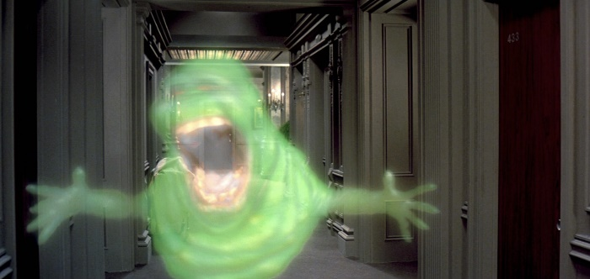
Fig. 4
Casper
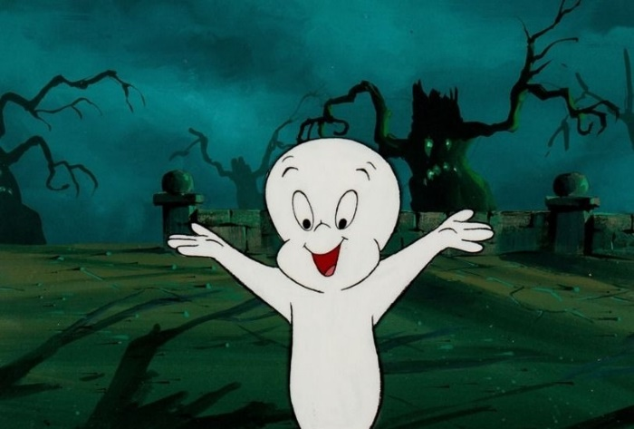
Fig. 5
For the Humanoid ghosts I chose to look at Beetlejuice and Danny Phantom. I have actually seen Beetlejuice in the past but not in full, however, I have not seen Danny Phantom, but I know people who like it, so I was very interested to see what it was about.
Beetlejuice has a very gothic aesthetic overall for the characters including the protagonist with the makeup being very gothic with black eyes. I felt this would be perfect to look into due to the Ysbryd’s style and character traits.
Although Beetlejuice is not animated I still felt I could include it within my inspiration as the main character is a ghost and as it is still a film and a very well-known one too.
Danny Phantom is a big contrast to Beetlejuice because the one is animated and the other one is not and also has a very stylistic art style for all of the characters and that is shown in the image below.

Beatle Juice
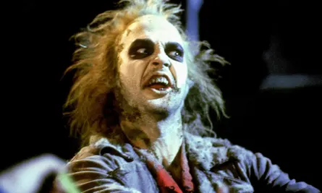
Fig. 6
Danny Phantom
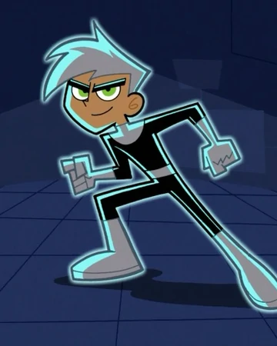
Fig. 7
The movements on these characters are the main reason why I looked into them for inspiration for three of the characters although one is humanoid are all animated characters so they would have characteristics about them that would differentiate them from Beetlejuice as he is an actor that is human. Additionally, two of the three animated are 2D as opposed to Ghostbusters where the ghost is overlayed on to film mixing both live action and animation content. As the first two who are not humanoid, they would have a stylised way of movement due to not having legs and being more stereotypically ghostly designed and animated. However, these are still inspired partly by humans so would still have some human characteristics, for example the arms and faces this would animism and anthropomorphism.
The concepts of anthropomorphism and animism are different although
at the same time strictly connected. We could say that animism is a weaker form of anthropomorphism. However, when humans attribute life to non-humans, they often also attribute to them human mental and affective states
(Airenti, 2018).

This quote explains the difference between anthropomorphism and animism and also explains that they are relating to non-humans having the mentality and characteristics of a human this would be relating to ghosts because although they do have human characteristics they are not entirely human especially the characters that are not humanoid but as said previously they do however take on human traits.

Bibliography
Airenti G. (2018). The Development of Anthropomorphism in Interaction: Intersubjectivity, Imagination, and Theory of Mind. Frontiers in psychology, 9, 2136. Available at: https://www.ncbi.nlm.nih.gov/pmc/articles/PMC6231421/ (Accessed: 20/10/2020)
Selby, A. (2013) Animation. London: Lawrence King Publishing (Accessed: 20/10/2020)
Illustrations
Fig. 1, Fig.2 and Fig.3: Anthony Regner (2016) available at: https://youtu.be/LXLone_rT4A All Intel Commercials v2 (Accessed 10/11/2020)
Fig. 4: Ghost busters available at: https://images.app.goo.gl/qAbnwBtdcLoakjSg9 (Accessed 10/11/2020)
Fig. 5: Casper available at: https://images.app.goo.gl/JeHLhcvMXz76p1BX9 (Accessed 10/11/2020)
Fig. 6: Beetlejuice available at: https://images.app.goo.gl/nRoNhavYTViwMjnp6 (Accessed 10/11/2020)
Fig. 7: Danny Phantom available at: https://images.app.goo.gl/giRoXSC7ucJgN3ev6 (Accessed 10/11/2020)
References:
'Top 10 unforgettable cartoon ghosts' available at: https://www.youtube.com/watch?v=mQTLyVHOCuY (Accessed 12/12/2020)
The Red Plumbob (2016) available at: https://youtu.be/VxpCUMJ-HK8 Sims 2 vs Sims 3 vs Sims 4: Ghosts (Accessed 12/12/2020)

