
Software Development.
Writing Programs using C.
Name: Anne Kelly Email address: 1809128@student.uwtsd.ac.uk
Module Code: ACCA4017
Lecturer: Gaynor Thomas

Contents.
PART A: Understanding. 2
A1: What is a variable? 2
A2: What is a for-loop? 3
A3: What is an array? 4
Part B: Implementation. 5
Exercise 1. 5
Exercise 2. 7
Exercise 3. 9
Exercise 4. 12
References. 15

PART A: Understanding.

A1: What is a variable?

In his book, C Programming, Mike McGrath describes a variable to be:
“A container in a C program in which a data value can be stored inside the computer’s memory” [1]. Variables store a value, programmers are able to use variables to represent data when they are writing programs. Below is a list of some variable types:
- Integers – An integer whole number e.g. “100”
- Float – A number with a decimal point e.g. “0.1234”
- Characters – A single letter e.g. “a”, “b”
- Strings – Multiple letters e.g. “book”
Before using variables, the NAME and TYPE must be specified and declared for the program to work.
An example of declaring a variable is shown below, declaring the program will have a variable and that x = 2 [2].
#include <stdio.H>
void main()
{
Int x=2;
}
In order to display the variables on the program, the printf() function must be used and placemarkers must be entered to identify the variable. Below is an example of placemarkers with their corresponding variable: [1] [2]
- Integers (Int) = %d
- Float = %f
- Characters = %c
An example of this is shown below, in order to print the value onto the screen the programmer would enter the following:
#include <stdio.H>
void main()
{
Int x=8;
printf(“The value of %d is stored in x”, x);
}

A2: What is a for-loop?

A piece of code in a program that repeats automatically is called a “loop” [1]. The most common type of loop is a known as a for loop. This can be used when the programmer knows how many iterations are required, the number of loops for a for loop, or counting loop as it is also called, needs to be predetermined and written into the code.
An example would be if the programmer was writing a code to countdown from 5 to 1, the program would display this on the console. A for loop is use as the programmer know how many iterations are required. 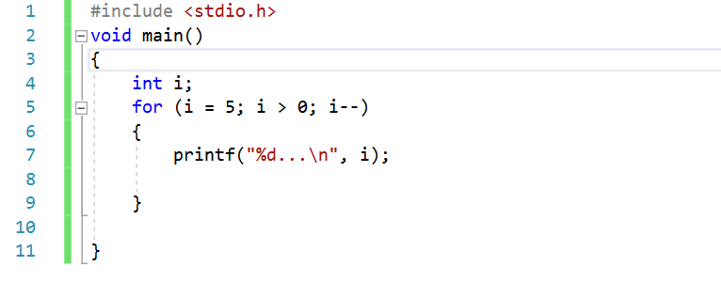
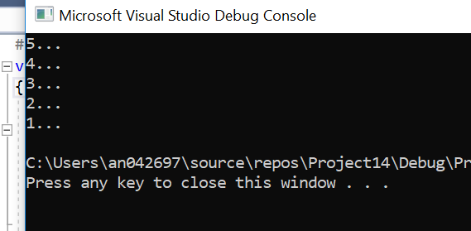

A3: What is an array?
An array is a collection or group of similar data/values. For example, if the programmer wanted to store 6 numbers in a sequence a declaration would be made at the start of the program to state this e.g. intmynumbers(6), which declares an index with 6 elements. The size and type of arrays cannot be changed afters its declaration.
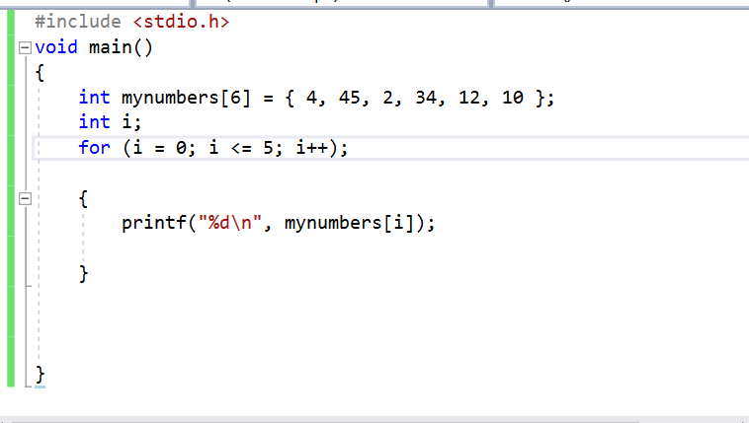

Part B: Implementation.

Exercise 1.

1.1 - Pseudocode.
- Write a program to declare three variables.
- Must contain a name, person’s height and person’s age.
- Display these values on the screen.

1.2 – Code.

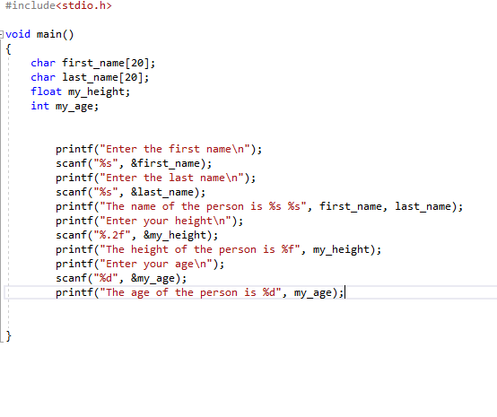

1.3 – Testing.
1.3.1 – Normal values.
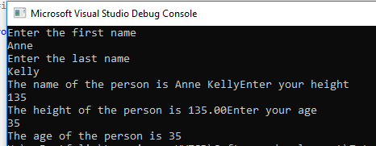

Result: Required values are displayed correctly as the name and type of variable are inputted into the program correctly.

1.3.2 – Boundary values – all numbers entered.
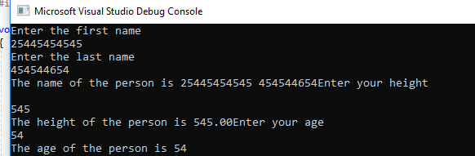

Result: Ran as expected, displays all as numbers.

1.3.3 – Impossible values.
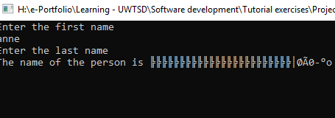
Result: Program failed.

Exercise 2.

2.0 – Pseudocode:
- Prompt the user to enter the shape dimensions.
- Find the area of the triangle.
- Find the area of the circle.
- Subtract the two results to find the shaded area.
- Print answer on screen.

2.1 – Annotated code.

#include <stdio.h>
#define PI 3.142 //Constant
float enterfloat(void);//prototype
float calculatetriangle(float base, float height);
float calculatecircle(float radius);
int a, b, s;
void main()
{
float base, height, radius, area1, area2;
base = enterfloat();
height = enterfloat();
area1 = calculatetriangle(base, height);
printf("the area of the triangle is %.2f\n", area1);
radius = enterfloat();
area2 = calculatecircle(radius);
printf("the area of the circle is %.2f", area2);
printf("enter two integer values: ");
scanf("%d%d", &a, &b);
s = a - b;//subtract triangle from circle to find shaded area
printf("subtraction of %d and %d = %d", a, b, s);

}
float calculatetriangle(float base, float height)//calculate triangle area
{
float result;
result = base * height / 2;
return result;
}
float calculatecircle(float radius)//calculate circle area
{
float result;
result = PI * radius * radius;
return result;
}
float enterfloat()
{
float thevalue;
printf("Please enter the value");
scanf("%f", &thevalue);
return thevalue;
}

2.2 – Testing.
2.2.1 - Normal Values.
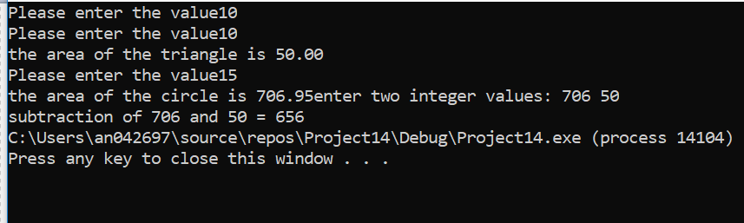

Result: The program will allow the area of the triangle and the area of the circle to be calculated.
To calculate the area of the shaded area the user can subtract the two values to get the answer, as illustrated above.

2.2.2– Impossible values – Letters entered.

Result: Program failed.

Exercise 3.

3.0 – Pseudocode:
- Prompt the user to enter the price of five products.
- Price implies float type.
- Calculate total price.
- Store total price.
- Add 20% VAT.
- Print on screen.

3.1 – Annotated code:
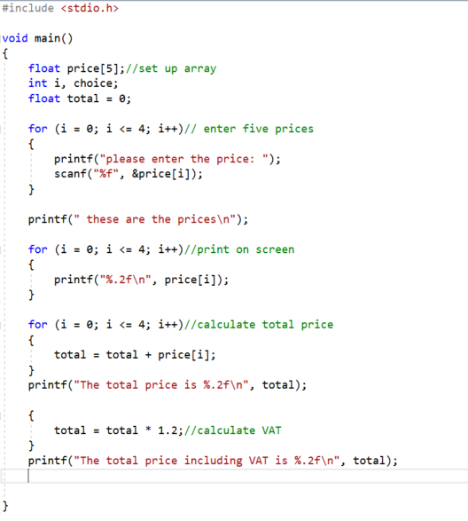

3.2 – Testing.
3.2.1 – Normal Values.

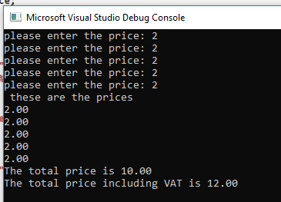
Result – Program worked as expected, calculating total price and adding VAT.

3.2.2 – Boundary Values.
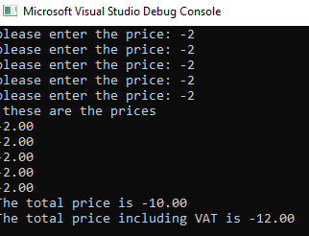

Result –correct result when minus numbers are inputted.

3.2.3 – Impossible values.

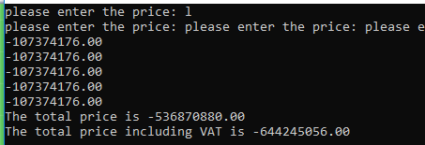
Result – letter entered, program failed.

Exercise 4.

4.0 - Pseudocode.

- Prompt the player to choose a number.
- Range has to be between 1 and 5.
- 3 of the same numbers (excluding 5’s)will pay a bonus of 20 points.
- 2 5’s will pay 100 points.
- 3 5’s pay out 2000 points.
- Display scores on console for player to see.
- Tell the player if they win or lose.
- Ask the player if they want another spin.

4.1 – Annotated code.

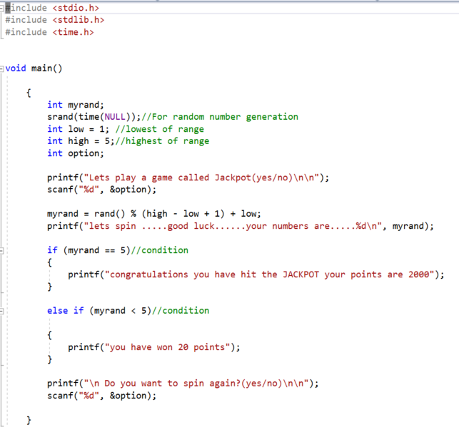

4.2 – Testing.

4.2.1
Normal Values.
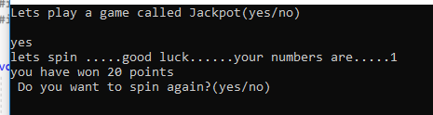

Result – able to generate a random number but unable to generate three random numbers or show correct scores. Program failed.

References.
[1] | M. McGrath, C programming, Leamington Spa: In Easy Steps LTD, 2014.
[2] | L. -. G. Thomas, Handout 1 - Basic structure, printf, variables.

