LCMB7003
Strategic Management

Contents
Executive Summary 3
Introduction 4
Section One 5
Company history of Netflix 5
Exploring strategies of Netflix 6
Strategic objectives and Mission of Netflix 7
Success factors in Netflix 7
Section Two 9
External Environment Industry Analysis of Netflix 9
Industry Analysis of Netflix 11
Section Three 14
Internal Environment Analysis of Netflix 14
SWOT Analysis 20
Conclusion 22
Recommendations 22
References 24

Executive Summary
Identifying and understanding the importance of strategic management in an organisation is necessary for enhancing the career and business thoughts of an individual or delivering better performance in an organisation. For giving a more clear understanding of strategic management the case of Netflix a popular streaming company in the global market is considered. Netflix is a prominent streaming service that provides a variety of entertainment options for users like movies, award-winning TV shows, anime, and documentaries through internet-connected devices. With monthly subscription charges, users can watch shows and events hosted by Netflix sitting in any part of the world.
Furthermore, to remain competitive and provide various opportunities according to customer demand and market trends Netflix has adopted several strategies and techniques. Through this study, a brief analysis of Netflix’s history, along with identified strategies, mission, strategic objectives, and success factors that constituted to growth and development of the company is analysed and highlighted. Besides, available theories and frameworks like PESTLE analysis, Porter’s five force model, SWOT analysis, VRIO analysis, and Porter’s Value Chain Analysis are performed to analyse and interpret the internal and external environment. Moreover, based on the analysis suitable recommendations are suggested for overcoming existing challenges and effectively managing strategic actions and decisions of the company.

Introduction
Strategic management is a crucial step that an organisation has to consider and analyse throughout its growth and expansion. Analysing and evaluating the strategic performance of an organisation with effective tools and techniques is equally important for evaluating existing growth and better opportunities in the market. A brief analysis of Netflix is performed through this study to identify what changes have been brought in the company from its earlier stages to the present based on market demand and customer preferences. Besides, understanding the existing growth and ways adopted by the company to tackle future opportunities can be analysed and identified through performing the proper strategic evaluation. Moreover, a better understanding of strategic management and its importance in enhancing business performance and competitive advantage was acquired and better growth opportunities for business were explained.
Through this report study, a clear examination of Netflix along with its identified strategies, mission, strategic objectives, and success factors that constituted to growth and development of the company is analysed and highlighted. Alongside, proper theories like PESTLE analysis and Porter’s five forces model are adopted for analysing and examining the external environment of the organisation. Alongside this, the internal environment of Netflix is analysed and evaluated with the help of SWOT analysis, VRIO analysis, and Value Chain analysis. The application of theories and frameworks is effective and beneficial for identifying how better growth and development in business can be achieved and how major drawbacks can be identified and mitigated were identified. Moreover, based on performed analysis and interpretation of Netflix suitable recommendations for enhancing overall performance and overcoming identified drawbacks and challenges were provided.

Section One

Company history of Netflix
Netflix Inc was founded 24 years ago i.e., on 29 August 1997 in Scotts Valley, California, the U.S. by Marc Randolph and Reed Hastings. Netflix is an American subscription streaming production and service company that delivers entertainment shows and services with its headquarters in Los Gatos, California, in Santa Clara County and has two CEOs, who split between Los Angeles and Los Gatos (Netflix India, 2022). Alongside, Netflix also has an international office in Asia, Europe and Latin America and its production hubs are in Albuquerque, Vancouver, London, Toronto, Madrid and also in Los Angeles. Netflix Inc. provides TV series and film studies through circulation deals as well similar to its creation known as Netflix Originals (Netflix India, 2022).
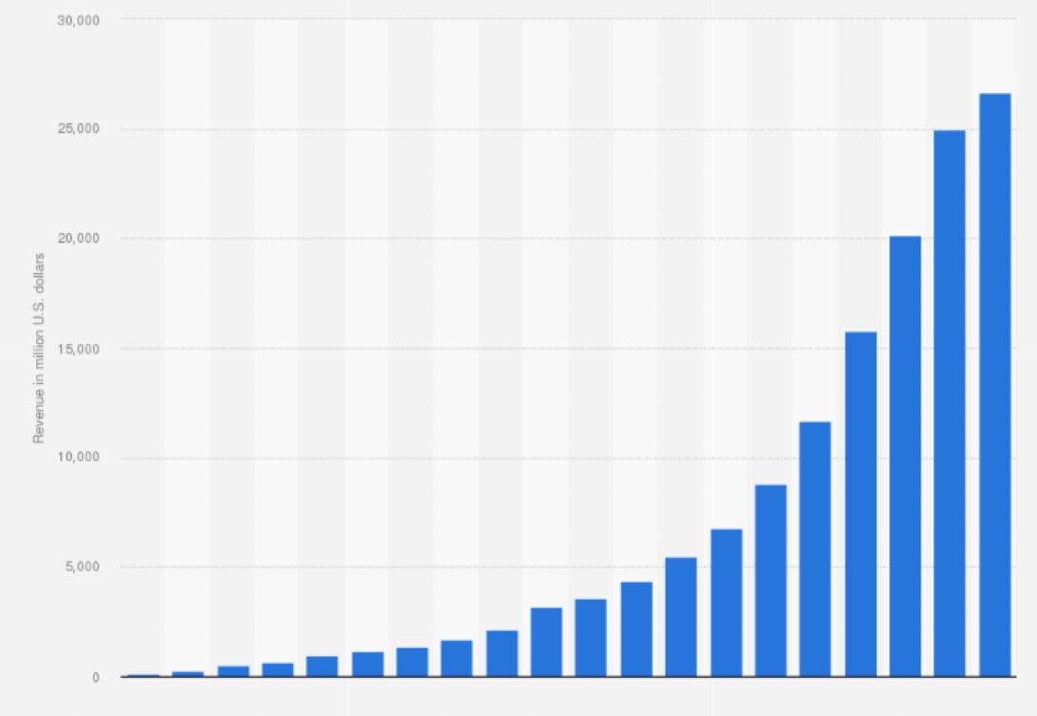
Figure 1: Netflix's annual revenue from 2002 to 2021
Source: Adapted from Statista (2022)
Netflix Inc. has its business outreach in the global market excluding Mainland China, Russia, Syria, and North Korea they are also a member of the Motion Picture Association. Netflix Inc. is an industry of Technology & Entertainment industry, mass media and they do services on Film production and distribution, Television production and distribution (Netflix India, 2022). Besides, the major services or products that are provided by Netflix Inc are Pay television, Streaming media, and also Video on demand and they play an important role in independent film distribution. Alongside, when analysing financial reports from Netflix pointed out that the company's current revenue (TTM) is $31.03 Billion. The corporation generated $29.69 billion in revenue in 2021, up from $24.99 billion in revenue in 2020.
The annual revenue and net income of Netflix Inc. increased according to the annual report in the year 2021 is US$29.7 billion and US$5.116 billion respectively and they also have 12,135 employees according to the annual report of the year 2021 (Netflix Investors, 2022). International Streaming, US Streaming and Domestic DVD are the three main divisions of Netflix Inc and as of the year June 30, 2022, Netflix have almost 220.7 million paid users (Netflix Investors, 2022). Moreover, digital media players, virtual reality headsets, tablet computers, smart TVs, smartphones, video game consoles, set-top boxes connected to televisions and Blu-ray players are the application software and web browsers which are installed access to Netflix.

Exploring strategies of Netflix
The cost-plus model was adopted by Netflix by breaking down all norms and rules of business for delivering its original content to targeted customers in the global market (Swarajya, 2022). The business acquired TV series for the full cost of production plus a premium of around 30% of the cost of production, but it kept the complete global rights to the programmes. Besides, traditional TV networks, in contrast, only paid for 60% to 70% of production, leaving the production company with the majority of the licencing rights and the potential for future profit if the programme was a success (Swarajya, 2022). At the same time, the deals' structures also varied and in the case of TV networks, customers who would normally pay for a delivery show, and Netflix spread their payments over several years.
It was noticed from the case study that just 10% of U.S. television viewing in 2019 was on Netflix and forecast that the company will eventually have between 60 and 90 million subscribers in the country (The Guardian, 2022). Alongside, it was identified that Netflix made significant investments in new programming to increase the number of customers. Besides, in the year 2019, the firm spent $15 billion on content production, acquisition, and licencing, up from $9 billion in 2017. At the same time, debt was used by Netflix to pay for most of its content investment (N LT obligations) and in the year 2018, the firm produced more than 2,000 hours of original material, more than four times HBO's output (US new shows) (The Guardian, 2022). Moreover, Netflix programmes received 23 Primetime Emmy nominations between 2015 and 2020, while HBO received 20 nominations (US awards).

Strategic objectives and Mission of Netflix
The purpose of Netflix Inc. is to entertain the globe with high-quality and better content. Based on the company's role as a provider of on-demand movie streaming services, this mission statement. This corporate mission stresses operations in the entertainment industry, much like the corporate vision statement does, as the company succeeds by catering to consumers' expectations and preferences regarding the media they access. Alongside, the entertainment and global scale subheads were the two areas focused on Netflix's corporate mission statement.
Netflix Inc.’s mission statement pointed out that the company focuses on achieving a position among top players or remaining as an effective or top company in the online entertainment era. Likewise, the vision statement of the company explained the company's strategic goal of dominating the competition. Alongside, the vision statement focuses on achieving or taking a position among global players like Amazon and Walmart, and is evident or identified in the corporate purpose statement. It is effective and beneficial that Netflix’s main target or goal was to remain a leading player in the market and achieve an entertainment experience through publishing new content or evidence. In light of these elements, Netflix's corporate vision statement mentions entertainment, the internet, and continuing leadership.
Furthermore, the goal of Netflix Inc. is to continue to be a leader in the online entertainment industry. When considering the purpose statement or main agenda of Netflix, this vision statement emphasises the organisation's strategic objective of dominating the competition, by considering and valuing big rivals like Amazon and Walmart. It is interesting that Netflix states in some of its official publications that one of its objectives is to remain leading by offering a great entertainment experience. Netflix's business vision statement refers to entertainment, the internet, and ongoing leadership in light of these factors. Moreover, the creation of original material by Netflix is already an indication of the diversification that the company's aim implies.

Success factors in Netflix
Netflix has taken initiatives and steps over the past years to deliver better service and steadily achieve a better position in the market. Initially, Netflix only sent DVDs via mail, and later they did away with late penalties, which considerably contributed to Blockbuster's decline (Choudhury, 2020). With time, they advanced from shipping the content to high-quality streaming of movies and TV episodes. To maintain its development potential, Netflix has already started creating its original content. The majority of people enjoy this original content, and hit shows across the board have been rated as such. The main benefit that Netflix offers its clients is the convenience of watching any content on any screen, Netflix chooses content that users can watch entertainment on demand (The Indian Express, 2019). Netflix makes sure to provide seamless experiences with individual preferences. Distribution partners offer a selection of films, TV shows, and documentaries to Netflix subscribers and this regularly creates new possibilities, drawing in millions of clients (Choudhury, 2020). According to a Variety source, Netflix expects to spend over $15 billion on content in 2019.
According to this, over $12 billion in new spending or almost 85% of all spending is set aside for original programming and his investment exceeds that of any of its rivals, including Amazon, Hulu, or HBO Now (Kariuki, 2022). Because of this, Netflix consistently ranks highest in customer satisfaction polls and many find it annoying when advertisements interrupt their favourite programming. It is the cause of the rising popularity of ad-blocking software and in recognition of this, Netflix provides ad-free entertainment. This shields consumers from intrusive and pointless adverts, ensuring that all of its users enjoy ad-free experiences (The Indian Express, 2019). All research is done by Netflix to create the optimal user experience and the most important feature is its user-made preview videos. A title card scrolls through the Netflix platform helps to watch the preview and users can view shows offline thanks to the download-and-go tools that are available (Kariuki, 2022). Additionally, it allows viewers to share individual Netflix accounts and offers a free 30-day trial. Netflix is aware of the daily content that can be watched on this site.

Section Two

External Environment Industry Analysis of Netflix
PESTLE Analysis
Sabourin and Jabo (2022) explained that PESTLE analysis is an effective analytical tool that can be adopted by business organisations for analysing the external environment of a selected organisation and based on which changes and modifications can be brought. PESTLE analysis also constitutes making effective strategic decisions for enhancing business performance and managing various business activities and achieving targeted goals and objectives.
Political Factors | - Netflix has faced Censorship as a major challenge or political issue because of that major economies like China restricted availability of Netflix.  - Every nation cannot access the contents and materials of Netflix and challenges like government laws and regulations ons affected by the greater loss. (Markham et al., 2019).  - Netflix has no permission in using the content or operating streaming activities in certain parts due to restricted access and brands’ negligence of government regulations are one of the reason.
Economic Factors | - When Netfix purchases content through other sources they have to face issues or challenges like the variable exchange rate. Besides options like films and television programmes can help Netflix to acquire more income and profit (Ruiz et al., 2020).  - Netflix and its committed or devoted customers are increasing and which has resulted in subscription costs. For satisfying visitors and making them understand the need for information, it is effective to highlight the importance and need for high-quality content.  - Strong and high competitors or rivals in the market and high-quality content shared by them have increased competition in the market. (Sabourin and Jabo, 2022).  - Content privacy is a major challenge or threat that affects the security and profitability of Netflix.
Social Factors | - The office atmosphere and ambience of Netflix are an added advantage or benefit of the business.  - Netflix not only provide the black community with 2% of their annual income, but they also aid youngsters from low-income families (Allam and Chan-Olmsted, 2021).  - The company does not give more importance to flexibility and is feasible by providing opportunities like watching live streams through mobile phones.
Technological Factors | - High-quality video is the main advantage of Netflix and only requires comparatively less data usage and can be considered as an added advantage.  - Constant shift noticed in Netflix’s content rating system serves and shifts in algorithms can be considered as an added advantage of advanced technologies and Netflix utilised Hermes as an automatic translation tool for managing all services (Daidj and Egert, 2018).
Legal Factors | - Increase in membership prices in Netflix resulted in major issues and challenges between consumers and corporations (Maddodi, 2019).  - Copyright claims heard against Netflix were a major challenge that affected overall business performance and a lack of an appropriate plan can be evident (Ruiz et al., 2020).
Environmental Factors | - Netflix invested in EPA for showcasing its interest in switching to renewable energy and the growth has resulted in increased environmental challenges or issues (Choudhury, 2020).  - Lot of energy or electricity consumption was a major challenge that affected Netflix while the focus on reducing office paper was a key or that helped Netflix to tackle existing issues and allegations.
The influence that the government and its policies are one of the effective challenges or political factors that affected the overall financial areas of Netflix including taxation, fiscal policies, and trade policy (Ruiz et al., 2020). In addition to that economic challenges that affected the overall growth and financial health of Netflix were interest and exchange rates, economic growth, and other factors including inflation rate variations (Maddodi, 2019). Revenue growth according to customer income and purchasing power along with economic factors affected the overall performance and growth of Netflix. The social aspects that were identified through PESTLE analysis were determining the socio-cultural context of markets in which Netflix is a significant player. Detailed examination of customs, demographics, societal norms, cultural trends and population analytics along with the most important part customer’s tastes and preferences affected the overall growth and success of businesses (Srivatsa Maddodi & Krishna Prasad, 2019).
Technology innovation plays a significant role in business growth and success and it is evident from PESTLE analysis that technical knowledge, advancements in technologies and automation of technologies played a crucial role in determining and explaining the operations of the business. Ecological awareness through generated awareness among employees through essential environmental issues such as carbon emission issues, a focus on sustainability, environmentally friendly services, and reusable resources (Maddodi, 2019). Alongside, business organisations should plan that various operations of business involve the environment and it is the responsibility of organisations to consider all environmental aspects while performing various actions or activities. At the same time, legal challenges or issues that impacted Netflix were the laws like labour legislation, health and safety laws, consumer law, copyright, and anti-discrimination laws (Srivatsa Maddodi & Krishna Prasad, 2019). Moreover, Netflix uses PESTEL analysis to identify risks, address issues, gauge the potential growth market, and concentrate on productivity.

Industry Analysis of Netflix
Porter’s Five Forces Model
Michael E. Porter introduced the theory or model named Porter's Five Forces Model for assessing as a tool to measure the degree of industry competitiveness for a corporation. It is evident that business organisations mainly adopted this model to identify the existing level or position of business organisations and various elements that created a rivalry. Through adopting this model, Netflix was able to identify various techniques or methods that constituted to growth and development of the company and five factors helped in performing effective industry analysis and achieving targeted goals and objectives.
Competition in the industry
When the rivalry of Netflix has been considered it is evident that there are significant streaming services in the market that is creating competition for the content market. Unexpected expenses and limited profitability were the major issues or challenges that affected the overall performance of Netflix and the entry of new players into the market. The active role-play of both Amazon and HBO has affected Netflix and created significant competition through developing content or creating services that are related to content published by Netflix (Bajaj, 2020).
The threat of new entrants
When considering the case entry of new entrants into the global market can be noted as a significant challenge or risky process. Only new entrants into new markets were successful because these entrants were able to identify customer needs and deliver better services (Fleischman et al., 2021). The loyal customers across the global market towards the competitors' products have grown over time, and better services delivered by rivals created challenges for new entrants or players in the market. A substantial international solid reputation and distribution network followed by Netflix was an added advantage and limited the chances of competition even after the entry of new players into the global market.
The bargaining power of suppliers
Netflix mainly provides streaming services that are comparatively inexpensively and mainly concentrate on producing content. Due to the scarcity of providers in the global market, Netflix was able to capture the market and remain a strong player. It is also evident why suppliers want to brand their material for their company now that even they are entering the consumer or VOD market (Kumar et al., 2020). One notable instance is the switch of the Friends sitcom from Netflix to HBO.
The bargaining power of customers
Customers have a relatively low switching cost when compared to other businesses because all services that provide streaming services mainly follow a similar pricing strategy. The quality of content published by the organisation is valued rather than the price of the product. Additionally, the users of Netflix make payments every month and it was noted that Netflix mainly provides wide payment options for delivering better options for customers (Gregory, 2021). Due to all of these elements, customers have tremendous negotiating power inside Netflix's five forces.
The threat of substitute products or services
In the market, alternative products of Netflix are available and even though the chances of replacing services provided by Netflix are less and can be considered as this power or force has a moderate impact on the company. Organisations that produce the same materials or content for DVDs or streaming pose can be considered a significant threat to Netflix (Fleischman et al., 2021). The availability of alternative entertainment options and pastimes are major challenge or threat for Netflix when it comes to overall performance and growth.

Section Three

Internal Environment Analysis of Netflix
VRIO Analysis
From the findings of Murcia et al. (2022), it is evident that VRIO analysis is effective and beneficial for businesses to identify the resources and capabilities of an organisation that helps in enhancing competitive advantage. VRIO analysis is adopted to identify the internal environment analysis of Netflix and based on which capabilities the organisation and its factors that constitute competitive advantage are identified and understood.
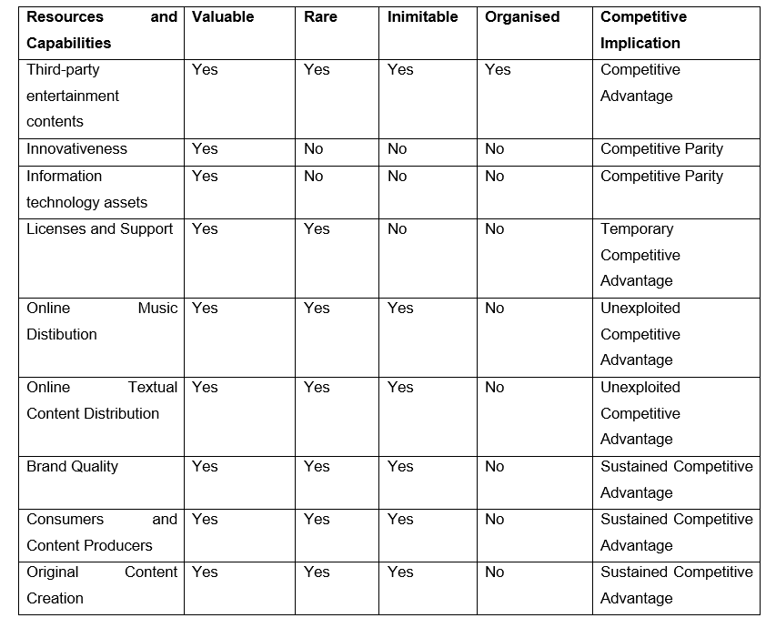
From the above table, it is evident that Netflix has highly competitive third-party content that is helping the company to remain competitive and achieve better growth and productivity. While the company is strong and sustained competitive because of its brand quality, content produced, consumers, and original content developed. These features or resources of Netflix help in enhance overall growth, productivity, and competitiveness (LEE et a., 2020). As a result, Netflix should enhance its research and development investments in these areas for bringing better competition with other online platforms while investments should be decreased in elements or resources that are least competitive for the company and its growth.
Value Chain Analysis
Stakeholders, investors, analysts or users can examine a company's activities using value chain analysis. The objective of this research is to determine how a business creates value and gets a competitive edge. The primary and secondary activities of a corporation are separated by the value chain analysis used by Netflix. The ability to thrive in both areas is essential for a business to obtain a competitive advantage. Fisher et al. (2020) opined that Porter’s value chain analysis is more effective and beneficial for tracing out internal environmental factors that impact the performance of the company.
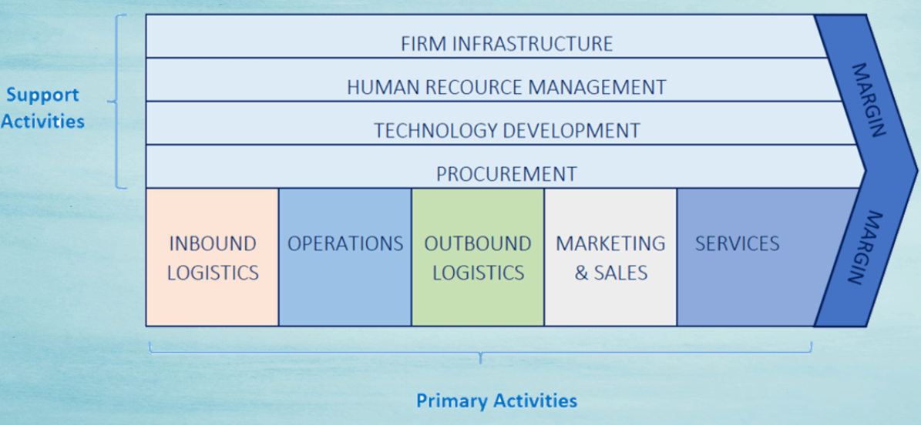
Figure 2: Porter’s Value Chain Analysis
Source: Adapted from Muflikh et al. (2021)
Primary Activities
The core tasks that are directly connected to a company's goods or services are known as primary activities. The five main components of a company's principal activities are operations, inbound logistics, marketing and sales, outbound logistics, and services (Muflikh et al., 2021). Moreover, managing and organising all primary activities are important for delivering better services and managing these sub-sections is equally important.
Inbound Logistics
The logistics of an organization's inbound freight define the way that it sources its operations (Markham et al., 2019). Similar to that, these production companies give Netflix access to the most recent material or content that is effective to enhance competitiveness and expanding growth. Typically, the content either debuts on Netflix for the first time or is unavailable on other platforms and it enables Netflix to give its users previously unreleased films and TV shows. By collaborating with others, it is how Netflix adds value to its incoming logistics operations. Additionally, Netflix has a house production that creates films and TV shows and this internal production is used by the business to create original content in many languages (Onyusheva and Seenalasataporn, 2018). Any content created in-house is less expensive and doesn't have copyright constraints. As a result, Netflix gains a competitive edge from that. Moreover, the company mainly focuses on delivering better services and activities for customers across the globe through managing inbound logistics and controlling other operations.
Operations
Netflix mainly focuses on managing various business operations to achieve productivity and profitability and operations of the company are carried out by considering the efficiency and effectiveness of the company. The platform and management of Netflix support all activities and actions of the company and focus on developing effective content and managing all servers and streaming options to deliver better service (Ruiz et al., 2020). Cloud infrastructure is valued and considered by Netflix for delivering better services and a user can connect numerous devices and access the account Netflix from various gadgets. Similar to this, various services and network features were provided for customers to provide better services and client services were also considered and focused on during this period. Moreover, search and organising capabilities were additionally provided for customers to provide text into lists and provide better services.
Outbound Logistics
Outbound logistics mainly includes various procedures that mainly comprise delivering better services or goods to clients. Customers can all contents and materials of Netflix through applications or websites of the company and the overall actions of the company consist of outbound logistics. Customers can access or view content published by Netflix by using the company's application available on both android and iOS mobile phones and along with the quickest streaming services (Sabourin and Jabo, 2022). The business also runs a DVD rental service. In such a situation, the services associated with transporting these DVDs to clients are included in the outbound logistics. However, just a small fraction of the company's network comes from the DVD industry.
Marketing and Sales
In a previous couple of fiscal years, Netflix has dramatically raised its marketing budget. In 2019, the business spent $2.65 billion on marketing. These included special offers and marketing materials to draw users to the platform. Similarly, Netflix also spent $2.37 billion on marketing in 2018, which also assisted in growing its consumer base (Bajaj, 2020). Customers have always had complete transparency with Netflix's marketing efforts and it is the reason why the business' marketing is so effective. The business does not deceptively promise its services either and from the overall analysis, it was noted that Netflix is enjoying a competitive advantage.
Services
The business model adopted by Netflix was effective and included better services and activities that constituted delivering better businesses or services. The majority of Netflix's value was noticed after better payments were provided for business strategies adopted by the company (Muflikh et al., 2021). Therefore, a key component of the company's value chain is delivering these services and meeting client expectations. Netflix offers better support were provided for top post-purchase made by customers and provides better customer support to assist clients with their needs, such as account or payment-related concerns. Netflix manages and operates activities across the globe based on customer preference and market demand and therefore, the organisation is offering several services around-the-clock (Sabourin and Jabo, 2022).
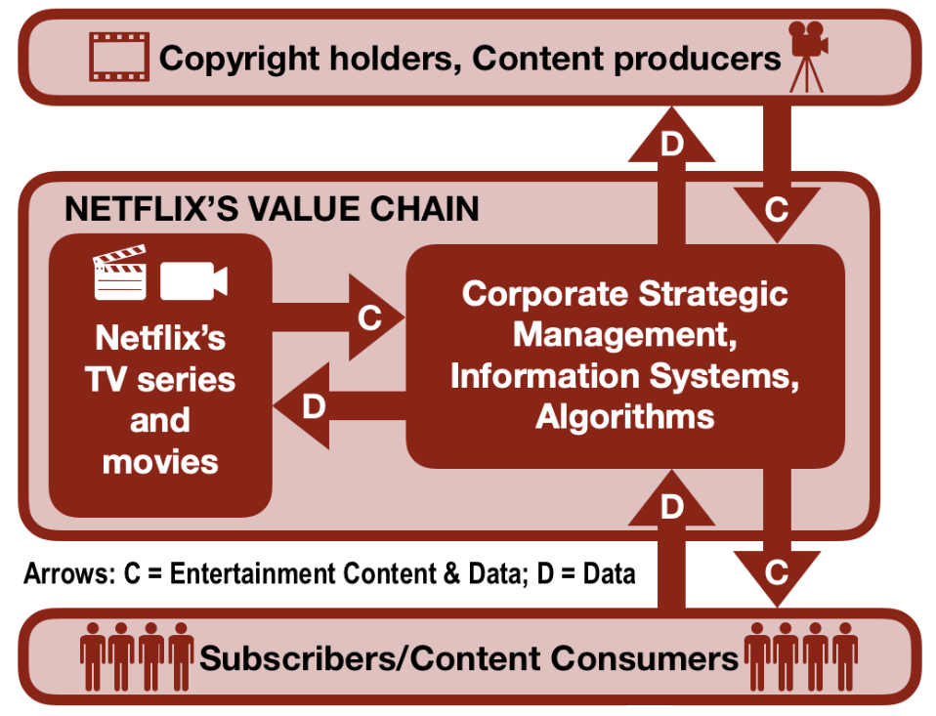
Figure 3: Netflix’s Value Chain
Source: Adapted from Rivera (2019)
Support Activities
Support activities are actions or procedures that have no bearing on a company's goods or services. They remain essential to a company's long-term success, nevertheless (Rivera, 2019). Additionally, they assist in organising and facilitating main actions or activities. The value chain analysis model for Netflix also identifies four support activities. They are procurement, technological development, human resource management, and organisational infrastructure.
Firm Infrastructure
When analysing the case of Netflix, the variety of operations performed by the company or its infrastructure included accounting, planning, quality control, financing, strategic management, financing, and legal services. Netflix benefitted from these services and was benefitted to enhance its value throughout the value chain process and achieving success in infrastructure management (Rivera, 2019). The business was an effective and excellent approach and with its integration of firm infrastructure with other aspects of its operations and over time, Netflix has also been able to keep its costs under control. Since more than ten years ago, Netflix never faced loss and the infrastructure of the business has made it possible for it to coordinate its operations and turn a profit overall (Seo and Park, 2020).
Human Resource Management
Netflix has been helpful to its staff in the past by providing numerous services and facilities. The organisation is an excellent resource for developing human resources since it involves its employees in decision-making. Additionally, as long as employees give their best effort, the organisation does not have stringent processes for them. Netflix has recognised staff for exceptional work, creating an excellent working environment all around (Seo and Park, 2020). Better value creation for the organisation has resulted from the wonderful working environment. Netflix has been able to lessen the pressure from competitors thanks to effective HR management. Employees at the organisation are driven, devoted, and eager to support the company in achieving its goals and due to the nature of its operation, Netflix needs a strong HR management system (Kumar et al., 2020).
Technology Development
The integration of technology into Netflix's business practices is crucial. For enhancing and acquiring competitive advantage, the business should collide and join with technologies for managing operations and other procedures (Fleischman et al., 2021). The platform is technological by nature, so the business must excel in it and through the use of technology, Netflix has consistently made new modifications along with creative ideas to remain a competitive platform, which benefitted in adding value for customers. Technology is used by Netflix in both its processes and products and for instance, the business links all of its processes together via cloud infrastructure. Similar to this, the organisation has made significant investments in R&D, enabling for acquiring and creating better value and the usage of technological developments and advancements has benefitted Netflix to enhance its competitive advantage.
Procurement
The actions needed to obtain products are specified by a company's procurement process and when comparing the case of Netflix, the company has acquired copyright rights through external production companies (Fleischman et al., 2021). The business has also proven successful in this area. The majority of customers have flocked to the company's platform since it includes the majority of popular and original content. As an illustration, Netflix can be named as the first platform to provide the Friends TV series and for effectively performing these activities Netflix has spent $100 million on acquiring copyrights. The company's purchase efforts also benefit its internal production (Seo and Park, 2020). The site has given many original content makers a place to shine because of its connections to the film and television industries. Both the value and the number of customers Netflix has attracted have increased.

SWOT Analysis
As per the findings of Benzaghta et al. (2021), this method is considered an effective and beneficial tool for business organisations to identify major strengths and weaknesses along with opportunities and threats that impact the overall performance of the company. Identifying important external and internal factors that constitute business growth and success can help in achieving targeted goals and objectives. Besides, the application of SWOT analysis is more effective and beneficial for achieving targeted goals and objectives by identifying resources and capabilities that constitute overall growth and success (Puyt et al., 2020). SWOT analysis is more effective and beneficial for achieving better opportunities in the market and achieving better growth. Moreover, detailed SWOT analysis of Netflix can be identified from the below table and based on which proper recommendations to overcome existing challenges and drawbacks of Netflix in India can be provided.
Strengths  - Strong brand image  - Original content published in the global market  - Easily adaptable to change  - Provide services depending on customer preferences and market demand  - High brand reputation and exponential growth (Sabourin and Jabo, 2022)  - Netflix is highly affordable for customers from South East Countries | Weaknesses  - Copywriting is restricted  - Customer service of Netflix is weak  - Higher price for accessing Netflix contents in some nations  - Increase in debts and lacking original content in many countries (Gregory, 2021)  - Highly dependent on North American markets  - Demand is decreasing because of high prices in certain countries
Opportunities  - Vast room and opportunities to expand business  - Netflix can freely develop and launch features related to customers  - Significant opportunities for an alliance with local markets (LEE et a., 2020)  - Brand recognition is strong because it is the highest OTT platform in demand  - Expansion opportunities are available for developing comic books and video games  - Netflix focus on working n new projects or product launch by ending the traditional advertisement-based business model | Threats  - Covid-19 challenges affected the reproduction of new films and original programs  - Rules and regulations prevailing in certain countries affected the expansion of services (Markham et al., 2019)  - Sever challenges and issues faced by content privacy  - Single account is accessed by numerous people  - Government regulations restricted expansion

Conclusion
From the overall report study, it is evident that Netflix is highly competitive in the market even though they have certain strategic challenges and issues which have to be mitigated by adopting suitable techniques and methods for delivering better services to customers. At the same time, the customer service of Netflix along with higher depts and prices for products and services has restricted its expansion in certain countries along with challenges faced by government restrictions. A more understanding of Netflix was acquired in section one where the history of the company along with exploring strategies, mission, strategic objectives, and success factors was evaluated and analysed. Likewise, how the external environment was impacting the overall performance of Netflix was analysed by adopting PESTLE analysis and Porter’s five forces model and this helped in identifying various factors that influenced the overall performance of Netflix. Besides, internal environmental analysis with the help of VRIO analysis and Value Chain analysis helped in examining how the internal functions of Netflix were functioning and how effective and strong were their internal factors. Moreover, a SWOT analysis was performed to trace out various strengths, weaknesses, opportunities, and threats that impacted the overall performance of Netflix.

Recommendations
Based on the overall analysis and interpretation performed on Netflix with the application of various theories and frameworks suitable recommendations were provided to overcome challenges and issues that impacted business performance.
- For attracting more customers in India, Netflix has to focus on revisiting the choices of Indian customers and develop contents that attract viewers from India.
- Merging or buying local players in the market can help Netflix to enhance its business growth in the Indian market.
- Company should give opportunities and options for leaders in India to analyse and adopt suitable decisions that are beneficial for attracting more users from the Indian market.
- Indian leaders can develop choices or options that are beneficial for the expansion of business while focussing on the overall global strategy adopted by the company.
- Adopting Bollywood will help Netflix to attract more Indian customers to this platform and expand its business successfully in India.

References
Allam, R. and Chan-Olmsted, S. (2021) The development of video streaming industry in Egypt: examining its market environment and business model. Journal of Media Business Studies, 18(4), pp.285-303.
Bajaj, D. (2020) Netflix Strategies for Marketing. Issue 2 Int'l JL Mgmt. & Human., 3, p.405.
Benzaghta, M.A., Elwalda, A., Mousa, M.M., Erkan, I. and Rahman, M. (2021) SWOT analysis applications: An integrative literature review. Journal of Global Business Insights, 6(1), pp.55-73.
Choudhury, S.R. (2020) Netflix bets big on Asia as it sees ‘significant potential in these markets. Available at: https://www.cnbc.com/2020/11/09/netflix-nflx-its-strategy-in-asian-markets-like-india-indonesia.html (Accessed 26 August 2022).
Daidj, N. and Egert, C. (2018) Towards new coopetition-based business models? The case of Netflix on the French market. Journal of Research in Marketing and Entrepreneurship.
Fisher, G., Wisneski, J.E. and Bakker, R.M. (2020) Strategy in 3D: Essential tools to diagnose, decide, and deliver. London: Oxford University Press.
Fleischman, B., Ondracek, J., Saeed, M. and Bertsch, A. (2021) Netflix: Strategizing Corporate Resources and Capabilities.
Gregory, A. (2021) Complete Analysis of Netflix, Inc.
Kariuki, P. (2022) How and When Did Netflix Start? A Brief History of the Company. Available at: https://www.makeuseof.com/how-when-netflix-start-brief-company-history/ (Accessed 26 August 2022).
Kumar, J., Gupta, A. and Dixit, S. (2020) Netflix: SVoD entertainment of next-gen. Emerald Emerging Markets Case Studies.
LEE, J.H., KIM, T. and PARK, H. (2020) Smart Study's Strategy in the Kids Content Industry: VRIO Framework. The Journal of Economics, Marketing and Management, 8(3), pp.1-8.
Maddodi, S. (2019) NETFLIX bigdata analytics-the emergence of data-driven recommendation.
Markham, A., Stavrova, S. and Schlüter, M. (2019) Netflix, imagined affordances, and the illusion of control. Netflix at the Nexus, pp.29-46.
Muflikh, Y.N., Smith, C. and Aziz, A.A. (2021) A systematic review of the contribution of system dynamics to value chain analysis in agricultural development. Agricultural Systems, 189, p.103044.
Murcia, N.N., Ferreira, F.A. and Ferreira, J.J. (2022) Enhancing strategic management using a “quantified VRIO”: Adding value with the MCDA approach. Technological Forecasting and Social Change, 174, p.121251.
Netflix India (2022) About Us. Available at: https://www.netflix.com/in/ (Accessed 24 August 2022).
Netflix Investors (2022) Annual Reports & Proxies. Available at: https://ir.netflix.net/financials/annual-reports-and-proxies/default.aspx (Accessed 24 August 2022).
Onyusheva, I. and Seenalasataporn, T. (2018) Strategic analysis of global e-commerce and diversification technology: the case of amazon. com inc. The EUrASEANs: journal on global socio-economic dynamics, (1 (8)), pp.48-63.
Puyt, R., Lie, F.B., De Graaf, F.J. and Wilderom, C.P. (2020) Origins of SWOT analysis. In Academy of Management Proceedings (Vol. 2020, No. 1, p. 17416). Briarcliff Manor, NY 10510: Academy of Management.
Rivera, A. (2019) Netflix VRIO/VRIN Analysis & Value Chain Analysis (Resource-Based View). Available at: https://www.rancord.org/netflix-vrio-vrin-analysis-value-chain-analysis-resource-based-view (Accessed 26 August 2022).
Ruiz, C.A.D., Baker, J.J., Mason, K. and Tierney, K. (2020) Market-scanning and market-shaping: why are firms blindsided by market-shaping acts? Journal of Business & Industrial Marketing, 35(9), pp.1389-1401.
Sabourin, V. and Jabo, J.T. (2022) IoT Benefits and Growth Opportunities for the Telecom Industry: Key Technology Drivers for Companies. London: CRC Press.
Seo, J.W. and Park, H. (2020) A Study on the Strengths of Cultural Content Company in the Long-Tail Market: Case of Kakao-Page. Journal of Convergence for Information Technology, 10(11), pp.117-130.
Srivatsa Maddodi, & Krishna Prasad, K. (2019) Netflix Bigdata Analytics-The Emergence of Data-Driven Recommendation. International Journal of Case Studies in Business, IT, and Education (IGCSE), 3(2), pp.41-51.
Statista (2022) Netflix's annual revenue from 2002 to 2021(in million U.S. dollars). Available at: https://www.statista.com/statistics/272545/annual-revenue-of-netflix/ (Accessed 24 August 2022).
Swarajya (2022) Why Is Netflix Changing Its Core Strategies? Available at: https://swarajyamag.com/analysis/why-is-netflix-changing-its-core-strategies. (Accessed 26 August 2022).
The Guardian (2022) Netflix is still several steps ahead in its strategy for wooing subscribers. Available at: https://www.theguardian.com/media/2021/jan/24/netflix-still-several-steps-ahead-in-strategy-for-wooing-subscribers (Accessed 26 August 2022).
The Indian Express (2019) The Netflix decade: How one company changed the way we watch TV. Available at: https://indianexpress.com/article/technology/social/the-netflix-decade-how-one-company-changed-the-way-we-watch-tv-6183308/ (Accessed 26 August 2022).

