

M5X01284
Ged Edwards

Contents

- Introduction

- Pestle Analysis Tool

- Types and Characteristics of Packaging
3.1 Costs of Alternatives

- Environment & Economy
  - EU Directive
  - Tesco
  - Society

- Conclusion

1 Introduction
Rather interestingly the following report aims to clearly evaluate the issues associated with packaging. These issues will be how packaging impacts the environment negatively most of the time. However, packaging can positively impact the environment when sourced from more cleaner products and using cleaner fuels to create them or transport. The report does aim to focus on the impacts that producing, sourcing and the use of packaging has on the environment. This is written from a distribution perspective since you cannot distribute products logistically without the need for packaging to aid the product or service from A to B, as well as the sell the product for its created purpose to demanding customers. In addition to above the report although remaining on the environmental impacts that packaging has in logistics can and will also be influenced by societal, economic and legislative factors too, and so there will be a pestle report featured below which was produced individually by the author to elaborate on how packaging can have an influence under a lot of factors in the external environment within its six elements. These elements are as follows political, economy, society, technological, environment and legal.
So first, what is packaging? Well according to SlideShare, packaging is “technology of enclosing or protecting products for distribution, storage, sale and use” so first up before the question is asked from an environmental perspective, yes packaging is useful and very much relevant considering how pollutive it can be. In addition to this it is also said it can be “the process of design, evaluation and production of packages” which also speaks for itself as there is no point putting expensive, humidity sensitive products in a plain cardboard box for transport when it can be placed in a secure temperature-controlled container. Which will then prevent any products from spoilage or even the simplest of damaging impacts.

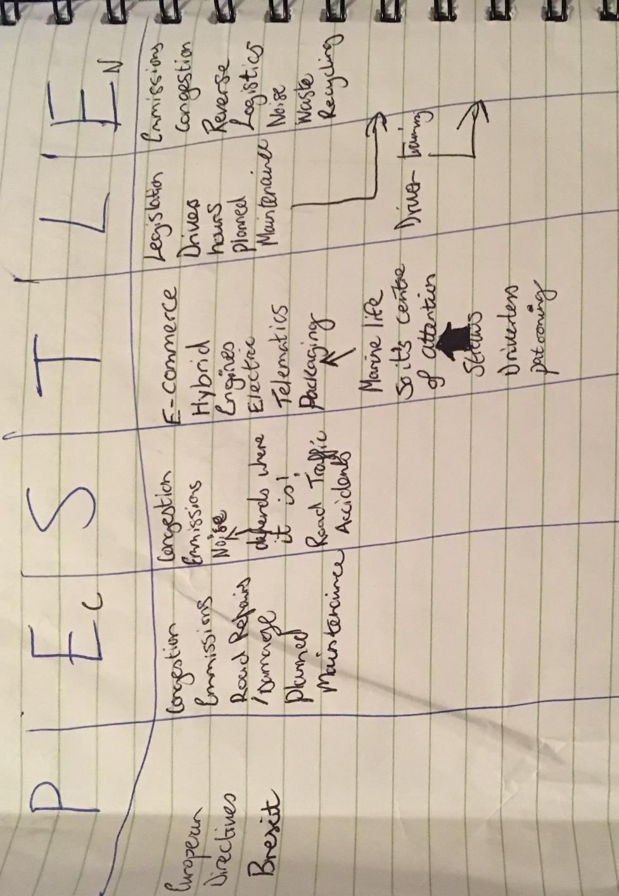
2 Pestle Analysis Tool
So as mentioned beforehand, below the pestle analysis of effect that distribution has on the external environment. In the below image a pestle analysis has been written up and evidenced in relation to packaging and its impact on the six elements: political, economic, society, technological, legal and environmental aspects of the outside world.

3 Types and Characteristics of Packaging
As some may know packaging it virtualy requied for any goods whether it be food, liquids, healthcare items, expensive goods like cars or car parts and so on, however for some goods “packaging can be the most expensive part of the good” (Grant, Trautrims and Wong, n.d.). In addition to this the more sought after and dangerous or combustible the good the more expensive as well as vigorous the packaging can be. As you cannot simply place so many gallons of petrol into a random container and take it half way across the country through different climates. This is because it will have a great impact on the environment if it were to leak out or explode due to heightened temperatures.
Paper as well as cardboard and the most commonly used packaging materials although plastic is somewhat preferred due to its lightness which aids business with cheaper transport costs due to less weight as well as benefitting the environment. This is one of the main reasons why companies switch to plastic packaging. This is because according to Bpf.co.uk. (2018). There would be a vast “increase in packaging consumption including mass, energy and greenhouse gas emissions would increase”. In some respects, this make plastic packaging look relatively sustainable in the logistics world, however it does pollute itself as well as some types of plastic not being able to recycle where ‘as cardboard and paper can. This means less costs economically to reproduce packaging if the paper and card are recycled compared to that of recyclable type plastic. However, on the other hand due to plastic’s lightweight less vehicles are used to transport the products using this packaging, thus saving on lorries as well as fuel and contributing less to emissions.
There are more benefits to using plastic type packaging especially within the food industry since it helps with freshness of food especially at home and provides a hygienic way to purchase food especially food and additionally reduce waste and save resources.

3.1 Costs of Alternatives
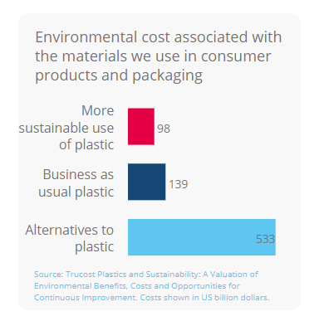
Figure 1 (Source above in the image)

4 Environment & Economy
So as you can see in the above chart in figure one it is a lot more expensive to package products in either plastic alternatives or doing business as usual using the same plastic compared to using more sustainable plastic which makes a lot of sense right as using more sustainable plastic packaging will have long term benefits and more than likely will be able to be recycled thus making it more sustainable for the environment as well as reducing the required energy next time when re-packaging. PlasticEurope2009 also back up the desired and logical requirement for plastic type packaging however less simple it is to recycle due to the fact that according to their study that “… tonnage of alternative packaging materials would go up by a factor of 4, GHG by 2, costs in general by 1.9” as well as waste being the same and energy also being increased by 1.5 which would negatively impact the environment. So environmentally this would result in an increase negative impact on the o-zone layer and economically as taxes would increase and more would be charged depending on the increasing levels of carbon dioxide in the atmosphere.
It is said that “technically, all packaging can be reused, recycled or recovered” but packaging itself is one of the “main waste streams that can and does harm the environment” (Grant, Trautrims and Wong, n.d.). Waste going to landfill alone is harmful for the environment but in this case some packaging materials aren’t biodegradable and so this can and has been proven to affect biodiversity and so in turn if not managed properly could affect a whole ecosystem of living beings let alone plants. Some business is partly to blame for this ongoing impact on the environment due to the plastic packaging being used is not widely or normally recycled and so ends up at landfill no matter what. This then further fuels the fire to lead a company to being less sustainable. Also, some countries are less susceptible to recycling than others. Since there is no or little recycling plants for these types of plastics, packaging producers are forced to redesign and rethink their packaging materials to comply with rules and regulation which promote the need for biodegradable packaging if not recyclable at all. This is sort of a vicious circle in some respects since they will be using fossil fuels and harmful gases will be released in the research and designing of the new packaging materials.
4.1 EU Directive
There is a European union directive set in place which constraints manufacturers of packaging to abide to some set regulations. Ec.europa.eu. (2018). The directive being for packaging waste (94/62/EC) this directive set the rules on the production, marketing, use, recycling and refilling of containers of liquids for human consumption and on the disposal of used containers. In 2004 this directive was amended to fuel or aid the recollection and recycling of packaging waste, again it was revised to allows newer states the opportunity to be able to reach targets on the recycling and recovery of packaging waste. One of the latest revisions of the directive was made in April 2015 with the use of lightweight plastic carrier bags. There was a standard 5p price charge placed on plastic carrier bags to aid the target of drastically reducing the consumption of plastic bags. Which will benefit the environment drastically since it will deter customers from waning carrier bags due to having to pay for them knowing that they’re not that durable. So instead customers will either bring their own bags or purchase recyclable bags for life and no longer require lightweight plastic bags therefore reaching the EU’s target for decreasing the consumption of plastic bags as well as the waste they create. This will also minimise the amount of fossil fuels burned producing toxic and harmful gases which are then released into the environment.
The main reason for eliminating plastic bags is because they have a detrimental effect on marine life due to waste and illegal littering EC.Europa.eu. “Plastic bags can also last up to 100 years” and so can be found everywhere. Marine life either get entangled within he plastic or ingest it in the form of microns which is hazardous and deadly hence why the charge on becoming more sustainable with packaging as it is harming wildlife, and this will have massive effect on ecosystems. Additionally, the less carrier bags mean less lorries needed to stock up on the bags therefore savings are being made globally. One for the government as business are acting more ethically and two for the business due to the fact of their ethicalness and being more sustainable in their everyday work which will speak volumes to their customers and stakeholders if any making them ideal for investing should they have shares on the market.
4.2 Tesco
Additionally, to reduction in plastic carrier bags, businesses such as Tescos have started to eradicate the non-biodegradable 5pence bags. A strategic move to ensure customers opt to purchase their slightly dear 10 pence bags for life or that they will bring their own bags in future. Therefore, cutting out plastic bags permanently therefore forcing their customers to be more sustainable when thought about. Another compromise they made was that these bags for life will be freely exchanged should they break through natural cause like wear and tear. These bags for life are made of “94%” recycled plastic which further enhances Tescos look on their ethics and caring for the environment. Smithers, R. (2018).

4.3 Society
From a societal perspective the savings on greenhouse house gas from these emitting fuels and even other more sustainable sources of fuel or even packaging will be more than enough to be complimentary and speak volumes to others as well as help shape the future of packaging. This will be because the its been deeply ploughed into business owner’s heads that the cheaper option in the long run will be to invest in more sustainable sources of packing initially. This will be because there will be less taxes to pay on the emissions the business may create. In addition to this there will be an increase in sales due to other likeminded business desiring the need to source packaging or raw materials for their packaging from respectable and more ethical companies therefore increasing the businesses customer base.
In addition to this there has been seen an increased effort from stakeholders to ensure packaging has less of an effect on the environment. This is due to packaging waste also increasing as well general waste and so ethical companies are making a stand as they want to make a change sustainably or are just increasing their corporate image for profitable use. As everyone knows consumers love a company that has a good profile for the environment. ProEurope4Prevention.
There are also a lot of factors to consider about packaging in terms of society and hence why they increase costs and the amount of fossil fuels being used. This is because within society there are many different people such as old people who like easy open systems on food packaging where ‘as a teenage just wants simple colourful packaging in oppose to families who want extra lasting packaging etc. All these different individuals with society will impact the effect that packaging has on the environment due to different needs required from the simplest of even food packaging.

5 Conclusion
So overall it very clear to see that packaging has a massive impact on the environment especially in terms of distribution within logistics practices. This is because you cannot distribute a product without the need for packaging to enclose and protect the product. Additionally, packaging can be the reason as to why a product is so expensive as it may need specific but sensitive type packaging and so again could be harder to recycle further impacting the environment negatively. It is also very visual that majority of any packaging is not easily recycled and so todays environment would benefit from more business that offer recycling of product packages or at least their recovery to be determined whether fit for purpose a second time and then used again. There are a lot of environmental costs associated with packaging. For example, collecting waste that has escaped naturally or from illegal dumping and fly-tipping. To the simplest of distributing non-recyclable packaging to landfill it all costs. However, if these packaging could be recovered back to the users then everything would be great, but this is not the case as elaborated above.
Packaging has had a dramatic effect on the environment evidently and so every day the government and likeminded business especially those who act strategically or even sustainably are trying to mitigate the issues with using pollutive packaging and move to alternatives that d just the same job but give less emissions or are more recyclable. Lastly there are a set of directives on the guidelines of what packaging standards should confer to and these are regularly amended to battle increasing levels of pollution caused by packaging and packaging waste.

Bibliography
[Infographic], H. (2017). How Product Packaging Affects Buying Decisions [Infographic]. [online] MarketingProfs. Available at: http://www.marketingprofs.com/chirp/2014/25957/how-product-packaging-affects-buying-decisions-infographic [Accessed 6 Dec. 2017].
Americanchemistry.com. (2017). Study: Plastic Packaging Enables Significant Energy and Greenhouse Gas Savings in U.S., Canada. [online] Available at: https://www.americanchemistry.com/Media/PressReleasesTranscripts/ACC-news-releases/Study-Plastic-Packaging-Enables-Significant-Energy-and-Greenhouse-Gas-Savings-in-US-Canada.html [Accessed 6 Dec. 2017].
Barma (2018). Packaging for the Logistics. [online] Slideshare.net. Available at: https://www.slideshare.net/Bhodan/packaging-for-the-logistics [Accessed 16 Mar. 2018].
Bizfluent.com. (2017). Cite a Website - Cite This for Me. [online] Available at: https://bizfluent.com/info-8215836-environmental-impacts-product-packaging.html [Accessed 4 Dec. 2017].
Bpf.co.uk. (2018). Plastic Packaging and the Environment. [online] Available at: http://www.bpf.co.uk/packaging/environment.aspx [Accessed 17 Mar. 2018].
Croucher, P., Baker, P. and Rushton, A. (2014). The Handbook of Logistics and Distribution Management: Understanding the Supply Chain. Kogan Page.
Ec.europa.eu. (2017). Packaging waste statistics - Statistics Explained. [online] Available at: http://ec.europa.eu/eurostat/statistics-explained/index.php/Packaging_waste_statistics [Accessed 1 Dec. 2017].
Ec.europa.eu. (2018). Packaging waste - Environment - European Commission. [online] Available at: http://ec.europa.eu/environment/waste/packaging/index_en.htm [Accessed 18 Mar. 2018].
Grant, D., Trautrims, A. and Wong, C. (n.d.). Sustainable logistics and supply chain management.
nibusinessinfo.co.uk. (2018). Reduce the environmental impact of transport logistics. [online] Available at: https://www.nibusinessinfo.co.uk/content/reduce-environmental-impact-transport-logistics [Accessed 16 Mar. 2018].
Proeurope4prevention.org. (2017). Packaging and society | proeurope4prevention.org. [online] Available at: http://www.proeurope4prevention.org/packaging-and-society [Accessed 1 Dec. 2017].
Reyhle, N. (2017). 4 Reasons Why Product Packaging Is Important. [online] Retail Minded. Available at: https://retailminded.com/4-reasons-why-product-packaging-is-important/ [Accessed 4 Dec. 2017].
Smithers, R. (2018). Tesco to end sales of 5p carrier bags. [online] the Guardian. Available at: https://www.theguardian.com/environment/2017/aug/07/tesco-to-end-sales-of-5p-carrier-bags [Accessed 18 Mar. 2018].
Tampa Bay AMA. (2017). How Packaging Can Help Market and Sell Products - Tampa Bay AMA. [online] Available at: http://amatampabay.org/how-packaging-can-help-market-and-sell-products/ [Accessed 4 Dec. 2017].
Ups.com. (2017). Cite a Website - Cite This For Me. [online] Available at: https://www.ups.com/media/news/en/pack_ship_batteries.pdf [Accessed 4 Dec. 2017].
US EPA. (2017). Sustainable Packaging | US EPA. [online] Available at: https://www.epa.gov/smm/sustainable-packaging [Accessed 4 Dec. 2017].
Valpak.co.uk. (2017). Cite a Website - Cite This For Me. [online] Available at: https://www.valpak.co.uk/docs/default-source/information-zone/packaging-waste-regulations-overview13bd00c1a5336c89be6fff0000348758.pdf?sfvrsn=12 [Accessed 1 Dec. 2017].
Valpak.co.uk. (2018). [online] Available at: https://www.valpak.co.uk/docs/default-source/external-publications/compelling_facts_about_plastics.pdf?sfvrsn=2db89911_0 [Accessed 17 Mar. 2018].
Watson, K., Watson, K. and Watson, K. (2017). The Importance of Packaging in Transport and Logistics. [online] Kimberley Watson Packaging. Available at: http://www.kimberleywatsonpackaging.co.uk/latest-news/2015/11/9/the-importance-of-packaging-in-transport-and-logistics [Accessed 6 Dec. 2017].
Worldpackaging.org. (2017). The Economic Role of Packaging - World Packaging Organisation. [online] Available at: http://www.worldpackaging.org/i4a/pages/index.cfm?pageID=3357 [Accessed 4 Dec. 2017].

