Ibrahim Balogun
Database Design (The Book Store)

Contents
Entity Relationship Diagram 2
Utilizing Of SQL 2
Tables 3
Relationships 4
Forms 4
Reports 5
Macros 5
Calculation in a report 5
Master and Embedded forms 6
Macro query 7
Main menus display 8
Evinced of database 8

Entity Relationship Diagram
The first part of creating a database is to find out the purpose of the database, to do this I made the first sketch in Visio to try and find out what I wanted to do with the database. As shown in figure 1, I will need to have the entries of customers, book, orders, bookstore, staff, and suppliers to make the library system to work. The table of customers is filled with all the customer-related detail; like their name address and date of birth, this table now has a one to many relationships with the orders as only one customer can have many orders, the book table also has a one to many relationships with the order table as only one book can be ordered many times. On the over side of the diagram, I have a table for staff information which has a many to one relationship with the bookstore table, as many staff working can work in one library. On the other hand, there are suppliers with publisher and book dealers details; the supplier table has a many to one relationship because many libraries in the area may have only one supplier. The last relationship is between the orders and bookstore table, as the bookstore has a many to one relationship with the bookstore, as many libraries may have one large orders for books.
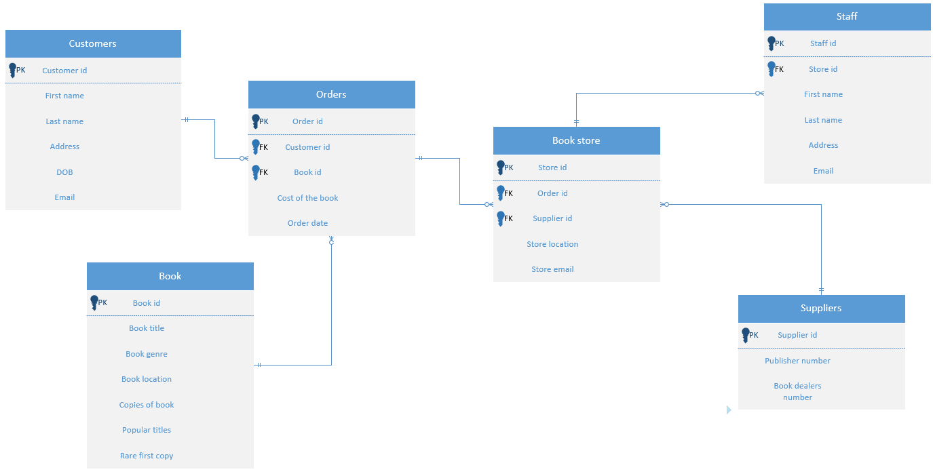
Figure 1

Utilizing Of SQL
To create the tables for the database in the most effective way, I used the structured query language, by using SQL it allowed for code to be entered to create tables, without using an overcomplicated UI system. Figure 2 shows the code I entered to create the store book table, the primary key is the StoreID, a constraint would need to be entered to create the primary key and the foreign key, another factor will need to be taken into account when creating this table, the order and suppliers table will need to have been created and running, the reason for this is that in the code you are referencing these tables, but if they have not been created they cannot be referenced. When thinking of data to enter into the database the programmer has to decide what value will need to be entered, for example, if the database asks for a name a text box will need to be available, you cannot place a yes/no drop down there as it the answers you will get will not match the question. The length of the answer will also need to be considered; for example, an email address will typically have the longest values, so placing a five-letter limit is unsuitable.
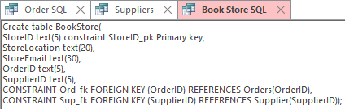
Figure 2

Figure 3 shows what the code looks like when it is run, it creates a table with all the right characters and lengths, with the foreign key form other tables present.
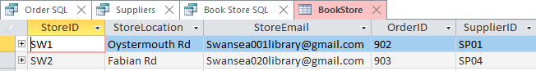
Figure 3

Tables
Tables are the most commonly used feature in any database as they allow for the data to be entered and store in an organised faction, if tables weren’t part of the database the storage of data will be messy and confusing for those who didn’t build the database and relationships between tables will be non-existent. Have the right amount of information for each category is necessary as you do not want to be asking the user to enter unnecessary values that will not serve any purpose for example figure 4 shows customer data being entered for a library system, asking the user what car they drive is worthless information.
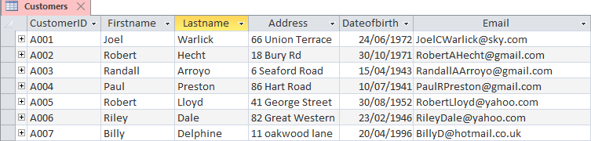
Figure 4

Relationships
When the SQL code has entirely been written, with the relationships being correct and the data on the table has fully been populated, this might be what the relationships of the tables will look like, figure 5 and figure 1 look the same, as I planned out what I would like the database to look like and I implemented the design.
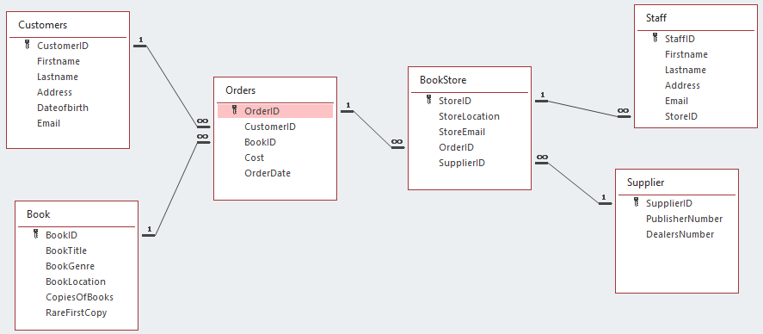
Figure 5

Forms
Forms are used to short cut the process of entering data on a table and help inexperienced users of the software to navigate the options once they are created. Once a table has been created, there will be an option to create a form. Shown in figure 6 I created a form from the by using the customer table, at the bottom of the table I added quick and easy navigation setting that make using the form easier, the buttons shaped as back and forward are quick ways to move through the customer's records, next this there is a create button when the button is clicked it will take the user to a blank page where they will have the option to type new data that will be saved into the database, at the bottom of the form is a back to the menu button, that when click will take the user to another form that I called “main menu” this is where all the options are to click on the different tables and edit or add new information. When creating a form buttons offer a quick way to run simple takes, for example, move data over there or open this file, they allow for the smallest yet most necessary actions to happen.
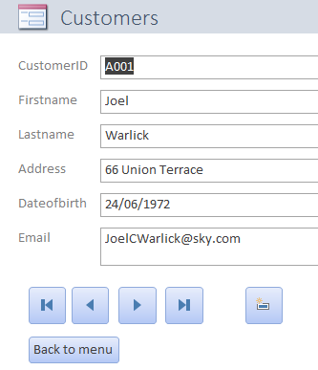
Figure 6

Reports
Reports are commonly used to display data that is on the database in a simple to read format, to create a report you first need to create a form that will run in the background and generate the data that you will need as shown in figure 6. The report I am trying to show is when the end-user enters a CustomerID it will generate all the books that they have ordered, when the CustomerID A002 has been entered a list of the BookID, book title, the genre and how many copies will be displayed as shown in figure 7.
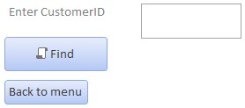
Figure 6
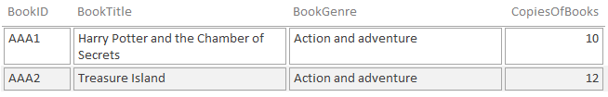
Figure 7

Macros
Macros are standard instructions that run and generate what they are set up to do; there are a substantial number of actions that can be run in a macro, figure 8 shows how I can use a macro to open a table, the macro action will need to be attached to a button so when pressed the action will run, there is also an option to add another action bellow the main action, this can allow for multiple actions to take place at once, for example building a report the actions of the macro allow for data to be recovered then displayed.
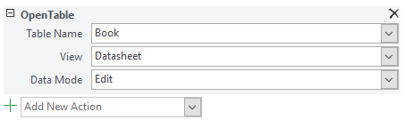
Figure 8

Calculation in a report
The first step on producing this calculation is finding out what type of data that will have the most significant importance being calculated, so I decided to calculate the total number of the book available in the library database. The creating of the books total report was straightforward, all that was need was the book table, data will need to be entered before starting as adding up nothing will give us nothing, while on the book table clicking the report button will create the layout as shown in figure 9, by using diagram view you will able to edit the report, I added a short line of code saying “=Sum([CopiesOfBooks])” this will add up all the copies of books that are available in the library database and will display the total amount once the report is viewed in report view as shown in figure 10.
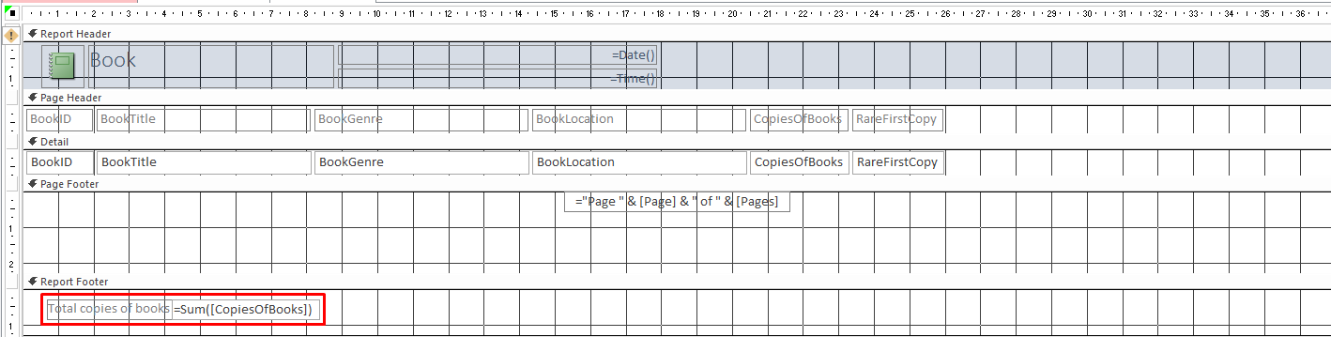
Figure 9
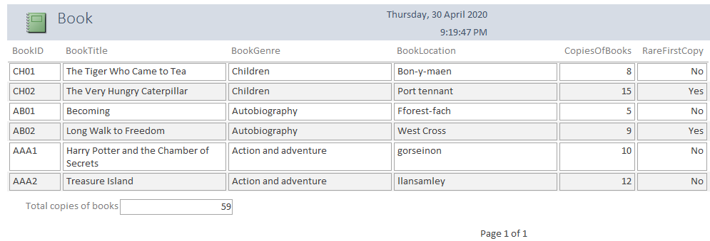
Figure 10

Master and Embedded forms
The process of producing a master and embedded form is beneficial, as shown in figure 11, the reason for creating this is that it allows for more information than normal to be displayed on-screen and in a report, a master and embedded form is created by using a macro as they can be used to run multiple actions at once. In the case of creating this form 3 actions were input the first action was to display the BookID “AAA1”, the second action was then to display how many orders have been put in place, and the last action was to output the data in a report, so by entering any BookID, it will display the information of the book, the people who have ordered the book and will display the information in a report.

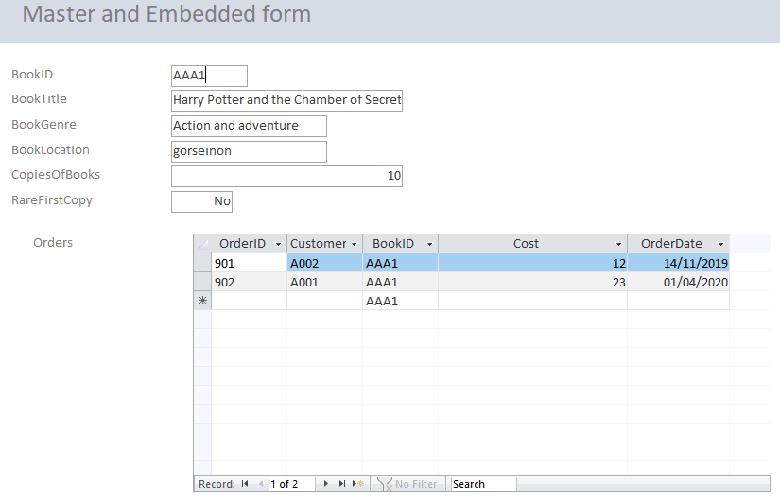
Figure 11

Macro query
The use of a macro query is to allow the user to input a data set then the corresponding data will be shown, for example, a worker at a library will enter a value as shown in figure 12, when the value is entered it will display all the books that the user is interested in or ordered, this is done by first creating a form as shown in figure 13, this will be the template that will be used to run the query as there is a button function so once the button is clicked the action will happen, the next set is creating a query, with the two table in a relationship together, then a form wizard will need to be created, with at done it will give you code that will late be executed, the results of this can be seen in figure 14, when the user enter a customer’s id and all the book they have ordered are displayed.
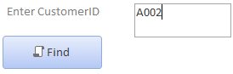
Figure 12
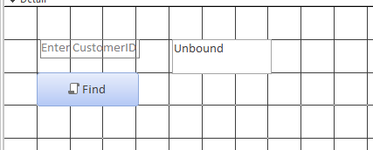
Figure 13
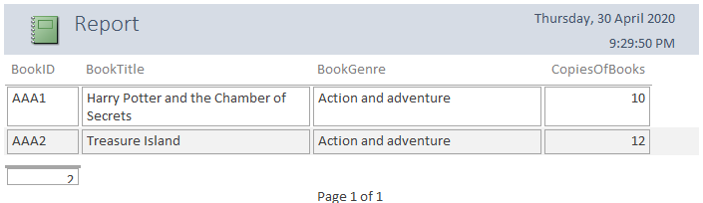
Figure 14

Main menus display
Having the main menu system is relatively useful and easy to make the first step is by creating a form and adding buttons, the buttons will then give roles to open other specific forms, tables or reports, by adding the buttons the user can navigate through other forms however there’s no way for the user to return to the main menu once finished with their task, so by adding another button to each form that will reopen the main menu allowing full navigation to take place. However you would want the main menu to be the first thing to open, as it would be easier for the end-users to navigate, to complete this task you will need to create a macro as shown in figure 15, the macro’s function will need to be able to open forms, and the name of the macro will need to be “Autoexec” as this will be the first code that will be run when the database is opened for the first time.
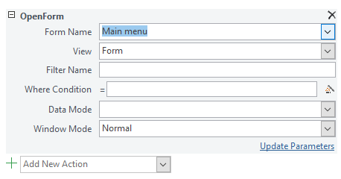
Figure 15

Evinced of database
Tables
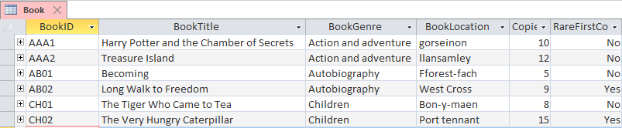
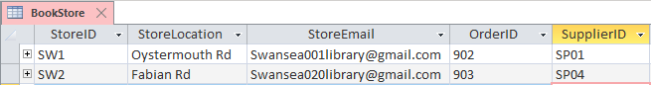
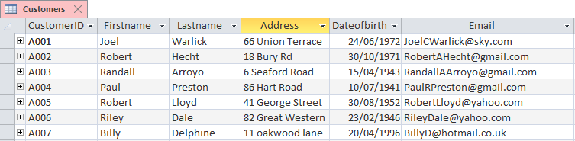
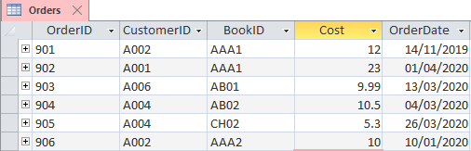
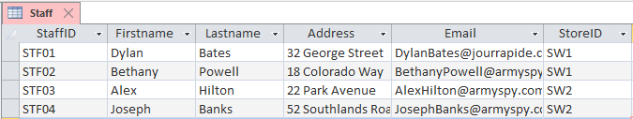
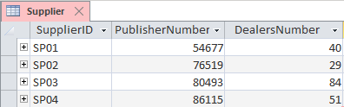

Queries
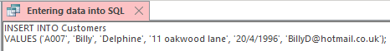
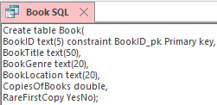
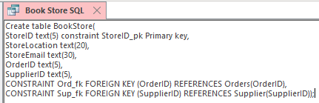
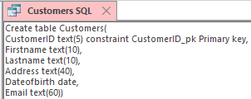
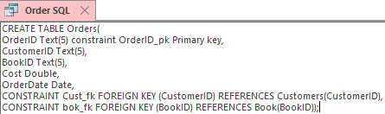
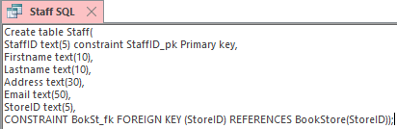
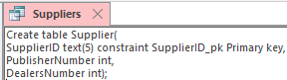
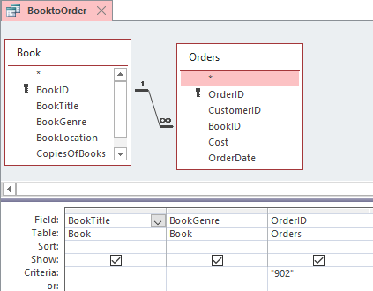
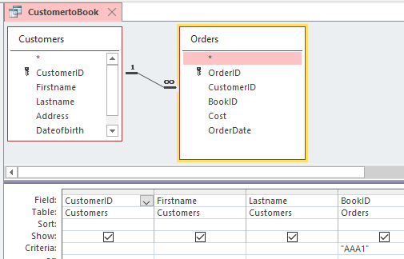
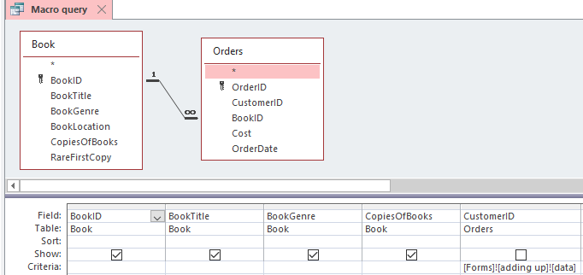
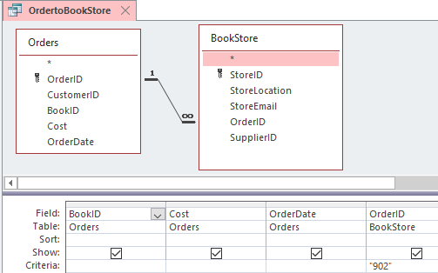
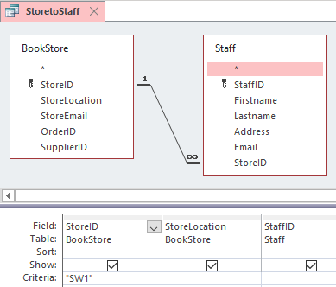

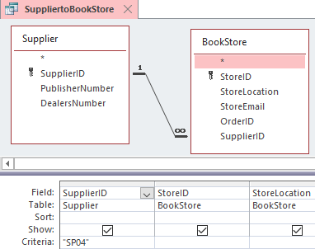

Forms
Form view Design view
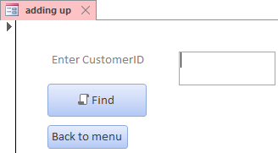 | 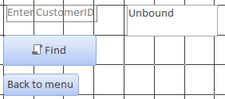
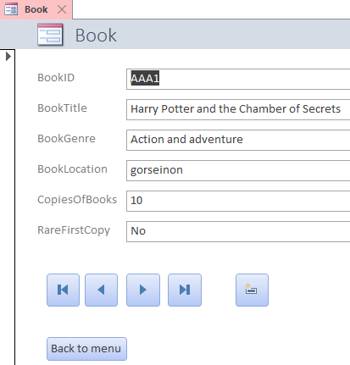 | 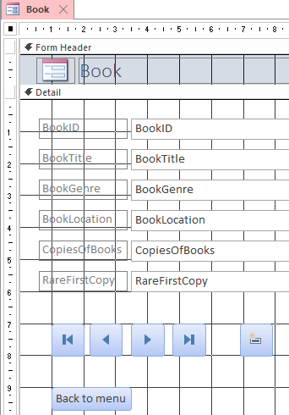
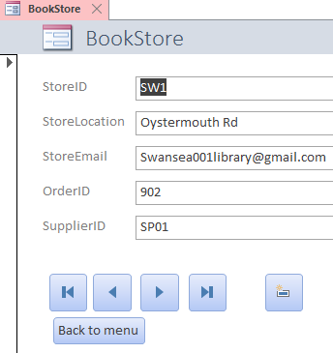 | 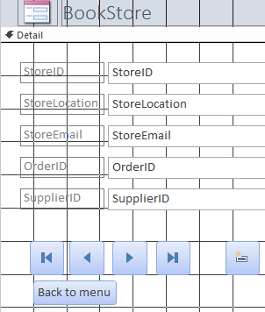
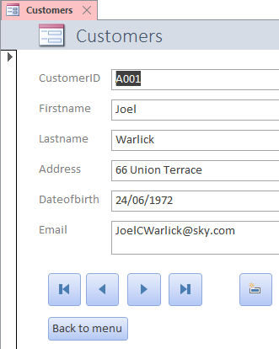 | 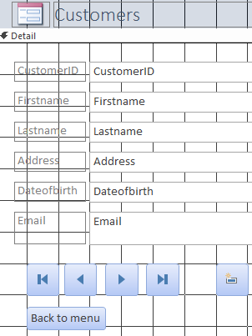
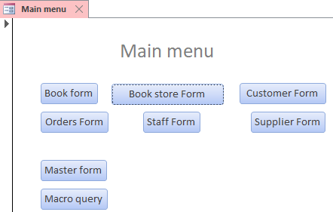 | 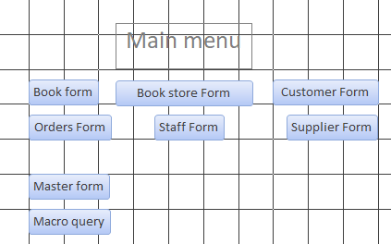
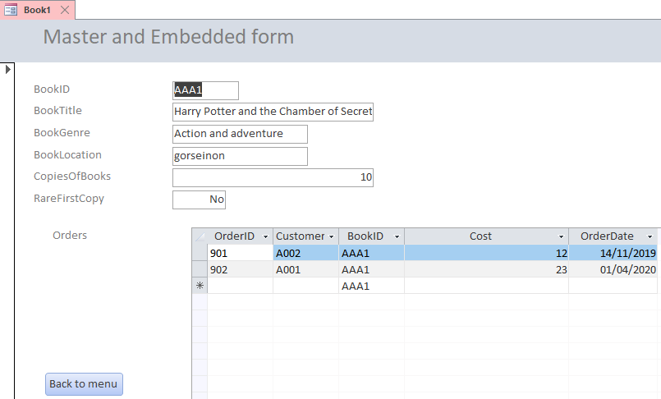 | 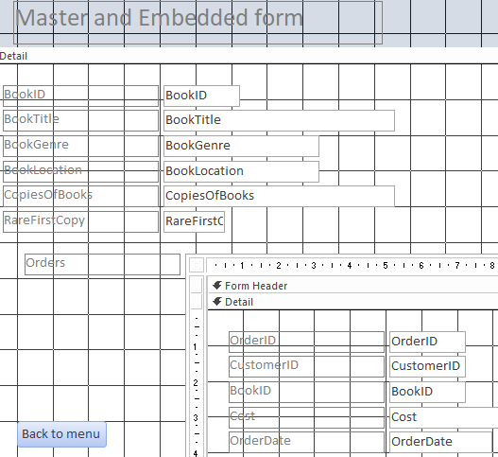
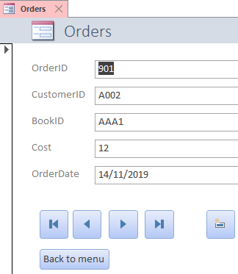 | 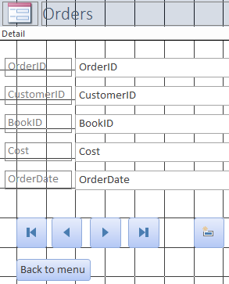
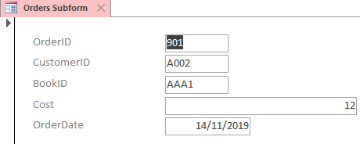 | 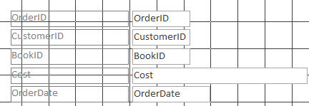
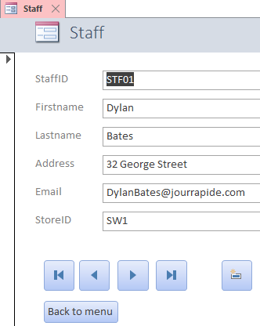 | 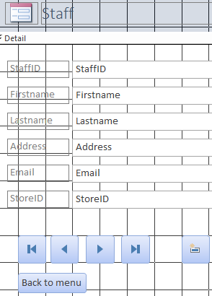
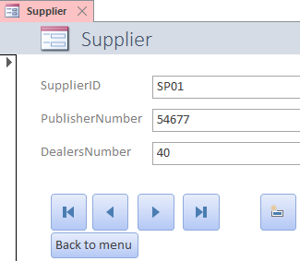 | 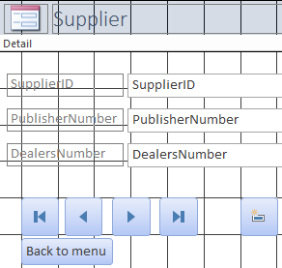

Reports
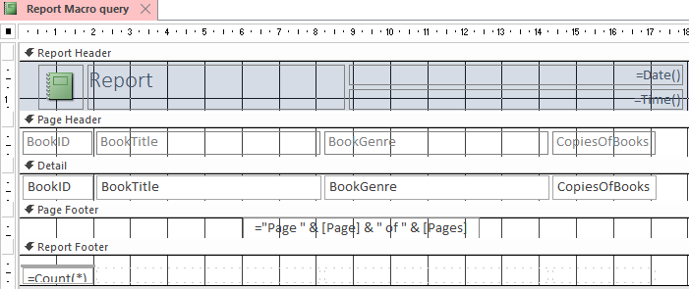
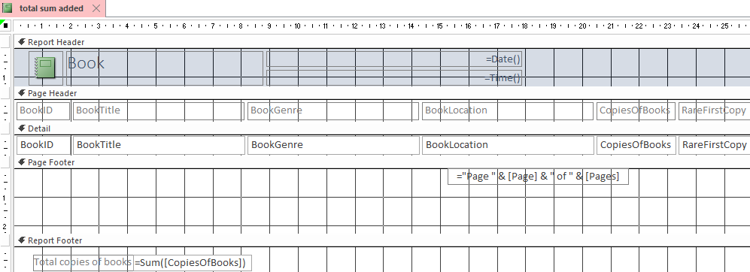

Macros


