Reflective blog
This is my reflective blog on my animation project and is where what I am doing and what my methods are to it will be documented with written and visual demonstrations of it. It will also be where I put problems and issues that I have run into and how I have overcome them or found a new method to get the desired result. Also, any changes from the idea and original designs and scene composition will be mentioned here along with anything else that I have chosen to make changes to. Also, any new methods that I try to incorporate into my animation through experimentation will also be here.
The Modelling
Today I started off the animation project by designing and modelling what I need. My animation is based on a race in space between two spaceships through a satellite debris field. To do this I need too model two ships and the obstacle that is the satellite debris field. I started off with the spaceship.
The first spaceship I have done was the villain’s ship. For the villains ship I started with looking at the 2D drawing I did.
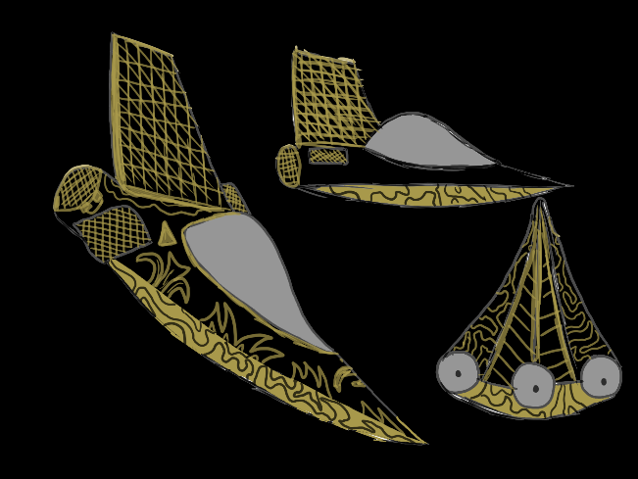
The Villains ships design is very sleek black ship with yellow/gold pattens and outlines with a light grey cockpit window. The design is meant to show a sort of rich, look at me kind of attitude that I want the villain to be, and I want the ship to reflect that.
However, when I was trying to transfer this 2D design to a 3D design I encounter some issues and other things that I didn’t like the look of. When I was moulding the ship in maya I didn’t like how some of it looked in 3D. An example of this was the lack of wings. Without them the spaceship looked more like a boat which I was not going for, so I decided to add some wings to it. The wing design I went with as a swept back wing design used on most airplanes. I also decided to add the ending of the wings to add some winglets to add to the design. Another thing that I have changed is the look of the engine which instead of having 3 small engines I’ve decided to just have one big one in the centre.

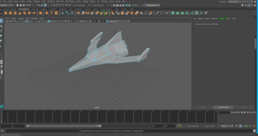

I’ve also decided to change the colour scheme of the spaceship. This is because the original colour of the ship was black which caused issues because of the black ship background. So, because of this I have decided to change the ships colour from black to a light grey because it will make it more visible, but still have the more villain/darker colour scheme. I also decide to remove the yellow/gold highlights because it didn’t love right on the model. I also decided the change the cockpit windscreen colour from light grey to black. I did this because the ship was now grey, so it was hard to tell the windscreen and ship apart and the black windscreen also allows the black to still be present in the ship design.
I have now decided to add some of the yellow colour scheme back to the ship. I added some yellow colouring to the winglet and added a yellow light to the cockpit windscreen to add more detail. The engine colour is also a yellow and it has a glow on it to better show he engine in the animation.
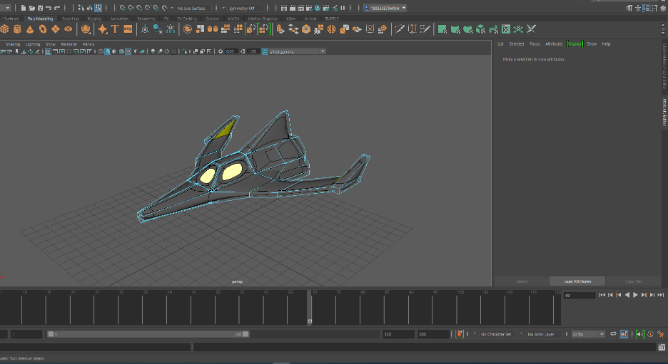

Now it was time for the hero ship.
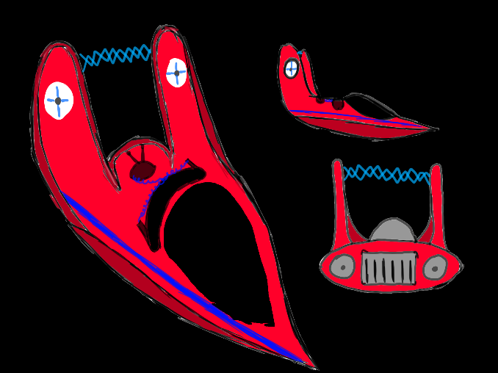

When I was modelling this 2D drawing of the spaceship into 3D it went a lot better and looked more closer to the original design than the villains ship the first time that I did it. However, there was some changes to the design.

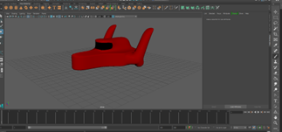
The first change I made was the front of the ship. I decided to cut of the point on the front and round it to get more of a smaller and jet ski look at the front. I also added a small bottom of the wings to give a muscle car feeling. I also have a flat windscreen and I have it curve from left to right. I also changed the style of the engine because of the original design of having two circler engine I have decided to change it to a rounded rectangle. With this I also added a light blue light to serve as its engine. I have also removed little details that was on the ship like the single on the back to make the spaceship more streamlined. I did attempt to create the electrical connection between the two tail wings, but I could figure out how to do it, so I decided to leave it off for now. Also didn’t add the blue stripe and white circles with the cross in them as I have decided the full coloured ship looked better.
The next model was the space station. The space station is where the race starts and house the two main ships of the race and the story. I wanted the space station to have a unique look, so I started experimenting by adding blocks randomly to get a non-symmetrical look for it. I made sure to have platforms on the front where the spaceships will be docked. For this I used a design based on how docks are built to hold boats in them, so I made sure that was part of the design. For the rest of the space station, I wanted it too to look like a space station that exists in real life that was mixed in with the sci-fi race that my animation and story is about. So, to do this I added some massive rectangular solar panels to the top of the space station like the international space station has to not only show that it is a space station but to also make some bind spots of the build, so I don’t have to detail non-important parts of the space station that effects the story. I decided to add 4 solar panels too each side to imply the space station is bigger than it really is.
I also decide to add a light source to the space station in the form of a box of light at the top of a pole. To do this I added a box to the top of the pole that is connected to the space station and each face on the box on the sides I want to put a light in so it not only sticks out and draws attention when then camera is on it but it is also a light source for the space station itself and the light will reflect of the walls to give a certain feel. The feel I wanted this to have been a bright colour on a dark background with two bright colours, red and green, because they are very racing colours and are bright and easy to see. Each face of the block will have a colour with the colours going around with red and green lights. To do this I added the Incandescent bulb effect too each side of the block at the top of the pole and added coloured light to emit from it. After that I started to texture the space station.
To start I needed a texture that would cover the main bit of the space station. For the space station I decided to use metal look to the structure because it gives it a metallic feel and also, I wanted the space station to have a silver feel and metal is a silver material, so it fitted perfectly. For this I got a metal texture to put on the space station from harrisonsteele.com.
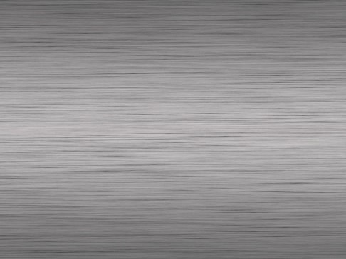
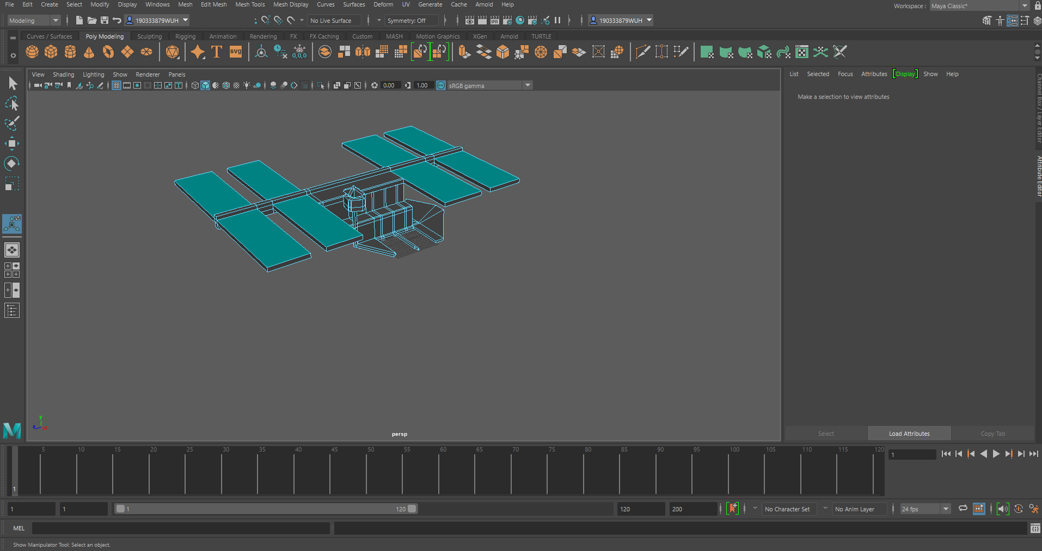

The next thing I needed was the space background for the sets to be on for the animation. I wanted a simple space background with just stars on it so I could use it every where without the worry of it not tiling correctly. I the end I got the Simple Starry Space Background from jooinn.com.
The next thing that I needed to texture was the solar panels that are on the top of the space station. For this I did some research to look at common space station solar panels and fount out they were a yellow foil type material on metal poles, and I tried that colour scheme and look on my space station and didn’t really like how it looked as it didn’t fit with the build. Because of this I looked for more inspirations about what look my solar panels should have. After a lot of searching for what I could use I thought about using the kind of solar panels that are used on earth. I know what to use a dark blue solar panel texture on my space station solar panels, so I went to go and look for the texture I need. In the end I chouse a dark blue earth style solar panel. I got a solar panel texture from archweb.com and used the planar in the UV editor to match it to the space stations solar panels style and size. After that I move onto the next thing that needs to be done.

The next thing I needed was the space background for all the sets to be on for the animation. I wanted a simple space background with just stars on it so I could use it everywhere without the worry of it not tiling correctly and having separating lines in-between them. After looking at some textures that I could use I go the Simple Starry Space Background from jooinn.com as my space background. However, when I activated it as my background on my set it didn’t look as good as I wanted it too. It has the black background that I wanted to show that it was in space but the stars were very small and hard too see so it looked like a black wall and when I tried to make the stars bigger so they are more visible in the animation but it reduced the image quality and make the background look pixelated so I went to look for a new background that was still space themed but had more visible stars. In the end after searching, I decided to get a brighter background for space where the stars are more visible but can still tile together. I got a new space background from wallpapercave.com. However, when I did a test render, I could see much as the only lighting was the light box on the space station so I needed to choose what form of light I want to use the light up the scenes in the animation.
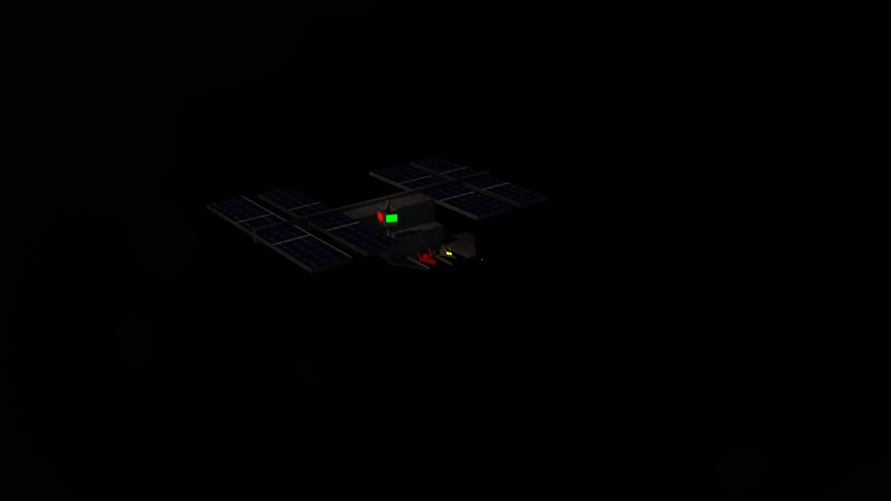
After test to see what light, I wanted to use I decided to use the Arnold Physical sky light as it made the scene easy the view and everything that is important is visible.
After that I imported my ship models that I modelled and textured in a different MAYA scene into the scene too see if there were any issues with it and luckily, it wasn’t. After that I placed the ships in there starting place for the ships in the animation. Now I plan to work on the satellite junk field and the ending finish line and them I shall start animating.
I also need to model some satellites for the debris field the spaceships are going to go through. For this I wanted some basic designs that I could duplicate to fill the scene and pose as obstacles for the two characters. As these will be used multiple times in the same scene I have designed them to look different when they are posed at a different angle.
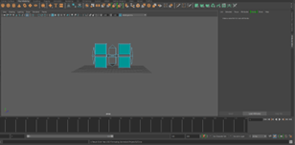
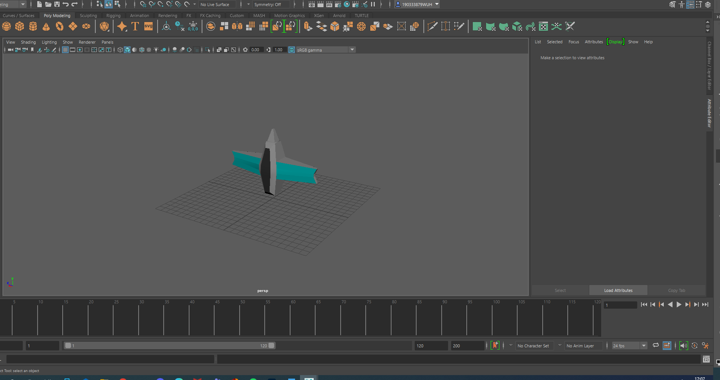
Animating
Now that all the models are done it is time to put it in the animation. I start on the main part of the race first because it was the important part of the animation and even though I had allotted time for the scene I wanted to do it first just in case I need to make it a bit longer of shorter because the start and the end can be tweaked in the amount of time they are on screen.
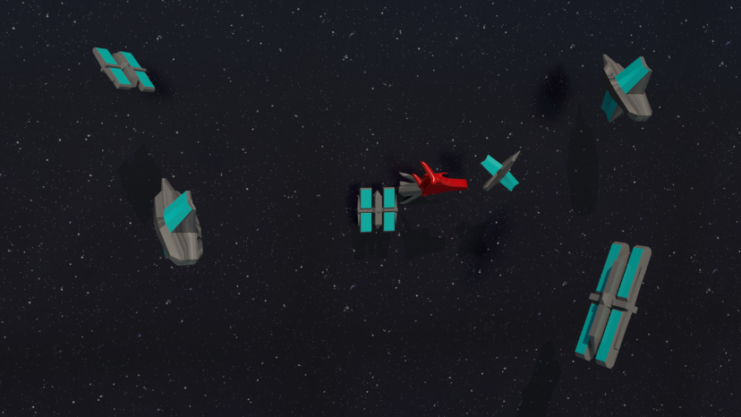
When animating I had to think about the camera and for the first part of the pace it was placed in a side view, so the animation goes from the right to the left of the screen. The background was the same one as all the scenes to have cohesion within the scenes and within this scene I will have the two spaceship models and some of my satellite designs to be the obstacle that the characters must overcome. This will be done with some movers like flips and going from left to right to avoid the satellite debris field.

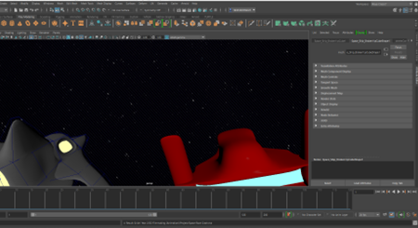
For the race part of the animation, I wanted to have many different camera angles, so I had many different cameras set up to get many different angles of the animation to make it not look stale with a single camera angle. With all of the images rendered I will take them all in to an editing software package and then chose what frames of the animation will be used so they flow the mostly smoothly but still get the story part of the animation through so it can be understood. This method also allows me to make cuts to move the pace of the animation along if I want to change it and won’t require me to go back into MAYA to render the animation again at a different angle, I already have many angles of the animation from the original render session.
Another reason I like the method of multiple camera angle of the animation is that it allows me to change the camera angle multiple times in a short amount of time to show something important to the audience with everything still lining up with each other and not being out of place.

For the climax the bad guy ship has its wing taken out by a satellite which causes a spin out and the ship stopping and breaking down, allowing the hero ship to go off and win the race. To do this I had the fixed ship in the first part and rendered that part first, then I replaced the normal villain ship with another one that I had broken in a different save so the wing can come off and float away with the rest of the ship spinning out of control.

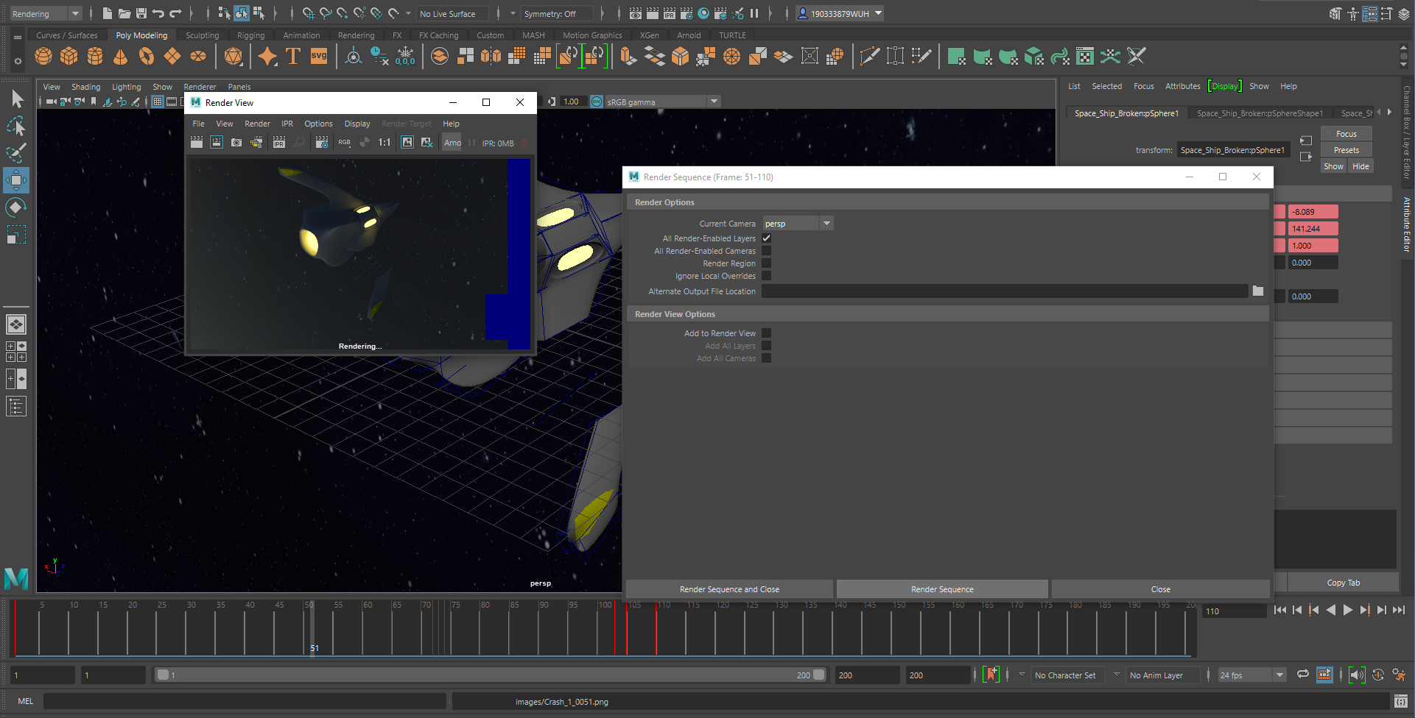

After all of the scenes were completed, I took them into Adobe After effects to put all of the rendered images together and in order so I can export it as a MP4 video so the full animation can be in a single video instead of split in to the different parts of the animation.
The final video all together came out to 40 seconds and 10 seconds.

