

Student Name:Galla Prasith

Student ID:2543438

Module Name: Marketing Management

Module Code: LCMB7024

Lecturer’s Name:Tushara balendran

Work Count:2962

Term 1

Marketing Environment Analysis of TATA Steel
Introduction

Tata Steel is one of the biggest steel producing companies in the world and a flag bearer of the Tata Group. The company is known for its innovative nature and commitment towards environmental sustainability and responsible business operations. Operating in more than 50 countries and having manufacturing units in Asia and Europe, Tata Steel is significantly involved in the supply of steel to various industries like construction, automobile, engineering and infrastructural industries. With the increase in pressure from the global steel industry towards the reduction of greenhouse gases and use of environmentally friendly production techniques, Tata Steel has placed sustainability in the heart of its business strategies. The current report critically evaluates the external marketing environment impacting the change of Tata Steel in terms of low carbon production of steel, focusing specifically on the natural environment and one more external factor. Moreover, the growth strategies of Tata Steel have been evaluated through Ansoff Matrix and how Tata Steel can enhance its competitive advantage by fulfilling the sustainability goals.(Services, H.D. (n.d.). Tata Steel Vision, Mission, Values & Objectives.)

Background
Tata Steel Limited is a company formerly called the Tata Iron and Steel Company (TISCO), which was founded on 26 August 1907 as India's first integrated private company that produces steel. The idea behind the company came from the mind of an Indian industrial pioneer named Jamsetji Nusserwanji Tata, who envisioned that having a steel industry in India would be necessary for the development of the economy. Unfortunately, the founder died before the company was registered, but his vision came true due to the actions of his son, who registered the company and built the first steel plant of the company in Jamshedpur, Jharkhandw. Tata Steel has been producing steel since 1912 and today it is considered one of the biggest producers of steel all over the world owing to its innovations, international expansion and successful acquisitions such as Corus Group in 2007. (According to Tata Steel's official website), the company's mission is: "We will build a profitable and sustainable UK steel company that strengthens industrial supply chains, creates value and supports communities through our people collaborating with partners to deliver differentiated, resource-efficient steel for a low-carbon future”.(Www.tata.com. (n.d.). Nerves Of Steel | Tata group.)
- Task 1: Marketing Environment Analysis
  - Macro Environment
The principal external factors that cannot be controlled (economic, demographic, technological, natural, social and cultural, legal and political) that affect the decision-making process of an organization.(Monash University (2025). Macro-environment).

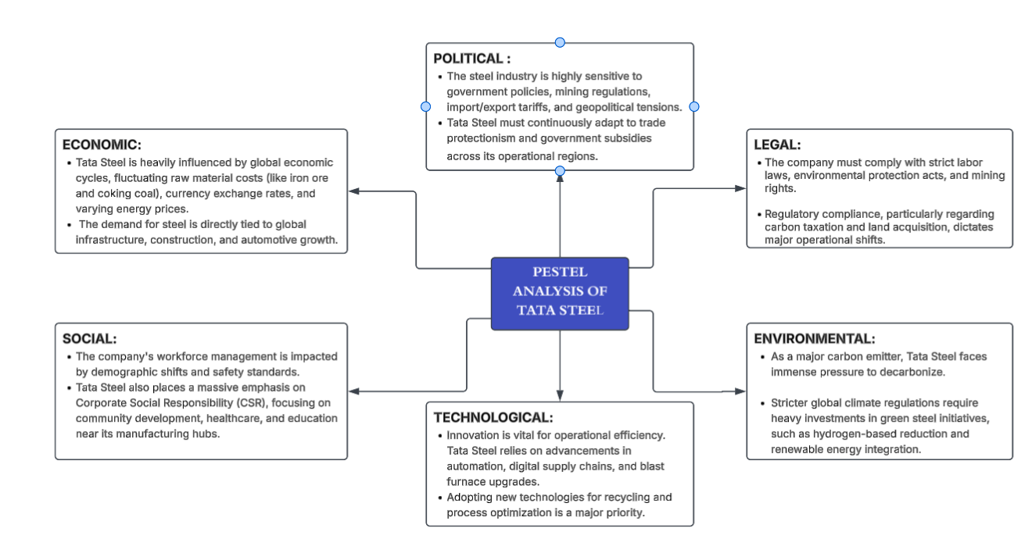
Figure 1 : PESTEL ANALYSIS OF TATA STEEL
Source : Created by learner

  - The Natural Environment
Climate change is among the major problems that Tata Steel faces, which require reduction of their carbon footprint to a great extent through the production of steel. This is necessary so that Tata Steel can be able to compete well with other organizations and countries, especially with regard to the current trend of de-carbonization.(Hungama Digital Services (2023). Tata Steel | Climate Action).

Opportunities

- Progress in Green Steel and Hydrogen TechnologiesThe Opportunity Moving away from high-carbon-emitting technologies like the blast furnace process reduces carbon emissions.

Example: Tata Steel has built up a pilot facility in Jamshedpur with a capacity of five tonnes per day to extract CO2 from blast furnace gas. The company is pursuing the notion of hydrogen based steelmaking combined with the injection of Coal Bed Methane (CBM).(Tatasteel.com. (2024). Integrated Report and Annual Accounts 2024-25 118th year.)
- Steel is very easy to recycle and may be recycled as ferrous scrap metal for the manufacturing of new steel, reducing the carbon footprint in comparison to the manufacturing of steel using primary iron ore. Tata Steel, which has plans for Net Zero emissions by 2045, has incorporated the recycling of scrap metal into its steelmaking process. Recycling of other waste produced during production may either be reused to reduce cost or sold to make money.(Tatasteel.com. (2024). Integrated Report and Annual Accounts 2024-25 118th year.)
Example: Tata Steel operates India's first state-of-the-art steel recycling plant in Rohtak, Haryana. This initiative allows them to turn end-of-life vehicles and industrial scrap into reusable steel, lowering their reliance on virgin iron ore.

Threats

- The steel industry is inherently energy-intensive and a major contributor to greenhouse gas (GHG) emissions. Tata Steel’s heavy reliance on traditional Blast Furnaces (BF) makes it highly vulnerable to climate regulations.
Example: With India's steel sector accounting for a significant share of national CO₂ emissions, Tata Steel faces the looming threat of strict carbon taxes, carbon credit trading schemes, or emission caps. Transitioning to greener alternatives (like Electric Arc Furnaces and Hydrogen-based steelmaking) requires massive capital outlays.
- Tata Steel is dependent on different sources of water for its functioning. Any failure on the part of the company to adhere to the guidelines regarding the use and disposal of water can lead to environmental charges and closure of operations. The impact of climate change will make it essential for Tata Steel to use minimal water and recycle it.

Example: Many of Tata Steel’s core operations (such as the Jamshedpur and Kalinganagar facilities) are located in regions increasingly impacted by industrial and urban water stress. Changing climate patterns leading to droughts pose a direct threat of water shortages, which can curtail production and trigger disputes with local communities.(Tatasteel.com. (2024). Integrated Report and Annual Accounts 2024-25 118th year.)

  - Technological
Technology in the PESTLE analysis of Tata Steel is another factor that plays an important role and indicates the great shift in favor of Industry 4.0 and greentech. The company is leading the world steel industry by intelligent manufacturing and supply chain management, and investing billions of dollars in replacing conventional blast furnaces with low carbon EAFs.(www.tata.com. (n.d.). Redefining the Future of Steelmaking | Tata Group).
Oppurtunities

- Utilizing AI, robotics, and IoT to upgrade blast furnaces and rolling mills.
Example: Tata Steel deploys AIPL (Artificial Intelligence and Machine Learning) platforms to monitor equipment health in real-time, predict maintenance needs, and optimize raw material usage, which significantly decreases plant downtime and operational costs.((Tatasteel.com. (2024). Integrated Report and Annual Accounts 2024-25 118th year).

- Leveraging digital infrastructure for better logistics management, customer targeting, and global market reach.
Example: Tata Steel’s Metal Junction, an advanced B2B e-commerce and e-auction portal, modernizes steel trading. It allows the company to engage a wider global buyer base, improve pricing transparency, and streamline inventory tracking.Tatasteel.com. (2024). Integrated Report and Annual Accounts 2024-25 118th year)

Threats
- As Tata Steel integrates IoT, digital twins, and virtual command centers to run its operations, the company becomes deeply exposed to cyberattacks targeting operational technology (OT).
Examples: Ransomware or malware attacks on smart manufacturing networks can hijack industrial control systems, bringing production lines to a grinding halt, leaking proprietary R&D data, or causing severe supply chain disruptions.
- While Tata Steel utilizes AI and digital twins to optimize its plants, global competitors investing more aggressively in automation and smart manufacturing could outpace Tata Steel in unit cost reduction and product quality.((Tatasteel.com. (2024). Integrated Report and Annual Accounts 2024-25 118th year).
Examples: Advanced AI-driven logistics and automated blast furnace systems require massive initial investments. Competitors who rapidly transition to fully autonomous, lights-out manufacturing can achieve higher precision and significantly lower long-term operating expenses.(Tatasteel.com. (2024). Integrated Report and Annual Accounts 2024-25 118th year).
- Task 2: Strategic Growth and Competitive Positioning
  - Strategic Growth Recommendation Using the Ansoff Matrix
Ansoff Matrix is a matrix for business development strategies by Igor Ansoff, which aids organizations in identifying areas where growth can take place through the analysis of the products and markets in an organization. The matrix helps businesses select a suitable growth strategy taking into account the risks involved in choosing such strategy.(Loredana, M.E. (2017). The Use of Ansoff Matrix in the Field of Business. )

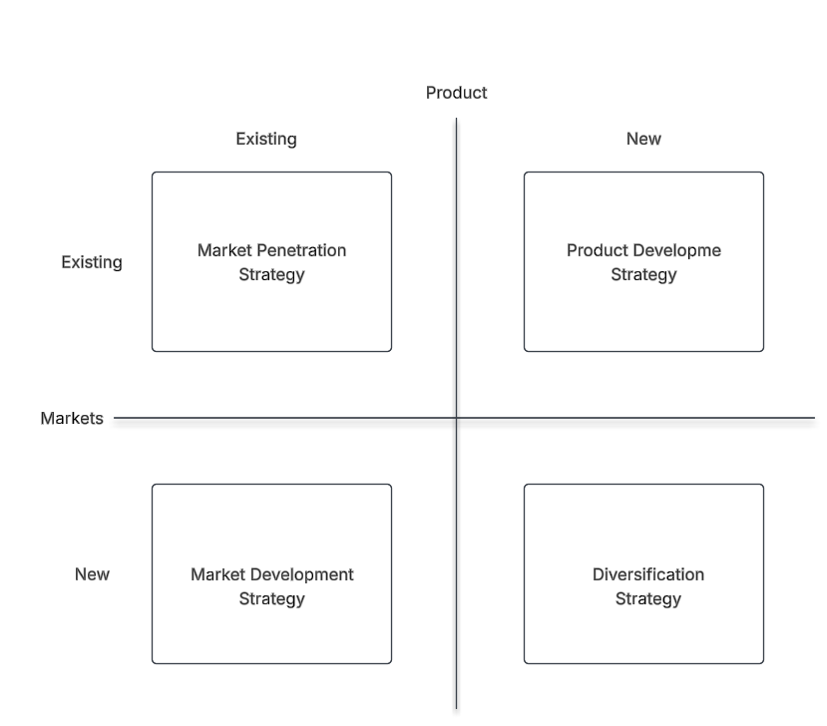
Figure 2 : ANSOFF MATRIX
Source : Created by the learner
Market penetration Strategy

Market penetration is a growth strategy in which a company seeks to increase its market share by selling its existing products to existing customers and markets. Rather than introducing new products or entering new geographical markets, the focus is on strengthening the company's position within its current markets. Tata Steel applies this strategy by enhancing customer relationships, improving operational efficiency, and increasing the value delivered to existing clients.(Tata steel UK. (2024a). Our strategy).

- Customer Retention through Long Term Partnerships

The market penetration strategy adopted by Tata Steel involves establishing long term relations with industrial consumers in areas such as the automotive industry, construction, engineering, and infrastructure in the UK and Europe. Instead of relying on short-term sales, the company gets long-term supply agreements, providing it with a constant stream of quality steel and making sure the customer always has the materials in stock. The approach ensures both the security of Tata Steel from unstable demand and competition from cheaper importers..(Tata steel UK. (2024a). Our strategy).

- Regional Expansion and Capacity Scaling

The Regional Expansion and Capacity Scaling strategy of Tata Steel is all about developing the company's strength in various regions in India through the creation of capacity for producing goods in various parts of the country. The main aim of Tata Steel through the use of this strategy is to ensure that the company is capable of increasing its capacity for the production of crude steel to 30 MnTPA (million tonnes per annum) by the year 2025. This will help the company to be able to fulfill the growing demands for steel among various industries such as construction, infrastructure, automobiles, and engineering industries. Through regional expansion and capacity scaling, Tata Steel will be able to expand its manufacturing capacity, create efficient distribution channels, deliver steel products in a better manner to the customers and satisfy their requirements.(Tata Steel (2019). Tata steel - strategy. Www.tatasteel.com.)

Market Development

Market development is an Ansoff Matrix growth strategy in which a company seeks to increase sales by introducing its existing products into new markets or targeting new customer segments. Market development for Tata Steel is centered around growing its production capabilities as well as increasing its presence in new regional markets within India. Tata Steel aims at developing itself in high value sectors such as automobiles, infrastructure, construction and engineering through offering superior steel products. Additionally, the firm seeks to enhance its logistics and manufacturing processes so as to facilitate quicker deliveries. In addition to business growth, Tata Steel is engaged in sustainable activities such as carbon reduction and efficient use of resources.(Tatasteel.com. (2023). Tata steel annual report 2023-2024).

- Capacity Expansion & Leadership

Expansion of Capacity & Leadership at Tata Steel: Tata Steel plans to expand its crude steel manufacturing capacity to 35–40 MTPA by 2030 through a mixture of organic capacity expansions in existing facilities and strategic acquisitions in India. The key priority of Tata Steel is expanding the capacity of Kalinganagar Plant in order to allow Tata Steel to manufacture more high-value-added steel for premium industries such as automotive, infrastructure, engineering and construction. With the help of capacity expansion, Tata Steel will be able to cope with the rising demand for steel and achieve greater leadership in the Indian market.((2025). Tata steel’s global expansion: Strong growth in India, UK operations under transition).
- Rural and Global Market Expansion

The market expansion policy of Tata Steel is aimed at extending the reach of its existing steel products into new markets domestically as well as internationally. Tata Steel creates awareness about the usage of steel in India in rural areas through various campaigns undertaken by Tata Steel Rural Development Society (TSRDS). On the other hand, Tata Steel has operations in more than 50 countries around the world, which enables the company to expand geographically and tap into newer markets. Thus, with its rural as well as global market expansion, Tata Steel not only increases its market share and customer base but also helps it grow as a business entity while selling its existing range of products.(Torres, V. (2026). MGT-Growth-Strategy-TATA-STEEL.docx.)

Advantages of Ansoff matrix
- The Ansoff Matrix offers an effective tool for analysing business opportunities for growth through four possible strategies: market penetration, market development, product development, and diversification.
- This model can be used by companies such as Tata Steel to determine the most appropriate approach to business growth according to their products and market.
- According to the matrix, market penetration is the strategy with the lowest risk whereas diversification is the most risky one.
- This model allows companies to look for the possibility to grow their business through different strategies.

Disadvantages of Ansoff matrix
- It takes into account only the products and markets, neglecting the other key aspects like competition, economy, and governmental restrictions.
- Selection of a particular strategy from the matrix cannot provide guaranteed business development due to possible changes in the market situation.
- Despite the fact that the matrix evaluates the level of risk relatively, it doesn’t explain ways of managing them.
- This matrix does not take into account the fact whether the company possesses enough money, technologies, or people who are qualified enough to realize the selected strategy.

  - Competitive Advantage Through a Lower-Carbon Business Model
The Generic Strategies of Michael Porter are fundamental business models that describe three main routes of achieving competitive advantage Cost Leadership, Differentiation, and Focus(University Of Cambridge (2020). Porter’s generic competitive strategies (ways of Competing).Tata Steel implements a combination of the Generic Strategy by Porter, mainly focusing on the Cost Leadership strategy with significant integration in the upstream activities and Differentiation Strategy by catering to certain industry segments.

- Cost Leadership
The Tata Steel UK business enterprise is enhancing its cost leadership approach through the use of a production process transformation through the introduction of an Electric Arc Furnace (EAF) in Port Talbot worth £1.25 billion. Through this transformation, the company is shifting from the use of blast furnaces to a downstream production process whereby substrates are imported into the production process, making the manufacturing process more efficient and reducing costs. In addition, the new production approach is predicted to lower carbon emissions by 90%, which will enable Tata Steel to adhere to environmental regulations in its operations. The new approach will make the organization less affected by high energy costs in its production processes.((2026). Transitioning through change with Long-Term commitment to the UK.)
- Differentiation
The firm uses a differentiation strategy through the provision of high-quality and customized steel products according to the unique needs of various sectors like automotive, construction, engineering, and packaging. Unlike other companies which compete based on pricing and production levels, Tata Steel is concerned about the provision of high quality and technical skills along with innovation in the production of steel products according to customer requirements. Moreover, the firm creates a long-lasting relationship with the customers through providing them with dependable supply, technical assistance, and services. Tata Steel provides more than 50% of the total amount of steel required by car makers in the UK market.(Tata steel UK. (2024a). Our strategy).
Conclusion
In conclusion as discussed how the marketing environment can be analyzed with respect to the natural and technological environments of Tata Steel by considering the PESTLE approach. This report highlighted the fact that the sustainability of the business, technology, and environmental regulations pose both opportunities and threats for the firm. Also, Ansoff Matrix has been considered in analyzing the growth strategy of Tata Steel by suggesting market penetration and market development as the appropriate approaches to enhance its market strength. Moreover, the competitive advantage of Tata Steel in terms of the Porter’s Generic Strategies has been analyzed and it revealed that the firm uses cost leadership and differentiation as a competitive advantage due to low-carbon steel manufacturing and customer-oriented approach.

- Task 3: Critical Relfection on AI Usage
3. 1 Tool Disclosure
In the process of creating this report, artificial intelligence software was used in order to perform research, to think of new ideas, to make the report more coherent and to enhance academic writing skills. AI helped to explain marketing topics including Ansoff Matrix and market segmentation. Moreover, it helped to structure data, to improve grammar and writing style. Nevertheless, AI was used solely as an auxiliary instrument in this case, whereas final decisions were made independently.
3.2 Critical Evaluation of AI output
The accuracy of the content created through the use of AI was checked before incorporating it into the report. The information that was generated by the use of AI technology was compared with academic sources such as annual reports of companies, peer-reviewed journal articles, lectures, and business websites. While reviewing the generated content, it was observed that some of the answers given by AI were generalized and contained statements that needed to be corrected. The incorrect and outdated information was taken out from the report and was replaced with accurate information.

3.3 Contribution analyasis
The role played by AI included helping to think about different ideas, the structuring of the report, enhancing the academic language used, and elaborating on marketing theories. Nonetheless, the choice of the company, analysis of marketing methods used, implementation of theories, analysis of results obtained, and recommendations made are mine. All the suggestions provided by AI have been analyzed critically and changed when need be. The information provided has been enhanced through further reading. Therefore, even though AI helped with writing the report, the analysis, judgements, and conclusions made are mine.

3.4 Ethical and Professional Refelection
Utilization of AI for market analysis is helpful in several ways such as efficiency, ideas, and academic writing. At the same time, there exist moral obligations that arise due to the use of AI. It produces biased, misleading, or false information that necessitates human verification of facts and figures. It is important for students to utilize AI ethically since there are guidelines to follow. First, one should declare the usage of AI tools. Academic integrity should also be maintained. For marketing practice, decision making needs to incorporate AI as an aid to human intelligence.

Reference list
- Hungama Digital Services (2023). Tata Steel | Climate Action. [online] Tatasteel.com. Available at: https://www.tatasteel.com/sustainability/social/climate-action/ [Accessed 28 June 2026].
- Loredana, M.E. (2017). The Use of Ansoff Matrix in the Field of Business. [online] p.144. Available at: https://www.utgjiu.ro/revista/ec/pdf/2017-02.Volumul_2_Special/21_EcobiciL.pdf [Accessed 4 July 2026].
- Monash University (2025). Macro-environment. [online] Monash Business School. Available at: https://www.monash.edu/business/marketing/marketing-dictionary/m/macro-environment [Accessed 26 June 2026].
- Rehman, S. (2024). CA 3 IB.docx. [online] Scribd. Available at: https://www.scribd.com/document/426058102/CA-3-IB-docx [Accessed 27 June 2026].
- Services, H.D. (n.d.). Tata Steel Vision, Mission, Values & Objectives. [online] www.tatasteel.com. Available at: https://www.tatasteel.com/corporate/our-organisation/vision-mission-values/ [Accessed 26 June 2026].
- Services, H.D. (n.d.). Tata Steel | Biodiversity. [online] www.tatasteel.com. Available at: https://www.tatasteel.com/sustainability/environment/biodiversity/ [Accessed 28 June 2026].
- Tata Steel (2019). Tata steel - strategy. [online] Www.tatasteel.com. Available at: https://www.tatasteel.com/investors/integrated-report-2018-19/strategy.html [Accessed 17 July 2026].
- Tata steel UK. (2024a). Our strategy. [online] Available at: https://www.tatasteeluk.com/about-us/our-strategy [Accessed 17 July 2026a].
- Tata Steel UK. (2026). Automotive - Digitalisation. [online] Available at: https://www.tatasteeluk.com/en-US/automotive/industry-themes/digitalisation [Accessed 28 June 2026].
- Tatasteel.com. (2023). Tata steel annual report 2023-2024. [online] Available at: https://www.tatasteel.com/investors/integrated-report-2023-24/strategic-objectives.html [Accessed 17 July 2026].
- Tatasteel.com. (2024b). Integrated Report and Annual Accounts 2024-25 118th year. [online] Available at: https://www.tatasteel.com/investors/integrated-report-2024-25/climate-change-report.html [Accessed 28 June 2026].
- Torres, V. (2026). MGT-Growth-Strategy-TATA-STEEL.docx. [online] Scribd. Available at: https://www.scribd.com/document/411223812/mgt-growth-strategy-tata-steel-docx [Accessed 17 July 2026].
- University Of Cambridge (2020). Porter’s generic competitive strategies (ways of Competing). [online] University of Cambridge. Available at: https://www.ifm.eng.cam.ac.uk/research/dstools/porters-generic-competitive-strategies/ [Accessed 17 July 2026].
- Www.tata.com. (n.d.). Nerves Of Steel | Tata group. [online] Available at: https://www.tata.com/newsroom/nerves-of-steel [Accessed 26 June 2026a].
- www.tata.com. (n.d.). Redefining the Future of Steelmaking | Tata Group. [online] Available at: https://www.tata.com/newsroom/business/tata-steel-plants-redefining-future-steelmaking [Accessed 28 June 2026b].
- Zoe, E. (2017). Essay on Tata Steel SWOT & PESTLE Analysis. [online] Medium. Available at: https://medium.com/@emma24zoe/essay-on-tata-steel-swot-pestle-analysis-eab72389794c [Accessed 28 June 2026].
- (2025). Tata steel’s global expansion: Strong growth in India, UK operations under transition. [online] Tata steel UK. Available at: https://www.tatasteeluk.com/corporate/news/tata-steels-global-expansion-strong-growth-in-india-uk-operations-under-transition [Accessed 17 July 2026].
- (2026). Transitioning through change with Long-Term commitment to the UK. [online] Tata steel UK. Available at: https://www.tatasteeluk.com/corporate/news/transitioning-through-change-with-long-term-commitment-to-the-uk [Accessed 17 July 2026].

