University of Wales Trinity Saint David
Wales Institute of Science and Art


Electronic Circuits Testing and Applications
Electrical Control Systems (ACHA4010)

Rhys Thomas
(2303931)

21/03/2024
Contents
1 Task 2 1
1.1 Scope Time Division Calculations (4) 1
1.2 Function Generator output sine wave (3) 1
1.3 Unsmoothed Rectifier Wave (3) 1
1.4 Smoothed Rectifier Wave with capacitor (3) 1
1.5 Drop in Voltage Question (4) 1
1.6 Different Voltage Readings Question (5) 1
1.7 Rectifiers use in Automotive applications Question. (4) 1
1.8 Probing Question (4) 1
2 Task 3 2
2.1 Scope Time Division Calculations (4) 2
2.2 Function Generator output square wave (3) 2
2.3 Capacitor charge and discharge wave marked at correct points. (3) 2
2.4 Basic Capacitor Calculations (3) 2
2.5 Capacitor discharge table (4) 2
2.6 Gradient Plot and calculations (4) 2
2.7 Capacitor Uses (5) 2
2.8 Inaccuracies Question (4) 2
3 References 3

Task 2

Scope Time Division Calculations (4)
The Frequency is 10Hz.
To turn this into a time period you must:
Time period = 1/10 = 0.1s
t/div = t/ndiv = 0.1/10 = 0.01s

Function Generator output sine wave (3)
Figure 1 - Function Generator Output Sine Wave
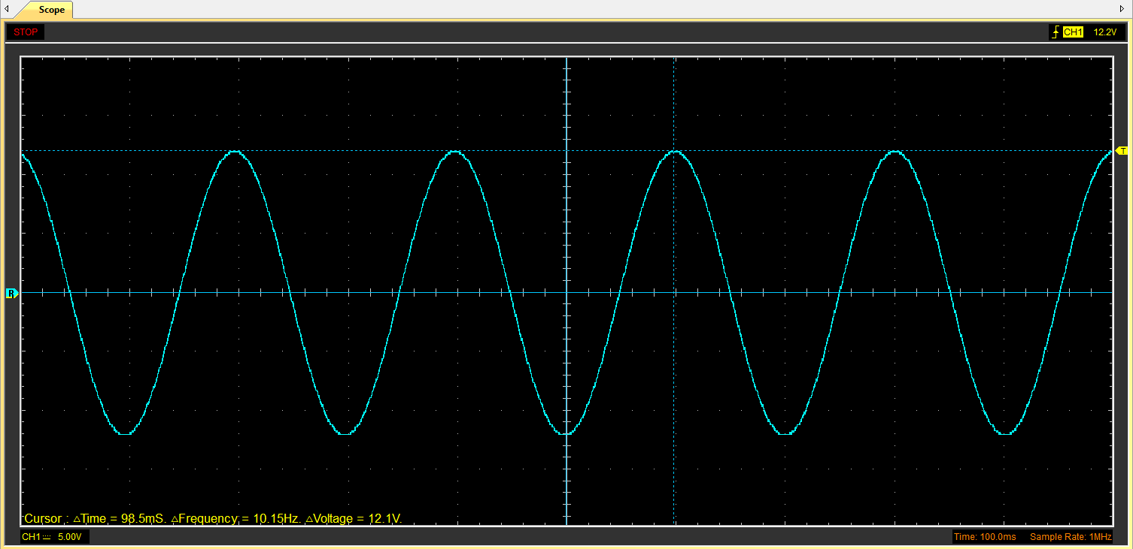

Unsmoothed Rectifier Wave (3)
Figure 2 - Unsmoothed Rectifier Wave
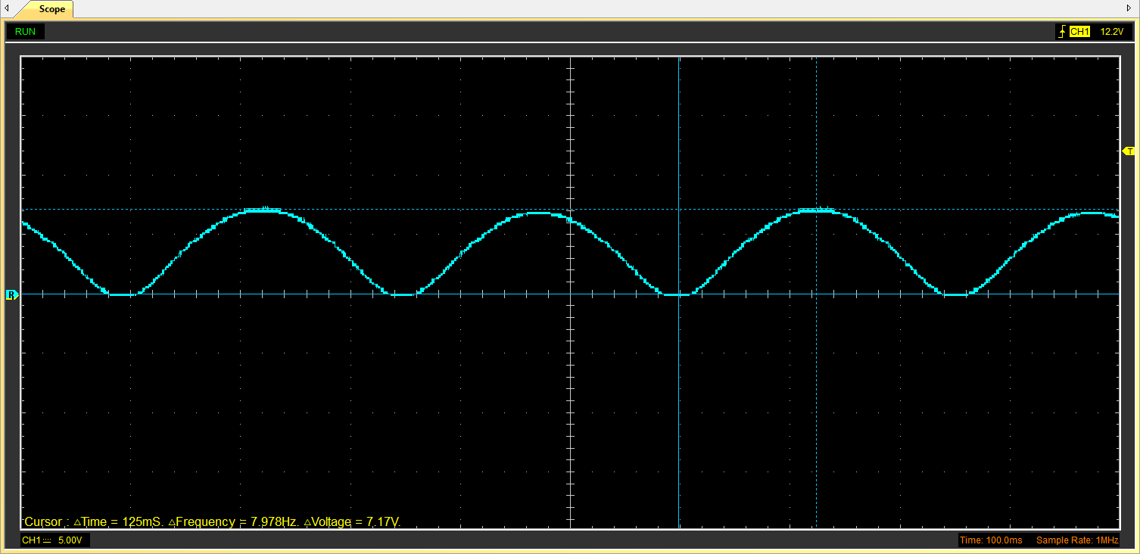

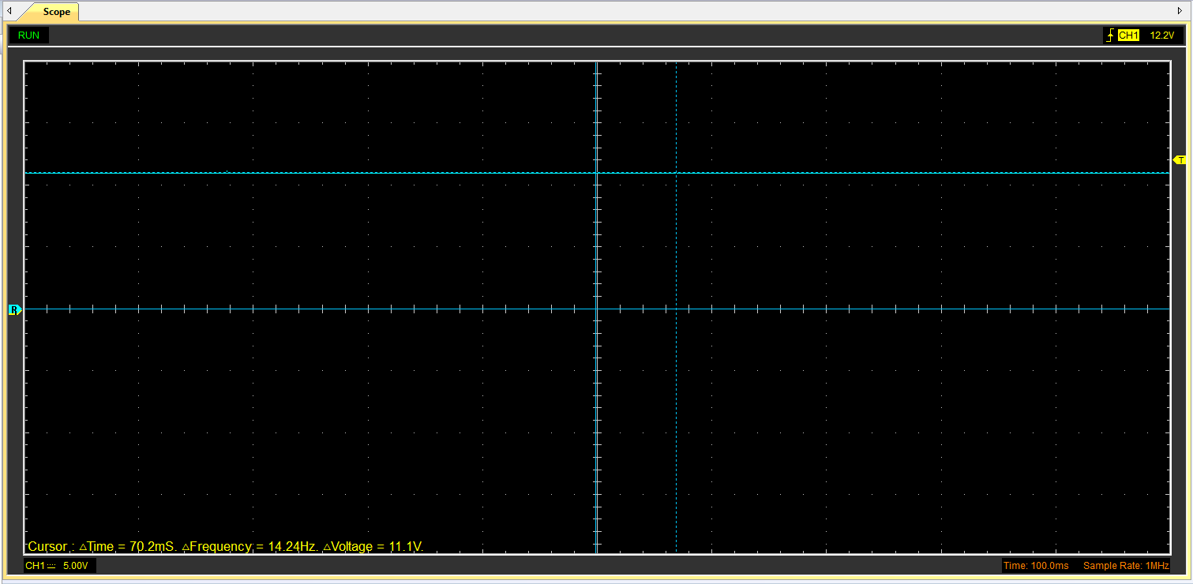
Smoothed Rectifier Wave with capacitor (3)
Figure 3 - Smoothed rectifier Wave with Capacitor

Drop in Voltage Question (4)
One of the main reasons for voltage to be lost during Alternating Current (AC) to Direct Current (DC) rectification is from a transformer’s efficiency, when using any electrical component there is a form of loss, the loss seen when using a transformer is heat loss, due to the work the transformer is doing it will create heat therefore dropping the voltage.

Different Voltage Readings Question (5)

Rectifiers use in Automotive applications Question. (4)
One of the main and most important uses of rectifiers in an automotive context is to convert the AC and DC. This is needed as all electrics in a modern car use a DC which isn’t produced by the alternator, the alternator produces an AC which has no use to the electrics in the car. However, this is where the rectifier is used, it takes the AC from the alternator and converts it to a DC. A more modern version of this is the use in an electric vehicle, the power going into the vehicle is AC and then as it goes into the vehicle a bridge rectifier is used to convert this to a DC. (Power Electronics, 2020)

Probing Question (4)
The scopes used for the data are basic and inexpensive scopes that do a simple job of just reading the data. Therefore, probing both the function generator and the rectifiers wont work as there aren’t enough channels for the data, using a more expensive scope for example a Pico oscilloscope is a better option for a wider range of channels. The software that comes with the scope can set data ranges for you in their functions bar and show you how to correctly setup the test to get the most accurate data possible.

Task 3

Scope Time Division Calculations (4)

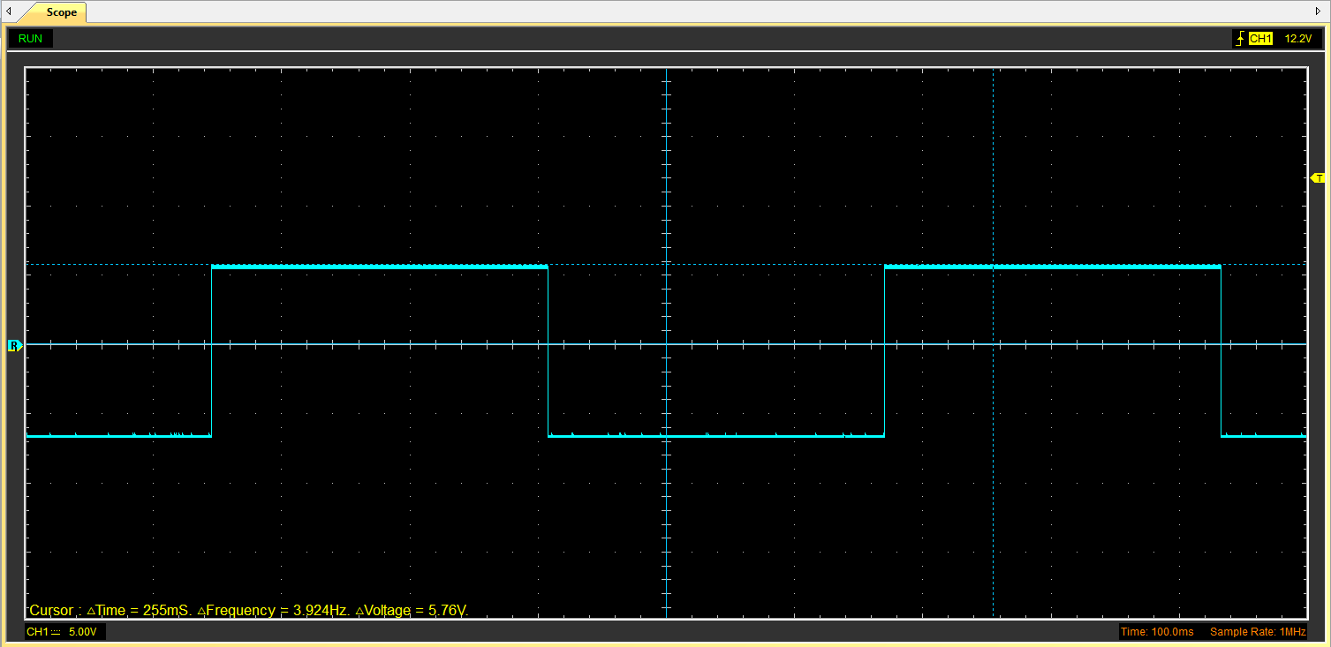
Function Generator output square wave (3)
Figure 4 - Function Generator Output Square Wave

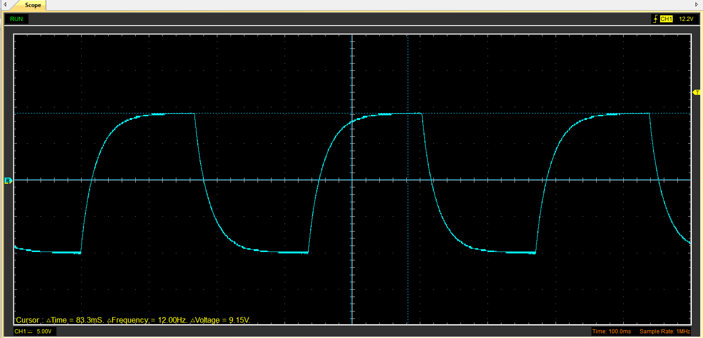
Capacitor charge and discharge wave marked at correct points. (3)
Figure 5 - Capacitor charge and discharge wave marked at correct points.

Basic Capacitor Calculations (3)
To be able to find capacitance use the formula T = R.C
To be able to find T the time constant for the 63.2% rise in the voltage. The marker on Figure 5 shows the Maximum voltage from zero.
(9.15 – 0) x 0.632 + 0 = 5.78V
Resistance was 10KΩ.
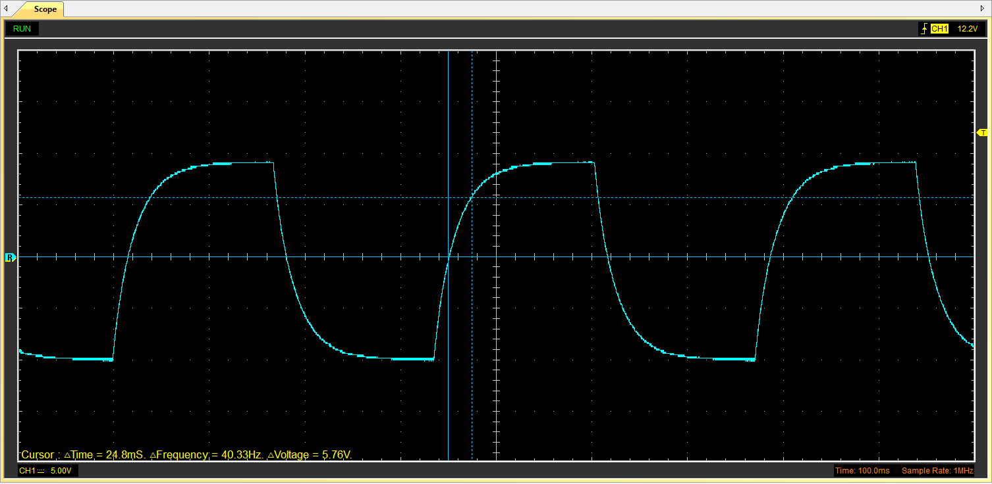
C = 24.8 x 10⁻⁶/10,000 = 24.8x10⁻¹⁰ Farads
Figure 6 - Capacitor charge and discharge wave Marked at a 63.2% Rise

Capacitor discharge table (4)

Figure 7 - Capacitor Discharge Table
Time | V | V+ | ln(V) | dy | dx | dy/dx
0.002078 | 1.0667 | 2.0667 | 0.725953 | x | x | x
0.002291 | 0.5961 | 1.5961 | 0.467563 | -0.25839 | 0.000213 | -1213.098592
0.002504 | 0.2353 | 1.2353 | 0.211314 | -0.256249 | 0.000213 | -1203.046948
0.002717 | -0.0471 | 0.9529 | -0.04825 | -0.259564 | 0.000213 | -1218.610329
0.00293 | -0.2353 | 0.7647 | -0.26827 | -0.22002 | 0.000213 | -1032.957746
0.003143 | -0.4392 | 0.5608 | -0.57839 | -0.31012 | 0.000213 | -1455.962441
0.003356 | -0.5961 | 0.4039 | -0.90659 | -0.3282 | 0.000213 | -1540.84507
0.003569 | -0.7216 | 0.2784 | -1.2787 | -0.37211 | 0.000213 | -1746.995305
0.003782 | -0.8 | 0.2 | -1.60944 | -0.33074 | 0.000213 | -1552.769953
0.003995 | -0.8784 | 0.1216 | -2.10702 | -0.49758 | 0.000213 | -2336.056338

Gradient Plot and calculations (4)
Figure 8 - Time Vs Log Gradient

The Gradient that is shown on Figure 8 is -1433.2
R² shows the difference between the trend line and the graph line, The closer the number is to 1 the closer they are to being the same.

Capacitor Uses (5)
Capacitors can be used for so many different applications and uses, for storing energy, filtering and signal processing are just a few. Here are a few different uses across different applications:
Energy storage: for example, in a computer power supply, capacitors store and then release energy to provide more power during an energy spike or if the power is interrupted.
Noise Filtering: They can filter out noise from power supplies ensuring the performance and reliability is met to the component’s standards. This is done by only letting the DC signal to pass through while the AC noise is grounded.
Signal coupling: Capacitors are used to connect two circuits so that only the AC signal passes from one circuit to the other, allowing the spread of audio signals or modulated RF signals without DC obstructing the signal.
Timing and Oscillation: In timing circuits, capacitors are used with resistors to create oscillators or timers. These are critical in applications like blinking LEDs and clocks.
Engine Start and Run: Capacitors provide a phase shift for starting single-phase induction motors and can improve engine efficiency and power factor when used in AC motor run applications.

Audio Systems: Capacitors are used to stabilize the power supply and storing energy to supply it quickly during high demand, ensuring consistent performance at high volumes.
Engine Control Units (ECUs): Capacitors in ECUs filter out noise and stabilize the power supply to the sensors and microcontrollers, ensuring accurate sensor readings and reliable operation of the vehicle's computer systems.
Ignition Systems: In automotive ignition systems, capacitors are used to suppress spark plug noise, improve the efficiency of the ignition system, and reduce radio frequency interference.
Regenerative Braking: In electric vehicles, capacitors can be used in regenerative braking systems to quickly store energy recovered during braking, which is then used to assist in accelerating the vehicle, enhancing efficiency.
LED Lighting: Capacitors are used in LED lighting systems to smooth out flickering caused by irregular power supply, ensuring steady illumination of LEDs for headlights, indicators, and brake lights.
(Chat GPT, 2024)

Inaccuracies Question (4)

References
Chat GPT, 2024. Chat GPT. [Online]
Available at: https://chat.openai.com/
[Accessed 21 03 2024].
Power Electronics, 2020. Appreciating onboard EV Charging Systems. [Online]
Available at: https://www.powerelectronicsnews.com/appreciating-onboard-ev-charging-systems/
[Accessed 21 03 2024].

