New Build Dwelling

Technical Report with Drawings

Contents
INTRODUCTION 3

CONSTRUCTION PROCESS 3

GROUND FLOOR CONSTRUCTION 3

1ST FLOOR CONSTRUCTION 4

EXTERNAL WALLS 5
EAVES DETAILING 6

ROOF STRUCTURE 7

VENTILATION 7

CONDENSATION 8

CONCLUSION 9

REFERENCES LIST 10

INTRODUCTION
Miss A Client has decided to build a 2-storey detached domestic dwelling the Swansea area. The project will need to be built on a level but reclaimed site, which prior to advanced groundworks. The dwelling is to be timber framed construction with the inner skin of the cavity wall to be 140mm insulated C16 timber frame, with the outer skin consisting of stack bonding facing brickwork and blockwork with a smooth render finish. There will also be insulated ground floor with underfloor heating within the screed and the upper floors will be traditional timber with tongue and groove softwood flooring. In the report the construction details for timber framed construction will be addressed and a neatly drawn sketch illustrating the materials and methods for detailing different construction methods will be produced, along with showing how the design will meet the current building regulations for a domestic new build.

CONSTRUCTION PROCESS
Timber frame construction uses prefabricated timber, which will be produced in a factory off site for the external and internal stud walls, the floor joists and roof trusses are there to form the super-structure which is a complete structural frame that transfers the vertical and horizontal loads to the foundations in this case for our project we will be using a raft foundation. The timber frame panels are rapidly erected on site and, with a roof structure formed from trussed rafter’s dependent on design. A weatherproof building can be created in just as little as a few days. This enables the work to continue in sheltered conditions within the building whilst the outer cladding and roof finishes are applied. This not only saves time but also allows decoration to be carried out soon after completion of the project without minimal risk of cracking and deterioration of finishes.

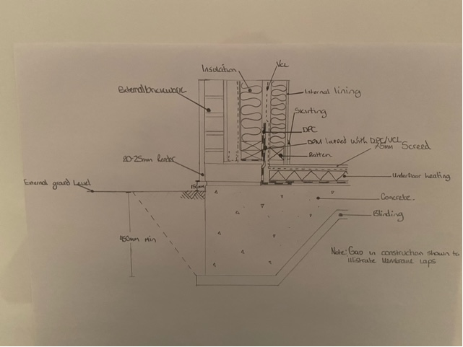
GROUND FLOOR CONSTRUCTION
Cavity

For this project a solid concrete floor will be used as it is easy to insulate and is moisture resistant. It also has a good loadbearing performance which is vital for this project as we will have a 2-storey dwelling sitting on top of it. As well as its positives it does have its negatives such as, it has a wet operation which could slow the construction process down and it can become expensive when dealing with deeper voids. There are no requirements for fire resistance for ground floors without a basement. BS EN ISO 13370:2007 Thermal performance of buildings will provide the correct thermal conductivity and U-Value that needs to be matched/bettered. For the project an underfloor heating system will be used within the screed shown in the diagram below. The building regulation for this section would-be document A.
  - (Trada, 2021)
  - 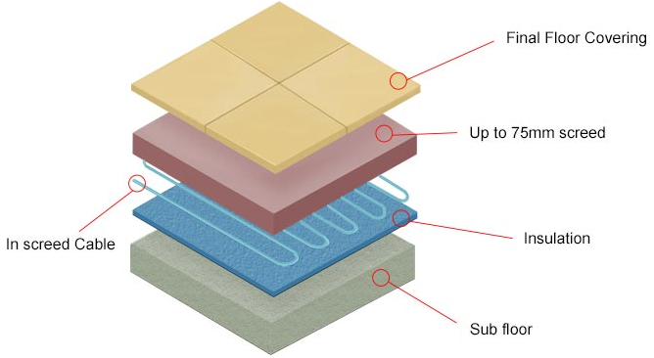
(LivingHeat,2020)

1ST FLOOR CONSTRUCTION
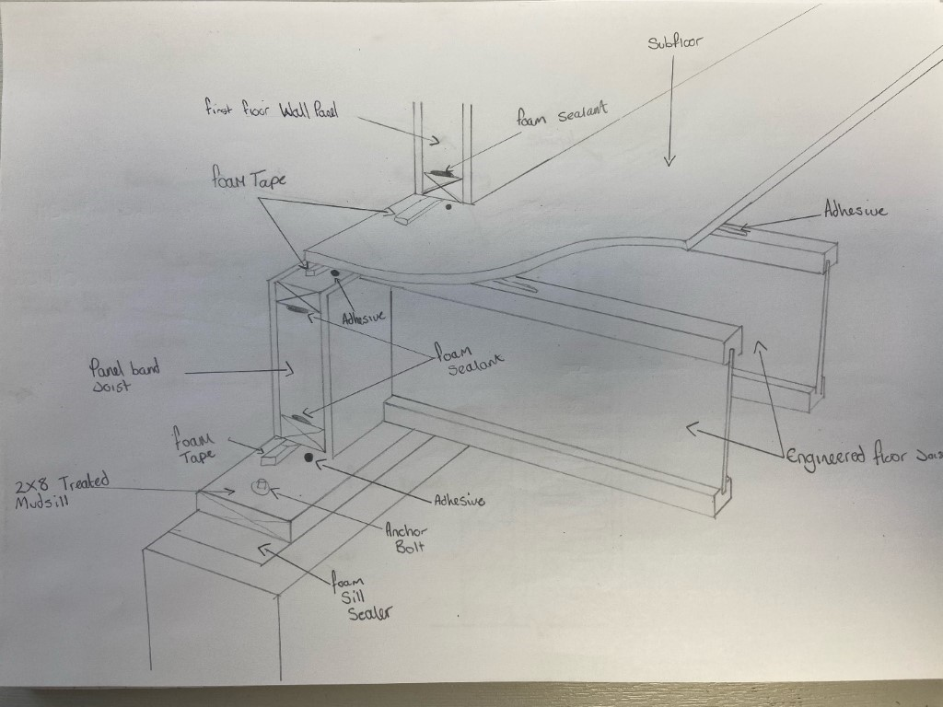
Tongue and groove softwood flooring

Floor Joists

Timber floor construction is one of the most cost effective and the easiest to construct. It can be adapted to site perfectly and the ground preparation is reduced massively compared to other alternatives. This type of construction is the solution for floor levels. This could also be used for ground floors. There is also the BS 8103-3:2009 structural design of low-rise buildings. Code of practice for timber floors and roofs for housing. A tongue and groove flooring will be used on this project. The fixing is very similar to a jigsaw puzzle as the planks can be installed and either left floating or glued down and it is very simple to Install.
(ClassNotes, 2021)

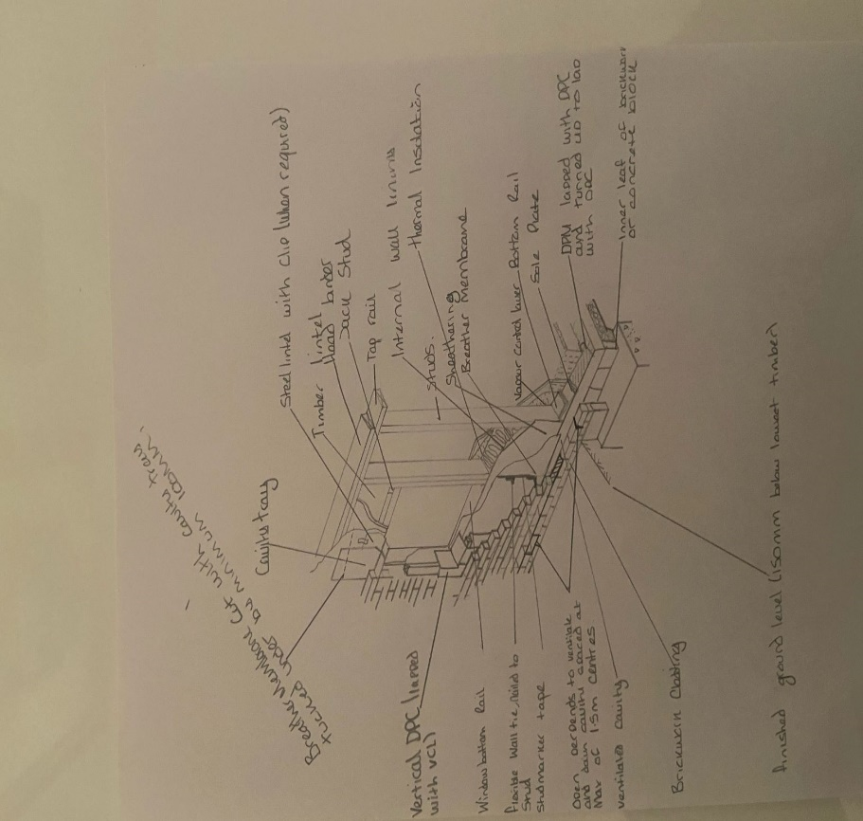
EXTERNAL WALLS

The external wall consists of two parts:
• the loadbearing timber frame wall.
• the outer cladding or brick and blockwork.
Timber frame external walls are required to carry the dead and imposed loads (including wind loads) acting on the structure and transmit them to the foundations. External walls are required to have thermal performance levels (insulation, thermal bridging, and airtightness) to meet the requirements of building regulations. The structural design of the building should be in accordance with BS 5268-6 Section 6.2.
(Trada, 2021)

EAVES DETAILING
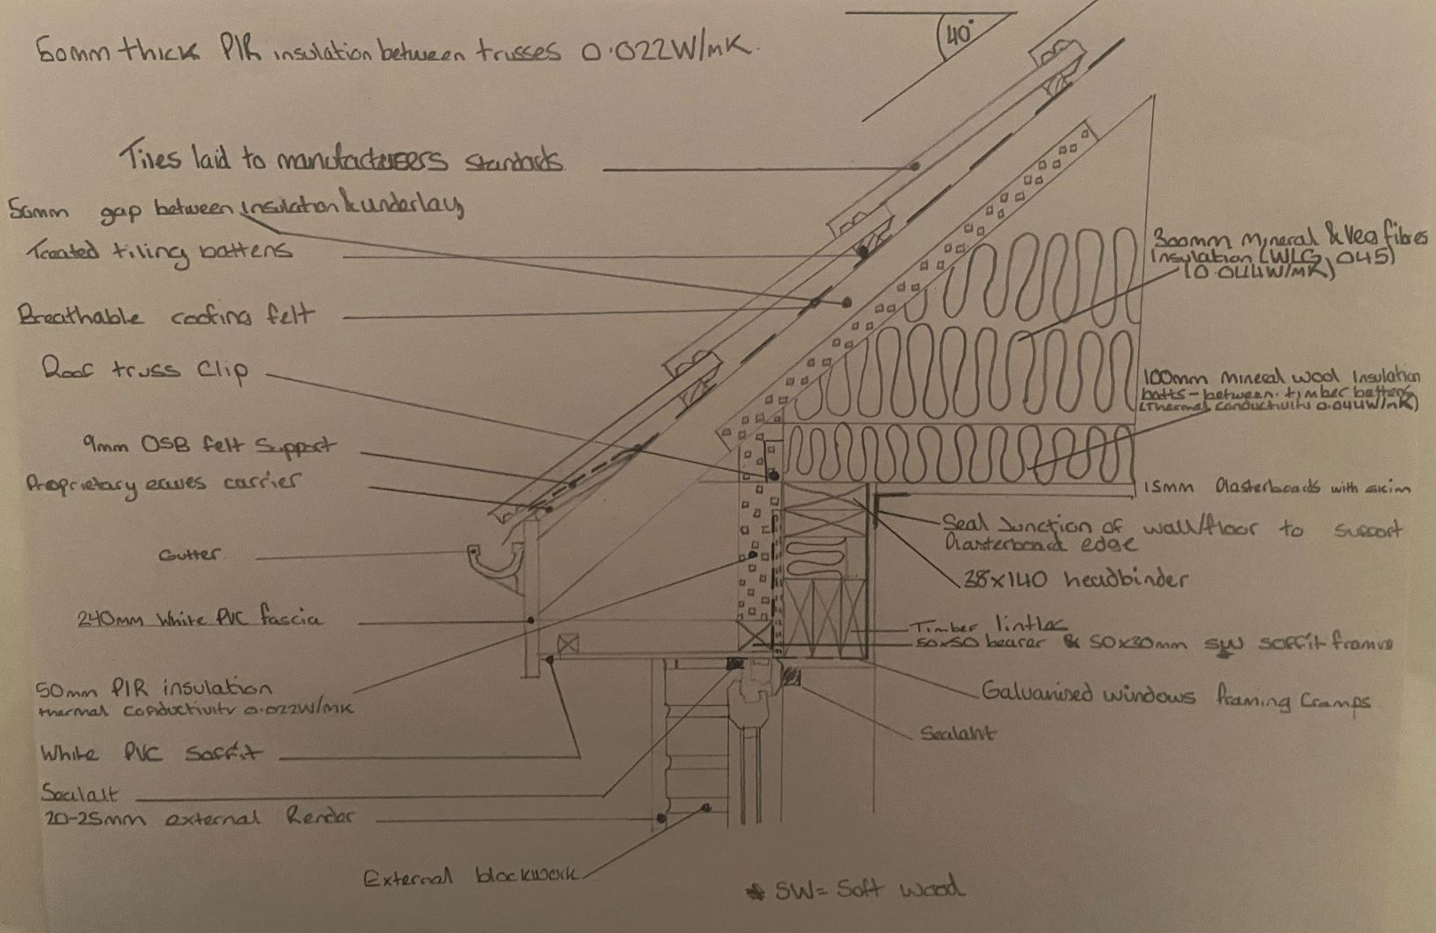
Metal Sheeting to be installed to manufacturers instructions

(A&N Lewis, 2020)
For the purpose of this project, I would suggest using a pitched gable roof structure as there are numerous advantages to the gable roof. Firstly, its simple design makes it easier to construct and a lot more cost effective than an alternative roof style, such as a hip roof. With a gable roof, the available space underneath the roof will also be much more spacious than the area beneath a hip roof which shown in the drawing above we could construct a queen’s post. Gable roof structures allow water and snow to run off easily, which make them great for areas with heavy rainfall in the UK. The steep pitch of gable roofs allows for excellent water drainage and fewer leaks which supports the previous point. The pitched gable roof also allows for more ventilation to allow hot air to escape to keep the roof and attic cooled. The gable roof also provides more space for an attic or vaulted ceilings allowing for the potential of an attic conversion in the future. The correct document for this would-be Document H.
(Angieslist,2021) (ClassNotes, 2021)

ROOF STRUCTURE
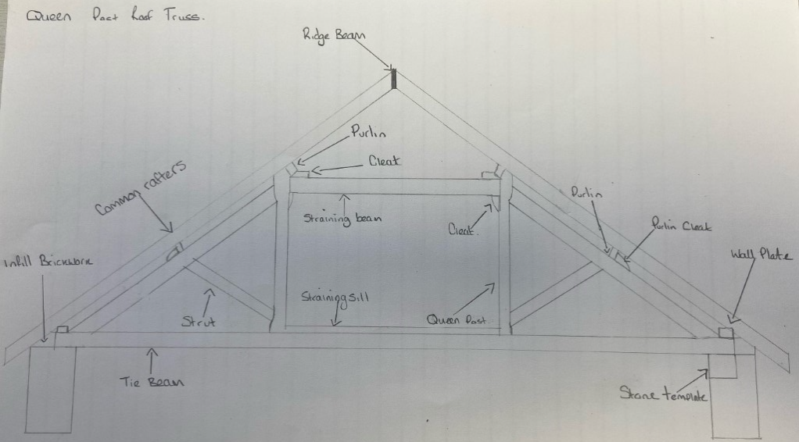
The reason the queens post was chosen is because it gives us many advantages such as using the roof space as a room with the possibility of a future conversion opportunity. Other benefits of queen trusses are their reliability, simplicity compared to other types, and usually, that their cost is relatively low. A queen post truss can look attractive in a building with exposed beams, and the dimensions can be adjusted quite significantly to fit a range of roofs and slopes. As well as there being advantages there are always disadvantages. These include If your roof will be below the minimum span for a queen post truss, a king post must be used instead. However, this is still an attractive look for exposed beams. Also, if you are planning a home with a more unusual roof shape for example a mansard roof, it would not be possible to use a queen post truss. There are many other suitable structures, though, so this should not cause any significant problems.
(Pecochui,2020)
Alternatively, the attic truss (see image below) can be used as the roof structure for this project. Much like the queen’s post, the attic truss allows for a habitable space in the attic to be used as an additional room maximising space within the build. The attic truss is a cost-effective roof structure similar to the queen’s post. However, the wooden frames can potentially become damaged and rot if not treated and maintained properly.
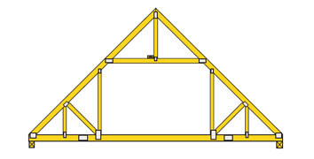

VENTILATION
Building regulations (F) state that a “ventilation gap of at least 50mm must be in place between the insulation and the underside of the roof structure. A vapour control layer must be installed.
The main reason that problems with condensation are on the increase is because of increased standards of insulation, double glazing, triple glazing and draught proofing making properties more airtight and resulting in moisture laden air staying within the property. There are limits set out in the Building Regulations. The limiting U-values are shown below and should never be exceeded:
- External walls: 0.30
- Roofs: 0.20
- Floors: 0.25
- Party walls: 0.20
- Windows: 2.0 (whole window value)
- You must also achieve a maximum air permeability of 10m3/h.m2 at 50Pa
Breather membranes are the most used on timber frame buildings this is to provide extra protection against weather conditions as well as moisture within the building. Timber frame breather membranes have been manufactured specifically for application onto timber frame buildings as they are lighter and thinner than a standard breather membrane, allowing for easy installation vertically as well as horizontally, meaning that they are suitable for both walls and roofs.”

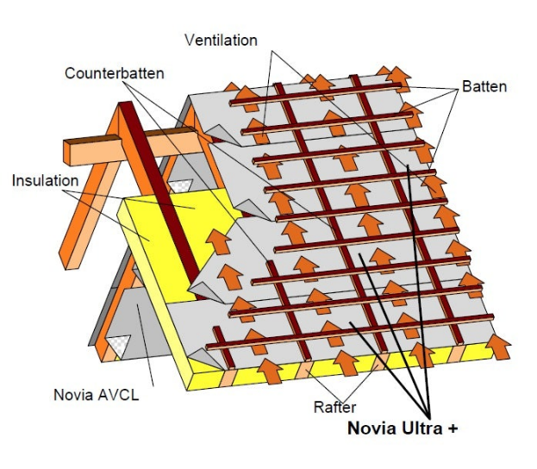
This Diagram shows us how the air will transfer through the roof structure.
(ClassNotes, 2021)

CONDENSATION
Condensation as the name suggests is water which has condensed from warm, moist air on contact with a cold surface. Air holds water in the form of water vapour/ moisture. Warm air can hold more moisture than cold air. Air which contains its maximum moisture content is said to be saturated. A warm shower in a cold bathroom is a perfect example.
Condensation is mainly a winter problem. The external air temperature is low and external walls and windows are cold. The usual sequence of events is as follows: 1. Cold air enters the building 2. The air is warmed for the comfort of the occupants. 3. The warm air takes up moisture. 4. The warm, moist air meets cold surfaces, walls, windows, etc. and is cooled below its Dew Point. 5. Condensation occurs as the excess moisture is released. Walls in kitchens and bathrooms (where atmospheric moisture levels are usually highest), solid external walls, un-insulated solid floors, and cold bridges such as concrete lintels set in cavity walls are commonly the areas in which condensation takes place. Intermittent heating and cooling of the property can aggravate condensation problems, since it allows warn damp air to cool, reducing its capacity to hold water. Dew points are reduced allowing condensation to occur. When the air is reheated water is taken back into the air only to be deposited again when the air temperature drops again.
Running water on windows and walls is perhaps the most immediate indication of a condensation problem. If ignored this can lead to a deterioration in the decorative condition of the property, stained curtains, and decay in window frames. The appearance of moulds on the surface of wallpapers and paints in poorly ventilated areas, e.g., behind large pieces of furniture, in cupboards and in the corners of rooms is not uncommon and in severe cases may occur on furnishing, books, papers and even clothing in wardrobes. Condensation can occur under suspended floors greatly increasing the chances of a fungal decay in floor timbers.
The best way to overcome condensation is to improved heating and ventilation paired with specific action in relation to cold spots will usually result in a significant improvement in conditions, although there may be situations in which alternative methods are required. A small but constant background heat if preferable to intermittent heating since this will help to maintain a higher ambient temperature within the building. The installation of a small extractor fan in a kitchen or bathroom will carry away moisture loaded air from the two areas most responsible for condensation with minimal running costs. This is now required by the Building Regulations in new construction. Extractor fans are now available which incorporate a humidistat which will control the operation of the fan within certain humidity limits. It is also possible to install fans that have an integrated heat exchanger. These have the advantage of providing effective ventilation while reducing heat loss from the property.
A much common form of condensation occurs when the dew point is reached, not only on the surface of a wall but within the structure of the building itself. This is known as interstitial condensation and can easily be mistaken for rising damp or penetrating damp.
All information – (PropertyCare,2015) (ClassNotes, 2021)


CONCLUSION
Throughout this technical report an outline of the building regulations that covers the basics of timber frame construction covering ground and first floor construction, eaves detailing and roof structure have been detailed to give the client a brief understanding of the work being carried out.

REFERENCES LIST
Images taken from
https://eldortrusses.com/pages/trusses/standard_truss_types/
https://www.greenbuildingadvisor.com/cad/detail/sip-foundation-first-floor-detail
https://commons.wikimedia.org/wiki/File:Queen-post-truss.png
https://www.landlordzone.co.uk/information/dampness-condensation-and-mould/
Building Regs – (Gov, 2010)
https://assets.publishing.service.gov.uk/government/uploads/system/uploads/attachment_data/file/468871/ADF_LOCKED.pdf
Condensation (Property Care, 2015)
https://www.property-care.org/wp-content/uploads/2015/05/Recognition-and-Causes-of-Condensation.pdf

