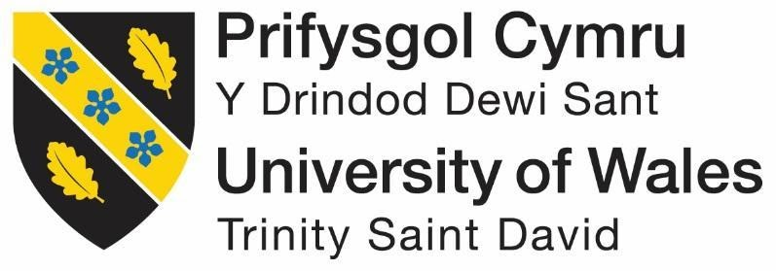

Data Security, Governance and Compliance

by
James Dunhill

Lecture: Dr Carlene Campbell

MSc Computer Networks and Cyber Security

January 2022

Contents
Contents 2
List of Acronyms 3
Table of Figures 3
Tables 3
Abstract 4
1 Introduction 4
2 Chapter 1 – Security Framework Research 6
2.1 Framework 1 - ISO/IEC 27001 6
2.1.1 Advantages & Disadvantages of ISO 27001 7
2.2 Framework 2 - ITIL 9
2.2.1 Advantages & Disadvantages of ITIL 10
2.3 Framework 3 - COBIT 10
2.3.1 Advantages of COBIT 5 11
2.3.2 Disadvantages of COBIT 5 11
2.4 Conclusion 12
3 Chapter 2 - Blue Mountain Peak Policy 13
3.1 Introduction 13
3.2 Policy Statement 13
3.3 Scope 13
3.4 Information Security Policy 13
3.4.1 Data Protection 14
3.4.2 Data Retention 14
3.4.3 Access Control 14
3.4.4 Risk Management 15
3.4.5 Backup 15
3.4.6 Malware and Antivirus 15
3.4.7 Logging and Monitoring 16
3.4.8 Network Security Management 16
3.4.9 Compliance Laws 17
4 Conclusion 18
5 References 20
6 Appendix 23

List of Acronyms
Acronyms | Items
GDPR | General Data Protection Regulation
ISMS | information security management system
ISO | International Organisation for Standardization
IEC | International Electrotechnical Commission
EU | European Union
ITIL | Information technology infrastructure library
CCTA | Central Computing and Telecoms Agency

Table of Figures
Figure 1 - ISO 27000 Standard Family 7
Figure 2 - ITIL flow chart 10
Figure 3 - COBIT framework is based on principles [25] 10
Figure 4 - COBIT 5 Flow Chart 11

Tables
Table 1 - Framework Feature Outline Comparison 8
Table 2 - Compliance Law 17

Abstract
Information security is a widely discussed and complex area within the computing sector its growth is increasing yearly as organisations and companies are putting more resources together to support technical levels that need to be addressed. This research is to gather information about different frameworks to compile that information to create a custom framework that would apply for Jamaican coffee mountain. Within the research collecting information on three different frameworks to critique analyse and compare them gives take deeper understanding about the benefits and drawbacks that the frameworks can offer when considering to design any framework. Throughout the research using diagrams tables and figures gives a clear understanding as well as a visual representation of the framework models. Furthermore breaking down individual frameworks into their core security features to analysing advantages and disadvantages.

Introduction
With the massively growing global usage of the Internet continues to grow, the demand for dependence on Internet-based data creates an increasing prospect of access required [2]. This leads to businesses being more reliant on the Internet, evermore creating a circle of increasing threat and attacks on information assets within company systems [1]. This then creates a need for a larger quantity of professionals that can protect those company assets & liabilities.
IT professionals are expected to have the ability skills and experience to set up and work in environments that require the ability to protect and secure a wide range of devices such as tablets, computers and phones. For IT professionals, working in different organisations or even different sectors can require a variety of different skills to deal with certain tasks or the environment that is set within the organisation/company. For example, the NHS works with a lot of critical patient data such as, name, date of birth, address, contact details. Also dealing with NHS numbers which is what is used to link up records containing health conditions and illnesses, medicines and other treatments that the general practitioner will use too prescribed medication too furthermore a list of services and contacts that the patients have had contact with through the NHS [4,5,6].
In comparison to a local bakery, they will not require to have as much data stored on their customers as the NHS does and this comes down to simply, they do not require it for law and use of data. The NHS has a reason for collecting this data on its customers and this is because it is viable information for them to operate their services, they need to have your history for medical records to be able to provide a service towards the customers, without this data they are unable to operate. For comparison the local bakery does not need any of this information so they can operate their business without needing to collect this data [2].
In 2018 a new law was brought in by the European Commission called the (GDPR) also known as the general data protection regulation, this law was brought in to stop companies from taking data and selling it on without giving consent to its users this law is part of many company's policies and procedures from 2018 when it was brought in from May [7].
- Lawfulness fairness & transparency [7]
- purpose limitation [7]
- data minimisation [7]
- Accuracy [7]
- storage limitation [7]
- integrity and confidentiality [7]
- Accountability [7]
This assignment is going to go through different types of frameworks and models that are currently used by company's organisations and governments around the world it will be critiquing and analysing them and then coming with the conclusion detailing a short summary of all the frameworks and models he used for this assignment. The second part of this assignment is based on a case scenario that will require creating a design that is a created based on the research conducted in the first half of this assignment.

Chapter 1 – Security Framework Research

This chapter will talk about different frameworks and discus the importance of why it is good practice to constantly have new or updated regulations and standards. The section will open with a brief introduction about the frameworks, then delving deeper in researching information to critique, analyse and then compare again the other frameworks. From the findings in chapter one or then be used to inform decisions when creating the security framework in chapter 2.

Framework 1 - ISO/IEC 27001
ISO/IEC 27000 is a family of international standard that set out how to handle information security [8]. This is accomplished by setting out detailed requirement for establishing, executing, sustaining and continually developing (ISMS) known as information security management system, this will then enable organisations the capability to make the knowledge assets they carry more secure [9]. The standard was initially published in 2005 by the (ISO) known as International Organisation for Standardization and (IEC) known as International Electrotechnical Commission, then in 2013 it was revitalised with modem standards. In 2017 the (EU) known as European Union made it where all organisations that were able to meet the new requirements would be able to get certified by an accredited certification body, only if they were able to pass an audit [10, 11].
Inside the organisation for them to be able to be ISO certified they have to be able to protect all forms of data, this can include information such as digital documents such as word, excel & PDF. Hard copies such as paper, books & files and information systems. this standard allows for any kind of organisation of any size be able to keep information assets secure by following a ten-clause structure that has 114 generic security controls grouped into 14 section called the Annex A [12]. What are the main and most common reasons why an organisation would choose to use I suppose certification and implement it is from a public perspective of trust and standard recommendations to show their clients and customers their ability to handle information securely and confidently.
Moreover, figure 1 shows the family of different types of standards and policies that can be obtained within the side of the ISO 27000, some of the different areas benefit more as requirement towards a standard where other areas provide more guideline standards, these do vary depending on the type of circumstances that they are being applied in as some of them are also sector specific guidelines standards so they would only apply to certain types of industries other than companies or organisations.

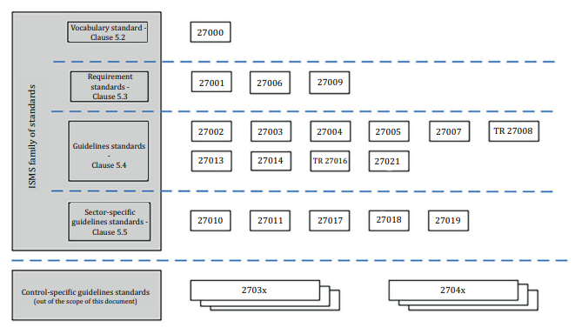
Advantages & Disadvantages of ISO 27001
Figure 1 - ISO 27000 Standard Family
There are lots of advantages and disadvantages that come with frameworks that are implemented across entire organisations. Some of the advantages that the certification offers can really benefit companies in the ability to work and cooperate with different customers, clients or partners [13]. A massive benefit would be enhanced competitive edge, this would give them a cutting edge on up-to-date standards and being able to have a global recognition of product quality. Another area would be improvements of the company, the more up to date with current standards gives the company a better standing against modern day threats and security vulnerabilities that may be targeted towards employees or certain members of departments. The other two benefits that can be gained from having this is reduction on losses due to security incidences, this will allow for less data to be lost if systems are correctly updated as it will be able to prevent certain entities from affecting such as hackers trying to steal data, another area would be is if a phishing / whaling email was able to trick a high profiling staff member, then would be able to gain access to certain information [14, 15].
The disadvantage found within the framework can lead extra cost that it presents towards the company, there's a lot of cost in setting this up and also getting everything to standard if systems are not up to standard this may require upgrading certain types of hardware such TPM V2 on motherboards and for Intel Xeon CPUs AES New Instructions, Trusted Execution Technology & Execute Disable Bit. Furthermore, upgrading software may be a necessary requirement as it may be UN secure and outdated requiring to be up to a latest standard for security. Another area would also be resources would have to be dedicated to giving ongoing training and awareness to potential staff and users [13, 15].
The table has been created below to show the outline of different control lists from the compared frameworks being researched and how they compare to each other. IOS 27001 sets a list of controls that our divided into 14 categories with a total of 114 individual controls. This is vastly different in comparison to the framework of ITIL and COBIT, these are based on five principles or actions that are the effective way to manage the policy under these are contains. Multiple principles that enable the organisations to build on the framework.
Table 1 - Framework Feature Outline Comparison
Framework Feature Outline
IOS 27001 | ITIL | COBIT 5
Information security policies | Service Strategy | Meeting stakeholder needs
Organisation of information security | Service Design | Covering the enterprise end to end
Human resource security | Service Transition | Applying a single integrated framework
Asset management | Service Operation | Enabling a holistic approach
Access control | Continual Service Improvement | Separating governance from management
Cryptography
Physical and environmental security
Operations security
Communications security
System acquisition, development & maintenance
Supplier relationships
Information security incident management
Information security aspects of business continuity management
Compliance

Framework 2 - ITIL
Information Technology Infrastructure Library which stands for (ITIL) is framework that was created by the Central Computing and Telecoms Agency (CCTA) in the UK around the early 80s. The original creation of this framework was to be used as a service management framework, the goal was to improve service management and as well as optimise value for customers and organisations. ITIL process is to set out a detailed practise for IT service management (ITSM), this allows for it to focus on positioning IT services within the needs of the company [17]. From this ITIL operates and uses the process of five sage life cycle to operate its service, The stages that follow our service strategy, service design, service transition, service operation, and continual service improvement. Furthermore a certification can only be awarded to individuals are not a company this is the same as COBIT and how they award certifications, when looking into ISO it is seem to be done differently as a company can be awarded a certification but also individuals can be certified as well making them assessors or implementor [18, 19].
The ITIL framework has been around for over 40 years and since then it has developed on itself multiple times coming out with the latest version being revision 4, over these years the framework has developed towards more of a community feedback allowing for change in the way the framework operates towards more of a competitive industry. Over these years there are still plenty of advantages and disadvantages that can come across this framework some of the most predominantly beneficial advantages are that it's very robust and detailed enable to help manage many different disciplinary's using one comprehensive volume it is well recognised and has being tested in real world environments over decades. the negatives that do follow with this framework is that it doesn't follow a holistic approach to I team management it is comprehensive but it is not considered to be as much of holistic approach to it in management as in comparison to other frameworks out. Another area that is not as widely criticised but does have some criticism around it is the fact that some topics are covered extensively and have high amounts of value and content while others have not received enough emphasis with quality being uneven and smaller in comparison to other frameworks [17 - 19].
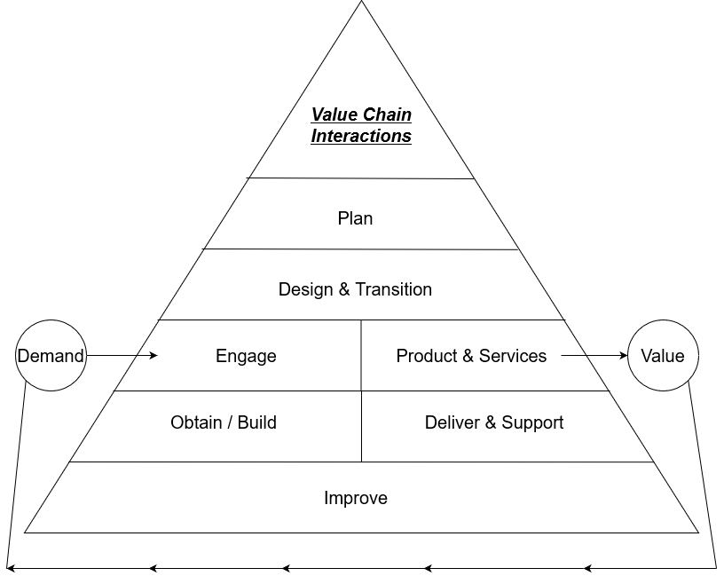
Figure 2 - ITIL flow chart

Advantages & Disadvantages of ITIL
The first thing that is easily displayed when comparing or examining the frameworks is ITIL very much similar to other frameworks that are being researched ISO & COBIT. A main comparable difference though for ITIL. A main compatible difference that ITIL uses in comparison would be that it follows more of a road map of exactly what should be done to accompanies it employees in a daily process this in comparison to COBIT which follows the practise for top management to understand how they should approach their enterprise systems [21, 23].
From an objectives point of view ITIL offers its main aims to manage IT services on entire and give IT division work in individual, this also present an opportunity for reliable process of fulfilment. This is vastly different in comparison when you start delving deeper into the objectives of COBIT, this frameworks main aim is targeting towards control of enterprise IT and setting it in a right direction for it business, it would work in a direction that provides management towards creating financial profit this would be managing resources, risks and IT efficiency [22, 23, 24].

Framework 3 - COBIT
Controlled Objectives for Information Related Technologies stands for (COBIT) and this framework has been around for over two decades starting back in 1996, with COBIT 5 being the most current version coming out in 2019 [24, 25]. As seen in figure 3 this framework is used to help organisations meets business tasks in fields of regulation compliance, risk management and also being able to currently have IT approach with organisation goals. This framework can be more considered as an umbrella, compared to the other two frameworks being discussed. The reason for this is it is more talk to towards managers auditors and users. By using a set of measures indicators this allows for the most optimal way to using IT systems [26 - 28].
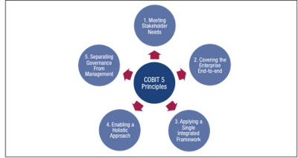
Figure 3 - COBIT framework is based on principles [25]
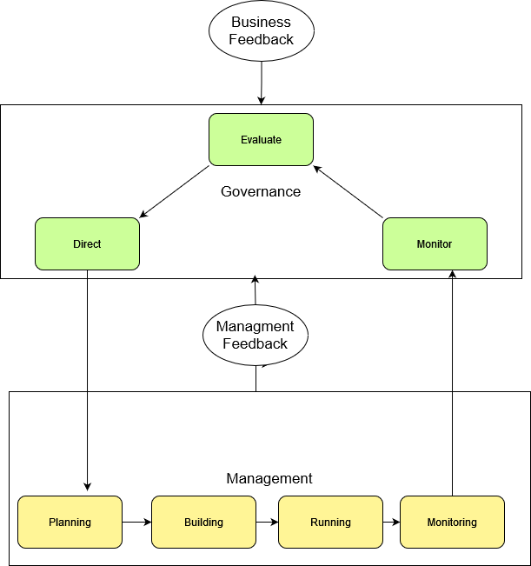
Figure 4 - COBIT 5 Flow Chart

Advantages of COBIT 5
Industry Standards - Every one of the processes and procedures of this system are utilised to guarantee that organisations listen to existing industry guidelines, this advantages the partners engaged with the association representatives improve comprehension of all benchmarks in their industry they then, at that point, can utilize those to further develop their conveyance prompting more proficiency working climate [29, 30].
Auditing – auditing is very crucial to companies making sure they follow regulations that are in place the main reasons that companies follow this is to avoid getting a court order against them to pay a fine for breaking the law. as part of this framework COBIT makes it compulsory that they follow laws and regulations to remain compliant as this improves the information security and insurance that the company is compliant [29, 30].
Planned Arrangement – This is one of the biggest benefits that COBIT offers within its framework allowing for the organisation to create a strategic business goal that the company will overall follow learning how to manage its IT department and process more efficiently [29, 30, 31].

Disadvantages of COBIT 5
Cost - one of the downsides that comes up with most frameworks is the cost to implement it throughout the organisation, the reasons for why it's so costly is the amount of knowledge and skill in order to implement it as a tool to provide support as well as implement information technology governance. this leads to companies taking COBIT 5 policies and twisting them to their own corporate design using them as guidelines more than getting certified [35].
Proof - It would seem that this disadvantage is also heavily opinion based looking up different types of research or web articles, so this individual disadvantage is very much a discussion not anything that can really be backed up by research. this point is that there is no evidence or assurance that experienced analytics would be able to get a required solution regarding the maturity of the organisations information technology [35].

Conclusion
In conclusion to the research found it would show that using these frameworks can offer plenty of potential towards companies and organisations looking towards implementing them for security or recognition towards their customers. The company's primary objective is to find the most fitting and best framework that operates within their companies structure. This will mean some frameworks will be UN compatible with certain types of companies or organisations in different industries ISO 27001 is able to work across multiple industries very easily by being broad and easily adoptable. Other frameworks such as COBIT is able to be implemented more towards The banking and insurance industries but it's less consultancy based operations it'll is more consultancy dealing with service systems integrators for clients or it backbone services.
By having COBIT implemented on a system allows for it'll to be more easily adopted smoothly into a infrastructure giving a benefit of having both at the same time giving better performance and also giving an overall more efficient and cleaner service. Furthermore having multiple frameworks implemented in an organisation is good practise by having up to date standards and up to date regulations at the same time alone for one framework to become outdated while another one is more updated giving coverage over an organisation.

Chapter 2 - Blue Mountain Peak Policy

Introduction
In this segment of the report the creation of a policy based around the requirements for this coffee distributor from Jamaica. There are lots of issues and present problems that are facing the company with the current state the company. Blue Mountain peak has a large international recognition as well as its growing audience around the world with this it is lacking any modern and UpToDate frameworks and policies with its current status in the global market. For this, the company needs to move forward with an update an approach for a new policy that will allow for the company to progress forward and support IT infrastructure.
The policy will be going over cloud based services with its growing usage and delivery of IT services in the cloud wireless networks based as large amounts of its network is coordinated through wireless access points creating and promoting awareness and protection for phishing and spam emails due to large amounts of their companies online presence with social media. Creating a policy that allows for employees to bring their own devices to work but also allow them to access work resources from home giving flexibility to devices being used. furthermore implementing security for staff and clients that operate within the companies network give him protection to all company intellectual property.
This document takes inspiration and points from three frameworks being previously researched further back in this report being ISO 27001 COBIT 5 & ITIL 4 .
For this company to operate within UK territory they must follow UK laws in trading standards but also must operate with in data regulations in how data is stored and processed within the companies network.

Policy Statement
This policy is to enable and provide employees of the company bracket Blue Mountain peak bracket the opportunities to work safely in an environment that ensures information security is optimum Lee in the benefit for the employees.

Scope
The scope of this policy provides an overview of information security management system it will also provide information on the terms and definitions commonly refer to within the standard set out this document is created purposely and pacifically for Blue Mountain peak.

Information Security Policy
Information security will set out rules and procedures that the company employees, members, guests and 3rd party will follow, this is a name to protect manage assets an resource is with inside the information technology. All information will apply to users inside of its networks as well as all information stored under its authority.

Data Protection
A data protection policy is a statement that allows the organisation to protect its personal data by setting out how it will achieve its principles rules and guidance. overall give ongoing compliance and show employees and members of staff how to remain within the data protection laws these will be followed by following GDPR.
- Lawfulness, fairness and transparency.
- Purpose limitation.
- Data minimisation.
- Accuracy.
- Storage limitation.
- Integrity and confidentiality (security)
- Accountability.

Data Retention
Data retention is about keeping information stored for the correct amount of time that is necessarily needed for the company once the expiration is sat on the data is no longer needed this can be deleted, or depending on the type of data it can be moved as historical data to storage.
Data Deletion
- Preserve each daily backup for 7 days then after can be deleted.
- Preserve each weekly backup for 4 weeks then after can be deleted.
- Preserve each monthly backup for 12 months then after can be deleted.
- Preserve each annual backup for 7 years then after can be deleted.

Access Control
Access control is a security measure that the correct and accurate control for the individuals accessing company systems.
Principles of Least Privilege Access
- Access is allocated on giving the least amount of privileges to users this must be provided with minimum access rights and permission to gaining system services information and resources this will be able to fulfil their role in the company.
Password Manager
- Passwords must not be shared with any other person under any circumstances, all passwords must be kept to the individuals to their account.
- all default system passwords must be changed immediately after system reset or new user accounts created.
- Minimum password standards must be 11 characters long including special characters numbers and upper case.

Risk Management
The purpose of risk management is able to give guidance and 2 the management of supporting the company objectives, this is to reduce risk & protect staff members and customers as well as business assets to ensure financial stability.
The Four R’s
- Risk acceptance - Accepting the risk with no action taken to mitigate any damage.
- Risk transference - Moving the risk to another external party who will take control of the risk on behalf of the company.
- Risk avoidance – The elimination by not taking any action that would mean the risk could occur.
- Risk reduction - Reducing the risk by planning and preventing or at least minimising the impact of the risk.

Backup
Setting up a backup procedure allows for individuals to understand and clarifies the responsibility of the individuals and its staff to maintain secure data backups, as well as schedule performing backups and ensuring more process are keeping contingency plans in place for storing data.
3-2-1 Rule
- All employees must maintain and keep consistent updates with their backups in three separate locations consistently. Two of these backups must be kept in different storage locations and the last one must be kept off site. E.g. PC files, USB, Cloud.

Malware and Antivirus
The goal for this section is to provide the requirements for preventing and how to address computer viruses worms spyware malware and other types of malicious software that can infect users devices on impact the company network or assets.
Computing Assets / All devices
- All assets including workstations and servers that are either connected to the network or standalone must use an improved company antivirus software to protect against threats.
  - Or bypassing virus protection is not allowed
  - automatic updates must not be altered and kept frequently updated
  - all mail must be scanned before entering into mailboxes checking for any attachments /if an attachment is found the email will be flagged and hidden from client.
  - any threat found must be quarantined cleaned and deleted buy the antivirus software following this a report of an incident must be logged and reported and sent to the coordinated person (administrator).
  - General maintenance must be given regularly.
- Management approved software installation
  - all software installed on users laptops and devices must be improved by management this is to prevent untrusted software being installed.
- Audit control and management
  - All virus and malware logs must be kept logged.
  - This also includes virus scans and history logs

Logging and Monitoring
the computer logs are essential for any management to sort through audits and also to find records and evidence of events that have taken place with inside of network. these provide primary evidence or ability for forensics investigation for reviewing audit and compliance, with the additional ability of tracking changes and troubleshooting issues.

Network Security Management
What are the important areas for this policy contains defence and security for network management the intentions of this section is too make honest mistakes or not following instructions less impactful on the company without compromising information. putting in place defences to help mitigate damage and affectively allow for procedures to be taken in case of a incident.
The following list is given common and appropriate areas too prioritise inside of this policy, given the list of categories or contain information under each one of how to follow and set out individual procedures set within the company.
- Vulnerability Scanning
- Penetration Testing
- Social Engineering
- Email Spam Filters
- Network Firewalls
- Security GAP Assessments
- Security Operations Centre
- Managed Security Services
- Intrusion Detection & Prevention Systems
- SIEM Solutions

Compliance Laws

Table 2 - Compliance Law
UK Data Protection Act (GDPR) 2018 | This Law is to protect data, it controls how your individual data is applied by businesses, corporations or the government [36].
Privacy and Electronic Communications Regulations | The Privacy and Electronic Communications Regulations (PECR) rest along with the Data Protection Act and the UK GDPR. They provide public particular privacy rights in relative to electronic communications [37].
Malicious Communications Act 1988 | The purpose of the Malicious Communications Act was to inhibit the posting of written matter, but the scale of the act has been continued to cover electronic communications [38].

Conclusion
To summarise what has been researched throughout this report is researching three different frameworks that are based around information governance and critiquing analysing and comparing them against each other to find out which framework has a more popular appeal to it and why it would have more and a popular appeal the answer that was found was surprisingly different but was very much a outcome that would be very useful and is currently being used as a way of increasing companies presents and security.
For the second half of this report it was about creating a policy for the company given out in the assignment brief the policy had said have included items such from the research of part one but also needed to contain information about current issues they currently dealing with that was introduced in the opening section of chapter 2. the overall outcome of this part of the research showed that it is critically important to have everything in a policy laid out correctly and contains every piece of information required for fault tolerance.
The research was oriented around looking at three different frameworks these frameworks were ISO 27001, ITIL & COBIT. Researching them involved condensing information down to critiquing analysing and discussing individual points about the frameworks to give an overall view of them and how they can generally feedback into the framework to be created for the second part of the assignment.
From the research a main conclusion has been found that the ISO 27001 is to be a very well-adjusted framework it is extremely detailed on is able to be implemented across nearly all types of industries and companies allowing it to be versatile and easily adopted with the cost of setting it up. In comparison to this it'll and cobit were found to be very much similar but complemented each other very much by having them running in parallel. having them running parallel allowed for them to cover areas that one framework may not cover as strongly giving strengths and benefits towards the company using both frameworks.
The second part of this assignment brought in the creation of a framework built custom for a company under specifications taking the research found from section one it was easy enough to implement different parts of the frameworks to create a hybrid framework. incorporating different areas such as data protection access controls backup and malware and antivirus policies allows for the company to operate more securely online and in person internationally as well giving a strong representation as well as also having detailed and dedicated guidelines in place to follow in certain circumstances. Furthermore also having constituency plans in place in case of an event and also how staff should operate on a day to day basis running the systems.
Going into further research for writing the policy would have been better in comparison to ISO which was used to create the framework NSIT would have been a more appropriate choice as NSIT is a framework based around starting and small organisations creating their first security policies compared to ISO which is more of a guidance structure that should be followed this would be future reading and development if took forward.

References
[1]
University of London St George's, “What is Information Governance?,” Sgul.ac.uk, Oct. 01, 2021. https://www.sgul.ac.uk/about/our-professional-services/information-services/information-governance/about-information-governance/what-is-information-governance (accessed Oct. 01, 2021).
[2]
D. Davis, “Data Security Governance,” IRI, Dec. 2016. https://www.iri.com/blog/vldb-operations/data-security-governance/ (accessed Oct. 01, 2021).
[3]
C. Brockman, “Data security governance explained,” Att.com, May 23, 2021. https://cybersecurity.att.com/blogs/security-essentials/data-governance.at-the-heart-of-security-privacy-and-risk (accessed Oct. 01, 2021).
[4]
NCSC, “Introduction to security governance,” Ncsc.gov.uk, 2021. https://www.ncsc.gov.uk/collection/risk-management-collection/governance-cyber-risk/security-governance-introduction (accessed Oct. 03, 2021).
[5]
IT Governance, “Cyber Governance | IT Governance UK,” Itgovernance.co.uk, 2018. https://www.itgovernance.co.uk/cyber-governance (accessed Oct. 03, 2021).
[6]
NHS England, “NHS England - Information Governance Policy,” England.nhs.uk, Dec. 15, 2016. https://www.england.nhs.uk/publication/information-governance-policy/ (accessed Oct. 03, 2021).
[7]
gdpr-info, “General Data Protection Regulation (GDPR) – Final text neatly arranged,” General Data Protection Regulation (GDPR), Oct. 22, 2021. https://gdpr-info.eu/art-5-gdpr/ (accessed Oct. 03, 2021).
[8]
IT Governance, “ISO 27000 Series of Standards | IT Governance UK,” Itgovernance.co.uk, 2018. https://www.itgovernance.co.uk/iso27000-family (accessed Nov. 05, 2021).
[9]
IT Governance, “ISO 27000 Series of Standards | IT Governance UK,” Itgovernance.co.uk, 2018. https://www.itgovernance.co.uk/iso27000-family (accessed Nov. 05, 2021).
[10]
ISO.ORG, “ISO/IEC 27001 — Information security management,” ISO, Feb. 16, 2021. https://www.iso.org/isoiec-27001-information-security.html (accessed Nov. 05, 2021).
[11]
ios.org, “ISO IEC 27000,” ISMS.online, Jun. 28, 2021. https://www.isms.online/iso-27000/ (accessed Nov. 05, 2021).
[12]
https://www.ogcio.gov.hk/, “An Overview of ISO/IEC 27000 family of Information Security Management System Standards,” Nov. 2021. Accessed: Nov. 06, 2021. [Online]. Available: https://www.ogcio.gov.hk/en/our_work/information_cyber_security/collaboration/doc/overview_of_iso_27000_family.pdf.
[13]
unknown, “Table 1 Advantages and Disadvantages of Using IT Standards in the UAE,” ResearchGate, Jan. 01, 2012. https://www.researchgate.net/figure/Advantages-and-Disadvantages-of-Using-IT-Standards-in-the-UAE_tbl1_320654835 (accessed Oct. 08, 2021).
[14]
BCS, “Why ISO 27001 is not enough,” Bcs.org, May 2009, Accessed: Nov. 24, 2021. [Online]. Available: https://www.bcs.org/articles-opinion-and-research/why-iso-27001-is-not-enough/.
[15]
Tolga Mataracioglu and Sevgi Ozkan, “Governing Information Security in Conjunction with COBIT and ISO 27001,” 2011. Accessed: Oct. 07, 2021. [Online]. Available: https://arxiv.org/ftp/arxiv/papers/1108/1108.2150.pdf.
[16]
https://www.isms.online/author/julia-heron, “Top 5 tips for achieving ISO 27001 Certification – Infographic,” ISMS.online, Dec. 09, 2015. https://www.isms.online/iso-27001/10-common-misconceptions-about-iso-27001/ (accessed Oct. 07, 2021).
[17]
AXELOS, “ITIL | IT Service Management | Axelos,” Axelos.com, 2021. https://www.axelos.com/certifications/itil-service-management (accessed Oct. 08, 2021).
[18]
S. K. White, “What is ITIL? Your guide to the IT Infrastructure Library,” CIO, Jan. 18, 2019. https://www.cio.com/article/2439501/infrastructure-it-infrastructure-library-itil-definition-and-solutions.html (accessed Oct. 08, 2021).
[19]
ITIL® Training Academy, “ITIL® Training Academy,” ITIL® Training Academy, 2017. https://www.itil.org.uk/ (accessed Oct. 09, 2021).
[20]
M. Watson, “What are the benefits and drawbacks to using ITIL? - IT Governance UK Blog,” IT Governance UK Blog, Jun. 21, 2011. https://www.itgovernance.co.uk/blog/what-are-the-benefits-and-drawbacks-to-using-itil (accessed Oct. 10, 2021).
[21]
S. Watts, “6 Benefits of ITIL,” BMC Blogs, 2017. https://www.bmc.com/blogs/6-benefits-of-itil/ (accessed Oct. 10, 2021).
[22]
T. Schroeder, “COBIT and ITIL: Differences and Similarities,” SoftExpert Excellence Blog, Mar. 08, 2016. https://blog.softexpert.com/en/cobit-itil-differences-similarities/ (accessed Oct. 10, 2021).
[23]
Simplilearn, “COBIT vs. ITIL: The Ultimate IT Governance Framework Comparison,” Simplilearn.com, Jun. 16, 2020. https://www.simplilearn.com/cobit-vs-itil-article (accessed Oct. 11, 2021).
[24]
S. Sahibudin, M. Sharifi, and M. Ayat, “Combining ITIL, COBIT and ISO/IEC 27002 in Order to Design a Comprehensive IT Framework in Organizations,” 2008 Second Asia International Conference on Modelling & Simulation (AMS), May 2008, doi: 10.1109/ams.2008.145.
[25]
M. Peña et al., “ITIL, COBIT and EFQM: Can They Work Together?,” México © International Journal of Combinatorial Optimization Problems and Informatics, vol. 4, no. 1, pp. 54–64, 2013, Accessed: Oct. 11, 2021. [Online]. Available: https://www.redalyc.org/pdf/2652/265225625006.pdf.
[26]
M. Gërvalla, N. Preniqi, and P. Kopacek, “IT Infrastructure Library (ITIL) framework approach to IT Governance,” IFAC-PapersOnLine, vol. 51, no. 30, pp. 181–185, 2018, doi: 10.1016/j.ifacol.2018.11.283.
[27]
S. De Haes, W. Van Grembergen, and R. S. Debreceny, “COBIT 5 and Enterprise Governance of Information Technology: Building Blocks and Research Opportunities,” Journal of Information Systems, vol. 27, no. 1, pp. 307–324, Jun. 2013, doi: 10.2308/isys-50422.
[28]
S. K. White, “What is COBIT? A framework for alignment and governance,” CIO, Jan. 15, 2019. https://www.cio.com/article/3243684/what-is-cobit-a-framework-for-alignment-and-governance.html (accessed Oct. 13, 2021).
[29]
I. Horvath, “Benefits of COBIT 5 That Help Achieve Digital Transformation,” Invensis Learning Blog, Sep. 08, 2020. https://www.invensislearning.com/blog/benefits-of-cobit-5/ (accessed Oct. 15, 2021).
[30]
S. Zhang and H. L. Fever, “An Examination of the Practicability of COBIT Framework and the Proposal of a COBIT-BSC Model,” Journal of Economics, Business and Management, pp. 391–395, Nov. 2013, doi: 10.7763/joebm.2013.v1.84.
[31]
intellectsoft, “COBIT vs ITIL: Selecting The Right IT Governance Framework,” Intellectsoft Blog, Nov. 30, 2017. https://www.intellectsoft.net/blog/cobit-vs-itil/ (accessed Oct. 15, 2021).
[32]
I. H. A. Wahab and A. Arief, “An integrative framework of COBIT and TOGAF for designing IT governance in local government,” 2015 2nd International Conference on Information Technology, Computer, and Electrical Engineering (ICITACEE), Oct. 2015, doi: 10.1109/icitacee.2015.7437766.
[33]
H. Nugroho, “CONCEPTUAL MODEL OF IT GOVERNANCE FOR HIGHER EDUCATION BASED ON COBIT 5 FRAMEWORK,” vol. 60, no. 2, 2014, Accessed: Oct. 16, 2021. [Online]. Available: https://oltconsulting.net/wp-content/uploads/2018/06/Gobierno-IT.pdf.
[34]
A. Omari, P. Barnes, and G. Pitman, “Optimising COBIT 5 for IT governance: Examples from the public sector | QUT ePrints,” Qut.edu.au, 2012, doi: Faculty of Health; Faculty of Law; Science & Engineering Faculty; School of Electrical Engineering & Computer Science; School of Justice; School of Public Health & Social Work.
[35]
P. Pedamkar, “COBIT vs ITIL | Learn The Top 5 Most Useful Differences,” EDUCBA, Dec. 24, 2018. https://www.educba.com/cobit-vs-itil/ (accessed Oct. 16, 2021).
[36]
Government Digital Service, “Data protection,” GOV.UK, Nov. 15, 2011. https://www.gov.uk/data-protection (accessed Oct. 16, 2021).
[37]
“The Privacy and Electronic Communications (EC Directive) Regulations 2003,” Legislation.gov.uk, 2011. https://www.legislation.gov.uk/uksi/2003/2426/contents/made (accessed Oct. 16, 2021).
[38]
Legislation, “Malicious Communications Act 1988,” Legislation.gov.uk, 2015. https://www.legislation.gov.uk/ukpga/1988/27/section/1 (accessed Oct. 16, 2021).

Appendix
Further areas of research could be conducted in these areas as they could have benefited the company in the ways they are operated by having third party suppliers security enhances the company's way and protection with contractors physical environment security is another way of protecting staff and also intellectual property on site being servers hardware files and anything physical. documents and records would come very closely attached to other points that have been made but it delves more into understanding the types of documents and how they should be secured and record kept.
Mobile and teleworking would be an ideal area to communicate due to the current situation for global pandemic has caused having staff with mobile and teleworking communications giving the ability for communication an hybrid meetings. Asset management is all about making sure that what products are kept are logged and identifiable this could mean being able to track the location of the item or even find out who is using the item at a given date and time this is down to creating an insurance policy for finance management and risk.

Points:
- Third Party Supplier Security
- Physical & Environmental Security
- Document and Record
- Mobile and Teleworking
- Asset Management

