Student number - 1902492
BA Course - Game Computer Design

Task 1 - Julia Lockheart-Manifesto Writing: “What do I believe in?”

8 statements
1. A game should be accessible for everyone including deaf, colourblind and etc
2. A game should have strong storyline behind the actions in the game
3. Add sign language on game for quests or storyline for education and fair for deaf people.
4. Make sure that there is good balance game flow of theory.
5. Games should be affordable to all
6. Games should be available to use on different platforms - PC and Playstation etc
7 . Games should offer Adaptability of characters
8. Games should have High quality graphics.

Graphics
High quality graphics are vital to the success of a game. Games need impressive graphics because if it has bad graphics it can make people less interested in the game and also it can damage eyes. High quality graphics can create the illusion that you are inside the world that the game is trying to create and this will lead to someone spending longer engaging with the game. On the other hand, poor use of too much strong colour contrast or blurry graphics can make you feel like that you do not want to spend a long time looking at it.
There has been a lot of discussion in the media about the negative effects of looking at a screen for too long on your eyes but some research has shown that playing action games with high quality graphics can actually help develop some parts of your vision. (http://news.bbc.co.uk/1/hi/health/7967381.stm)
This is because it can help you improve your ability to see smaller contrasts which can be helpful for example when you are driving at night.
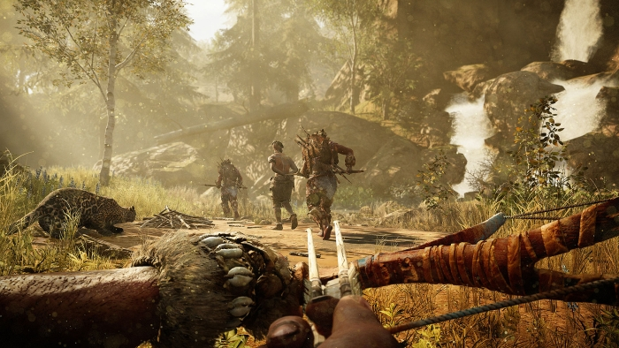
ARK
This image shows that the game has a high quality graphics that represent the world in a way that the player can recognise straight away. There are elements that are particularly effective like sunshine reflecting on surfaces and characters’ shadows on the water and life like objects such as the boots, weapons and gold.

Adaptability
It's important that a game has character adaptability because people can choose what they look like to show their personality more or to show how powerful they are when in the game. They can also make their character the same as their own looks to make them feel like they are in the game. There are also many adaptability options in this game with cars and weapons. “Gamers should be able to create a character that they feel comfortable playing and lets their individualism as a player shine through. Having an option to create something unique in a gaming world filled with lookalikes should be treasured, as it it sometimes overlooked by a large portion of a game's player base.”

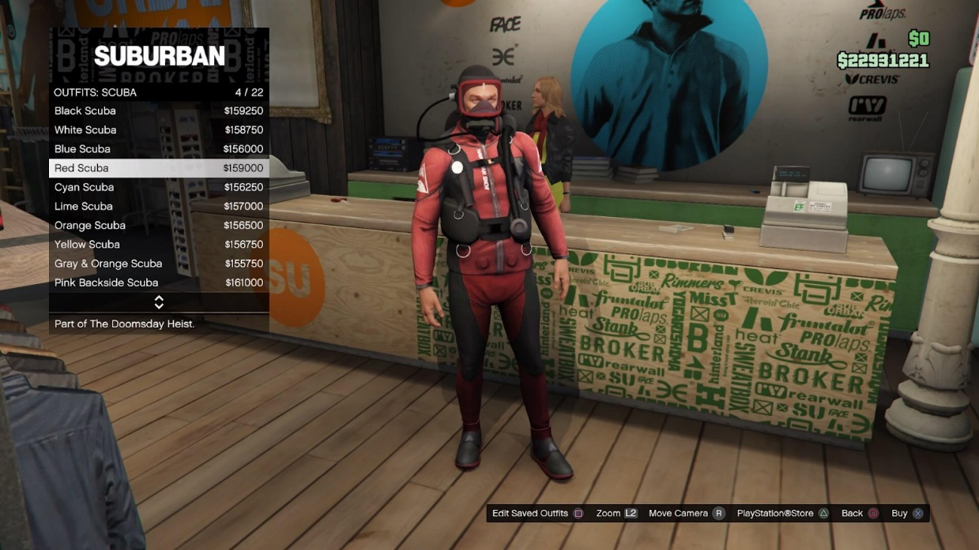

Storyline

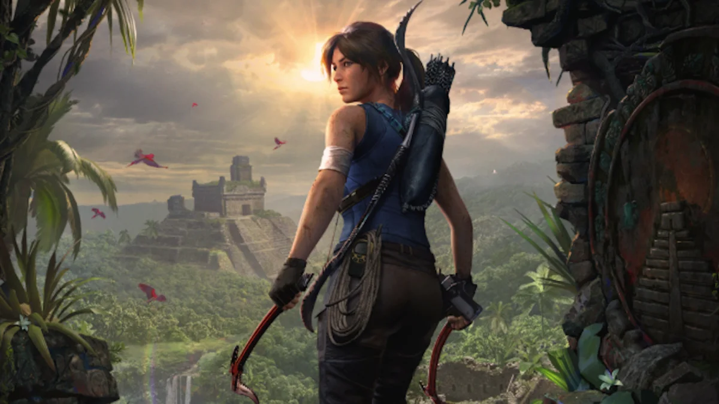

The in-game’s storyline is important because it helps the player feel more involved and more absorbed within the game. The storyline in the game gives the game meaning and it can help players understand what they need to do in the game. Games that have players as part of the story tend to have players more absorbed.
“Storytelling isn’t an idle leisure activity that humans developed to while away the hours: It evolved for serious purposes, as a necessary component in the development of human culture. Without storytelling, humans could never have communicated complex information. Storytelling isn’t merely characteristic or even definitive of the human condition- it’s absolutely necessary to the existence of human culture.”
(Crawford.C , 2006. pp - 3)

Reference List
Book:
(Crawford.C , 2006. Chris crawford on interactive storytelling)

Online sources;
BBC, 2009, video games can improve vision. Available at: <http://news.bbc.co.uk/1/hi/health/7967381.stm>

GameZone, 2014, How important is character creation and customisation? Available at:<https://www.mweb.co.za/games/view/tabid/4210/Article/16268/How-important-is-character-creation-and-customisation.aspx>

Task 2 - Jon Pugh-Reflective Writing: Do you know what you think?

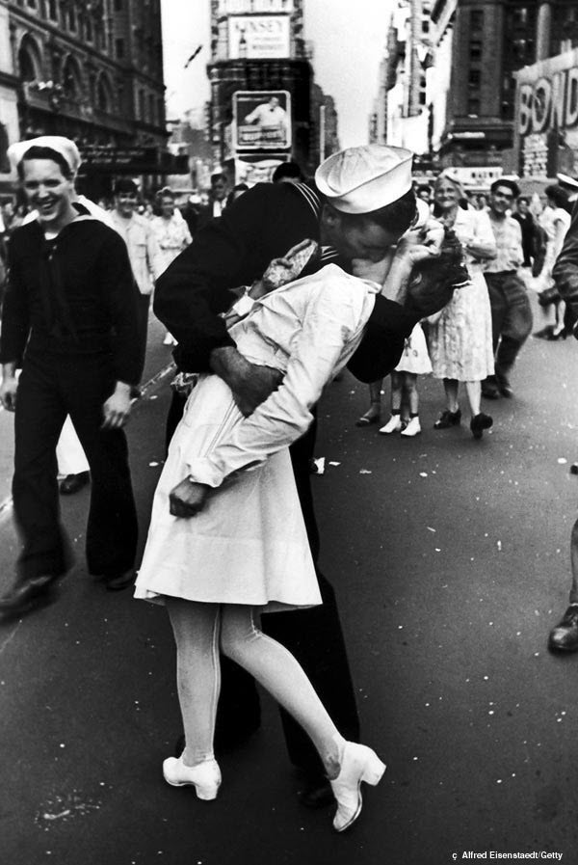
V-J Day in Times Square 2000. p.134.

What this image meant at the time?
This photograph was taken by Alfred Eisenstaedt on 14th August 1945 which was the date when Japan surrendered to the USA at the end of World War 2.
The picture shows a sailor kissing a nurse in Times Square in the centre of New York which is a place that most people in the USA and even across the world can recognise. The faces of the people in the background show their reaction to the kiss but also their relief that the war had ended and so the soldiers and sailors could come back home. The photograph became a reminder to people of where they were and what they were doing when they heard the news about the Japanese surrender.
The photograph became famous and was published and exhibited in many different places across the world - it made Eisenstaedt famous. A background story grew up around the nurse and the sailor in the photo. Some people believed that it was the start of a great love story and should be looked at as two young people celebrating a big day in history. (Teproff, 2006)They thought that it also showed the power of the USA to overcome anything and succeed in the end. The picture linked together lots of different elements that represented the strengths of America ; the armed forces, the support of women for the war and the heart of the USA in New York.
What the image means now?
In 1979 Eisenstaedt thought that he had found the nurse, Greta Zimmer Friedman from the photograph and another story built up around what actually happened on that day. Whereas at the time the photograph was linked only to positive feelings, it is now looked at in another way as well. In the 21st century we would not see it as acceptable for a man to just walk up to a woman that they did not know in the street and kiss her in this dominating manner. The sailor, George Mendosa, was quoted as saying that it was all innocent and just his response to having a few drinks after hearing about the surrender.
Another difference with looking at the photograph 74 years after it was taken is that the world sees the USA in a different way and the American people themselves have a different view of the world. (Martino, 2006. When there are big events, people are more likely to see them on TV or on a mobile device and less likely to hear about it by word of mouth and share it with the people around them. People are less likely to go out and celebrate in the street with strangers and this makes the photograph seem unusual. Now that most people have access to a camera on their phone all the time it is easier to take photographs but maybe we do not think of them as something that is so important or that we need to keep for the future.

Reference list
V-J Day in Times Square". The Photo Book. London: Phaeton. 2000. P.134
Martino, A. (2016). "How a celebrated image marking V-J Day in Times Square has taken on a sinister shade" Daily News. New York. Archived
Teproff, C. (2010). "WWII 'Kissing Sailor' Carl Muscarello visits Fort Lauderdale school kids". Sun-Sentinel. Archived

Task 3 - Ryan Moule-Observational Writing: Identify an image and write a semiotic analysis
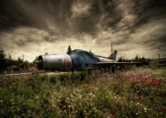
https://www.aliciariusphotography.com/abandoned

The image, to me, represents a mysterious and sombre feeling, it has lots of history but is also abandoned. This image made me feel that we have ignored the great history story behind the photos. I think the colours have an impact on it because they draw your eyes to it and make you ignore and forget about the main object, the plane. The, almost dirtiness of the sky, dark grey and white give you a feeling of smoke in the air which would have been common in the World War II era. I believe that this could be the result of editing. This photo does not have the rule of thirds or the golden ratio but the plane is perfectly situated in the middle of the image with a good frame (shown above)

The lines of rolling clouds in the sky and density of the flowers in the foreground draw your eye to the plane. The composition is bold and draws the viewer into the image, the white and red flowers in the grass at the foreground of the image are a well-used contrast with the splash of colour against the dark of both the plane and the sky. The photograph doesn’t use the rules of third although it has been framed very well using a good angle and position for editing. This work has been presented in many online digital articles as well as other photos from her collection of portfolios, I feel it could be presented in an exhibition. Alicia Rius has a portfolio of work in this genre. It could show people the photographer’s views and a different way to think about photography as art. Rius tried new things and her more recent work may draw a new audience, they might be inspired to try something new themselves and experiment with their work
This work is created in-camera technique then using contrast and brightness to create the effect of dark and light.
The image by Alicia Rius has a much darker tone and mood. Here she has used a slow shutter speed to capture as much detail as possible. The angle of the photograph also makes it more interesting because we associate planes with the air and here it is linked to the ground and we are looking at it from eye level. The photographer has used low contrast and brightness to give the image a sepia tone.
I think the focal point of this is grass and flowers because my eyes were drawn to bright colours like red and white flowers. I think Rius is using a wide filter lens because it enhances the frame with three different layers, like grass, plane and the sky.
It is natural for your eyes to be drawn to the white and red flowers in the grass at the front of the image because they are a splash of colour against the dark of both the plane and the sky. The red flowers seem to be poppies which we associate with war and this makes a strong link to the plane which could have been used in combat.
It also seems that this shows the power of nature to claim back what man has tried to dictate. This is backed up by James (2019), who states; “In a clash between man and nature, it currently seems that nature is losing the battle. But when humans are not around – it doesn’t take long before nature starts taking over.”

Reference List

Alicia Rius Photography, 2014, Abandoned Places Available at:< https://www.aliciariusphotography.com/abandoned >

Dean, R., 2008. Tales from Topographic Oceans. [electronic print].

James, L. 2019. Abandoned buildings seen reclaimed by nature after humans leave, in collection of eerie photos.
Task 1 – 521
Tast 2 - 502
Tast 2 - 519

