Sanda Eugen Bogdan
Student ID: 2108537
Component 1 Report Effective Teamworking for team success
BMSW4002 Effective team working and communication

Summary
Teamwork is not something that can be turned on and off; it necessitates a concerted effort on the part of all team members. Tuckman's approach, on the other hand, can assist you in determining which phase your team is in and how to solve the situation as efficiently as feasible. A team is a collaboration between people who work together to achieve a common goal. Teams are formed to complete activities that are complex or are sought for a variety of reasons. Different models for team development have been developed in order to help a team succeed and become more successful. Tuckman's concept of team development was adopted for this paper. Also the Team Role model of Glenn Parker had been use to do a research for the report to have a better understanding of how to develop an effective teamwork and how to build a team.

Table of Contents
Summary 1
Introduction: 3
Overview of teamwork: 3
Teamwork models of development: 3
Team Role: 5
Discussion: 6
Conclusion: 6
References 7

Introduction:

This report is about an research regarding Teamworking, because of that this report will cover the following subject , what is teamwork overview, what is teamwork model for development, what are the team roles and a discussion regarding all of theat. The research used in this report include the Tuckman model of team development, and Glen parker model for team role. Also in order to ensure that I also use research from other books and websites. The purpose of this report is to analyse the concept of teamworking and give an understanding of the teamworking process and how to build and effective one.

Overview of teamwork:
A team is a group of individuals linked in a common purpose. Teams are created in order to accomplished tasks that are high in complexity or is requested from different reasons. Examples of team are : football teams , business or organization teams like project team, as in any work place or different channels people will meet and work as teams. The team members can be chosen or even self-appointed. Also they may work together for longer or shorter time periods depend the purpose of the team was created for. And the team members should promote and facilitate relationships and maintain harmony and trust. Teamwork can lead to better decisions, products, or services if they are an efficient teamworking. The attributes of an effective teamwork should be: communication, coordination, balance of member contributions, mutual support, effort and cohesion. Also the contribution for an effective teamwork are:
- Problem solving – All the team members have the responsibility to contribute equally in the team task for the set goal, and because of that all the team members should have problem solving skills in order to contribute to the team and be flexible.
- Accomplish tasks faster – As one person taking on multiple tasks you will not be able to perform at a same pace as a team can. When people work together they can complete tasks faster by dividing the work to people of different abilities and knowledge.
- Healthy competition – in the team, members can be competitive and bring more achievements to the team, a healthy competition between members can accomplished more knowledge, develop the team and members skills, and motivate the members.
- Developing relationships – An united team with strong relation can bring a lot of benefits to all members as they will stay in to a happy environment and will always help each other to complete the project task of the team. Also the members become more flexible as they will be always engaged to help each other and cover one of the team members in case is needed.
(Hali R. Keeler, 2018) (Clint A. Bowers, 2001)

Teamwork models of development:
In order a team to success, and become more effective had ben created different models for team development. In this report the team development chosen is Tuckman's model which explains that as the team achieve knowledge and skills, relationships moving through coaching, the team go thru some stages in order to develop the Tuckman stages of development are 'Forming, Storming, Norming, Performing', the model offers a simple explanation in order to understand how teams develop:
Stage 1: Forming
There is a high reliance on the leader for advice and direction. There was little unanimity on team objectives other than those provided by the captain. Individual duties and responsibilities are not clearly defined. The leader must be prepared to answer a slew of questions regarding the team's mission, goals, and external relationships. Processes are frequently overlooked. Members put the system and the leader to the test.
Stage 2: Storming
The lack of agreement regarding Team decisions which have conflict as result. Team members try to establish themselves and their place in relation to other team members as well as the leader, who may face challenges from team members.
The team's objective becomes clearer, but many questions remain. This could result in power disputes. To avoid being side-tracked by relationships and emotional concerns, the team must stay focused on its objectives. Compromises may be required to move forward.
Stage 3: Norming
The team responds well to the leader's guidance in forming agreement and consensus. Roles and responsibilities have been defined and accepted. Group consensus is used to make major choices. Smaller decisions within the group may be allocated to individuals or small teams. The sense of commitment and solidarity is palpable. The team may participate in enjoyable and social activities. The team meets to review and refine its methods and working style. The leader is widely respected, and leadership responsibilities are now spread across the team. The leader makes things easier and more possible.
Stage 4: Performing
The team's strategic knowledge has improved and now is evident why the team is acting the way it is. The team goal It is now self-sufficient and clear, does not require the leader's intervention or participation. A emphasis on exceeding goals, and the team bases the majority of its decisions on criteria agreed upon with the leader. The team enjoys a great level of autonomy. (Donald B. Egolf, 2013) (Bruce Martin, 2017)
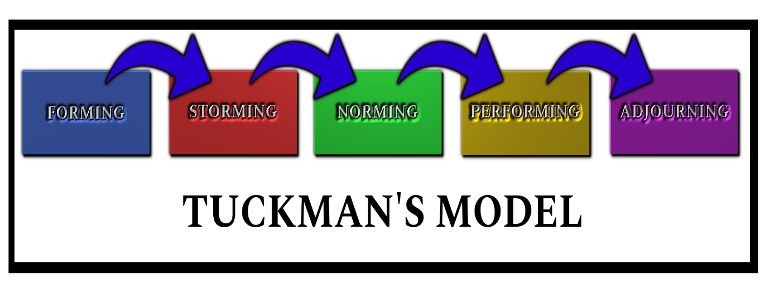

Team Role:
At the end of the twentieth century, according with Glen M. Parker, the teamwork has been established as an key aspect in the business strategy and the team members had been seen since then very valuable as an effective teamwork which can produce tangible benefits and higher performance for the organization. In the result of that event Glen M. Parker had create the 4 team players model for team development (Parker, 2008). The 4 team players of the model are:

- The Contributor
Contributors are the task-oriented team members who are fully determined in completing tasks allocated. The Contributor are characterized as responsible, well-organised and detail-oriented. Also they are devoted to their work and contribute to the team by providing and sharing all the technical information and data. The Contributors are known as the team members who set high performance standards and ensure that every aspect of the team duty is well done.

- The Collaborator
The Collaborators can be describe as highly goal-oriented members who sees the vision, mission and goal of the team as being a must! The collaborators are usually flexible in the team, creative and open to new ideas and innovation. Also an another characteristic of the collaborators is that they like to collaborate with the other team members and enjoy working outside their comfort zone to bring value to the team.

- The Communicator
Communicators are characterized as process-oriented members and they are devoted to ensure an effective management to the team. The communicators have strong communication skills and are good listeners, are very engaged in they team and have good conflict resolution skills . the communicators are half leaders and half supporters as they are good in motivating the team and maintaining a healthy and happy working environment as they are positive people, enthusiastic, supportive and tactful.

- The Challenger
Challengers most likely to see the bigger picture and are often asking lots of questions about the goals sets of the team. They encourage the team to take calculated risks and they are willing to disagree with high authorities or leaders if they this those are wrong. Also they are known as honest and direct people, with strong build principles, ethical and adventurous. (Ngo, 2016)

Discussion:
An effective team work can bring a lot of benefice but an ineffective team can impact in a negative why the organization and can result that the team to loss in accomplishing they common goal. The evidence to support this affirmation comes even from the theory and models I previously talk about. Peter and Tuckman models show the benefits of an effective team work which are increase of performance, innovation at the work place, a happy environment, achieve of knowledge, produce tangible benefits and higher performance for the organization because a Good teams share thoughts and ideas where on the other hand a bad team blame each other and doesn’t engage with the team. Also a Good teams are in developing because they learn from their mistakes, support each other and help each other to implement new ideas and innovate the team. Also a good team is engaged to achieve collective goals and a bad team members are self centred. How I previous said in a good team everyone is playing his role and a good team can take risk as there is the challenger who encourage the team to take calculated risks. Also an united team will always have the task done where on the other hand a bad team because is to busy to blame someone and are to developing relationships in the team, the team is not flexible as they want to blame instead of supporting each other. Also, a Good team achieve knowledge and skills because the team members encourage each other as the support role is doing in order to grow whereas on the other side a bad team without a support member role, don’t care about others’ growth. Also, the team members grow by having the leader feedback. Feedback is an effective way for preventing team members from guessing or assuming each other's motivations. It is most effective when is offered frequently also, been aware about the achievements and weaknesses each member can improve himself and also as for help to do that and learn from the other members of the team as there is always room for improvement. The lack of team support, trust, poor leadership can drive the team to do mistakes, confusion, missing of motivation which will lead the member to unhappy environment, unnecessary risk which can affect the team for a longer time and so on. (West, 2012) (Skills Assure, 2022)

Conclusion:
Teamwork is not something that can be turned on and off; it requires an effort from all team members. However, using Tuckman's model can help you determine which phase your team is in and how to address the situation as effectively as possible. In conclusion an effective teamwork should pass the Tuckman stages and built as glen team roles. Being at the end of the report the research conclude that and effective team work can bring a lot of benefice to a team and in order to do that there is needed the team to be united , support each other and organized and for that there are models that can be use, which in this report had been the model of Glenn Parker and Tukman team development. Those models and the discussion show in this report that everything can be possible and any goal can be achieve with the right team, at time the members have they roles and engage, avoid conflicts and so on, the team will always go further and will resist thru the conflicts as they support each other not blaming and gossiping. So is always better to know your role in the team and respect your colleagues and keep the environment for you and other heathy and happy!

References
Bruce Martin, M. W. M. G., 2017. Group Effectivness . In: 2, ed. Outdoor Leadership. 2 ed. Badford: Human Kinetics, pp. 172-173.
Clint A. Bowers, E. S. E. E., 2001. Improving Teamwork in Organizations. 1 ed. Fort Lauderdale: CRC Press.
Donald B. Egolf, D. E. a. S. C., 2013. Forming Storming Norming Performing. 1 ed. Bloomington: iUniverse.
Hali R. Keeler, M. K. S., 2018. Communication and Teamwork An Introduction for Support Staff. 5 ed. New York: Rowman & Littlefield Publishers.
Ngo, S., 2016. The 4 Types of Team Players: Which Are You?. [Online]
Available at: https://www.wallstwatchdog.com/money-career/the-4-types-of-team-players-which-are-you/
[Accessed 27 02 2022].
Parker, G. M., 2008. Team Players and Teamwork. 2nd ed. San Francisco: Jossey-Bass.
Skills Assure, 2022. Effective teamwork: the key to success. [Online]
Available at: https://leadershipmanagement.com.au/effective-teamwork-the-key-to-success/
[Accessed 04 03 2022].
West, M. A., 2012. Effective Teamwork. 1 ed. Oxford: Wiley.

