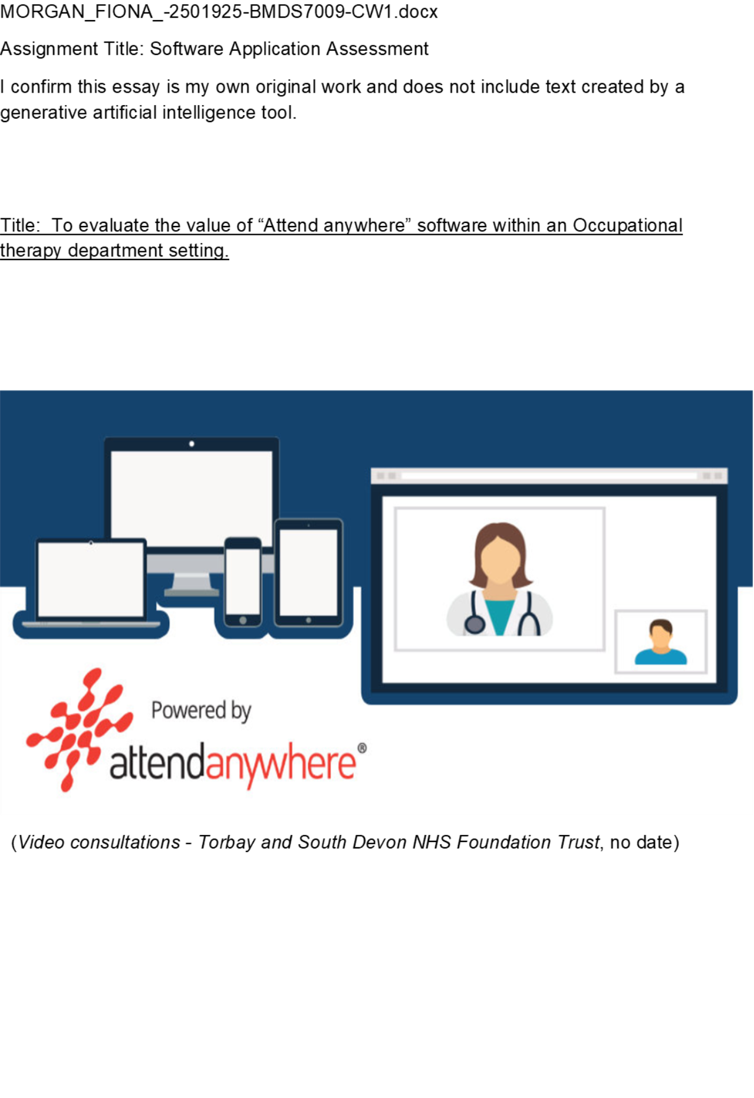Introduction

Within the Occupational Therapy (OT) Service at Aneurin Bevan University Heath Board (ABUHB) the Attend Anywhere (AA) software was adopted during Covid-19 as another means of communicating with the service users whilst staying at home restrictions were in place. AA was put in place as part of the Welsh Government response to provide a safe and secure way for health professionals to stay connected to their patients (Aneurin Bevan University Health Board, 2026 a). This software was mainly used for outpatients' services to link health professionals with patients, providing them interventions which enables them to stay independent and safe. (Johns et al., 2022). By using AA software, ABUHB aimed to reduce appointment waiting times, therefore reducing waiting lists times. ABUHB covers large areas (Blaenau Gwent, Caerphilly, Monmouthshire, Newport, Torfaen and South Powys), which can be quite rural. This has helped save patients time and money without the need for traveling and has allowed the patient to have the freedom to attend their appointment from anywhere (Aneurin Bevan University Health Board, 2026 b). ABUHB is still using the AA software today as part of their Digital Strategy ensuring that health care is being delivered with quality holistic care, through the most effective digital solutions available, using telehealth like AA software as a platform (Aneurin Bevan University Health Board, 2019).
AA software has been used in many health boards across the UK to facilitate the provision of safe and reliable interventions virtually within an individual or group setting ​(Gormley et al., 2023).​ In 2010 this software was used for the first time for patient consultations. It took until 2016 to be introduced in Scotland and in 2019 Wales adopted the approach. In March 2020, due to the pandemic AA won the contract to carry out a pilot study for NHS England and was rapidly rolled out within 12 weeks. The main aim at the time was a means to minimise the risk of infection and deliver safe and accessible healthcare with the COVID-19 restrictions (Crouch, 2021; Shaw et al., 2021).
AA allows a single-entry point on a heath boards providers webpage, allowing the service user to enter a waiting room for their appointment. The patient does not need an account or specific software to use the service however would need access to a device to take video calls. The Clinician manages the appointments and accepts the patient to the video consultation instead of a physical appointment ​(Attend Anywhere /Involve, 2025).​

Method

This study will examine the AA software looking at its value, the success of the programme and changes implemented to improve operation of the software within the OT service at ABUHB. The study will examine the literature, the ABUHB reports /guidance and healthcare professional opinions who have used this software for their patients. This will allow a full analysis of qualitive data of the software to fully understand the pros and cons of using this when providing OT interventions to patients.
Five journal articles will be analysed to review the main themes of using the AA software to obtain an overview of how the software has worked for other healthcare settings. The ABUHB reports and guidance will be evaluated and analysed. A questionnaire was sent to Occupational Therapists within ABUHB to find out personal thoughts regarding the use of AA software when carrying out OT intervention (see appendix 1).
This study will adopt the Fit between Individual, Task and Technology framework (FITT framework) to assist with this analysis. This framework was introduced by ​Ammenwerth, Iller and Mahler, (2006)​ due to clinical settings using information technology (IT) in their workplace and ensuring that the Fit between the quality of the individual users, (the individuals perceptions /attitude /their motivation or anxieties), the quality of the technology (how the systems work, their usability and what technology support) and the quality of the clinical tasks /processes were evaluated, (the decisions being made, what challenges there are and the advantages and barriers). The extended version of the FITT framework which also looks at the organisational context of the IT adoption can be used to demonstrate how the organisation fits within the individual, task and technology of the evaluation of the IT software ​(Kujala et al., 2018)​.
Figure 1 demonstrates how the framework can be used to analyse IT adopted between individual tasks and technology and the how the organisation can influence these.
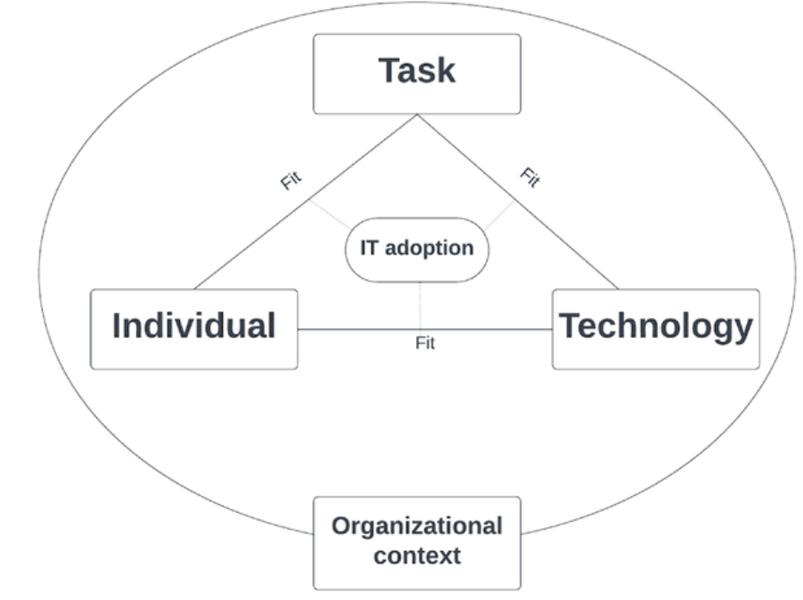
​​Figure 1 The Extended FITT framework (the fit between individual, task technology and organisational context) (Berkhout et al., 2025)​

The FITT framework will assist to analyse the “Attend Anywhere” software, to help to determine how to improve and future proof the delivery of the OT service in ABUHB using this software.

Results
The Extended FITT framework will be used to guide the results through using the categories Individual and task, task and technology, technology and individuals and Organisational context.
Literature findings
Tables 1 - 4 highlight the themes gathered from 5 Journal articles which were selected due to the studies using the AA software in a healthcare setting.

Table 1: Individual and Task
Impairments | Kumar, (2021) | reported it was difficult due to a person's visual and hearing impairment.
Materials | Kumar, (2021); Saif et al., (2025) | Individuals requiring to have equipment at home to complete some of the tasks IE blood pressure machine. Measuring tape.
Planning | Kumar, (2021) | Reported good planning was needed prior to the appointment
Diagnostic /interventions. | Watila, Duncan and Mackay, (2022); Gormley et al., (2023); Saif et al., (2025) | Stated physical examinations were difficult
 | Watila, Duncan and Mackay, (2022) | Stated it took longer to diagnose patients and increased the risk for re assessment and re investigation
 | Johnstone-Burt, Giles and Wright, (2021); Kumar, (2021) | Stated it allowed interventions to be completed successfully.
 | Saif et al., (2025) | Reported only certain interventions can work and need to be selected.
 | Kumar, (2021) | Reports to needing to be more probing questions to be able to get a diagnosis or clinical condition.
 | Saif et al., (2025) | Reported difficulty undertaking physical examinations and providing equipment.
Environment | Gormley et al., (2023); Saif et al., (2025) | Highlighted sharing an office space –limited due to needing to provide an office place confidential uninterrupted space
 | Gormley et al., (2023) | Mentioned patients were being interrupted/ distracted by family members whilst on video consultation

Table 2: Task and technology
Infrastructure | Kumar, (2021); Gormley et al.,(2023); Saif et al., (2025) | Highlighted there were internet connection problems which caused disruptions to interventions.
 | Kumar, (2021) | Reported the software kept freezing and
Design | Kumar, 2021; Saif et al., (2025)  Kumar, (2021) | Stated they were unable to share information when on the video call therefore information had to be sent either prior or post session.  Reported professional had difficulty with screen sharing
 | Johnstone-Burt, Giles and Wright, (2021) | States the software is a secure video call system which is easy to use for both staff and patient.
Training | Gormley et al., (2023); Saif et al., (2025) | Identified training to complete the task. Needing operational guidance for both health professionals and patients.
 | Saif et al., (2025) | Suggested a need for a technology champion to assist with tech advise

Table 3: Technology and individual
Capability | Watila, Duncan and Mackay, (2022) | Difficulty in accepting and using information technology or cognitive decline. No family to help.
 | Kumar, (2021); Watila, Duncan and Mackay,(2022) | Report the elderly were Unable to handle the smart phone or laptop, however 1 article reported most elderly were able to use the software.
 | Gormley et al., (2023) | Reports Older aged children were more engaged due to use to technology.
Infrastructure | (Johnstone-Burt, Giles and Wright, 2021) | Report clients felt it was a Safe place in own home to complete intervention
 | Gormley et al., (2023) | Engaged clients that may not have felt comfortable engaging with face-to-face sessions
 | Gormley et al.,(2023) | Reported Convenance as the main improvement but did not elaborate on this
 | Watila, Duncan and Mackay, (2022); Gormley et al., (2023); Saif et al., (2025) | Stated a beneficial impact of travel to their face-to-face appointments both time and expense.

Table 4: Organisation Context
Regulations | Johnstone-Burt, Giles and Wright, (2021); Kumar, (2021); Watila, Duncan and Mackay, (2022); Gormley et al., (2023); Saif et al., (2025) | Had to put Attend anyway software in place due to the concerns of COVID 19
 | Saif et al., (2025) | Stated NHS long term plan is committed to reducing face to face appointments by a third
Environmental | Gormley et al., (2023); Saif et al., (2025) | Report the space and appropriate clinic/group facilities were limited to carry out face to face sessions.
Resources | Saif et al., (2025) | States the need for ongoing funding, investment in technology and resources
Design | Saif et al., (2025) | Mentions NHS digital solutions and future planning of video technology would benefit from co-designing with all staff.

ABUHB Evidence findings

ABUHB have been guided by Digital NHS Wales in the implementation of video consultations. Tables 5 -8 will gather information through analysing the Digital NHS Wales findings ​(Johns et al., 2022)​ using the FITT framework also looking at ABUHB website ​(Aneurin Bevan University Health Board, 2026b)​.

Table 5: Individual and task
Diagnostic /interventions | Johns et al., (2022) | More personalised and patient centre approach and rapport with clinicians
 | Johns et al., (2022) | Comparable aims and goals to be achieved like face-to-face interventions reducing hospital admissions
Enviroment | Johns et al., (2022) | Lacked engagement with the patient especially with children if family are on the video call

Table 6: Task and technology
Design | Johns et al., (2022) | Deliver safe and timely care
 | Johns et al., (2022) | Quality ensured yet cost- effective care and treatment
 | Johns et al., (2022) | Unable to do all treatments and need face to face.
 | Johns et al., (2022) | Enhances the clinical session or determine the clinical need
 | Johns et al., (2022) | Small number of patients reported there were long wait in the waiting area.
Infrastructure | Johns et al., (2022) | Technology is good quality however poor connection impact on the visual and audio
 | (Johns et al., (2022) | Saves time using attend anywhere than doing face to face for health professional
Training | Aneurin Bevan University Health Board, (2026 b) | Training is available for both health care professionals and patients on the health boards intranet for staff and the internet for patients.

Table 7: Technology and individual
Capability | Johns et al., (2022) | Easy to use- rating excellent, very good or good by patients and health professions
 | Johns et al., (2022) | Clients are not familiar with the equipment and struggled to video call due to lack of technology ability.
Infrastructure | Johns et al., (2022) | Can make patients feel safer, less stressed as they are in their own homes, home comforts and is flexible.
 | Johns et al., (2022) | Been able to have multiple numbers of people on the video call, other multidiscipline or family.
Training | Aneurin Bevan University Health Board, (2026 b) | Training is available for both health care professionals and patients on the health boards intranet for staff and the internet for patients.

Table 8: Organisation context
Regulations | Johns et al., (2022) | Was used due to the mandatory distance laws through COVID 19
 | Aneurin Bevan University Health Board, (2026 b) | Follow Digital NHS guidelines
Resources | Aneurin Bevan University Health Board, (2026b) | The only software for video consultations accessible to the health board for patients

Questionnaire Results

A questionnaire (see appendix 1) was sent to 8 OTs within ABUHB who had experience of using the AA software with patients. 6 health professionals completed the questionnaire. They had all used the software during COVID-19 and 5 were still using it. All therapists used the software regularly, 4 use it weekly and 2 use it monthly. The extended FITT framework will guide the findings of the questionnaire.
Individual and task
The therapists used the AA software for carrying out triages, initial assessments and follow up calls. It was used for group work and teaching sessions within mental health and fatigue management. It was clear, space and time were an issue when carrying out interventions face to face as 1 therapist stated, “It allows me to see a number of patients in one place as physical space is an issue” and another “Allows me to move quickly through my patient list from one location.” Their comments illustrated it was beneficial to gather information from the patients and one stated “I can see a patient’s home without doing a home visit”. This allows the therapist to have an insight of patients so intervention plans can be formed.
Task and technology
It was highlighted AA software cannot fulfil the whole task, a face-to-face would have been better to fully assess the patient’s needs.
Infrastructure played a large part when using the software. If patients were in rural areas or using their mobile phone when not in their own home, signal was an issue.
Technology and individual
5 therapists did not have any difficulties with the technology, however 2 therapists stated this was once they understood the software and had training. 1 therapist mentioned they had difficulty with the waiting room system: Patients not logging into the waiting room and therefore missing the appointment. Therapist stated “Patients initially were hesitant of using the system. But became comfortable as time progressed”.
There were issues with patients’ capabilities of managing the software. One therapist expressed “Some elderly patients are unfamiliar with the technology and had some issues with logging in”. Some patients require family members to support them.
2 therapists discussed patients found it difficult to engage within group settings. “Some patients are resistant to talking on video groups”.
There were very mixed reviews towards training. Some Occupational therapists stated they had training and others said there was none available
Patients can access training, but therapists found some patients still had difficulties to organise appointments.
Organisation
All therapists had to use the AA software during Covid-19 due to movement restrictions.

Discussion

Studying the AA software whilst using the extended FITT framework to guide the study, has provided an overview of how the software is used, the benefits and the challenges.

Fit between the individual and the task
There were mixed views into whether the software assisted the health professionals achieve their interventions with patients. Clinicians found physical examinations difficult to do on video consultations and felt it took longer to diagnose patients and increased the risk for re-assessment and re-investigation​ (Watila, Duncan and Mackay, 2022).​ Asking detailed questions whilst on the video call is crucial to determine a diagnosis of an intervention this is support by Kumar, (2021)who carried out a study on video consultation using AA software with patients who have Parkinson’s disease. He suggested preparation is important and preparing questions will make the consultation more focused and efficient for both the patient and the clinician. However, Johns et al., (2022)​ indicated using the AA software and face-to-face appointments were very similar when setting patients goals, which helped with reducing hospital admissions​ Therefore, if AA is similar to face-to-face appointments, then the health professional should establish which platform would be better for the patient and would get the best outcomes for the intervention carried out. Saif et al., (2025)​ agreed only certain interventions can work when using AA software for example information gathering and information giving, either through individual or group settings​. This indicates a hybrid approach to patient’s treatment needs to be considered. Johns et al., (2022) who studied 22,978 patients and clinicians across different settings in Wales concluded a blended approach would be best in the future, allowing clinical judgement and patients’ choice of intervention to be at the forefront.

Fit between the task and technology

AA is a secure video call system which is being used all over the UK, but it has come with its complications. Saif et al., (2025) described difficulties with sharing information with the patients on the video consultation which, led to needing further administration resources to send information out to the patients. This could have be a design fault of the software. Furthermore, the waiting area has been a concern with logging in difficulties or long waits for the patients. Johns et al., (2022) evidence supported this, where patients had to wait long periods of time for their appointment, or their appointments were being missed. However, this may not be due to failure of the software but of human error. Johns et al., (2022) also expressed the error could be due to the clinicians missing the appointment or even failure to attend. To ensure these faults are rectified whether they are design faults or human error, stakeholders should be engaged on the future planning of video consultation to ensure all problems can be resolved and new plans are implemented (Saif et al., 2025).
Finding space for carrying out assessments and group work is a premium in a healthcare setting. AA software allows healthcare professionals to carry out their interventions without having to find space. Gormley et al., (2023)​ highlighted lack of space for face-to-face interventions had motivated mental health professionals to adopt the AA software as they were able to see several patients in the same place and time.

Fit between the individual and technology
The infrastructure played a part with how AA software performed Gormley et al., (2023) and Johns et al., (2022) both experienced poor internet connections, causing interruption to appointments and impacting the sessions. However, the convenience of AA software, which reduced the time and cost of traveling to a healthcare setting both for the patient and the clinician, was beneficial (Saif et al.,2025). Johns et al.,(2022) also suggested the software had allowed health professionals to see more patients due to the logistics, with saved travel time to and from appointments allowed availability for consultations to increase.
Capability of the health professional and patients play a large part towards the success of the software working. There are 876,338 people aged 60 years or over living in Wales ​(The older peoples commissioner for Wales, 2024)​. It is more likely that the aging population uses the NHS more than others. The elderly population are unfamiliar with this type of IT,​ Watila, Duncan and Mackay, (2022) found that re assessment with the over 60 years was high as they found the elderly population were unaccepting of technology or were unable to handle a smart phone or a laptop. However, this should not be assumed but should be a consideration when deciding whether a video consultation would be best for an older person. ​Kumar, (2021)​ supports this and found most of the elderly population who attended the video consultation had positive feedback regarding using it.
Training is key for the AA software to be used correctly. Guidance should be in place to assist health care workers/patients if they come into difficulty setting up and during the video consultation ​(Saif et al., 2025)​. Lack of training could lead to difficulty in navigating the technology and potentially an incomplete intervention. Gromley et al.,(2023) highlighted this when analysing the AA software in a child/adolescent mental health setting. Professionals and the parents found due to technical issues their sessions were disrupted. This highlights the need for more support for patients/health professionals to access video consultations smoothly.​ Saif et al., (2025)​ suggested there is a need for technology champions within individual services to assist with advice to both patients and health professionals.

Organisation
Covid-19 was a large reason why AA software was implemented within the NHS. Video consultation was needed fast to assist with the “Stay at Home” policy from the government which the NHS had to abide to (Shaw et al., 2021). AA software is widely used within the NHS for video consultation. With the NHS long-term plan 2019 in England to reduce face-to-face consultations by a third (Scordis et al., 2022) and ABUHB digital strategy promoting telehealth (Aneurin Bevan University Health Board, 2019). It is important there are ongoing resources, which continues to have investment and funding to ensure patients and health professions can continue video consultations into the future.

By using the extended FITT framework, it has allowed an analysis of the AA software. Figure 2 indicates where the problems are with the Fit in all 3 areas, with Individual and Technology having more difficulties.

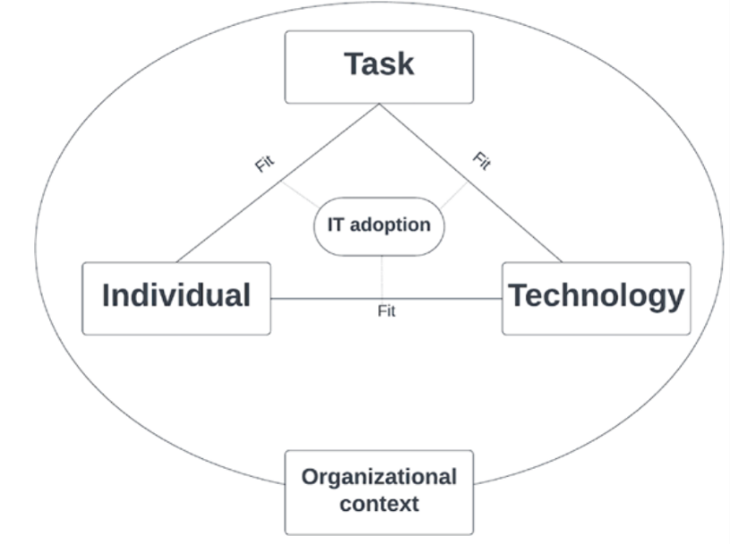
Attend anywhere
A
Figure 2 Adaption of Extended FITT framework -Analysis of the fit of AA software between task, technology and individual (Ammenwerth, Iller and Mahler, 2006; Berkhout et al., 2025). An arrow illustrates small concerns and 2 arrows with a larger concern with the fit.

This highlights if AA software is to continue within ABUHB OT department, clinicians will need to reflect on the concerns. They will need to consider what interventions are carried out with patients when using the software and whether a combined approach to treatment with both face-to-face appointments and video consultations is more appropriate. Clinicians need to be mindful who would be able to engage with the software and that patients have choices whether this is right for them. Ongoing training is vital to ensure all professionals and patients have an understanding of the software and are able to rectify any problems they encounter whilst using it. Finally, it is important to continue to review the service and ensure money and resources are available to continue to use this platform.

References
​​Ammenwerth, E., Iller, C. and Mahler, C. (2006) “BMC Medical Informatics and Decision Making IT-adoption and the interaction of task, technology and individuals: a fit framework and a case study.” Available at: https://doi.org/10.1186/1472-6947-6-3.

Aneurin Bevan University Health Board (2026 a)-Over a quarter of a million Video Consultations delivered across Wales - Available at: https://abuhb.nhs.wales/news/news/over-a-quarter-of-a-million-video-consultations-delivered-across-wales/ (Accessed: January 27, 2026). ​

Aneurin Bevan University Health Board (2026 b). – Video Consultation. Available at: https://abuhb.nhs.wales/hospitals/video-consultations/ (Accessed: January 19, 2026).

Aneurin Bevan University Health Board (2019) “Digital Strategy Transformation through digital Information Community Foundations Organisation.”
​Attend Anywhere | Involve (2025). Available at: https://involve.vc/attend-anywhere/ (Accessed: December 29, 2025).

​Berkhout, M. et al. (2025) “Understanding the Role of Clinical Decision Support Systems Among Hospital Nurses Using the FITT (Fit Between Individuals, Tasks, and Technology) Framework: Qualitative Study.” Available at: https://doi.org/10.2196/76025.
Crouch (2021) From Australia to the UK - Attend Anywhere’s 10 year journey. Available at: https://www.digitalhealth.net/2021/03/from-australia-to-the-uk-attend-anywheres-10-year-journey/ (Accessed: January 27, 2026).
​Gormley, E. et al. (2023) “The experiences of young people, parents and professionals of using the attend anywhere video consultation system in a child and adolescent mental health service: a mixed-methods approach,” Frontiers in Child and Adolescent Psychiatry, 2. Available at: https://doi.org/10.3389/frcha.2023.1194302.

​Johns, G. et al. (2022) “Digital NHS Wales: A coding reliability analysis based on the voices of 22 978 patients and clinicians on the benefits, challenges and sustainability of video consulting,” BMJ Open, 12(4). Available at: https://doi.org/10.1136/bmjopen-2021-057874.

​Johnstone-Burt, A., Giles, S. and Wright, R. (2021) “P111. ‘Attend anywhere’: A virtual success? Patient feedback from breast nurse specialists using ‘attend anywhere’ technology during the COVID-19 pandemic,” European Journal of Surgical Oncology, 47(5). Available at: https://doi.org/10.1016/j.ejso.2021.03.115.

​Kujala, S. et al. (2018) “Applying and Extending the FITT Framework to Identify the Challenges and Opportunities of Successful eHealth Services for Patient Self-Management: Qualitative Interview Study.” Available at: https://doi.org/10.2196/17696.

​Kumar, A. (2021) “Experience of video consultation during the COVID-19 pandemic in elderly population for Parkinson’s disease and movement disorders,” Postgraduate Medical Journal, 97(1144). Available at: https://doi.org/10.1136/postgradmedj-2020-138846.

Saif, A. et al. (2025) “A service evaluation of patient and clinician experience of video consultations in a specialist outpatient neurorehabilitation service,” Future Healthcare Journal, 12(1), p. 100209. Available at: https://doi.org/10.1016/j.fhj.2024.100209.
Scordis, C. et al. (2022) “5 The risk of increasing health inequalities when implementing a virtual cardiac rehabilitation service: a service evaluation,” in. Available at: https://doi.org/10.1136/heartjnl-2022-bacpr.5
Shaw, S.E. et al. (2021) “Achieving Spread, Scale Up and Sustainability of Video Consulting Services During the COVID-19 Pandemic? Findings From a Comparative Case Study of Policy Implementation in England, Wales, Scotland and Northern Ireland,” Frontiers in Digital Health, 3, p. 754319. Available at: https://doi.org/10.3389/FDGTH.2021.754319.
​The older peoples commissioner for wales (2024) “The Older People’s Commissioner for Wales.” Available at: www.olderpeople.wales (Accessed: January 19, 2026).

​Video consultations - Torbay and South Devon NHS Foundation Trust (no date). Available at: https://www.torbayandsouthdevon.nhs.uk/services/video-consultations/ (Accessed: December 29, 2025).

​Watila, M.M., Duncan, C. and Mackay, G. (2022) “Evaluation of telemedicine for new outpatient neurological consultations,” BMJ Neurology Open, 4(1), p. e000260. Available at: https://doi.org/10.1136/bmjno-2021-000260.
​ ​

Appendix 1
Evaluation of Attend Anywhere software
To gain Occupational Therapist experiences with using Attend Anywhere Software
1.Have you used Attend anywhere software for Occupational Therapy interventions for your patients?
Yes
No
2.How often do you use this software?
Daily
Weekly
Monthly
3.Do you still use Attend Anywhere software since COVID 19?
Yes
No
4.What occupational therapy interventions do you use Attend Anywhere software for?
Enter your answer
5.What are the benefits for yourself as an Occupational therapist when using attend anywhere software?
Enter your answer
6.What are the benefits for your patients when using Attend Anywhere software?
Enter your answer
7. Do you prefer using Attend Anywhere or face to face for your occupational therapy interventions? Explain your answer
Enter your answer
8.What challenges did you or your patients encounter when using Attend Anywhere software?
Enter your answer
9.Did you encounter any technical issues whilst using Attend Anywhere software?
Enter your answer
10.Did your patients encounter any technical issues whilst using Attend Anywhere software?

