Marketing fundamentals
(LCBB4004)
Assignment 1

Teacher:Riaz Bhatti
Student:Marius Racovet
(2030601)

Mercedes-Benz

There isn't anything we love more than vehicles and cars! For this reason, we feel it is essential for us to know the historical backdrop of the makes and models we have all developed to adore which carries us to Mercedes-Benz. I assume the majority of us appreciate the quality of the well known brand . Mercedes-Benz,when you hear or read that brand somewhere,the first think it comes up in our mind is the luxury cars,with a good colaboration between company and needs of the people about the quality and luxury cars with a big variety of cars,a worldwide brand and company with millions of customers,admirers and fans.Mercedes-Benz is not just a brand,it became more than that,it’s a cult,it’s a conection between mercedes cars lovers wich shares the same passion.

Mercedes-Benz is the grandad of vehicle makers; most reference books give the credit of the primary vehicle to Mercedes-Benz fellow benefactor Carl Benz. For this reason we feel that the historical backdrop of this specific maker is certainly worth knowing. In the next slides we are going to discuss about the history of this splendid brand that win the admiration of thousands of people, so keep reading to discover more.

Where it started
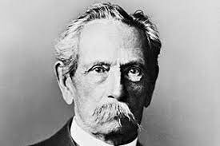
(Carl Benz: https://mercedes-benz-publicarchive.com/marsClassic/en/instance/ko/Carl-Benz.xhtml?oid=580)

The story starts in Germany,Carl Benz was born on November 25, 1844, in Karlsruhe. In July 1846, his father passes away. Despite their meagre financial resources, his mother ensures that her son attends elementary school and eventually pursues a degree in mechanical engineering. From locksmith to designer and workshop foreman, the young engineer makes rapid progress. Carl Benz teams up with'mechanician' August Ritter to form the 'Carl Benz and August Ritter, Engineering Workshop' in Mannheim in 1871. Carl Benz is obliged to pay Ritter off with the dowry of his bride, Bertha Ringer, and runs the company alone when Ritter proves to be an untrustworthy partner. Carl Benz begins work on a gas-powered two-stroke engine in 1878 in order to realise his goal of a "mobile without horses."
. On New Year's Eve in 1879, after many lengthy and exhausting attempts, he gets the engine going for the first time. In October 1882, he establishes the 'Gasmotorenfabrik Mannheim' (Mannheim Gas Engine Factory) as a shareholding company. However, Benz's ownership stake in the company is merely 5%, and he has little influence in technical matters. His supporters are mostly concerned about the safety of fixed gas engines.

In January 1883, Benz departs the company and forms a new partnership with Max Rose and Friedrich Wilhelm Esslinger. They found 'Benz & Cie. Rheinische Gasmotoren-Fabrik Mannheim' (Benz & Cie. Rheinische Gasmotoren-Fabrik Mannheim) and introduced the two-stroke 'System Benz' engine.
. While Benz works to put his automobile vision into action, his business colleagues Rose and Esslinger are sceptical. Carl Benz is looking for new investors once more. In May 1890, Julius Ganss and Friedrich von Fischer take over for Rose and Esslinger. The integrated business model of manufacturing stationary and vehicle engines has proven to be successful. However, Benz wanted to concentrate solely on automobiles, so he founded 'Carl Benz Söhne' (Carl Benz & Sons) in Ladenburg in 1906. Carl Benz resigns as Managing Director in 1912, handing over complete business power to his sons. He sees the rise of motorisation and his thoughts come to fruition.
On the occasion of his 80th birthday, the 'once scorned and misunderstood inventor,' as he has been dubbed in the past, has received accolades from all over the world. Carl Benz stays a Board Member of the new Daimler-Benz AG firm during his final years (1926 to 1929). On April 4, 1929, the car pioneer passes away at his house in Ladenburg.

Mercedes-Benz has now been set up for quite some time (89 years) and has developed itself into one of the most dependable brands in the auto area, which isn't is actually to be expected because of its rich history.

This finishes up our concise history of the incredibly famous vehicle maker, Mercedes-Benz!
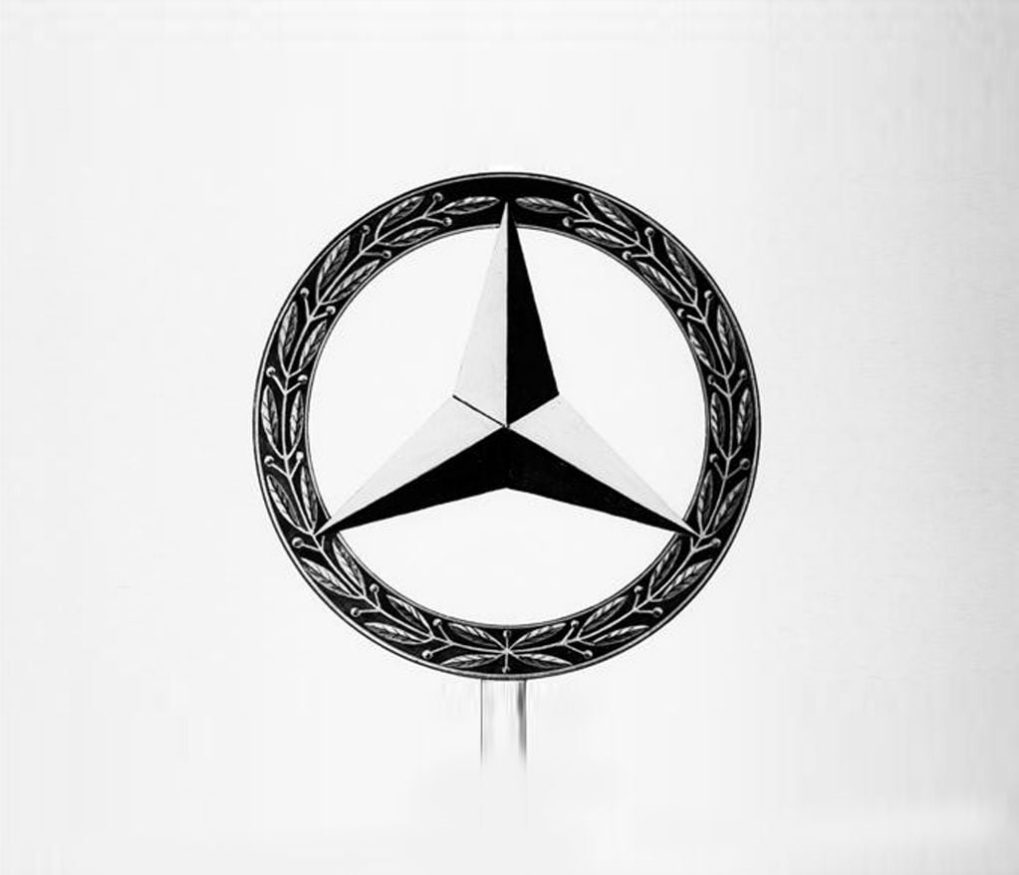
The three-pointed star appeared on all routes in 1909.

DMG has held the patent for the successful "Mercedes" brand name since September 1902. The only thing that's missing is a distinctive trademark. That's when Gottlieb Daimler's sons, Paul and Adolf, recall their father's past use of a star as a symbol. Following this lead, the DMG Board of Management registers trademarks for both a three-pointed and four-pointed star in June 1909. Both designs are legally protected, but the three-pointed star is the one that is eventually used, and a three-dimensional star adorns the front radiator of automobiles starting in 1910. When the two companies merged in June 1926, a new brand name was born, combining the fundamental features of the prior logos.

Aims and objectives of company
The vision articulation for Mercedes-Benz is its essential arrangement for the future – it characterizes what and where Mercedes-Benz Company needs to be later on. The vision proclamation for Mercedes-Benz is a record recognizing the objectives of Mercedes-Benz to work with its key, administrative, just as broad dynamic cycles.

Mercedes-Benz AG is one of the world's biggest makers of extravagance traveler vehicles. In 2020, it sold around 2.1 million traveler vehicles and almost 375,000 vans. In its two business fragments, Mercedes-Benz AG is persistently growing its overall creation network with around 35 creation destinations on four mainlands, while equipping itself to meet the necessities of electric versatility. Simultaneously, the organization is developing and broadening its worldwide battery creation network on three landmasses.
Mercedes-Benz AG is liable for the worldwide business of Mercedes-Benz Cars and Mercedes-Benz Vans, with more than 170,000 workers around the world. Ola Källenius is Chairman of the Board of Management of Mercedes-Benz AG. The organization centers around the turn of events, creation and deals of traveler vehicles, vans and vehicle-related administrations. Moreover, the organization tries to be the forerunner in the fields of electric portability and vehicle programming. The item portfolio involves the Mercedes-Benz brand with the sub-brands of Mercedes-AMG, Mercedes-Maybach, Mercedes-EQ, G-Class and the savvy brand. The Mercedes me brand offers admittance to the computerized administrations from Mercedes-Benz.

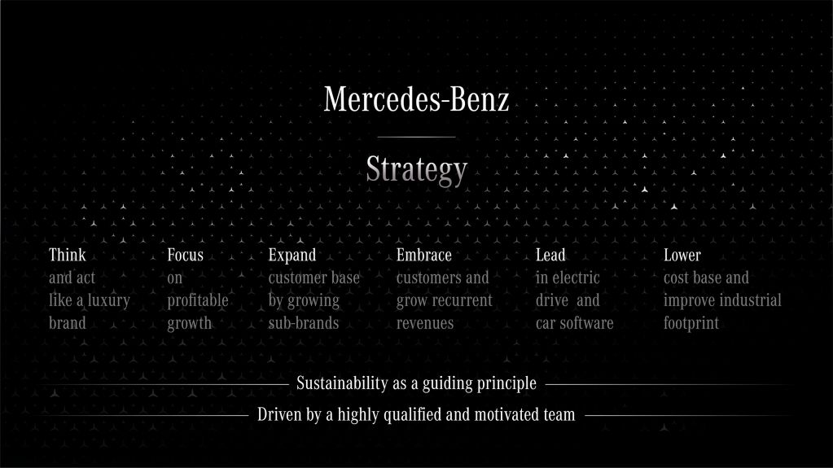
6 Pylons of the Mercedes strategy
Mercedes-Benz official website:
https://www.mercedes-benz.com/en/company/)

1.Tink and act like a luxury brand

Mercedes-Benz has always been synonymous with luxury. The company will place a renewed emphasis on luxury in the future, making it a part of all goods, consumer interactions, and digital technologies. Mercedes-Benz will reconfigure its product line, brand marketing, and sales network to create a truly luxury experience that is electrified, software-driven, and environmentally friendly.

2.Focus on profitable growth
Mercedes-Benz will make changes to its market strategy in order to improve and adjust it. These will be focused on ensuring enhanced contribution margins from the present and future portfolio by improving the balance between volume, pricing, and channel mix. In order to assure structurally increased profitability, Mercedes-Benz will focus its product development resources and capital on the most profitable areas of the market and categories in which it competes.

3.Expand customer base by growing sub-brands

According to Interbrand, Mercedes-Benz is the most valuable luxury car brand in the world. It will continue to be the guiding light. AMG, Maybach, G, and EQ are just a few of Mercedes-exceptional Benz's sub-brands. The new strategy will propel them to the next level, with clear and targeted goals to maximise their potential and generate significant incremental EBIT growth.

Starting in 2021, AMG will go to the next level with high-performance electrification. To reflect its status as Mercedes' high-performance sub-brand, its ties to Formula 1 will be strengthened next year. Maybach will double in size and go electric in order to seek worldwide opportunities. The renowned G is in high demand, outpacing current supply. The legend will continue to expand and electrify. Mercedes-Benz will target a new audience with the EQ brand, which will feature innovative high-tech items built on specific electric architectures.

4.Embrace Customers and grow recurrent revenues
Mercedes-Benz is dedicated to building long-term partnerships with its clients. Customers should enjoy owning a Mercedes-Benz and be so pleased with their experience that they stay with the brand for a long time, ideally forever. Mercedes-Benz will now strive for even greater customer loyalty, increased repeat purchases, and quicker development in recurring revenues — mostly from services and parts, but increasingly via OTA updates and subscription services. Because the Mercedes-Benz fleet will reach 20 million fully linked vehicles by 2025, the expanding number of connected cars will bring considerable revenue potential in the future.

5.Lead in electric car and drive software
With ambitious product development ambitions and the rapid deployment of new technology, Mercedes-Benz aims to seize the lead in electric drive and car software. Mercedes-Benz has introduced four all-new electric vehicles based on its forthcoming large-car Electric Vehicle Architecture as part of its »Electric First« strategy (EVA). The EQS luxury sedan is the first vehicle to be built on this new dedicated architecture, and it will be available in 2021 with a range of more than 700 kilometres (WLTP). The EQE, the EQSSUV, and the EQE-SUV will all follow. AMG, Maybach, and G will also go electric. Multiple new electric vehicle models will be added to the portfolio starting in 2025 on the Mercedes-Benz Modular Architecture (MMA), a second all-new dedicated electric platform developed for compact and medium-sized cars.
Mercedes-Benz is devoting even more of its product development resources and expertise to electric vehicles, as well as investing in innovative technologies and concepts to extend electric range and efficiency. The next generation of eMotors will be designed in-house and will have advanced inverter and high-voltage technology. With in-house battery R&D and tight partnerships with major strategic partners CATL, Farasis, and Sila Nano, the company is making enormous breakthroughs in battery technology. New materials and manufacturing technologies will extend range while lowering charging time and cost.
Mercedes-Benz also unveiled today the Vision EQXX technology initiative, which is an exciting next step in electric car development. The goal is to create an electric car that is both efficient and long-range. Mercedes-Benz has tasked its engineering group with pushing the limits of electric range and efficiency with a cross-functional, multidisciplinary team based in Stuttgart, aided by experts from the Mercedes-Benz F1 HPP group in the UK, who bring eMotors expertise as well as motorsport-inspired development speed. While Vision EQXX is a technology programme, it is expected to yield advances that will be quickly integrated into serial production vehicles. Mercedes-Benz has announced its own proprietary MB.OS operating system for automobiles. This will be created in-house and will be released in 2024. Mercedes-Benz will be able to consolidate control of all vehicle domains as well as consumer interfaces. Private software development will allow for faster and more frequent updates, as well as scalable structures that will keep development costs down in the future.

6.Lower cost base and improve industrial footprint
Mercedes-Benz will increase profitability and cash flow, as well as take steps to prepare for the future and speed up the transition to electric vehicles. The events of 2020 have revealed that the company's break-even point is excessively high, and that additional efforts will be required to meet the transformational challenges that lie ahead. In the time leading up to 2025, Mercedes-Benz will take major new initiatives to save costs and improve its industrial footprint. Reduced spending, capacity modifications, and lower human expenses will reduce fixed costs by more than 20% in absolute terms by 2025 compared to the 2019 baseline. By 2025, capex and R&D spending are expected to be down by more than 20% compared to 2019. During the period from 2019 to 2025, variable costs will be lowered by 1% net each year, including material cost savings targets that will be raised and extended. The impacts of a higher xEV mix are not considered in this goal.

Mercedes-Benz: Innovation.

Significantly more than its careful designing, Mercedes-Benz is characterized by its ceaseless advancement. Since creating the vehicle in 1886, Mercedes-Benz doesn't just represent the historical backdrop of the auto, yet additionally for its future. The brand just reinvented constantly it. Working with an open corporate gas pedal program permits Mercedes to all the more rapidly join new advances from new companies.
Merecedes-Benz proceeded to accomplish both a record number of vehicles produced (1.49 million) and record number of vehicles sold (over 1.4 million).

The extravagance automaker likewise figured out how to end BMW's two-year reign as America's smash hit extravagance vehicle brand in 2013. For the entire year, Mercedes-Benz's business rose 14% to 312,534 units, 3,254 units more than BMW. Brand execution was driven by the new passage level CLA, and redid moderate size E-Class and premium S-Class vehicles.

Mercedes Benz - environmental impact

Climate cause is a significant piece of the corporate social obligation plan for Daimler and Mercedes-Benz. As a vehicle maker, that isn't by definition the best defender of the climate, Mercedes-Benz takes part in limiting its ecological effect. Also, the organization takes part in activities for climate conservation and regard. For sure, Mercedes-Benz utilizes advancement to serve an origination of the items life cycles and their creation more conscious of the climate : electric vehicles, green ignitable, squander decrease, manageability, and so on

Alongside chipping away at its item, Mercedes-Benz embraces climate protection and manageability activities.

