University of Wales Trinity Saint David
School of Computing
Network Operating Systems and Services
ACCA5023
Jericho Uzzell
1702201
02/03/2021


Table of contents
- Introduction; [page 3]
- Documentation; [page 3-31]
  - Building, deploying, configuring and managing a Type 2 Hypervisor platform; [page 3-27]
    - Setting up the servers; [page 3-11]
    - Setting up the clients; [page 11-16]
    - Performance enhancements; page 17]
    - Setting up the networks; [page 18-29]
      - Server and client 1; [page 18-23]
      - Server and client 2; [page 23-27]
      - Server and client communication; [page 27-29]
  - Observational task; [page 30-31]
    - What is the difference between a type one and type two hypervisor? [page 30]
    - What is the significance of the subnet mask in IPv4 addressing? [page 30]
    - Cloud computing benefits and drawbacks; [page 30]
    - Terminology used; [page 31]
      - Pings;
      - Server manager;
      - Firewall;
- Reference; [page 32]
- Bibliography; [page 32]

1. Introduction
This report will go over the building, deployment, confirmation and managing of a type two hypervisor platform. It will also look at deployment of DHCP and creating active directories, each will have their own observational task.

2. Documentation;

2.1. Building, deploying, configuring and managing a Type 2 Hypervisor platform;

2.1.1. Setting up the servers;

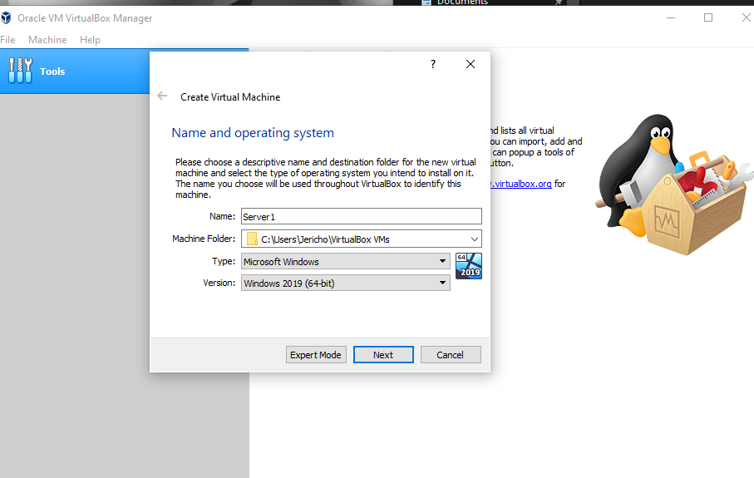
The above image shows the student installing server one. Selecting Microsoft Windows and selecting Windows 2019 (64bit) which is the latest version.

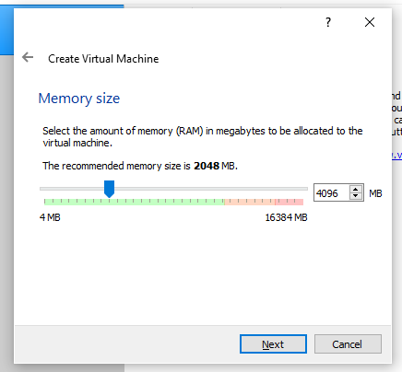
Whilst installing the virtual machine, you need to specify the amount of RAM it will be able to to use. This will use RAM on the host machine so the host machine must be able to have enough available RAM, we have assigned 4GB.

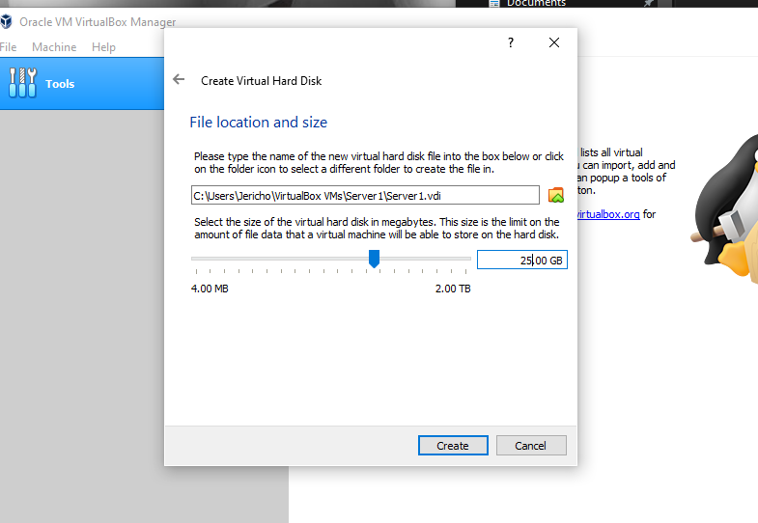
This part of the installation shows how much disk space you are allowing the virtual machine to have available. This will take away from the host machines storage so you must have enough available. We have assigned 25GB.

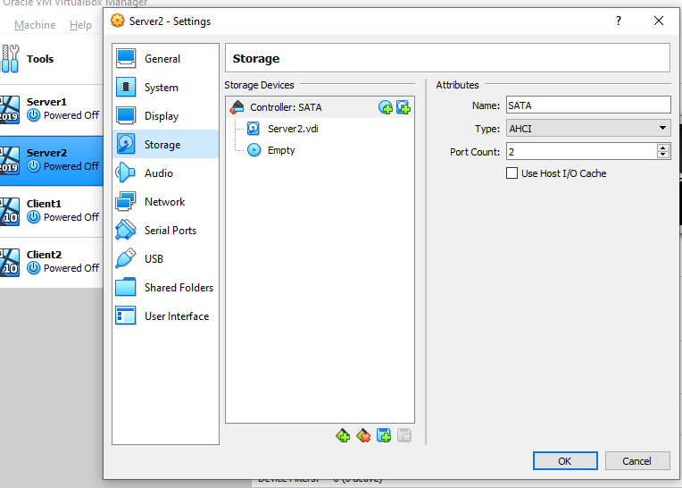
The next step of the installation process is to give this virtual machine an operating system. To do this, you use an ISO. Ensure you select it when clicking the disk file which states “Empty” (shown below).

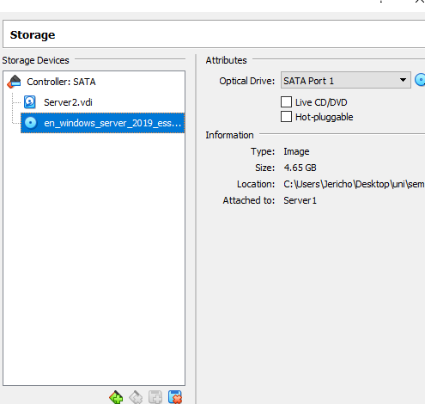
Click the disk and then on the right, click the blue disk and select the ISO file.

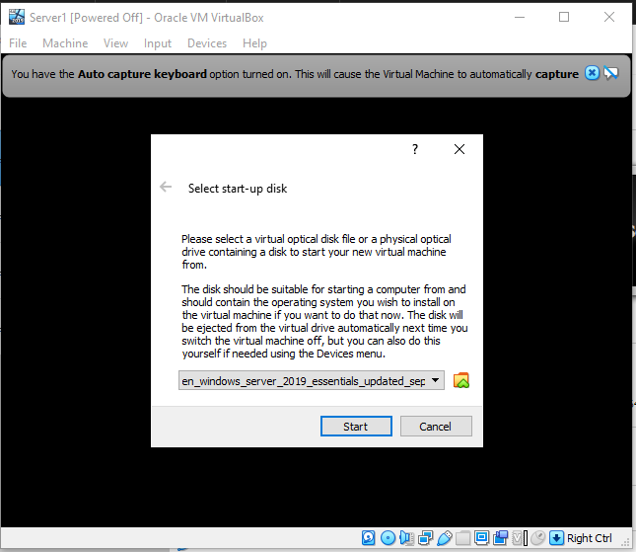
You can now click the “Start” button where this screen will be shown. Click start.

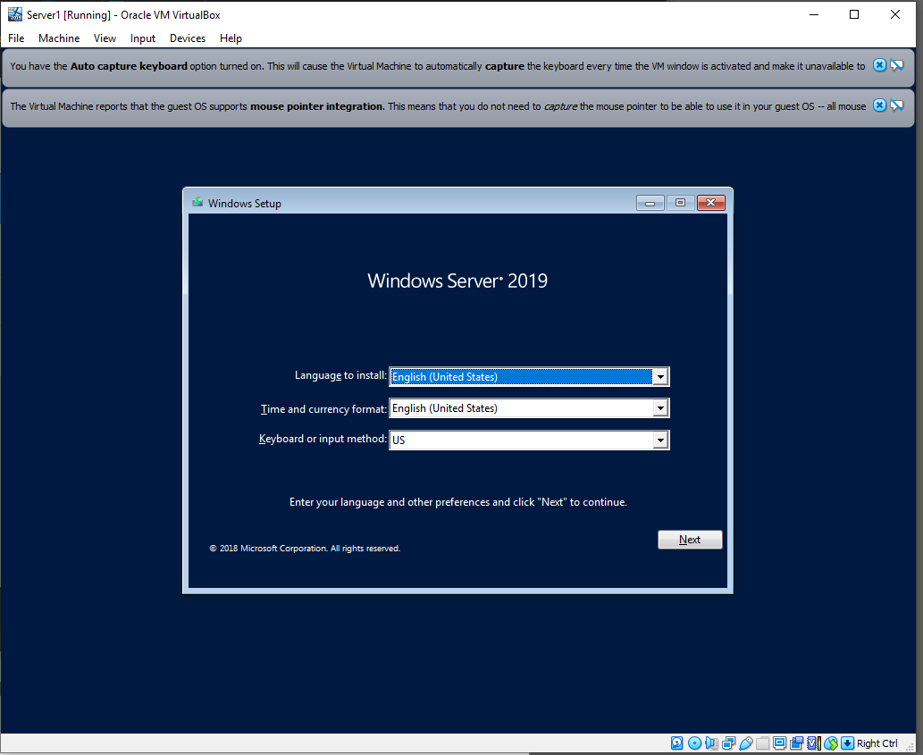
The default options are fine for this installation however, if you want a different language etc, this is the screen to choose.

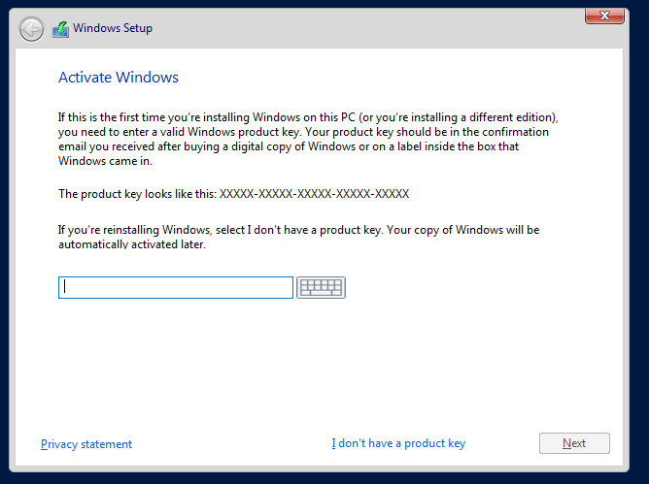
If you have a produce key, input it here. Unfortunately, we do not have one do we will be clicking “I don’t have a product key”.

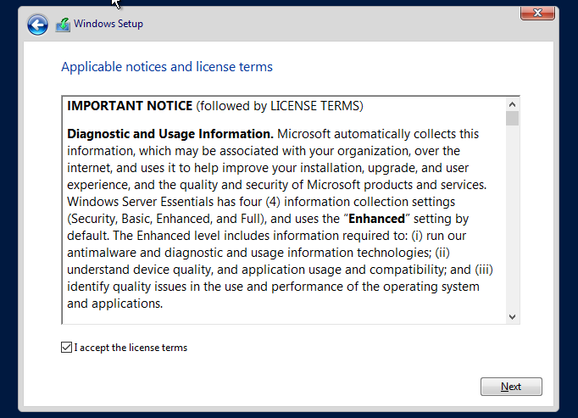
This is the license agreement, you must read this. Once read, click “I accept the license terms”, then click next.

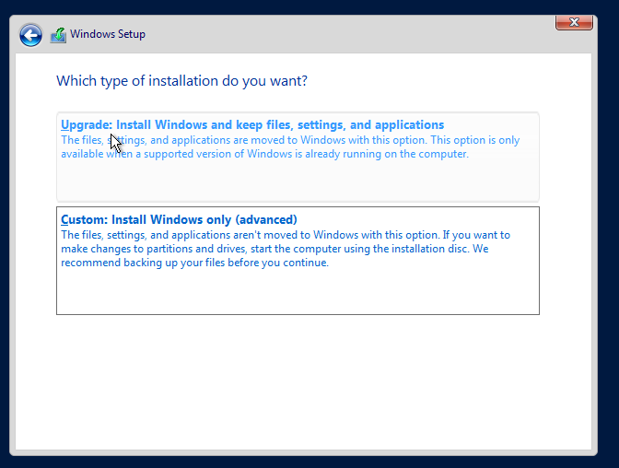
For this installation, we will be selecting “Custom: Install Windows only (advanced)”, this is a fresh install. If you are wanting to keep files from a previous windows install, click the top option.

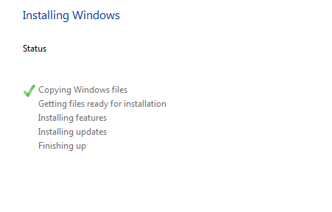
This step shows windows copying its files and running installations. This can take twenty minutes.
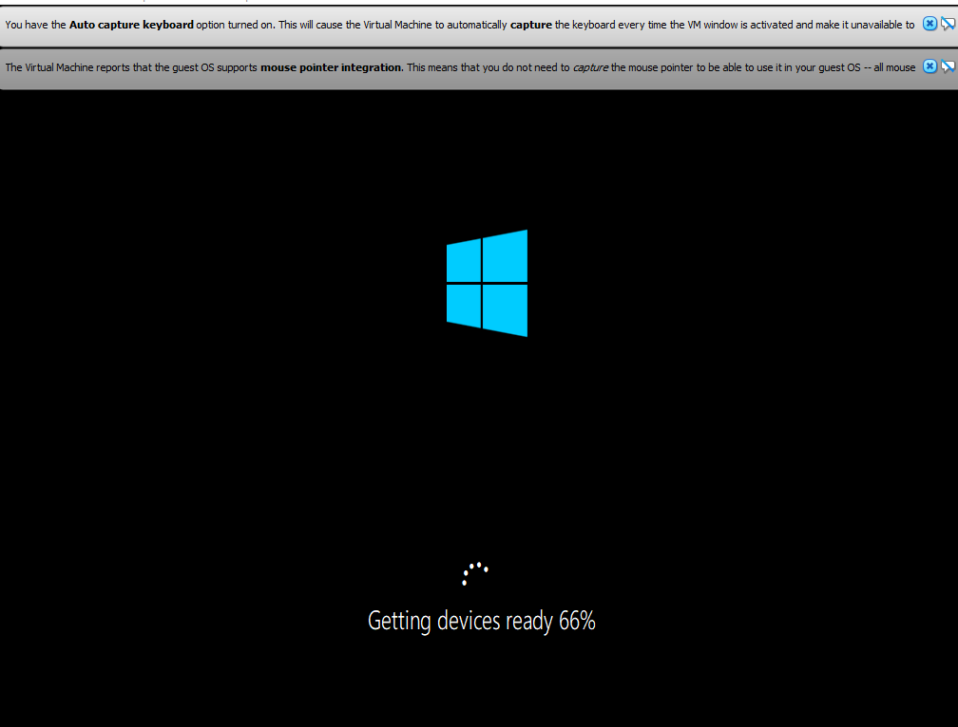
Once completed, this step will then get windows ready.
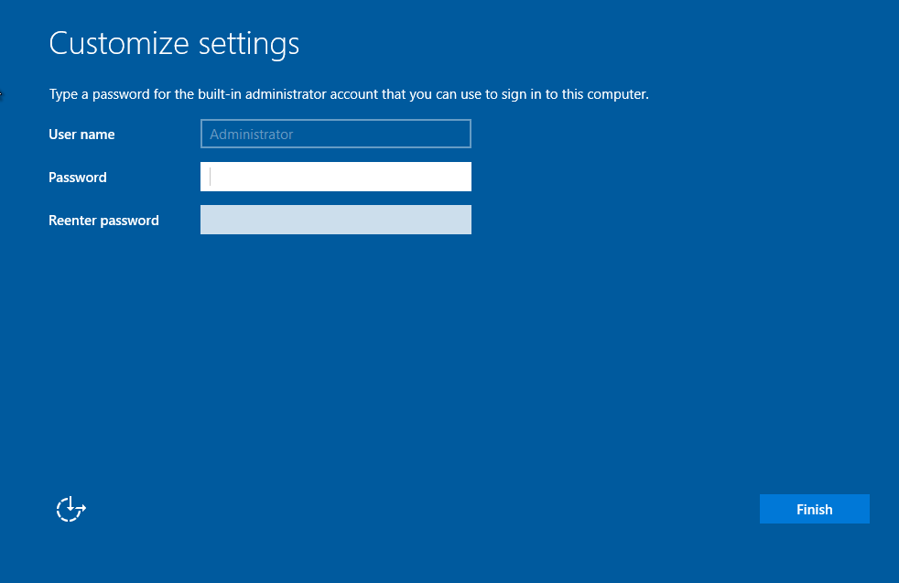
Setting up a password is required for our step to comply with security requirements. Our password is “P@ssw0rd”, you are not required to have a password however.

Windows will launch into the desktop where we can configure settings later on. Shutdown the machine and copy these steps for server two -- once done you can move onto client one.

2.1.2. Setting up the clients;
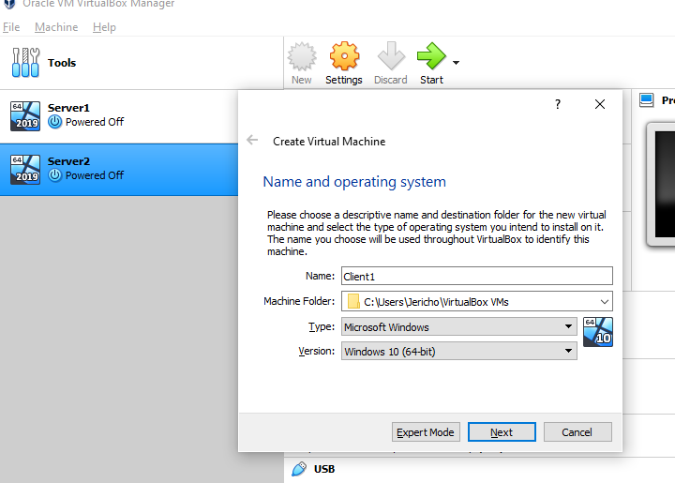
The above image shows the creation of Client 1. Select Windows 10 (64-bit).
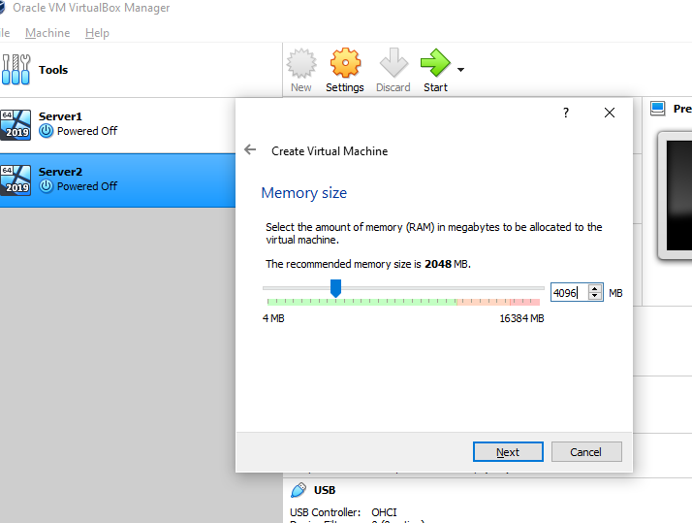
Select the same amount of RAM as you did for the server (4GB). Remember, the RAM is taken from the host machine.

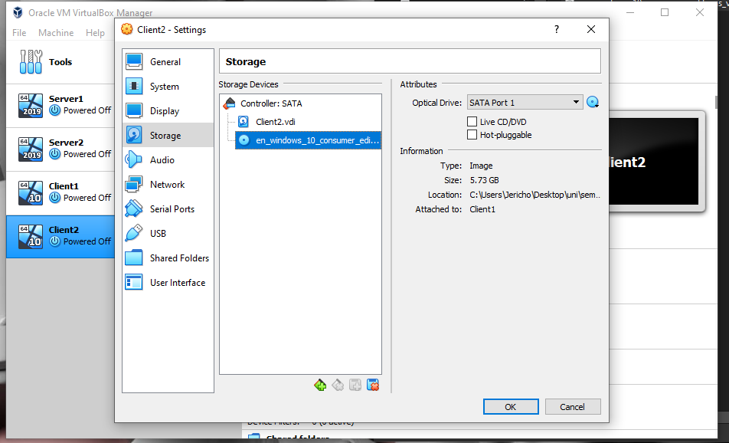
Selecting the empty CD disk under storage. On the right hand side, select the SD disk and then select the windows 10 ISO.
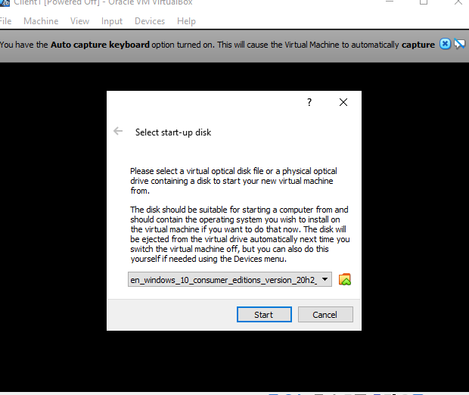
On the drop down, select windows 10 consumer editions and then click start.

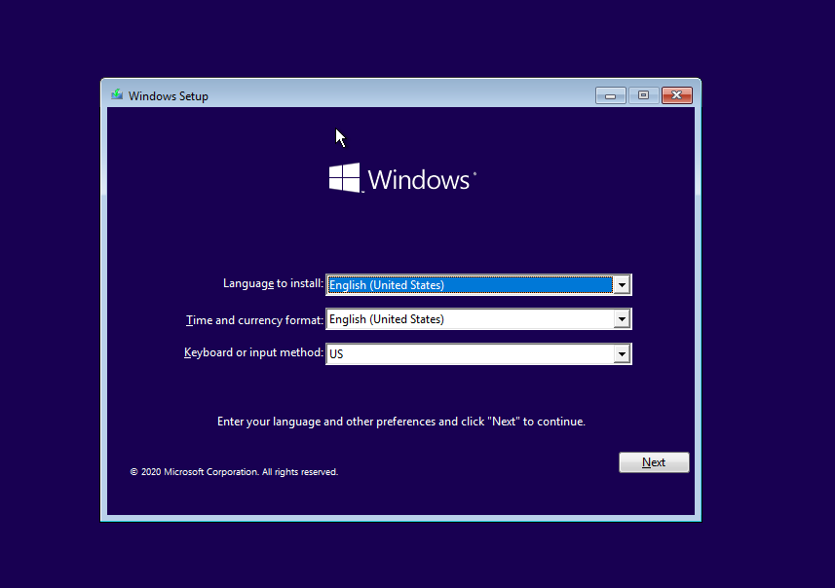
Now select the options that apply to you and then click next. The next screen will have a “Install now”, just click that.
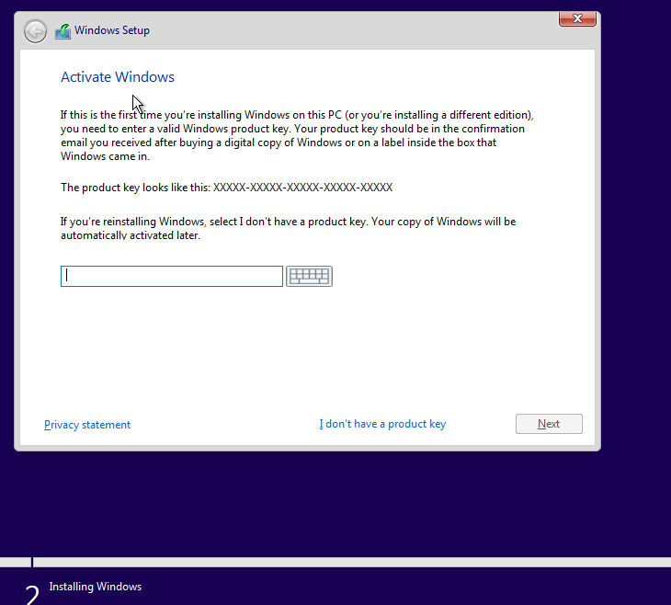
As stated previously, if you have a product key enter it here. Else click the “I don’t have a product key”. You can always enter it later.
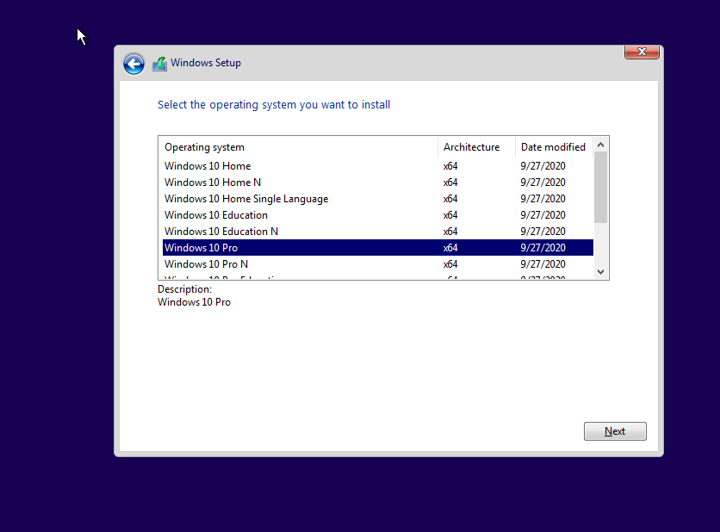
Now ensure you click “Windows 10 Pro”. Although Windows 10 Home is standard, Pro gives more options and abilities.

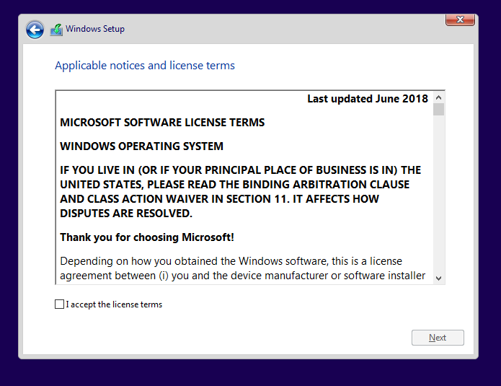
Read through the Microsoft software license terms, once read and you are happy, click “I accept the license terms”, and then next to proceed.
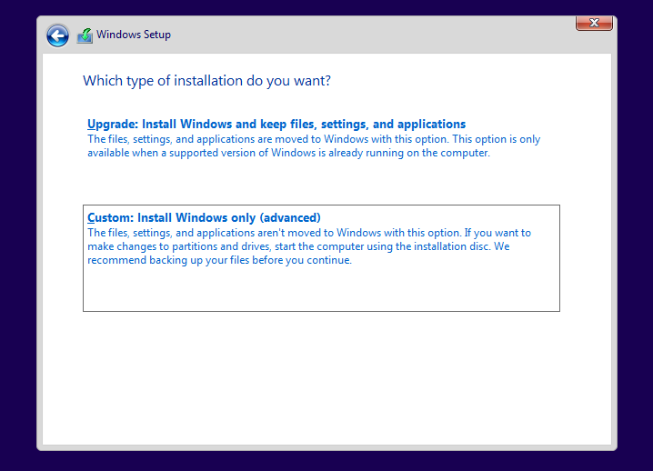
As this is a fresh hard drive, we are going to click “Custom: Install windows only (advanced)”, however you can use the top option if you are install from an old drive.
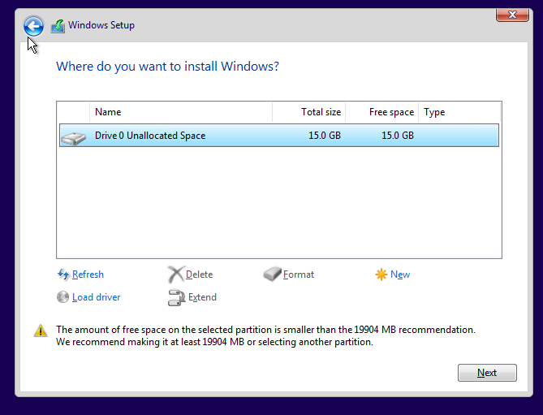
This step shows the available amount of space, click next when you want to proceed.

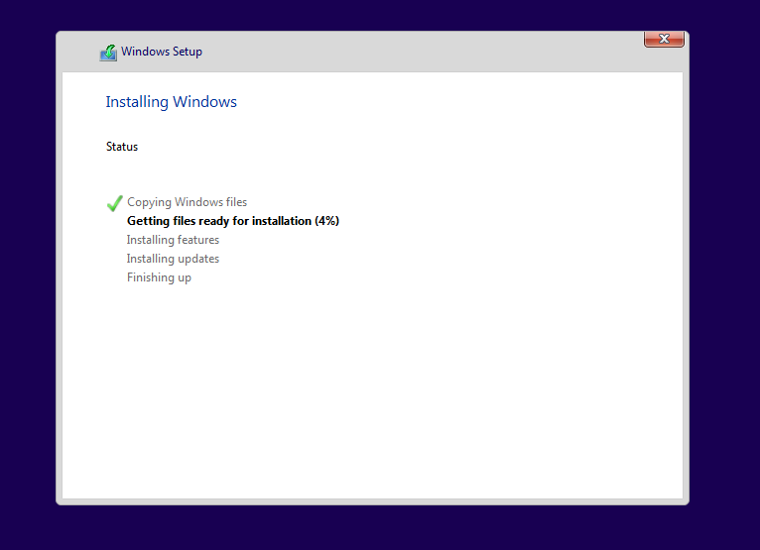
This step can take 20 minutes.
Repeat for client two. Once done, you can move on to the next step.

2.1.3. Performance enhancements;
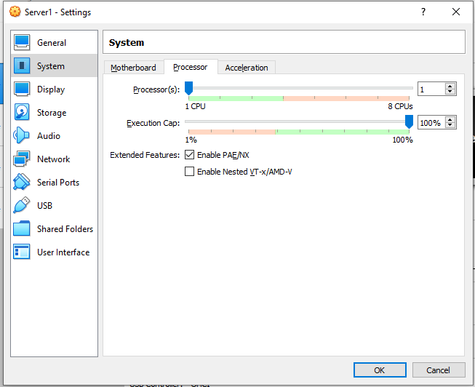
On the server settings within Oracle for Server 1. Under the system tab, then under the processor tab. You can enable PAE/NX for a physical address of the CPU, this makes it more accessible. This should be done for all virtual machines.
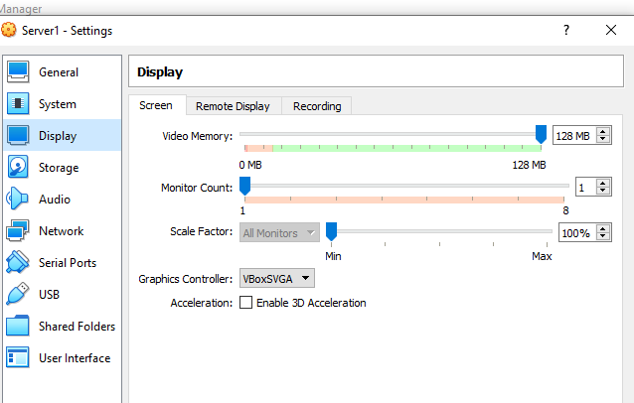
For performance, you should have at least 128MB of video memory. This is under the display tab. This should be done for all three virtual machines.

2.1.4. Setting up the networks;

2.1.4.1 Server and Client 1;
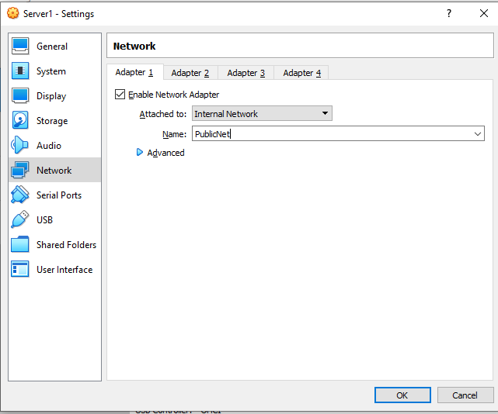
On server one, under the Network tab, the field that states “attached to”, change it from NAT to Internet Network, then name it PublicNet1.

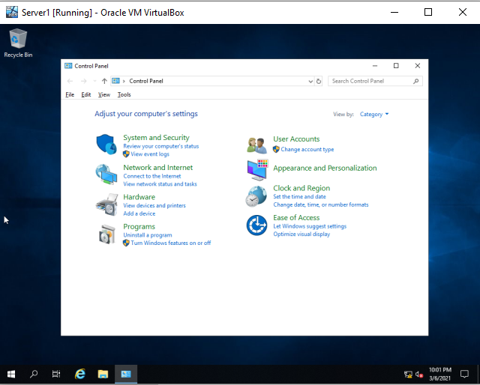
Navigate to the control panel, under the Network and Internet options, a link for, “View network status and tasks”, click it.
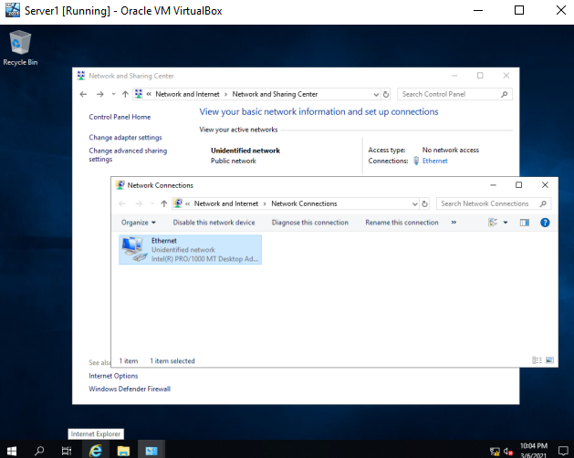
On the left, click “change adapter settings” and network connections should open up.
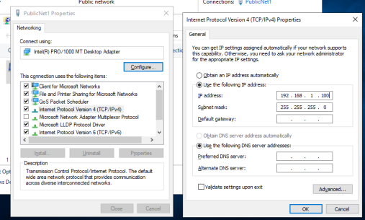
Right click PublicNet1, click properties and then left click Internet Protocol Version 4. An option to enter the properties will be available where another window will pop up, click “Use the following IP address” and enter “192.168.1.100”. Ensure you make the subject mask “255.255.255.0”, select okay and then shutdown the virtual machine.
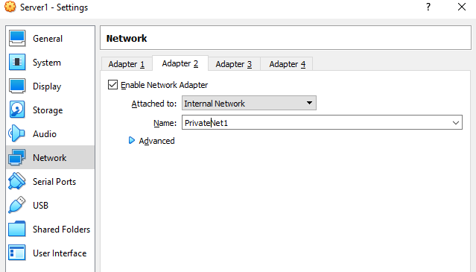
Now under the settings of server one, under network and under adapter 2. Make sure you select “enable network adapter” and under attached to, change it to internet network -- name this PrivateNet1.

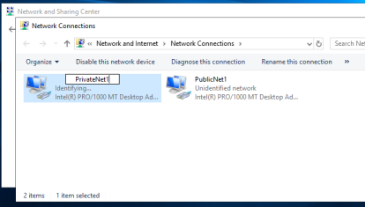
Start server one up, under the network connections panel (under control panel), rename the network to PrivateNet1.

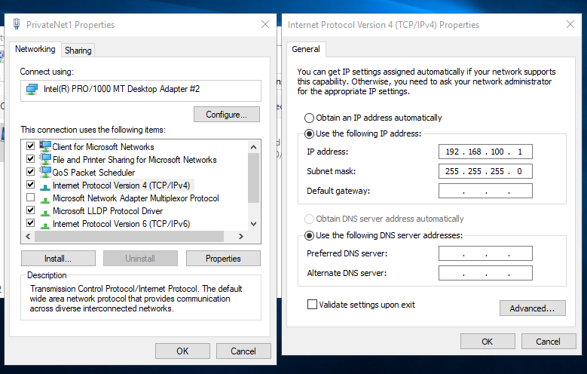
Right click PrivateNet1, under properties find Internet Protocol Version 4, then go to properties. In the new window, click “use the following IP address” and use “192.168.100.1”, and the subnet mask changed to, “255.255.255.0”. Once done, click okay and then hit shutdown.
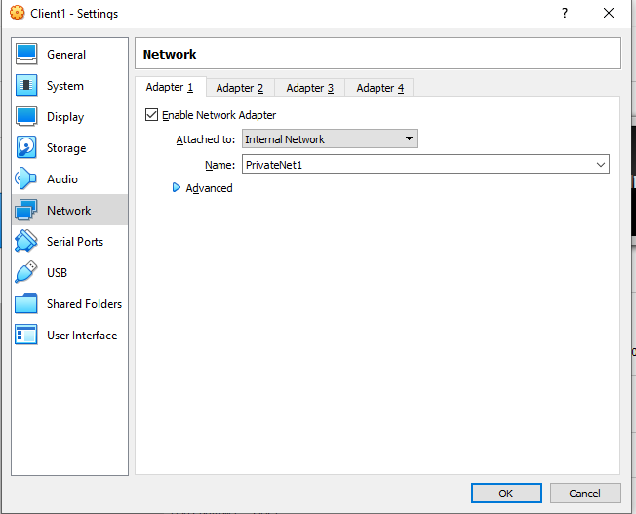
On Virtual box, select client one and under its settings find the network tab. This network will only have one adapter which will be PrivateNet1. Ensure the attached to is Internet Network.

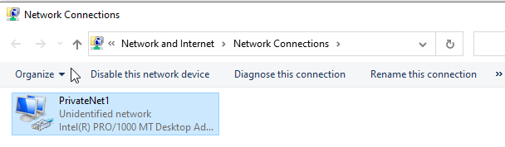
Start client one, go to the control panel, under the network connections ensure you rename the network to PrivateNet1.
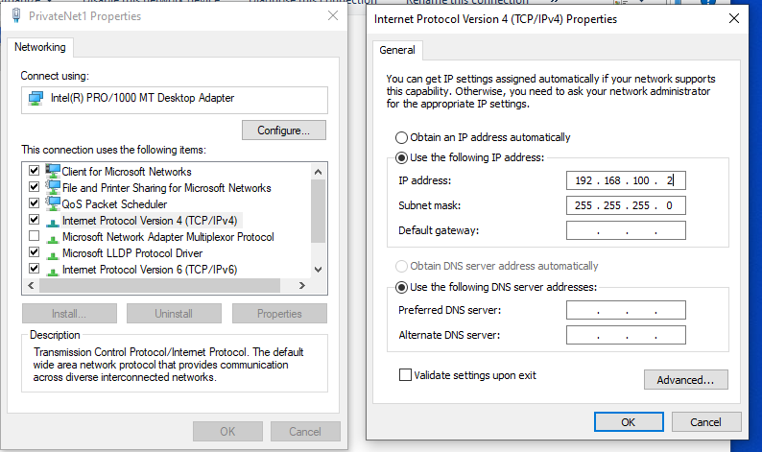
Select properties of the PrivateNet1, select internet protocol version 4 and under the properties of that. Lastly, enter “192.168.100.1”, with a subject mask of “255.255.255.0” then click okay.

2.1.4.2 Server and Client 2;

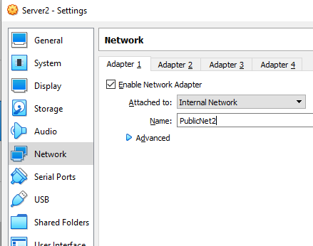
Under settings, network and adapter 1 of server two. Ensure under the attached field you select Internal Network, named “PublicNet2”.
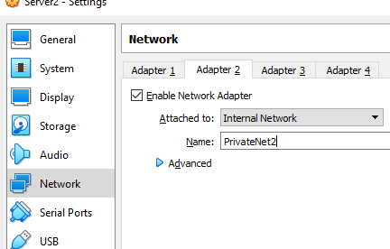
Now go to adapter 2 and enable the network adapter. Select Internal Network and name it PrivateNet2.

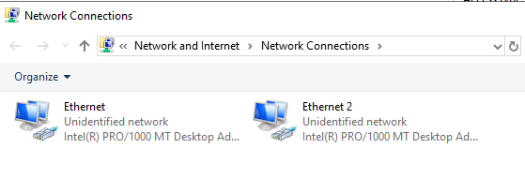
Start server two, go to the control panel, under network status and tasks, on the left side bar click “change adapter settings”. You should see ethernet and ethernet 2, left click and right click rename on ethernet (not ethernet 2). Name ethernet to “PublicNet2” -- then name Ethernet2 to “PrivateNet2”.

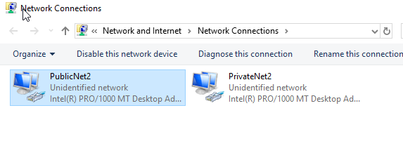
Should look like above.
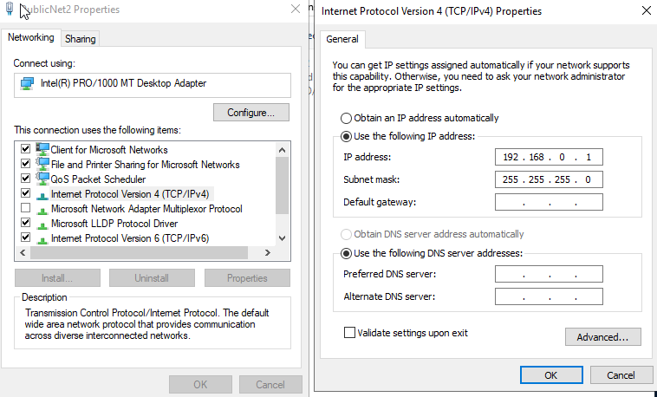
Left click on PublicNet2 and click properties, under internet protocol version 4, under properties of IPv4 another window will pop up. Click “use the following IP address”, enter the IP address “192.168.0.1”, and the subnet mask will be “255.255.255.0”, hit okay.

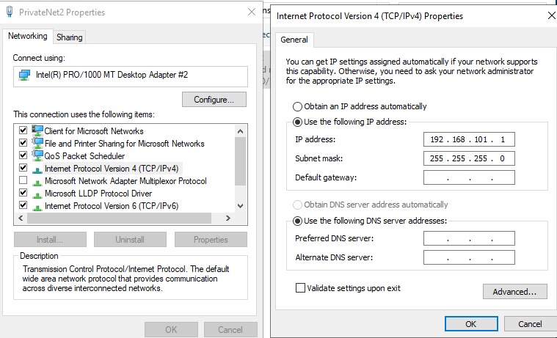
Now, left click on PrivateNet2, right click and under properties you should see internet protocol version 4. Under IPv4 click properties and under that window click “use the following IP address”, then ensure you type “192.168.101.1”, with a subnet mask of “255.255.255.0” -- then press okay, now shutdown.
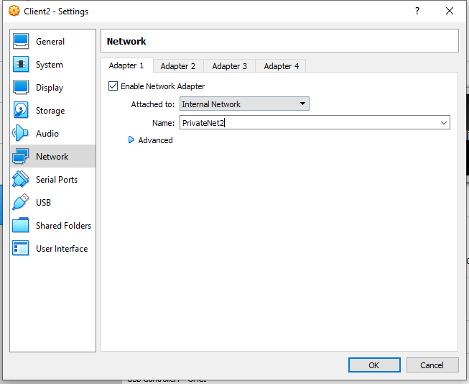
On client two, click settings and under the network tab, select “internal network” and name it PrivateNet2 -- then start the client.

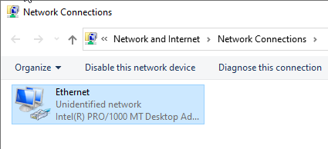
Go to the control panel network connections section, you should see ethernet, right click on it and rename it to PrivateNet2.
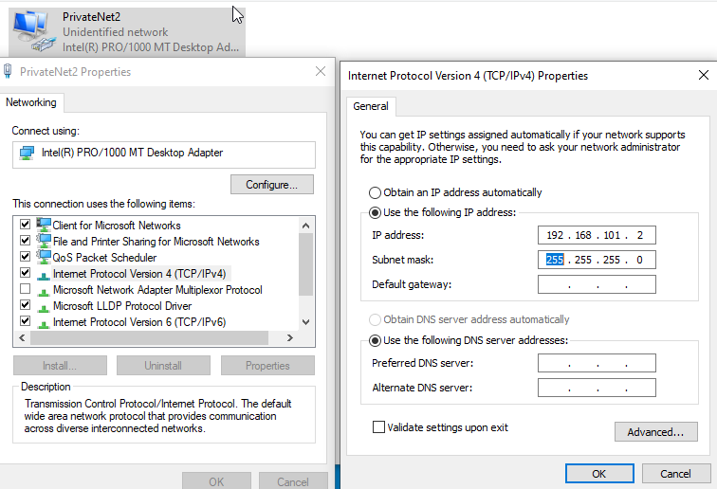
Right click on PrivateNet2 and click properties, under the IPv4 section click onto properties and then enter the IP address “192.168.101.2”, then shutdown the computer.

2.1.4.3. Server and Client communication;
For all servers and clients, you need to disable the firewall. To do this, type in “firewall”, within the windows search bar.
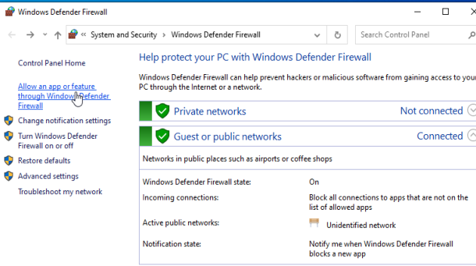
Click “turn windows defender off or on”.

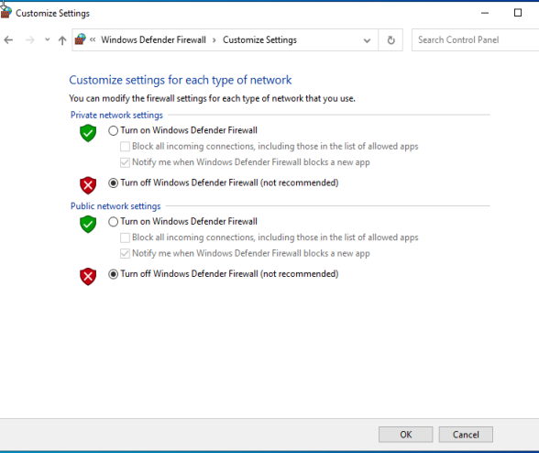
Then click “turn off windows defender firewall”, click okay.

Now, within the windows search bar for the client and server, search for “cmd” or “command prompt”. On client1, type “ping 192.168.100.1” to ping server one.
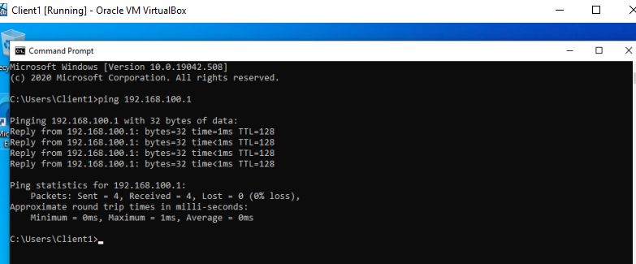

For server one, type “ping 192.168.100.2”.
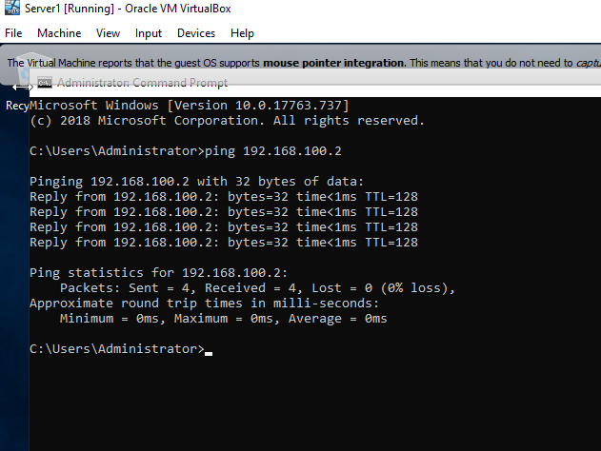

For both of the replies, you should have “Reply from 192.168.100.?: bytes=32 time<?ms TTL=128”. If there is no reply, you must have gone wrong on Virtual box or within the computers themes.

2.2. Observational task;

2.2.1. What is the difference between a type one and type two hypervisor?
Hypervisors have two types, one and two. Type one has no operating system or software between itself whereas type two has an operating system, according to [1]. [1] Type ones are found more in enterprise environments and type two are found in schools, homes and other.

2.2.2. What is the significance of the subnet mask in IPv4 addressing?
A subnet mask can range from 0 and 255. According to [2]. A subnet mask can be “255.255.255.0”, a shorthand version is a slash then the number, for example “/22”. Each Octet (which is the number between the full stop) determines whether the subnet mask is a class a, b or c according to [2] -- although you can have d,e and f categories, it's common to see a to c.

[2] Continues to state that the subnet mask is a 32-bit number, sets host bits to 0s and the network bits to 1s. 255 is always assigned to the host and 0 is assigned to to the network and no computers can be assigned them according to [2].

2.2.3. Cloud computing benefits and drawbacks;
Cloud computing has many benefits to customers and companies. Cloud computing has been known to allow users and companies to host files, play computer games, stream videos and more. Services such as Amazon's AWS, Google drive, Netflix, Steam and more.

Some negatives could include pricing as some services may charge more to do a thing you want and also the stuff offered to you might not be relevant, needed or not enough for pricing -- customisation means a lot to some.

According to [3], a business can increase or decrease bandwidth per requirement, moving to cloud computing removes the need for servers that would require specialised staff to maintain the servers, access to the cloud can be from any location and backups for the servers can be made so disaster can be totally eliminated.

With all that said, [4] states that downtime can be unpredictable for cloud platforms for maintenance or outages. Security and privacy should also be considered as you are allowing storage offsite to a third party which may open its own risks, [4] continues to state that online attacks can be more frequent as now anyone can might be able see a login page or intercept data, whereas that might have only been something you could have seen within the network (intranet).

2.2.4. Terminologies used;

2.2.4.1. Pings;
Ping(s) within the Microsoft Windows sense and not ping for the internet, verifies that a connection for an IP is connected according to [5]. This is done by going into the command prompt (CMD) and typing a command for the host computer to “ping” another computer, then windows will return whether the IP can be reached, if not an error is returned.
[5] continues and states that this is not limited to an IP address, instead you can use a domain name system (DNS).

2.2.4.2. Server manager;
According to [6], Windows Server Manager helps IT professionals manage local and remote windows-based servers from their desktops utilising a management console. [6] states that this feature is only available within Windows Servers from 2008 R2 and up to 2019.

2.2.4.3. Firewall;
Within this report, we turn off Windows Firewall to ping another computer, you should not turn off the firewall if you are connected to the internet. [7] states that the firewall can allow you to authorise applications, ports or files through the firewall for inbound or outbound traffic.

[7] states that the firewall “reduces the risk of network security threats”, “safeguards sensitive data and intellectual property” and lastly “extends the value of existing investment s”.

3. References
author/site, “Title”, site, [written/current data], [Online.], Available: URL, [Accessed: DATE]
[1] S.Simic, “What Is A Hypervisor? Types Of Hypervisors 1 & 2”, phoenixnap, 24 Jan 2019, [Online.] Available: https://phoenixnap.com/kb/what-is-hypervisor-type-1-2, [Accessed: 05 March 2021]
[2] avinetworks, “What is Subnet Mask?”, avinetworks, 2021, [Online.], Available: https://avinetworks.com/glossary/subnet-mask/, [Accessed: 05 March 2021]
[3] anblicks, “Benefits of Cloud Computing”, anblicks, 12 May 2016, [Online.], Available: https://anblicks-inc.medium.com/benefits-of-cloud-computing-8f6eee9a28e, [Accessed: 05 March 2021]
[4] A.Larkin, “Disadvantages of Cloud Computing”, cloudacademy, 7 August 2019, [Online.] Available: https://cloudacademy.com/blog/disadvantages-of-cloud-computing/, [Accessed: 05 March 2021]
[5] J.Gerend, E.Ross, T.Krokli, J.Parente, L.Poggemeyer, C.Plett, “ping”, microsoft, 11 July 2018, [Online.], Available: https://docs.microsoft.com/en-us/windows-server/administration/windows-commands/ping#:~:text=ping%20is%20the%20primary%20TCP,IP%20address%20of%20the%20computer, [Accessed: 10 March 2021]
[6] J.Gerend, E.Ross, J.Parente, I.Prittie, L.Poggemeyer, C.Plett, “Server Manager”, Microsoft, 16 October, [Online.], Available: https://docs.microsoft.com/en-us/windows-server/administration/server-manager/server-manager, [Accessed: 10 March 2021]
[7] D.Vangel, D.Simpson, M.Imran, M,Cruz, jcaparasm D.Mabee, et al, “Windows Defender Firewall with Advanced Security”, Microsoft, 21 October 2020, [Online.], Available: https://docs.microsoft.com/en-us/windows/security/threat-protection/windows-firewall/windows-firewall-with-advanced-security, [Accessed: 10 March 2021]
[8] cloudflare, “What is DNS?”, cloudflare, 2021, [Online.], Available: https://www.cloudflare.com/learning/dns/what-is-dns/, [Accessed: 10 March 2021]
[9] tenfold, “AGDLP”, tenfold, 2021, [Online.], Available: https://www.tenfold-security.com/en/wiki/agdlp/, [Accessed: 10 March 2021]
[10] zap, “About Cross-domain Windows Authentication and AGUDLP”, zap, 15 February 2021, [Online.], Available: https://help.zapbi.com/DataHub/CurrentVersion/content/topics/Security/security_about_agudlp.htm#:~:text=The%20AGUDLP%20method%20has%20the,provide%20access%20to%20Data%20Hub, [Accessed: 10 March 2021]

4. Bibliography
https://www.watchguard.com/help/docs/help-center/en-US/Content/en-US/Fireware/overview/networksecurity/slash_about_c.html

https://docs.microsoft.com/en-us/previous-versions/windows/it-pro/windows-server-2003/cc755692(v=ws.10)?redirectedfrom=MSDN

