Human Resource Management – Assignment

How the current and predicted changes in the external environment are related to the people resourcing strategies in Sports Direct International plc.

Module Lecturer: Mary March
Author: Dilyana Dimova
Student Number: 1908491

Table of contents
- Introduction …………………………………………………………………………….3
- Technological advancement as an external factor that could influence an HRM practices
  - How the technology could impact the recruitment process …………3
  - Innovative practises considered as a technology ………………………...4
- Casualisation of the workforce…………………………………………………5
- Diversity in the workplace ……………………………………………………….6
- Overview of the company ………………………….……………………………8
- Sports Direct International – resourcing strategies ………………….8
- Conclusion …………………………………………………………………………….10
References……………………………………………………………….…………….11

- Introduction

This report is going to look at several external factors that could influence and have already had a significant effect over HRM recruitment strategies. A definition of HRM has been presented (Armstrong, 2008) as a company’s assets of the most utter significance would be the workers, as they help achieving its goals. Being of such an importance would arise the need for the management of the organisation to apply a detailed and diplomatic approach towards them.

Another topic that would be presented is how these factors can affect the HR departments of the companies. Significantly, the changes these factors are going to raise in HR will be discussed as well as what issues the companies could face as a challenge and analyse the problems.

Firstly, this report is going to investigate the technological external factor, giving the right examples of technology transforming every part of the business environment nowadays and how it was adopted as to be of a benefit to each and every enterprise. Secondly, the casualisation of the workforce would be discussed. The positive and negative outcomes derived from the mechanism of hiring people on the position of casual workers would be examined. Furthermore, the concept of diversity and integration would be comprehensively reviewed. Finally, this report is going to look what influence these factors could have on the companies, in particular Sports Direct International plc.

- Technological advancement as an external factor that could influence an HRM practices

  - How the technology could impact the recruitment process

The work of HR department is never going to be the same as it was before. (CIPD, 2015) Nowadays, the hiring process is technologically advanced. Most of the steps before the actual face to face interview are online supported. If one organization would like to be successful, the HR unit has to make sure the best recruitment strategy has been applied. In order to do that, preselection technology could be used. For instance, this could be a software designed to do selection of the future employees without going through thousands of CVs manually. To give an illustration of how that software would work for the companies, the way this segmentation is done could be observed. For example, if an organization is looking for a candidate with specific qualities, parameters could easily be set in the software, so all the CVs that do not match the criteria would be set aside and the selection would be precisely finished. To put it in another words ‘’Ability to quickly apply higher selection standards to a number of applications’’ (Rietsema, 2019)

In addition to the previous example, it should be mentioned that there are various of different software operating with extremely smart algorithms, programmed to work in order to get a specific result. One of them is Connectifier. It has been presented by (Weekes, 2016) ‘’The system is 100% software driven with almost no manual intervention required. It will display and rank candidates that it believes are the best fit for a role and provides a number of different ways to contact people.’’

Furthermore, technological advancement has given the ability to not only search for qualified employees around the world but also to be able to interview them from a significant distance. Nowadays, some companies are going even further than that. According to The Guardian Unilever is using a software to evaluate and analyse graduates’ video interviews. The company is using it only optionally. The candidates have the right to choose a standard face to face interview instead. (Booth, 2019) But are these technologies good enough? Is that what the big organizations need to do? Saving from reducing the amount of the people in the HR departments should be good news for the employers, but is it that good for the current and future employees which pursue a career in the HRM?

  - Innovative practises considered as a technology

According to (Muller-Heyndyk, 2018) ‘’Recruitment is reactive and focuses only on short-term needs, whereas resourcing is long term and strategic.’’ With this in mind, an outline could be made that the report is not only looking on the recruitment process itself, but on the investing in the employees prosper.
In order to make the idea of innovative practises clear the definition by (Kossek, Spring 1987) could be used: a policy, program or practise that was invented to affect the way staff behave and was considered a brand-new idea is an HRM innovation. This would mark the difference between an HRM innovation and change in an organization.
For example, to measure and improve the employee’s engagement a suitable software could be used to send monthly surveys from the management with wide range of topics including level of stress, teamwork, friendly atmosphere, health and safety at the work place. Then the feedback from it could help in planning further actions of developing the work environment. In other words, ‘’ HRM is a technology associated with higher productivity performance. There is a view that managerial and organisational practices – specifically innovative ones – are a technology, since they aim to improve the efficiency of the productive factors used by the firm. This includes, most obviously labour, but also capital, and the interaction between the two.” (Forth, et al., October 2019)
To expand on this topic an idea to be mentioned is ‘’the main aim of the strategic human resources development is to increase the human resources ability in compliance with the fact that human capital of the company is the main source of competitive advantage.’’ (Kashi, 2014) Keeping that in mind, a conclusion that could be made is that investing in staff’s growth and competence is a technological resource which refers to the theory of the soft HRM.

- Casualisation of the workforce

The casual workers are people who work for a specific business that provides them with the necessary tools or equipment they need. They are offered work hours which they can reject but cannot send someone else to do their job for them. (Gov.uk, 2019) The process of casualization could be perceived as positive by the younger generation as they need to be flexible with the working time as most of them need to study and work simultaneously. However, for the rest of the population a ‘zero-hours’ contract could be a problem. These types of employment are quite risky. The people cannot be certain about the working hours they are going to have which consequently means they cannot be sure what amount of money they are going to receive at the end of the month. ‘’Some part-time and casual workers hold multiple jobs, working in split-shifts in different workplaces in order to achieve full-time hours of work (and to earn a liveable income)’’ (Zeytinoglu, et al., 2004)This process is usually used in the retail sector in order for the busy hours to be covered. Furthermore, the workers on such a contract are entitled to earn less than their co-workers on a full-time contract.

On the other hand, some women returned from their maternity leave are ‘forced’ to work part time so they can take care of their children. That is the main reason for the existing of the gender pay gap. (Burt, 2018)

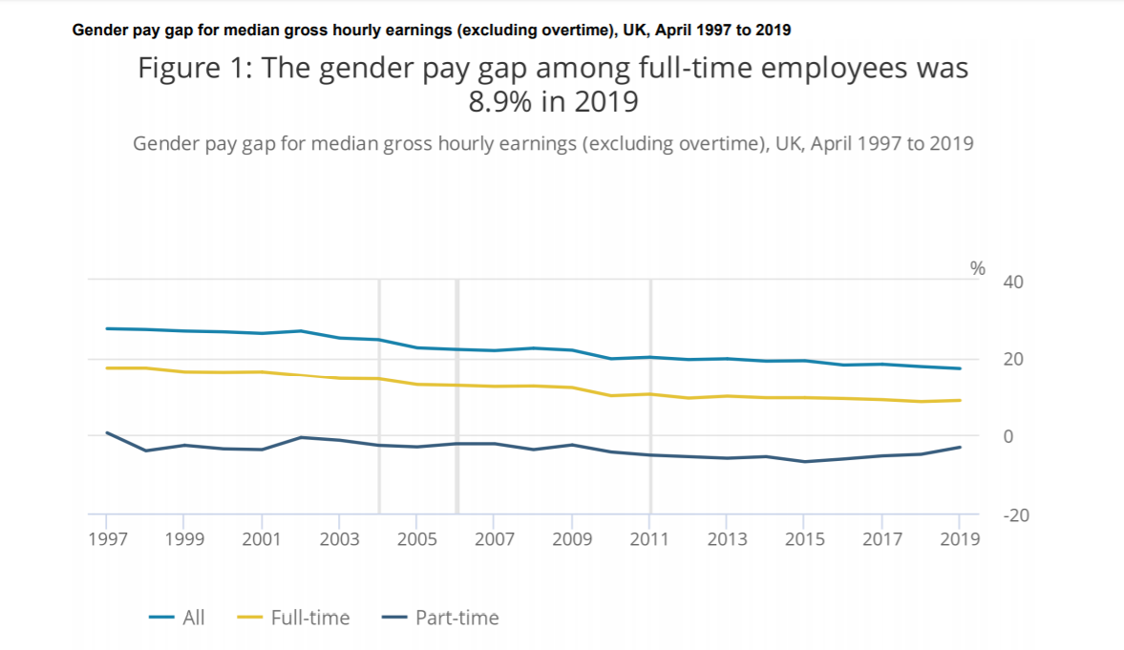
(Statistics, 2019)

This statement could be seen as part of the diversity pattern. The big question is: what about the people who desire to be employed on full time contract but there are not any available positions? Is it difficult nowadays to find a ‘secure’ job? And most importantly, is this not the century of the gig economic where the job with working time 9 to 5 is quite outdated?

- Diversity

Diversity is about not discriminating people. Factors that could be considered as discrimination are: race, gender, political beliefs, religion. The workforce diversity is
about understanding the difference between the human beings. Apart from discrimination being not only morally wrong but also legally, managers now claim that diversity will bring many benefits to the business. The diverse workforce will make the effectiveness of the organization higher, lift the morale and boost productivity. (David & Robin, October 1996) Bearing that in mind, the diverse environment could have an impact over the company’s performance. In the process of looking for talents, the organisation should look all around the world.

It has been reported that the inclusiveness at the workplace can be accomplished by taking several steps to ensure its success. For example, diversity trainings that would help employees feel welcome into the work organisation. However, those have been regarded as not likely to be quite effective. Another matter worth discussing is the name-blind hiring process. It has many advantages, one of which is cutting down on the possible biased opinion based on name, gender or the different circumstances of a person. Being a good first step into reducing the risk of bias, this alone would not minimize the problem of hiring minority groups. (CIPD, 2018)

A problem that men are facing is the stereotype for masculinity. For instance, one in five men (21%) are reported to be discouraged by their bosses to be taking time off work to take care of their children. Only 11% have said their superiors are comfortable with them taking unexpected days off in order to perform their parenting duties. (Muller-Heyndyk, 2019)

In order for the diversity pattern to be completely clear, the globalisation should be considered as an indicator that could have an influence. ‘’The way in which the country’s population expands, whether as a result of natural change or migration patterns, affects the gender composition, age profile and ethnic diversity of the labour market.’’ (Beardwell & Claydon, 2010)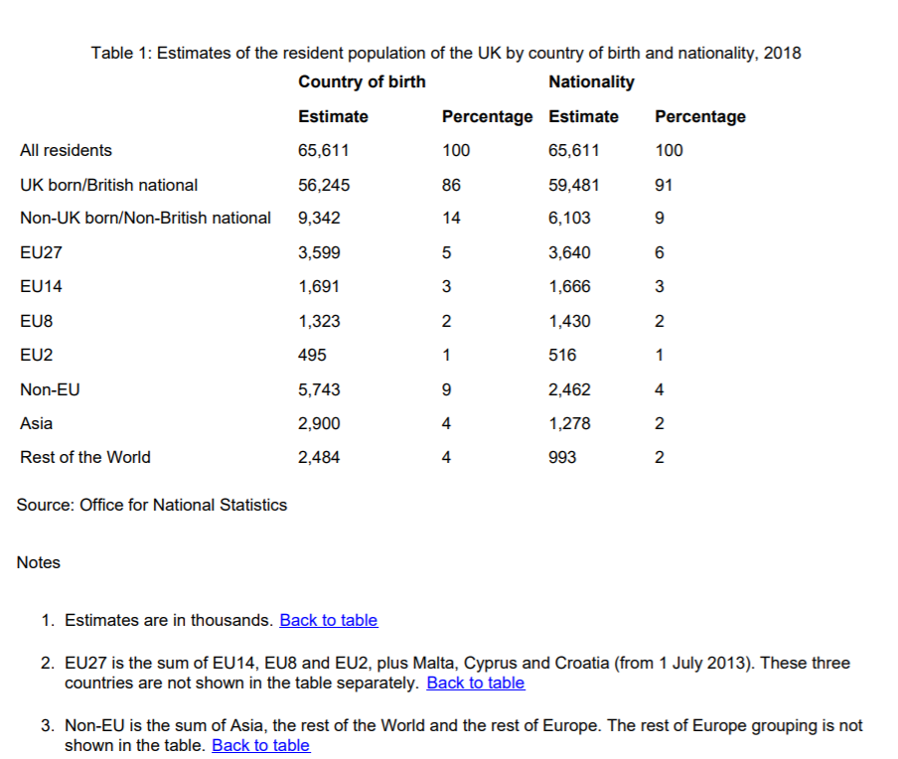

(Statistics, 2019)

- Overview of the company

Sports Direct International plc (Sports Direct, the Group, the Business or the Company) has bees founded in 1982 as a single store. The company is the biggest sporting goods retailer by revenue in the UK. There are approximately 29, 400 staff across six business segments which according to the Group are committed to treating all people with dignity and respect. ( International plc, 2019)

- Sports Direct resourcing strategies

According to one of the branch managers in Sports Direct, the company uses few different ways for recruitment. One of it is the traditional way for hiring going through the CVs manually and then inviting the chosen candidates to attend an interview. This method is usually related to the store’s managers and the hiring process for the staff needed to work in the shop floors. The other one is a bit more related to the work of the HR department. The human resource workers are responsible for the segmentation of the candidates in order for the company to choose the most suitable for the role employees. Then they divide them in groups for the interviews. There could be few interviews per day, which are going to be conducted by the managers of the particular branch or depending on the advertised position the interviews are going to be done by the manager in the particular working department. The manager strongly believes that the HR department is using a recruitment software in order for their job to be more efficient and quicker. (Brown, 2019)
Furthermore, according to the company Sports Direct operates in investing and rewarding their staff. The 5 stars commission scheme could help the employees to earn additional money on top of their salaries. (Direct, 2019) There are available opportunities for future career development which are represented by portfolio of training courses. Considering the theory explored in this report, it could be said that for Sports Direct International plc., the technological developments could be a serious advantage. Bear in mind that the Group is a global company, and living into a technological era would help the process of recruitment to occur effortlessly. The company believes that the employees need to be encouraged to develop their full potential along with the practices of staff rewarding. The communication between the workforce and the Group occurs via news emails, letters, staff portal / staff app and the intranet, as well as through briefings by direct managers and through the Group’s training programmes. ( International plc, 2019)

On the other hand, there are few more points of view to be considered. The first one would be that there were illegal practises in the company. Not only were there accusations of workers being treated with no respect in the shops but also treated as commodities (Commons, 2016-17)
Another matter worth discussing is the illegal act of hiring staff with no contract, which is unlawful by the Employment Rights Act 1996. As Commons (2016-17) have stated in their report, employees have been bullied and pushed around. What is more, a person was called selfish for expressing his desire to leave work on time. Mr Ashley, chief executive at Sports Direct, has said that such a treatment is unacceptable. (Commons, 2016-17)
Finally, Sports Direct is a company hiring people via zero hours contracts. In the year 2013 there was an announcement about the percentage of the workforce working on zero hours contracts. According to The Guardian, 90% of the employees were on such a contract and also giving them no sick leave or holiday. (Neville, 2013)
An issue that had emerged from court documents stated violation of contracts. Sports Direct had been reported to place returned workers after maternity leave on zero hours contracts. As a consequence, they were missing out on a bonus scheme. (Butler, 2016)
Having this problem with the maternity leave would bring about different issues as well. An example would be the difference between the genders having managerial positions. For instance, more male workers would be employed on higher position as women having maternity leave and the responsibility for looking after their children would slow down the development of their careers.

BREAKDOWN OF GENDER DIVERSITY IN SPORTS DIRECT INTERNATIONAL PLC.
Male Female
Directors | 5 | 2
Other senior managers | 589 | 232
All UK workforce | 5,600 | 8,577

( International plc, 2019)

- Conclusion

In conclusion, it could be said that the external factors are important for any organisation. They could have an impact on the recruitment strategies, as well as on the resourcing ones in order for the companies to keep their employees satisfied, safe and informed about the rights they have implemented by the employment law.
Even though there are some negative aspects of the external environment that affects Sports Direct, the Group could benefit from those who would have a positive and welcome influence over the business. The technological factor could have effect the way of hiring the future employees, the casualisation one could have impact on the company in order to offer work to the younger generation while they are still studying. All in all, zero hours contracts have their benefits, as long as they are not the main source of hiring employees. Nowadays, the companies need to look into the Employment law, and to make sure they are up to date. Finally, the diversity of the workforce would be crucial for Sports Direct, as a diverse working environment would be more efficient.

References
International plc, S. D., 2019. ANNUAL REPORT & ACCOUNTS 2019, s.l.: s.n.
Armstrong, . M., 2008. Strategic human resource management. s.l.:Kogan Page Ltd.
Beardwell, J. & Claydon, T., 2010. Human resource management a contemporary approach. 6th ed. s.l.:s.n.
Booth, R., 2019. The Gardian -Unilever saves on recruiters by using AI to assess job interviews. [Online]
Available at: https://www.theguardian.com/technology/2019/oct/25/unilever-saves-on-recruiters-by-using-ai-to-assess-job-interviews
[Accessed 25 November 2019].
Brown, J., 2019. Sports Direct-recruitment strategies [Interview] (26 November 2019).
Burt, E., 2018. Fewer than one in five women feel confident returning to work after maternity leave. [Online]
Available at: https://www.peoplemanagement.co.uk/news/articles/fewer-than-one-in-five-women-confident-return-maternity-leave
[Accessed 27 November 2019].
Butler, S., 2016. Sports Direct staff 'who took maternity leave put on zero-hours contracts'. [Online]
Available at: https://www.theguardian.com/business/2016/aug/12/sports-direct-staff-who-took-maternity-leave-put-on-zero-hours-contracts
[Accessed 29 November 2019].
CIPD, 2015. Changing HR operating models. s.l.:CIPD.
CIPD, 2018. Diversity and Inclusion at work: facing up to the business case, s.l.: CIPD.
Commons, T. H. o., 2016-17. Employment practices at Sports Direct, London : The House of Commons.
David , T. & Robin, E., October 1996. Making differences matter: A new paradigm for managing diversity. p. 79.
Direct, S., 2019. WHAT WE OFFER YOU. [Online]
Available at: https://www.sportsdirect.com/jobs/rewards
[Accessed 1 December 2019].
Dixon, H., 2017. Sports Direct bans foreign languages. The Daily Telegraph.
Forth, A., Askenazy, P. & Bryson, A., October 2019. Human resource management diffusion and productivity imbalances, s.l.: s.n.
Gov.uk, 2019. Employment status. [Online]
Available at: https://www.gov.uk/employment-status/worker
[Accessed 27 November 2019].
Kashi, K., 2014. Employees Training and Development: What Competencies Should be Developed the Most?. European Conference on Management, Leadership & Governance, pp. 452-459.
Kossek, E., Spring 1987. Human resource management. Volume 26, p. 72.
Muller-Heyndyk, R., 2018. https://www.hrmagazine.co.uk/article-details/organisations-should-focus-on-resourcing-rather-than-recruitment. [Online]
Available at: https://www.hrmagazine.co.uk/article-details/organisations-should-focus-on-resourcing-rather-than-recruitment
[Accessed 26 November 2019].
Muller-Heyndyk, R., 2019. Employers must combat outdated masculinity stereotypes. [Online]
Available at: https://www.hrmagazine.co.uk/article-details/employers-must-combat-outdated-masculinity-stereotypes
[Accessed 1 December 2019].
Neville, S., 2013. Sports Direct faces zero-hours backlash. The Guardian .
Rietsema, D., 2019. What is HRIS?. [Online]
Available at: https://www.hrpayrollsystems.net/hris/
[Accessed 28 November 2019].
Statistics, O. f. N., 2019. Gender pay gap in the UK: 2019. Gender pay gap in the UK.
Statistics, O. f. N., 2019. Population of the UK by country of birth and.
Weekes, S., 2016. GAME CHANGERS 2016. Recruiter, 2016, pp. 20-25.
Zeytinoglu, I. U., Lillevik, W., Seaton, M. B. & Moruz, J., 2004. Part-Time and Casual Work in Retail Trade. Relations Industrielles, pp. 516-543.

