Robert McIntyre
P149064
Implementation Project
Registration using Near Field communications - Designing
Tim Bashford.

Table of Contents
4 - Amendment Index 3
System description 3
Use case – Class Diagrams 3
Use Case Sequence Diagrams 4
Entity Relationship Diagram 4
Implication of the new system 7
Hardware and Equipment 8
Hardware Specifications 8
Cost 8
Benefits 9
Output Specification 9
Input Specification 10
Website Design 10
File Specification 10
Implementation Plan 12
References 13

4 - Amendment Index
There is one change to the original specification requirements.
LCD screen
There won’t be a screen attached to the Raspberry Pi as the GPIO pins are needed for the RFID scanner module. In place of this buttons may be used to interface to the program. This change occurs on page 4 section 2.1 explanation of software development methodology. This was agreed with the client at our weekly meeting on the 12th February 2018.

System description

Use case – Class Diagrams

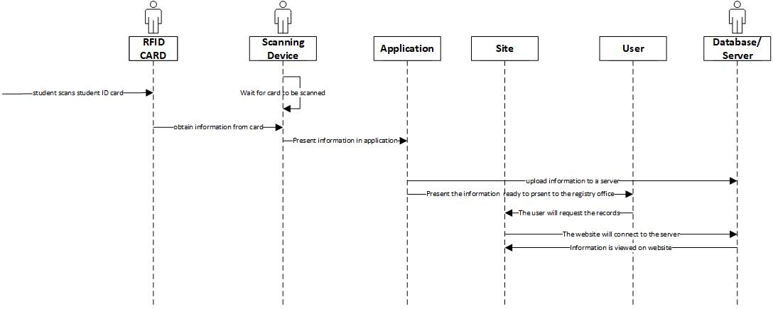
Use Case Sequence Diagrams

Entity Relationship Diagram
This show how all the tables are linked together.

Scanning the system – Flow chart diagram
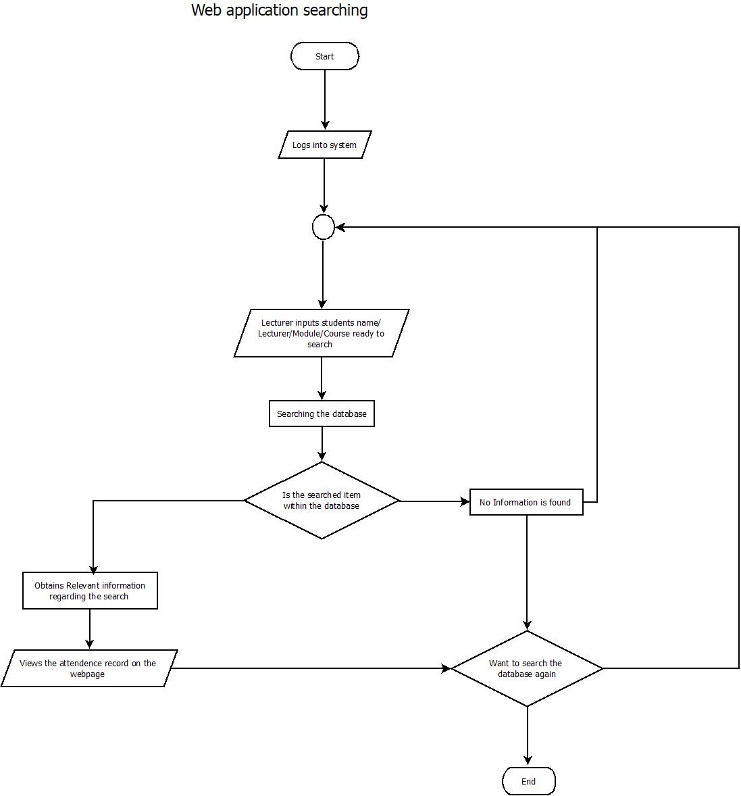
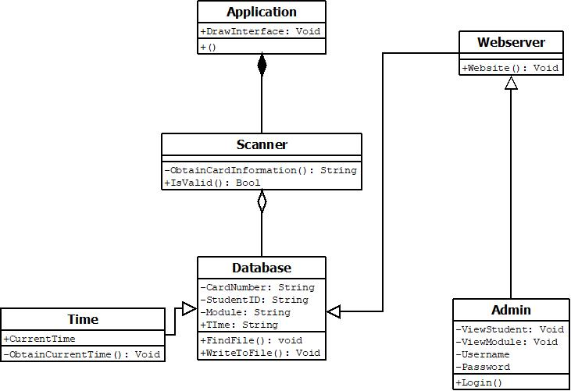
This flowchart shows how the raspberry pi will host the webserver.

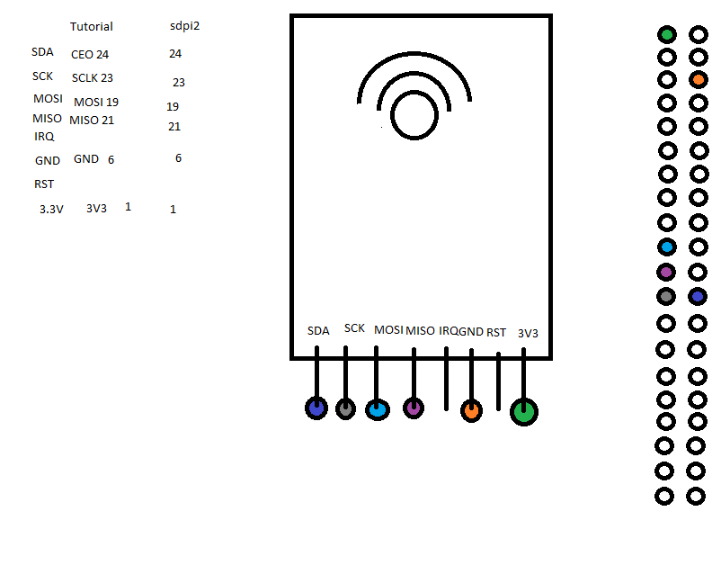
This is a diagram to connect the wires to the correct pins on the board.

Implication of the new system
The staff will need to be trained to learn how the system works. The students’ needs to be notified at the start of the year to bring in their student ID card every day to sign the register. There is will be a way to download the data from the device. The device will only be used to scan the cards. There will be a manual in place to instruct the client on how to use the device. Some security is needed on the Raspberry Pi as the device has data that needs protecting on it.

Hardware and Equipment
There are necessary pieces of equipment to use for this project. The main piece of hardware that is used is a Raspberry Pi computer. This is a single board computer. There is a module that connects to the Raspberry Pi which is required to scan the RFID on a student ID card. The module is an “RC522 reader” This module is compatible with the Arduino and the Raspberry Pi. To connect the module to the Raspberry Pi jumper cables are required. The RC522 module requires pins to be soldered to enable it to be connected to the Raspberry Pi board. This requires the soldering Iron and some solder.
A micro SD card is required to run a debian operating system on the Raspberry Pi
Web hosting is required to host the site to store the registers.

Hardware Specifications
The software is written for the Raspberry Pi 3.
As there was not enough room to connect all the external devices to the Raspberry Pi, the display was taken out. As there is no screen a LED may be needed to indicate the card has been scanned.
Raspberry pi specs:
‘CPU: 4× ARM Cortex-A53, 1.2GHz
GPU: Broadcom VideoCore IV
RAM: 1GB LPDDR2 (900 MHz)
Networking: 10/100 Ethernet, 2.4GHz 802.11n wireless
Storage: [8GB]microSD
GPIO: 40-pin header, populated’[1]

As the Raspberry Pi 3 is compatible with the previous versions they would also work if there is a wireless dongle attached and connected to the network. The Web hosting is also hosted from the Raspberry Pi, but this requires port forwarding on a local network. The student records are stored on the boot drive of the Raspberry Pi (micro SD card).

Cost
There are costs involved in making the project work correctly.
The main cost of the project is the hardware. Costs of items are below
- Raspberry Pi - £35
- Jumper Wire - £5.99
- RFID Kit RC522 Reader – £5.99
- Server cost - Unknown
There only cost is time in producing the software as this project is created and compiled within Linux.[2] The product is made for the university to replace their old system.
There is training required for the lecturers. A tutorial can be presented to a group of lecturers or lecturers can be shown it individually. A written manual on how the system works will contain the main troubleshooting points. Training will take some of the lecturers’ time.
When hosting a website there are several different options to choose from. One option is to pay a monthly fee to host your server. Another option is to host the website yourself. This requires setting up the website and port forwarding the IP address of PC which stores the website and the database. To make the website easily accessible the website needs a Domain Name. For this project the website is hosted within the Raspberry Pi so that the lecturers can retrieve the Students’ Registers.

Benefits
This system brings many benefits for both lecturer and the student as the device saves time for the lecturers as they do not have to input the data into an excel spreadsheet. The information quality is in a standard format ready for the registry office and can be managed by the lecturer. Students only need to swipe their card when they have entered their lecture. There are less chances for someone to accidently sign the wrong name. The database is stored in one location which is then accessed through the web, therefore the information is not duplicated.

Output Specification
There is a web interface for the lecturer to interact with. This interface will allow the lecturers to send the data to the registry office and make any amendments such as reasons for absence. The website will be made using visual studio as this
Upload document to registry office from the website.
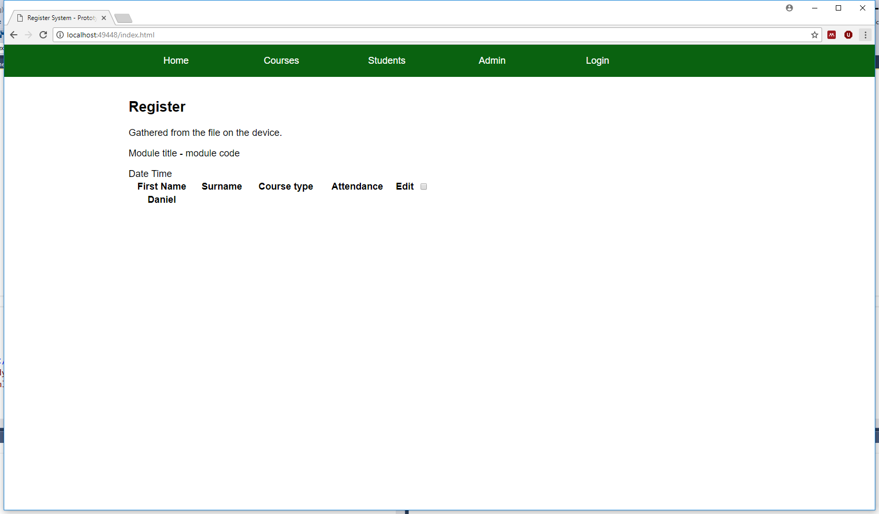
The figure above is the prototype of the output where the register will show on the left hand side.
Text file example sent to registry

Input Specification
There main input for this project is the scanner as this is able to store inputs.
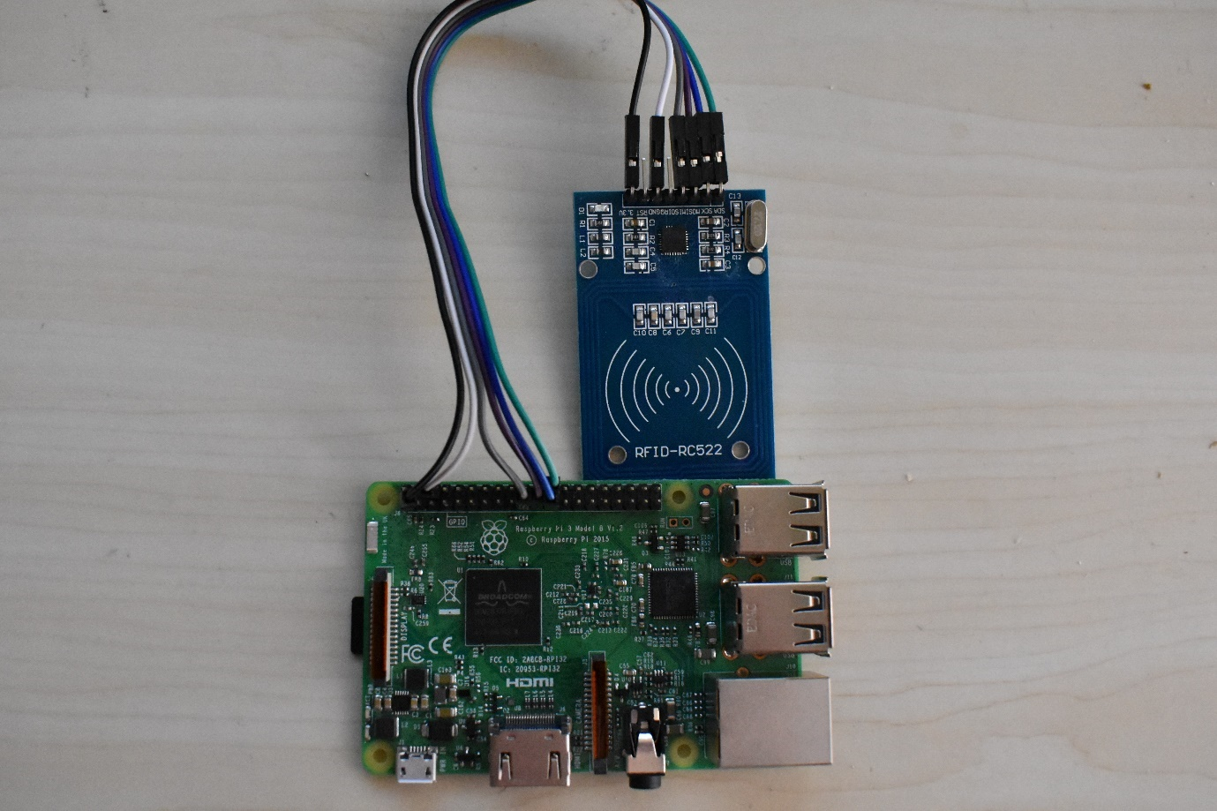
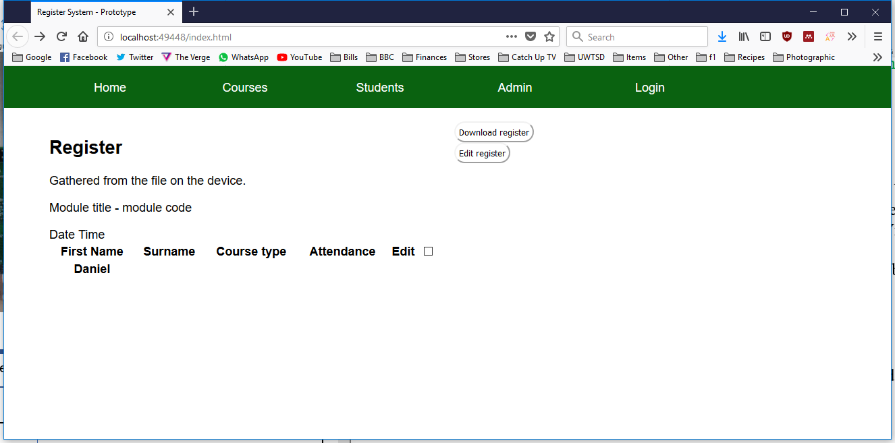

Website Design
Banner – Menu icons
Main Window

File Specification
Text file from Raspberry Pi. Lecturer accesses file through the website and makes any changes saves and sends the file to registry. Raw file and processed file. Database will store the students information and their student ID card information so, when scanned the address on the register will search the database to see if the student exists. The possible names of the database and text files
Database – The text in bold are the primary keys.
- Student table
  - StudentID – 8
  - First name – 25
  - Surname – 25
- Course Table
  - CourseID – 15
  - Title – 30
  - Room – 6
  - Time – Time
- Register Table
  - RegisterID – 8
  - LectureID – 8
  - StudentID - 8
  - Time Of Arrival – DateTime
  - ModuleID – 15
- Module
  - ModuleID – 15
  - LectureID – 8
  - Number of lecture in a week - 1
  - Lecturer teaching – 8
- Lectures Table
  - LectureID - 8
  - Time Date – Date/ Time
  - CourseID - 15
  - Room - 6
  - Length - Time

- Lecturers Table
  - LecturerID - 8
  - First Name - 25
  - Surname -25
  - Title - 5
  - RegisterID - 8
There will be a file that stores the recorded information called “Register recorded.txt”
The may be a hundred records per lecture to the device which collects the information for the whole academic year. The information will be deleted when the project is finished, so that data is not stored. The text files are updated regularly when the student ID cards are scanned. As the data is important there is going to be a back up strategy.

Implementation Plan
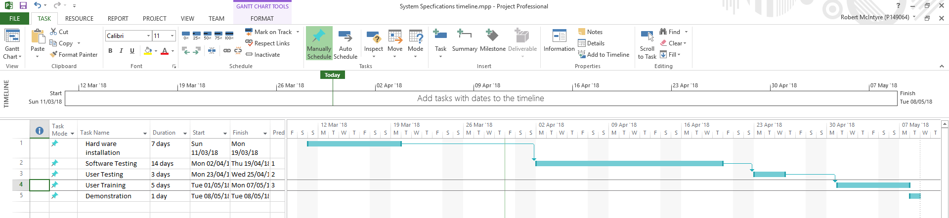
This is the plan for testing and supplying to the user for testing. Some of the testing is providing the lecturers the device for them to use in order to get some feedback. The lecturers will also be asked to test the website to see if they find the website user friendly. The hardware installation consisted of soldering the pins to the board and connecting the correct pins between the module and the Raspberry Pi . The software testing tests to see if the ID card registers and saves the information to the file and uploads the file to the webserver making sure that the information is accessible on the website.

References
[1] “Raspberry Pi 3 is out now! Specs, benchmarks &amp; more - The MagPi MagazineThe MagPi Magazine.” [Online]. Available: https://www.raspberrypi.org/magpi/raspberry-pi-3-specs-benchmarks/. [Accessed: 18-Mar-2018].
[2] “Install Mono on Linux | Mono.” [Online]. Available: http://www.mono-project.com/docs/getting-started/install/linux/. [Accessed: 19-Mar-2018].

