
Networks and Cyber Security Essentials - ACCA4024

Lecturer: Muhammad Azeem Abbas

Assignment Topic
A Cybersecurity and Data Governance: The Case of SteelForm Manufacturing Ltd

Student: Assadullah Gulamhussein (2509693)

Word Count: 1,969
(Excluding title page, Abstract, content list, list of figures, list of tables, references, appendices)

UNIVERSITY OF WALES TRINITY SAINT DAVID

Abstract
This report outlines a cyber-security and data-governance plan for SteelForm Manufacturing Ltd (SFM), a mid-sized automotive and aerospace parts manufacturer. SFM has implemented smart-manufacturing technologies such as Internet of Things (IoT) sensors, automated manufacturing equipment and a cloud-based production system that enhance productivity, but also creates its own body of vulnerabilities. Malware infection, procurement personnel phishing and intruder activity have demonstrated the risk is present right now. The report identifies current internal and external threats and then proposes a layered response built on the CIA triad, the Zero Trust model, ISO/IEC 27001:2022 and the NIST. Cybersecurity Framework 2.0. It outlines security policies, technical and administrative controls, a proactive monitoring and response plan, and a continuous staff training program. Its result is a proportionate, standards-based approach that minimises the risk and effect of attacks, enables compliance with United Kingdom law and safeguards SFM's production and intellectual property.

Table of Contents
Abstract 2
1. Introduction 4
2. Task 6
2.1. Identification of Modern Threats 6
2.2. Modern Security Policies 7
2.3. Technical Mitigation Measures 9
2.4. Proactive Monitoring and Incident Response 11
2.5. Continuous Training and Awareness 13
3. Conclusion 15
4. Reference 16
5. Appendices 18

Introduction
Computer security is a major issue of the digital era. Organisations are increasingly integrating their processes into the global network, which has led to cyberattacks becoming larger, faster and more complex, impacting hospitals, governments, utilities and factories worldwide [1]. Information Technology (IT) and Operational Technology (OT) merging in Industry 4.0 has enabled efficiencies in a very vulnerable environment for industry. However, manufacturing is the sector that is hardest hit, with 27.7% of reported incidents in 2025, and it has the most ransomware incidents, as production downtime is very costly [2], [3]. The average cost of data breaches has risen to USD 4.44 million on the global level in 2025 [4].
SteelForm Manufacturing Ltd (SFM) is a medium-sized company manufacturing a range of custom-engineered components for the automobile and aircraft industries. It has implemented IoT sensors, automated machines, and a cloud-based production network, and has already had malware attacks, phishing targeting procurement staff, and attempts to grant unauthorised access to its production network. In this report, the author proposes a plan to defend SFM from contemporary internal and external threats, based on widely used cybersecurity frameworks like the NIST Cybersecurity Framework and CISA Known Exploited Vulnerabilities catalogue.

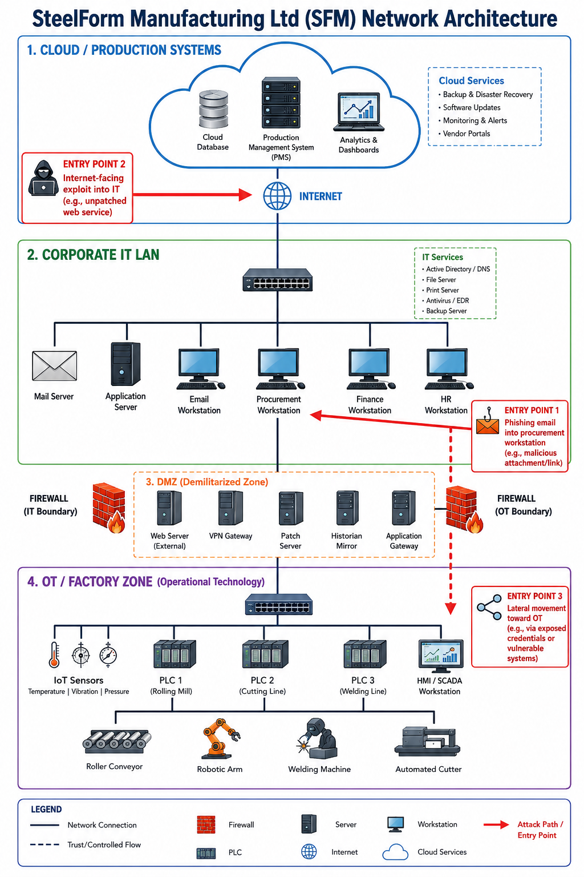

Figure 1: SFM smart-factory architecture and cyber-attack surface

Task

2.1. Identification of Modern Threats
A clear understanding of the threat landscape is the foundation of any security strategy. Threats to SFM are grouped into external threats, from outside the organisation, and internal threats, from people or systems inside it, and each is assessed against the CIA triad of confidentiality, integrity and availability [5].
The most pressing external threat is ransomware, which is now widely sold through Ransomware-as-a-Service (RaaS) models that let low-skilled criminals rent ready-made attack tools [6], [7]. This risk is not hypothetical. In 2019, the aluminium producer Norsk Hydro became the victim of a LockerGoga ransomware attack, where several plants were unlawfully put to manual operation at $75 million in estimated damages; the company backed up to resume operations and not pay ransom [8]. The primary entry vectors are phishing and AI-enabled social engineering, such as Deep Voice Phishing (vishing), and SFM has already witnessed phishing targeting procurement [6]. Attackers use internet-facing applications, stolen credentials, and supply chain compromises are growing significantly: involvement of third parties doubles year-on-year [2], [6]. The migration to cloud services and hybrid working has also further increased the attack surface. Being in an industry that serves the automotive and aerospace industries, threats of industrial espionage and intellectual-property theft are also possible threats. People are the weakest link within the organisation and participate in approximately 60% of breaches [6]. Staff members can be caught by phishing scams and use weak passwords, and malicious inside users with access to expensive plans are a persistent threat. Unauthorised shadow IT and shadow AI result in uncontrolled data transfer, and SFM's all-in-one IT/OT network is also brittle. Often, legacy programmable logic controllers (PLCs) are not patchable, there are flat networks from which lateral movement can be made, and IoT devices come with the low-level default credentials. Table I summarises the main threats. The financial and operational effects of incidents can be significant: loss or reduction of production, contractual penalties and reputational damage to automotive and aerospace clients, including in excess of the ransom demand. Since the threats vary by their likelihood of occurring, SFM should consider ransomware, phishing, and insecure OT devices as top priorities (Table I).

Table I: SteelForm Manufacturing threat register (summary).
Threat | Type | Primary CIA impact | Likelihood / Impact
Ransomware / RaaS on IT and OT | External | Availability, Integrity | High / Critical
Phishing & AI-powered vishing (procurement) | External | Confidentiality | High / High
Exploitation of internet-facing apps / stolen credentials | External | Confidentiality, Integrity | High / High
Supply-chain / third-party compromise | External | All three | Medium / High
Cloud and hybrid-work exposure | External | Confidentiality | Medium / High
Industrial espionage / IP theft | External | Confidentiality | Medium / Critical
Insecure IoT / legacy OT devices | Internal | Availability, Integrity | High / High
Negligent staff / weak passwords | Internal | All three | High / High
Malicious insider; shadow IT / shadow AI | Internal | Confidentiality | Low–Med / Critical

2.2. Modern Security Policies
SFM should manage security through an Information Security Management System (ISMS) aligned with ISO/IEC 27001:2022, the international standard that provides a risk-based framework and 93 Annex A controls across four themes: organisational, people, physical and technological [9]. The ISMS should be governed based on the six functions of the NIST Cybersecurity Framework 2.0: Govern, Identify, Protect, Detect, Respond and Recover with explicit governance and supply-chain expectations [10]. Importantly, the policies should be based on Zero Trust, which adopts the principle that no user or device should be trusted by default, and requests verification of each and every access request from anywhere. Importantly, the policies should be based on Zero Trust, which is defined by the principle that nobody and nothing is trusted by default, and requests verification of every access request from anywhere [11]. This works well with SFM's cloud and hybrid-working workplace. Each policy should help to implement the CIA triad and should be approved by the board [5]. ISO 27001 and the NIST CSF are selected as they are well-known frameworks and overlap, providing SFM with certifiable rigour as well as a more flexible language for governance; a lighter scheme like Cyber Essentials would be simpler, but would not cover OT and supply-chain risks to the same level.
A documented risk-assessment process should sit at the heart of the ISMS that identifies what assets are there, whether there are threats to that asset, and whether there are proportionate controls to address it; the risk-assessment process should be reviewed at least once a year [12]. Accordingly, SFM should have a comprehensive set of policies in place, including acceptable use, access control/identification, data classification and governance, authentication, remote access and BYOD, patch/vulnerability management, third-party and supply-chain security, incident response, and backup and business continuity. The Data Classification and Governance Policy must include adequate policies and procedures for processing information for legitimate purposes according to the criteria of the requirements of the UK GDPR and the Data Protection Act 2018, as amended by the Data (Use and Access) Act 2025. The Information Commissioner's Office has the power to fine organisations up to £17.5m or 4% of global turnover for severe breaches [13]. To stay effective, the ISMS should be maintained through internal audits and management reviews under a plan-do-check-act cycle, so that controls improve as the threat landscape changes. Table II maps the main policies to their objectives and standards.
Table II: Proposed security policies mapped to objectives and standards.
Policy | Objective | Aligned control/standard
Access Control & Identity (Zero Trust) | Verify every access; least privilege, RBAC, MFA | ISO 27001 A.5.15–A.5.18; NIST Protect
Data Classification & Governance | Classify and lawfully protect data | UK GDPR / DPA 2018 (DUAA 2025)
Patch & Vulnerability Management | Fix exploited flaws first (CISA KEV) | ISO 27001 A.8.8; NIST Identify
Third-Party / Supply-Chain | Assure supplier and cloud security | ISO 27001 A.5.19–A.5.23; NIST Govern
Incident Response | Detect, respond to and recover from incidents | ISO 27001 A.5.24–A.5.28; NIST Respond
Backup & Business Continuity | Immutable backups for ransomware resilience | ISO 27001 A.8.13; NIST Recover

2.3. Technical Mitigation Measures
Policies must be enforced through practical, layered controls, following a defence-in-depth approach so that no single failure exposes the organisation [5]. As SFM is a medium-sized firm with a limited budget and a small team, controls should be prioritised by risk and feasibility.
First, SFM should segment its network using virtual LANs (VLANs) and subnetting to separate corporate IT from the OT/factory zone, place internet-facing services in a demilitarised zone (DMZ) behind firewalls, and isolate PLCs and IoT devices. This limits lateral movement and would have contained an incident such as the Norsk Hydro attack, which spread because the network was not sufficiently divided [8]. Second, because stolen credentials are a leading entry vector, SFM should deploy identity and access management with multi-factor authentication (MFA), least-privilege roles and prompt de-provisioning of leavers [2], [6]. Third, endpoint detection and response (EDR), anti-malware and application allow-listing should be installed across devices [14]. Fourth, patch and vulnerability management should be prioritised using the CISA Known Exploited Vulnerabilities (KEV) catalogue, so that flaws known to be exploited are fixed first; where legacy PLCs cannot be patched, virtual patching and network isolation should be used [15]. Fifth, sensitive design data should be encrypted at rest and in transit. Sixth, an email and web security gateway with anti-phishing filtering should protect staff, supported by email authentication (SPF, DKIM and DMARC) to reduce spoofing. Seventh, the cloud production system should be hardened using secure configuration, cloud security posture management (CSPM) and protected APIs. Finally, SFM must keep immutable, offline copies in alignment with the 3-2-1 principle, which ensures that data cannot be compromised by ransomware. Access by remote users and third parties must be provided via a secure VPN connection or a third-party zero trust network access service, with enhanced authentication means and comprehensive logging. Administrative controls include risk assessments, vendor due diligence and supplier security clauses, as well as physical security like access control and CCTV for areas such as the plant floor and server rooms. They are layered with each other, meaning that if one security measure fails, such as one of the staff members clicking on a malicious link, others, like MFA and segmentation, hold the damage back; they are also selected to safeguard security without interfering with continuous production. The measures should be phased in (Table III), and Table IV shows the costs and benefits of the measures. Figure 2 illustrates the layered model.
Table III: Phased implementation roadmap for SteelForm Manufacturing.
Phase | Timescale | Key actions | Cost | Owner
Quick wins | 0–3 months | MFA, immutable backups, email filtering, launch awareness training | Low | IT / Security Manager
Medium term | 3–12 months | IT/OT segmentation, EDR, CISA-KEV patching, SIEM/SOAR via MSSP | Medium | IT team + MSSP
Strategic | 12+ months | Full Zero Trust, ISO 27001 certification, secure-by-design procurement | High | Board + Security function

Table IV: Indicative cost and benefit of the main controls.
Control | Cost | Primary benefit/risk reduced
MFA & identity management (Zero Trust) | Low | Blocks most credential-theft attacks [2], [6]
Network segmentation & firewalls | Medium | Contains ransomware and protects OT [8]
Immutable, offline backups | Low–Medium | Enables recovery without paying a ransom [8]
Security awareness training | Low | Cuts phishing susceptibility from 33.1% to 4.1% [16]
SIEM / SOAR monitoring (MSSP) | Medium–High | Faster detection and lower breach cost [4]
CISA-KEV patch management & EDR | Medium | Reduces exploited vulnerabilities and malware risk [2]

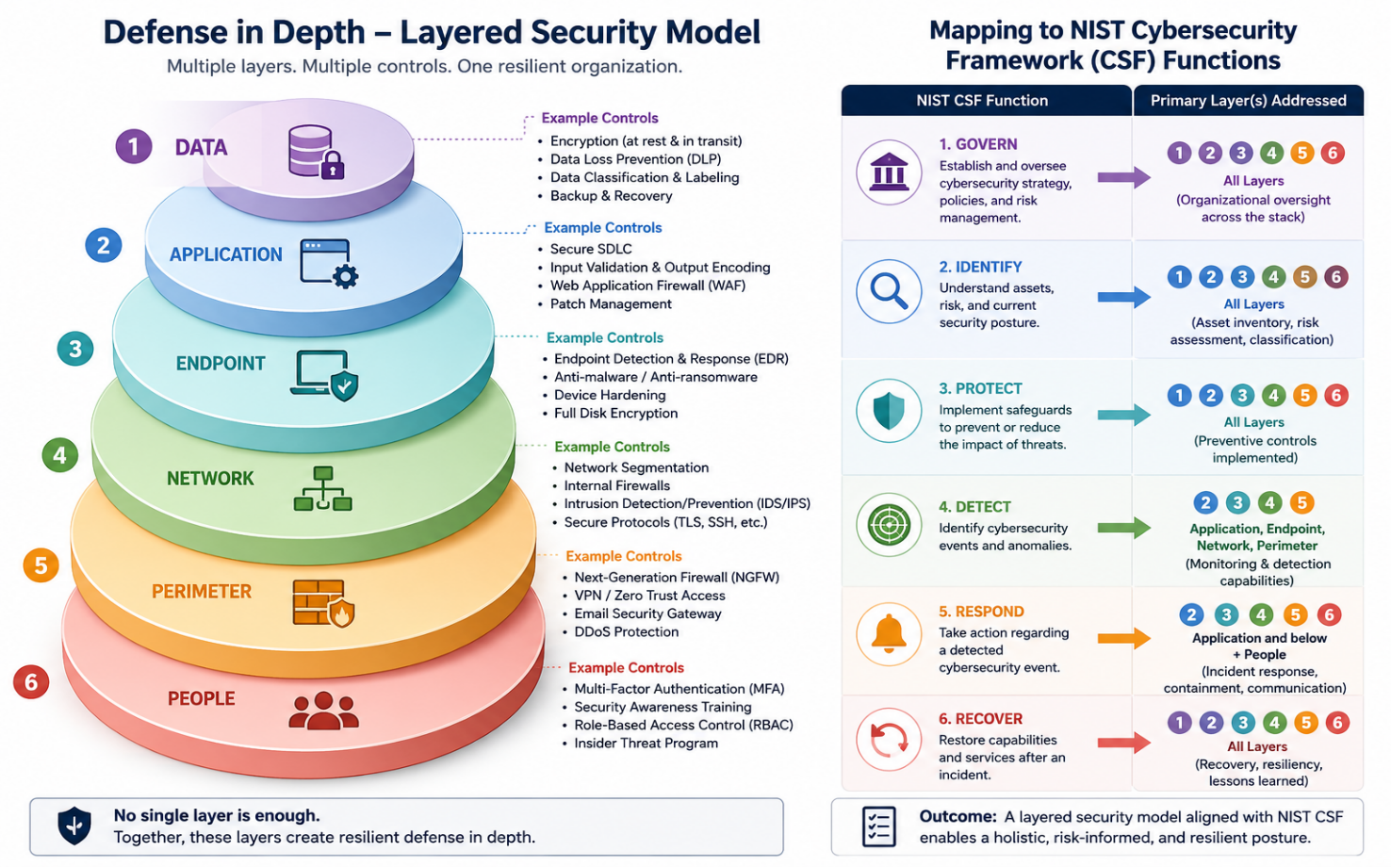

Figure 2: Defence-in-depth controls mapped to the NIST CSF 2.0 functions.

2.4. Proactive Monitoring and Incident Response
Prevention is not enough; SFM must detect and respond to incidents quickly. Continuous 24/7 monitoring should be achieved through a Security Information and Event Management (SIEM) platform that collects logs from IT and OT systems, increasingly paired with Security Orchestration, Automation and Response (SOAR) to speed up and partly automate reactions [10]. Given SFM’s size, a managed security service provider (MSSP) can deliver round-the-clock monitoring and threat intelligence cost-effectively. Faster detection matters, as the average breach lifecycle is 241 days and shorter lifecycles cost far less [4]. SFM should also take part in threat-intelligence sharing, for example through national bodies such as the NCSC, so that it learns of emerging attacks before they reach its own network.
A formal incident-response plan should follow the recognised lifecycle of preparation, detection and analysis, containment, eradication, recovery, and post-incident review, carried out by a Computer Security Incident Response Team (CSIRT) with clear roles [5]. Specific ransomware procedures should include isolating affected systems, preserving evidence and restoring from immutable backups. Where personal data is involved, SFM must notify the Information Commissioner’s Office within 72 hours [13]. Effectiveness should be measured through mean time to detect and respond, and every incident should feed lessons back into policy. A tested business-continuity and disaster-recovery plan should also define recovery time and recovery point objectives (RTO and RPO) for critical production systems and be rehearsed through tabletop exercises, so that recovery is proven rather than assumed. Figure 3 shows the workflow.
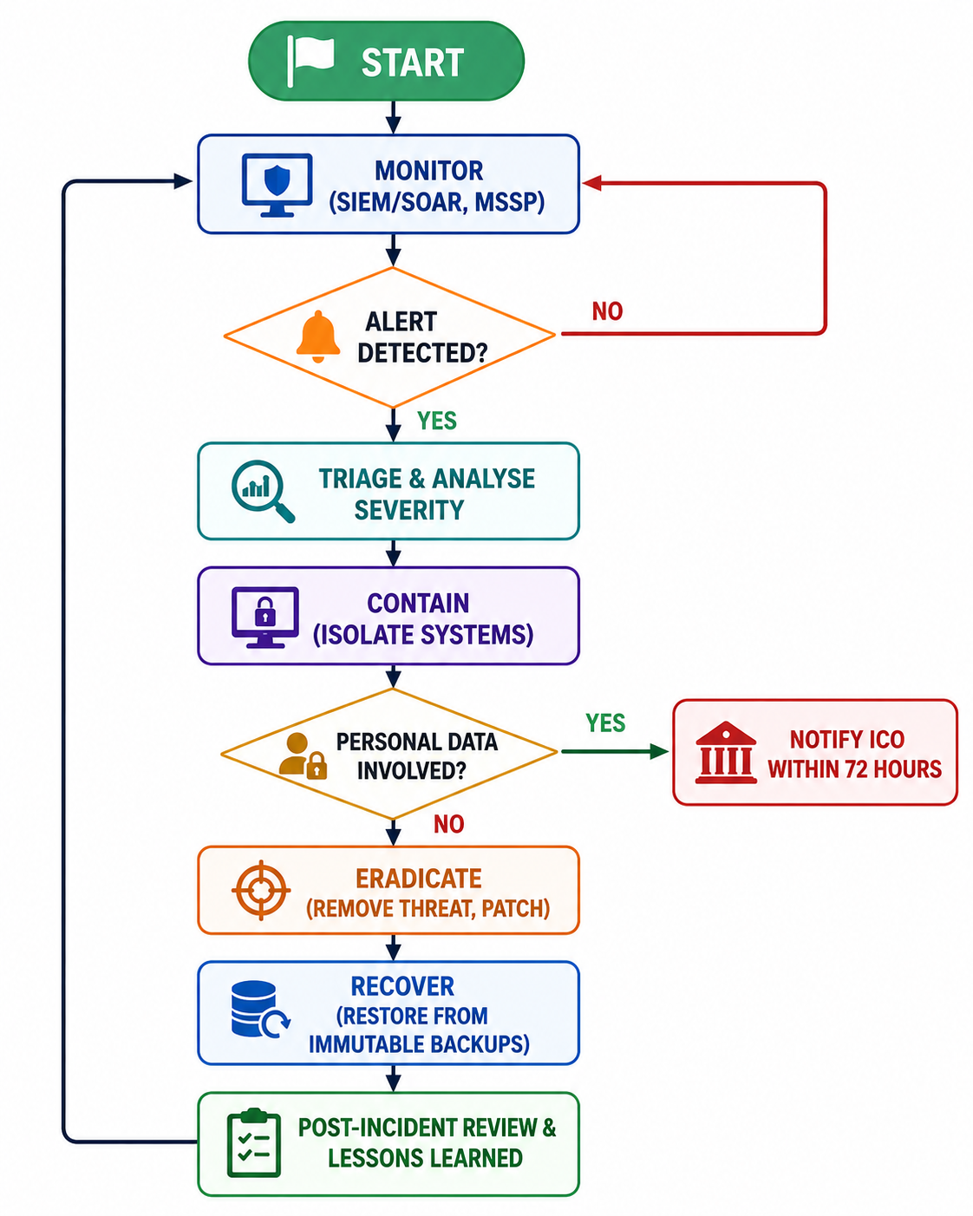
Figure 3: SFM incident-response and monitoring flowchart.

2.5. Continuous Training and Awareness
Because people are involved in around 60% of breaches [6], training is one of SFM’s most cost-effective defences. Structured security awareness training reduces the average phish-prone rate from 33.1% to 4.1% within twelve months, an improvement of 86% [16]. SFM should therefore run a continuous, role-based programme rather than a single annual video, in line with the people controls of ISO/IEC 27001:2022 [9].
The programme should begin with a security induction for new staff and continue through regular micro-learning. It should include continuous simulated attacks covering both phishing and AI-driven vishing, so that staff learn to recognise modern lures. Content should be tailored: procurement staff need training on phishing, vishing and business-email compromise; engineers need OT and IoT security awareness; and executives need awareness of whaling. A blame-free culture that encourages prompt reporting turns staff into an active line of defence. Effectiveness should be tracked through phish-prone percentage, completion rates and reported incidents, building over time a positive security culture. Investment in training is easy to justify, because staff awareness measurably lowers breach cost and reduces the human error behind most incidents [4]. Visible support from senior leaders is important, as it signals that security is a shared responsibility rather than only an IT concern. Table V outlines the programme.
Table V: Proposed staff training and awareness programme.
Audience | Focus | Frequency | Method | Key metric
All staff | Security basics, passwords, data handling | Induction + annual | E-learning + micro-learning | Completion rate
Procurement/finance | Phishing, vishing, BEC, invoice fraud | Quarterly | Simulated phishing/vishing | Phish-prone %
Engineers/OT operators | IoT & OT security, safe device use | Bi-annual | Hands-on briefings | Incidents reported
Executives/board | Whaling, governance, breach duties | Bi-annual | Targeted briefings | Awareness score
Security champions | Reinforcement & peer support | Ongoing | Community + updates | Engagement

Conclusion
The transformation to smart manufacturing will provide great advantages to SFM, but it will also pose threats from among the most attacked sectors of the United States. Layered mitigation, proactive SIEM/SOAR monitoring and regular training can, when combined with a Zero Trust policy-driven and ISO 27001-managed ISMS, help to minimise cyber risk and secure production and IP. It's advised that the board implement a progressive approach, starting with the easy wins like MFA, immutable backups and then staff awareness, and progressing onto network segmentation and the deployment of Zero Trust. The strategy should be reviewed regularly as no organisation can eliminate cyber risk. More work is needed to move towards the complete ISO 27001 standard, quantify the degree of security maturity in the factory, using the NIST framework to monitor, and create OT-specific threat modelling as the factory grows increasingly connected.

Reference
[1] P. Ewoh and T. Vartiainen, “Vulnerability to Cyberattacks and Sociotechnical Solutions for Health Care Systems: Systematic Review,” J Med Internet Res, vol. 26, p. e46904, May 2024, doi: 10.2196/46904.
[2] IBM, “X-Force Threat Intelligence Index 2026 | IBM.” Accessed: Jul. 23, 2026. [Online]. Available: https://www.ibm.com/reports/threat-intelligence
[3] Chris Caridi, “X-Force Threat Intelligence Index 2025 highlights attackers steal, and sell, user identities at scale | IBM.” Accessed: Jul. 23, 2026. [Online]. Available: https://www.ibm.com/think/x-force/x-force-threat-intelligence-index-2025-attackers-steal-sell-user-identities
[4] IBM, “Cost of a data breach 2025 | IBM.” Accessed: Jul. 23, 2026. [Online]. Available: https://www.ibm.com/reports/data-breach
[5] Cisco Networking Academy, “Cybersecurity Essentials.” Accessed: Jul. 23, 2026. [Online]. Available: https://www.netacad.com/courses/cybersecurity-essentials?courseLang=en-US
[6] Verizon, “2026 Data Breach Investigations Report (DBIR),” Verizon Business. Accessed: Jul. 23, 2026. [Online]. Available: https://www.verizon.com/business/resources/reports/dbir/
[7] Er. Kritika, “A comprehensive literature review on ransomware detection using deep learning,” Cyber Security and Applications, vol. 3, p. 100078, Dec. 2025, doi: 10.1016/j.csa.2024.100078.
[8] gcohen, “Throwback Attack: Norsk Hydro gets hit by LockerGoga ransomware,” Control Engineering. Accessed: Jul. 23, 2026. [Online]. Available: https://www.controleng.com/throwback-attack-norsk-hydro-gets-hit-by-lockergoga-ransomware/
[9] ISO, “ISO/IEC 27001:2022,” International Organization for Standardization. Accessed: Jul. 23, 2026. [Online]. Available: https://www.iso.org/standard/27001
[10] C. Pascoe, S. Quinn, and K. Scarfone, “The NIST Cybersecurity Framework (CSF) 2.0,” NIST, Feb. 2024, Accessed: Jul. 23, 2026. [Online]. Available: https://www.nist.gov/publications/nist-cybersecurity-framework-csf-20
[11] National Cyber Security Centre, “10 Steps to Cyber Security | National Cyber Security Centre.” Accessed: Jul. 23, 2026. [Online]. Available: https://www.ncsc.gov.uk/collection/10-steps
[12] ISMS, “Risk Assessment - ISMS.online,” https://www.isms.online/. Accessed: Jul. 23, 2026. [Online]. Available: https://www.isms.online/glossary/risk-assessment/
[13] ICO, “The Data Use and Access Act 2025 (DUAA) - what does it mean for organisations?” Accessed: Jul. 23, 2026. [Online]. Available: https://ico.org.uk/about-the-ico/what-we-do/legislation-we-cover/data-use-and-access-act-2025/the-data-use-and-access-act-2025-what-does-it-mean-for-organisations/
[14] P. Udayakumar, “Design and Deploy Security for Infrastructure, Data, and Applications,” in Design and Deploy a Secure Azure Environment: Mapping the NIST Cybersecurity Framework to Azure Services, P. Udayakumar, Ed., Berkeley, CA: Apress, 2023, pp. 75–148. doi: 10.1007/978-1-4842-9678-3_2.
[15] CISA, “Reducing the Significant Risk of Known Exploited Vulnerabilities | CISA.” Accessed: Jul. 23, 2026. [Online]. Available: https://www.cisa.gov/known-exploited-vulnerabilities-catalog/reducing-significant-risk-known-exploited-vulnerabilities
[16] knowbe4, “Report | 2026 Phishing by Industry Benchmarking Report.” Accessed: Jul. 23, 2026. [Online]. Available: https://www.knowbe4.com/resources/reports/phishing-by-industry-benchmarking-report

Appendices


