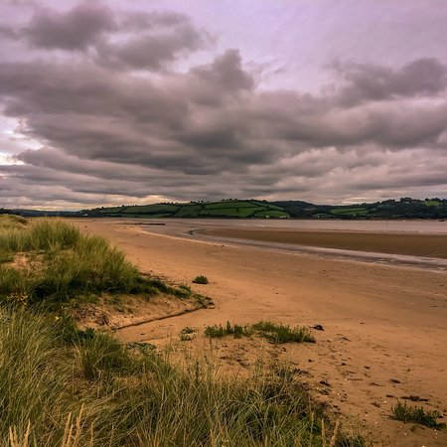
Beach clean up

Plastic in our Oceans is at a huge and rapidly growing rate.
Christopher.E. 2018

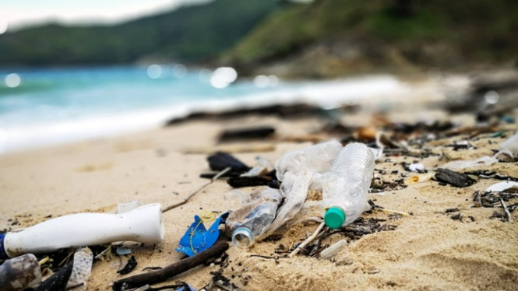

Join us and tackle the plastic by cleaning the beach at Llansteffan on December 5th at 1pm.

Wonderland / Shutterstock. 2022.
Although it would be impossible to comment the exact amount of plastic that entered the Ocean in 2010, Scientists estimated the number to be around 8 million metric tons.
National Ocean service. A guide to plastic in the Ocean.
‘’Plastic kills 100 million marine mammals and up to a million seabirds every year’’.
What is marine life and its importance? 2021.

Top 10 most found single-use plastics found on beaches
- Plastic bottles and lids.
- Cigarette butts.
- Cotton bud sticks.
- Crisp packets and sweet wrappers.
- Period products.
- Plastic bags.
- Plastic cutlery and straws.
- Coffee cups and drink containers.
- Balloons.
- Food containers and fast food packaging.
City to Sea. The most polluting single-use plastic items.

References Picture 1. Christopher.E. 2018. Retrieved from https://www.tripadvisor.co.uk/attraction_review-g793317-d3369364--reviews-orlo-llansteffan_beach_llansteffan_carmarthenshire_wales.html National Ocean service. A guide to plastic in the ocean. https://oceanservice.noaa.gov/hazards/marinedebris/plastics-in-the-ocean.html City to Sea. The most polluting single-use plastic items. https://www.citytosea.org.uk/top-10-single-use-plastic-items-on-seashores What is marine life and its importance? 2021. Retrieved from https://genv.org/marine-life/ Picture 2. Wonderland / Shutterstock. Retrieved November 22 2022 from https://www.thegef.org/blog/local-global-action-saving-ocean-requires-re-thinking-our-relationship-single-use-plastic

