Investigation of NoSQL Solutions to WCRS Problem

(ACCA6029)

Industrial Research Proposal

Stephen Protheroe-Hewitt – 2112883

Digital Health and Care Wales

Data and Information Systems

Contents

List of Figures/Tables 4
Abstract 5
Introduction 6
Background to Proposed Research/Literature Review 7
Aim and Objectives 10
Aim 10
Objectives 10
Methodology 11
Philosophy 12
Approach 12
Strategies 13
Experimentation 13
Software Development 13
Risks and Limitations 15
Ethical Issues 17
Validity, Reliability and Generalisability 18
Validity 18
Reliability 18
Generalisability 18
Data Evaluation Methods 19
Data Collection 19
Data Evaluation 20
Development Methodology 21
Software Development Methodology OR Other Relevant Major Methodology 21
Any Other Relevant Subsidiary Methodologies 22
Resources and Planning 23
Hardware Resources 23
Software Resources 23
Information Resources 23
Human Resources 24
Project Plan 24
Personal Reflection 28
Conclusion 29
References 30

List of Figures/Tables

Fig. 1 Research Onion for Data Collection 11
Fig. 2 Software Development Lifecycle 14
Fig. 3 Project Risk Table 16
Fig. 4 FDD Process Model 21
Fig. 5 Agile Model Features and Comparisons 22
Fig. 6 Project Gantt Chart 25
Fig. 7 Initiation and Prerequisite Task List 25
Fig. 8 Planning Task List 26
Fig. 9 Development Task List 26
Fig. 10 SIT Development and Testing Task List 26
Fig. 11 UAT Development and Testing Task List 26
Fig. 12 Production Development and Validation Task List 27
Fig. 13 Project Completion Task List 27

Abstract

Digital Health and Care Wales (DHCW) is a Special Health Authority (SHA) offering frontline staff systems to access patient information. The Welsh Care Record Service (WCRS) is a central data repository service storing clinical documentation for clinicians to view on systems, storing binary and XML formats within a single table of an SQL relational database.

However, due to minimal scalability and rigid schemas, there is little flexibility. Cost also increases due to ongoing continuous storage requirements, maintenance, and administration difficulties. This requires more efficient methods of documentation retrieval, as this adversely affects other systems.

This report analyses and evaluates different NoSQL solutions for a document repository and retrieval service, working in conjunction with a SQL database, showing proposed research methodologies and any issues and risks mitigated. The report concludes with a proposed logical solution, how project management would implement the proposed solution, and future research that can be undertaken.

Introduction

Digital Health and Care Wales (DHCW) are a Special Health Authority (SHA) offering frontline staff systems to access patient information, improving healthcare services using readily available data and continuous security against cyber threats [1]. The Welsh Care Record Service (WCRS) is a central data repository service storing clinical documentation for clinicians to view on systems like the Welsh Clinical Portal (WCP), providing access to real-time digital patient records across NHS Wales [2].

WCRS stores binary (like PDF and Word) and XML formats within a single table of a SQL relational database. Though there are advantages like storage and service integration [3], there is minimal scalability and rigid schemas, offering little flexibility [4]. Cost increases due to continuous storage requirements, maintenance, and administration difficulties, with decreased efficiency due to consuming 15TB of 18TB of an ever-increasing database. This requires more efficient methods of document storage and retrieval, as this adversely affects other systems.

This report analyses and evaluates different NoSQL solutions for a document repository and retrieval service, working in conjunction with a SQL database, showing proposed research methodologies and any issues and risks mitigated. The report concludes with how project management would implement the proposed solution, and future research that can be undertaken.

Researchers must understand fundamentals of WCRS’s operation within relational databases and how it communicates with other systems. The researcher has the necessary skillset to undertake a thorough analysis of current and future WCRS requirements, as they work in DHCW within the National Operational Database (NOD) team.

Background to Proposed Research/Literature Review

The relational model and relational database management systems (RDBMS) are primary sources of data storage and retrieval, using SQL as the standard for information systems from suppliers like Microsoft [5]. As of July 2024, RDBMSs remain the most popular [6]. However, the increase in real-time data processing by the Internet of Things (IoT) creates performance bottlenecks due to areas like normalisation of data affecting data storage and retrieval within systems [5]. Inefficient queries in SQL databases use significant server resources, causing database locks and data loss. While RDBMSs manage different data structures, there is limited scalability [7].

Therefore, organisations are using NoSQL (‘Not Only SQL’) databases due to storage and retrieval of high volumes of unstructured and variable data, improving flexibility where data resource management are major issues, and improving efficiency in data storage and retrieval [8]. NoSQL databases offer further advantages, like how unstructured data is overseen by databases [7].

There are four main types of NoSQL databases.

- Key-value-based – The least complicated, data is stored by key-value pairs, using strings to represent keys, like documents or images. They have no specific schema and design to process high data volumes [8]
- Document-orientated – These store and retrieve data via hierarchies, with documents stored in XML format. RDBMSs can convert documents to XML, though more complex databases must include redundant data to avoid losing information [8]
- Graph-based – These use graph structures to query with nodes, edges (node relationships) and edge properties to represent and store data, allowing data to be linked and retrieved, using visualised graphical databases for interconnected data [8]
- Column-based – These use columns to manage aspects like data warehouses and business intelligence, offering flexibility and scalability via high-performance levels on aggregate queries in columns, as column alterations do not cause database issues [8]

There are different NoSQL databases available.

- MongoDB – An open-sourced, document-oriented, and schema-free database, allowing for automatic scalability, providing high performance, and offering security features like role-based authentication [9]
- Couchbase – An open-sourced, document-oriented database designed for web and mobile applications for create, read, update and delete (CRUD) operations, ad hoc queries and indexing, though indexing can cause RAM constraints [10]
- Neo4j – The most popular graph-based database, location-type applications use this due to using one spatial geometry type (Point) and point-based spatial functionalities [11]
- Redis (REmote DIctionary Server) – A key-value database providing the highest performance, being used by The Guardian and Blizzard Entertainment in many real-world applications and social networks [12]

When deciding NoSQL solutions, areas to consider are:

- Data analysis – This involves developers creating query code in programming languages like Python and though complex, it is more effective for big data [13]
- Scalability – Where replicas are ready to receive requests should nodes fail; this increases robustness where data can be distributed among available nodes in clusters [13]
- Schema flexibility – RDBMSs have tables with fixed schemas and tuples having the same field numbers, limiting their flexibility, while NOSQL databases do not [13]
- Deployment speed – These are deployed more effectively in clusters, with automatic replications and sharding configurations improving quickness [13]
- Data location – NoSQL databases are distributed and cache remote data, meaning queries in nodes located closer improve network usage and efficiency [13]

There are concerns regarding data security in NoSQL databases. As evidenced in [14], a NoSQL solution was investigated for patient information storage relating to COVID-19, but due to minimal security, they presented significant issues.

Security issues include:

- Script injections – Document-oriented databases are vulnerable to script injections, using scripts like JavaScript and JSON to attack them [14]
- Authorisation – Key-value-based databases have little authorisation controls, with databases like Redis providing no controls [14]
- Authentication – Graph-based databases have little authentication controls, with databases like Neo4j providing no support, though AllegroGraph does support authentication [14]
- Data encryption – Column-based databases have little data encryption, with Hypertable not providing any. While HBase does not support encryption at rest, there is support for encryption between clients and servers [14]

It is therefore vital that security issues are considered when choosing the most appropriate NoSQL database within any organisation.

Aim and Objectives

The aim and objectives are as follows.

Aim

- To analyse and evaluate different NoSQL database solutions for document repository and retrieval.

Objectives

- To critically analyse current literature to identify NoSQL solutions.
- To assess effectiveness of all available and logical NoSQL solutions.
- To compare and evaluate NoSQL solutions.
- To create recommendations on proposed solutions to implement within WCRS.

Methodology

There are numerous research methodologies, approaches and strategies that must be planned for the most appropriate data collection and analysis (see Figure 1).

Fig. 1 Research Onion for Data Collection [15]

Philosophy

The research adopts a positivistic philosophy, as data investigates quantitative data (like document retrieval speed and query analysis) based on real-time, first-hand data [16], providing highly precise and reliably accurate data.

While phenomenological philosophies have better validity, using smaller but improved qualitative data, this focuses on subjective social data compared to positivistic philosophies that focus on software development and testing theories [17]. While validity is low, this data is collated by the primary researcher and as testing occurs, with any qualitative data focusing internally within DHCW with similar knowledge bases, improving data validity.

Approach

The research adopts a deductive approach, as it focuses on creating theories and hypotheses when creating the NoSQL solution, analysing quantitative data from current and proposed systems, then comparing and evaluating whether the NoSQL solution is quicker and improves efficiency [17], rather than collating and analysing data, then creating a theoretical framework.

However, Theophilus [18] evidenced that deductive and inductive approaches can achieve quality qualitative data for analysis, though lead to subjectivity due to researcher and interviewee biases. To mitigate this, interviews and data were cross-checked with documentation to verify evidence, with future research recommending reassessing opinions over time.

Strategies

The research adopts the following research strategies.

Experimentation

According to Bolinger, Josefy, Stevenson and Hitt [19], experimentation is an undervalued research strategy with high potential, with experiments enhancing knowledge in strategic management by summarising approaches and recommendations for best practices. Di Stefano and Gutierrez further evidence this [20], whereby experimentations establish causal relationships and improve validity. While used sparingly, they are significant and increasing in number, highlighting successful strategic research and usage for new and future research.

This is assessed by comparing and evaluating document retrieval times between both systems while testing performances by validating document storage speed and querying both systems to retrieve requested documents, monitoring query speed and CPU usage, confirming performance efficiency.

Software Development

Software development strategies require agreed plans before creation, continuously adapting to minimise threats within the software development lifecycle (see Figure 2), allowing threats and challenges to be investigated and mitigated, creating value to reduce financial and timely errors, and enhancing productivity and collaboration between teams and stakeholders [21].

Fig. 2 Software Development Lifecycle [21]

This is vital as it involves planning the NoSQL solution for DHCW requirements to establish communication and retrieve correct information between systems and testing intensively, ensuring the main requirements are fulfilled.

Risks and Limitations

The limitations are:

- Tight deadlines – All teams must collaborate to ensure task completion within required deadlines. This is mitigated via project management and regular meetings (especially with unique challenges like continuous emerging technologies and specific technological risks [22]) against the project plan.
- Senior managerial/directorial restrictions – Management could restrict resources to use specific software or block certain tasks. This is mitigated by persuading management that the project plan and required software are vital and in line with DHCW’s five missions underpinning the strategic objectives [23].
- Rigid NHS structure – Rigid NHS structures and change reluctance could cause project flexibility limitations, even if patient care improves. As evidenced in [24] and [25], target-driven focus and traditional structures allowing no flexibility can cause serious harm and even death in patient care. While DHCW has flexibility, long-standing issues could determine project progression.
- Software issues – Unexpected bugs and errors will occur, which could breach confidentiality and create significant risks with patient data. This is mitigated by resolving key bugs and errors that could derail the project and covering all security vulnerabilities.

The risks are summarised as follows.
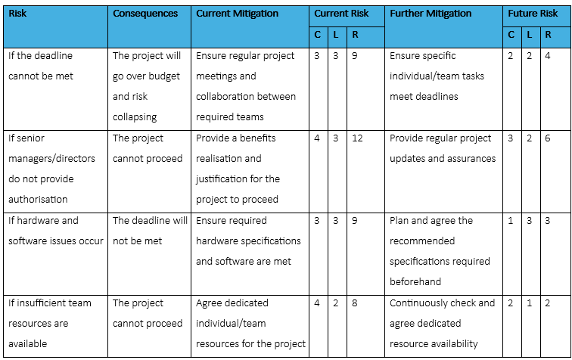
Fig. 3 Project Risk Table

Ethical Issues

Ethical issues are:

- Patient confidentiality – Patient data is required to confirm information flows between systems are successful. While development and test versions have test patient data, the production version requires real patient data. If confidentiality breaches occur, reputational harm could occur to the researcher and DHCW, with serious breaches resulting in potential legal action and negative media coverage.
- Security – Any exploited security vulnerabilities cause reputational harm to the researcher and DHCW, resulting in the Information Commissioners Office (ICO) being informed and potential legal action and fines. Mitigations include vulnerabilities being closed using security techniques like penetration testing, with authorisation measures like access controls in place to monitor and prevent unauthorised access [26].

Validity, Reliability and Generalisability

Validity

Validity is low because of positivistic research philosophies. However, as evidenced by [27] and [28] in 2013 and 2023 respectively, the Danish Fracture Database (DFDB) from its establishment in 2011 to its closure in 2020 has had high and consistent validity between 82-100% in 2013 and 2023, though completeness dropped from 83% in 2013 to 55% in 2023. Surgeons entered data into the DFDB via a front-facing web application like how WCP operates, further confirming data validity.

Reliability

Reliability is high as primary data is retrieved by the researcher, with development of the NoSQL database created and implemented within DHCW, with all measurable data collated, analysed, and evaluated internally for in-house decision-making, conclusions, and recommendations. If a different researcher investigated the same problem, they would get comparable results, depending on database performance.

Generalisability

This is suitable for similar problems in similar organisations, as other public sector organisations could benefit. For example, the Driver and Vehicle Licensing Agency (DVLA) uses MongoDB to store and retrieve documentation and a potential case study candidate to understand its implementation and how DHCW could benefit due to organisation similarities.

Data Evaluation Methods

The data evaluation methodologies to use are:

Data Collection

This is quantitative data collection as follows.

- Documentation – This is available within DHCW via SharePoint and used to check historical and current processes for documentation retrieval in WCRS. This provides underlying knowledge for WCRS, as well as how the database works. This will highlight documentation gaps to review and improve, ensuring streamlined processes and more efficient documentation retrieval.
- Surveys – This will be collected within DHCW due to the knowledge base available, focusing more on respondents using SQL as they have the underlying knowledge of SQL. They would be contacted via email or Microsoft Teams, with all correspondence and responses kept locally and confidentially within password-protected folders. The survey aims for approximately fifty responders, ensuring a detailed number of responses to analyse and evaluate.
- Statistical Collation – This will be collected on current and new processes (length of time to retrieve required documents from both databases) to compare, analyse and evaluate findings, draw conclusions, and make recommendations for continuous service improvement.

The statistical collation of retrieved documents from SQL and NoSQL databases provides the minimum dataset to provide comparative baselines of efficiency levels between SQL and NoSQL databases to analyse. While no unforeseen issues should occur for the data collation, if survey responses are low, this must be noted and recommended as a limitation and future research for responses to be expanded.

Data Evaluation

The data will be evaluated as follows.

- Descriptive statistical analysis – The core data are figures from SQL and NoSQL databases to which datasets are compared and analysed for improved interpretation, though cannot be used on their own due to interpretive bias. This data is summarised using the likes of mean and standard deviation to find patterns.
- Exploratory statistical analysis – Using an experiment research strategy helps identify patterns within datasets, as well as create hypotheses.

The experimental hypothesis is:

H₀ – There are no significant differences in performance between SQL and NoSQL databases.
H₁ – There are significant differences in performance between SQL and NoSQL databases.

The statistical significance level will be 0.05, as this is a generalisation for 95% accuracy for researchers [29].

The data will be presented via data visualisation techniques like infographics, using software like Tableau to convey information. This allows for datasets to be presented to audiences in plain English to understand the information clearly, using meaningful graphical information instead of technical jargon [30].

Development Methodology

The following methodologies will be used.

Software Development Methodology OR Other Relevant Major Methodology

The feature-driven development (FDD) agile methodology is an easy-to-use methodology for larger, complex projects [31] and involves DHCW teams helping with continuous database design, development, testing and release. The FDD methodology also helps with designing and implementing via a feature-based approach, meaning ‘MoSCoW’ requirements are easier to create and implement, as per Figure 4.

Fig. 4 FDD Process Model [32]

While it has simplicity, it focuses only on design and implementation, not providing support mechanisms compared to other software methodologies (see Figure 5).

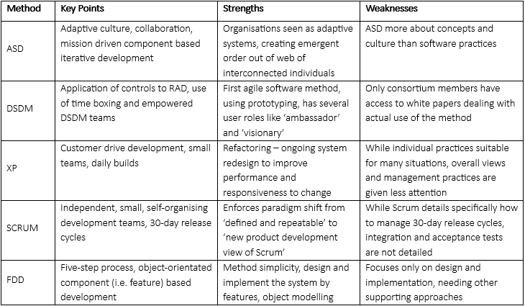
Fig. 5 Agile Model Features and Comparisons [31]

Any Other Relevant Subsidiary Methodologies

The following agile methodologies will also be used.

- Scrums – Considered the most successful framework [33], this focuses on smaller tasks, ensuring task completion within specified periods.
- Sprints – This assist with smaller tasks for individual members and teams for completion by specified deadlines.
- Daily Stand-ups – Daily meetings with team members help understand what everyone did the previous day and what they will do on the current day, identifying blockers and allowing escalations for project issues.

Resources and Planning

Hardware Resources

The hardware resources are:

- Integrated databases – The NoSQL database must integrate with systems seamlessly without affecting performance or efficiency, ensuring documentation is correctly retrieved without compromising patient care and confidentiality. All-consuming applications of WCRS would connect to web services, which connect to the database, ensuring that continuous data sharing is maintained.
- Dedicated server(s) – This optimises database performance based on minimum requirements, ensuring high database performance and efficiency. This involves minimising costs to ensure cost efficiency.

Software Resources

The software resources are:

- Microsoft SQL Server Management Studio – This is used within WCRS managing all databases, with the version as 15.0.4385.2 [34].
- Chosen NoSQL database – Some NoSQL databases are open-sourced and can be downloaded for free (MongoDB and Couchbase are available via [35] and [36] respectively). The version used for MongoDB is 7.0 [37] and Couchbase using 7.6.2 on servers [38].
- Tableau – This is used to present data and is available via [39]. There is a cost involved if required for longer than 14 days. The version used is 2024.2 [40].

Information Resources

While not essential, Freedom of Information (FOI) requests were made to the DVLA, South Wales Police and Welsh Government regarding any NoSQL databases used. If information is provided, this helps establish what other public sector organisations use to help draw conclusions and recommendations for project progression, like NoSQL databases used and processes for document retrieval.

Human Resources

The project requires the NOD team and other teams for the development, support, and testing of the NoSQL solution, with senior managers, directors and information governance departments providing required permissions and approvals. This ensures ethical and legal issues are minimised, avoiding reputational harm within DHCW.

As NODs are part of the Integration and Reference (IRAT) department, a test team is available to perform testing, while user testing is performed by health boards, receiving first-hand information from users regarding performance and improvements for future development.

Project Plan

The planned outcome is for a NoSQL database to be designed, built and implemented for WCRS requirements, ensuring any required changes can be fulfilled without jeopardising deadlines. This includes contingency planning if areas fall behind or technical difficulties occur when building and implementing the database. This ensures WCRS requirements are fulfilled, and issues mitigated during design and build phases.

The project has a six-month duration and while this deadline is tight, planning and scoping can occur, like managerial discussions, agreements, and resource requirements from DHCW teams and departments before design and implementation.

A ‘lessons learnt’ document will be created upon completion, documenting what went well, what went wrong and what was learnt to mitigate risks, limitations and/or issues that occurred. This ensures similar projects can review this to minimise the same issues occurring, improving effectiveness and efficiency of future implementations.

The proposed Gantt chart is as follows.

Fig. 6 Project Gantt Chart

The task lists are as follows.

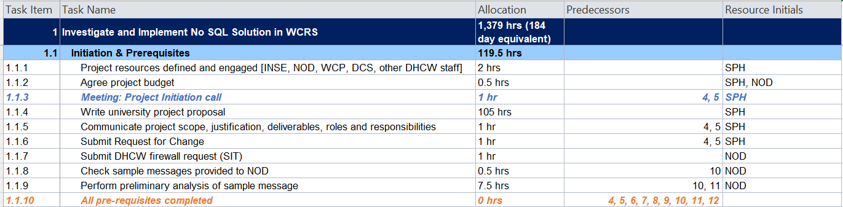
Fig. 7 Initiation and Prerequisite Task List

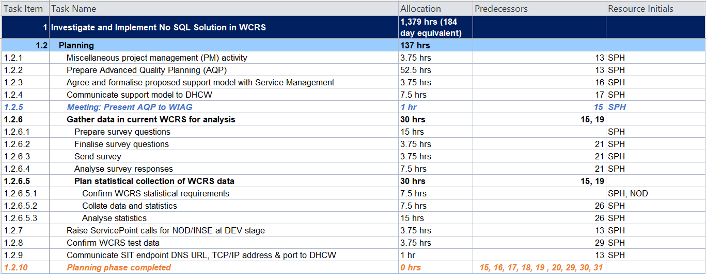
Fig. 8 Planning Task List

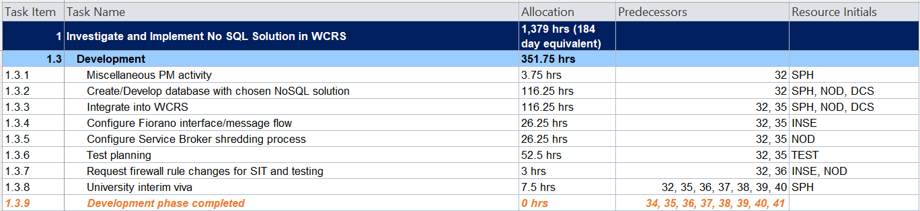
Fig. 9 Development Task List

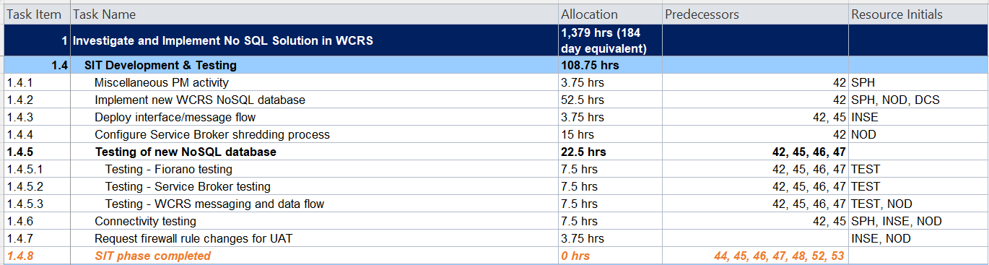
Fig. 10 SIT Development and Testing Task List

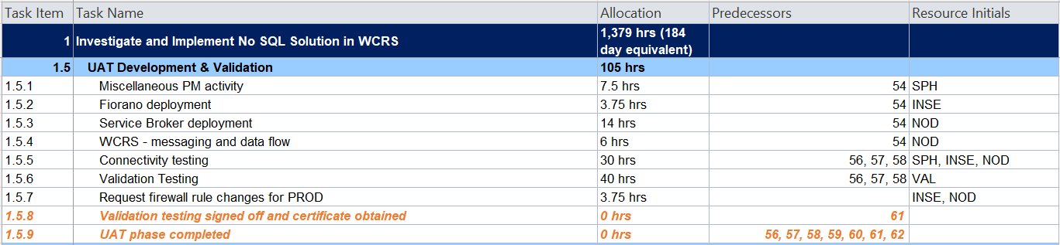
Fig. 11 UAT Development and Testing Task List

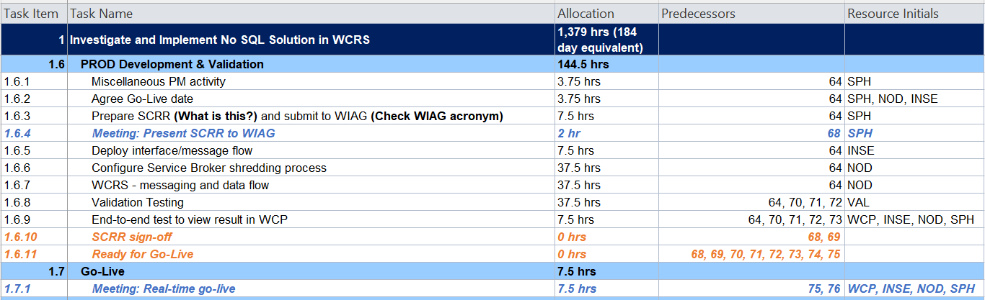
Fig. 12 Production Development and Validation Task List

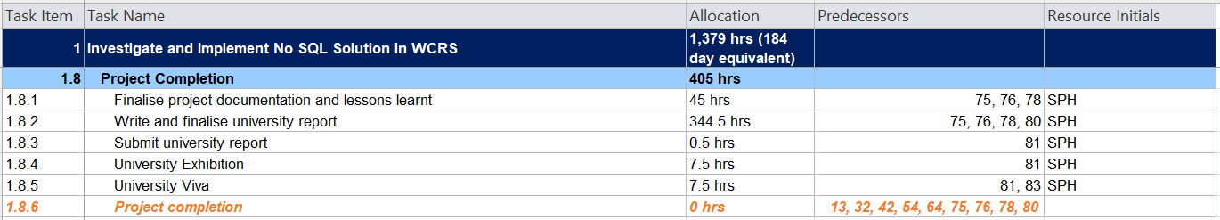
Fig. 13 Project Completion Task List

Personal Reflection

This was difficult due to researching areas where the researcher had minimal knowledge and understanding. Therefore, research must be thorough to provide the correct information, assisting with improved decision-making for the most efficient NoSQL database implementation. This has improved the researcher’s knowledge of NoSQL, highlighting the flexibility and scalability required for WCRS to improve efficiently and effectively.

The research was difficult due to a lack of research and project management experience, as well as knowledge gaps for the researcher, causing challenges when communicating goals of the project within DHCW. As evidenced in [41], software designers can lack understanding around software approaches, leading to requirement confusion, creating poor designs for inefficient and non-understandable software development and making prototype database creations difficult. ChatGPT has been used for knowledge clarification, though has not been significantly used.

There has been continuous support from NOD team management, providing vital knowledge input and experience to ensure requirements can be met. This provides improved knowledge for decision-making and allows suggestions, improving project success. As the team has a dedicated project manager, this improves project organisation to meet targets and improve the researcher’s project management skills, while improving WCRS knowledge to link with the NoSQL solution.

Conclusion

Thorough research is vital to successful projects, especially in an ever-evolving technological world where innovative technologies and practices continuously emerge, and organisations must continuously adapt to these changes. While agile methodology provides solutions to ever-changing requirements in service development processes, challenges like lack of communication and documentation must be overcome, ensuring that agile methodologies are utilised for successful project completion [42].

Future research would involve retrieving detailed understandings of NoSQL databases within public sector organisations. As mentioned previously, researching, and understanding full processes, as well as available documentation, would provide evidence-based research for the most appropriate NoSQL database, allowing for a more consistent approach within public sector organisations.

References

[1] | Digital Health and Care Wales, “About Digital Health and Care Wales”, Digital Health and Care Wales [Online] Available: https://dhcw.nhs.wales/about-us/ [Accessed Jun. 30, 2024].
[2] | Digital Health and Care Wales, “Welsh Clinical Portal” Digital Health and Care Wales [Online] Available: https://dhcw.nhs.wales/product-directory/our-digital-services/welsh-clinical-portal/ [Accessed Jun. 16, 2024].
[3] | Microsoft, “Compare Options for Storing Blobs (SQL Server)”, Microsoft, Feb. 28, 2023 [Online] Available: https://learn.microsoft.com/en-us/sql/relational-databases/blob/compare-options-for-storing-blobs-sql-server?view=sql-server-ver16#Expectations [Accessed Aug. 20, 2024].
[4] | R. Sheldon, “How to choose between SQL and NoSQL databases,” Redgate, Apr. 13, 2021 [Online] Available: https://www.red-gate.com/simple-talk/featured/how-to-choose-between-sql-and-nosql-databases/ [Accessed Aug. 20, 2024].
[5] | A. Bajaj and W. Bick, “The Rise of NoSQL Systems: Research and Pedagogy”, Journal of database management, vol. 31, no. 3, pp. 67-82, Jul. 2020 [Online] Available: 10.4018/JDM.2020070104 [Accessed Jul. 2, 2024].
[6] | DB-Engines, “DB-Engines Ranking”, Redgate Software, Jul. 2024 [Online] Available: https://db-engines.com/en/ranking [Accessed Jul. 2, 2024].
[7] | W. Khan, T. Kumar, C. Zhang, K. Raj, A. M. Roy and B. Luo, “SQL and NoSQL Database Software Architecture Performance Analysis and Assessments—A Systematic Literature Review”, Big data and cognitive computing, vol. 7, no. 2, p. 97, Jun. 2023 [Online] Available: 10.3390/bdcc7020097 [Accessed Jul. 9, 2024].
[8] | H. Wang and S. Wang, “Teaching NoSQL Databases in a Database Course for Business Students”, Journal of information systems education, vol. 34, no. 1, pp. 32-40, 2023 [Online] Available: https://www.proquest.com/scholarly-journals/teaching-nosql-databases-database-course-business/docview/2774977620/se-2 [Accessed Jul. 2, 2024].
[9] | C. A. Győrödi, D. V. Dumşe-Burescu, D. R. Zmaranda and R. S. Győrödi, “A Comparative Study of MongoDB and Document-Based MySQL for Big Data Application Data Management”, vol. 6, no. 2, p. 49, Jun. 2022 [Online] Available: 10.3390/bdcc6020049 [Accessed Jul. 9, 2024].
[10] | I. Carvalho, F. Sá and J. Bernardino, “Performance Evaluation of NoSQL Document Databases: Couchbase, CouchDB, and MongoDB”, Algorithms, vol. 16, no. 2, p. 78, Feb. 2023 [Online] Available: 10.3390/a16020078 [Accessed Jul. 9, 2024].
[11] | D. Guo and E. Onstein, “State-of-the-Art Geospatial Information Processing in NoSQL Databases”, ISPRS international journal of geo-information, vol. 9, no. 5, p. 331, May 2020 [Online] Available: 10.3390/ijgi9050331 [Accessed Jul. 9, 2024].
[12] | G. Belalem, H. Matallah and K. Bouamrane, “Evaluation of NoSQL Databases: MongoDB, Cassandra, HBase, Redis, Couchbase, OrientDB”, International journal of software science and computational intelligence, vol. 12, no. 4, pp. 71-91, Oct. 2020 [Online] Available: 10.4018/IJSSCI.2020100105 [Accessed Jul. 9, 2024].
[13] | A. Corbellini, C. Mateos, A. Zunino, D. Godoy and S. Schiaffino, “Persisting big-data: The NoSQL landscape”, Information systems (Oxford), vol. 63, pp. 1-23, Jan. 2017. [Online] Available: 10.1016/j.is.2016.07.009 [Accessed Jul. 9, 2024].
[14] | K. A. ElDahshan, A. A. AlHabshy and G. E. Abutaleb, “Data in the time of COVID-19: a general methodology to select and secure a NoSQL DBMS for medical data”, PeerJ. Computer science, vol. 6, p. 297, Sept. 10, 2020 [Online] Available: 10.7717/peerj-cs.297 [Accessed Jul. 9, 2024].
[15] | J. Bergmann, “Research Philosophy, Methodological Implications, and Research Design”, in At Risk of Deprivation, Springer Fachmedien Wiesbaden GmbH, 2023, p. 471. [E-book]
[16] | G. Ryan, “Introduction to positivism, interpretivism and critical theory”, Nurse researcher, vol. 25, no. 4, pp. 14-20, Mar. 2018 [Online] Available: https://doi.org/10.7748/nr.2018.e1466 [Accessed Jul. 16, 2024].
[17] | S. Joseph, Research Philosophies, Strategies & Methodologies, Swansea: University of Wales Trinity St. Davids, 2024.
[18] | T. Azungah, “Qualitative research: deductive and inductive approaches to data analysis”, Qualitative research journal, vol. 18, no. 4, pp. 383-400, Nov. 2018 [Online] Available: 10.1108/QRJ-D-18-00035 [Accessed Jul. 16, 2024].
[19] | M. T. Bolinger, M. A. Josefy, R. Stevenson and M. A. Hitt, “Experiments in Strategy Research: A Critical Review and Future Research Opportunities”, vol. 48, no. 1, pp. 77-113, Jan. 2022 [Online] Available: 10.1177/01492063211044416 [Accessed Jul. 16, 2024].
[20] | G. Di Stefano and C. Gutierrez, “Under a magnifying glass: On the use of experiments in strategy research”, Strategic organization, vol. 17, no. 4, pp. 405-507, Nov. 2019 [Online] Available: 10.1177/1476127018803840 [Accessed Jul. 16, 2024].
[21] | T. Sire, “The Ultimate Software Development Strategy for Successful Development”, Pulsion, Jul. 10, 2024 [Online] Available: https://www.pulsion.co.uk/blog/software-development-strategy/ [Accessed Jul. 16, 2024].
[22] | B. McGannon, “Project Management: Technical Projects”, Linkedin Learning, Carpenteria, 2021 [Online] Available: https://www.linkedin.com/learning/project-management-technical-projects-2021/what-is-a-technical-project?u=77966930 [Accessed Aug. 20, 2024].
[23] | Digital Health and Care Wales, “Our Strategic Objectives”, Digital Health and Care Wales [Online] Available: https://dhcw.nhs.wales/about-us/key-documents/strategies/organisational-strategy-2024-2030/our-strategic-objectives/ [Accessed Sept. 2, 2024].
[24] | N. Edwards and S. Black, “Targets: unintended and unanticipated effects”, BMJ quality & safety, vol. 32, no. 12, pp. 697-699, Sept. 2023 [Online] Available: 10.1136/bmjqs-2023-016247 [Accessed Jul. 23, 2024].
[25] | C. Kanaris, “Mind the power gap: How hierarchical leadership in healthcare is a risk to patient safety”, Journal of child health care, vol. 27, no. 3, pp. 319-322, Sept. 2023 [Online] Available: 10.1177/13674935231196197 [Accessed Jul. 23, 2024].
[26] | A. Mohammad, “Distributed Authentication and Authorization Models in Cloud Computing Systems: A Literature Review”, Journal of cybersecurity and privacy, vol. 2, no. 1, pp. 107-123, Mar. 2022 [Online] Available: 10.3390/jcp2010008 [Accessed Aug. 20, 2024].
[27] | K. Gromov, J. V. Fristed, M. Brix and A. Troelsen, “Completeness and Data Validity for the Danish Fracture Database”, Danish Medical Journal, vol. 60, no. 10, p. A4712, Oct. 2013 [Online] Available: https://content.ugeskriftet.dk/sites/default/files/scientific_article_files/2018-12/a4712.pdf [Accessed Jul. 23, 2024].
[28] | A. B. Roennegaard, P. H. Gundtoft, P. T. Tengberg and B. Viberg, “Completeness and validity of the Danish fracture database”, Injury, vol. 54, no. 10, p. 110769, Oct. 2023 [Online] Available: 10.1016/j.injury.2023.05.001 [Accessed Jul. 23, 2024].
[29] | S. Tenny and I. Abdelgawad, “Statistical Significance”, National Library of Medicine, Nov. 23, 2023 [Online] Available: https://www.ncbi.nlm.nih.gov/books/NBK459346/ [Accessed Jul. 30, 2024].
[30] | B. Shander, “Learning Data Visualization”, Linkedin Learning, Carpenteria, 2022 [Online] Available: https://www.linkedin.com/learning/learning-data-visualization-15572314/why-visualize-data?resume=false&u=77966930 [Accessed Jul. 30, 2024].
[31] | C. M. Budoya, M. M. Kissaka and J. S. Mtebe, “Instructional Design Enabled Agile Method Using ADDIE Model and Feature Driven Development Process”, International journal of education and development using information and communication technology, vol. 15, no. 1, pp. 35-54, 2019 [Online] Available: https://research-ebsco-com.ezproxy.uwtsd.ac.uk/c/onvpsy/viewer/pdf/r5kzcfejgz [Accessed Aug. 6, 2024].
[32] | S. Aftab, Z. Nawaz, F. Anwer, M. Ahmad, A. Iqbal, A. Ahmad and M. Salman, “Using FDD for Small Project: An Empirical Case Study”, International journal of advanced computer science & applications, vol. 10, no. 3, 2019 [Online] Available: 10.14569/IJACSA.2019.0100319 [Accessed Aug. 6, 2024].
[33] | P. Ashun and T. R. Brown, “Agile project management,” PACKT Publishing, Birmingham, 2022 [Online] Available: https://video.alexanderstreet.com/watch/agile-project-management [Accessed Aug. 30, 2024].
[34] | Microsoft, “Latest updates and version history for SQL Server”, Microsoft, Aug. 1, 2024 [Online] Available: https://learn.microsoft.com/en-us/troubleshoot/sql/releases/download-and-install-latest-updates#sql-server-complete-version-list-tables [Accessed Sept. 2, 2024].
[35] | MongoDB, “MongoDB”, MongoDB [Online] Available: https://www.mongodb.com/ [Accessed Jul. 30, 2024].
[36] | Couchbase, “Couchbase”, Couchbase [Online] Available: https://www.couchbase.com/ [Accessed Jul. 30, 2024].
[37] | MongoDB, “MongoDB Evolved – Version History”, MongoDB [Online] Available: https://www.mongodb.com/resources/products/mongodb-version-history [Accessed Aug. 30, 2024].
[38] | Couchbase, “What’s New in Version 7.6”, Couchbase [Online] Available: https://docs.couchbase.com/server/current/introduction/whats-new.html [Accessed Aug. 30, 2024].
[39] | Tableau, “Tableau”, Tableau [Online] Available: https://www.tableau.com/en-gb [Accessed Jul. 30, 2024].
[40] | Tableau, “All releases”, Tableau, Jun. 2024 [Online] Available: https://www.tableau.com/en-gb/products/all-features [Accessed Aug. 30, 2024].
[41] | P. Flores, M. Alvarez and J. Torres, “Identifying Difficulties of Software Modeling Through Class Diagrams: A Long-Term Comparative Analysis”, IEEE access, vol. 10, pp. 28895-28910, Mar. 8, 2022 [Online] Available: https://doi.org/10.1109/ACCESS.2022.3157290 [Accessed Aug. 27, 2024].
[42] | Management Association, Research anthology on agile software, software development, and testing, Hershey, Pennsylvania: IGI Global, 2022, p. 2164. [E-book]

