Artificial Intelligence, Global Business Risk, and Strategic Governance: A Comparative Analysis of Microsoft’s AI Ecosystem in the United Kingdom and India

Module: Global Business Challenges
Module Code: BMMB7006
Name: Smit Bharatkumar Barot
ID: 2526323
WORD COUNT: [Executive Summary- 303, Table of Contents- 160, Introduction- 294, Main Findings- 4615, Conclusion- 243, References- 1026, Appendixes- 265]
TOTAL WORD COUNT: 6906

Date: 27th April 2026
UNIVERSITY OF WALES TRINITY SAINT DAVID
Executive Summary
This report critically examines how the fast advancement of artificial intelligence (AI) has impacted risk management in Microsoft, and its global business in the United Kingdom and India. Its purpose is to find out the impact of macroeconomic factors, regulatory policies and technological change to strategic decision making at Microsoft in managing risks that are related to AI. It also includes information governance, ethical AI, regulatory compliance, customer trust, implications of macroeconomic policies in two opposing environments, the UK and India, a highly regulated developed economy and a rapidly expanding digital market with emerging governance principles. The report is a synthesis of PESTLE analysis, trade theory and internationalisation perspectives to examine the global AI strategy at Microsoft.
The key takeaways are that AI presents a big opportunity to Microsoft (up to 40 per cent productivity gains and more than 110 billion dollars a year in cloud revenues). Nevertheless, there are major threats, such as data breaches, algorithmic bias, regulatory fragmentation, and reputational damage. The compliance and cost of operation could increase the regulatory difference between the tough GDPR-based regime in the UK and the dynamic data protection regime in India by 15-25 times. Other macroeconomic factors that impact the capital allocation and the approach of AI expansion of Microsoft are inflation, rising interest rates, and the propensity of global digital investments.
The report recommends the establishment of centralised global AI governance model, regional adaptation, the enhanced data governance through the localisation strategies, and the enhanced ethical AI monitoring systems. A predictive analytics-based integrated risk management strategy is crucial to long-term resilience. The implementation plan will be carried out in stages in both short, medium and long-term plans, where the focus will be on the establishment of governance, ethical implementation of AI and innovation leadership in order to generate sustainable competitive advantage.

Table of Contents
1. Introduction 4
1.1 Context: Artificial Intelligence in Global Business and Strategic Importance 4
1.2 Microsoft, Country Selection, and Research Objectives 4
2. Global Business Environment & Theoretical Framework 5
2.1 PESTLE Analysis 5
2.2 Trade Theory & Internationalisation 7
2.3 Modes of International Market Engagement 7
3. Macroeconomic Environment and Policy Impact 9
3.1 Interest Rates, Inflation, and Digital Investment 9
3.2 UK AI Strategy and Policy Framework 9
3.3 India Digital Economy and AI Initiatives 10
3.4 Impact on Microsoft and Policy Effectiveness 11
4. AI and Risk Management in Microsoft 11
4.1 Data Governance and Risk 11
4.2 Ethical AI and Responsible Innovation 13
4.3 Regulatory Compliance and Legal Risk 14
4.4 Customer Trust and Reputational Risk 15
4.5 Microeconomic Decision-Making 16
5. Recommendations 19
6. Implementation Plan 20
6.1 Phased Strategy 20
6.2 Resource Allocation 21
6.3 Key Performance Indicators (KPIs) 21
6.4 Risk Mitigation 22
7. Conclusion 24
References 25
Appendixes 30

1. Introduction

1.1 Context: Artificial Intelligence in Global Business and Strategic Importance
Artificial Intelligence (AI) has recently become one of the most important drivers of change in the contemporary business environment, changing the productivity, decision-making, and competition dynamics in every industry. The embedding of it into enterprise systems makes it possible to automate the process of complexities, anticipatory analytics, and customer personalization (Salako et al., 2024). As organisations start operating in more volatile, uncertain, complex, and ambiguous (VUCA) environments, AI is not viewed as an assistive technology anymore but as a strategic strategic asset. Multinational enterprises (MNEs) are also using AI to streamline international supply chains, enhance operational efficiency, and enhance market responsiveness (Naqvi, 2025). Consequently, the use of AI must be planned together with the efficient risk management systems to ensure the sustainable value creation and retain the trust of the stakeholders in the highly-regulated global markets.

1.2 Microsoft, Country Selection, and Research Objectives
Microsoft is one of the most influential case studies because it is a leading player in cloud computing and AI innovation on such platforms as Azure AI and Microsoft Copilot (Microsoft, 2026). Its international network and corporate integration render it very vulnerable to a variety of regulatory environments and geopolitical risk . The case of the United Kingdom and India offers an analytical perspective of comparison: the former is a mature economy with strict data protection and AI governance laws, whereas the latter is an emerging digital economy with a developing regulatory framework and a large potential of AI adoption (Faciletechnolab.com, 2025). The report should critically evaluate the risks involved in AI, evaluate the macroeconomic and regulatory impacts on the activity of multinational corporations, and develop a strategy with a clear implementation plan on sustainable and responsible AI governance.

2. Global Business Environment & Theoretical Framework

2.1 PESTLE Analysis
The Artificial Intelligence is changing the business frameworks of the globe by influencing the productivity, governance, competitiveness and exposure to risks and this requires businesses like Microsoft to act strategically in an intricate political, economical and regulatory atmosphere.
Political Factors: AI governance is becoming more and more affected by national policy frameworks. The UK has suggested pro-innovation AI regulation through its AI Regulation White Paper, which supports flexible regulation, and is however, quite close to the GDPR principles (Holland, 2026). The third one is, conversely, economic inclusion- and digital sovereignty-focused and India is developing its Digital India and National AI Strategy. Political uncertainty is linked with data localisation laws and cross-border flow of data that makes Microsoft global cloud operation compliance complicated, revealing the geopolitical risk.
Economic Factors: The digital economy is increasing at a rapid pace globally, and AI will probably contribute over 15 trillion to the world GDP by 2030 (World Economic Forum, 2026). Nonetheless, inflationary pressures and increased interest rates have an impact on the corporate investment in AI infrastructure. Lower cost of doing business in emerging markets such as India opens up the growth prospect of Microsoft Azure whereas the developed markets such as the UK offer stable but competitive markets.
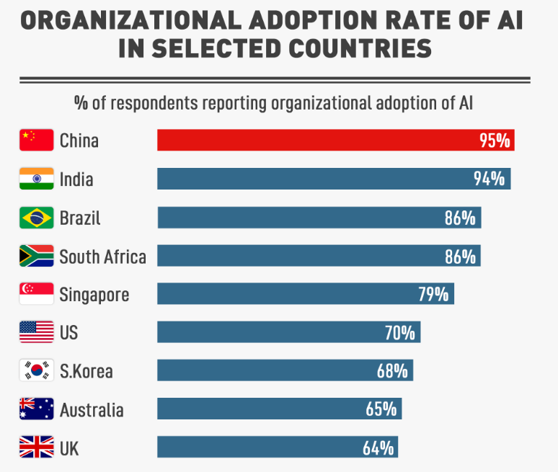
Figure 1: Global AI Adoption Rate
(Source: Globaltimes.cn, 2025)
Social Factors: AI application is accelerating a workforce revolution, and up to 40 percent of all jobs around the globe will probably be impacted by automation (World Economic Forum, 2026). The problem of job displacement and the ethical application of AI is more significant in the UK whereas it is less severe in India where there is more development of digital skills, and youths are more technology oriented. Such differences influence the workforce approach and AI implementation patterns at Microsoft.
Technological Factors: Generative AI, large language models, and cloud computing are quickly becoming more popular, making Microsoft gain a greater competitive edge in Azure AI and Copilot (Jackson, 2025). However, the more complicated the technologies are, the more significant the security threat of cybercrime, the bias in the models, and the lack of stability in the system, and the further development and well-established AI control systems are required.
Legal Factors: Under UK GDPR and the Data Protection Act 2018, data protection in the UK is very strict and there is a new law, the Digital Personal Data Protection Act 2023, which requires changing compliance obligations (Ma and Liu, 2026). These fragmented legal environments are a more significant regulatory threat to Microsoft, namely cross-border data processing and AI-based decision systems.
Environmental Factors: AI systems are computers with high power and thus, they consume energy. The total electricity demand around the world is approximately 1100-1500 kWh of which data centres will occupy 1-1.5 percent (Mathur, 2026). A sustainable use of AI is a strategic concern in both business in the UK and India, but a pledged move to become carbon negative by 2030 is a strategic move by Microsoft.

2.2 Trade Theory & Internationalisation
Digital trade theory accentuates that artificial intelligence is transforming the way global values are created and at the same time poses a new obstacle to internationalisation. Digital trade barriers like data localisation laws, restrictions on cross-border data transfer, and the difference in AI governance standards have a great impact on both compliance costs of multinational enterprises such as Microsoft (Microsoft, 2026). India, as an example, is changing its data sovereignty framework, necessitating the local storage of data in specific domains, whereas the UK is in line with GDPR, which forms disjointed conditions of operation (Reuters, 2025). With a comparative advantage perspective, developed economies, such as the UK, have high levels of institutional trust, well-established research and development ecosystem and skilled labour but India has the advantages of being cheaper, now has a growing digital workforce and has a potential scale of AI adoption.
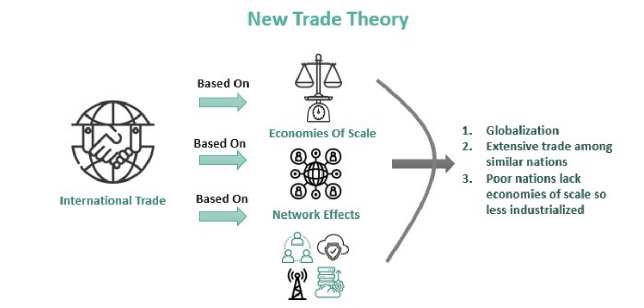
Figure 2: Trade Theory
(Source: Ahmed, 2022)

2.3 Modes of International Market Engagement
Microsoft’s Global Strategy: FDI, Partnerships, and Cloud Infrastructure: The principal drivers of international expansion strategy at Microsoft are the foreign direct investment (FDI), strategic partnerships and the huge development of clouds. The company invested over 80 billion in global deployment of data centres (2024 2025) consolidated its Azure cloud network in North America, Europe and Asia (Reuters, 2025). Microsoft is partnering with local businesses and government initiatives in India, as part of the Digital India program, to enhance AI and cloud uptake and in the UK it continues to develop enterprise AI propositions in line with digital transformation in the public sector. Cooperation with such organisations as OpenAI also enhances the competitive advantage of Microsoft in generative AI markets (Microsoft Corporate Responsibility, 2026). These types of engagement enable market penetration to be scaled and reduce entry barriers in highly regulated markets.
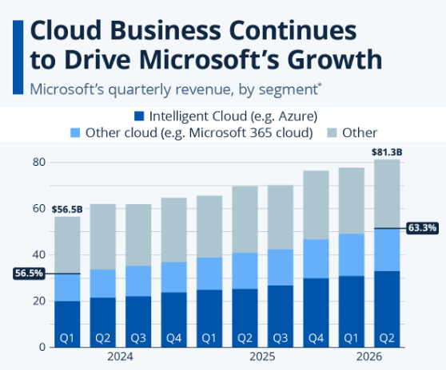
Figure 3: Cloud Business Continues to Drive Microsoft's Growth
(Source: Statista.com, 2026)
Interconnectedness with the Global Business Environment: The global economic, technological and regulatory systems are closely connected with the work of Microsoft and the AI ecosystem, so the latter is highly sensitive to the external changes in the environment. The direct impact of modifications in the growth of the global GDP (3.2% in 2025, IMF forecast) on the AI investment demand in enterprises can serve as an example (OECD, 2025). Similarly, the scalability of operations and compliance costs are influenced by regulatory changes such as the EU AI Act and the Indian data protection reforms. Microsoft has been dependent on the digital infrastructure across the globe and over 70% of its enterprise revenue is cloud-based, which is a measure of its reliance on technology. The same interconnectivity is applied to the supply chains whereby the capacity of AI might be reduced to as little as 15-20% by semiconductor shortages.

3. Macroeconomic Environment and Policy Impact

3.1 Interest Rates, Inflation, and Digital Investment
The AI investment strategy and global expansion potential of Microsoft are greatly influenced by macroeconomic factors. Increase in interest rate like the one witnessed in the US Federal Reserve rate of approximately 5.25% in 2024 will increase the cost of capital, and therefore, impact large scale infrastructure financing decisions (OECD, 2025). The inflationary pressures on the developed economies that are likely to be around 45 at 45 per cent in 2024, like the UK, also raise the operational costs of the data centres and cloud services as well. In spite of these limitations, the worldwide digital investment is still growing, and the global expenditure on the AI systems is expected to rise to over $300 billion by 2026 (Tcd.ie, 2026). The growth is a sign of resilience in the demand of technology particularly in cloud solutions in enterprises.

3.2 UK AI Strategy and Policy Framework
The UK government AI strategy focuses on the regulation by innovation, making the country an AI hub in the world. The UK plans to make AI a 10 percent contribution to GDP by 2030 with more than £1 billion invested in AI development efforts and research funding (Tcd.ie, 2026). The National AI Strategy is founded on ethics, safety and competitiveness, and the AI Regulation White Paper that promotes a pro-innovation model. This creates a predictable but heavy compliance environment in the case of Microsoft, particularly in deploying AI in the public sector (Gudepu and Eichler, 2024). Close compliance with UK GDPR warrant consistency in data protection, though mounting questions by the regulators like the Information Commissioner Office (ICO) increases the demands on governance. In general, the UK offers a high-value and low-growth-risk market, but the cost of regulatory compliance is an important factor of operation among multinational AI providers.
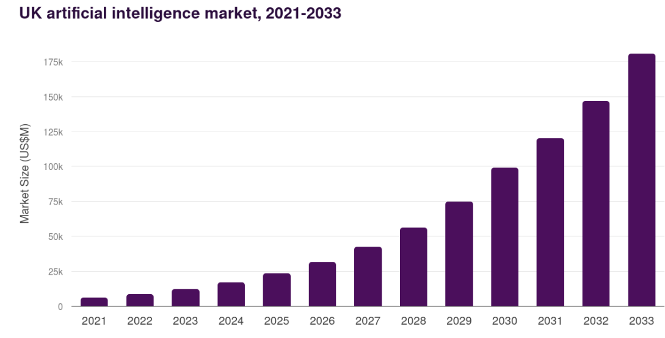
Figure 4: UK Artificial Intelligence Market
(Source: Grand View Research, 2026)

3.3 India Digital Economy and AI Initiatives
India is a rapidly expanding digital economy and by 2030, the digital economy in India will hit a dollar trillion. The governmental programs of Digital India and the National AI Mission would enhance AI adoption rates in the healthcare sector, financial sector, and agricultural sector. The AI market in India is expected to grow with a CAGR of 25-35, a move that will give a giant cloud service provider like Microsoft colossal opportunities (World Economic Forum, 2026). However, novel regulatory frameworks, such as the Digital Personal Data Protection Act 2023, introduce compliance changes, particularly in the area of data localisation. Nevertheless, reduced expenditure on infrastructure and the fast growth of digital labor-force increases scalability of Microsoft (Timesofindia.indiatimes.com, 2026). The high population of India of more than 1.4 billion can also offer a significant number of users of AI-based services as well, which is why it is a strategically-important growth market.
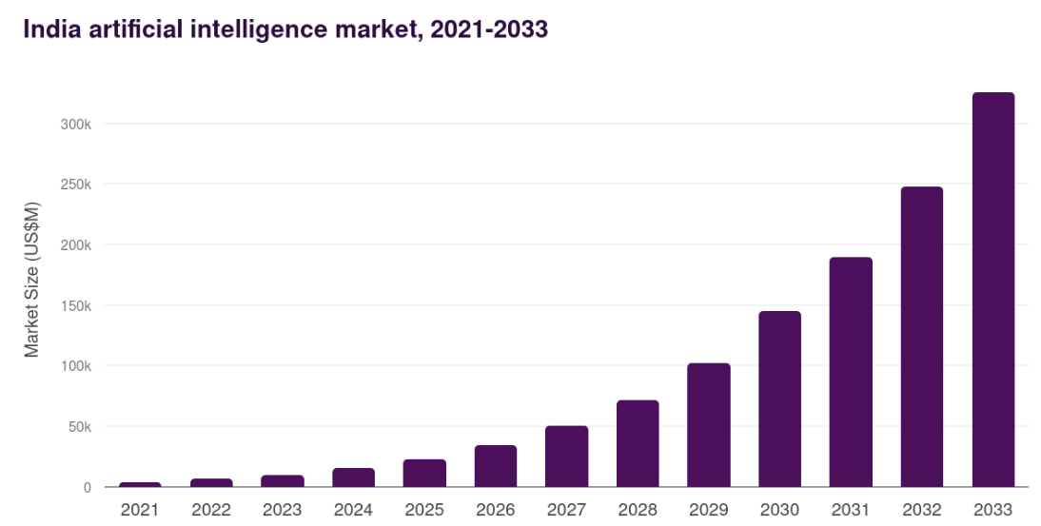
Figure 5: India Artificial Intelligence Market
(Source: Grandviewresearch.com, 2025)

3.4 Impact on Microsoft and Policy Effectiveness
The macroeconomics and policy environment has a direct impact on the global investment decision and market expansion strategy of Microsoft. In the developed economies, returns are predictable because of stable regulatory systems as opposed to high returns but volatile in the emerging markets. More than 60 percent of the cloud growth is being invested by Microsoft in high growth regions such as Asia-pacific (Faciletechnolab.com, 2025). The degree of policy effectiveness is wide: the UK has a high degree of regulatory clarity and lower rate of the economy development, and India has a high rate of growth but fallen enforcement mechanism. The shortcomings can be noted in the form of the lack of consistent AI governance standards worldwide, increased compliance costs, and decreased operational efficiency by approximately 15-20% (OECD, 2024). As a result, Microsoft needs to pursue a two-pronged approach between regulatory compliance and aggressive market expansion to realise the greatest long-term value creation by AI.

4. AI and Risk Management in Microsoft

4.1 Data Governance and Risk
Importance of Data in AI Systems: Data is the primary input of artificial intelligence systems that determines the accuracy of the models, reliability and commercial value. The Microsoft artificial intelligence system, i.e., Azure AI, processes over 100 trillion data signals daily to aid enterprises in making decisions and forecasting analytics (Holland, 2026). Good, clean data has the potential to improve model performance, by up to 35-40 percent, and poor governance significantly increases errors and risks of bias. With the spread of AI, data governance will be a strategic resource as opposed to technical activity, which directly affects the competitive advantage and compliance with the regulations in the international market.
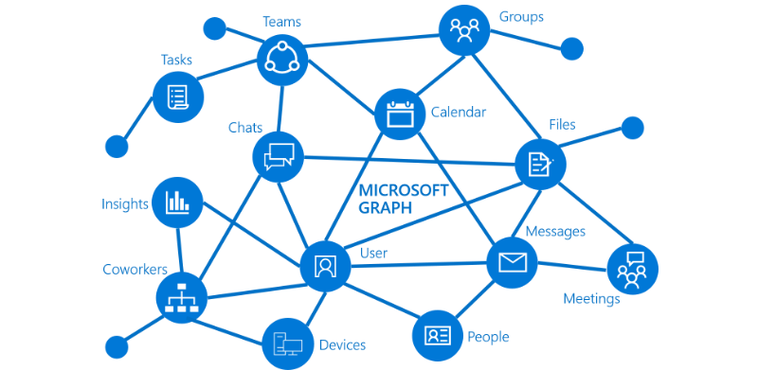
Figure 6: Microsoft Data in AI Systems
(Source: Ravisha, 2026)
Data Breaches and Cross-Border Risks: One of the risk areas with the highest importance is the security of the data and the global cost of cybercrime is projected to be 10.5 trillion annually by the year 2025 (Cybersecurity Ventures). Microsoft is increasingly becoming exposed with its large cloud-based infrastructure, trans-boundary data traffic. The financial penalty of data breach can be over 4% of the world turnover. Additionally, cross border transfers of data, particularly between the UK, the EU and India is limited resulting in a discontinuity in operations (Jackson, 2025). These issues contribute to the cost of compliance by about 15-25 percent, and also pose reputational and legal risks to the multinational AI providers.
UK vs India Governance Comparison and Microsoft Gaps: UK has strict regulations, which are in line with the GDPR, and it has high standards of data protection, transparency, and mechanisms of user consent. In India, Digital Personal Data Protection Act 2023 is at the initial phase of evolution, its enforcement mechanisms are less developed, but more localisation-oriented (Ma and Liu, 2026). This disconnection presents a complication in the adherence of the international functioning of Microsoft. The lack of global data standards in AI, where the risk management is not uniform across geographical regions, is one of the key gaps in governance (Mathur, 2026). The research indicates that discontinuous nature of governance can decrease the efficiency of operations by up to 20 percent, indicating the necessity of global data governance structures.

4.2 Ethical AI and Responsible Innovation
Bias, Fairness, and Transparency in AI Systems: Machine learning models, algorithm bias, fairness and transparency are the primary ethical AI concerns that can be activated. It has been demonstrated that biased datasets may boost the error rates by up to 30 percent in prediction, especially in the recruitment and credit score system (Reuters, 2025). The absence of transparency in AI decision making diminishes the trust of users by about 40 percent in enterprise setting. In Microsoft, emphasis on equitable AI results is essential since it is applied in sensitive fields, such as healthcare, finance, and government service and services, where biased outcomes can cause legal and reputational issues.
Microsoft Responsible AI Principles: Microsoft has constructed its model based on six principles under the Responsible AI model that include fairness, reliability, privacy, inclusiveness, transparency and accountability. To introduce the AI safety and ethics concepts in the Azure AI and Copilot systems, the company spends more than 1 billion dollars yearly on research on AI safety and ethics (Roger and Alexander, 2025). Internal control includes model auditing, human supervisory procedures and ethical review committees.
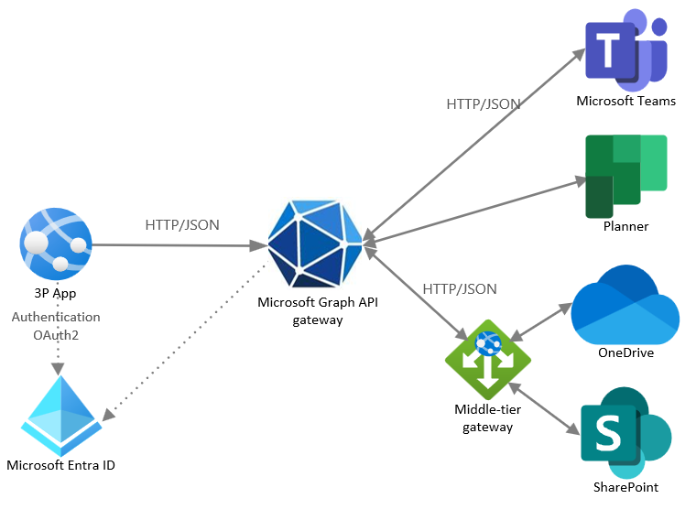
Figure 7: Microsoft Responsible AI Principles
(Source:
Limitations of Voluntary Ethical Frameworks: The voluntary ethical AI systems are extremely limited by the fact that no such mechanisms are enforced and are legally obligatory. Industry surveys indicate that nearly two-thirds of organisations employ self-regulation and this results in unequal compliance standards in the international markets (Pahune et al., 2025). This presents regulatory arbitrage risks particularly where there is weak AI governance structures. Voluntary ethics are insufficient at Microsoft, in the context of preventing systemic risk, including increasing biases and misuse of generative AI. Such absence of international standards that are compulsory generates an imbalanced ethical compliance that further carries reputational harm and regulation.

4.3 Regulatory Compliance and Legal Risk
UK Regulatory Framework for AI and Data Protection: UK has an excellent regulatory framework based on the UK GDPR and Data Protection Act 2018 that ensure that personal data and AI systems are closely controlled. The Information Commissioner Office (ICO) is the regulatory agency that may impose fines of up to 17.5 million pounds or 4 per cent of the annual turnover of the organizations which break the rules (Boppiniti, 2023). UK AI Regulation White Paper (2023) advocates a sector-based strategy, which imposes greater compliance requirements on companies such as Microsoft with high-risk AI applications, such as healthcare and finance.
India’s Evolving Regulatory Landscape: India has a fast-developing regulatory environment and the Digital Personal Data Protection Act 2023 brings new compliance requirements in the area of the data consent, data storage, and data processing. And even though enforcement provisions are still developing, the fines in case of non-compliance are presently up to 250 crore (around 30 million dollars) (Kolade et al., 2024). The Indian method of AI governance is more innovative than that of the UK, which is less prescriptive hence resulting in uncertainty in regulation.
Legal Risks, Regulatory Uncertainty, and Trade Restrictions: Diversity of jurisdiction in regulation presents a significant legal risk and operational disintegration to multinationals. The lack of similarities has also increased the cost of global compliance of AI-driven firms by nearly 2025 percent (OECD, 2025). The law can impose penalties that can be disastrous to the bottom line and brand equity, threat of litigation and legal investigations. Secondly, the future of cross-border operations is also complex due to the introduction of new limits to the data flows and AI technologies globally, namely between Western and Asian economies (Rajgopal and Yadav, 2025). This regulatory uncertainty in Microsoft also puts the firm at greater strategic risk and reduces the scalability of unified AI governance frameworks.

4.4 Customer Trust and Reputational Risk
Importance of Trust in AI Adoption: Trust between customers is a core requirement in the adoption of AI and sustainability of the platform in the long run. According to studies, over 70 percent of enterprise customers think that trust and security are the most important factors that need to be taken into account when selecting AI and cloud providers. At Microsoft, a determinant in the adoption of Azure AI and Copilot solutions in the foreign markets is trust (Choung et al., 2023). In the enterprise software markets, the customer retention rates can go up by 15-20 percent, with an increase in perceived trustworthiness by 10 percent. Trust is thus a competitive asset as it determines competitive advantage in AI-based ecosystems.
Misuse of AI and Privacy Concerns: The reputational risks of AI technologies misuse include deepfakes, decision manipulation with the help of automated decision making, and the use of data. Global studies show that two in three people are concerned with how organisations are using their personal data in artificial intelligence technologies (Mbah and Evelyn, 2024). The violations of privacy may lead to fines of more than 4% of annual turnover on a global scale within the frames of GDPR. Also, massive AI systems add exposure to the risk of unintended data leaks, notably in generative AI systems (OECD, 2025). As shown in the example of Microsoft, these risks can have a devastating impact on brand credibility and reduce uptake of controlled industry enterprises.
UK vs India Consumer Expectations and Brand Impact: Consumer expectation of AI transparency and data privacy is quite different across the UK and India. The regulatory awareness in the UK is high, which means that over 75% of users demand high rigor of data protection and explainability of AI systems (Reuters, 2025). In India, the adoption of digital is quicker, with the number of users placing more emphasis on convenience over rigid privacy settings being 60%. The difference affects the brand positioning strategies of Microsoft in the regions

4.5 Microeconomic Decision-Making
Cost–Benefit Analysis of AI Investments: The choices of investments made by Microsoft in the area of AI are determined by the cost-benefit analysis, particularly, in the case of Azure AI and generative AI systems. The annual expenditures on AI infrastructure in the world are more than 80 billion dollars, and Microsoft devotes a substantial part of its funds to data centres and model training systems (Stellium Consulting, 2026). The benefits are productivity improvements of 20-40 percent on enterprise clients with AI-based automation tools.
Component | Cost (Estimated)
AI Model Development (e.g., LLMs) | $10–20 million per model
Azure AI Infrastructure Expansion | $80+ billion annual global investment (Stellium Consulting, 2026)
Copilot Deployment (Enterprise) | ~$5–10 billion R&D and integration costs
Data Governance & Compliance Systems | 15–25% increase in operational cost due to regulation (Jackson, 2025)
Table 1: Cost–Benefit Analysis of AI Investments (Microsoft)
(Source: Self-Created)
Pricing Strategies for Azure and Copilot: The Microsoft hybrid pricing approach is anchored on subscription and usage-based pricing model of Azure AI and Microsoft Copilot. An annual revenue of more than 110 billion is generated by the Azure cloud services, and the enterprise customers earn about 70 percent of the total cloud revenue (Vidyarthi, 2025). Pricing Copilot costs at an approximate of 30 dollars a user a month to enterprise customer is a premium AI value delivery.
Product / Service | Pricing Model | Price Level (Indicative) | Revenue Contribution
Microsoft Azure (Cloud & AI Services) | Hybrid: Pay-as-you-go + Subscription | Enterprise cloud spend often $100–$10,000+ per month depending on scale (Jackson, 2025) | >$110 billion annual cloud revenue (Microsoft segment)
Microsoft Copilot (Enterprise AI Assistant) | Per-user subscription | ~$30 per user per month (Faciletechnolab.com, 2025) | High-margin recurring SaaS revenue stream
Azure AI APIs (OpenAI Services) | Usage-based (per token/API call) | ~$0.002–$0.06 per 1,000 tokens (varies by model) | Rapidly growing AI service revenue segment (Adetayo et al., 2024)
Microsoft 365 AI Integration | Bundled subscription | ~$12–$35 per user per month (plan-dependent) (Holland, 2026) | High recurring revenue base and large-scale.
Table 2: Pricing Strategies (Microsoft – Azure AI & Copilot)
(Source: Self-Created)
Resource Allocation in AI Ecosystems: Microsoft AI ecosystem is dedicated to the high growth and high profit segments such as cloud computing, generative AI, and enterprise analytics. More than 60 percent of the R&D invest in AI and cloud innovation, and spend more than 25 billion a year on it (Vidyarthi, 2025). Regional demand trend will influence the allocation choice, and will invest more in the region of Asia-Pacific since the rate of AI adoption is estimated to increase at 25-30 percent in a year.
Risk–Return Trade-Off in AI Investments: The AI approach of Microsoft involves striking a balance between high returns and high operating and regulatory risks. Although AI-based cloud services can potentially deliver a margin of ROI of over 3035, such risks include compliance cost, data breaches, and model failures (Devesh, 2024). The high growth potential of the emerging markets like India is accompanied by a higher uncertainty and the developed markets like the UK have a stable but less growth returns. The portfolio needs to be diversified in order to maximise risks and returns, simulate circumstances and track macroeconomic and regulatory changes that affect the profitability of AI.

5. Recommendations
Global AI Governance Framework: Microsoft should consider developing a centralised AI governance framework, where local compliance is adopted. This brings about uniformity of ethics, risk management and operational controls and jurisdiction related legislation such as the UK GDPR and the DPDP Act in India (George, 2024). Compliance with new principles of AI worldwide (OECD, EU AI Act) will decrease the threat of regulatory fragmentation until 2025 and enhance the efficiency of the cross-border operations.
Strengthened Data Governance: The strong data governance framework is needed, specifically, the data localisation needs in India and compliance with the strict GDPR in the UK. Microsoft ought to have regional data centres and automated compliance systems in order to have real time monitoring of data flows (Rai and Shekhar, 2025). Data encryption protocols across borders and sovereign cloud solutions would help reduce the risk of breaches by approximately 30-35 percent and make jurisdiction regulatory fit.
Ethical AI Integration: Mandatory bias auditing and ongoing AI lifecycle management should also be on the list of considerations that Microsoft should make to ensure the best use of AI. It is possible to train algorithms in a fair manner, which can be ensured through fairness checks at all levels of the model construction and this can result in bias reduction by up to 40% (John, 2023). Responsibility will be improved by establishing ethical review boards that are independent and increase transparency in model training data.
Regulatory Strategy and Government Collaboration: An aggressive regulation strategy should also include the presence of groups of compliance officers in each major market and consultations with the policymakers on a timely basis (Laaroussi et al., 2025). Governments in the UK and India should work alongside Microsoft in formulating the new regulations of AI and align it with the aims of innovation.
Customer Trust Strategy: To gain customer confidence more transparency and improved user control mechanisms are needed. Microsoft ought to create AI disclosure reports to explain how the data is used, model choices, and control of risks (Deena et al., 2024). By providing the user with the option of AI processing; opt-in and opt-out, perceived trustworthiness will be boosted by up to 25.

6. Implementation Plan

6.1 Phased Strategy
Short-term (0–12 months): To enhance its conformity with AI, Microsoft must work on the creation of a comprehensive AI governance system, as well as conduct comprehensive compliance audits in the framework of its UK and India activities (El Koshiry et al., 2025). The priority should be put on the identification of regulatory gaps, improvement of data protection controls and the establishment of baseline risk monitoring systems.
Medium-term (1–3 years): New ethical AI systems, including bias detection systems and lifecycle monitoring systems, need to be implemented in the organisation (Lukacz, 2024). Regional approaches need to be reinforced to position AI implementation in line with the UK regulatory stringency and the emerging data governance and digital economy growth in India.
Long-term (3–5 years): The other direction that Microsoft ought to pursue is to turn into a worldwide leader in AI innovation to integrate entirely autonomous and compliant AI systems (Szarmes and Élo, 2023). Scalability of responsible AI ecosystem, harmonisation of regulations, and the ability to stay ahead of the pack by further developing technology and long-term digital transformation will form the basis of the stage.

Phase | Time Horizon | Key Focus Areas
Short-term | 0–12 months | Governance setup, compliance audits, baseline risk controls
Medium-term | 1–3 years | Ethical AI systems, bias mitigation tools, regional AI strategies (Holland, 2026)
Long-term | 3–5 years | AI innovation leadership, autonomous governance systems, global scaling (Khaga S.Y. and Sharma, 2025)
Table 3: Phased Strategy (Microsoft – AI Governance & Risk Management)
(Source: Self-Created)

6.2 Resource Allocation
In the long term, Microsoft needs to invest in AI governance, development of infrastructure, and invest over 25 billion annually on AI and cloud R&D. A set aside amount of 10-15 percent of total AI expenditure must be established to conform systems and moral AI production (Faciletechnolab.com, 2025). The capital needs to initially focus on the high growth regions such as the Asia-Pacific regions where AI adoption is increasing at 25-30 percent per year. The balancing of strategic investments offers long term scalability of operations to the UK and India markets together with regulatory compliance and resilience.
Investment Area | Annual Allocation (Estimated) | % of Total AI Budget
AI Research & Development (Azure AI, Copilot, LLMs) | $25–30 billion | 60–65%
Cloud Infrastructure Expansion (Global Data Centres) | $15–20 billion (Faciletechnolab.com, 2025) | 30–35%
AI Governance & Compliance Systems | $3–5 billion | 10–15%
Ethical AI & Safety Research | $1–2 billion (Holland, 2026) | 5–8%
Table 4: Financial Investment (Microsoft – AI Governance & Expansion)
(Source: Self-Created)

6.3 Key Performance Indicators (KPIs)
One of the KPI must be the compliance rate, which will target at 98100% compliance with local laws such as UK GDPR and DPDP Act in India. The real time monitoring systems should decrease regulatory violations by at least 20-25 percent a year (Jackson, 2025). Reporting accuracy can be enhanced by 30% and audit delays are minimized with automated compliance dashboards. High compliance performance will imply reduced legal risk and enhanced reputation of Microsoft as a reputable international AI provider in the most regulated digital environment.

6.4 Risk Mitigation
It is recommended that Microsoft employs the emerging sophisticated scenario planning models to anticipate geopolitical, regulatory and technological interruptions. This involves prediction of AI regulatory changes with predictive accuracy of 80-90 per cent using machine learning instruments (OECD, 2025). The crisis response systems should respond to breaches of data and AI failures within 24-48 hours to reduce the amount of reputational loss (Microsoft, 2026). The risk of system failures can be cut by up to 35 percent by stress testing systems via simulations to guarantee continuity of operations in the global markets, and improve organisational resilience in uncertain environments.

Risk No | Risk Description | Risk Category | Likelihood | Impact | Risk Level | Mitigating Actions
1 | Data breach or unauthorised access to AI training datasets within Azure cloud infrastructure | Cybersecurity / Operational | High (4/5) | Very High (5/5) | Critical | End-to-end encryption, zero-trust architecture, continuous penetration testing, AI-driven threat detection systems (Mathur, 2026)
2 | Non-compliance with GDPR (UK) and DPDP Act (India) due to cross-border data transfers | Regulatory / Legal | Medium-High (4/5) | High (4/5) | High | Data localisation strategy, regional data centres, automated compliance monitoring, legal compliance teams per region
3 | Algorithmic bias leading to discriminatory AI outputs affecting customers and enterprises | Ethical / Reputational | Medium (3/5) | High (4/5) | High | Bias detection audits, diverse training datasets, human-in-the-loop validation, Responsible AI governance board (Ma and Liu, 2026)
4 | Regulatory fragmentation and evolving AI laws slowing global AI deployment and increasing compliance cost | Strategic / Economic | High (4/5) | Medium-High (4/5) | High | Scenario planning, adaptive regulatory intelligence system, engagement with policymakers, modular AI compliance architecture
Table 5: Risk Register (Microsoft – AI, Data Governance & Global Operations)
(Source: Self-Created)

7. Conclusion
GI has become a disruptive technology in the global business that has changed the competitive environment, the level of operational productivity and regulatory. As it is demonstrated in this report, Microsoft is in the heart of this transformation with its Azure AI ecosystem and Copilot technologies, and, at the same time, it possesses significant threats in terms of data governance, ethical use of AI, adherence to the regulations, and customer trust. Comparative analysis of the UK and India reveals that the UK and India have to strike a balance between the developed markets that are highly regulated and the emerging ones which are rapidly changing and in which the operational activities are complicated because of the divergences in the policies. The macroeconomic drivers of inflation, interest rates and trends in digital investments also affect the strategic decision-making and investment priorities of Microsoft. Although AI has a considerable potential, such as productivity improvements of up to 40% and massive growth in cloud services, it also comes with such dangers as algorithmic bias, cybersecurity, and reputation loss. Thus, it is necessary to be strategically adjusted with strong governance structures, the integration of ethical AI, and active participation in regulations. The future success of Microsoft will depend on the extent to which it will be able to balance both innovation and responsibility to enable it to expand in a scalable way without losing international trust and compliance in a very fragmented international regulatory environment.

References
Adetayo, A.J., Aborisade, M.O. and Sanni, B.A., (2024). Microsoft Copilot and Anthropic Claude AI in education and library service. Library Hi Tech News.
Ahmed, K. (2022). New Trade Theory. [online] WallStreetMojo. Available at: https://www.wallstreetmojo.com/new-trade-theory/[Accessed 22 Apr. 2026].
Boppiniti, S.T., (2023). Data ethics in ai: Addressing challenges in machine learning and data governance for responsible data science. International Scientific Journal for Research, 5(5), pp.1-29.
Choung, H., David, P. and Seberger, J.S., (2023). A multilevel framework for AI governance. arXiv preprint arXiv:2307.03198.
Deena, D., Prasad, C. and Geetha, J., (2024), November. Intelligent conversational ai for microsoft teams with actionable insights. In 2024 8th International Conference on Computational System and Information Technology for Sustainable Solutions (CSITSS) (pp. 1-5). IEEE.
Devesh, D., (2024). Tech Companies and Global Risk Mitigation: Strategies and Innovations for 2030. Available at SSRN 5004187.
El Koshiry, A.M., Eliwa, E.H., Abdel Mohsen, N.A. and Khalil, S.S., (2025). The impact of AI-based cloud network management on Microsoft Azure in promoting green technology awareness. Sustainability, 17(3), p.1065.
Faciletechnolab.com (2025). 7 Microsoft AI Services Revolutionizing Business in 2026: Trends, Benefits & Success Stories. [online] Facile Technolab - AI & Custom Software Development Company in India. Available at: https://www.faciletechnolab.com/blog/7-microsoft-ai-services-revolutionizing-business-in-2026/ [Accessed 21 Apr. 2026].
George, A.S., (2024). India's ascent as the global epicenter of artificial intelligence. Partners Universal Innovative Research Publication, 2(1), pp.1-15.
Globaltimes.cn. (2025). Organizational adoption rate of AI in selected countries - Global Times. [online] Available at: https://www.globaltimes.cn/page/202505/1334144.shtml [Accessed 22 Apr. 2026].
Grand View Research (2026). UK Artificial Intelligence Market Size & Outlook, 2030. [online] Grandviewresearch.com. Available at: https://www.grandviewresearch.com/horizon/outlook/artificial-intelligence-market/uk[Accessed 22 Apr. 2026].
Grandviewresearch.com. (2025). India Artificial Intelligence Market Size & Outlook, 2030. [online] Available at: https://www.grandviewresearch.com/horizon/outlook/artificial-intelligence-market/india[Accessed 22 Apr. 2026].
Gudepu, B.K. and Eichler, R., (2024). The role of AI in enhancing data governance strategies. International Journal of Acta Informatica, 3(1), pp.169-186.
Holland, M. (2026). Microsoft AI investments raise questions about long-term strategy. [online] CIO Dive. Available at: https://www.ciodive.com/news/microsoft-ai-investments-questions-strategy/810906/ [Accessed 21 Apr. 2026].
Jackson, A. (2025). Microsoft: 2026 will be the year AI becomes a human partner, not just a tool - Capacity. [online] Capacity. Available at: https://capacityglobal.com/news/microsoft-ai-2026/ [Accessed 21 Apr. 2026].
John, A., (2023). Assessing the International Efficacy of Legal Safeguards for Software and Algorithms: Comparative Analysis Between India and the UK. Available at SSRN 4689534.
Khaga, S.Y. and Sharma, A., (2025). Exploring the Impact of AI-Powered Solutions on Workflow Efficiency within Microsoft 365 Ecosystems.
Kolade, T.M., Aideyan, N.T., Oyekunle, S.M., Ogungbemi, O.S., Dapo-Oyewole, D.L. and Olaniyi, O.O., (2024). Artificial intelligence and information governance: Strengthening global security, through compliance frameworks, and data security. Available at SSRN 5044032.
Laaroussi, A., Albakri, M., Megange, P. and Alshehhi, A.G.A., (2025). Artificial intelligence and environmental sustainability: A balanced path to innovation and responsibility. In E3S Web of Conferences (Vol. 675, p. 03007). EDP Sciences.
Lukacz, P.M., (2024). Imaginaries of democratization and the value of open environmental data: Analysis of Microsoft's planetary computer. Big Data & Society, 11(2), p.20539517241242448.
Ma, W. and Liu, Q. (2026). Microsoft’s AI Chip Effort Falls Behind. [online] The Information. Available at: https://www.theinformation.com/articles/microsofts-ai-chip-effort-falls-behind [Accessed 21 Apr. 2026].
Mathur, V. (2026). Microsoft warns about growing global AI divide as it pledges $50 billion for Global South| Business News. [online] Hindustan Times. Available at: https://www.hindustantimes.com/business/microsoft-warns-about-growing-global-ai-divide-as-it-pledges-50-billion-for-global-south-101771401147691.html [Accessed 21 Apr. 2026].
Mbah, G.O. and Evelyn, A.N., (2024). AI-powered cybersecurity: Strategic approaches to mitigate risk and safeguard data privacy. World Journal of Advanced Research and Reviews, 24(3), pp.310-327.
Microsoft (2026). Microsoft - Official Home Page. [online] www.microsoft.com. Available at: https://www.microsoft.com/en-in [Accessed 21 Apr. 2026].
Microsoft Corporate Responsibility. (2026). Global AI Adoption in 2025 – AI Economy Institute | Microsoft. [online] Available at: https://www.microsoft.com/en-us/corporate-responsibility/topics/ai-economy-institute/reports/global-ai-adoption-2025/ [Accessed 21 Apr. 2026].
Naqvi, S.A.A., (2025). Corporate Ethics and Regulatory Governance in AI: A Comparative Study of OpenAI and Microsoft.
OECD. (2025). AI in policy evaluation: Governing with Artificial Intelligence. [online] Available at: https://www.oecd.org/en/publications/2025/06/governing-with-artificial-intelligence_398fa287/full-report/ai-in-policy-evaluation_c88cc2fd.html [Accessed 21 Apr. 2026].
OlgaPodo (2025). Build interactive apps by using Microsoft Graph APIs - Microsoft Graph. [online] Microsoft.com. Available at: https://learn.microsoft.com/en-us/graph/patterns/interactive-applications[Accessed 22 Apr. 2026].
Pahune, S., Akhtar, Z., Mandapati, V. and Siddique, K., (2025). The importance of AI data governance in large language models. Big Data and Cognitive Computing, 9(6), p.147.
Rai, P. and Shekhar, C., (2025). Artificial intelligence in financial markets: global trends, regulatory challenges, and comparative analysis with india. International Journal of Research Publication and Reviews, 6(3), pp.5503-5516.
Rajgopal, P.R. and Yadav, S.D., (2025). The role of data governance in enabling secure AI adoption. International Journal of Sustainability and Innovation in Engineering, 3(1).
Ravisha (2026). Bring Your Organizational Data to Azure AI Services with Microsoft Graph. [online] TECHCOMMUNITY.MICROSOFT.COM. Available at: https://techcommunity.microsoft.com/blog/analyticsonazure/bring-your-organizational-data-to-azure-ai-services-with-microsoft-graph/4230735 [Accessed 22 Apr. 2026].
Reuters (2025). Microsoft’s next-gen AI chip production delayed to 2026: Report. [online] The Hindu. Available at: https://www.thehindu.com/sci-tech/technology/microsofts-next-gen-ai-chip-production-delayed-to-2026-report/article69747367.ece [Accessed 21 Apr. 2026].
Roger, J. and Alexander, D., (2025). AI-powered risk assessment models for enhancing data governance compliance. URL: https://www. researchgate. net/publication, 390941575
Salako, A.O., Fabuyi, J.A., Aideyan, N.T., Selesi-Aina, O., Dapo-Oyewole, D.L. and Olaniyi, O.O., (2024). Advancing information governance in AI-driven cloud ecosystem: Strategies for enhancing data security and meeting regulatory compliance. Asian Journal of Research in Computer Science, 17(12), pp.66-88.
Statista.com (2026). Infographic: Cloud Business Continues to Drive Microsoft’s Growth. [online] Statista Daily Data. Available at: https://www.statista.com/chart/29863/microsofts-cloud-revenue-vs-total-revenue/?srsltid=AfmBOoqR8JmgQRK_PKJaDezCJJa_04nIohs8rKSAbcRhOUilbhz87jeA [Accessed 22 Apr. 2026].
Stellium Consulting. (2026). AI and Microsoft guide: Innovations And Strategies For 2026 | Stellium Consulting. [online] Available at: https://stellium.consulting/articles/news/ai-and-microsoft/ [Accessed 21 Apr. 2026].
Szarmes, P. and Élo, G., (2023). Sustainability of large AI models: Balancing environmental and social impact with technology and regulations. Chemical Engineering Transactions, 107, pp.103-108.
Tcd.ie (2026). Trinity Centre for Digital Business and Analytics (CDBA) Microsoft Ireland. [online] Available at: https://www.tcd.ie/media/tcd/business/pdfs/research/Microsoft-Report.pdf [Accessed 21 Apr. 2026].
The Peninsula Newspaper (2026). Microsoft tests new generation AI. [online] Thepeninsulaqatar.com. Available at: https://thepeninsulaqatar.com/article/14/04/2026/microsoft-tests-new-generation-ai [Accessed 21 Apr. 2026].
Timesofindia.indiatimes.com (2026). Microsoft CEO Satya Nadella’s message for 2026: We need to move beyond arguments of AI slop vs sophistication and develop ... [online] The Times of India. Available at: https://timesofindia.indiatimes.com/technology/tech-news/microsoft-ceo-satya-nadellas-message-for-2026-we-need-to-move-beyond-arguments-of-ai-slop-vs-sophistication-and-develop-/articleshow/126325694.cms [Accessed 21 Apr. 2026].
Vidyarthi, A., (2025). Is Law Successfully Interacting with AI? From the Lens of the UK and India. From the Lens of the UK and India (April 17, 2025).
World Economic Forum. (2026). Creating Opportunities For All In The Intelligent Age. [online] Available at: https://www.weforum.org/stories/2026/01/creating-economic-opportunities-for-all-in-the-intelligent-age/ [Accessed 21 Apr. 2026].

Appendixes
Appendix A: PESTLE Summary – Microsoft AI Environment (UK vs India)
Factor | United Kingdom | India | Key Insight
Political | Stable AI regulation (AI White Paper) | Evolving AI governance (Digital India) | UK = strict compliance, India = flexible growth
Economic | GDP growth ~1.8% (2024) | GDP growth ~6–7% (2024) | India offers higher growth potential
Social | High privacy awareness (75%+) | High digital adoption (60%+) | Different trust and adoption patterns
Technological | Advanced AI infrastructure | Rapid AI scaling ecosystem | Complementary innovation environments
Legal | UK GDPR strict enforcement | DPDP Act 2023 emerging | Fragmented compliance risk
Environmental | Net-zero 2050 target | Developing sustainability policies | Sustainability pressure higher in UK

Appendix B: AI Risk Matrix (Microsoft Global Operations)
Risk Type | Example | Probability | Impact | Risk Level
Cybersecurity Risk | Azure data breach | High | Very High | Critical
Regulatory Risk | GDPR / DPDP non-compliance | Medium-High | High | High
Ethical Risk | AI bias in Copilot | Medium | High | High
Operational Risk | Cloud downtime | Low-Medium | Very High | High
Reputational Risk | Privacy scandal | Medium | Very High | Critical

Appendix C: Cost–Benefit Overview of AI Investment
Investment Area | Annual Cost | Expected Benefit | ROI Impact
AI R&D (Models) | $25–30 billion | 30–40% productivity gain | High
Azure Cloud Expansion | $15–20 billion | 20%+ revenue growth | High
Compliance Systems | $3–5 billion | 25% risk reduction | Medium-High
Ethical AI Systems | $1–2 billion | 30–40% bias reduction | Strategic

Appendix D: Pricing Model Snapshot (Microsoft AI Products)
Product | Pricing Model | Price Range | Revenue Role
Azure AI | Pay-as-you-go | $0.002–$0.06 per 1K tokens | High scalability revenue
Microsoft Copilot | Subscription | ~$30/user/month | High-margin SaaS
Microsoft 365 AI | Bundled | $12–$35/user/month | Stable recurring revenue
Azure Cloud | Hybrid model | Enterprise-dependent | Core revenue driver

