Student Learning Log - Hilton Garden Inn Luton North

Student name: Andreea Violeta Panciu
Student ID Number: 2214991
Module Title: Managing Guest Service Operations
Module code: BMIH6003
Lecturer’s Name : Jessica Newport
Date : 07 March 2025

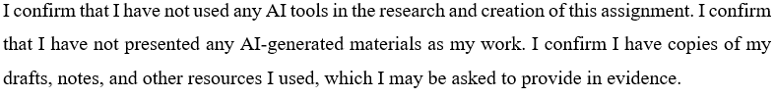
Table of Contents
1 Introduction 3
1.1 Learning Objectives 3
2 Challenges in Managing Guest Expectations And Ensuring Service Efficiency 4
2.1 Description (Gibbs) – Front Desk Experience 4
2.2 Feelings (Gibbs) – Adapting to the Work Environment 5
2.3 Evaluation (Gibbs) – What Worked Well & Challenges Faced 5
3 Critical Analysis of Work-Based Skills and Technical Knowledge 5
3.1 Importance of Work-Based Skills in Guest Service Standards 5
3.2 Relevance of Technical Knowledge 6
3.3 Theoretical Integration 6
4 Reflection on Organisational Issues 6
4.1 Identified Issue: Staffing and Workload Management 6
4.2 Impact of the Issue 7
4.3 Suggested Solutions (Backed by Theory) 7
5 Conclusion and Action Plan 7
References 8

Introduction
Hilton Garden Inn Luton North is a well-known business hotel that offers modern accommodations, standard services, and services that focus on guest satisfaction (Aung, 2024). The hotel has key departments like the Front Office, Food and beverage (F&B), and Housekeeping, which are essential to ensure smooth operations and an exceptional guest experience (Mbagga et al., 2021). The department provides high-quality dining services, including breakfast, lunch, and dinner, as well as bar service, by the Hilton brand standard. During my placement, I worked mostly at the Front Desk, where I was well acquainted with guest check-in and check-out, financial transactions, and daily operations using OnQ, Hilton’s property management system. I had direct guest interaction and problem-solving and ensured service delivery. Joana (Front Office Manager) and supervisors Tharin, Dre, and Raluca offered me great support and guidance during my learning process.

Learning Objectives
Next week, I will transition to the F&B department under Maria's supervision. This shift will help gain insight into a different aspect of hotel operations, focusing on guest service, order management, and restaurant efficiency (Yaacob et al., 2023). My learning objectives for the F&B placement are:
1. To understand supervisory responsibilities in the F&B department.
2. To develop guest service and communication skills in a fast-paced dining environment.
3. To learn technical F&B operations, such as order processing and POS system usage.
4. To observe how teamwork and leadership function within the department.

Challenges in Managing Guest Expectations And Ensuring Service Efficiency
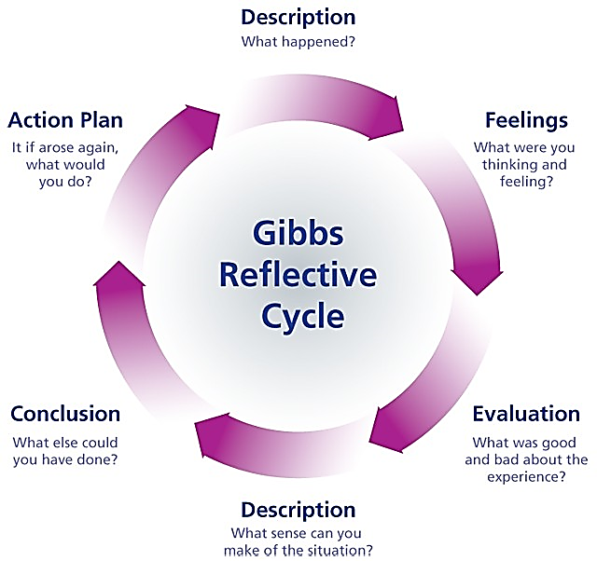
Figure 1 Gibb's Reflective Cycle
Source: Stewart (2015)

Description (Gibbs) – Front Desk Experience
While at the Front Desk, I welcomed and bid the guests goodbye, facilitated hassle-free cheque ins and outs, handled financial transactions, and dealt with any guest complaints. OnQ became something I was able to master as it helped me to make reservations, update guest information, and process payments. Personalised service was my responsibility, for instance, delivering welcome letters to guests’ rooms and showing how small details matter in hospitality. The working environment was team-oriented, and much was supportive; asking questions was not uncomfortable, and one could learn at speed (Azzahra and Asshofi, 2024). The structured operations of the Front Desk provided me with a sense of structure, which increased my confidence in handling guests and operational issues.

Feelings (Gibbs) – Adapting to the Work Environment
Working at a hotel was exciting and scary at first. As I learnt OnQ and Front Desk duties, I felt more comfortable managing visitor requests alone. My managers and coworkers were kind and eager to help me with procedures, making my transfer easier. I'm eager and nervous to join F&B. From a desk-based profession to a guest-facing service function, additional obstacles arise, such as managing high-pressure meal services, various client demands, and food and beverage standards (Dang and Moreo, 2022). Despite my initial worries, I'm excited to apply my Front Desk guest service skills to F&B and learn new operations.

Evaluation (Gibbs) – What Worked Well & Challenges Faced
I honed my communication skills at the Front Desk and interacted with guests professionally and effectively. The first lesson was to stay calm under pressure, especially during peak times when there were multiple guests to assist simultaneously (McCartney and Liew Kim Yoke, 2024). I also gained knowledge in team collaboration, as the Front Desk team needed to work closely to run things smoothly. One problem I had was dealing with guest complaints and special requests when the hotel was full or when there were metre billing discrepancies. These were situations where problem-solving skills, patience and professionalism had to be applied (Papageorgiou et al., 2024). I then realised that guests expect great service and are sensitive to poor communication skills, as it affects the overall experience.

Critical Analysis of Work-Based Skills and Technical Knowledge

Importance of Work-Based Skills in Guest Service Standards
Diverse job abilities are needed in hospitality to satisfy guests. My communication skills were essential for resolving visitor enquiries, addressing issues, and working with coworkers. Communicating well at the Front Desk meant visitor requests were noted and handled quickly (Sheoran, 2025). F&B, where visitors engage more often and need rapid replies, will also demand good communication. Teamwork is crucial for hotel operations since divisions must work together (Villaluna Jr, 2024). Staff worked together to handle high-volume check-ins, resolve issues, and communicate with housekeeping and F&B at the Front Desk. Teams are needed to coordinate food orders, maintain service efficiency, and provide visitors with a good experience in F&B (Wang, 2025).

Relevance of Technical Knowledge
Hotel operations rely heavily on technology, and after learning OnQ, the person could be enlightened on reservation management, financial handling and guest record keeping (Wen and Chen, 2024). I will move into F&B and gain experience using a point of sale (POS) system at the hotel, adding to my technical competency in hotel technology systems. In the same fashion, guest service standards are equally important. I’m at the Front Desk and experienced how personalised attention can make a lot of difference in guest satisfaction. As a part of the F&B department, it is important to maintain service standards per order accuracy, prompt response times, and Hilton’s brand policy (Aung, 2024).

Theoretical Integration
Hospitality directly applies to Maslow’s Hierarchy of Needs, whereby guests seek comfort, security and a personalised experience (Mbagga et al., 2021). I realised that with knowledge of Kolb’s Experiential Learning Cycle, I understood how hands-on experience contributes to professional learning. In addition, Tuckman’s Team Development Model provided insight into how teams achieve efficiency and performance in hospitality environments that are subjected to high pressure (Yaacob et al., 2023).

Reflection on Organisational Issues

Identified Issue: Staffing and Workload Management
The Front Desk was one of the key challenges; staff shortages during peak hours were common, resulting in higher workload stress and sometimes delayed services (Azzahra and Asshofi, 2024). While the team worked well together, the necessity to provide additional support when the occupancy rates were high meant that sometimes that support was unavailable. The same problems may occur in F&B, especially during rush hour for breakfast, lunch, and dinner. A fast-paced restaurant needs adequate staffing to meet order fulfilment and guest satisfaction times (Dang and Moreo, 2022).

Impact of the Issue
The issue seriously affects guest experience since long wait times may not satisfy guests. Furthermore, when the workload is unmanageable, it causes the employees to be more stressed, leading to errors and decreased performance (McCartney and Liew Kim Yoke, 2024). Therefore, it is important to have a structured staffing strategy to balance the load distribution and maintain operational efficiency.

Suggested Solutions (Backed by Theory)
Cross-training employees is one of these, and it fits with human capital theory, which allows employees to work across different departments when required (Papageorgiou et al., 2024). Predictive scheduling is another approach, along with data-driven forecasting methods, to apportion shifts based on demand. Herzberg’s Two-Factor theory also states that recognition, incentives and professional development opportunities can enhance employee motivation (Sheoran, 2025).

Conclusion and Action Plan
My placement at Hilton Garden Inn Luton North has been an invaluable learning curve, as I was exposed practically to guest service operations, technical systems, and team dynamics. This has helped me to improve my handling of guest concerns, to work efficiently under pressure and to strengthen my communication skills. In transitioning to F&B, I also wish to improve my problem-solving, adaptability, and service-mindedness. I will learn F&B operations, take supervisor feedback and research for the best in class hospitality workforce management. I feel more dedicated to pursuing a career in hospitality, and with this experience, I feel that I have gained the basic skills to grow professionally in the future.

References
Aung, L. (2024). A Study on Hotel Industry Growth in Regional Development (Case Study: Ngwe Saung Beach)(Linn Aung, 2024).
Azzahra, M. S., and Asshofi, I. U. A. (2024). Study of the cooperation relationship between the front office and housekeeping departments through communication at hotel tentrem semarang. Journal of Gastro Tourism, 2(2), 75-92.
Dang, A. S., and Moreo, P. J. (2022). Hospitality education program student-operated restaurants: An applied analysis. Journal of Hospitality and Tourism Education, 34(4), 217-228.
Mbagga, S., Malusu, J., & Lyamtane, E. (2021). Implementation of Hospitality Programme to Facilitate Skills Acquisition among Trainees in Arusha Region, Tanzania. International Journal of Innovative Research and Development, 10(10).
McCartney, G., and Liew Kim Yoke, A. (2024). Lights, camera, action! Adding showmanship to the hospitality servicescape and experiencescape to attract customers: a management perspective. British Food Journal, 126(7), 2809-2824.
Papageorgiou, G., Marneros, S., and Efstathiades, A. (2024). Predicting career success in the hospitality industry of Cyprus: A competency-based approach. Journal of Teaching in Travel and Tourism, 24(3), 236-268.
Sheoran, M. (2025). Hospitality Industry: Insights and Perspectives. Educohack Press.
Stewart, S., 2015. Gibb’s Reflective Cycle. Sarah Stewart's Eportfolio, 25 October.
Villaluna Jr, M. P. (2024). PROFESSIONAL INDUSTRY EXPERIENCES AND COMPETENCIES OF HOSPITALITY AND TOURISM EDUCATORS: BASIS FOR A PROPOSED WORK IMMERSION PROGRAM. BIMP-EAGA Journal for Sustainable Tourism Development, 13(1), 72-80.
Wang, P. Q. (2025). Personalizing guest experience with generative AI in the hotel industry: there's more to it than meets a Kiwi’s eye. Current Issues in Tourism, 28(4), 527-544.
Wen, T., and Chen, L. (2024, September). Application and Development of Opera Computer System in Hospitality Management. In 2024 3rd International Conference on Artificial Intelligence and Computer Information Technology (AICIT) (pp. 1-7). IEEE.
Yaacob, S. A. M., Nawawi, W. N. W., Ramli, N., Kamal, M. H. M., & Abd Majid, H. A. (2023). The Importance of Digital Skills Training Towards Employees’ Development in the Hospitality Industry. International Journal of Business and Technology Management, 5(S1), 283-291.

