Archival Exercise: Frederick Douglass

For this exercise I have chosen to conduct some archival research on Fredrick Douglass, thought to have been born around 1818 in the United States Douglass was a social reformer, abolitionist, writer, and statesman; he became a leading voice for the abolitionist movement in both Massachusetts and New York after having escaping enslavement in Maryland. Douglass is recognised for his exemplary oratory skills as well as his impactful antislavery writings. Douglass’s work and life have been heavily researched into however due to my unfamiliarity but existing interest in the abolitionist movement I am hoping to gather a deeper understanding of Douglass and his part in the movement, in order to do this, I have found a number of different resources from accessible archives and will explaining why I believe they are a valuable resource.

Speech: My Slave Experience in Maryland (1845)

This first resource is found in The Frederick Douglass Papers, this online resource aims to eventually contain Douglass’s speeches, autobiographies, correspondence, and other writings. The source itself is a small description from Douglass of his experience of slavery in Maryland. Douglass’s infamous Narrative would be published a few days after this address in New York. This speech lends itself to be highly valuable for two main reasons, the first being it gives the reader an insight into Douglass’s oratory range by both the speech’s design and its reception. The other reason is that is provides the reader with a brief introduction to Douglass’s horrifying experience of slavery and his views on the matter.
[Douglass, F. (2007) MY SLAVE EXPERIENCE IN MARYLAND, My slave experience in Maryland · Digital Edition · Frederick Douglass papers project. Yale University Press 1979. Available at: https://frederickdouglasspapersproject.com/s/digitaledition/item/8205 (Accessed: November 24, 2022).]

Book: Narrative of the life of Frederick Douglass, an American slave (1845)
This second source comes from the Internet Archive, this archive is an American digital archive that gives free public access to digitised collections of resources such as websites, software applications/games, music, movies/videos, and millions of books. Narrative is perhaps one of the most influential and valuable sources on this list of resources due to its influence of fuelling the abolitionist movement in the United States.
[Douglass, F. (2012) Narrative of the life of Frederick Douglass, an American slave: Douglass, Frederick, 1818-1895, Internet Archive. Boston: Published at the Anti-Slavery Office. Available at: https://archive.org/details/narrativeoflifeo1845doug/page/n9/mode/2up (Accessed: November 24, 2022).]

Newspaper: The North star (December 3rd 1847)

This third source I found to be highly valuable as it provides an insight into Douglass’s life and writings, the source is located in the Library of Congress. This source marks the first publication of Douglass’s paper lobbying for African American rights.
[Douglass, F. Image 1 of the North Star (Rochester, N.Y.), December 3, 1847, The North star (Rochester, N.Y.), December 3, 1847. Library of Congress. Available at: https://www.loc.gov/resource/sn84026365/1847-12-03/ed-1/?sp=1&r=-0.673,0.099,2.346,1.038,0 (Accessed: November 27, 2022).]

Speech: What to the Slave Is the Fourth of July? (1852)

This fourth source I found in Archives at Yale, a part of Yale University’s digital assets from across Yale’s collection the archive hosts millions of resources including extremely rare manuscripts. This speech given by Douglass on the 5th of July is held as one of Douglass’s most influential, the speech addresses the founding fathers and their conflicting ideals surrounding slavery taking place on American soil with a call on the American people to extend the right to freedom to the African American community.
["What to the Slave Is the Fourth of July?" speech by Frederick Douglass, typescript version. Beinecke Rare Book and Manuscript Library. https://archives.yale.edu/repositories/11/digital_objects/140583 Accessed November 26, 2022.]

Book: My Bondage and My Freedom (1857)

The fifth source that I have decided to put on this list is Frederick Douglass’s second book from the Internet Archive, this second novel functions as primarily a continuation of his first. This second book highlights some areas of slavery in the 19th century that the first book does not mention in detail, the differences Douglass’s experiences between British attitudes towards American slavery and segregation. As well as Douglass’s relationship with Irish immigrants.
[Douglass, F. (1970) My bondage and my freedom: Frederick Douglass: Borrow, and streaming, Internet Archive. Miller, Orton & co. Available at: https://archive.org/details/mybondageandmyf02douggoog/page/n138/mode/2up (Accessed: November 26, 2022).]

Photograph: Studio portrait of Frederick Douglass (1875-1880)

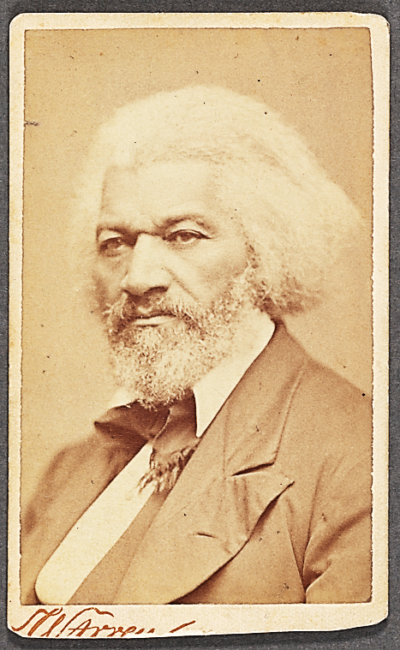

This source although very different from the other text sources I felt brought a different type of value, found in the New York Public Library within the Black culture, photographs and prints division this photograph taken of Douglass by George Kendall shows Douglass in his late 50’s. After conducting research on a historical figure, it is nice to place a face to a name.
[Schomburg Center for Research in Black Culture, Photographs and Prints Division, The New York Public Library. "Studio portrait of Frederick Douglass" The New York Public Library Digital Collections. 1875 - 1880. https://digitalcollections.nypl.org/items/82c9f300-9980-0139-aa81-0242ac110003]

Speech: 79th Anniversary of Abraham Lincoln’s Birth (1888)

This seventh resource is one that I found in the Library of Congress’s Manuscript Division, this resource I felt was one of the more valuable on the list for a few reasons. The first reason being that it marks the fact that Douglass was among the few Black figures to meet the president, in this rare case Frederick was actually invited to the white house by president Abraham Lincoln in 1864 after their first meeting involving Douglass’s protesting for the end of discrimination facing black soldiers serving within the union army. To me this written speech emphasises the long-standing relationship Douglass had with Lincoln and only further places Douglass in the rare number of black figures in this period of slavery able to build relationships with presidential figures.
[Douglass, F. (1970) My bondage and my freedom: Frederick Douglass: Borrow, Internet Archive. Miller, Orton & co. Available at: https://archive.org/details/mybondageandmyf02douggoog/page/n138/mode/2up (Accessed: November 26, 2022).]

Diary: Tour of Europe and Africa (1886-1894)

The eight source I am including on this list is Fredericks single diary that hold the details of his tour throughout Europe and Africa, found in the Library of Congress’s manuscript archive. Consisting of 72 pages his entries shed light on how the rest of Europe engaged in slavery as well as their perceptions of how America conducted slavery.
[Douglass, F. (1886) Welcome to LC Catalog, LC Catalog. Library of Congress. Available at: https://catalog.loc.gov/ (Accessed: November 27, 2022).]

To conclude this list of resources, there are a plethora of archival resources on Douglass and all of them fairly easy to both find and access. Overall, from the sources I found Douglass is a very interesting 18th century Black figure of the abolitionist movement and it could be said that he is a key figure for slavery during this period. As some suggestions for future archival searches on the topic I would recommend the Library of Congress, I found this to have a large selection of resources to offer in addition to this it was very easy to navigate.

