
Intercultural competence report
Syeda Rahma Begum – 2207458

Cultural Awareness – BMIH5003

Word Count: 1025

Lecturer: Guilia Chifari

Executive Summary
This is a cultural competence report which has been prepared for the general manager of Hotel Diversity and Spa in London. This document will inform the general manager on the key cultural differences, customs, and behaviour of Qatar.
There are several graphs within this report from the GLOBE project that shows the cultural and leadership visualisation of data collected for Qatar and includes a graph showing Hofstede’s 6D Model of Qatar’s values.
This report will briefly outline the importance of cultural differences and customs within Qatar and how they have a variety of customs which they follow. Also, the importance of cultural sensitivity and the importance of cultural intelligence within the industry. As a hotelier it is very important to be aware of this especially when a hotel is placed in a certain country, so employers and employees have knowledge and awareness of cultural backgrounds and customs so cultural misunderstandings and problems do not occur.

Table of Contents
Executive Summary 1
Introduction 3
Main Findings – Culture Overview 4
Country Analysis 1 5
Country Analysis 1.1 6
Conclusion …………………………………………………………………………………………………………………………………….7
Recommendations ………………………………………………………………………………………………………………………..8
References ……………………………………………………………………………………………………………………………………9

Introduction
The purpose of this report is to look at the cultural overview and the GLOBE project country analysis of Qatar. Qatar has a variety of cultures and customs. “The culture in Qatar is an exotic mix of past and future: the fascinating ancient traditions and the facilities of an ultramodern world” (Camacho, 2023). There are many customs in Qatar such as language as the “official language spoken in Qatar is Arabic however, English is also widely spoken in the country and Persian and Urdu are often spoken too” (Camacho, 2023). There are a few main cultural customs in Qatar such as, “Food, marriage, and religious beliefs. Islam is the official religion in Qatar, and the regime and government are linked to Islamic Sharia” (Info Countries, 2023). Clothing is also a cultural entity as they all dress very modest for example the “women are expected to dress appropriately and in Qatar it is also rude to “stare at people for too long. Also, in Muslim communities handshakes are avoided between a man and a woman” therefore it is better to wait for the first approach rather than offending anyone (Qatarofw, 2022). However, “adjusting to Qatari culture is not as difficult as it is in other Arab nations because a strong majority of people living in this country are foreign born” (Qatarofw, 2022).

Cultural Overview of Qatar
“Although being a country booming with development, Qatar hasn’t forgotten its roots, and the natives carry immense faith in Islam which is the official religion of the country. Although this is the case the country doesn’t impose any restrictions on any other religious identity” (Kanoja, 2021). Furthermore, “Even though the Qataris have a strong sense of family privacy, they always extend their hospitality to strangers and the elderly people are given great respect and politely spoken to by the younger generation” (Nag, 2018). Qatar is a country with a variety of cultures and customs and in order not to disrespect or offend anyone it is important to respect the country’s religion, faith and the cultural and customs that they have.
For a hotel personnel cultural intelligence is very important as it “refers to the knowledge of a person by which the person understands how people of a different country, religion and race behave or lead life it is the ability to work in a multi-cultural environment” (GBR, 2022). Cultural sensitivity within the workplace “is represented through the organisational and interpersonal recognition and appreciation of cultural diversity among professionals the success of this is dependent on the polices and behaviours” (Indeed, 2023). By prioritising cultural sensitivity in the workplace, it creates a “safe working environment, minimises bias, diversifies and strengthens the talent pool, inspires innovation and creativity, improves collaboration, boosts job satisfaction and increases audience engagement” (Indeed, 2023).

Country Analysis of Qatar
Below is the cultural and leadership visualisation of data collected for Qatar according to the GLOBE project.

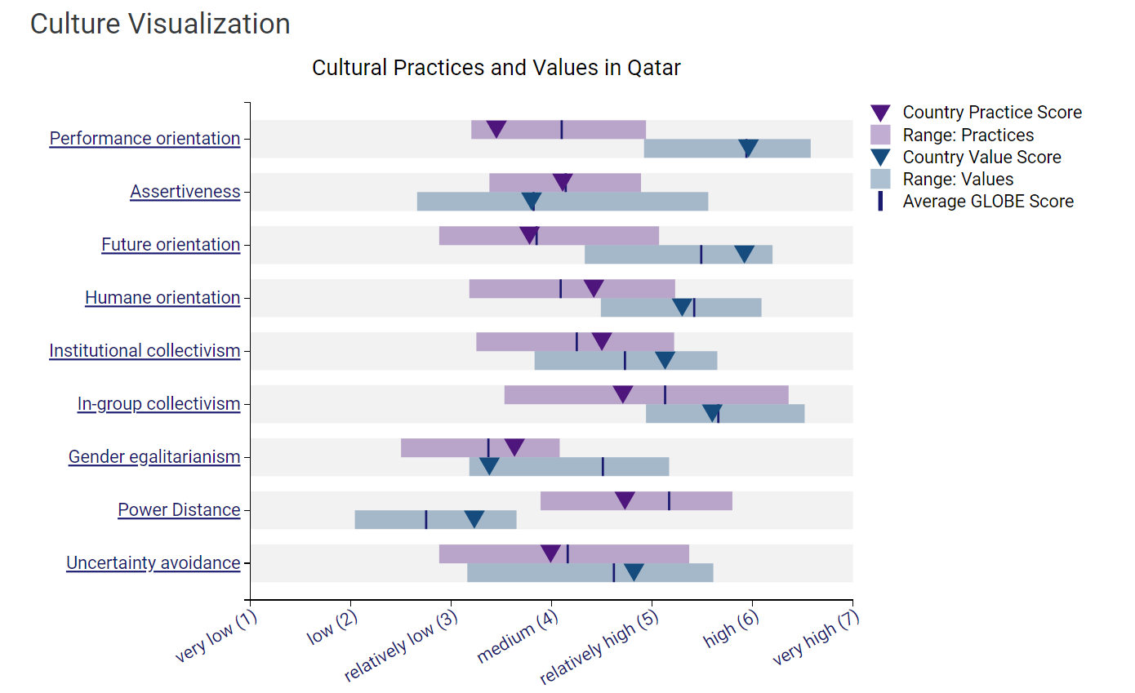
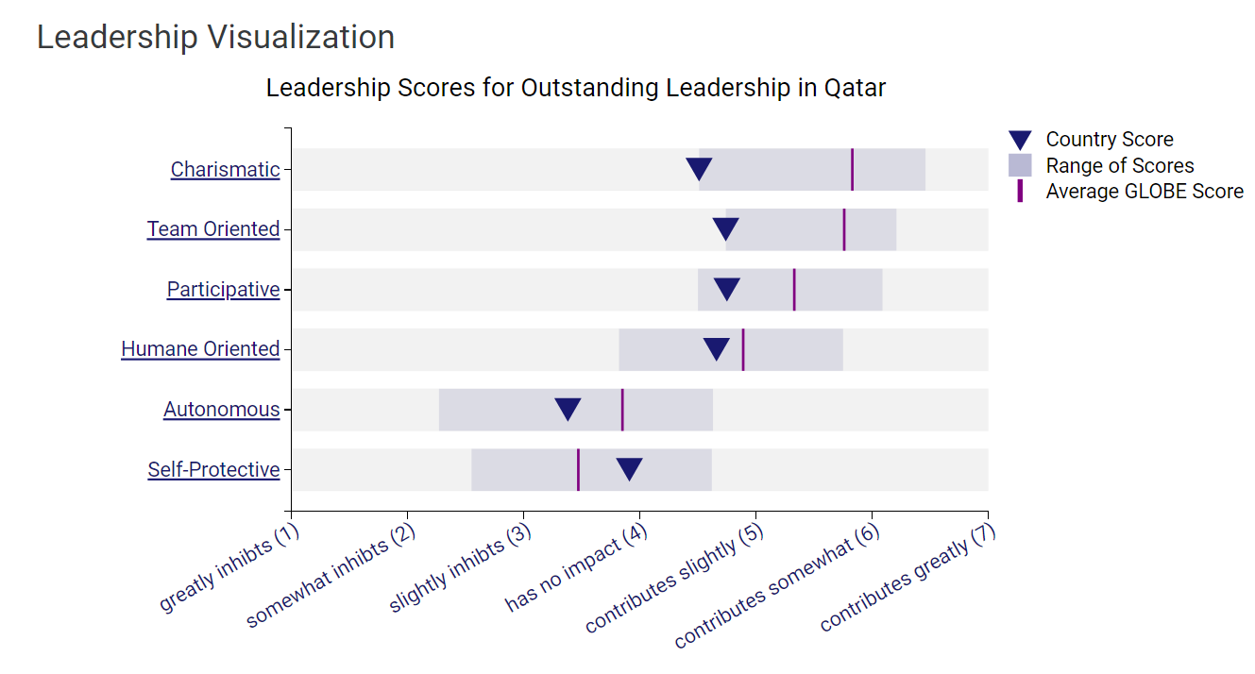(Globe, 2020)
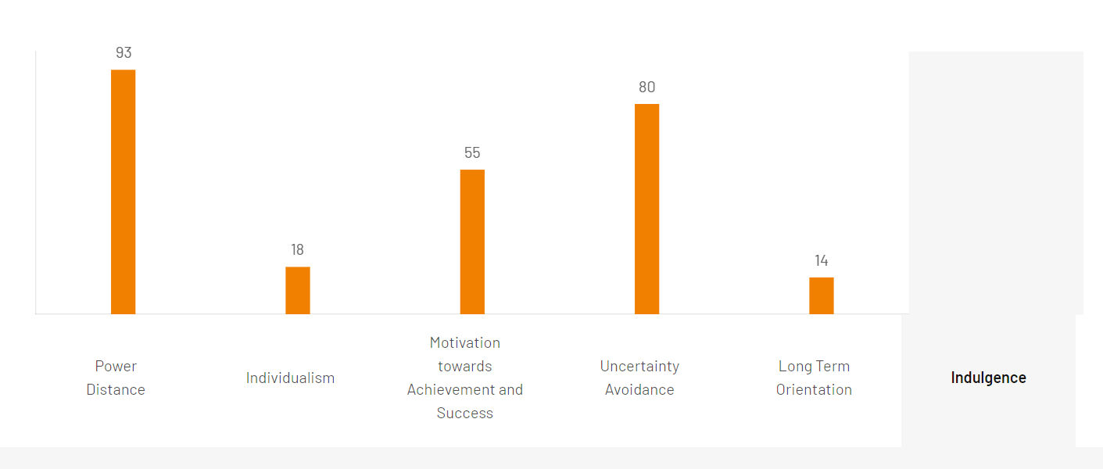 (Hofstede Insights, 2022).
Looking at the above chart on Hofstede’s 6D Model it shows that Qatar has a power distance of 93, Qatar scores high on this because it shows “that people accept a hierarchical order in which everybody has a place, and which needs no further justification” (Hofstede Insights, 2022). “With a score of 18, Qatar is certainly a collective society. This is manifest in a close long-term commitment to the member ‘group’, be that a family, extended family, or extended relationships” (Hofstede Insights, 2022). Also, with motivation towards achievement and success Qatar scored 55 this score “indicates a tendency towards decisive society. Where people ‘live to work’ so managers are expected to be decisive and assertive” (Hofstede Insights, 2022). Furthermore, with a high score of 80 in uncertainty avoidance this “indicates a high preference to avoid unpredictability. Qatar maintains rigid codes of belief and behaviour and is tolerant to unorthodox behaviour and ideas. In these cultures, there is an emotional need for rules” (Hofstede Insights, 2022). Moreover, “with a low score of 14 means that Qatar has a normative culture, they exhibit great respect for traditions and are normative in their thinking” (Hofstede Insights, 2022). Finally, Qatar has scored 0 in indulgence as the rating has not been done yet but in Qatar the indulgence would be relatively low as it is a Muslim country which means they know relatively well and are expected to control their impulses and desires no matter how tempting it may be hence why the woman and men dress a certain way and a lot of segregation is within the country between both male and female.

Conclusion
To conclude this report the general manager must ensure that all hotel personnel have got adequate training and are aware and have knowledge of the cultural differences, cultural sensitivity, cultural intelligence and customs that the people of Qatar have. As compared to the Hotel Diversity and Spa in London the cultures are both very different and it is important not to offend anyone. “Employees of hotels have to face people from different countries of a range of cultures. Such cultures are very different from one another. Therefore, employees of such hotels have to have a sound understanding of different cultures, customs and behaviour” (GBR, 2022). It is also important for the general manager to ensure that all employees do not unconsciously bias guests and colleagues as even though Qatar is a modern country it still has a strong sense of cultures and customs so by understanding this it ensures a welcoming environment for co workers not just guests for example when greeting guests it is better to wait for them if they want to shake your hand as some women do shake hands in Qatar but some don’t due to cultural customs and religious beliefs. This will prevent offense to anyone and will show cultural knowledge to the guest.

Recommendations
To build cultural awareness and cultural sensitivity in the workplace below are a few points that the hotel manager can implement:
- Celebrate cultural differences
- Prioritise fairness and Inclusion
- Seek out cultural sensitivity training
- Practise active listening (Indeed, 2023)
- Be conscious of food requirements
- Accommodate religious beliefs and rituals
- Educate yourself on customs and preferences
- Know how to get the best out of the employees (Siteminder, 2020)

References
Camacho, B (2023) Culture and social etiquette in Qatar, 15 March. Available at: A guide to social norms and etiquette in Qatar | Expatica (Accessed: 04 November 2023).
GBR Editorial Team (2022) Importance of cultural intelligence for hotel personeel, 17 October. Available at: Importance of cultural intelligence for hotel personnel (george-business-review.com) (Accessed: 5 November 2023).
Globe (2020) A unique large-scale study of cultural practices, leadership ideals, and generalized and interpersonal trust in 150 countries in collaboration with nearly 500 researchers. Available at: Results - Qatar GLOBE Project (Accessed: 04 November 2023).
Hofstede Insights (2023) Country comparison Tool. Available at: Country comparison tool (hofstede-insights.com) (Accessed: 04 November 2023).
Indeed (2023) Importance of Cultural Sensitivity in Today’s Workplace, 4 February. Available at: Importance of Cultural Sensitivity in Today's Workplace | Indeed.com (Accessed: 05 November 2023).
Info Countries (2023) Qatari Traditions and Customs. Available at: ▷▷ Qatari traditions and customs - Info Countries (info-countries.com) (Accessed: 04 November 2023).
Kanojia, R (2021) Culture of Qatar: A Glimpse Into The Life Of The Natives, 18 February. Available at: Culture Of Qatar: All One Needs To Know About This Vibrant Country (myholidays.com) (Accessed: 04 November 2023).
Nag, S, O (2018) The Culture Of Qatar, 29 November. Available at: The Culture Of Qatar - WorldAtlas (Accessed: 04 November 2023).
Qatar OFW (2022) 5 Things You Need To Know About Qatar Culture. Available at: 5 Things You Need to Know About Qatar Culture · Qatar OFW (Accessed: 04 November 2023).
Site Minder (2020) Cultural Sensitivity: Does your hotel cater for all? 28 December. Available at: Cultural Sensitivity: Does your hotel cater for all? - SiteMinder (Accessed: 05 November 2023).
Travel S Helper (2022) Traditions & Customs in Qatar. Available at: Traditions & Customs in Qatar - (2023) By Travel S Helper (Accessed: 04 November 2023).

