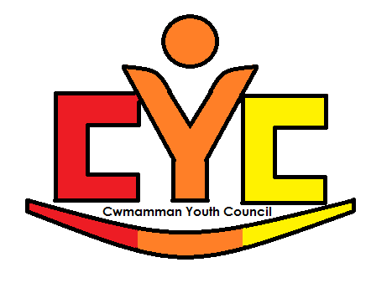

Cwmamman Youth Club – Creating a better community for everyone.
  - Business Plan

Contents
Executive Summary………………………………….………………………Page 3
Introduction…………………………………………………………………...Page 3-4
Business aims………………………………………………………………..Page 5-6
Community Profile…………………………………………………………...Page 6-7
Broader context……………………………………………………………...Page 7-8
Business organisational structure……………………………………….…Page 9
Roles and responsibilities…………………………………………………..Page 10-11
Performance evaluations…………………………………………………...Page 11
Sample timetable…………………..………………………………………..Page 12
Implementation Plan………………………………………………………..Page 13
Budget…………………………..……………………………………………Page 14
Moving forward – The Future………………………………………………Page 14-15
Reference list………………………………………………………………..Page 15-16

Executive Summary
The vision of this business is to establish more youth work provision for the young people in the rural community of Cwmamman using a youth council. This business will include the participation of young people to enable them to develop their own voice, influence and place within their community (LSIS, 2012). This business recognises that youth work is committed to work with the young people in a participative way to encourage them to share responsibility and become equal partners in their learning and development within their community (WG, 2014). By working closely with the young people, their needs and wants within the community can be easily identified and voiced. Through their shared decision making, more provision can be made within the community to support and educate young people.
Introduction
The aim of this business is to establish a youth council in order to develop more youth work provision to meet the needs of the young people in the rural community of Cwmamman. This business will enable young people to have a voice and come together to make positive changes within their community. This business is hoped to make the community a better place for young people, give them a sense of belonging, purpose and responsibility. This business can bring together members of the community including other organisations, such as the town council, and work together to make a difference. This business can reduce the stigma against young people and enable other generations to work together and create community unity and cohesion.
The youth council will be based in the Cwmamman Youth Resource Centre, which is a building created and leased for a youth council. This suggests that the building is already available for a newly formed youth council and cost will not be an issue. The building includes a large communal area suitable for meetings, a large fully furnished kitchen that can be used for cooking projects and has a furnished bunk house that can be rented out or used for international projects. Therefore, resources are available, minimising costs. This building has potential to enable the council to book educational workshops, youth clubs, training sessions, community groups and other organisations to meet the needs of young people in the community. In order to keep the business going, this building can be rented out to other community groups such as the brownies, art classes or the choir. This can be done for £10 an hour or the bunk house £5 per head each night. In addition to the businesses sustainability, the youth council can create fundraising projects if needed.
There will need to be a lead youth worker and a support youth worker paid to guide the young people in the meetings and with the projects, as well as ensuring the business runs smoothly. This lead youth worker will need to be professionally qualified in order to recognise the needs of young people, the outcomes and have the capability to help organise projects and provision bookings. These youth workers will commit to meeting with the young people for meetings every month and in-between if actions are required. Between each meeting a rota of bookings will take place in the centre for the young people in the community such as drugs and alcohol workshops, youth club, drop ins and training sessions which the youth worker is expected to facilitate or supervise.
The centre is expected to be open every day, Monday to Friday. Each evening will have something on for young people and a youth worker available to them.
Business aims
- Encourage young people in the community to become a part of a youth council.
This aim will enable the young people of the community to voice their opinion on their community and have a say on the issues that affect them. This is a basic right for young people that the community, government and youth workers should ensure is put into place (Unicef, 1989).
- Provide more youth work provision for young people in the community
Using the help of the youth council and community profiling, the needs of young people can be continually identified. This aim will enable the business to meet the needs of the young people and provide them with the provisions they need to achieve outcomes. This includes; first aid training, OCN opportunities, youth clubs, homework club, issue-based workshops, Maths and English GCSE’s and projects that include their own outcomes. This aim can enable the young people to learn nessasary life skills and employability skills. This will enable the needs of the young people to be met and enable them to reach their potentials (LSIS, 2012).
- Create and facilitate a variety of activities that are suitable for all members of the community to create unity and minimise social isolation.
The business is very passionate about the community and the members in it. This business will provide activities and projects that are inclusive to all members of the community to create unity and reduce isolation. This is also hoped to change and shape the views the older generation may have on young people and create a community that works together to better outcomes for everyone. This will be done through training opportunities, coffee mornings, community projects, young parent groups, mixed age choirs, art classes and themed events such as barbecues.
- To support local community events and businesses.
This aim will be done through enabling other organisations of the community to book and host their events and businesses in the youth councils centre when it is not in use by young people. Things such as book clubs, music nights and fundraising events of their own. This will benefit both the community and the business by providing the community with facilities and space for a very low price and enables the business to be recognised and sustained by some sort of income to keep it afloat.
Community profile
Cwmamman is traditionally known as an area formed by two small villages called Glanamman and Garnant (cwmammanhistory.co.uk, 2017). These villages lie next to one another and have a shared community. Cwmamman’s community population is four thousand, four hundred and ninety-six, when both villages are recognised as one (Carmarthenshire County Council, 2015a and Carmarthenshire County Council, 2015b). The area of Cwmamman is sited in the Amman Valley, Carmarthenshire and is approximately four miles from its nearest town of Ammanford suggesting it is particularly rural (cwmammanhistory.co.uk, 2017). Because of this, it is essential to have its travel links for residents to commute. The villages do have services and facilities of their own, such as the Amman valley hospital, two surgeries, pharmacies, local corner shops, community centre and primary schools. However, to access a dentist, secondary schools, food banks, the job centre and other services such as domestic abuse and mental health services, the residents will have to travel out of the community. This can be difficult for those who do not drive or own a car, therefore they would have to rely on public services that may not always be reliable or convenient. Cwmamman has a very strong community of welsh speakers, in fact, 59.8 percent of Glanamman and 58.5 percent of Garnant are welsh speakers (Carmarthenshire County Council, 2015a and Carmarthenshire County Council, 2015b). This is a high number, however can be improved by providing welsh lessons throughout the business to the residents.
Both villages rank very low on the most deprived areas in Carmarthenshire and within Wales (Carmarthenshire County Council, 2014 and Carmarthenshire County Council, 2015a). In fact, the highest levels of deprivation attributed to Glanamman and Garnant is the health domain, employment domain and the income domains (Carmarthenshire County Council, 2015a and Carmarthenshire County Council, 2015b). This could be down to the limited number of services and businesses in the area. In addition to this, a third of both villages have no qualifications, this can contribute to the lack of employment resulting in low income if qualifications are required.
The business will be able to provide young people and other generations of the community more provision and services regarding education, health workshops and employment skills by calling in professionals to the building, to work on these weaknesses and provide the residents access to more services.
Broader context
The work of this business is hoped to better the community development and the young people in it. To Recap, the main aims are to enable young people to have a voice and to provide young people with more youth work provision to enhance their development. The business is also concerned with creating community cohesion.
The work of this business plan will provide young people with the necessary skills to enhance their chances of being employed throughout workshops, GCSE’s and CV writing. This follow suits with the governments aims to reduce the number of young people that are not in education, employment or training (Welsh Government, 2015).
The business is also working towards the Governments Well-being of Future Generations Act (2015) by meeting its aim of creating community cohesion. This aim enables the business to create a prosperous Wales, a more equal Wales and Wales of cohesive communities (Welsh Government, 2016). By meeting these goals, it enables Cwmamman to be a better place in which to live and improves the social, economic, environmental and cultural well-being of Wales (Welsh Government, 2016).
Social isolation and loneliness can impact the physical and mental health wellbeing of an individual (National Assembly for Wales, 2017). According to the British Red Cross (no date, cited in National Assembly for Wales, 2017) “A lack of social connections can be linked to cardiovascular health risks and increased death rates, blood pressure, signs of ageing, symptoms of depression and risk of dementia”. The National Assembly for Wales plans to tackle this issue and provide services to support individuals. The business recognises this as an issue, therefore meeting the aim to reduce social isolation also supports government plans. By reducing isolation in Cwmamman, it can potentially improve the health and wellbeing of local residents and unite the community.

Business organisational structure
The business will be registered as a community interest company. This suggests that the business was created in order to use the assets and profits for the good of the community, not for our own benefit (Company Address, 2016).
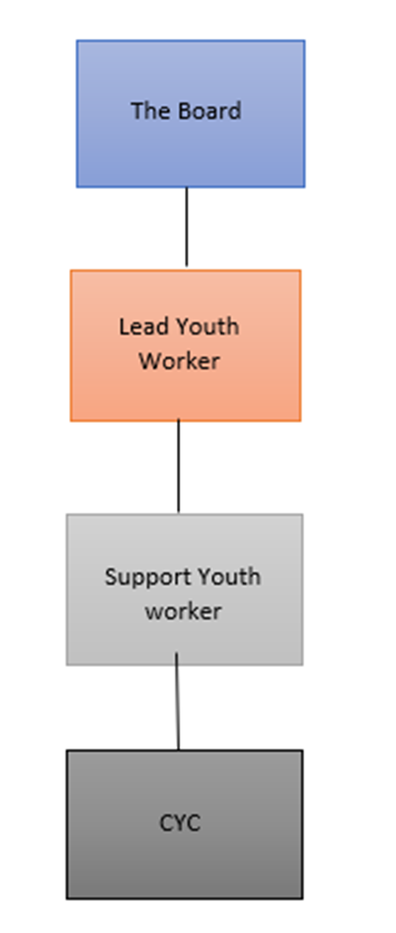
The business will include a board of people that meet voluntary with a keen interest in the company. This board will consist of people from different organisations to make impartial decisions on important aspects of the business. These organisations include the Carmarthenshire County Council, the Carmarthenshire Youth Support Service, the Cwmamman Town Council, the Lead youth worker and members of the community.

Roles and responsibilities
Each role in the business will require responsiblities that must be fulfiled. These responsibilities will ensure that the business runs smoothly and orderly.
The Board:
- Make executive decisions on important aspects of the business e.g finances.
- Meet monthly to discuss business to ensure it is running smoothly and meeting needs.
- Communicate regularly with ideas to make the business better.
- Finalise decisions made by CYC members and youth workers.
Lead Youth Worker:
- Develop and organise projects
- Provide supervison to other staff and CYC
- Provide support to CYC and other young people in the community
- Complete adminastrative tasks such as managing rotas and finances
- Contact and organise other professionals to facilitate specific sessions
- Promote the businness and marketing
- Facilitate workshops
- Take care of building
- Meet with CYC monthly
Support Youth Worker:
- Support lead youth worker on tasks
- Support activities being facilitated
- Provide support to young people
- Help with resources
- Help take care of the building

CYC:
- Meet monthly for meetings to disucss opertation of business
- Participate and help plan projects
- Volunteer turing sessions
- Participate in community projects and fundraising
- Share opinions and views
Performance evaluations
In order to ensure that the business is running successfully and is meeting its objective, the business will use tools to evaluate their work. By doing this, the business can follow suggestions, make improvements and ensure they are meeting the needs of the young people. In addition to this, the information gathered can be used to assist funding applications. These methods are:
- The number of young people taking part in activities
- The number of young people taking up new activities
Informal evaluation techniques to ensure young people are having fun and learning
- Continual discussions with young people about the activities and feedback
- Suggestion box
- Outcome tick list after each session
- Regular SWOT analysis.

Sample weekly Timetable
This timetable will change every week with new activities and opportunities.
 | Mon | Tue | Wed | Thu | Fri
12pm | Coffee and Cake |  |  | Welsh Lessons | Closed
1pm | Coffee and Cake | English GCSE | Maths GCSE | Welsh Lessons | Closed
2pm | Post 16 drop in | English GCSE | Maths GCSE | CV writing skills
3pm | Post 16 drop in
4pm | Young  Parents | Homework club | Drop in  (anyone) | Homework  Club | Social afternoon
5pm | Young Parents | Homework club | Drop in  (anyone) | ICT | Social afternoon
6pm |  | Youth club | Mental health awareness | Youth club | Substance misuse workshop
7pm | First aid awareness training | Youth club | Mental health awareness | Youth club | Substance misuse workshop
8pm | First aid awareness training | Youth Club |  | Youth club

Implementation Plan
Activity | Jan | Feb | Mar | Apr | May | Jun | Jul | Aug | Sep | Oct | Nov | Dec
Develop business plan
Create organisation
Appoint board members
Recruit staff
Recruit Cyc members
Identify community needs (this will be constant)
Community research
Lease building
Renovation and decorating the building
Buy more facilities
Marketing and publicity
Develop weekly programmes
Develop relationships with community and organisations
Risk assessment of building (once a month to ensure safety)
Open building and business

Budget
Income
Grants | £50000
Fundraising | £2500
Hall hires | £5000
Events | £3000
Bunk house hires | £10000
Total income | £70,500
Outgoings
Bills for building (electric, Water, Gas, Tv license, WIFI, etc) | £10000
Employment costs | £36500
Renovation and repairs | £2000
Bookings and training expenses | £6000
Miscellaneous (Milk, Tea, Coffee, biscuits etc) | £1000
Total Outgoings | £55,500

Moving forward – The Future
This business has been set up with an aim to be sustainable for more years to come. The business relies on the needs and interests of the community and works to overcome and support them. The business understands that needs and interests can continually change, therefore the business has left opportunity for innovations to take place. The aims set out by the business do not specifically rely on supporting specific needs and is created to support any needs of the young people and the community.
The business can be sustained though hires of the building. Profits made by the business will be used to go back into the business to keep it operating and to benefit the community. In addition to this, fundraising can also be done within the community.
In desperate situations, the business can make applications for addition funding. Although additional funding may require specific programmes to be run, the business will not fall desperate enough to accept anything that doesn’t meet the needs of the community. The business will continue to achieve its original aims and developing its services for the community. By continuing this, the business can apply for more funding after the three years to continue its operation or expand and support more rural communities that are in need.
Reference List
Carmarthenshire County Council. (2014) WIMD 2014: Carmarthenshire Summary. Available at: http://www.carmarthenshire.gov.wales/media/2038371/carmarthenshire_updated_summary.pdf (Accessed: 1st January 2018)
Carmarthenshire County Council. (2015a) Garnant Ward: Electoral Division Profile. Available at: http://www.carmarthenshire.gov.wales/media/1749907/Garnant_Ward.pdf. (Accessed: 1st January 2018)
Carmarthenshire County Council. (2015b) Glanamman Ward: Electoral Division Profile. Available at: http://www.carmarthenshire.gov.wales/media/1749910/Glanamman_Ward.pdf. (Accessed: 1st January 2018)
Company Address (2016) Types of company in the UK. Available at: https://www.companyaddress.co.uk/blog/starting-business/types-of-company. (Accessed: 1st January 2018)
cwmammanhistory.co.uk. (2017) Some Captured History of Glanamman and Garnant. Available at: http://cwmammanhistory.co.uk/Amman_Valley_History/Homepage.html. (Accessed: 1st January 2018
Learning and Skills Improvement Service (2012). National Occupational Standards for Youth Work. Coventry: LSIS
National Assembly for Wales (2017) Health, Social Care and Sport Committee: Inquiry into loneliness and isolation. Available at: http://www.assembly.wales/laid%20documents/cr-ld11310/cr-ld11310-e.pdf. (Accessed: 3rd January 2018)
Unicef. (1989) The United Nations Convention on the Rights of the Child. Available at: https://downloads.unicef.org.uk/wp-content/uploads/2010/05/UNCRC_united_nations_convention_on_the_rights_of_the_child.pdf?_ga=2.185089644.477656992.1514983918-841050504.1493727975 (Accessed: 1st January 2018)
Welsh Government (2016) A Guide to the Wellbeing of Future Generations Act. Available at: http://gov.wales/docs/dsjlg/publications/160401-wfg-easy-read-en.pdf (Accessed 2nd January 2018)
Welsh Government. (2015) Youth engagement and progression. Available at: http://gov.wales/topics/educationandskills/skillsandtraining/youthengagement/?lang=en (Accessed: 2nd January 2018)
Welsh Local Government (2007) young people, youth work, youth service. The National Youth Work Strategy for Wales 2014-2018 Available at: http://www.youthworkwales.org.uk/creo_files/upload/files/140221-national-youth-work-strategy-en.pdf (Accessed: 1st January 2018)

