2020
Student Name: Radu Buzatu
Id number: 1817385
Lecturer Name: Afzal Munna

PROBLEM SOLVING
AND
DECISION MAKING

Lousy Manager

Tabel of contents
Part 1. The problem………………………………………………………..2
1.2 Lousy manager Reasons of the problem. ………………………………………...2
1.3 Advantages and disadvantages……………………………………………………2
1.4 How to overcome/resolve the problem……………………………………………3
1.5 My experience of the problem at workplace……………………………………...3
1.6 Seven steps to problem solving…………………………………………………...4
Part 2. Decision Making ………………………………………………………………………………………………5
2.1 Types of decisions………………………………………………………………..5
2.2 Factors affecting decision making………………………………………………..5
2.3 Ingredients for Good Decision Making…………………………………………..6
2.4 Fishbone analysis…………………………………………………………………6
2.5 SWOT Analysis…………………………………………………………………..7
2.6 PESTEL Analysis………………………………………………………………...7
2.7 Five’s Porters …………………………………………………………………….8
Part 3. Solutions……………………………………………………………8
3.1 Proposed solution 1………………………………………………………………8
3.2 Proposed solution 2………………………………………………………………8
3.3 Evaluation of the proposed solutions…………………………………………….9
Part 4: Implementation …………………………………………………...9
4.1 Implementation plan the proposed solution………………………………………9
Conclusion………………………………………………………………….9
References …………………………………………………………………10
Appendix……………………………………………………………………11

“Every problem has a solution.
You just have to be creative enough to find it.”
Travis Kalanick

  - The problem.
Workplace is the place where every adult spends 1/3 of their life and of course like in a family it is impossible to create something in common without having conflicts. So, workplace issues are common source of stress for many and may cause negative psychological symptoms.
A workplace contains different people with different personalities and communication styles, that is why can appear all kind of problems.
There are a lot of types of problems which you can meet at a workplace, for example:
- Interpersonal conflict
- Communication problems
- Low motivation and job satisfaction
- Discrimination
- Lack of training
- A lousy manager etc.

1.2 Lousy manager Reasons of the problem.
I would like to talk about the last one – A lousy manager. As it is known a manager must to be an example, a good model for employees. He is the key for the success environment of the company.
In a company with a bad manager the problems will never end. A lousy manager is problem because his actions create other problems.
there are a lot of bad qualities of a manager, such as:
- Does not show appreciation or give recognition to employees
- Unable to trust
- Does not provide clear or realistic direction
- Is unavailable or avoids tough conversations
- Unable to listen and respond to feedback
- Does not live up to workplace values etc.

1.3 Advantages and disadvantages
Well, having a lousy manager can’t have any advantages for the company, more than that it is all disadvantage! Because of such manager, the staff don’t work properly, the clients are not thankful of quality and to the end the company is losing money and the position on the market. With such steps it is not far away fom closing.

1.4 How to overcome/resolve the problem

There are different ways to overcome a problem like this. For example:
- Change the department, at the same time you change the boss.
- Try to talk to find out what is wrong
- Speak to HR
- Change the workplace

1.5 My experience of the problem at workplace

As our teacher Afzal Munna told, there are problems which people doesn’t want to speak about, well I will try to address this topic.
Working in a small company of 5 persons, we overcome the communication problems, but I really like to speak the biggest problem which is A LOUSY MANAGER.

I am will not say that I know my manager very well, but from the beginning of my career in this company, I observed that Mr. X is bad-organized person.
First of all, to specify I work in a company of bespoke furniture. From the beginning I learned this job very quick. First problem appeared when I was sent at the customer to fix the wardrobes. As is normal this customer was in the office and discussed all the moments with my manager. When I start to fix the furniture, it was totally different from the customer wishes. The owner started to ask questions why it is looking like this, I told him that I am doing my job exactly how I was told to do it. Then the customer called my manager and started to ask why the job is different. Their discussion ended with customer tiers. But this wasn’t the last drop. In that day I didn’t finish the job because of lack of materials. By the end of the working day I left the site and I returned there after two weeks. To be serious at the moment we have about 4 unfinished jobs to do that can be done in a week but we are working there already one month. You will ask why? For example, I need for fixing one kitchen 10 doors. My manager is sending like today 3 doors, then after 3 days another 2 doors, then after another couple of days the rest of the doors in case that we are so lucky. And this is happening at the all sites we are working with every single piece of furniture.

1.6 Seven steps to problem solving.

In order to solve a problem we should make 7 steps:
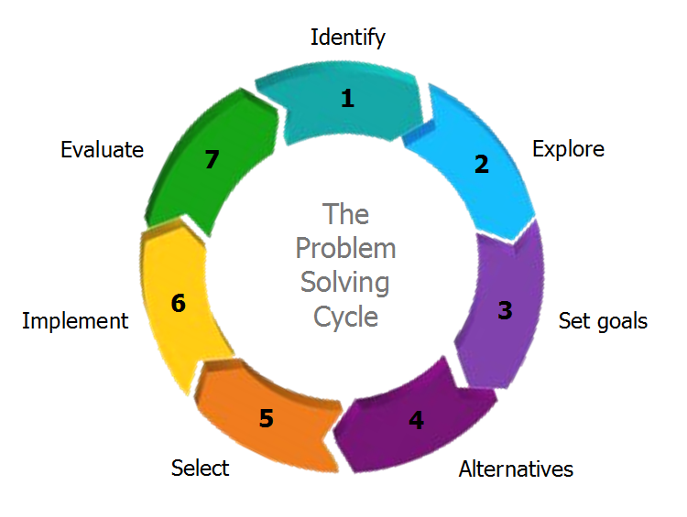
- Identify the problem - recognize the problem that needs to be solved, to identify and name the problem (the thing I have done above).
- Explore - to analyze the problem from different angles and find solving strategies.
- Set goals – is a process of thinking of what you really want to achieve, to reach your strategic objectives. One effective tool to set goals at the right level is the SMART criteria.
- Alternatives – seek ideas about possible solutions, using brain storming. The aim is to collect as many alternative solutions as possible.
- Select – decide what solution you will choose and explain why is the best one. Choosing an option, it is good to predict the consequences, which will help understand better if it the right option.
- Implement and Evaluate - having a possible solution, put it into action and evaluate the results. Make a conclusion how efficient it was and if it helped to achieve the wanted result.

Part 2. Decision Making

“Decisions are the hardest thing to make especially when it is between where you should be and where you want to be.”
Unkown

According to the Oxford Advanced Learner’s Dictionary the term decision making means - the process of deciding about something important, especially in a group of people or in an organization.

2.1 Types of decisions.
There are programmed and non-programmed decisions.
Programmed decisions – a decision made in response to a situation
that has occurred often enough to enable decision rules to be developed and applied in the future.

Non - Programmed decisions – a decision made in response to a situation
that is unique poorly defined, largely unstructured, or involve important
consequences for the organization.

2.2 Factors affecting decision making
There are several vital components that influence the decision making, such as past experience, individual differences, including age and socioeconomic status.
According to (E Ásgeir Juliusson, 2005) past decisions influence the decisions people make in the future, epecially when pat experience had a positive result.
Cognitive biasis are considering designs based on perception and generalizations that will lead to memory blundres, wrong judgements and defective rationale (Evans, Barston, & Pollard, 1983; West, Toplak, & Stanovich, 2008)
Some individual differences may also influence decision making. Research has indicated that age, socioeconomic status (SES), and cognitive abilities influences decision making (de Bruin, Parker, & Fischoff, 2007; Finucane, Mertz, Slovic, & Schmidt, 2005).

2.3 Ingredients for Good Decision Making:
- Pay attention on the most important things.
- Do not make a decision until you are ready.
- Look for all positive things that can happen.
- Consider the decisions sitting on the back burner.
- Base your decision on self-acceptance.
- Look ahead.
- Turn big decisions into a series of little decisions.
- Do not feel you are locked into only one or two alternatives.
- Get what you need to feel safe.
- Do what you really want.

2.4 Fishbone analysis
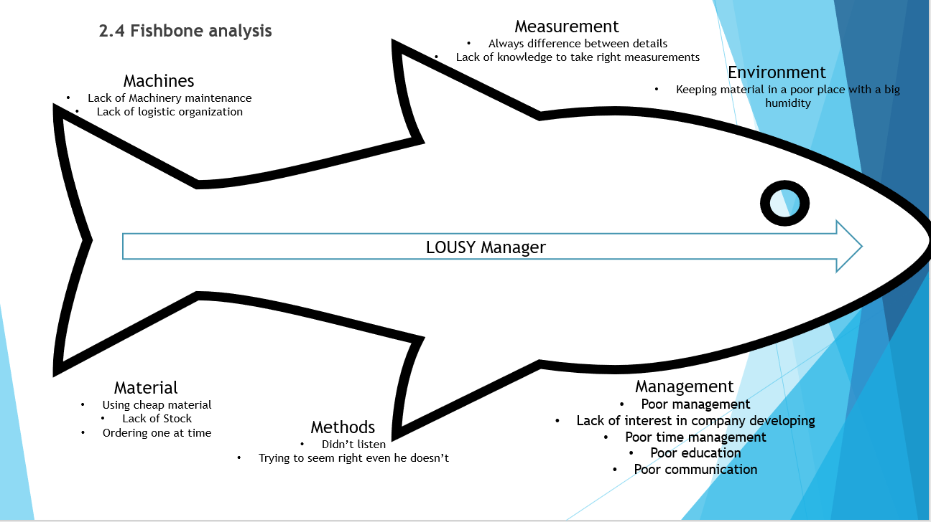

2.5 SWOT Analysis

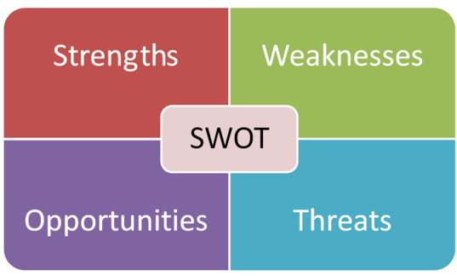

  - PESTEL Analysis
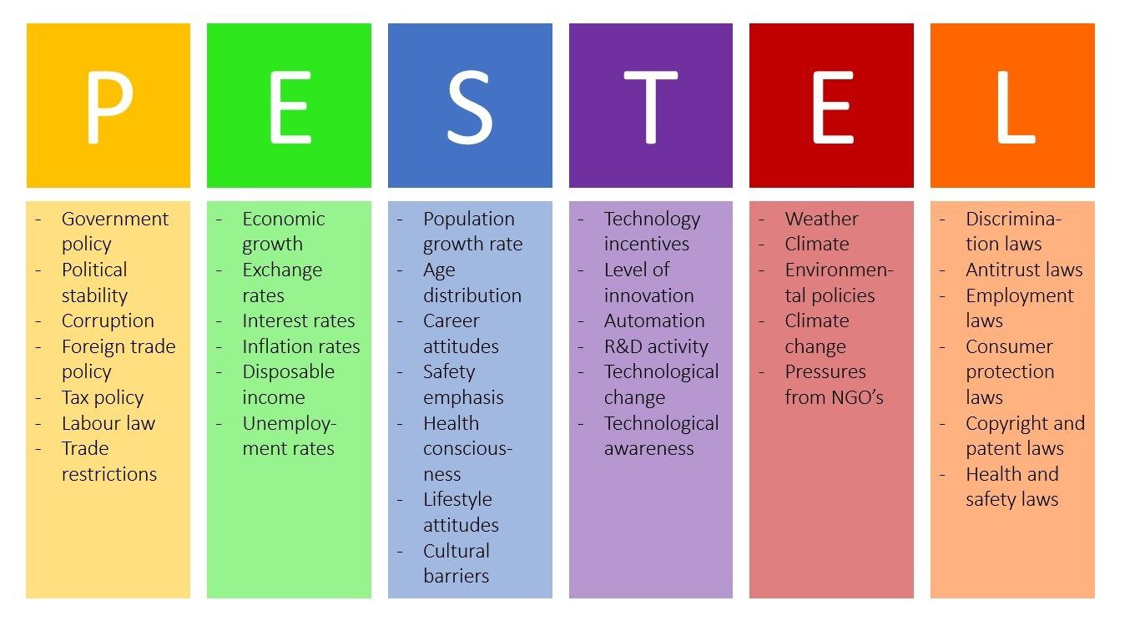

  - Five’s Porters

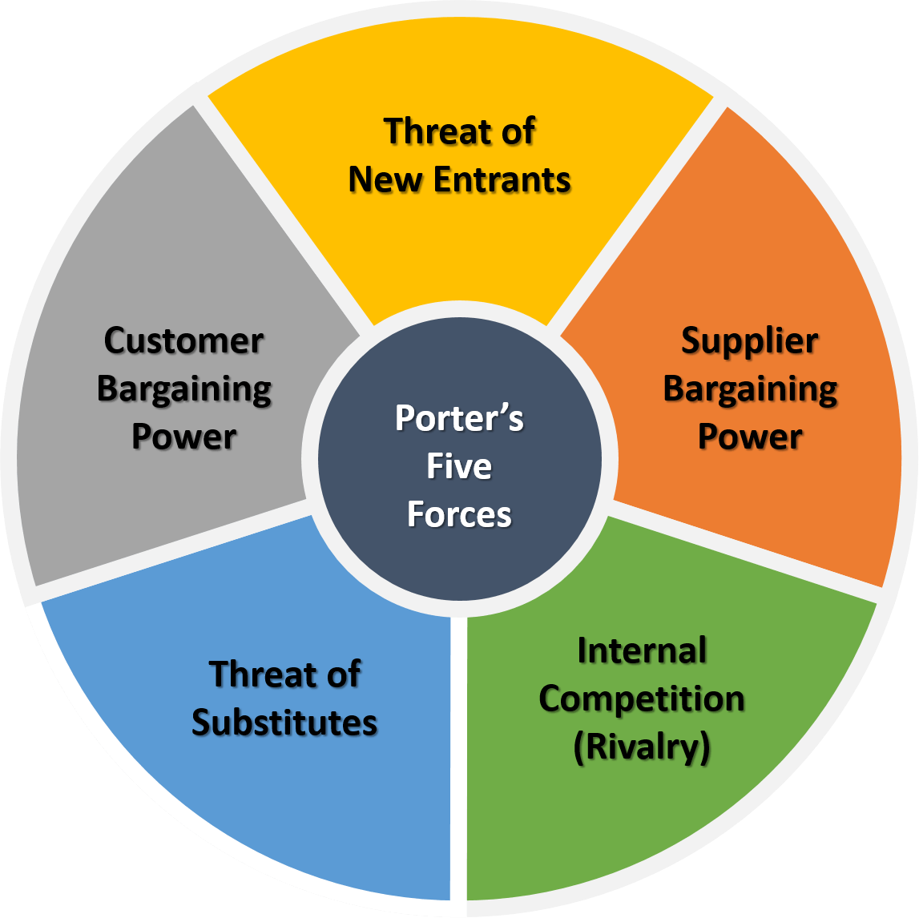

Part 3. Solutions
3.1 Proposed solution 1
One of solutions can be Forget giving feedback. Make requests instead.
It is a good idea to try to talk to your boss and to find out what is going on, but this conversation must to be a specific one. By specific I mean to speak about support and resources you need for your job, explaining how it will help the organization. Before this conversation you should anticipate the reaction, for knowing how to act and what to tell.
3.2 Proposed solution 2
Find another job.
If you have a really toxic boss, then is obvious that it will impossible to make health team together and it will destroy you psychologically. In this case the best option is to change the department you work, in this way changing the boss, in my case it is impossible, we have only one section and only one boss. So, the solution is to change the job.

3.3 Evaluation of the proposed solutions.
Evaluating the solutions, I have made a conclusion that these are corelated, you can’t begin to search another, not before trying to talk with your boss. Well, you can, but if you really like the job, first you will try to solve the problem inside.
Part 4: Implementation

Implementation plan the proposed solution.
To implement the solutions are not so complicate, the question is if it will work. Well, first of all, I already had that conversation, which unfortunately didn’t have a positive result,
Now it is time to implement the second solution – to find another job. But before this, I should give a notice and prepare a transition timeline. Being a responsible employee, I will do the right thing, even if I am angry with my boss.
In my case I don’t have to monitor the situation, because I choose to solve the problem by starting from the beginning in another company.
Conclusion.
In conclusion what can I say? In every organization, company where are working more people, will be always some kind of problems and it is normal. How to identify the problem, how to make a decision for solve it and through which ways, I tried to explain in my report.
I think, the solution comes in dependence of how responsible and receptive we are.

References

Abbajay, M., 2018. hbr.org. [Online]
Available at: https://hbr.org/2018/09/what-to-do-when-you-have-a-bad-boss
[Accessed 18 04 2020].
Anon., 2015. goodtherapy.org. [Online]
Available at: https://www.goodtherapy.org/learn-about-therapy/issues/workplace-issues
[Accessed 17 04 2020].
Anon., n.d. managementstudyguide.com. [Online]
Available at: https://www.managementstudyguide.com/what-is-decision-making.htm
[Accessed 2 05 2020].
Dietrich, C., 2010. inquiriesjournal.com. [Online]
Available at: http://www.inquiriesjournal.com/articles/180/decision-making-factors-that-influence-decision-making-heuristics-used-and-decision-outcomes
[Accessed 28 04 2020].
E Ásgeir Juliusson, N. K. G. T., 2005. tandfonline.com. [Online]
Available at: https://www.tandfonline.com/doi/abs/10.1080/09541440440000159
[Accessed 2 05 2020].
McGurgan, H., n.d. smallbusiness.chron.com. [Online]
Available at: https://smallbusiness.chron.com/negative-impacts-bad-manager-35304.html
[Accessed 11 04 2020].
Petrick, K., 2013. wordpress.com. [Online]
Available at: https://ansusconsultingblog.wordpress.com/2013/05/18/the-problem-solving-cycle-an-effective-step-by-step-approach-to-find-viable-solutions/
[Accessed 20 04 2020].
Phan, L. L., 2018. kununu.com. [Online]
Available at: https://transparency.kununu.com/unmistakable-qualities-of-bad-managers/
[Accessed 19 04 2020].
Tompkins, C., 2017. glassmagazine.com. [Online]
Available at: https://www.glassmagazine.com/article/10-most-common-problems-workplace
[Accessed 11 04 2020].

Appendix

