

University of Wales Trinity Saint Davids
Ordnance, Munitions and Explosives Principals

Academic Year 2026

Eryn Legg

Use of multi-physics software to simulate ranging geometry liners of shape charges

Supervisor: Professor Kelvin Donne

This thesis is submitted in partial fulfilment of the requirements for the degree of Ordnance, Munitions and Explosives BEng

© UWTSD 2025. All rights reserved. No part of this publication may be reproduced without the written permission of the copyright owner.

Academic integrity declaration
I declare that:
- the thesis submitted has been written by me alone.
- the thesis submitted has not been previously submitted to this university or any other.
- that all content, including primary and/or secondary data, is true to the best of my knowledge.
- that all quotations and references have been duly acknowledged according to the requirements of academic research.
I understand that to knowingly submit work in violation of the above statement will be considered by examiners as academic misconduct.

Abstract
Using only EOS material behavioural indicator parameters, a cone liner of 2mm and 1mm thickness was simulated in the context of a simplistic shape charge to determine the pressure wave interaction and the formation of jet. When investigated, it was found the 1mm liner presented as undergoing jet formation as a faster rate which allowed for dispersal of energy in a confined area with greater accuracy. The 2mm liner underwent a slower jet formation however, the designs added mass allowed for greater kinetic energy storage and transference.

Keywords:
Primary
Secondary
3D design
Jet formation

Table of Contents
Academic integrity declaration i
Abstract ii
Keywords: ii
List of Figures v
List of Tables vi
List of Equations vii
List of Abbreviations vii
1 Introduction to primary understanding, analysis, and use of computer-based systems to simulate OME designs. 8
2 Literature review of Shape charge geometry, material modelling and multi-physics software 8
2.1 Historical and developmental context of Shape charges 8
2.2 Comparison of different modelling software, in respect to OME 9
2.3 Material science and key physics concepts 9
2.4 Importance of Analysis and further implications 10
3 Practical design application, influenced by literature review and high-strain rate limitations. 11
3.1 Contextual literature influence 11
3.2 Validity of Jet Velocity 11
3.3 Real World Application of both product use and software use 12
4 Theoretical understanding of computer-based modelling for Shape charge design 12
4.1 Stress analysis and high strain considerations. 12
4.2 Effect of Jet velocity variance 12
4.3 Mesh independence study. 13
4.4 Boundary influence consideration 15
4.5 Modelling of explosive and shockwave effects 15
4.6 Primary 2D Shape charge design 15
4.7 Secondary 2D Shape charge Design 16
4.8 3D Shape charge design 16
5 Primary analysis of ballistic, blast and shock waves on a 2D Shape charge design 16
5.1 Components and assembly 16
5.2 Material Modelling and justification 17
5.3 Mesh independence study and process of inputs. 18
5.4 Results 18
6 Secondary analysis of ballistic, blast and shock waves on a 2D Shape charge design 20
6.1 Components and assembly 20
6.2 Material Modelling and justification 20
6.3 Mesh independence study and process of inputs. 21
6.4 Results 21
7 Analysis of ballistic, blast and shock waves on a 3D Shape charge design 22
7.1 Components and assembly 22
7.2 Mesh independence study and process of inputs. 22
7.3 Results 23
8 Comparison and conclusive results 25
9 Analysis and validation of computer model 27
10 Conclusion 28
Bibliography 29
Appendix 30
Primary 2D design 30
Secondary 2D design 37
3D design 38
Additionally 39

List of Figures
1 | A literature example of a jet formation over time [3]
2 | A standard tetrahedral fine mesh
3 | A standard tetrahedral course mesh
4 | An example of a graduated mesh
5 | A literature example of different mesh geometries [13]
6 | Multiple geometry node alignment
7 | A literature example of a basic shape charge design [3]
8 | Representation of basic casing geometry
9 | Extreme Step Distortion of primary 2D design
10 | Mesh display of 2D primary Liner
11 | Primary 2D design showing first point of liner contact
12 | Continuation of liner deformation
13 | Primary 2D design showing continuation of pressure wave movement
14 | Secondary 2D design showing first point of liner contact
15 | Continuation of liner deformation of secondary design
16 | Secondary 2D design showing continuation of pressure wave movement
17 | 3D Mesh orientation and gradient display
18 | Original Failure of 3D design simulation
19 | Original SPH display of 3D design
20 | 3D design showing first point of liner contact
21 | Continuation of liner deformation of 3D design
22 | Secondary 3D design showing continuation of pressure wave movement
23 | Origins of Jet formation in 3D design
24 | Graphical representation of nodal velocity in 2D primary design
25 | Graphical representation of nodal velocity in 2D secondary design
26 | Extreme distorted jet formation of 3D design
27 | SPH representation of liner

List of Tables
1 | Copper and Steel input parameters
2 | TNT fill input parameters

List of Equations
1 | Eulers conservation of Energy Formula
2 | Eulers conservation of Mass Formula
3 | Eulers description of Mass and Cross-sectional area as a constant
4 | Eulers conservation of Momentum Formula
5 | Jones-Wilkins-Lee Equation of State
6 | Impact penetration length of a projectile

List of Abbreviations
CAE | Computer Aided Engineering
CAD | Computer Aided Desing
OME | Ordnance, Munitions and Explosives
HE | High Explosive
CFD | Computational Fluid Analysis
JWL | Jones Wilkins Lee
EOS | Equation of State
PER | Pugh-Eichelberger-Rostoker theory
HEAT | High-Explosive Anti-Tank
HOT | High Subsonic, Optical, Remote-Guided, Tube-Launched
SPH | Solid Particle Hydrodynamics

Introduction to primary understanding, analysis, and use of computer-based systems to simulate OME designs.
Computer-aided engineering involves the use of multi-physics software and Computer Aided Design to artificially create an approximation of a product. This transitions from primary geometry in CAD to applying real world variables to approximate how the product would function. This approximation can include variables such as material behavioral parameters, assigning forces and environmental conditions.
OME, Ordnance, Munitions and Explosives, designs include Shape Charges. Shape charges are a cylindrical explosive devices where on impact, detonation occurs in an HE fill, causing high stress and pressure through the casing and fill until affecting the liner which then causes jet formation.
In defense, the shape charge is used in a wide range of contexts, [1] including anti-structural and anti-tank. Shape charges are also used in civil engineering as demolition tools. [1] The use of CAE when considering these industries is crucial to provide a safe, fast and low-cost testing approximation for the products.

Literature review of Shape charge geometry, material modelling and multi-physics software

Historical and developmental context of Shape charges
According to literature, the first cited reference to a shape charge like design appeared in 1972, where F. Von Baader designed an unlined-cavity charge where the energy of an explosive blast was focused using a hollow charge. Utilising black powder, the design was unable to achieve complete detonation. In 1867, the detonator was invented by Alfred Nobel, revolutionising the design that would later iterate to a shape charge. Unlined shape charges went on to be re-designed by Charlse Munroe; he went on to popularise the hollow charge design in 1888.[1]

Munroe went on to conduct several experiments, investigating material science, physics implications, geometry and flight path as well as explosive chemistry. [1] Using this research the iteration design of the shape charge led to the design of the first lined shape charge. This design contained a tin can with dynamite surrounding it and, on the top, which was able to provide a reasonable explosive ability.

As design iteration continues, making significant advancements during the Second World War, [1] the modern design of the casing, liner, internal explosive and detonator became common, these designs continue to progress and advance. From the 1800s to today, the primary function remains of a shape charge to be a controlled detonation through a cavity, producing a high-velocity jet capable of damaging high-density materials, this design usually consists of a casing, liner and explosive fill. [1]

Modern shape charges consist of a casing, usually plastic or metal such as steel, a high explosive fill, and a liner. This liner’s material and geometry depend on the intended use of the shape charge for example; an aluminium liner allows greater control and shallow damage when working in demolition and civil engineering. These lines are cone shaped, with varying angles internally, with varying thicknesses. On detonation, these lines undergo jet formation where the liner inverts into the hollow cavity, this shape and effect is displayed in Figure 1, a literature example of jet formation over time. [1]

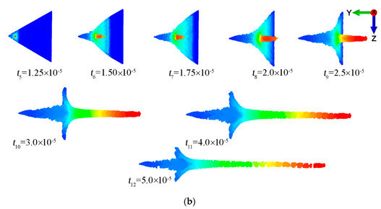
Figure 1, A literature example of a jet formation over time [3]

The liner transitions as it experiences extreme plastic deformation hence why ductile materials rather than brittle materials are used during the design process. This high energy transfer is the mechanical process that allows for shape charges to cause destruction in their target as the jet formation results in extreme pressure, allowing the projectile to cut through the target. [1]

Comparison of different modelling software, in respect to OME
When considering modelling OME products, limitations such as the context resulting in extreme stress and strain rates, supersonic velocities, and high quantity of external variables occurring must be considered in the validation and justification of the software chosen.
Abaqus is a multi-physics software capable of simulating up to 250,000 nodal points. The software also allows for these nodal points to be calculated using Johnson-Cook and EOS as well as giving a multitude of methodologies to manipulate surface to surface interactions and use the explicit solver choice. This allows for the software to best calculate extreme loads and material behaviour.
Other multi-physics software, such as ANSYS, have similar primary capabilities, however, are limited by intention of software design. ANSYS is a greater use for industries such as automotive due to the fluid-structural interaction however would be at a disadvantage when calculating extreme loads and material behaviors.

Material science and key physics concepts

To model and understand the mechanical and chemical functions of a Shape Charge, although designed geometry is important, using physics such as the Euler Equations [1] Pugh-Eichelberger-Rostoker, and Jones-Wilkins-Lee Equation of State [2] models a shape charge can be modelled to represent an approximation of a real-life occurrence.

Euler Equations are used to describe the conservation of energy in flowing gases, mass and momentum. The conservation of energy equation, Equation 1, describes an idea situation of a steady flow without consideration of heat, work done and energy change. Instead, this equation describes the sum of enthalpy as well as kinetic energy remaining a constant. [4]

$$C_{p}T+\frac{u^{2}}{2}=constant={C_{p}T}^{*}+\frac{{(a^{*})}^{2}}{2}$$
Equation 1, Eulers conservation of Energy Formula

As shown in Equation 2, the conservation of mass where ‘m’ is the mass flow rate and ‘A’ is the cross-sectional area describes how the flow of mass through a normal shock with ‘x’ denoting the front facing and ‘y’ denoting rear facing, with both mass and area remain a constant. This links to Equation 3, which describes the mass and area remaining constant [4]

$$Mx=My and Ax=Ay$$

Equation 2, Eulers conservation of Mass Formula

$$m=\frac{dm}{dt}=ρAu$$

Equation 3, Eulers description of Mass and Cross-sectional area as a constant

Finally, Equation 4 is Eulers equation for the conservation of momentum, describing, in an ideal environment, the forces acting upon each face of the shock respectively. This is calculated as the inertial effects of the wave as well as the sum of the pressures acting. [4]

$$P_{x}A+{mu}_{x}=P_{y}A+{mu}_{y}$$
Equation 4, Eulers conservation of Momentum Formula

Pugh-Eichelberger-Rostoker (PER Theory) describes how particles and wave exchange energy interact and exchange energy. In Shape charge formation, using PER, every particle of the liner is under the assumption to be instantaneously accelerated and to collapsed in a straight line, an important distinction when using multi-physics software. [3]

Jones-Wilkins-Lee equations of state is used to describe the thermodynamics of both detonation products and unreacted high explosives. Using these equations, multi-physics software can approximate the interactions between the HE fills, the liner and casing of the shape charge however, validation of this model must consider the level of accuracy in the pressure-volume domain. [3]

$$P=λ[Aexp \left(R_{1} V_{r}\right)+Bexp \left({-R}_{2} V_{r}\right)+ {CV}_{r}^{-(ω+1)}$$

Equation 5, Jones-Wilkins-Lee Equation of State [3]

JWL, Figure 5, is the preferential method of material prediction over EOS due to the ability to model detonation products behaviour under high pressure conditions however, this is limited due to known parameters.

Importance of Analysis and further implications
Analysis and comparative validation of a CAE simulation allow for development of the accuracy of the results. By using validation methodologies such as practical experimentation and firsthand practical experimentation, a comparison of the results from the simulation can be made, where limitations and inaccuracies appear may show a parameter issue or software limitation, such as course meshing losing resolution or idealised environment not considering external input. By finding these limitations and including them in future simulations, the approximation can be improved in accuracy. [5]
By finding and classifying limitations, the model can be iteratively improved and refined when considering only software. As parameter requirements and material behaviour increases, such as extreme stress and strain occurring in a ductile materials causing rapid deformation, this simulation is further limited by the hardware of the computer system. This is due to demand for calculations and complexity of each nodal experience. Continuation of integration of high-speed cores and processing components allow for greater use of the software.

Practical design application, influenced by literature review and high-strain rate limitations.

Contextual literature influence
Confinement is crucial in shape charge design as the casing must be able to keep the explosive in place for the duration of detonation to allow for the liner to collapse. Controlling fragmentation is a design choice, this can be natural or unnatural fragments, both have individual benefits and drawbacks [7].
The casing also needs to react predictably under detonation for desired effect and to allow chosen energy transfer. The function of the HE fills is to provide high detonation velocity, and cause a high-pressure collapse of the liner, and therefore properties such as homogeneity of the material in the desired geometry, sensitivity, detonation and pressure velocity achievable is considered. [8]
Prioritising ductility in liner design is crucial; a brittle material will undergo fracturing under extreme loading whilst a ductile material will allow for deformation under loading and stress/strain inputs. This deformation allows for jet formation to occur. Density should further be considered when choosing material for the liner due to the products mass having a direct correlation with momentum and penetration ability.
Liner thickness decides successful jet formation and impact penetration length, where the pressure wave moves through the liner forcing deformation into jet formation. In cases where the liner is overly thick, [7] the energy movement dissipates before successful jet formation occurs. Impact penetration length is decided by average density of the projectile and therefore in cases of material lack in the liner, penetration is decreased due to a decreased average density. [14]
$$P=L√\frac{ρ(p)}{ρ(t)}$$
Equation 6, Impact penetration length of a projectile [14]

Validity of Jet Velocity
Jet Velocity can be confirmed using various techniques giving ranging accuracy. A low accuracy but fast and low-cost way is by using the Gurney Equations, although primarily used when calculation the velocity of fragmentation of explosive, they can be adapted for jet velocity calculations. [9] Using the Gurney Equations, Shock wave effect is disregarded and there is the assumption of uniform expansion in a perfect homogenous material. [3]
For greater accuracy, PER (Pugh-Eichelberger-Rostoker) modelling can be used in combination with the Gurney Equations to consider effecting geometry and other added factors. This improves the validity of the calculated results. [10]
Literature reviews can also be used to decide validity, where trials can use sensors and high-speed cameras as well as fragmentation and debris to physically see the jet velocity effect in real life. [5]

Real World Application of both product use and software use
Civil use of shape charges is commonly used in mining and destruction including for gas and oil where the materials chosen for the HE and liner allow for varying results from wide damage with shallow penetration to localized damage with deep penetration in a multitude of materials. [1]
In the defense industry, shape charges are used primarily for destruction of armor, meaning that the product can be used as tandem warheads, air to air missiles, surface to air missiles, and air to ground weaponry as well as finally anti-tank systems. Recognised examples include the United States of Americas commonly used high explosive, anti-tank shape charge, HEAT, and Germany’s HOT missile. [1]

Theoretical understanding of computer-based modelling for Shape charge design

Stress analysis and high strain considerations.
Firstly, due to the energy transfer from chemical to kinetic stored in the HE fill and transferred t the case liner, it is expected due to practical testing [1] [4] [8], that as the pressure wave moves from the detonation point to the apex of the conical liner. This results in the relevant nodal points experiencing extreme stress and strain, reaching up to 50GPa stress level.
The high variance in the stress level requires dense nodes as each segment the geometry is divided into will experience varying results. This high density of nodes can result in a long run time and high costing software and hardware, so the primary consideration is the conduction of a mesh independence study appropriate for the context.
High strain can lead to extreme element distortion where the simulation may abort due to failure or results become inaccurate due to compounding error. Inaccuracy reduction can be completed by both software selection, parameter input and conditions such as simulating a 2D representation to receive a higher resolution of results demanding less developed software and hardware.

Effect of Jet velocity variance
Jet formation and jet velocity is calculated via the material properties and geometry. Depending on the material properties assigned, such as Johnson-Cook or EOS, depends on the accuracy and type of results the software can calculate. As in Abaqus, these values are manually assigned, this introduces great variance across the methodologies and materials as well as introduces human error.
Other factors effecting the jet velocity and formation includes mesh resolution, geometry, as well as mesh application whether manual or adaptive. In combination with theoretical calculations and geometrical factors, such as mesh and surface interactions, there accuracy of the jet velocity can only be considered an approximation.

Mesh independence study.
Mesh balance is crucial is simulation different scenarios. The finer the mesh, the more points of calculations completed usually render higher accuracy results however, this quantity of the equations requires both time and computer ability. A more course mesh allows for fewer calculations but decreases the accuracy of the results, useful for simulations on less powerful computers or when a short run time is needed. Figures 2 and 3 show the difference in the mesh types of two similar geometries.

Figure 2, A standard tetrahedral fine mesh
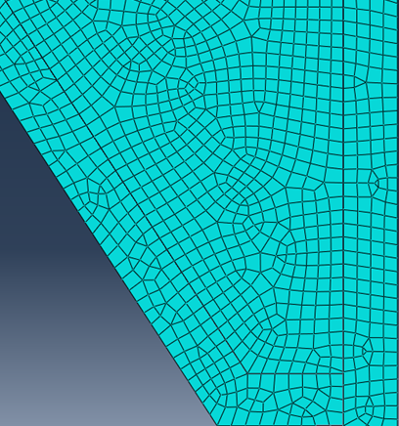
Figure 3, A standard tetrahedral course mesh
If a simulation is complex in geometry, material properties, force and contextual programming (such as material detonating) a finer mesh is needed as each section will have a greater variance of result. If a simulation is simple, such as a cantilever beam with force applied to one side and a boundary condition of the other, then there will not be as much variance across the sections so a courser mesh will provide comparable results to finer mesh.
Determining the mesh is crucial as the mesh becomes finer, the quality result will eventually plateau where the results are as detailed as possible and making the mesh finer simply wastes processing time and computer usage.
Equally, in some cases, results are more varied in one section of the model, for example in a plate and projectile model, although there are waves of force moving through the plate after impact, the greatest variance is around where the projectile hits the plate. In this circumstance, a graduated mesh would be appropriate meaning, the mesh becomes finer towards the point of interest and courser further away. This way fewer calculations are necessary in the areas where there is less variance, and more calculations are used where there is more variance. Figure 4 shows the graduation from a fine to a course mesh, focusing on simulation type and importance of selected areas.
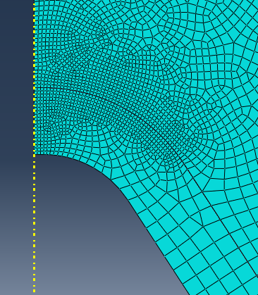
Figure 4, An example of a graduated mesh
Mesh geometry and topology should also be considered. Mesh geometry is important, it allows complex shapes to be partitioned and broken down in the greatest accuracy. This is completed by a series of triangles and quadrilaterals, connected at points called Nodes. An example of this is shown in figure 5, A literature example of different mesh geometries. These nodes are the point of each calculation, and the results are average between them. Therefore, the less nodes due to a finer mesh, the greater averaging of the results.
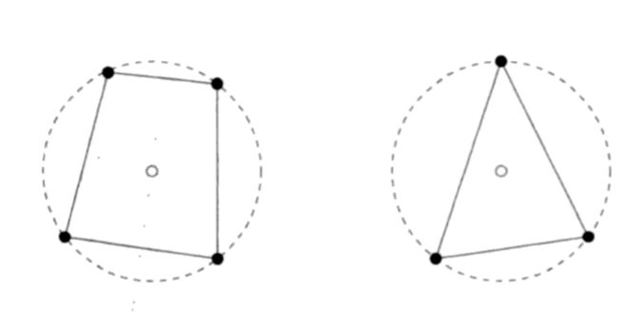
Figure 5, A literature example of different mesh geometries [13]
Nodes are important to consider if there are a graduated mesh or multiple components. If the nodes don’t align, the program will struggle to calculate how the forces are interaction between a node and an empty space. This is shown in figure 6, Multiple geometry node alignment, to show how two different geometries interact.
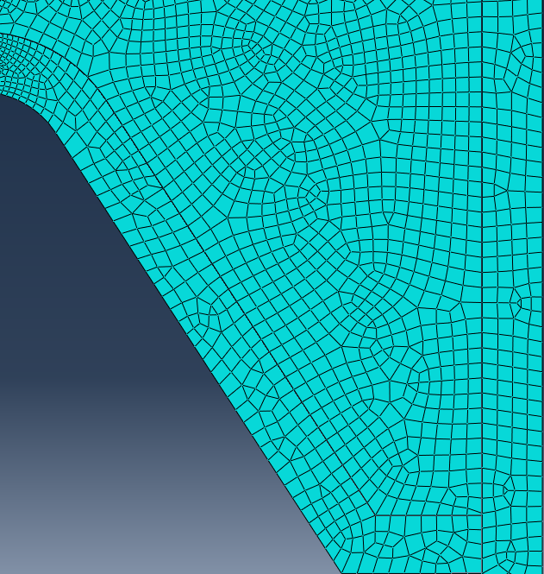
Figure 6, Multiple geometry node alignment

Boundary influence consideration
Boundary influence is a primary condition when simulates a situation. This allows for outside the model factors to influence the modelled parts without over complicating the simulation. Boundary influence can be to show force and energy movement (heat/force moving from an external source in a particular direction), structurally forcing a component part to not move, for example a beam being fixed to a particular side, it can be used to determine air flow through components and simply to reduce computer workload. [5]

Modelling of explosive and shockwave effects
To model explosives, using the correct parameters are crucial; JWL Equation of State is used to decide pressure to volume to energy interaction and mechanical behaviour. Crucial values that also affect the multi-physics software’s ability to predict the behaviour of the explosive are the detonation velocity, energy and density. [5]
When simulation explosive, detonation points and timing also have a significant effect on the results as the detonation point decides where the shockwave originates, effecting the mechanical interactions. Timing is crucial as it decides if the material is undergoing burning, detonation or deflagration of which is expected to provide significantly varied results in explosive. [5]
When modelling shockwave effects, contact and interaction as well as boundary conditions are crucial as this decides how the shockwave moves through the components and overall effect the node experience and resulting data.

Primary 2D Shape charge design
The primary 2D Shape charge chosen was a singular cone liner, copper, a steel outer case and a HE fills. Key features include the liner having a thickness of 1mm, the copper being modelled using EOS rather than Johnson-Cook and a graduated mesh to prioritise a finer mesh around the expected jet formation area.
The use of copper as the liner is due to the materials’ ductility and historical use providing significant literature validation of functionality. An example of this basic design in Figure 7, A literature example of a basic shape charge design.
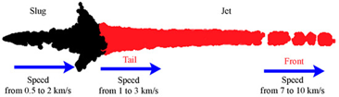
Figure 7, A literature example of a basic shape charge design [3]

Secondary 2D Shape charge Design
The secondary 2D shape charge chosen was a singular cone liner, with the same copper properties, as well as the casing also being Steel 4340. The meaningful change is the thickness of the liner increasing to 2mm. The copper stays modelled using EOS and a graduated mesh to maintain consistency through my results.

3D Shape charge design
The 3D modelled liner uses the secondary shape charge design, revolving the design to maintain the exact dimensions and material features. Detonation point, materials and key functions remain the same as the secondary 2D design for comparability of results.

Primary analysis of ballistic, blast and shock waves on a 2D Shape charge design

Components and assembly
Table 1, Material Properties and Components, shows the materials used for the design. To provide consistent, comparable results, these materials are considered part of the control variables. The dependent variable is the geometrical thickness of the liner and therefore, there is no need for material variance throughout the three varied designs.

 | A | B | n | m | C | Density | E (e09) | V | Transition Temp (K) | Melt  Temp (K)
Copper OFHC | 1425 | 168 | 0.12 | 1 | 0.032 | 8960 | 125 | 0.34 | 293 | 1356
Steel AISI | 553 | 600 | 0.234 | 1 | 0.013 | 7850 | 210 | 0.3 | 293 | 1733

Table 1, Copper and Steel input parameters [12]
Based on findings from Walter P. Walters [1], copper was selected due to its high ductility, which is essential for stable jet formation under high strain-rate deformation. This liner has a thickness of 2mm, with an internal angle of 55 degrees. Curvature at the apex allows for distribution of energy at the point for jet formation whilst also not having a point. If the liner comes to a point, in multi-physics software, this can cause extreme distortion of the singular node, in real life, this point can often become damaged and deformed due to tolerancing and price. This geometry is shown in figure 8.
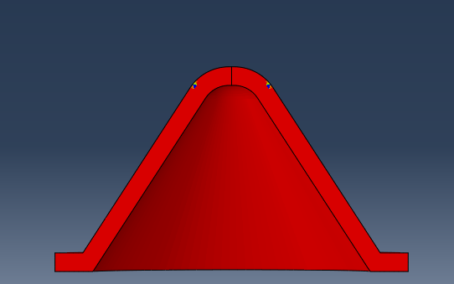
Figure 8, Representation of liner geometry

Material Modelling and justification
When allocating the material properties for the liner using Abaqus Property Module, as part of the assembly in Abaqus, originally the copper component was modelled using Johnson-Cook Parameters alone however, as shown in Figure 9, extreme step distortion was observed. This caused the multi-physics simulation to abort without completing jet formation.
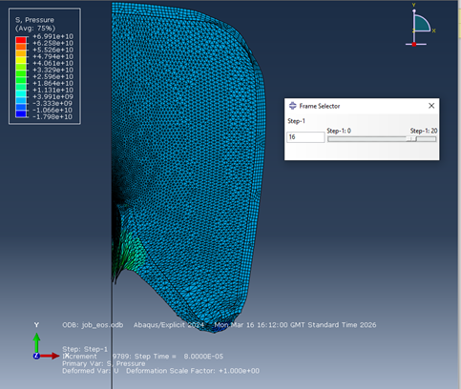
Figure 9, Extreme Step Distortion of primary 2D design
Further steps were taken to try to resolve the material issue with the liner before the solution was decided to model the component using Equation of State parameters which allowed the assembly to function and for the simulation to complete.
Johnson Cook modelling would have allowed representation of how the material reacts to deformation under extreme conditions, considering variables such as plastic strain, strain rate and temperature. [12] This is calculated using yield strength, plastic flow and failure rate which is the typical modelling methodology when working with metals in multi-physics software.
By using EOS, the simulation represents how the pressure relates to density and internal energy, which can then be used to describe compressibility, shockwave propagation through the material and expansion of detonation products. [11] Using the Mie-Gruneisen equation of states, the material is simulated under shock whilst the Jones-Wilkins-Lee equation of states calculates the detonation products. [11]
Ideally, EOS and Johnson-Cook would be used together in this simulation.

Mesh independence study and process of inputs.
Using Abaqus Mesh Module, a general mesh size was used for the casing as there are no points of interest due to the focus being jet formation, which occurs at the inner center of the model. This allowed for a courser mesh to be used, reducing the simulation design as there was minimal complexity occurring in the casing.
The point of interest for the liner is where the jet formation begins, the external peak. Therefore, mesh was at the smallest size, graduating to a larger size moving away from this point. The fine mesh size was 0.005, graduating to 0.01.
The mesh size of the HE filling was decided by the gradient of the liner for nodal contact to be optimal for calculations. Therefore, the outer edge of the HE fills graduated from 0.005 to 0.01 before matching the same liner coarseness as the casing. This is showing in Figure 10, Mesh display of 2D primary Assembly.
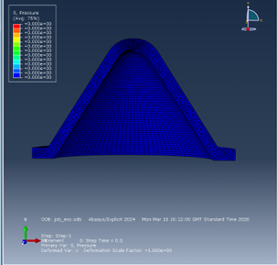
Figure 10, Mesh display of 2D primary Liner
Due to further extreme distortion, surface to surface meshing was then used where additional surfacing input and controls allowed the simulation to calculate the component interaction with greater accuracy.

Results
Using Abaqus Visualisation Module, where EOS was used to simulate the copper liner, modelling it under plastic flow, stress and strain cannot be seen, rather the effect of pressure where positive pressure shows compression of material and the negative shows the material under tension.
Figure 11 shows the first point of pressure wave contact with the liner, with the side scale showing the tension and compression spike to +2.401e10. This high-pressure result is due to the wave moving from the medium of the HE fill to the highly ductile copper liner. Wasted energy will dissipate, however this pressure will cause plastic deformation into jet formation.
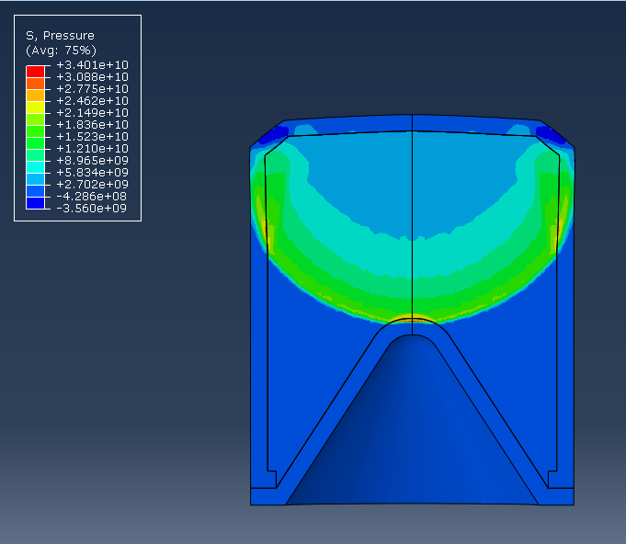
Figure 11, Primary 2D design showing first point of liner contact
As the pressure wave moves through the component, compressure in the liner increases rapidly before disopating through the design. The liner deformation begins showing the jet formation progression. This progress is shown in figure 12, isolating the liner for readiblity and clarity.
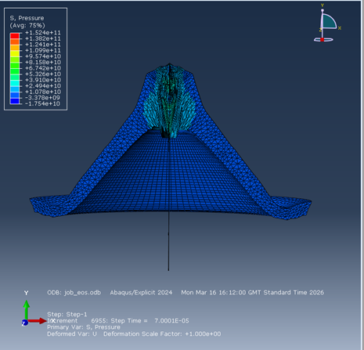
Figure 12, Continuation of liner deformation
As shown above, there is already extreme nodal defomation. This is due to a multitude of factors including material properties, surface to surface interactions and geometry conditions. This nodal distortion can be considered an outlire and distregarded from data however does speak to the accuracy of the simulated model.
Finally, the pressure wave have moved entirely through the geometry, resulting in a fully formed jet. Using this model, we can observe both a visual representation of the simualtion and the data produced can be used for graphical representations. Figure 13, shows the final data collected of the visual representation.
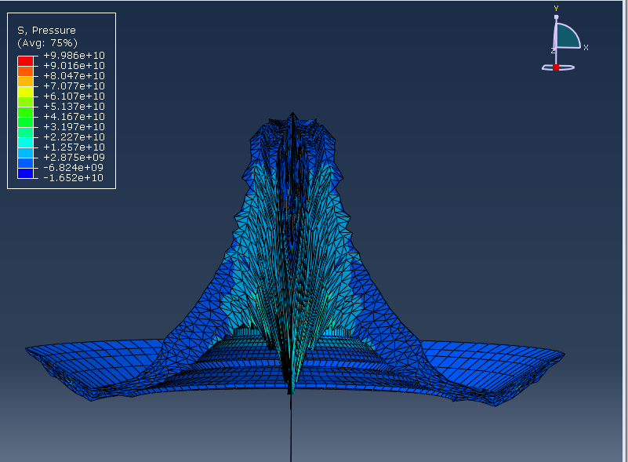
Figure 13, Primary 2D design showing continuation of pressure wave movement
This model is considered a partial failure due to extreme distortion. As shown in Figure 13, a literature example of a fully formed jet simulation, the data collection shoes early abortion. This simulation still provided useful insite as the how the liner deformed in comparative to the secondary design allows for further insite into future designs of shape charges.

Secondary analysis of ballistic, blast and shock waves on a 2D Shape charge design

Components and assembly
The secondary design showed identical casing and explosive fill but with a 1mm liner thickness. This thickness decreased upwards, meaning the HE fills remained unchanged in quantity and proportioned to the liner.

Material Modelling and justification
The modelling of the copper using EOS rather than Johnson-Cook methodology was continued for simulation consistency purposes and for comparative data.
The casing and HE fill remained constant with the same parameters displayed in Table 2.

Density  (kgm⁻³) | Detonation  Velocity | A  (GPa) | B  (GPa) | R1  n/a | R2  n/a | $$ω$$  n/a | Pre-Det’ Bulk Modulus  (GPa) | Detonation energy Density (Jkg⁻¹)
1600 | 8193 | 610 | 13 | 4.50 | 1.40 | 0.3 | 9.00 | 3680000
Table 2, TNT fill input parameters [15]

Mesh independence study and process of inputs.
Meshing stayed to have a finer to courser gradient, with nodal matching from the liner to the HE fills to the casing to allow for the best surface interaction capable. The mesh is shown to have a finer point at the apex of the liner, where jet formation is expected.
0.005 to 0.01 stayed the chosen gradient for the mesh.

Results
Figure 14 shows the pressure wave moving through the HE fill and having primary contact with the liner. Due to how fine the liner is in the secondary design, this interaction occurs incredibly quickly where there is a clear pressure change in the material almost instantaneously. The positive pressure shown describes the liner being under compression before negative pressure causes tension as the liner begins to distort.
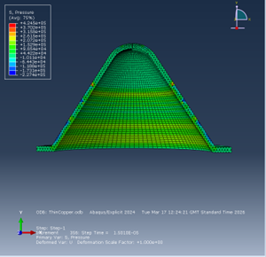
Figure 14, Secondary 2D design showing first point of liner contact.
This continues through the simulation as shown in Figure 15, where jet formation has begun and the pressure wave continues to move through the components.
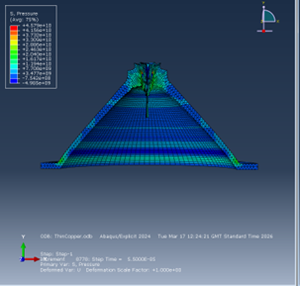
Figure 15, Continuation of liner deformation of secondary design
Finally, Figure 16 shows the final collected data of a partially formed jet formation. As with the primary design, this is considered a partial failure as the simulation did not complete full jet formation. This could be for a myriad of reasons including extreme distortion, material input and extreme stress and strain values causing the program to abort.
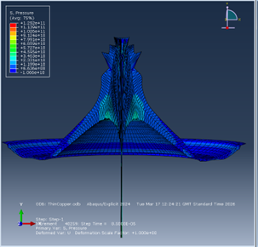
Figure 16, Secondary 2D design showing continuation of pressure wave movement.

Analysis of ballistic, blast and shock waves on a 3D Shape charge design

Components and assembly
Using the primary 2D shape charge design, the 3D model was constructed using identical parameters and surface to surface interactions with a 3D rather than 2D representation. The assembly can be reviewed further in Appendix 3D design.

Mesh independence study and process of inputs.
The student version of Abaqus has the limitation of 250,000 nodes and therefore the 3D model must be meshed strategically to accumulate the data of most relevance. For this reason, the gradient from finer to courser mesh traveled linearly from the detonation point to the apex of the liner and through to the edges of the liner as shown in Figure 17.
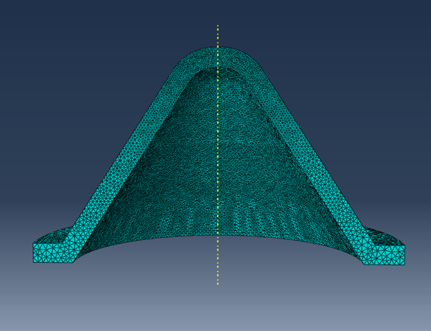
Figure 17, 3D Mesh orientation and gradient display.
Initially, issues occurred with the interaction between the HE with the liner and casing where the HE was flowing through the solid components. Figure 18 shows this failure after a run simulation. To fix this error, aggressive surface to surface interaction was used as well as boundary conditions to prevent flow of the explosive. As seen in Appendix 3D design, multiple attempts were conducted.
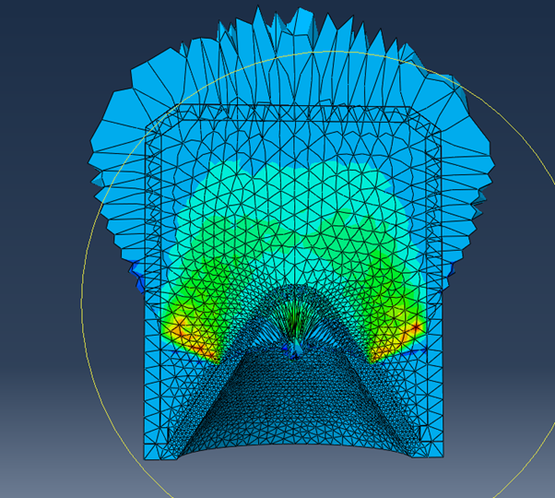
Figure 18, Original Failure of 3D design simulation
Finally, a combination of SPH and Boundary influence allowed the liner to undergo defamation as it collapsed, and jet formation occurred. As shown in Figure 19 below.
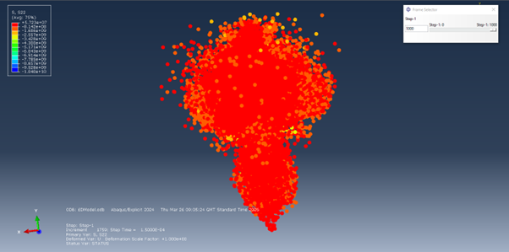
Figure 19, Original SPH display of 3D design

Results
As seen in Figure 20, as the pressure wave moves through the liner, compressive tension force rapidly changes through the liner, adjusting for the deformation similarly seen in the primary 2D shape charge design.
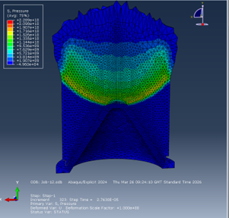
Figure 20, 3D designs showing first point of liner contact.
Once deformation occurs, the liner collapses inward as expected and jet formation occurs. It is seen in Figure 21, spots of extreme positive pressure where the liner would be undergoing extreme high stress and strain. This is expected in cases of extreme deformation.
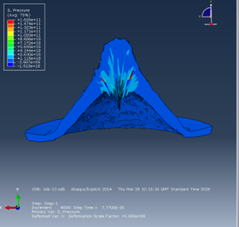
Figure 21, Continuation of liner deformation of 3D design
Finally, as shown in Figure 22, although some jet formation was observed, there is extreme nodal deformation at the apex of the liner, highlighted by shards of high pressure where the rest of the liner is in negative pressure and therefore under tension.
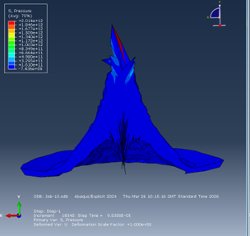
Figure 22, Secondary 3D design showing continuation of pressure wave movement.

Comparison and conclusive results
Literature figure 23 shows expected jet formation shaping, although that did not occur for the 2D shape charge designs, deformation of the liner occurred and begun to collapse inwards for both. As both simulations occurred to due excessive nodal distortion, it can be assumed that had the program continued, this liner would have continued to collapse. A comparison of this collapse can be seen previously in figure 1.
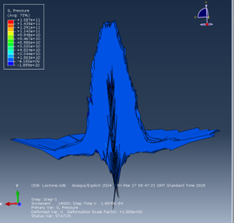
Figure 23, Origins of Jet formation in 3D design
Comparison of nodal velocity during deformation and jet formation can be observed in Figures 24 and 25. The primary design reached a velocity of approaching 2e3 m/s before having a high gradient incline in velocity over time suggesting rapid collapse. Comparatively, at the same time marker, the primary design was closer to 1e03 m/s showing a distinct slower deformation rate. This slower rate can result in wasted energy and negatively effect penetration performance. The simulated jet velocity (2e3 to 5e3 m/s) aligns with reported values in Numerical and Experimental Studies of the ŁK Type Shaped Charge [3], supporting partial validation of the model.
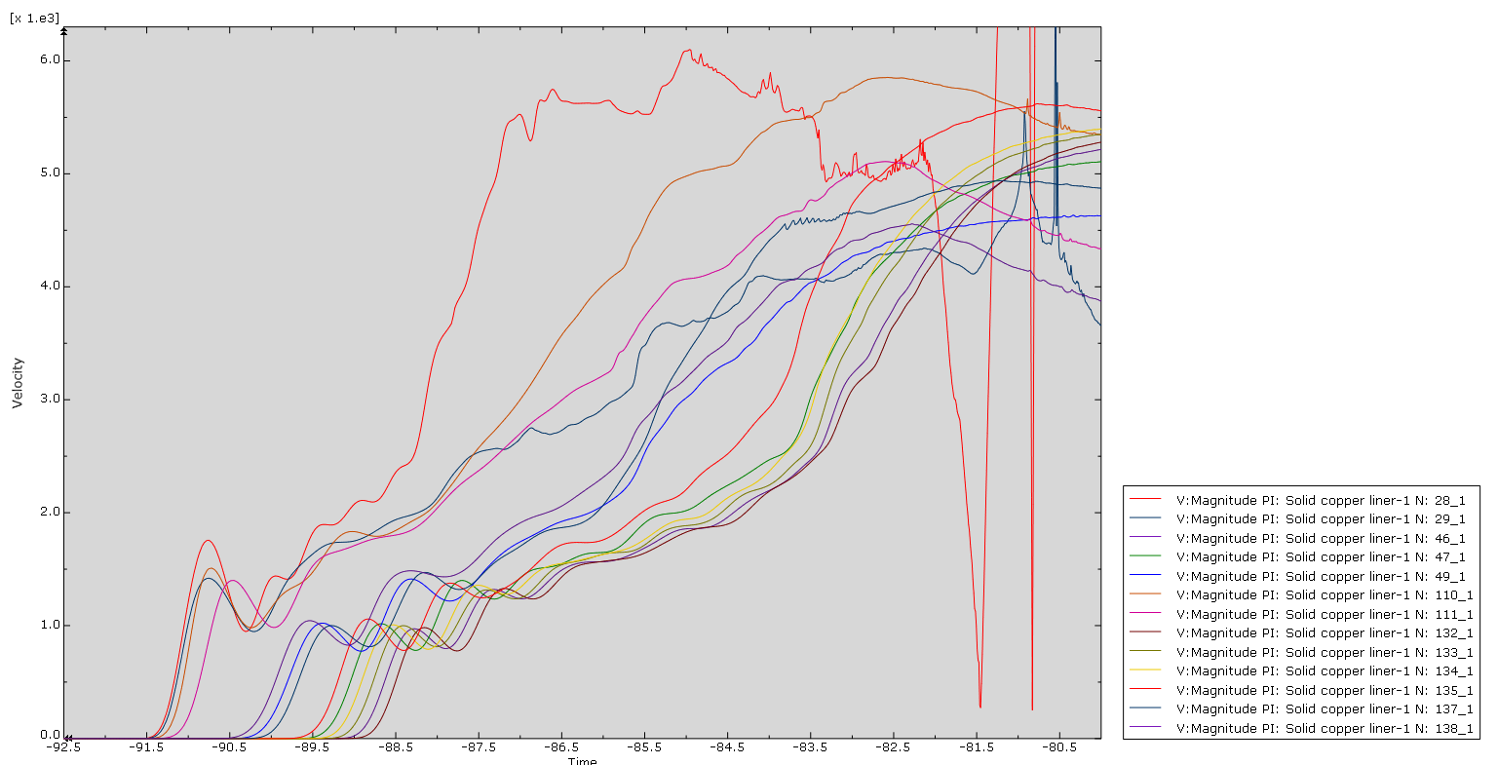
Figure 24, Graphical representation of nodal velocity in 2D secondary design
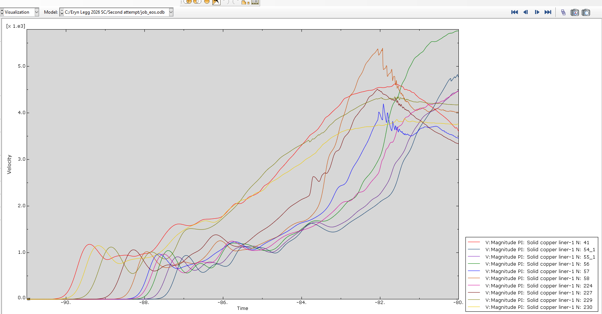
Figure 25, Graphical representation of nodal velocity in 2D primary design
Due to the primary liner showing greater success of jet formation, the 3D study was conducted and primary data collected is shown above. When conducting this simulation both tradition result and SPH (Solid Particle Hydrodynamics) was used.
Using the traditional representation of results, it can be observed that extreme nodal deformation occurred however there is evidence of jet formation and liner collapse occurring. It can be further hypothesised that had the extreme deformation not occurred this liner would have continued to collapse and result in a fully formed jet formation. This is shown in Figure 27.
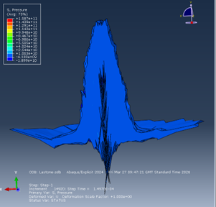
Figure 26, Extreme distorted jet formation of 3D design
SPH is shown in Figure 27, displaying the liner isolated, showing the liner under tension. Nas seen centrally, there is a distinct jet formation however the results lacked symmetry suggesting a calculational error in the display. Therefore, the results from the SPH should be considered an approximation with a lower representation of accuracy than the traditional results.
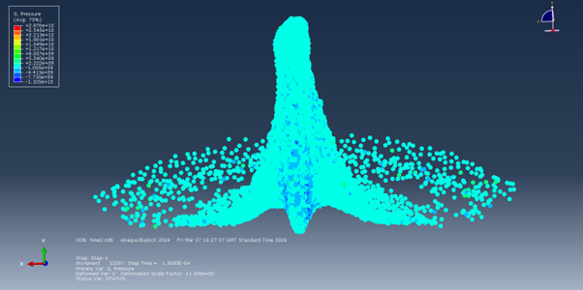
Figure 27, SPH representation of liner

Analysis and validation of computer model
As shown previously in Figures 1, 5 and 23, jet geometries and results from previously conducted literature show similar geometry and velocities as collected in both 2D studies and 3D study suggesting that although all simulations aborted before complete jet formation, had the simulations have a longer run time, full jet formation would have occurred. This provides validation of a reasonable degree of accuracy in Abaqus’s ability to calculate the simulation.
Further, when reviewing jet velocity, the accuracy according to several literature examples, [2] [4] of the same HE fills resulted in similar ranged of jet velocity. However, due to the pre-abortion of the simulation, it can be assumed that the jet would have continued to accelerate the liner underwent extreme plastic deformation and this final velocity may not have been accurate to comparative literature.

Conclusion
Eulerian and Lagrangian modelling can both be applied to contexts of extreme deformation and complex numerical simulations. The use of lagrangian methodology allowed for the mesh to deform with the material providing highly accurate material interaction and behaviour however, this is limited by simulations requiring severe plastic deformation and jet formation due to the elemental distortion. Further use of Eulerian methodologies, where the mesh is constrained and material moves through, and SPH can be sued further to provide either contradiction or validation of the collected data through lagrangian methodology.
The data collected, approximated that the thicker liner has a significant jet velocity decrease comparative to the finer liner which can negatively impact the functionality and penetration ability of the shape charge. Further investigation into the effect of the mass variance should be undertaken to verify if this difference is nominal due to the finer liner causing a decreased average density or if the jet velocity difference makes a significant impact on performance.

Bibliography
[1]
W. P. Walters, The Shaped Charge Concept. Defense Technical Information Center, 1990.

[2]
“Modelling of fast jet formation under explosion collision of two-layer alumina/copper tubes,” The International Journal of Multiphysics, vol. 11, no. 3, Sep. 2017, doi: https://doi.org/10.21152/1750-9548.11.3.265.

[3]
D. Pyka et al., “Numerical and Experimental Studies of the ŁK Type Shaped Charge,” Applied sciences, vol. 10, no. 19, pp. 6742–6742, Sep. 2020, doi: https://doi.org/10.3390/app10196742.

[4]
J. F. Clarke, “Explosive Shocks in the Air — Second edition. G. F. Kinney and K. J. Graham. Springer-Verlag, Berlin. 1985. 269 pp. Illustrated. DM134.,” The Aeronautical Journal, vol. 90, no. 894, pp. 152–153, Apr. 1986, doi: https://doi.org/10.1017/s0001924000015591.

[5]
J. F. Molinari, “Finite element simulation of shaped charges,” Finite Elements in Analysis and Design, vol. 38, no. 10, pp. 921–936, Aug. 2002, doi: https://doi.org/10.1016/s0168-874x(02)00085-9.

[6]
S. Sun, J. Jiang, S. Wang, J. Men, and M. Li, “Structural design of the fluted shaped charge liner using multi-section optimization method,” Defence Technology, vol. 25, pp. 249–262, Jul. 2023, doi: https://doi.org/10.1016/j.dt.2023.01.008.

[7]
H. Hafizoglu, H. E. Konokman, L. Kesemen, and A. K. Atay, “Effect of fragment impact on shaped charge jet formation and penetration into steel target,” World Journal of Engineering, vol. 20, no. 3, pp. 577–590, Jan. 2022, doi: https://doi.org/10.1108/wje-10-2021-0588.

[8]
“Penetration by shaped charge jets of nonuniform velocity,” Vacuum, vol. 14, no. 1, p. 26, Jan. 1964, doi: https://doi.org/10.1016/0042-207x(64)90801-2.

[9]
G. E. Jones, “The Gurney equations for multilayered fragments,” Journal of Applied Physics, vol. 50, no. 5, pp. 3746–3747, May 1979, doi: https://doi.org/10.1063/1.326282.

[10]
E. M. Pugh, R. J. Eichelberger, and N. Rostoker, “Theory of Jet Formation by Charges with Lined Conical Cavities,” Journal of Applied Physics, vol. 23, no. 5, pp. 532–536, May 1952, doi: https://doi.org/10.1063/1.1702246.

[11]
L. Stiel, E. Baker, P. Samuels, R. Cornell, and D. Rydzewski, “Extended JCZ3 Equation of State and JAGUAR Implementation for High Explosives,” Propellants, Explosives, Pyrotechnics, vol. 48, no. 1, Jul. 2022, doi: https://doi.org/10.1002/prep.202200039.

[12]
M. F. Ashby, H. Shercliff, and D. Cebon, Materials. Butterworth-Heinemann, 2013.

[13]
H. Edelsbrunner, Geometry and topology for mesh generation. Cambridge: Cambridge Univ. Press, 2008.

[14]
H. Dong, X. Zhang, H. Wu, Z. Tian, X. Deng, and F. Huang, “Trajectory prediction of the tapered projectile and grooved projectile in deep penetration,” International Journal of Impact Engineering, vol. 170, p. 104337, Dec. 2022, doi: https://doi.org/10.1016/j.ijimpeng.2022.104337.

[15]
“Analysis of Criteria for Determining a TNT Equivalent,” Strojniški vestnik - Journal of Mechanical Engineering, vol. 63, no. 11, Nov. 2017, doi: https://doi.org/10.5545/sv-jme.2016.4230.

Appendix

Primary 2D design
Explicit surface too surface with matched mesh at 0.005
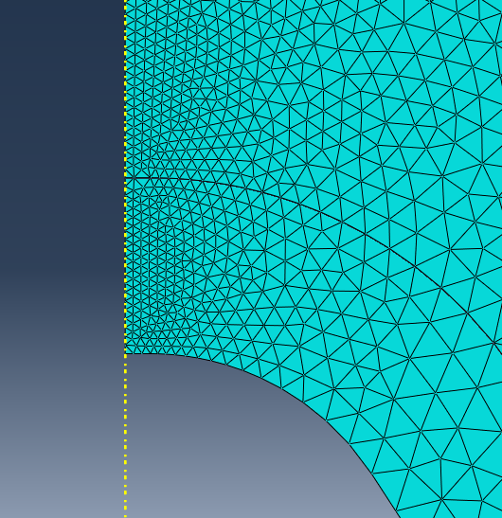
Failed contact interaction due to small line – see mesh distortion. Fix – specific surface to surface explicit interaction selected.
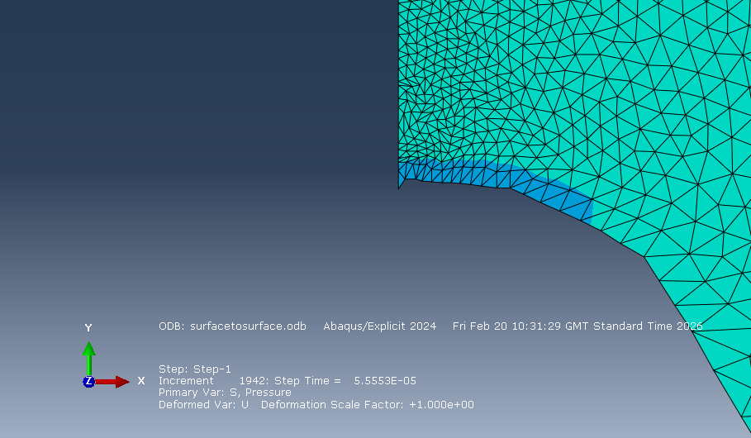
First evidence of surface-to-surface failure contact
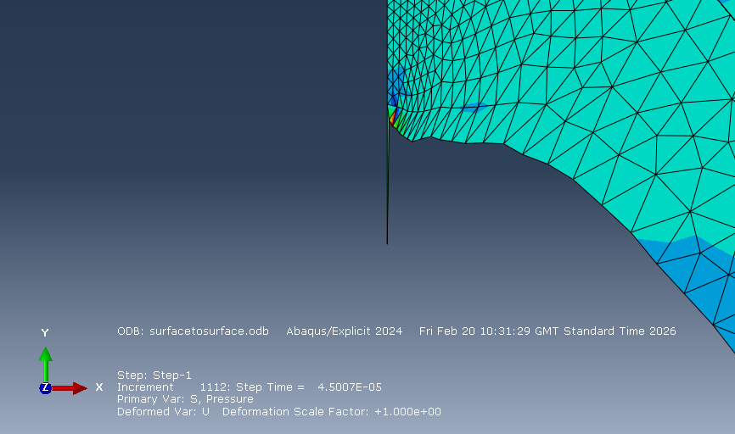
Contact failure continues.
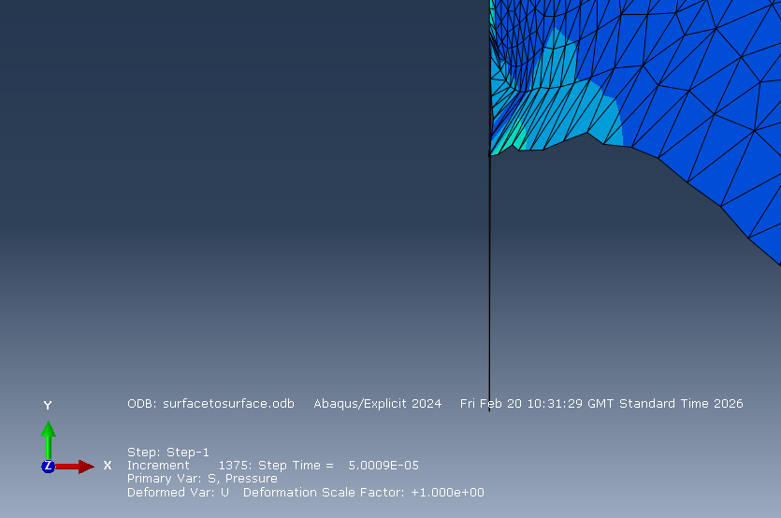
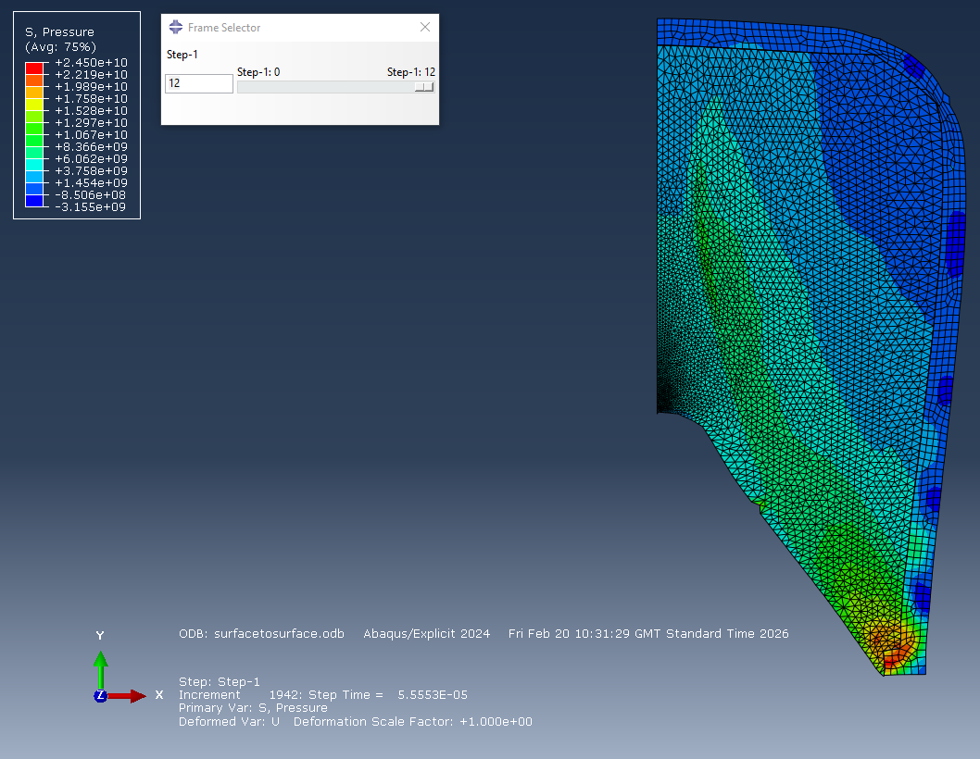
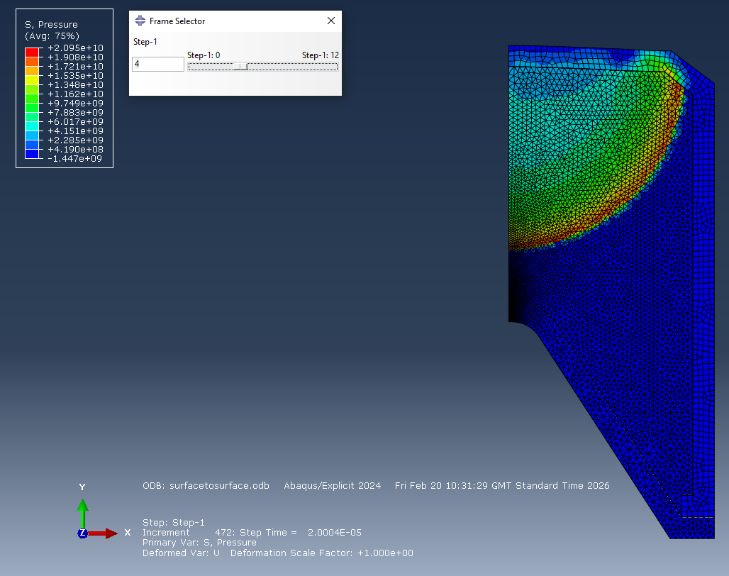
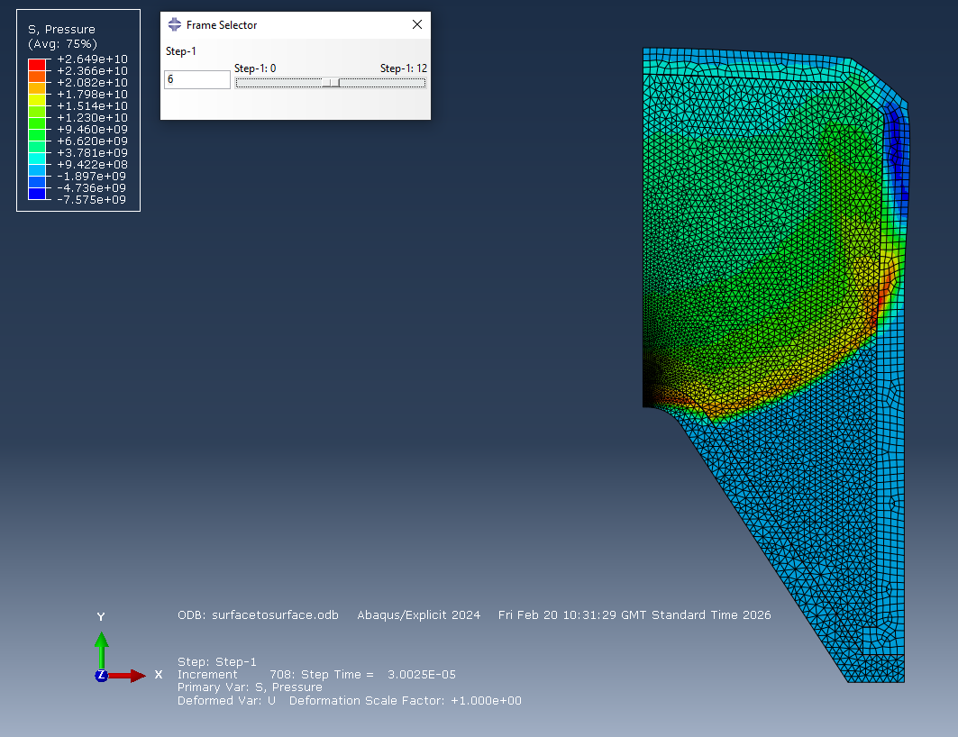
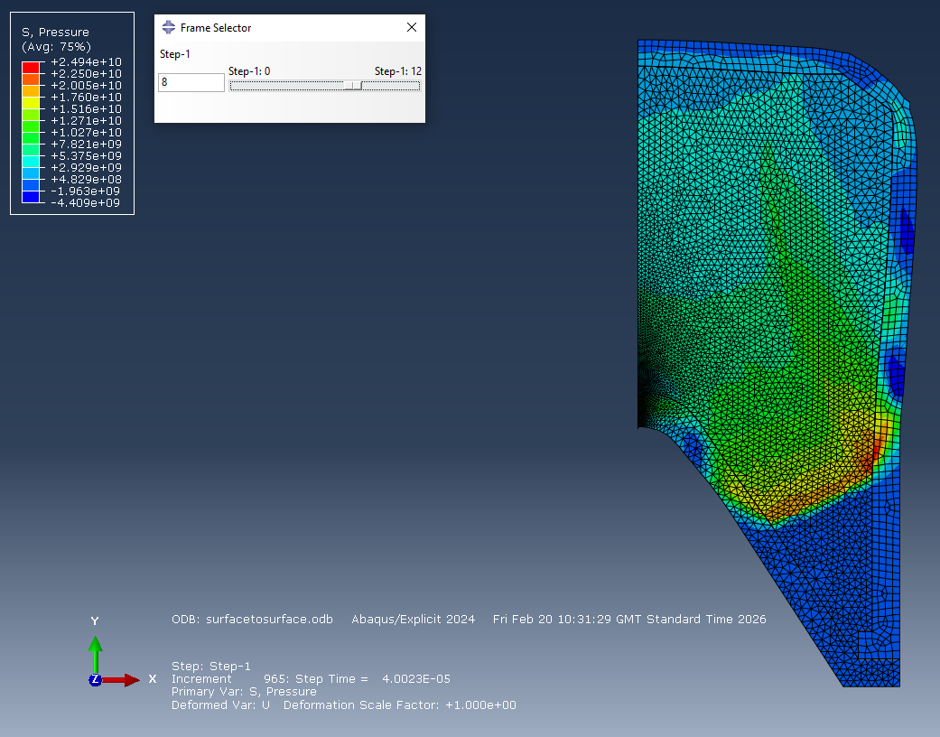
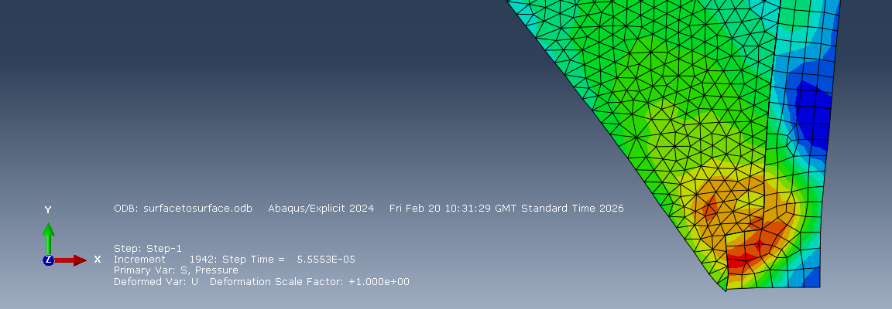
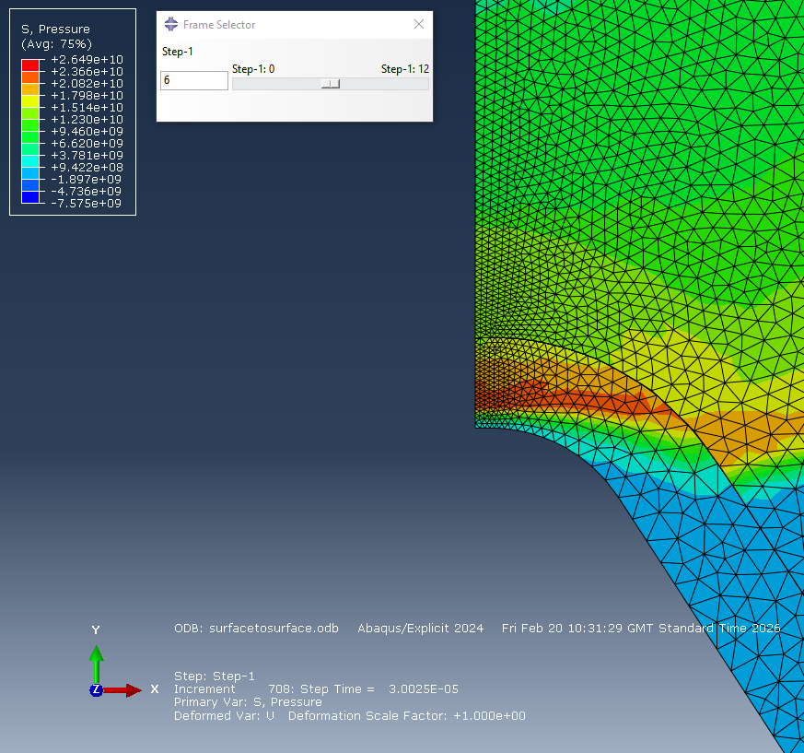
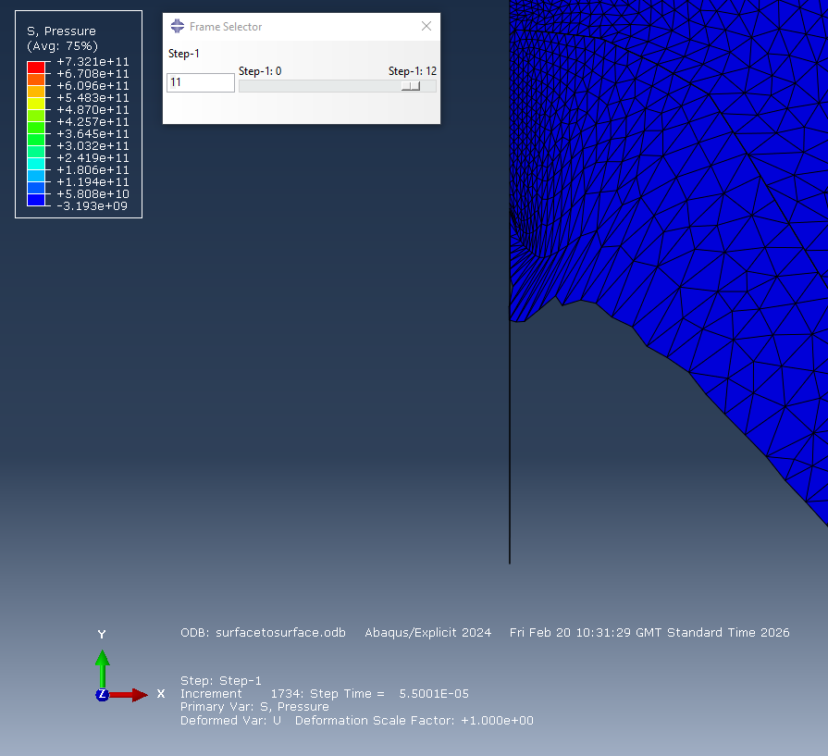
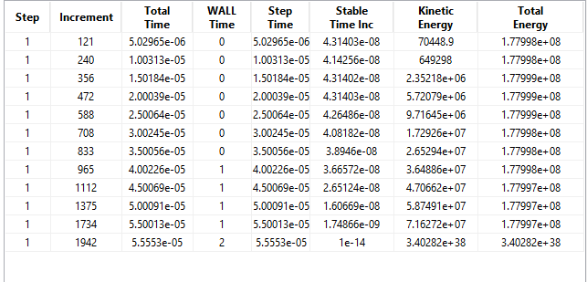
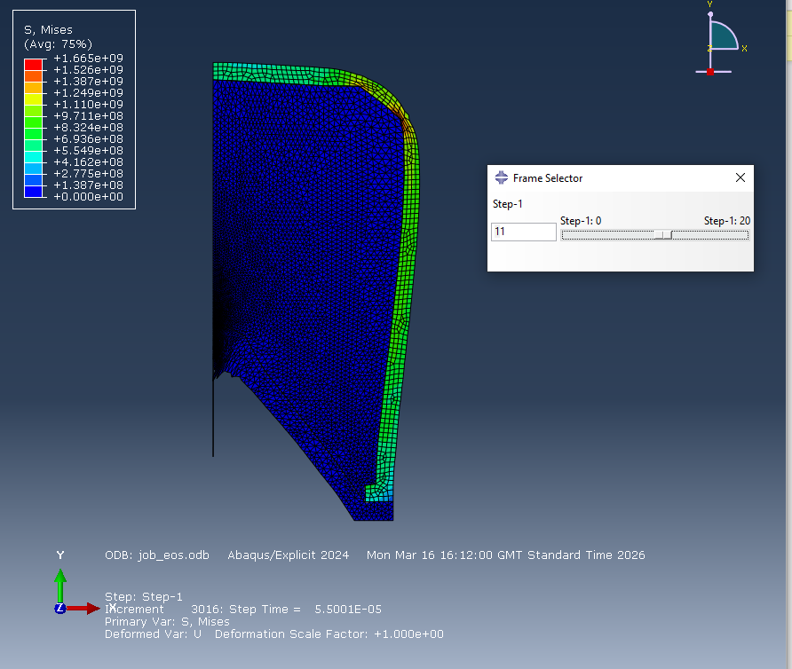

Secondary 2D design
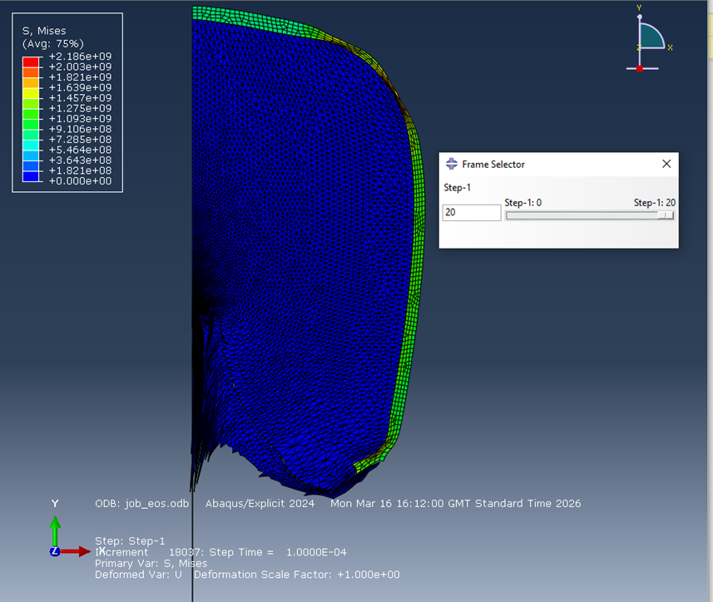
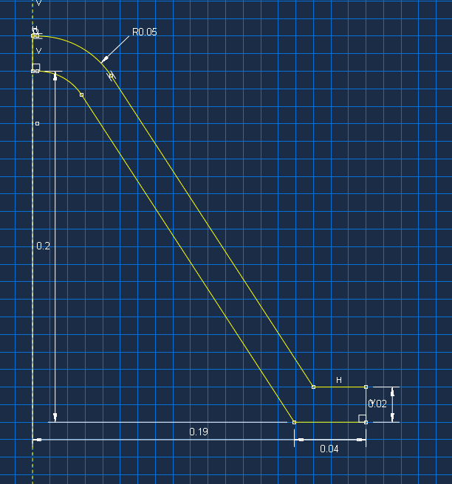

3D design
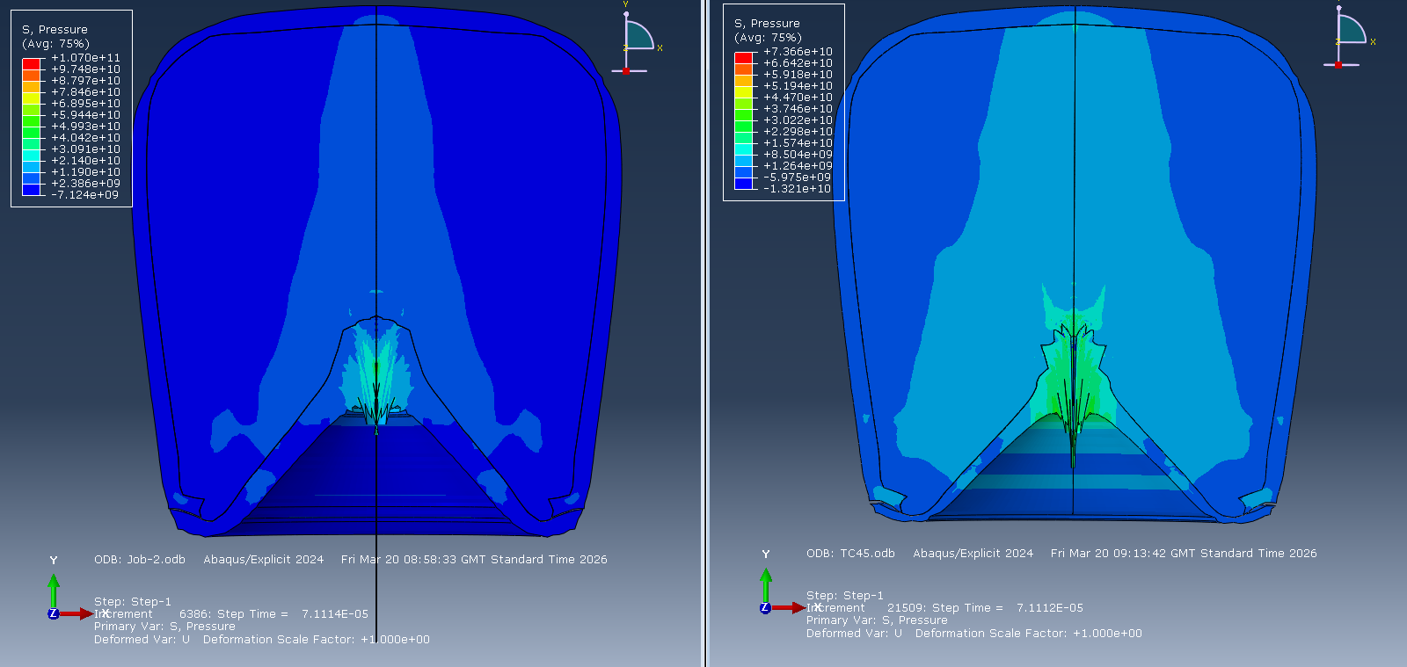
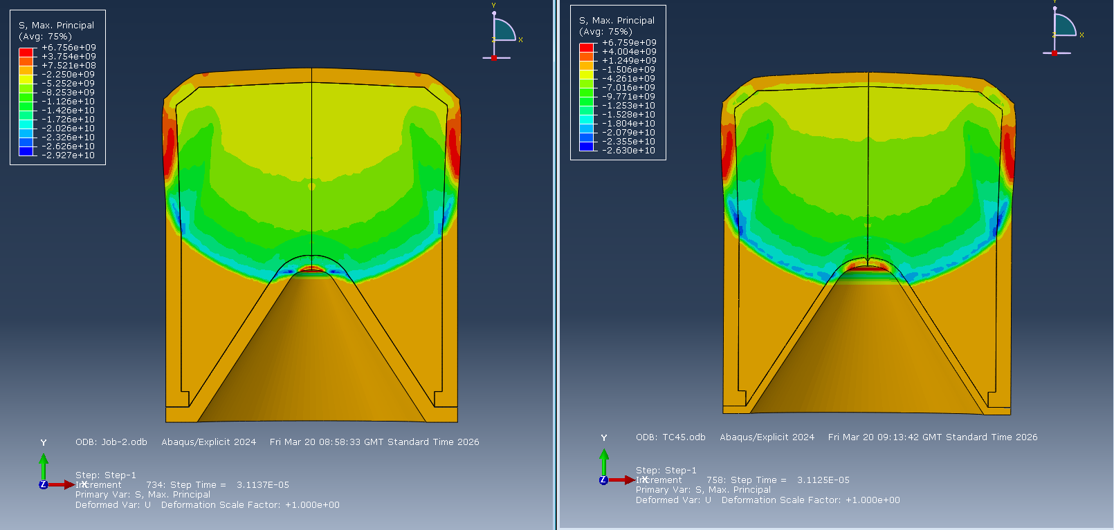
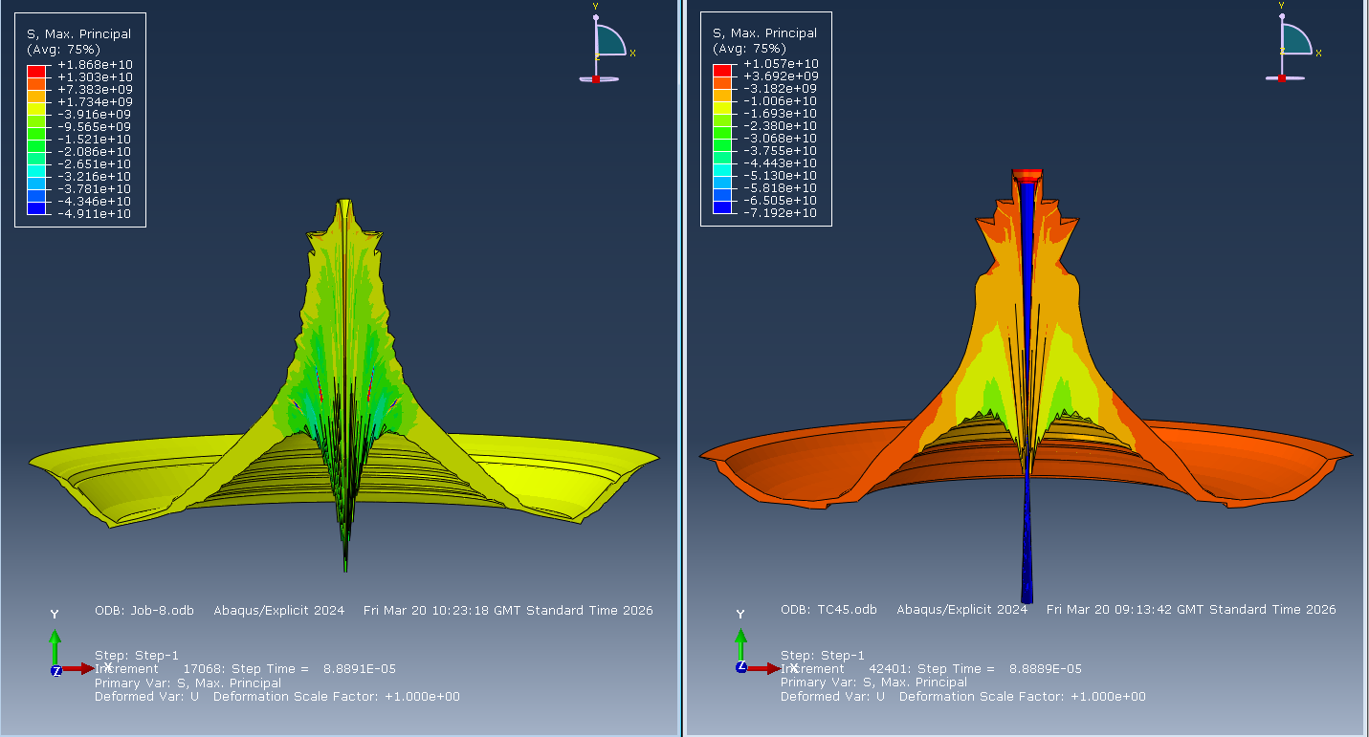

Additionally


