THE IMPACT OF DIGITAL TRANSFORMATION ON THE EFFICIENCY AND PRODUCTIVITY OF NEPALESE COMMERCIAL BANKS

Program: DBA
Module: Advancing to Doctoral Research Stage
Module code: LCDB7012- LON

Student Name: Umesh Giri
Student ID: 2426565

Date of Submissions:

Table of Contents
1. INTRODUCTION 5
1.1 Justification for the Study 5
1.2 Theoretical and Practical Contribution. 6
1.3 Objectives of the Study 6
1.4 Research Questions 6
1.5 Hypotheses 7
1.6 Business and Societal Problems Addressed 7
1.7 Background to the Research 7
1.7.1 The Role of Commercial Banks in Nepal 7
1.7.2 Nepalese Commercial Banks Challenges 8
1.7.3 The Digital Transformation Imperative 9
1.7.4 Bridging the Research Gap 9
2. KUHN’S PARADIGM – A FRAMEWORK FOR DIGITAL TRANSFORMATION 10
2.1 The implications of the Paradigm Shift 11
2.2 Problems with the New Paradigm implementation. 12
2.3 Applicability of the Cycle presented by Kuhn to the current study. 13
3. RISING ACTION 13
3.1 Research approaches 13
3.2 Methodological Strategies 14
3.3 Sample Population and Sample Frame 14
3.4 Sampling Method 15
4. CLIMAX 16
5. DENOUEMENT 17
6. NEXT STEPS 19
References 21

List of figures
Figure 1: The Kuhn Paradigm 11
Figure 2: Paradigm Shift 13
Figure 3: Research sampling 16
Figure 4: DENOUEMENT 19

1. INTRODUCTION
The digital transformation has become part of a strategic necessity of financial institutions that exist in the twenty-first-century economy. The banking industry that is historically founded on a physical branch network and manual service delivery is currently being transformed into data-driven and digitally enabled platforms (Malhotra and Malhotra, 2023). At the same time as global leaders in the industry were able to exploit artificial intelligence, automation, cloud and digital payment ecosystems, emerging economies like Nepal are in an acute inflection point. The operating environment is growing more complex, with more demanding customer expectations, increased competition in the area of fintech using mighty tools, regulatory reforms to encourage the adoption of digital payments, and the national agenda of becoming more financially inclusive (Dhakal and Acharya, 2025). It is against this backdrop that the paper explores how digital transformation influences the performance of Nepalese commercial banks in terms of efficiency and productivity of employees. The study aims at developing empirical understanding which can contribute an insight on strategic, technological and policy level decision making.

1.1 Justification for the Study
This research is justified by three facts:
(a) Empirical Need: As much as Nepalese banks have made investments in mobile banking applications, core banking platforms, digital wallets and automated processing systems, empirical evidence has not been conducted rigorously to measure the extent to which these systems have yielded any measurable improvements in efficiency or productivity (Anagreh et al. 2024). This is due to the fact that currently, discussions mainly stay descriptive but not impact-oriented. To address this gap use of advanced quantitative tools like Data Envelopment Analysis (DEA) and the Malmquist Productivity Index can be employed to measure the efficiency level and productivity change over time (Coelli et al., 2005).
(b) Economic Relevance: Banking performance is directly related to the national economic growth, credit circulation, investor confidence and financial stability. Inefficiencies in the banking system operation do hence have macro-economic implications. A developing economy like Nepal cannot do away with the understanding of productivity outcomes.
(c) Policy Significance: Nepal Rastra bank still supports the idea of digital transformation by means of policy instruments, such as digital KYC, e-payments framework, and financial inclusion strategies (Kandel, 2024). Research needs to be evidence based in order to inform policy improvement, risk mitigation and regulatory innovation.

1.2 Theoretical and Practical Contribution.
Theoretical Contribution:
This paper will combine theory of digital transformation and the Paradigm shift Theory of Thomas Kuhn to conceptualise the evolution of the banking system in the setting of emerging economies (Anand et al. 2024). The study presents itself to the academic debate by showing how leadership models, logic of operation, and the use of technology will shift from bureaucratic norms to the agile and innovation-based systems.
Practical Contribution:
The research can offer practical suggestions to top bank management, regulators, technology strategists and policy makers. The results will help stakeholders understand what domains of transformation provide the most significant effect, where the organisational bottlenecks are still present, and where the resources should be focused on to enhance the digital-financial ecosystem of Nepal.

1.3 Objectives of the Study
The general aim of the study is to look at how digital transformation has affected the efficiency and productivity of commercial banks in Nepal. Precisely, the research will be looking to:
- Evaluate the extent of digital transformation implemented across Nepalese commercial banks.
- Assess the relationship between digital transformation and operational efficiency.
- Analyse the impact of digital transformation on employee productivity.
- Identify organisational, technological, and regulatory barriers constraining successful digital adoption.

1.4 Research Questions
To achieve the above objectives, the following research questions guide the study:
- To what degree have Nepalese commercial banks adopted digital transformation initiatives?
- How does digital transformation influence operational efficiency within commercial banks?
- In what ways does digital transformation affect employee productivity?
- What key challenges inhibit the effective implementation of digital transformation?

1.5 Hypotheses
Based on the theoretical underpinnings of digital transformation, the study proposes:
H1: Digital transformation has a positive and statistically significant impact on operational efficiency in Nepalese commercial banks.
H2: Digital transformation significantly enhances employee productivity within Nepalese commercial banks.
H3: Organisational, regulatory, and infrastructural barriers negatively moderate the relationship between digital transformation and banking performance.

1.6 Business and Societal Problems Addressed
This study will focus on the major issues such as excessive service turn-around time, high administrative cost base, slow credit-processing cycle, rural financial exclusion, and system distrust in the digital financial systems by people. Through examining the relevance of digital solutions towards alleviating such pain-points, the research paper will add to larger goals of financial inclusion, economic development and service delivery centred on the citizens.

1.7 Background to the Research

1.7.1 The Role of Commercial Banks in Nepal
The basic structure on which the formal financial system in Nepal is organised is made up of commercial banks who are the main channels in mobilising and allocating economic resources. They are in the centre of gathering deposits among individuals, households, and business and later channelling this as a productive investment by way of lending money (KC, 2024). In addition to core deposit-credit intermediation, banks also enable domestic and international remittances- another particularly important task in light of the reliance of Nepal on foreign-based labour income. Moreover, commercial banks assist in business growth through lending working capital, investment finance, trade and payment facilitation and digital solutions. They also support the fiscal activities of the public-sector by tax-revenue processing, governmental payroll processing and issuance of treasury activities (Bazarbash et al. 2024). Due to such a widespread economic impact, the commercial banks functioning has a direct effect on the developmental patterns of the countries, the performance of the industries, the creation of jobs, and the stability of the Nepalese economy. When the banks operate efficiently, they lead to increased resort to capital flows, entrepreneurial activity and access to sound financial services by consumers, therefore, banking performance is a priority topic of scholarly and policy attention.

1.7.2 Nepalese Commercial Banks Challenges
However, being the key, the Nepalese commercial banks exist in a sophisticated environment that is distinguished by structural constraints. A large number of banking establishments still use their old-fashioned information systems which were created during the previous decades, which leads to disjointed digital functions and the lack of interoperability between platforms (Krasonikolakis et al. 2020). Such old systems tend to stall smooth flow of information, slow delivery of services and cause points of operation stalls at the branch and back-office levels. To make this issue worse, there is a lack of human capital with the required skills in Information technology, data analytics, cybersecurity, and fintech controls (Wu and Kao, 2022). Banks are often having trouble hiring and keeping digitally savvy personnel that limits their innovation capacity or capability to respond to the modern digital risk. The adoption of the digital financial services by customers is also not uniform; this is mainly because of the reluctance to rely on online security, absence of digital literacies and the use of the culture as the reason to prefer face-to-face dealings. Due to the geographical distribution of members in Nepal, the digital infrastructure deployed has been very urban-intensive which results in the rural populations having poor access to digital networks and having limited coverage to the digital banking services and their facilities (Shah et al. 2025). Though regulatory rules are essential in sustaining financial discipline and customer protection, they are also associated with costly compliance processes that unintentionally slug technological trials and digital products implementation. Efficiency gains vary by bank size, technology readiness and digital maturity (Gherțescu et al., 2024). Collectively, these limitations bring to focus a national financial landscape that is operable but poorly prepared to grow moving forward without systematic adjustment. Cyber security and privacy concerns have significantly affected customers’ willingness to use e-banking in Nepal (Joshi, 2025).

1.7.3 The Digital Transformation Imperative
Digital transformation has thus not been an exercise of the strategy of operational optimization only but an existential agenda of banks in Nepal. Potential improvement in performance rate can be achieved by modernising banking operations, either by automating the system of loan issuance, by digital verification of policy documents, or through online service provision, or even by using AI to establish contact with clients (Ashurov, 2025). The new technologies impact positively on processing time, reduce human error, enhance regulatory reporting, make the operations more secure due to encryption and blockchain-based solutions, and help the banks to provide personalised financial solutions based on the analytics of customer information (Addula et al. 2024). Global studies report that digitalization improves bank productivity and cost efficiency after initial investment stages (Ayadi et al., 2025).On the societal level, digital transformation facilitates a comprehensive development by increasing financial access to remote and underserved groups of people by using mobile banking solutions, agent banking, and branchless banking solutions. It also ensures access to financial services regardless of location and socio-economic background and thus complies with national goals of increasing financial inclusion. As the competition by the South Asian fintech innovators and regional banking trends continue to grow, Nepal commercial banks cannot afford to stick to its traditional mode of operation in case it is determined to keep pace with current industry competitors (Tan, 2024). Digitalisation is thus a necessity to stay alive, to scale, to have stakeholder trust and to have resilience over time in terms of systems.

1.7.4 Bridging the Research Gap
Even though some studies within Nepal have analysed the adoption of digital banking and customer perception, most of them are descriptive and not analytical. The available publications rarely assess the pre-eminent effect of digitalization on quantifiable performance metrics like operational efficiency, cost ratio, employee output, turnaround time to transaction, or risk reduction efficiency (Hasrin, 2020). Moreover, there is a lack of studies that employ a theoretical prism to explain the structural change that digitalisation symbolises, neither does it analyse the role of leadership as well as the organisational culture as elements of transformation. This study thus satisfies a critical void by taking a systematic approach with a theoretical framework and performs an empirical study to establish the actual results of digital transformation.

2. KUHN’S PARADIGM – A FRAMEWORK FOR DIGITAL TRANSFORMATION
The paradigm theory of Thomas Kuhn offers a theoretical basis of comprehending transformational change. The paradigm cycle which is traditionally applied to refer to scientific revolutions can also be applied to the process of organisational evolution, especially in those sectors where habitual practices have become established (Anand et al. 2020). When extended to the Nepalese commercial banking, the framework used by Kuhn allows a step-by-step approach to comprehend how the conventional model of banking is disrupted, coping with crisis, and finally changing to the new dominant regime with the influence of digital technology.
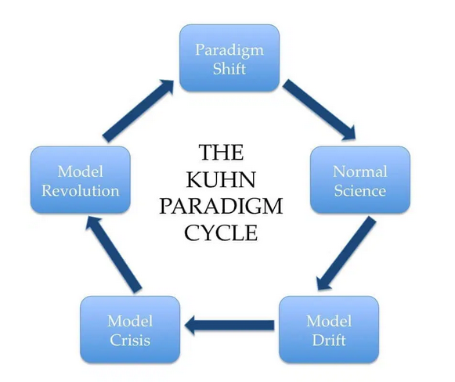

Figure 1: The Kuhn Paradigm
(Source: Adams, 2020)

2.1 The implications of the Paradigm Shift
The process under Kuhn model starts with a phase of a period of normal science where the prevailing mode of banking in Nepal was typified by paper-based, branch-based banking, hierarchical system of approval and reactive leader orientation. Banks provided services by physical contact and efficiency was gauged by man power and physical growth unlike the leverage of technological advancement (Attah et al. 2024). But with time, some anomalies started appearing in this classic paradigm that were questioning the validity and adequacy of this classical paradigm. The old system had vulnerabilities in the form of its tendency to create more customer dissatisfaction in the form of long queues, slow loan processing, and insufficient accessibility to the rural population (Su et al. 2024). At the same time, new market entrants, such as fintech payment systems and online service providers, started to change the expectations of the consumers. These irregularities escalated and their climax was what Kuhn termed as a Crisis Stage. This crisis took the shape of the external shocks seen in Nepal with the COVID-19 pandemic compelling both customers and banks to go online via remote digital channels (Shrestha et al. 2020). Additional pressure on the system was driven by the dramatic expansion of digital wallets, increased demands by the government towards online services.
The environment encouraged a so-called Scientific Revolution, the stage at which Nepalese banks started working on the adoption of the transformative digital solutions on a proactive basis, such as mobile banking apps, digital KYC processes, blockchain-backed data security, chatbots powered by AI, cloud-based data storage, and customer data analytics (Dhakal and Acharya, 2025). These were not technologies that simply brought convenience to the world, but rather technologies that disrupted the logic behind banking. The last phase within the Kuhn cycle called the New Normal refers to a paradigm shift, which has been permanently entrenched within organisational logic. To Nepalese banks, this marks the beginning of lean and digital-first, customer-oriented models in which technology is not an addition but core in service delivery (Simkhada, 2024). Constant innovation, resilience in cybersecurity, the use of data to make decisions, and human-technology integration under this new paradigm would be an expectation and not some optional strategies. It has been observed that banks that do not move into this new paradigm also stand the risk of becoming irrelevant in the market, their customers, and being able to survive in the financial industry.
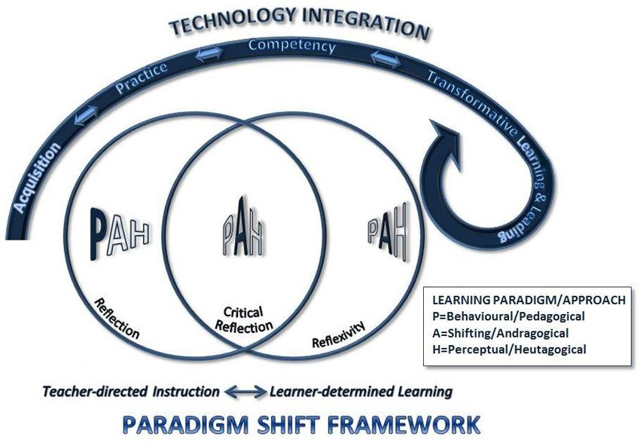

Figure 2: Paradigm Shift
(Source: Wark, 2018)

2.2 Problems with the New Paradigm implementation.
The adoption of the new paradigm is not a homogeneous and an easy process even though the process of digitalisation is inevitable. This is because a number of Nepalese banks cannot find staff who can handle digital architecture, data analytics as well as cyber security threats (Giri, 2024). The replacement of the old systems by entirely integrated digital resources is not only expensive but also to banks where the competitive market conditions necessitate a low margin situation. The threat of cyber security is a continuous risk, especially with cases of cyber fraud and hacking across the globe increasing (Uddin et al. 2020). Also, institutional inertia, manifested in the unwillingness to adopt new processes, fear of job elimination, and conservatism at the top, is often a barrier to digital innovation. Additional demands on building awareness and capacity-building efforts are also challenged by the reality that the transformation of banking is also complicated because of low digital literacy in the customer side.

2.3 Applicability of the Cycle presented by Kuhn to the current study.
The paradigm cycle developed by Kuhn can be motivated not only to be a theoretic analogy but a framework that adds academic value to a work. Traditionally, Nepal banking research has focused on the physical branch growth, customer behaviour or financial ratios (Subedi, 2024). It was not till recently that researchers have realised the inadequacies of manual systems and shifted to technological innovation. The lack of intellectual crisis is clearly seen in the literature by the researchers who admit that conventional operational models do not have the capacity to sustain contemporary financial needs (De Villiers and Sharma, 2020). It is this transformation that has led to this research focus upon digital transformation and performance metrics, which is now the revolutionary phase in the academic discussions. Digitalisation is now a part of the performance of banks, their efficiency, and the trust that customers have in them; hence, in the future, a digital-based assessment is bound to become the so-called New Normal of research. The current research study is directly linked to the new paradigm because it provides empirical evidence to measure the effects of digital transformation. It provides a template that will allow future researchers to investigate parallel variables, which will enhance the aggregation of a digitally-inclined research base on Nepalese banking research.

3. RISING ACTION

3.1 Research approaches
This research project takes the mixed method of direction since it incorporates both the quantitative and qualitative aspects of research. Addressing how digital transformation affects the efficiency and productivity of banks objectively in terms of numerical and time-series financial data is done in the quantitative strand. This will entail the secondary level analysis of financial and operational predictors of a sample of Nepalese commercial banks over the period 2016-2025. The qualitative strand will be used to supplement the statistical results by gathering narrative and experience-based data among the banking staff to learn more about the organisational issues, staff impressions, and the internal processes that shape the digital transformation. The mixed method enhances validity of the research process through the combination of scientific results with situational knowledge.

3.2 Methodological Strategies
An ordered mixed approach is used where the initial step starts with a quantitative step. Secondary data on the bank level (2016-2025) will be analysed with the aid of the Data Envelopment Analysis (DEA-CRS and DEA- VRS) to obtain the efficiency scores and subsequently Malmquist Productivity Index to evaluate the mean efficiency reveals the changes in productivity. The econometric analysis such as panel regression model/Tobit model will analyse the usage of the digitalisation indicators to explain the variations in efficiency with the strength of the explanation with the bootstrapped DEA and the Stochastic Frontier Analysis (Narayanan et al. 2024). Following the quantitative findings, qualitative research will be carried out by semi-structured interviews with employees of banks in person or using safe online websites.

3.3 Sample Population and Sample Frame
The population of the research will be all the A-class 20 commercial banks that are under the Nepal Rastra Bank. In the quantitative section, audited financial statements, public disclosures, or NRB records on a sample of commercial banks that are selected will comprise the sample frame between the years 2016 and 2025. The timeframe of this ten year represents the pre-digital low-ground, interim digital adoption phase, and new phase of maturity of Nepalese banking digitalisation. Regarding the qualitative aspect, the sampled population includes the staff employed by a bank, which deals with digital banking, information technology, operations, and customer service. These members of staff possess workable experience of the implementation of digital systems and therefore, they can offer pertinent information on internal change.
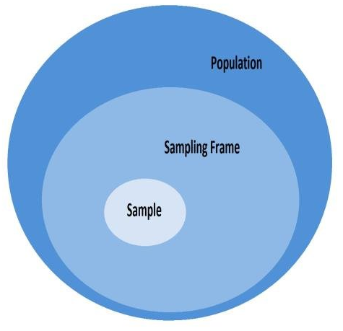

Figure 3: Research sampling
(Source: Ktistakis et al. 2021)

3.4 Sampling Method
The sampling approach indicates the mixed approach In the case of the quantitative secondary data, the panel sampling technique will be employed, and that is, a specific set of commercial banks should be monitored within several years. Banks are chosen according to the data assembled and are a sample of large, medium and smaller banks to obtain representation of sectors. In the qualitative interviews, a purposive method of sampling is applied (Ahmad, and Wilkins, 2025). The participants are specifically targeted according to their professional role, experience in online banking and their capability to present detailed information. Each of the participating banks will be targeting at least one of its staff members that represent one of the operational units or divisions of its digital banking platforms, IT support, or customer-facing teams to capture various perspectives of functioning units.

4. CLIMAX
- Personal reflection on preparation
Initially started from broader interest in banking digitalisation, the research thinking gradually became concentrated toward investigating the impact of digital transformation on efficiency and employee productivity in Nepalese commercial banks. In this process, the role of empirical literature understanding is crucial as it reshapes the understanding of digital transformation. The development of methodological confidence was a critical evaluation process with integrated research philosophy and led to a justified approach of a mixed method which aligns with the research object and complexity of the phenomenon (Shan, 2022). The challenges occurring during the preparation include addressing data accessibility, aligning theory with context which further resulted in the development of problem-solving ability and research design rigour. Additionally increasing awareness of research possibility enables reflection on potential bias, contextual influences and importance of maintaining objectivity. Lastly, the structured portfolio development ensures readiness to undertake doctoral-level empirical research execution.
- Evaluation of portfolio content
In the process of portfolio evaluations, the literature review played a crucial role as a demonstrated extensive engagement with contemporary and seminal sources which contributed to the identification of research gas in the emerging economy banking sector. Identifying this research gap directly affects the formulation of research questions and hypotheses ensuring theoretical relevance analytical depth and strong alignment between existing scholarship and studies empirical focus. The integration of digital transformational theory followed by Kuhn's paradigm shift theory is essential for development of research. Development of provinces to explain change in the Nepalese banking sector. The selection of a mix-method approach in this research is justified as it aligns with the requirement of research question and data sources. The combined strength of quality and quantitative data provide validity and reliability and mitigate the limitation related to access and generalizability which are acknowledged and mitigated through triangulation (Donkoh, and Mensah, 2023). In this process special consideration needs to be made for ethical standards especially regarding banking research. In this process the research should ensure participant confidentiality and anonymity protection. Utilization of data collection tools such as structure survey and semi-structure interview are most suitable for capturing both measurable outcome and contextual inside (Le Thanh Thao et al. 2023). Anticipated access and data sensitivity issues are key concerns of this research. The mitigation of this issue followed by meteorological limitations are acknowledged through triangulation, and phase data collection. Interestedly, the portfolio demonstrated from readiness for doctoral research by confirming metrological competence, theoretical clarity, and analytical coherence. Presence of clear alignment between theory research objective and methodology are essential. This integration makes a decisive transition from conceptual preparation to empirical execution.

5. DENOUEMENT
The denouement represents the resolution of conceptual, methodological, and practical tension within the research process. Denouement is an important component of research proposal development as it shaped, refined and strengthened the final research proposal (Dervin, 2024). Analysis of this factor provides information regarding early uncertainty of research focus and methods which need to be resolved which further contribute to the development of theoretical ground methodological feasibility and empirical focus. Understanding of this factor highlights the importance of denouement in proposal development that demonstrates clear readiness for doctoral-level investigation.
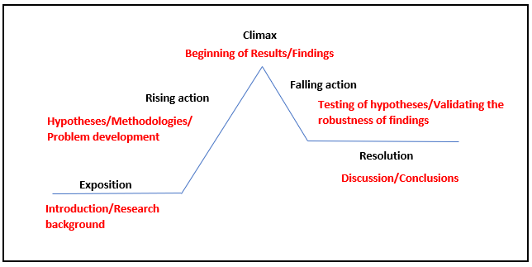

Figure 4: DENOUEMENT
(Source: Sindhuja, 2025)
Additionally, resolution of conceptual framework and practical contradiction are essential parts of the research. Existence of internal tension between technological determinism and human or organisational factors are essential part of conceptual femur resolution. Understanding conflicting views in the literature perspective regarding digital transformation outcome is essential. Additionally, differences between strategic intent and operational realities are key factors integrated into practical contradiction in Nepalese banking.
A key contradiction addressed in this research concerns the traditional divide between quantitative and qualitative research paradigms. Separate implementations of quantitative methods or quality methods were unable to fulfil the requirement of the research (Taherdoost, 2022). The reasoning behind this occurrence includes that quantitative methods alone have major efficiency and productivity outcomes whereas qualitative approach provided inside into perception and experiences. Quantitative methods are insufficient to capture the contextual organisation and human dimension of digital transformation (Leso et al. 2023) within Nepalese commercial banks, on the other hand quality approaches like the ability to generalized finding or statistical taste performance relationship. Understanding this scenario implementation of the mix method approach is ideal as it integrated both the qualitative and quantitative method with integrated strength of both paradigms. Additionally mixed-method design reconciles positive measurement with interpretive insight (Siponen et al. 2021). This methodological choice for the align with triangular edition enhances its validity, reliability and provides depth to the research by cross verification of the research finding. Within Kuhn’s paradigm shift framework, this integration reflects a move beyond rigid methodological orthodox.
Definitional ambiguity was addressed by conceptualising digital transformation as an integrated socio-technological change beyond its adoption. Which encompasses process skill and culture. Additionally, constructs were operationalized into measurable indicators such as performance time and output. These definitions were tailored to Nepalese banking realities, ensuring contextual relevance, empirical clarity, and meaningful interpretation of digital transformation outcome. Managing ethical consideration and research basis is also an essential part. In the scenario handling confidential banking data followed by mitigating response biases, social disabilities bias, and researcher bias are essential. Additionally, utilisation of informed consent and ethical approval processes need to be addressed during ethical consideration. Additionally, for overcoming data collection and access challenges, utilization of institutional permission and confidentiality assurance where plan to use however in occurrence of failure assistance will be requested from peers and supervisor. For mitigating time constraints and organisation gatekeeping, effective utilization of Data collection via phase is ideal.
For the theoretical lens this study implements digital transformation theory, and Kuhn's Paradigm Shift theory which assists in expanding structural changes in the Nepalese banking sector. Finalisation of instrument and analytical techniques for the strengthening Research design whereas existence of clearing between objective hypothesis and analysis improve data analysis plan which ultimately contributed to the enhancement of research feasibility. Ensuring integration of all the necessary elements the research plan is defensible, coherent which are necessary criteria for doctoral-level research completion. The study is positioned to generate original policy revenue and practical oriented knowledge.

6. NEXT STEPS
The next steps involve transitioning from research design to empirical execution. The immediate priorities include finalising research instruments, obtaining ethical approval pursued, and data collection. The presence of this methodological factor contributes to generation of robust context specific evidence for Nepalese commercial banks. Effective adaptation of validated instrument scale in the analysis of the banking sector of Nepal provides necessary information. Additionally, the presence of this measurement scale ensures construct validity, reliability and contextual relevance. Moreover, completion of pilot testing using a sample size of a small group consisting of bank employees and manager will provide information regarding reliability, internal consistency of survey and interview instrument which will further provide clarity (Lewis et al. 2021). The feedback and preliminary result of the spider testing will further contribute to refinement of question wording measurement scaling and overall data collection process which will ensure effective utilisation of full-scale survey success.
Fulfilment of ethical consideration are essential in order to ensure informed consent confidentiality of individuals followed by maintaining their anonymity (Alhabsi, 2024). Insurance of data security and handling are also essential part of ethical considerations (Pina et al. 2024). Ethical approval for this research will be obtained through the institutional review processes prior to data collection. Adhering to the ethical standard and requirement of research objective the data collection strategy plan rollout of quantitative survey (secondary data) across selected commercial banks. Additionally, the completion of semi-structure interviews with managerial and technical stakeholders will provide essential information. Institutional permissions and access constraints will be carefully managed to ensure adequate participation data accuracy and timely completion of both quantitative and qualitative data collection phases which are required for this study. Analysis of both the qualitative and quantitative data from appropriate methods will be integrated through triangulation to enhance validity, deepen integration and provide a comprehensive understanding of digital transformation impact. After the completion of analysis, the final stage will include synthesizing empirical findings into a digital transformation-performance framework which is tailored to Nepal’s regulatory, infrastructural, and organisation context.
The development of this framework is ideal as it provides contribution and efficiency regarding banking and digital transformation literature and knowledge in emerging economies. This productivity given outcome of this analysis will contribute to development of actionable recommendations for bank managers which will assist them in improving efficiency and operation productivity. The end result will provide information regarding Nepal Rastra Bank in refining digital banking policy and regulatory framework. By doing so the study will contribute to the enlargement of knowledge by extending digital transformation literature within emerging economic banking contexts. This knowledge will further contribute to the development of future research which should focus on comparative study across South Asia and other emerging economies. By conducting longitudinal studies on the topic and focusing on digital maturity and productivity outcome the future research has the ability to provide doctoral-level Research development which provide information regarding institutional expectations.

References
Addula, S.R., Meduri, K., Nadella, G.S. and Gonaygunta, H., 2024. ‘AI and blockchain in finance: Opportunities and challenges for the banking sector’, International Journal of Advanced Research in Computer and Communication Engineering, 13(2), pp.184-190.
Ahmad, M. and Wilkins, S., 2025. ‘Purposive sampling in qualitative research: A framework for the entire journey’, Quality & Quantity, 59(2), pp.1461-1479.
Alhabsi, S.S., 2024. ‘Ethical considerations in obtaining informed consent in research participation’, International Journal of Educational Contemporary Explorations, 1(1), pp.22-32.
Anagreh, S., Al-Momani, A.A., Maabreh, H.M.A., Sharairi, J.A., Alrfai, M.M., Haija, A.A.A., Rahahle, M.Y., Alzyoud, M., Mohammad, A.A.S. and Al-Hawary, S.I.S., 2024. ‘Mobile payment and digital financial inclusion: a study in Jordanian banking sector using unified theory of acceptance and use of technology’, In Business Analytical Capabilities and Artificial Intelligence-Enabled Analytics: Applications and Challenges in the Digital Era, Volume 1 (pp. 107-124). Cham: Springer Nature Switzerland.
Anand, G., Larson, E.C. and Mahoney, J.T., 2020. ‘Thomas Kuhn on paradigms’, Production and Operations Management, 29(7), pp.1650-1657.
Ashurov, F., 2025. ‘THE ROLE OF TECHNOLOGY IN MODERNIZING MORTGAGE LOAN ACCOUNTING PROCESSES IN COMMERCIAL BANKS’, Развитие и инновации в науке, 4(1), pp.20-22.
Attah, R.U., Garba, B.M.P., Gil-Ozoudeh, I. and Iwuanyanwu, O., 2024. ‘Corporate banking strategies and financial services innovation: Conceptual analysis for driving corporate growth and market expansion’, Int J Eng Res Dev, 20(11), pp.1339-49.
Ayadi, R., Chiaramonte, L., Cucinelli, D. and Migliavacca, M., 2025. Digitalization and banks' efficiency: Evidence from a European analysis. International Review of Financial Analysis, 97, p.103837.

Bazarbash, M., Griffin, N.N., Una, G. and Verma, A., 2023. ‘Emerging ideas for fintech applications in public finance’, In Research Handbook on Public Financial Management (pp. 31-56). Edward Elgar Publishing.
Coelli, T.J., Prasada Rao, D.S., O’donnell, C.J. and Battese, G.E., 2005. An introduction to efficiency and productivity analysis. Boston, MA: Springer US.
De Villiers, C. and Sharma, U., 2020. ‘A critical reflection on the future of financial, intellectual capital, sustainability and integrated reporting’, Critical perspectives on accounting, 70, p.101999.
Dervin, F., 2024. ‘Provisional Denouement’, In The Routledge Handbook of Critical Interculturality in Communication and Education (pp. 536-546). Routledge.
Dhakal, P. and Acharya, S.L., 2025. ‘The Impact of Digital Transformation on Banking Services and Customer Experience: a study of the Nepalese banking sector’.
Donkoh, S. and Mensah, J., 2023. ‘Application of triangulation in qualitative research’, Journal of Applied Biotechnology and Bioengineering, 10(1), pp.6-9.
Gherțescu, C., Manta, A.G., Bădîrcea, R.M. and Manta, L.F., 2024. ‘How does the digitalization strategy affect bank efficiency in Industry 4.0? A bibliometric analysis’, Systems, 12(11), p.492.
Giri, P., 2024. MANAGEMENT INFORMATION SYSTEM REPORT ON NMB BANK (Doctoral dissertation, Faculty of Management, Tribhuvan University).
Hasrin, A., 2020. An investigation into the importance and relevance of intangible assets in Malaysian digital small and medium-sized enterprises (SMES) performance: The balanced scorecard approach. University of Salford (United Kingdom).
Joshi, S.R., 2025. ‘Cyber Security Issues Affecting the Users’ Willingness to Use E-Banking: A Case of Nepalese Commercial Banks’, Nepalese Journal of Economics, 9(1), pp.214-228.
Kandel, B.P., 2024. FINANCIAL TECHNOLOGY AND PAYMENT SYSTEMS IN NEPAL (Doctoral dissertation, Shanker Dev Campus).
KC, P., 2024. Deposit mobilization of commercial banks in Nepal (Doctoral dissertation).
Krasonikolakis, I., Tsarbopoulos, M. and Eng, T.Y., 2020. ‘Are incumbent banks bygones in the face of digital transformation?’, Journal of General Management, 46(1), pp.60-69.
Ktistakis, M.A., Pavlovic, J. and Fontaras, G., 2021. ‘Sampling approaches for road vehicle fuel consumption monitoring’, Report EUR, 30420.
Le Thanh Thao, Trut Thuy, P., Anh Thi, N., Hoang Yen, P., Thi Anh Thu, H. and Huong Tra, N., 2023. ‘An insight into reflective teaching levels of Vietnamese EFL teachers in a premier language center’,Cogent Education, 10(2), p.2243118.
Leso, B.H., Cortimiglia, M.N. and Ghezzi, A., 2023. ‘The contribution of organizational culture, structure, and leadership factors in the digital transformation of SMEs: a mixed-methods approach’, Cognition, Technology & Work, 25(1), pp.151-179.
Lewis, M., Bromley, K., Sutton, C.J., McCray, G., Myers, H.L. and Lancaster, G.A., 2021. ‘Determining sample size for progression criteria for pragmatic pilot RCTs: the hypothesis test strikes back!’, Pilot and feasibility studies, 7(1), p.40.
Malhotra, R. and Malhotra, D.K., 2023. ‘The Impact of Technology, Big Data, and Analytics: The Evolving Data-Driven Model of Innovation in the Finance Industry’, Journal of Financial Data Science, 5(3).
Narayanan, E., Ismail, W.R. and Mustafa, Z., 2024. ‘Unlocking Global Innovation: Leveraging Non-Parametric Analytics with Data Envelopment Analysis and Tobit Insights on External Factors’, Journal on Innovation and Sustainability RISUS, 15(3), pp.107-131.
Pina, E., Ramos, J., Jorge, H., Váz, P., Silva, J., Wanzeller, C., Abbasi, M. and Martins, P., 2024. ‘Data privacy and ethical considerations in database management’, Journal of Cybersecurity and Privacy, 4(3), pp.494-517.
Shah, B., Sah, K.K. and Jha, M., 2025. ‘Digital transformation in Nepal: Navigating opportunities and challenges in the Digital Era’, Rajarshi Janak University Research Journal, 3(1), pp.104-115.
Shan, Y., 2022. ‘Philosophical foundations of mixed methods research’, Philosophy Compass, 17(1), p.e12804.
Shrestha, M.R., Sapkota, R. and Shrestha, M.M., 2020. COVID-19 Multidisciplinary Narratives.
Simkhada, S., 2024. ‘Employee readiness for digital banking transformation of commercial bank in Nepal’.
Sindhuja A (2025). Freytag’s Pyramid for Storytelling in Research Papers | Editage Insights. [online] Editage Insights.
Siponen, M., Soliman, W. and Holtkamp, P., 2021, July. ‘Research perspectives: Reconsidering the role of research method guidelines for interpretive, mixed methods, and design science research. Association for Information Systems’.
Su, H., Duan, L. and Wang, L., 2024, September. ‘From Lines to Algorithms: Transforming Customer Experience in Rural Banking with Smart Queue Systems’, In 2024 International Annual Conference on Complex Systems and Intelligent Science (CSIS-IAC) (pp. 831-836). IEEE.
Subedi, P., 2024.’ Exploring Trends in Financial Performance Metrics: An In-Depth Study of Nepalese Banks Over the Past Decade’, NPRC Journal of Multidisciplinary Research, 1(3), pp.105-119.
Taherdoost, H., 2022. ‘What are different research approaches? Comprehensive review of qualitative, quantitative, and mixed method research, their applications, types, and limitations.’, Journal of Management Science & Engineering Research, 5(1), pp.53-63.
Tan, A., 2024. Bridging the gap: Transforming financial inclusion in Nepal through fintech innovation and sustainability [online]
Uddin, M.H., Ali, M.H. and Hassan, M.K., 2020. ‘Cybersecurity hazards and financial system vulnerability: a synthesis of literature’, Risk Management, 22(4), pp.239-309.
Wark, N., 2018. Shifting paradigms: ‘A critical pragmatic evaluation of key factors affecting learner-empowered emergent technology integration’.
Wu, A.C. and Kao, D.D., 2022. ‘Mapping the sustainable human-resource challenges in southeast Asia’s FinTech sector’, Journal of Risk and Financial Management, 15(7), p.307.

